1. Create the necessary tables for the identified database objects from the ER Diagram of your business domain with necessary constraints (Primary Key, Unique, Not Null, Check, Default and Foreign Key).

create table Football (

Admin_Id varchar2(20) constraint Admin_Id_pk primary key,

Admin_Name varchar2(50)not null,

Manager_Name varchar2(50) not null,

Manager_Id varchar2(50) not null,

Player_Id varchar2(30)not null,

Game_Data varchar2(50)not null);

alter set constraint

ALTER TABLE Manager ADD CONSTRAINT MyUniquekey UNIQUE (Email);

create table Manager (

Manager_Name varchar2(50) NOT NULL,

Manager_Id varchar2(30) constraint Manager_Id_pk primary key,

Address varchar2(80)NOT NULL,

Email varchar2(60)NOT NULL,

contact_No varchar2(50)NOT NULL,

Age varchar2(30)NOT NULL,

Achievements varchar2(100)NOT NULL,

Previous_Club varchar2(80)NOT NULL,

Admin_Id varchar2(20) references Football( Admin_Id));

create table Coach (

Coach_Name varchar2(50) NOT NULL,

Coach_Id varchar2(30) constraint Coach_Id_pk primary key,

Address varchar2(80)NOT NULL,

Email varchar2(60)NOT NULL,

Contact_No varchar2(50)NOT NULL,

Age varchar2(30)NOT NULL,

Achievements varchar2(100)NOT NULL,

Previous_Club varchar2(80)NOT NULL,

Manager_Id varchar2(20) references Manager( Manager_Id));

alter set constraint

ALTER TABLE Coach ADD CONSTRAINT MyUniquekey UNIQUE (Email);

create table Assistant_coach (

Assist_Coach_Name varchar2(50)NOT NULL,

Assist_Coach_Id varchar2(30) constraint Assistant_coach_Id_pk primary key,

Address varchar2(80)NOT NULL,

Email varchar2(60)NOT NULL,

Contact_No varchar2(50)NOT NULL,

Age varchar2(30)NOT NULL,

Achievements varchar2(100)NOT NULL,

Previous_Club varchar2(80)NOT NULL,

Coach_Id varchar2(20) references Coach( Coach_Id));

create table Gym_Trainer (

Gym_Trainer_Name varchar2(50) not null,

Gym_Trainer_Id varchar2(30) constraint Gym_Trainer_pk primary key,

Address varchar2(80),

Email varchar2(60),

Contact_No varchar2(50),

Age varchar2(30),

Special_Workout_Player varchar2(100),

Previous_Club varchar2(80));

create table Physiotherapist (

Physiotherapist_Name varchar2(50)NOT NULL,

Physiotherapist_Id varchar2(30) constraint Physiotherapist_Id_pk primary key,

Address varchar2(80)NOT NULL,

Email varchar2(60)NOT NULL,

Contact_No varchar2(50)NOT NULL,

Age varchar2(30)NOT NULL,

Special_Exercise_Player varchar2(100)NOT NULL,

Previous_Club varchar2(80)NOT NULL,

Assist_Coach_Id varchar2(20) references Assistant_coach(Assist_Coach_Id));

create table Dietitian (

Dietitian_Name varchar2(50)NOT NULL,

Dietitian_Id varchar2(30) constraint Dietitian_Id_pk primary key,

Address varchar2(80)NOT NULL,

Email varchar2(60)NOT NULL,

Contact_No varchar2(50)NOT NULL,

Age varchar2(30)NOT NULL,

Special_Diet_player varchar2(100)NOT NULL,

Previous_Club varchar2(80)NOT NULL,

Assist_Coach_Id varchar2(20) references Assistant_coach(Assist_Coach_Id));

create table Game_Data (

Game_Id varchar2(30) constraint Game_Id_pk primary key,

Ball_Possession varchar2(30)NOT NULL,

Keyy_Chances varchar2(30)NOT NULL,

Goal_Scored varchar2(20)NOT NULL,

Pass_Completion varchar2(20)NOT NULL,

Interception varchar2(30)NOT NULL,

Assists varchar2(30)NOT NULL,

Yellow_Card varchar2(30)NOT NULL,

Break_The_Defence varchar2(30)NOT NULL,

Admin_Id varchar2(20) references Football( Admin_Id));

create table Player (

Player_Name varchar2(50)NOT NULL,

Player_Id varchar2(30) constraint Player_Id_pk primary key,

Address varchar2(80)NOT NULL,

Email varchar2(60)NOT NULL,

Contact_No varchar2(50)NOT NULL,

Age varchar2(30)NOT NULL,

Position varchar2(80)NOT NULL,

Admin_Id varchar2(20) references Football( Admin_Id));

create table Player_Data (

Player_Data_Id varchar2(30) constraint Player_Data_Id_pk primary key,

Health_Details varchar2(50)NOT NULL,

Touches_On_Ball varchar2(50)NOT NULL,

Pass_Completion varchar2(50)NOT NULL,

Pass_Received varchar2(50)NOT NULL,

Pass_Missed varchar2 (50)NOT NULL,

Goal_Scored varchar2 (50)NOT NULL,

Key_Pass varchar2 (50)NOT NULL,

Interceptions varchar2(50)NOT NULL,

Play_Time varchar2(50)NOT NULL,

Position_Of_Player varchar2(50) NOT NULL,

Player_Id varchar2(20) references Player( Player_Id)

);

"Insert into the first table football"

insert into Football(

Admin_Id,

Admin_Name,

Manager_Name,

Manager_Id,

Player_Id,

Game_Data)values ('008','Reeve','Ajith','Man001','Pla001','Gd001');

"Insert into the first table Manager"

insert into Manager(

Manager_Name,

Manager_Id,

Address,

Email,contact_No,

Age,

Achievements,

Previous_Club)

values ('Ajith','Man001','abc','xyz@gmail.com','1234567899','50','premier league','mancity');

insert into Manager(

Manager_Name,

Manager_Id,

Address,

Email,contact_No,

Age,

Achievements,

Previous_Club)

values ('Bolt','Man002','agbc','xyzz@gmail.com','1234567599','54','ligue1 league','man united');

insert into Manager(

Manager_Name,

Manager_Id,

Address,

Email,contact_No,

Age,

Achievements,

Previous_Club)

values ('zoom','Man003','bbc','yyz@gmail.com','1234567898','68','champions league','mancity');

"Insert into the first table Coach"

insert into Coach(

Coach_Name,

Coach_Id,

Address,

Email,

contact_No,

Age,

Achievements

,Previous_Club)

values ('Senthil','Coa003','abc','xyz@gmail.com','1234567899','58','Isl league',' city');

insert into Coach(

Coach_Name,

Coach_Id,

Address,

Email,

contact_No,

Age,

Achievements

,Previous_Club)

values ('Nadhan_sir','Coa002','abc','xyzzz@gmail.com','1234547899','55','Isl league',' gg city');

"Insert into the first table Assistant coach"

insert into Assistant_coach(

Assist_coach_Name,

Assist_coach_Id,

Address,

Email,

contact_No,

Age,

Achievements,

Previous_Club)

values ('Neha','Acoa001','abc','xyz@gmail.com','1234567899','60','Christ league','jain');

insert into Assistant_coach(

Assist_coach_Name,

Assist_coach_Id,

Address,

Email,

contact_No,

Age,

Achievements,

Previous_Club)

values ('Aleena','Acoa002','abccc','xysz@gmail.com','1234563899','40','tow league','savior');

"Insert into the first table Gym Trainer"

insert into Gym_Trainer(

Gym_Trainer_Name,

Gym_Trainer_Id,

Address,

Email,

contact_No,

Age,

Special_Workout_Player,

Previous_Club)

values ('Christina','Gt001','abc','xyz@gmail.com','1234567899','30','stregthening','mancity');

"Insert into the first table Physiotherapist"

insert into physiotherapist (

physiotherapist_Name,

physiotherapist_Id,

Address,

Email,

contact_No,

Age,

Special_Exercise_Player,

Previous_Club)

values ('Sathyam','Phy001','abc','xyz@gmail.com','1234567899','30','Condition','mancity');

"Insert into the first table Dietitian"

insert into Dietitian (

Dietitian_Name,

Dietitian_Id,

Address,

Email,

contact_No,Age,

Special_Diet_Player,

Previous_Club)

values ('Sneha','Die001','abc','xyz@gmail.com','1234567899','40','Renal','mancity');

"Insert into the first table Game data"

insert into Game_Data

( Game_Id,

Ball_Possession,

Keyy_Chances,

Goal_Scored,

Pass_Completion,

Interception,Assists,Yellow_Card,Break_The_Defence)

values ('Pl01','10','5','4','7','8','10','10','8');

"Insert into the first table Player"

insert into Player(Player_Name,

Player_Id,

Address,

Email,

contact_No,

Age,

position)

values ('sujith','pl01','abc','xxyz@gmail.com','1234567899','20','RW');

insert into Player(Player_Name,

Player_Id,

Address,

Email,

contact_No,

Age,

position)

values ('vishnu','pl002','abec','xtyz@gmail.com','1234277899','20','lW');

insert into Player(Player_Name,

Player_Id,

Address,

Email,

contact_No,

Age,

position)

values ('kiki','pl003','abc','xysz@gmail.com','1234544899','27','cb');

"Insert into the first table Player_Data"

insert into Player_Data (

Player_Data_Id,

Health_Details,

Touches_On_Ball,

Pass_Completion,

Pass_Received,

Pass_Missed,

Goal_Scored,

Key_Pass,

Interceptions,

Play_Time,

Position_Of_Player)

values ('Pld001','fit','5','8','18','5','2','7','4','12','RW');

insert into Player_Data (

Player_Data_Id,

Health_Details,

Touches_On_Ball,

Pass_Completion,

Pass_Received,

Pass_Missed,

Goal_Scored,

Key_Pass,

Interceptions,

Play_Time,

Position_Of_Player)

values ('Pld002','fit','6','5','19','5','2','8','4','19','RW');

insert into Player_Data (

Player_Data_Id,

Health_Details,

Touches_On_Ball,

Pass_Completion,

Pass_Received,

Pass_Missed,

Goal_Scored,

Key_Pass,

Interceptions,

Play_Time,

Position_Of_Player)

values ('Pld003','un_fit','8','8','18','12','1','9','14','15','RW');

select*from Football;

select*from Coach;

select*from Assistant_coach;

select*from Gym_Trainer;

select*from Physiotherapist;

select*from Dietitian;

select*from Game_Data;

select*from Player;

select*from Player_Data;

select*from Manager;

insert into Manager(

Manager_Name,

Manager_Id,

Address,

Email,

contact_No,

Age,

Achievements,

Previous_Club)

values ('Ajith','Man001','abc','xyz@gmail.com','1234567899','50','premier league','mancity');

3. alter table Manager drop constraint MyUniquekey;

select * from Manager;

insert into Manager(

Manager_Name,

Manager_Id,

Address,

Email,

contact_No,

Age,

Achievements,

Previous_Club)

values ('Ajith','Man005','abc','xyz@gmail.com','1234567899','50','premier league','mancity');

select * from Manager;

4.

select constraint_name,constraint_type from user_constraints;

5. alter table Manager drop constraint MyUniquekey;

insert into Manager vl

select * from Manager;

insert into Manager(

Manager_Name,

Manager_Id,

Address,

Email,

contact_No,

Age,

Achievements,

Previous_Club)

values ('Ajith','Man006','abc','xyz@gmail.com','1234567899','50','premier league','mancity');

select * from Manager;

6. drop table Manager;

drop table Manager;

delete * from Manager where Manager_id='Man006';

7. DROP TABLE Manager;

truncate table Manger;

2. Demonstrate the enforcement of constraint with necessary inputs. 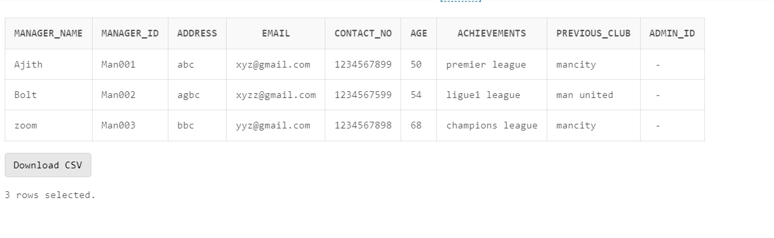

insert into Manager(

Manager_Name,

Manager_Id,

Address,

Email,

contact_No,

Age,

Achievements,

Previous_Club)

values ('Ajith','Man001','abc','xyz@gmail.com','1234567899','50','premier league','mancity');

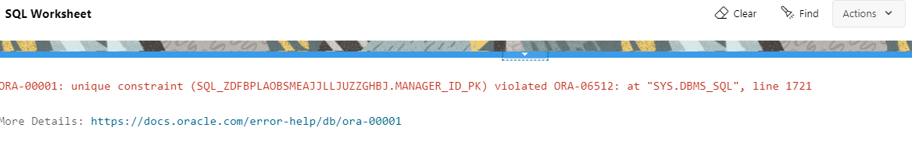

1. Demonstrate the enforcement of constraint using alter table command.

alter table Manager drop constraint MyUniquekey;

Before dropping the Unique constraint on Manager:

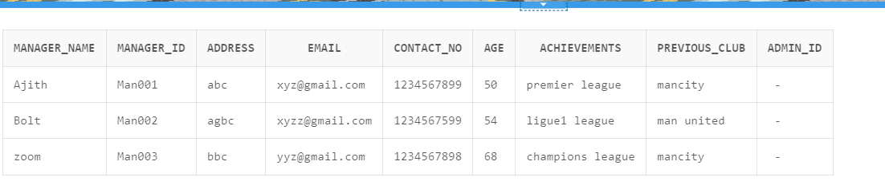

After dropping:

insert into Manager(

Manager_Name,

Manager_Id,

Address,

Email,

contact_No,

Age,

Achievements,

Previous_Club)

values ('Ajith','Man005','abc','xyz@gmail.com','1234567899','50','premier league','mancity');

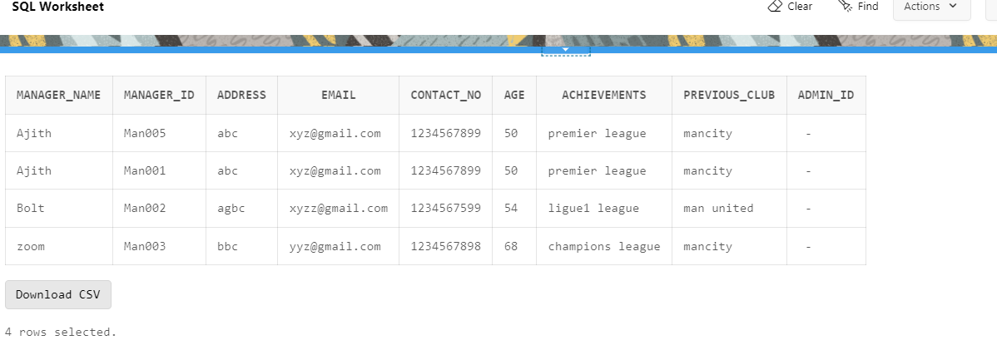

1. List the constraints enforced on each table.

select constraint_name,constraint_type from user_constraints;

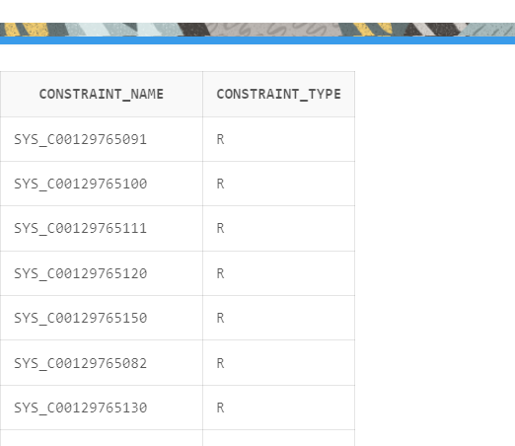

1. Demonstrate dropping of any one constraint of an object

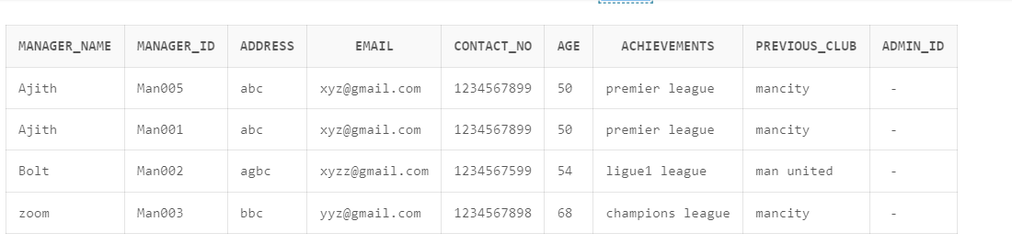

alter table Manager drop constraint MyUniquekey;

insert into Manager(

Manager_Name,

Manager_Id,

Address,

Email,

contact_No,

Age,

Achievements,

Previous_Club)

values ('Ajith','Man006','abc','xyz@gmail.com','1234567899','50','premier league','mancity');

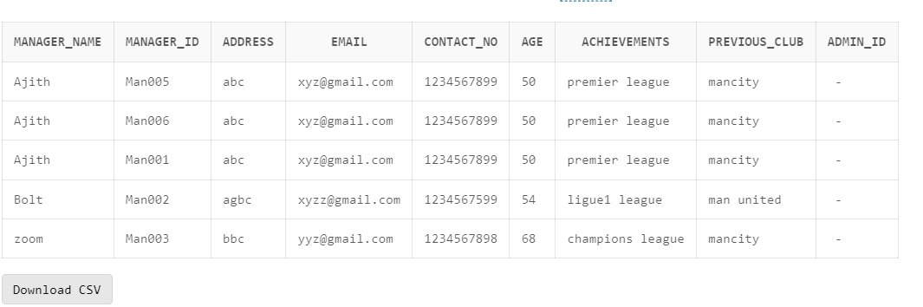

6. Demonstrate, How the data integrity is maintained by propagating changes across parent and child tables present in the database.

tried dropping the parent table, football tabke.

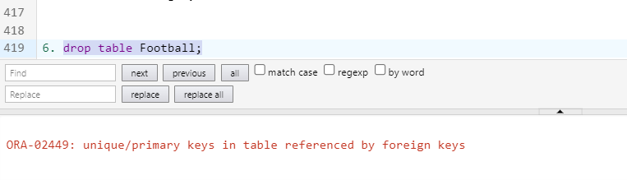

Tried dropping the child table, Manager

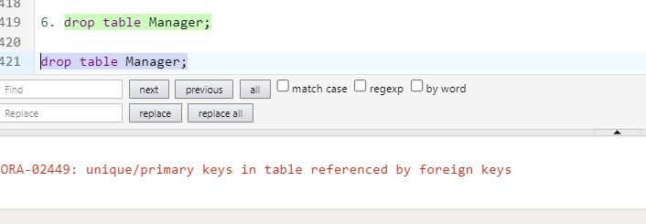

7 Demonstrate Drop and Truncate Commands onto the objects and display the records.

DROP TABLE Manager;

truncate table Manger;

