|  |  |
| --- | --- |
| OIP.jpg  Lab Assignment 01 | Name: Sohardya Golder  ID: 201006412  Course CODE: 124.3  Section: 03  Mohammmed Nazim Uddin  **Instructor** |

**1. Display course names/string using user input with private instance variable and set-get methods/constructor.**

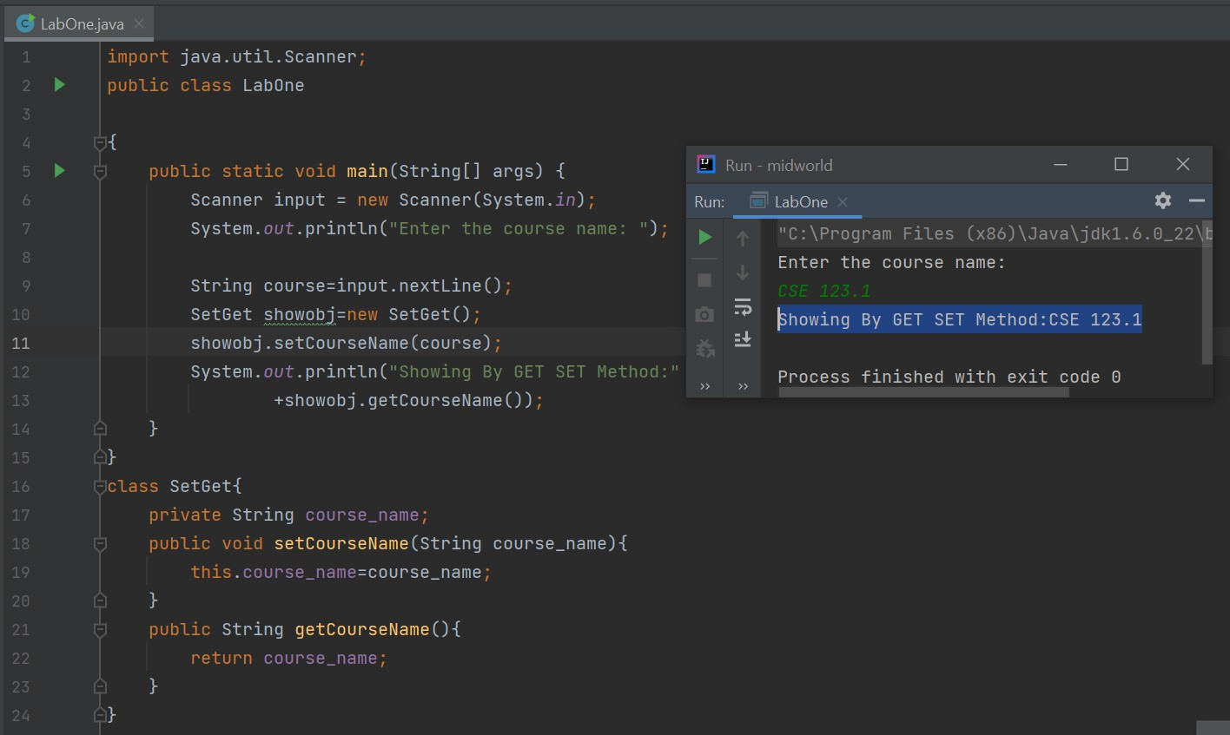

**Last Page of program 01**

**2. Create and Update bank account with deposit and withdraw. using constructor. Create at least two bank accounts**

**Program 02**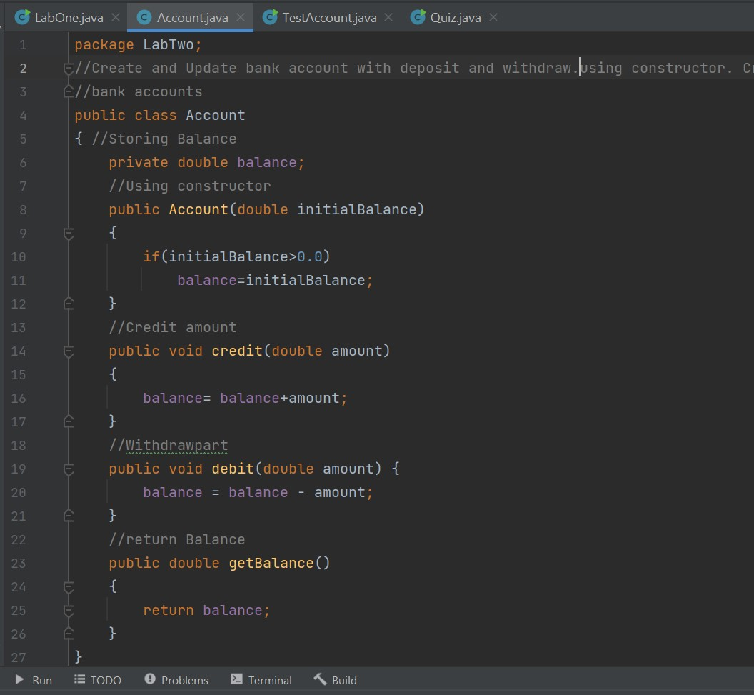

**Program 02**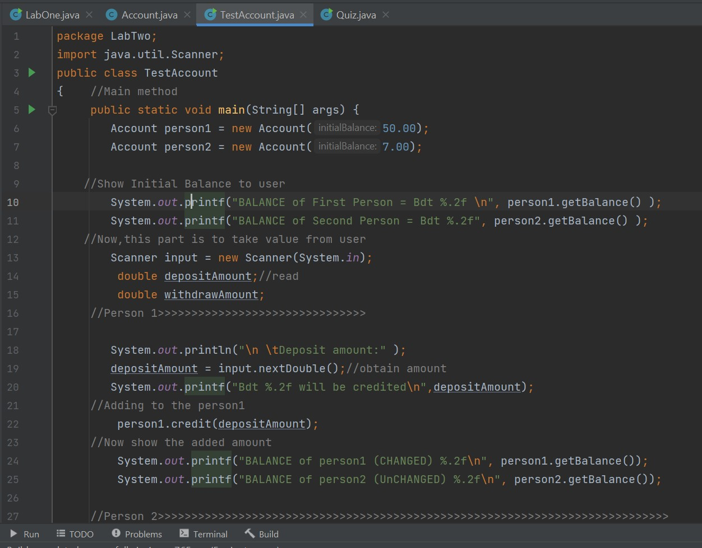

**Program 02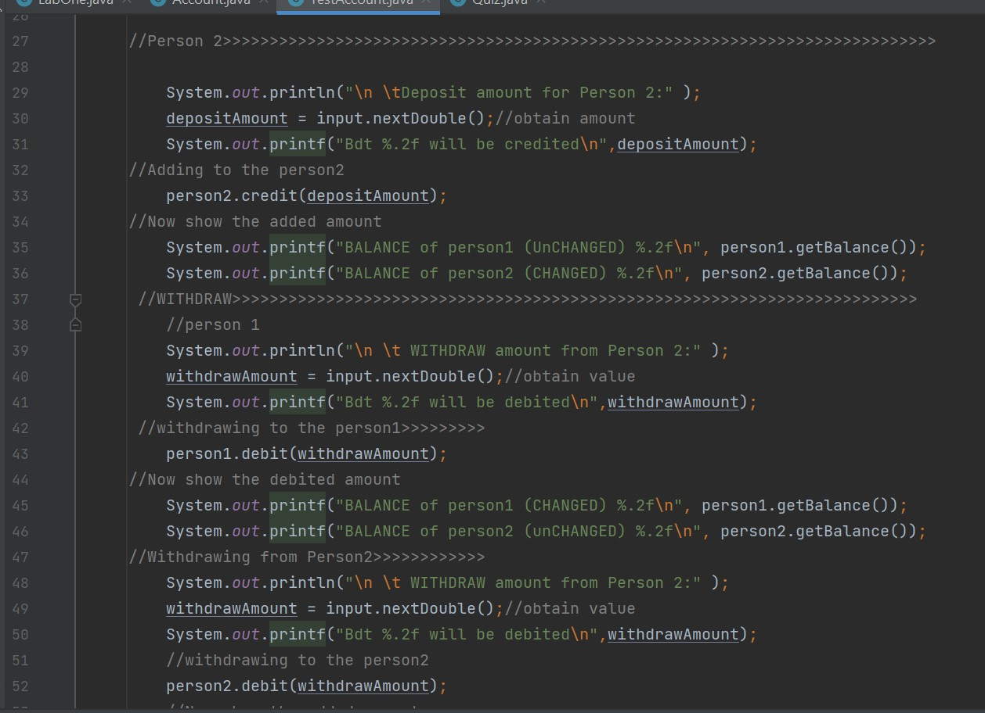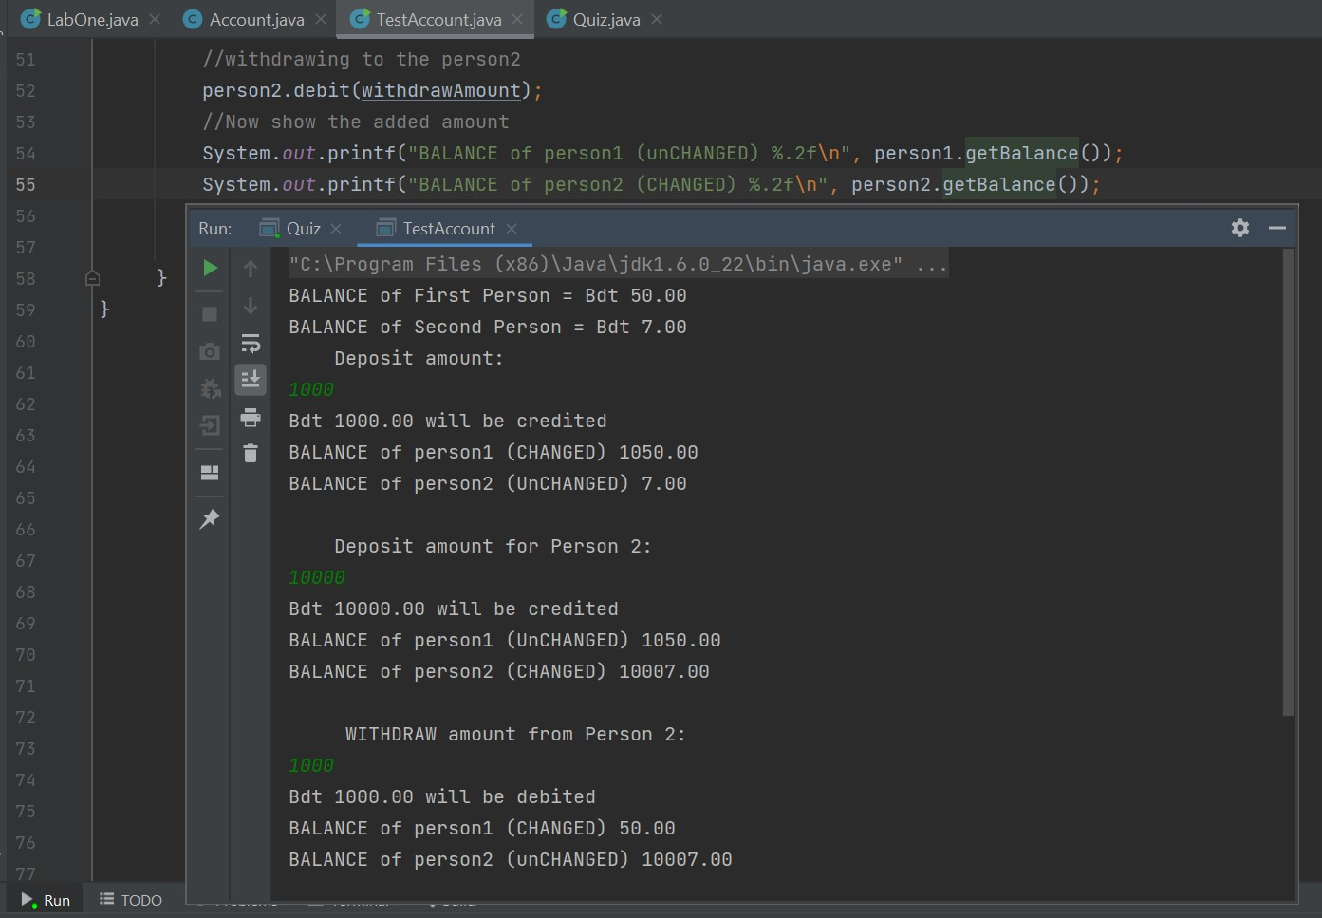Last Page of program 02** 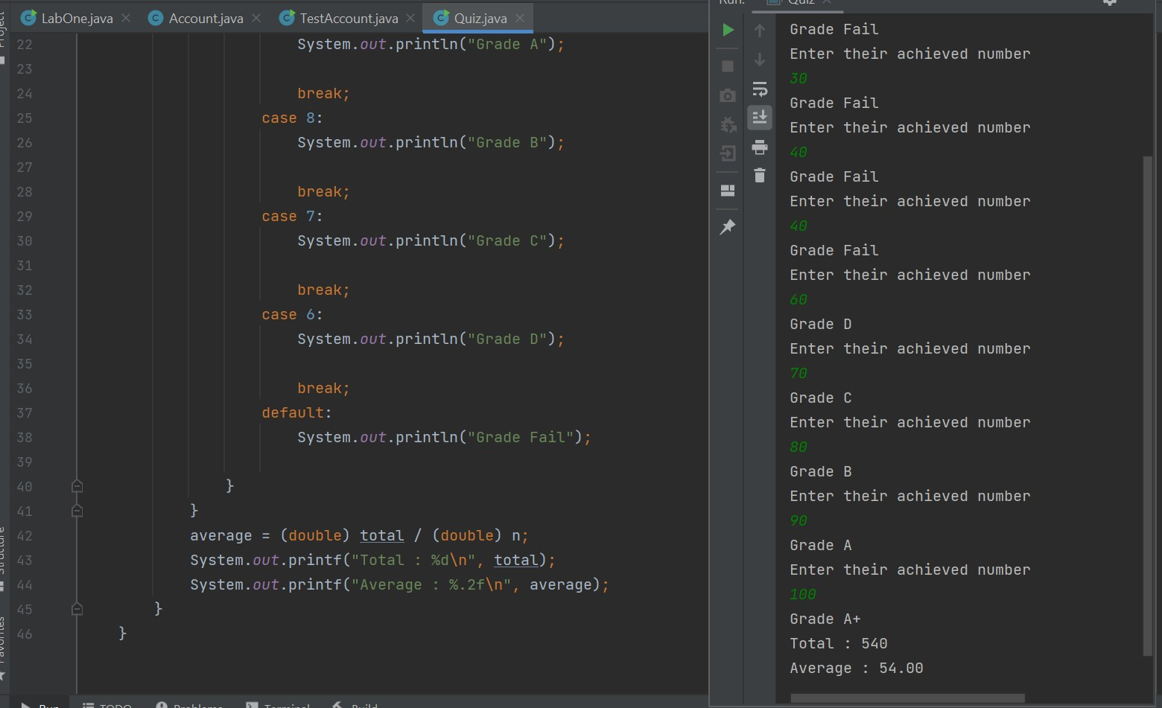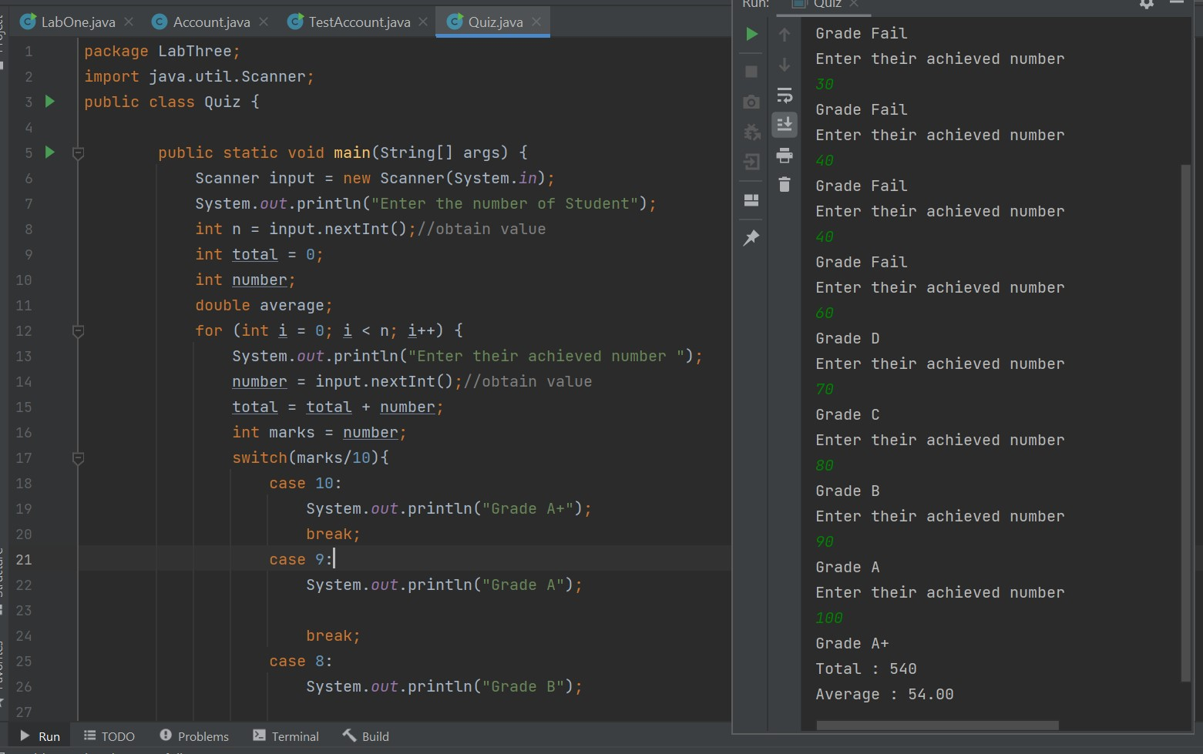

**3. Quiz average of 10 students.**

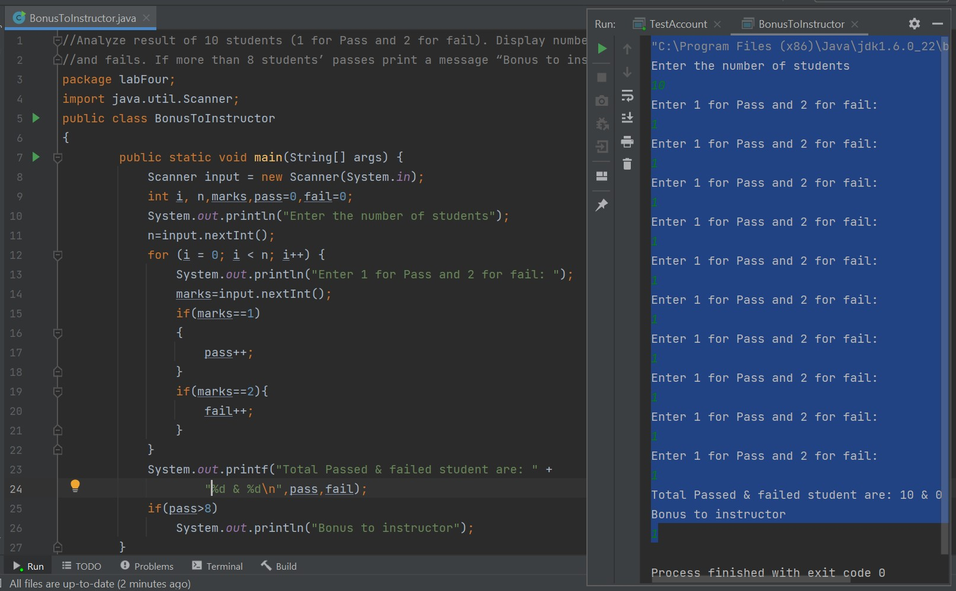**4. Analyze result of 10 students (1 for Pass and 2 for fail). Display number of students passes**

**and fails. If more than 8 students’ passes print a message “Bonus to instructor”.**

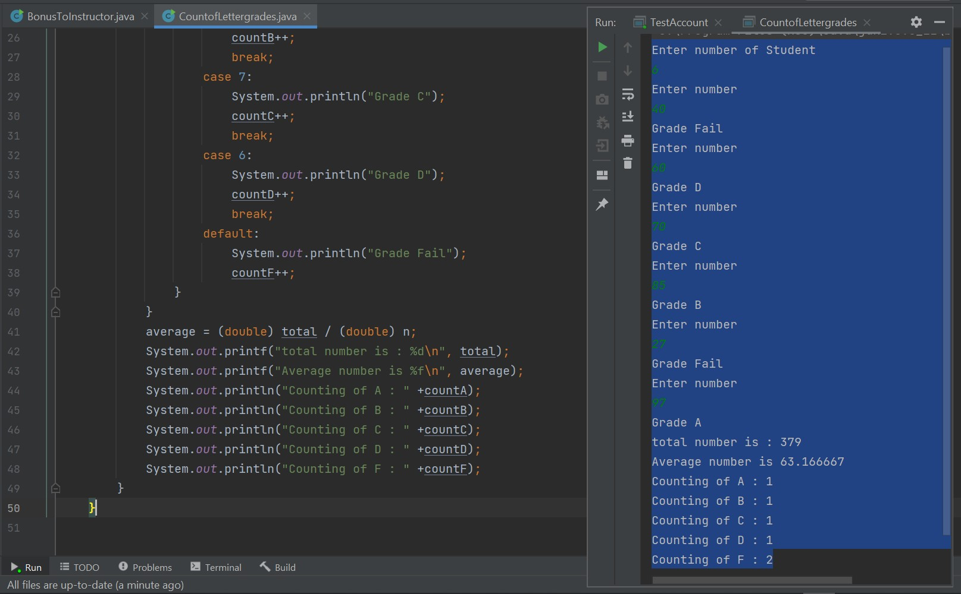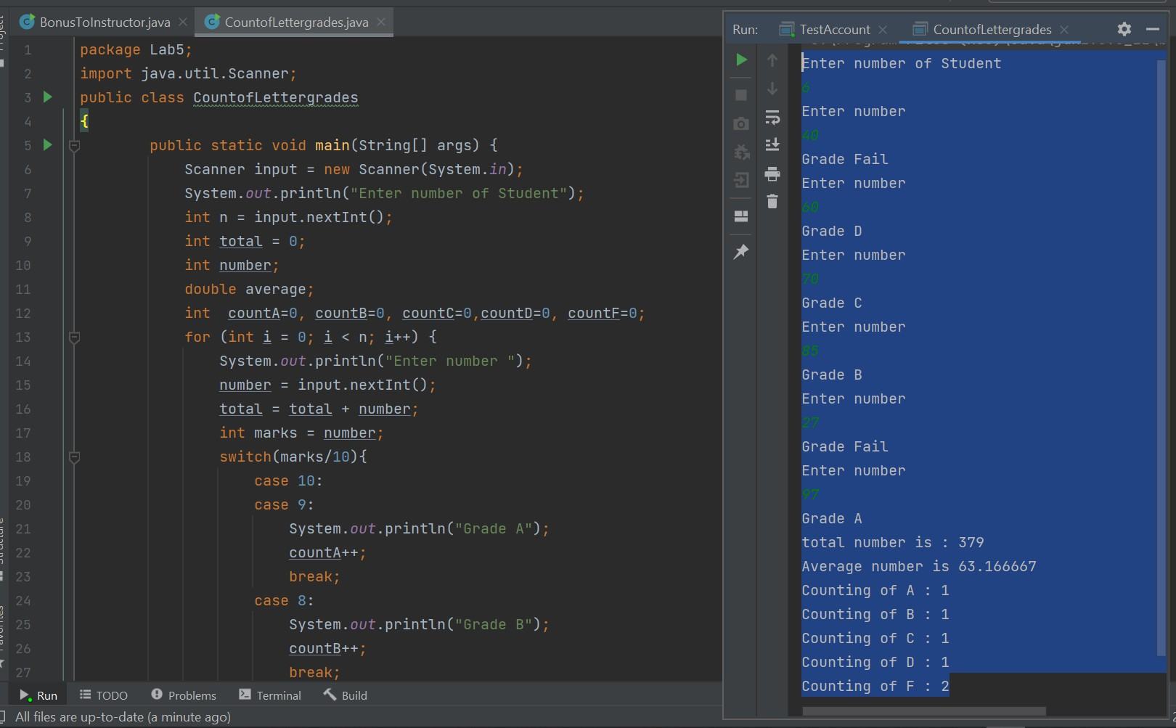**5. Write a program to calculate sum, average and Count of Letter grades for 10 students using switch.**

**6. Maximum and minimum of 3 numbers using Math.max.**

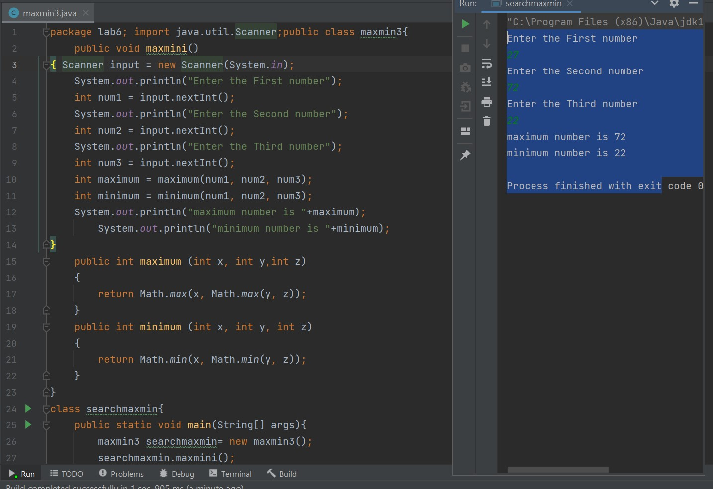

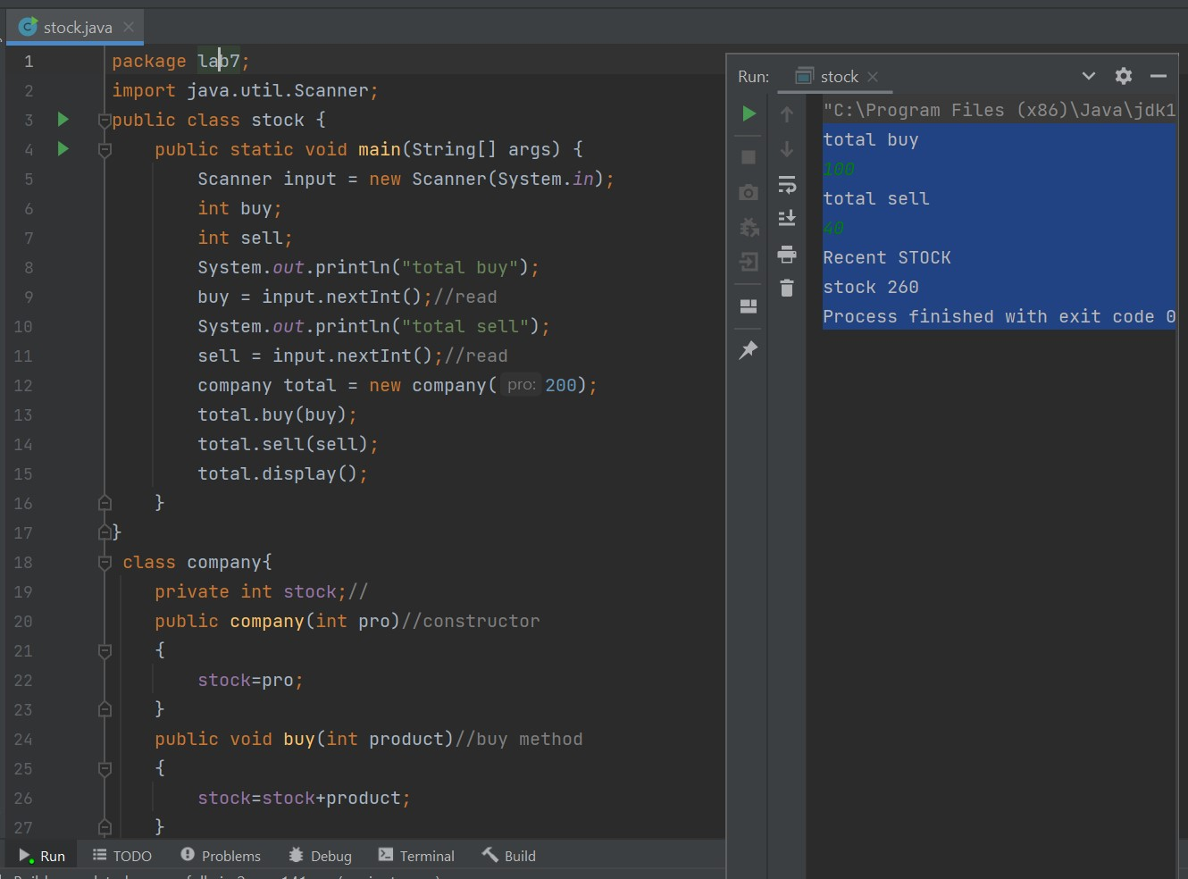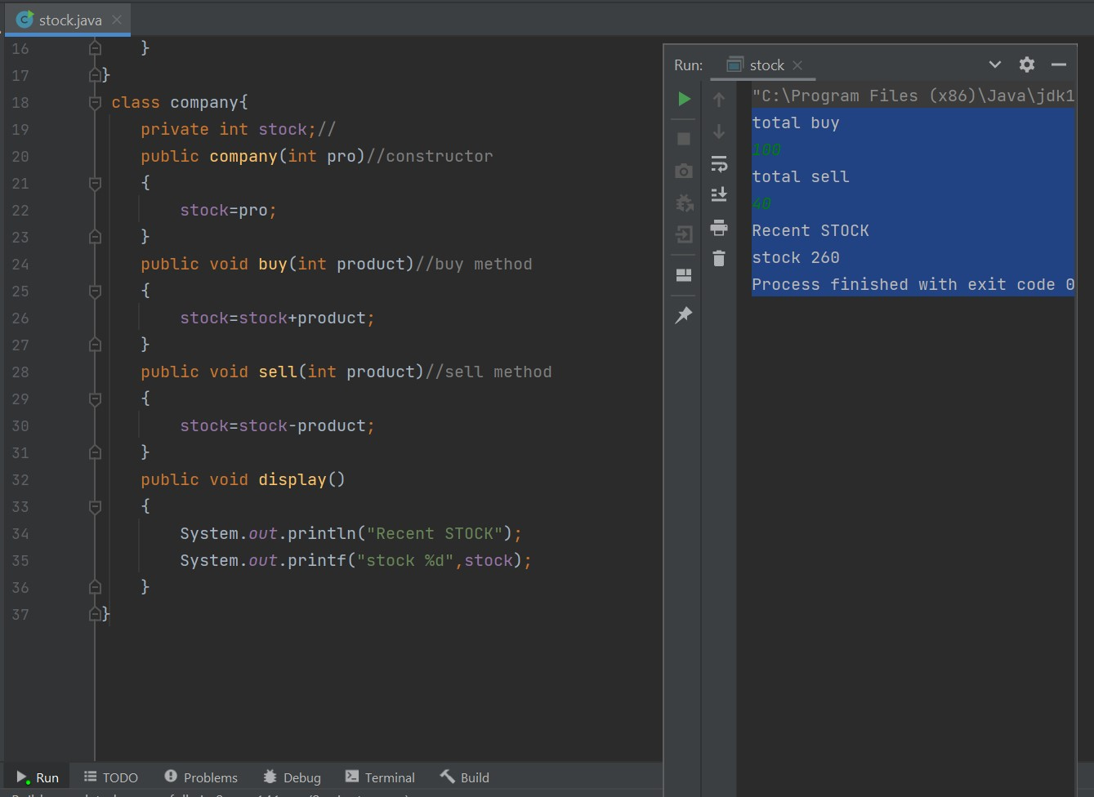

**7. An Electronics company wishes to maintain stock of items with buy and sells of details. Write a java application to show total stock, total buy and total sell of the company. Apply object-oriented approaches in the application.**

**8.**

**a. Create a class A**

**i. Declare a private static instance variable.**

**ii. Write a constructor which will increase instance variable.**

**iii. Write a method to return value of instance variable**

**b. Create a Class B**

**i. Display value of instance variable of class A**

**ii. Create three objects of class A**

**iii. Display value of instance variable of Class A**

