1.Explain what variables are in C programming?

Variables are containers for storing different types of data data values, like numbers and characters. These containers act as storage storage areas in a code that the program can easily manipulate.

2.Explain what declaring a variable means?

A variable declaration is when you specify a type and an identifier, but have not yet assigned a value to the variable.

3.Explain what assigning a variable means ?

Assigning a variable in C means storing a specific value or data into a previously declared variable. The assignment operator (=) is used for this purpose

4. Whats is a data type in C programming?

Data types are used to specify what kind of data or values can be stored in a variable.

5.Explain what a function is in C?Why do we need functions in C?

A function is a group of statements that together perform a task

Functions are used to perform certain actions, and they are important for reusing code: Define the code once, and use it many times

- Enables re usability and reduces redundancy
- Makes a code modular
- Provides abstraction functionality
- The program becomes easy to understand and manage
- Breaks an extensive program into smaller and simpler pieces

6.Explain what formate specific is in C ?

Format specifiers in C are used to take inputs and print the output of a type. The symbol we use in every format specifier is %. Format specifiers tell the compiler about the type of data that must be given or input and the type of data that must be printed on the screen
7.Using a table list down all the formate specifiers supported by c language with there corresponding?
A table of showing formate specific in C

%d or %i | A decimal integer or signed integer
%c | Signed character
%f | Signed float
%e | A floating-point number
%s | A string or sequence of character
%lf | double
%Lf | Long double
%o  %u | Octal integer  Short unsigned integer
%ld | Long decimal integer
%x | Hexadecimal integer
%p | Print memory address in the hexadecimal form

8.explain the main method is in C?
Main method is where a c program starts executing from. The main method can be identified with the word main and it appears like this

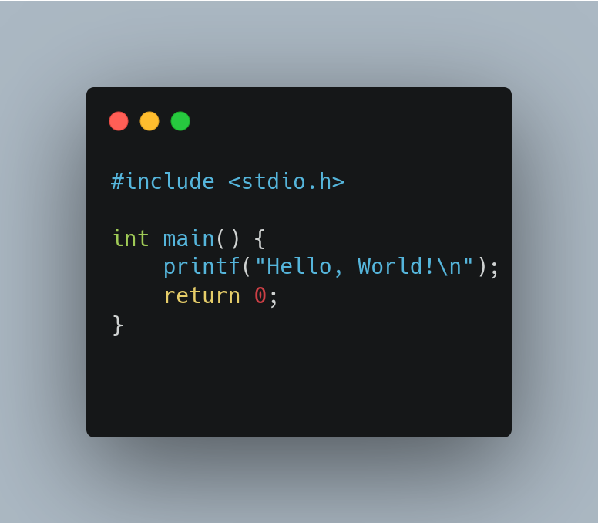

9.Explain what a library is in C?
A library is a collection of functions . it is collection of prewritten code that programmers can use to optimize tasks.
This collection of reusable code is usually targeted for specific common problems..

10.Show how you can install CodeBlocks and Visual Studio Code for C Programming

What is Code::Blocks?
Code::Blocks is a versatile and extensible Integrated Development Environment (IDE) that supports programming in C, C++, and Fortran. It's designed to cater to the needs of programmers, providing a highly configurable and user-friendly environment.
How to Install Code::Blocks:
Visit the Code::Blocks Website:
Navigate to the official Code::Blocks website by going to https://www.codeblocks.org/downloads/.

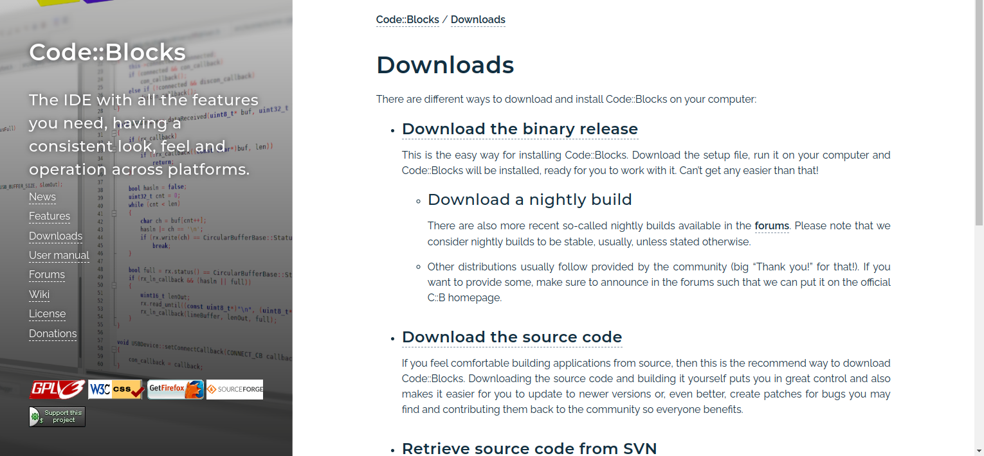
Scroll down the page until you see "Binary Releases."

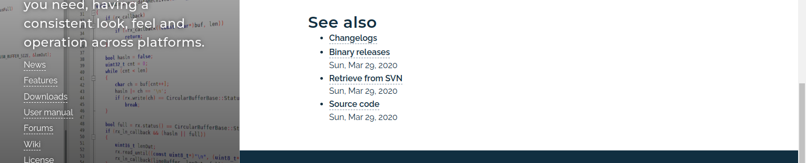

Download Options:
Here, you'll find various options for different operating systems.

For Windows
Click on "FooseHUBor sourceforge.net" to download the Windows installer
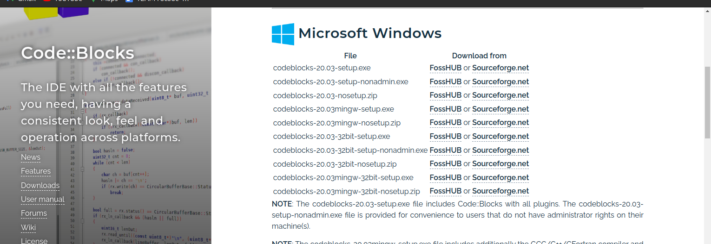

For Linux:
You'll see options for different Linux distributions. Click on the one that matches your distribution
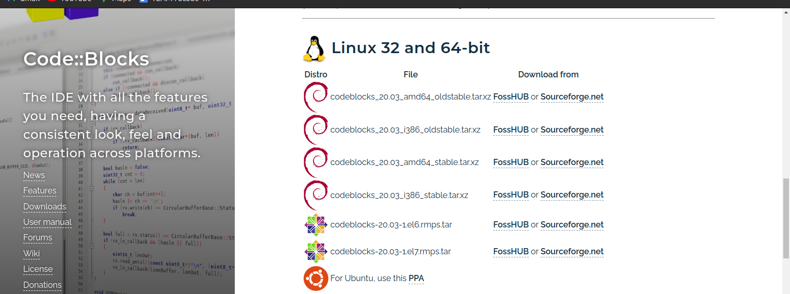

For macOS:
You can download from either FossHUB or Sourceforge.net. Choose the source that suits you, and click the download link.
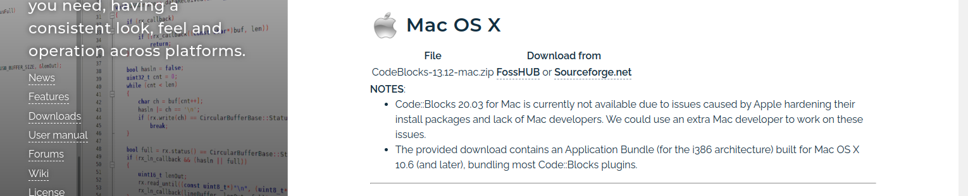

Then the download will begin in
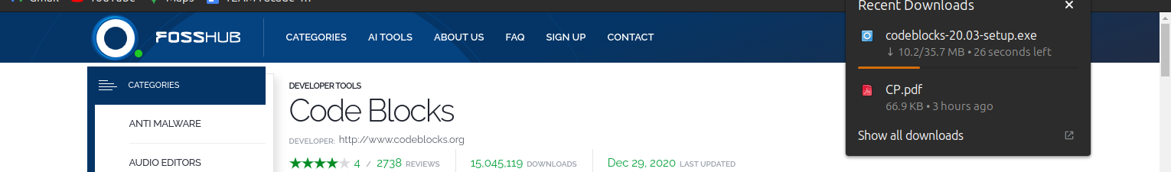

When the download is completed, Open Your Code Blocks Setup File When the download is completed, Open Your Code Blocks Setup File
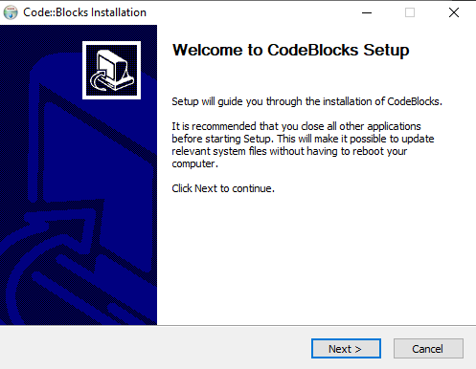
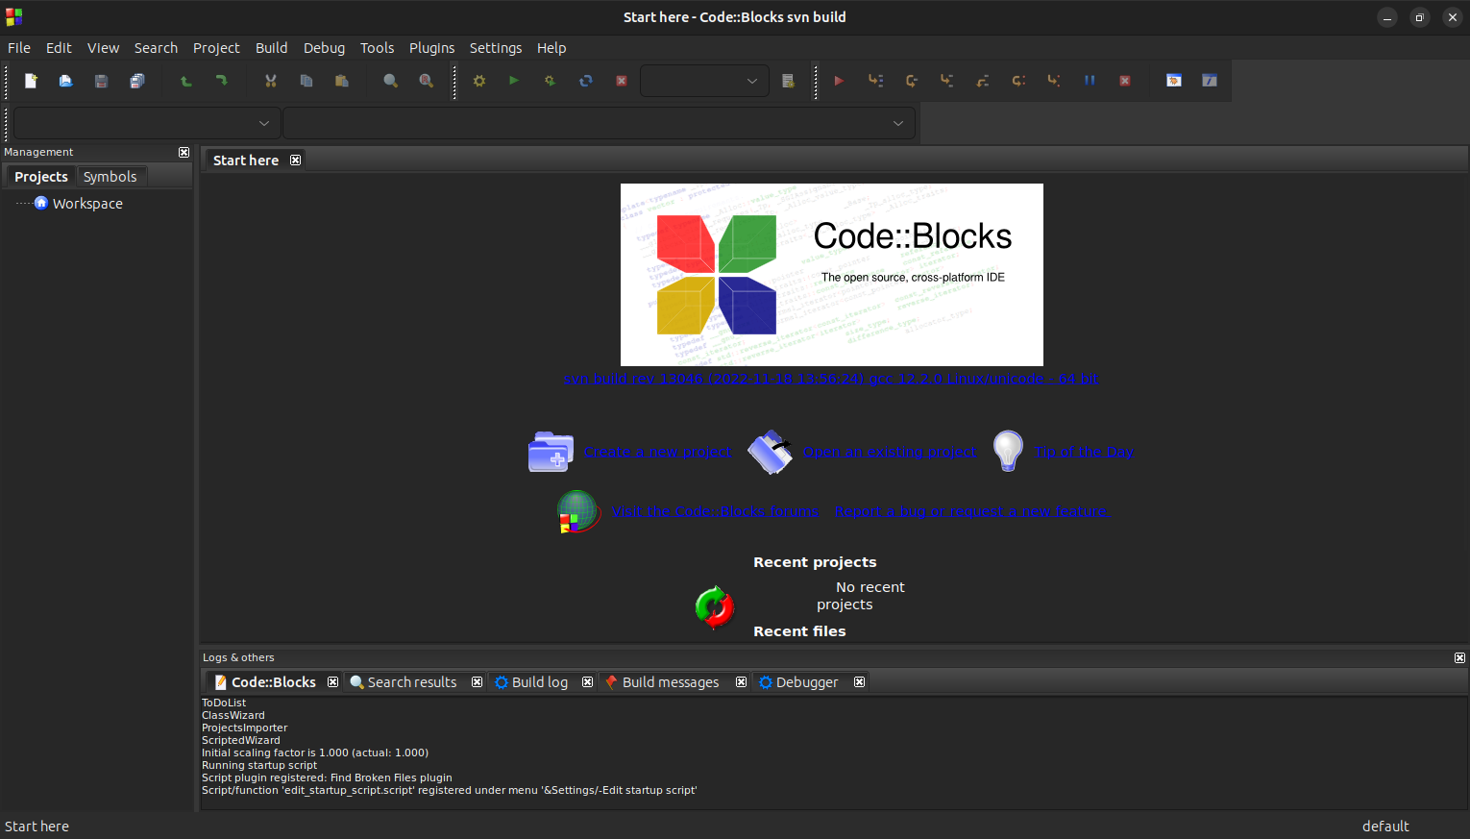
After a successful installation you will be presented with this above page

What is Visual Studio Code ?
Visual Studio Code, also commonly referred to as VS Code, is a source-code editor made by Microsoft with the Electron Framework, for Windows, Linux and macOS. Features include support for debugging, syntax highlighting, intelligent code completion, snippets, code refactoring, and embedded Git

How Install visual Studio Code (VS Code)

Visit the official visual Studio Code website
Navigate to the official download page by going to
https://code.visualstudio.com/download

You will be provided with page like this where you can choose to download
which operating system your computer runs on you click on which on e you prefer

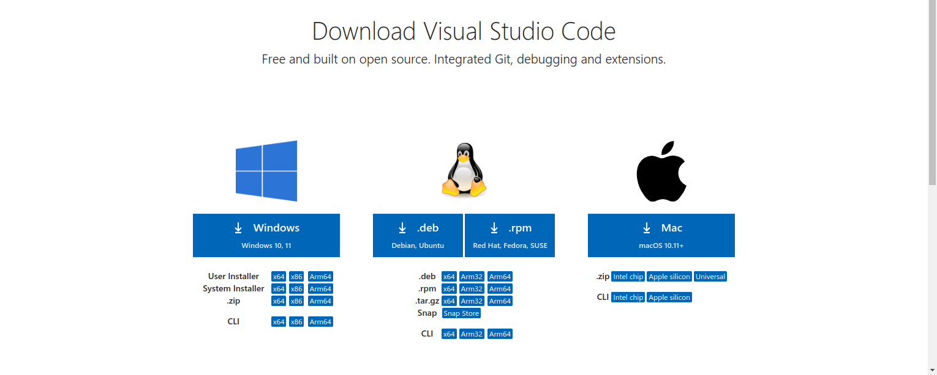

The browser will automatically start the download for the software as shown below

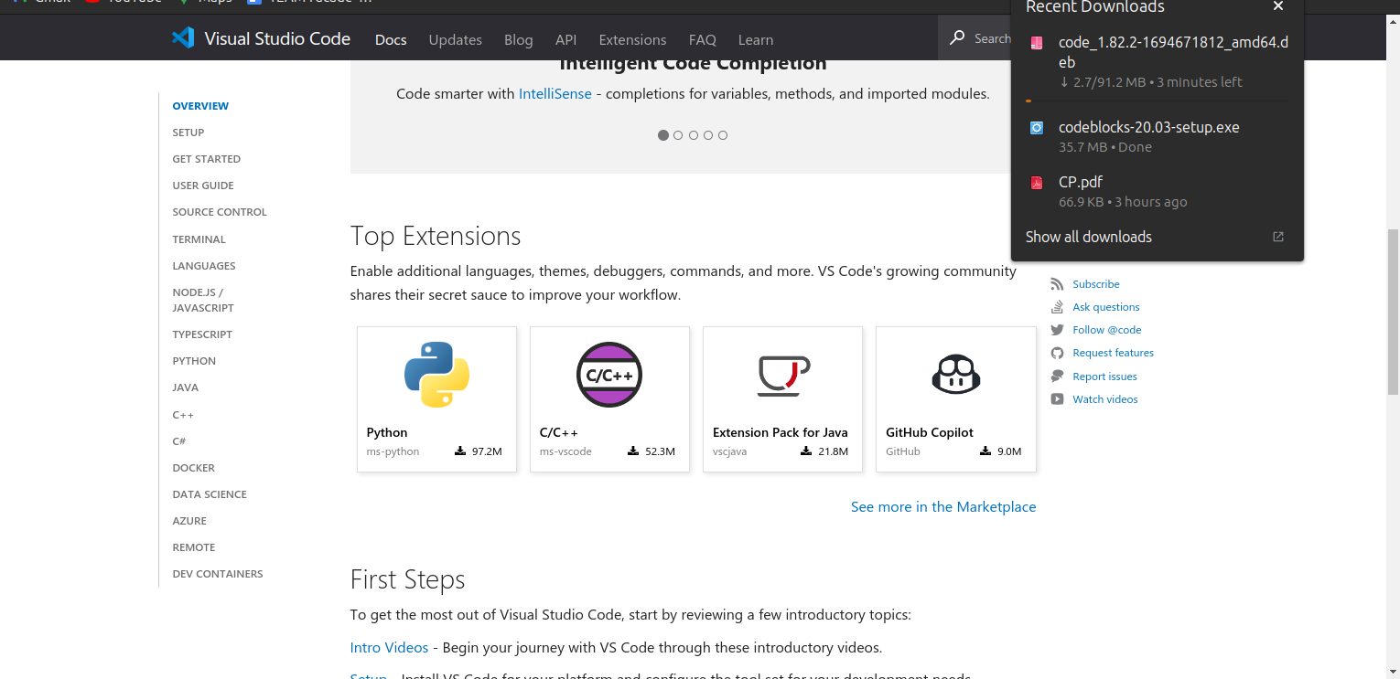

When the download is completed, Open Visual Studio Code setup File When the download is completed, Open Your Visual Studio Code Setup File

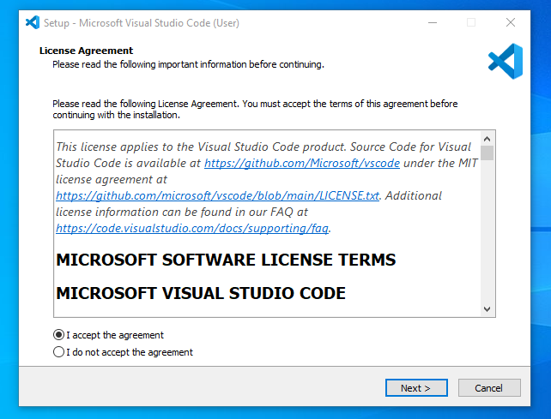

After successful installation you will be presented with this page
