
WIPRO CLOUD PRODUCT AND PLATFORM ENGINEERING – 2025

Mini Project Report

Name of the Student : Prakash P
Department : Computer Science And Engineering
Year / Sem / Section : IV/VII/A
Date of Submission :

Scenario - #1
Title: Host an E-Commerce website on a scalable cloud platform with AI-driven load balancing and data Encryption
Steps for Cloud Engineering:
Create a virtual machine in AWS
Step1:Create an Instance with amazon EC2, Give name for the instance and select the machine image (os) of the instance
Screenshot 1:
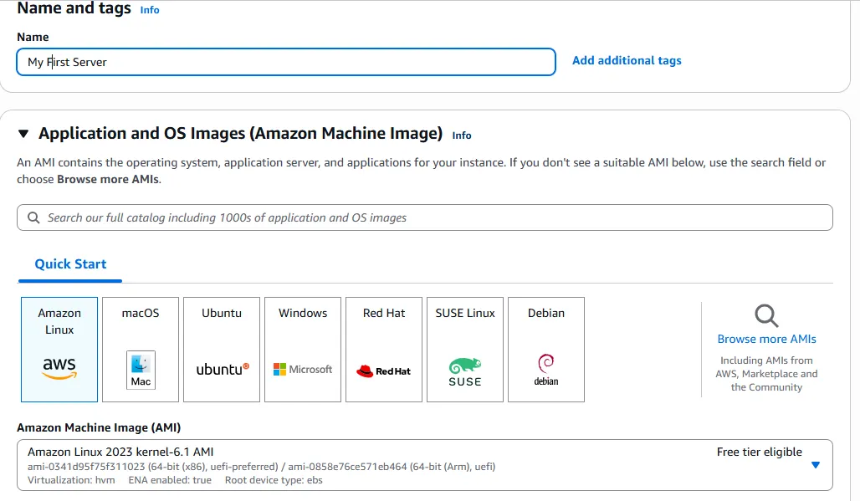
Step2: Create a key pair for the instance, this will be used to login to the virtual machine with open ssh connection
Screenshot2:

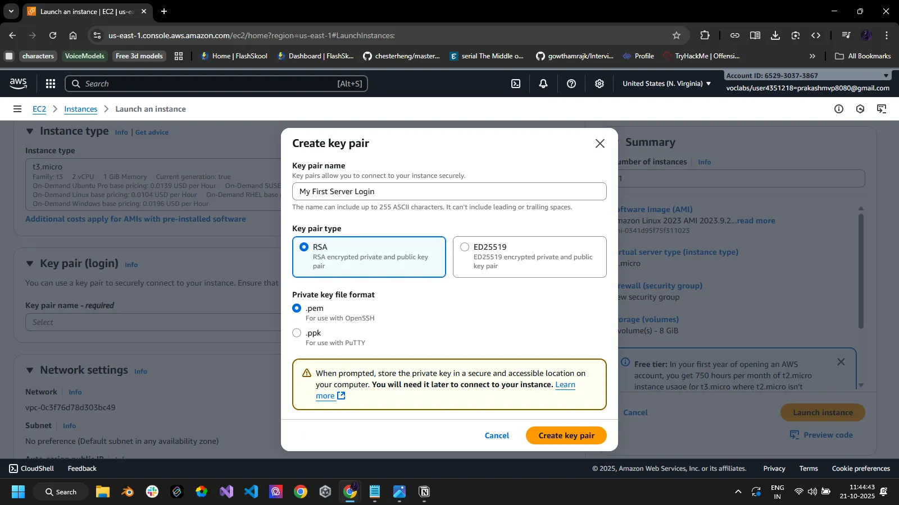
Step 3: select the instance type , storage size requited and create a new security group for the instance
Screenshot 3:
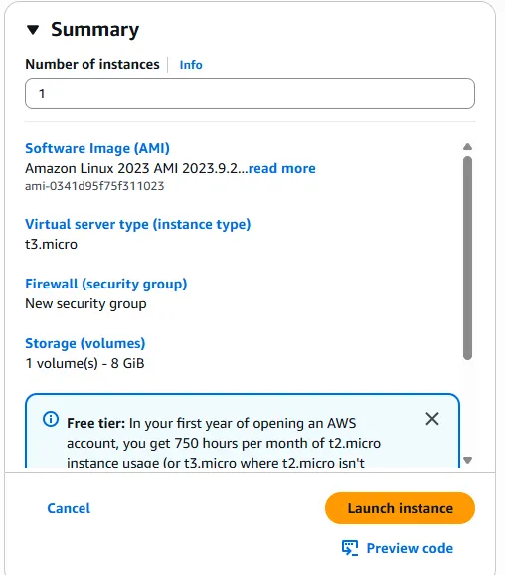
Step 4: Connecting to the instance with ssh using the .pem key file
Screenshot 4: 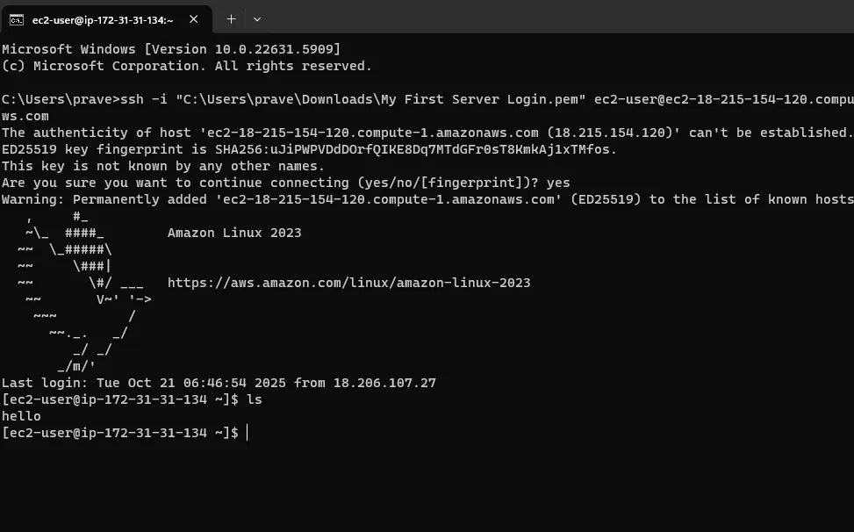
Step 5: install httpd and update the system to latest version using yum update -y and yum install httpd -y
Screenshot 5: 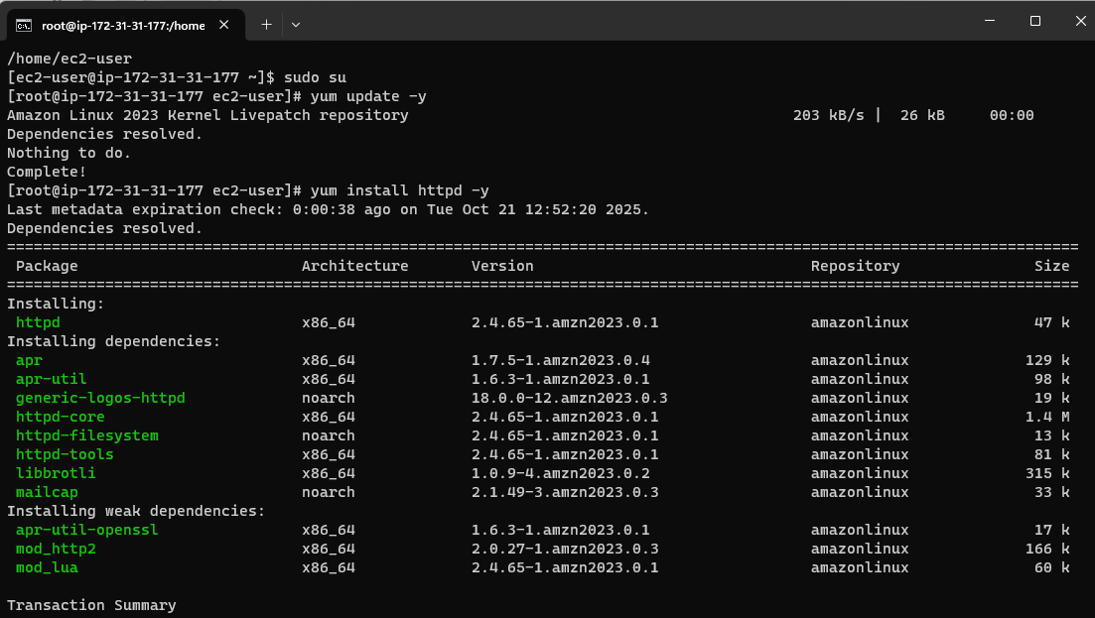
Deploy a simple web server on the created instance
Step 6: Create a index.html file containing the code for the website
Screenshot 6:
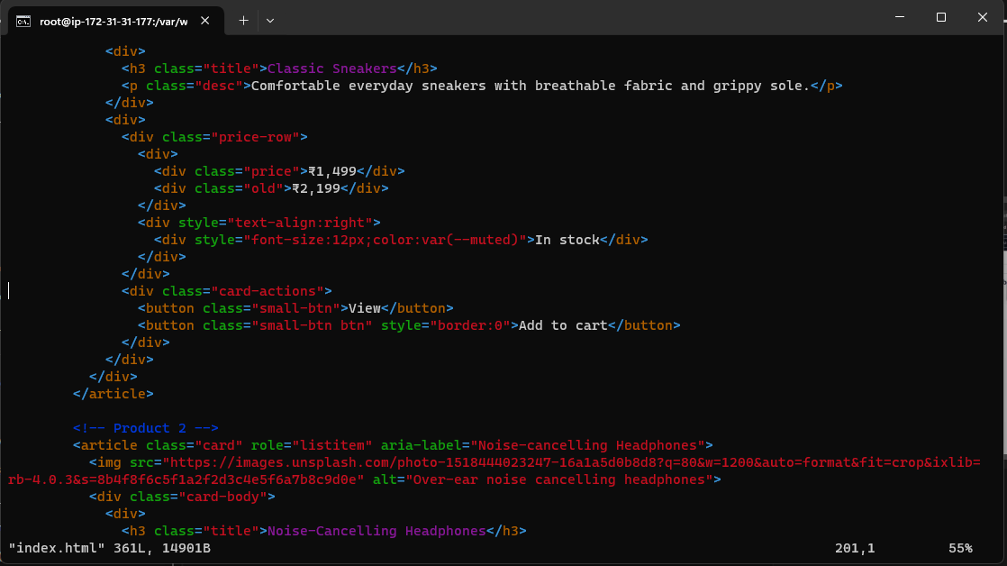
Step 7: start the htdp service to run the index.html and host in on the created instance in aws
-service httpd start
Step 8: Use the public ip in the instance to launch the E commerce site
Screenshot 8:
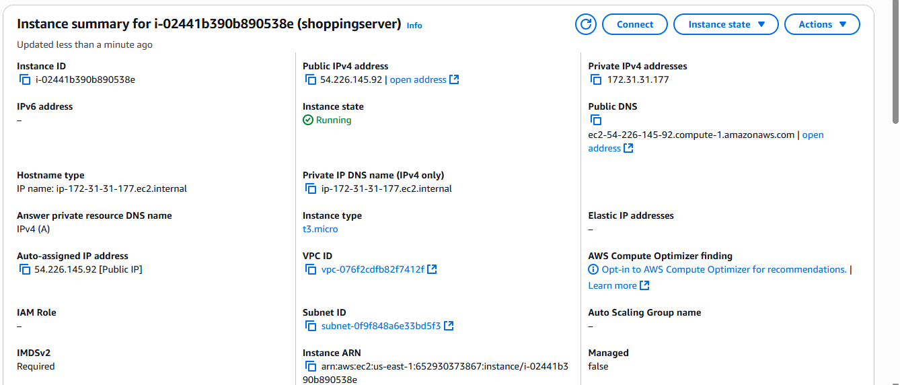

Step 9: Create another EC2 instance form the EC2 dashboard to create a load balancer
Create a load balancer
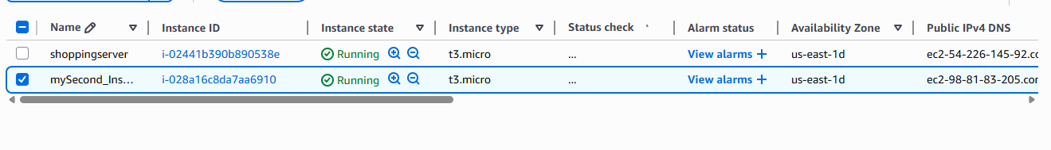
Screenshot 9:
Step 10: go to load balancer dashboard and create a new application load balancer
Screenshot 10 :
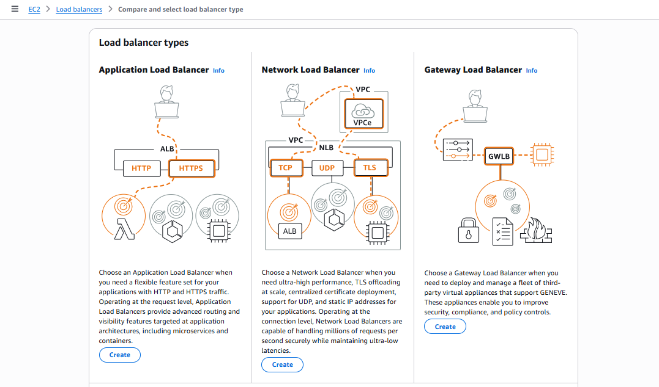
Step 11: do the basic configurations for the load balancer , setup the VPC (virtual private network) and finally create a new security for the loadbalancer and uncheck the default one.
Screenshot 11:
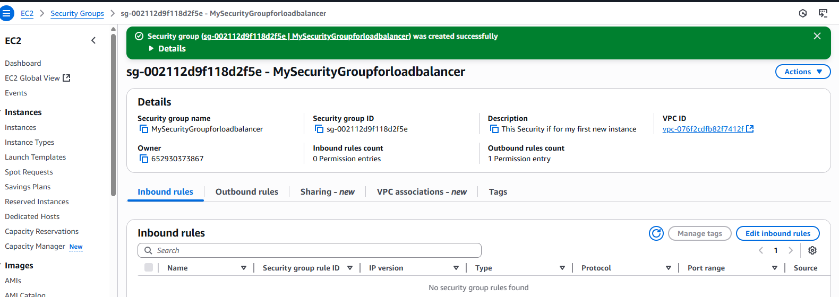
Step 12: Create a new Target group for the load balancer
Screenshot 12: 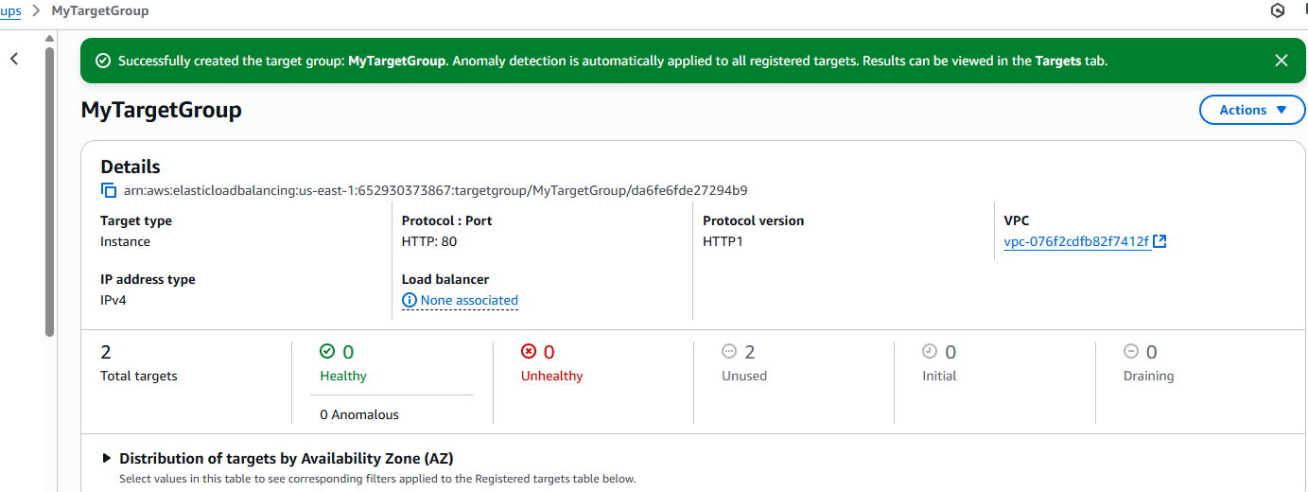

Step 13 : Verify the summary and create the load balancer
Screenshot 13: 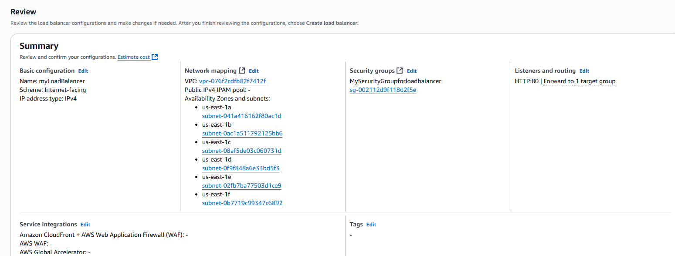
Load sample data and visualize it using Matplotlib
Step 14 : Create an amzon s3 bucket and upload the dataset in it
Screenshot 14: 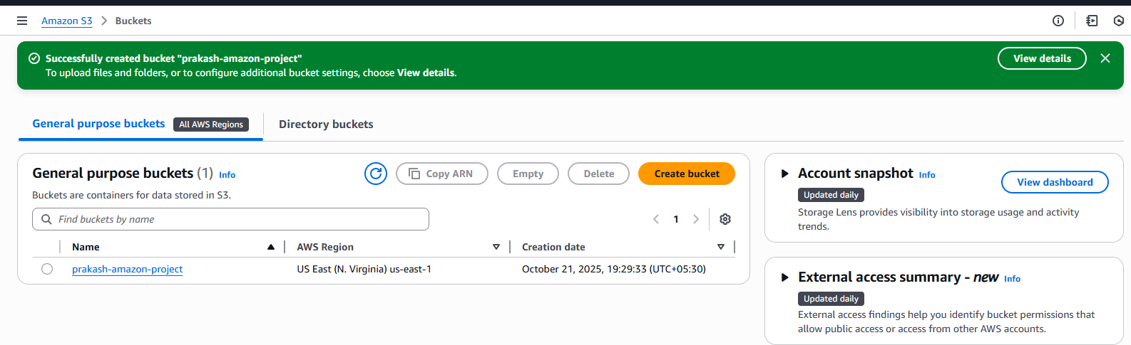
Step 15: Create a manifest.json file and upload the file and the dataset into the bucket
Screenshot 15:

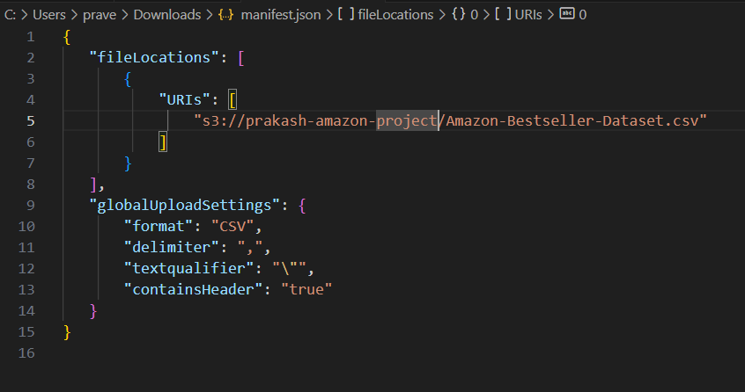
Step 16 :Create a maazon quicksight account and open the quicksight tool
Step 17: Import the s3 dataset into quick Sight
Screenshot 17:
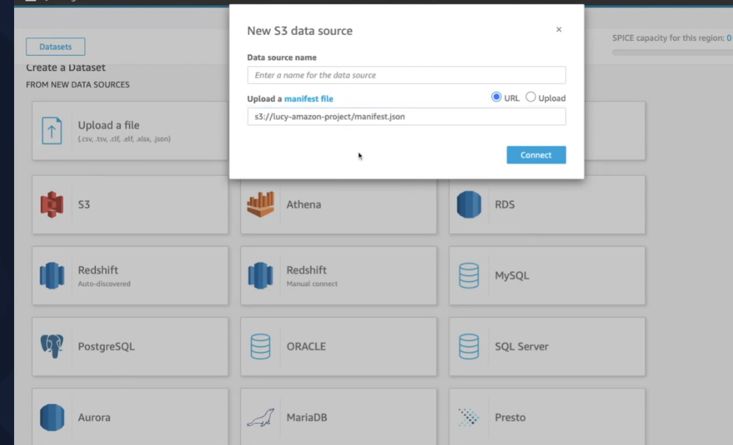
Step 18: visualize the data in the dataset with quicksight visualization tool
Screenshot 18: 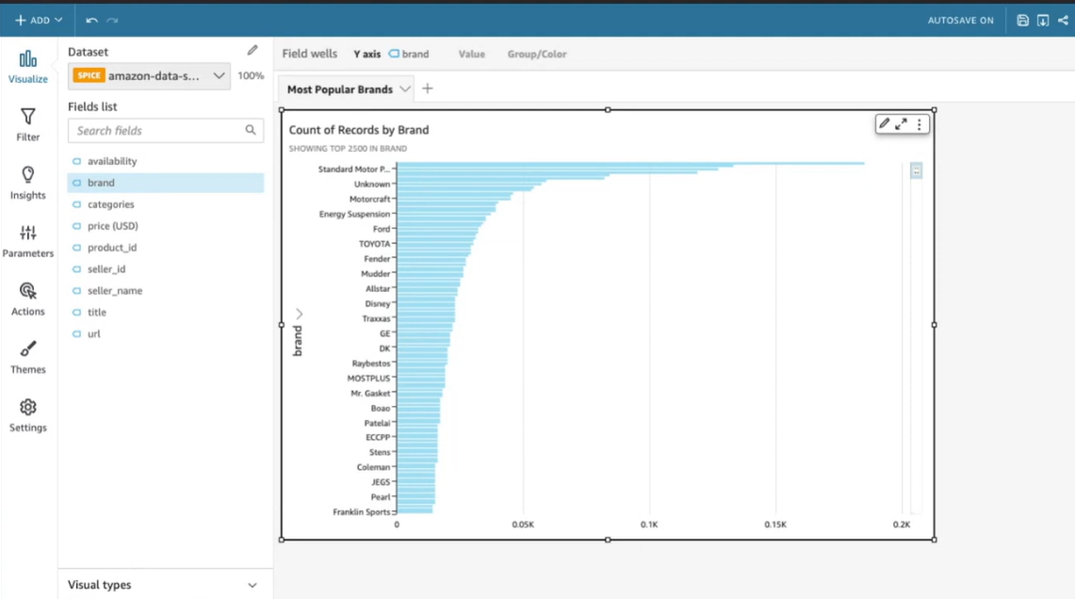

GitHub Link for Scenario #1:

Scenario - #2
Title:
Steps for Cloud Engineering:
Step1:
Screenshot 1:
Step2:
Screenshot2:
:
:

GitHub Link for Scenario #2:

Scenario - #3
Title:
Steps for Cloud Engineering:
Step1:
Screenshot 1:
Step2:
Screenshot2:
:
:

GitHub Link for Scenario #3:

