**EXERCISE-01: ReactJS-HOL**

**App.js**

import React from 'react';

function App() {

  return (

    <div>

      <h1>Welcome to the first session of React</h1>

    </div>

  );

}

export default App;

**Output:**

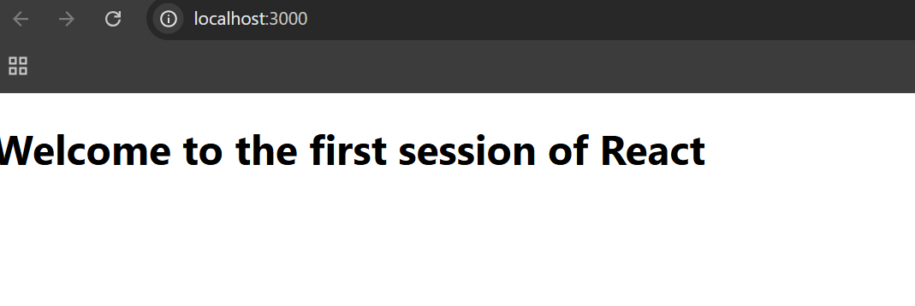

**EXERCISE-02 : ReactJS-HOL**

**App.js**

import React from 'react';

import Home from './Components/Home';

import About from './Components/About';

import Contact from './Components/Contact';

function App() {

  return (

    <div className="App">

      <Home />

      <About />

      <Contact />

    </div>

  );

}

export default App;

**Home.js**

import React from 'react';

function Home() {

  return (

    <div>

      <h2>Welcome to the Home page of Student Management Portal</h2>

    </div>

  );

}

export default Home;

**About.js**

import React from 'react';

function About() {

  return (

    <div>

      <h2>Welcome to the About page of the Student Management Portal</h2>

    </div>

  );

}

export default About;

**Contact.js**

import React from 'react';

function Contact() {

  return (

    <div>

      <h2>Welcome to the Contact page of the Student Management Portal</h2>

    </div>

  );

}

export default Contact;

**Output:**

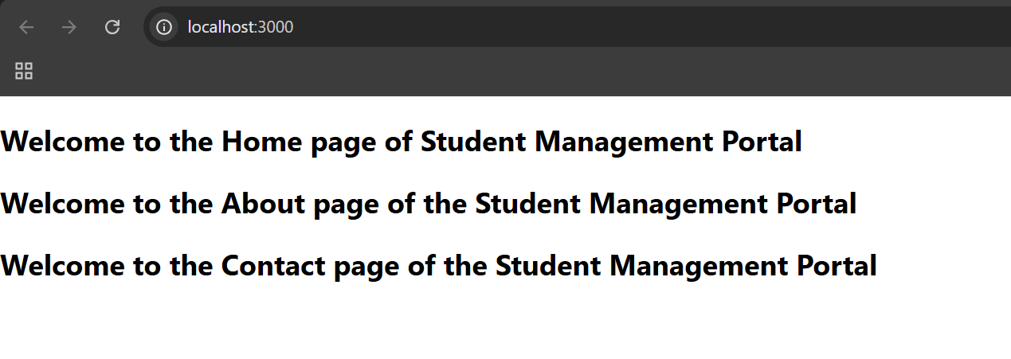

**EXERCISE-03 : ReactJS-HOL**

**CalculateScore.js**

import React from 'react';

import '../Stylesheets/mystyle.css';

function CalculateScore() {

  const name = "Louis Vuitton";

  const school = "Porche School";

  const total = 450;

  const goal = 500;

  const average = (total / goal) * 100;

  return (

    <div className="score-container">

      <h2>Student Score Report</h2>

      <p><strong>Name:</strong> {name}</p>

      <p><strong>School:</strong> {school}</p>

      <p><strong>Total Marks:</strong> {total}</p>

      <p><strong>Goal:</strong> {goal}</p>

      <p><strong>Average Score:</strong> {average.toFixed(2)}%</p>

    </div>

  );

}

export default CalculateScore;

**mystyle.css**

.score-container {

  background-color: #f2f2f2;

  padding: 20px;

  border-radius: 8px;

  max-width: 400px;

  margin: 40px auto;

  box-shadow: 0 4px 6px rgba(0, 0, 0, 0.1);

  font-family: Arial, sans-serif;

}

.score-container h2 {

  color: #333;

  text-align: center;

  margin-bottom: 20px;

}

.score-container p {

  font-size: 16px;

  color: #444;

  margin: 6px 0;

}

**App.js**

import React from 'react';

import CalculateScore from './Components/CalculateScore';

function App() {

  return (

    <div className="App">

      <CalculateScore />

    </div>

  );

}

export default App;

**Output:**

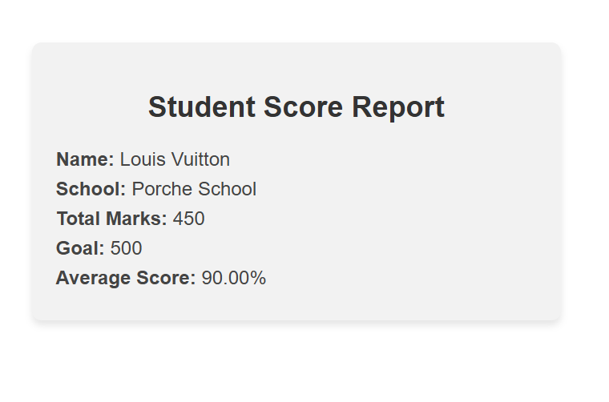

**EXERCISE-04 : ReactJS-HOL**

**Post.js**

import React from 'react';

class Post extends React.Component {

  render() {

    const { title, body } = this.props;

    return (

      <div style={{ margin: '20px', padding: '10px', border: '1px solid #ccc' }}>

        <h3>{title}</h3>

        <p>{body}</p>

      </div>

    );

  }

}

export default Post;

**Posts.js**

import React, { Component } from 'react';

import Post from './Post';

class Posts extends Component {

  constructor(props) {

    super(props);

    this.state = {

      posts: [],

      hasError: false,

    };

  }

  loadPosts = () => {

    fetch("https://jsonplaceholder.typicode.com/posts")

      .then((response) => response.json())

      .then((data) => this.setState({ posts: data }))

      .catch((error) => {

        console.error("Error loading posts:", error);

        this.setState({ hasError: true });

      });

  };

  componentDidMount() {

    this.loadPosts();

  }

  componentDidCatch(error, info) {

    alert("An error occurred: " + error);

    this.setState({ hasError: true });

  }

  render() {

    const { posts, hasError } = this.state;

    if (hasError) {

      return <h2>Something went wrong while loading posts.</h2>;

    }

    return (

      <div>

        <h1>Blog Posts</h1>

        {posts.map((post) => (

          <Post key={post.id} title={post.title} body={post.body} />

        ))}

      </div>

    );

  }

}

export default Posts;

**App.js**

import React from 'react';

import Posts from './Posts';

function App() {

  return (

    <div className="App">

      <Posts />

    </div>

  );

}

export default App;

**Output:**

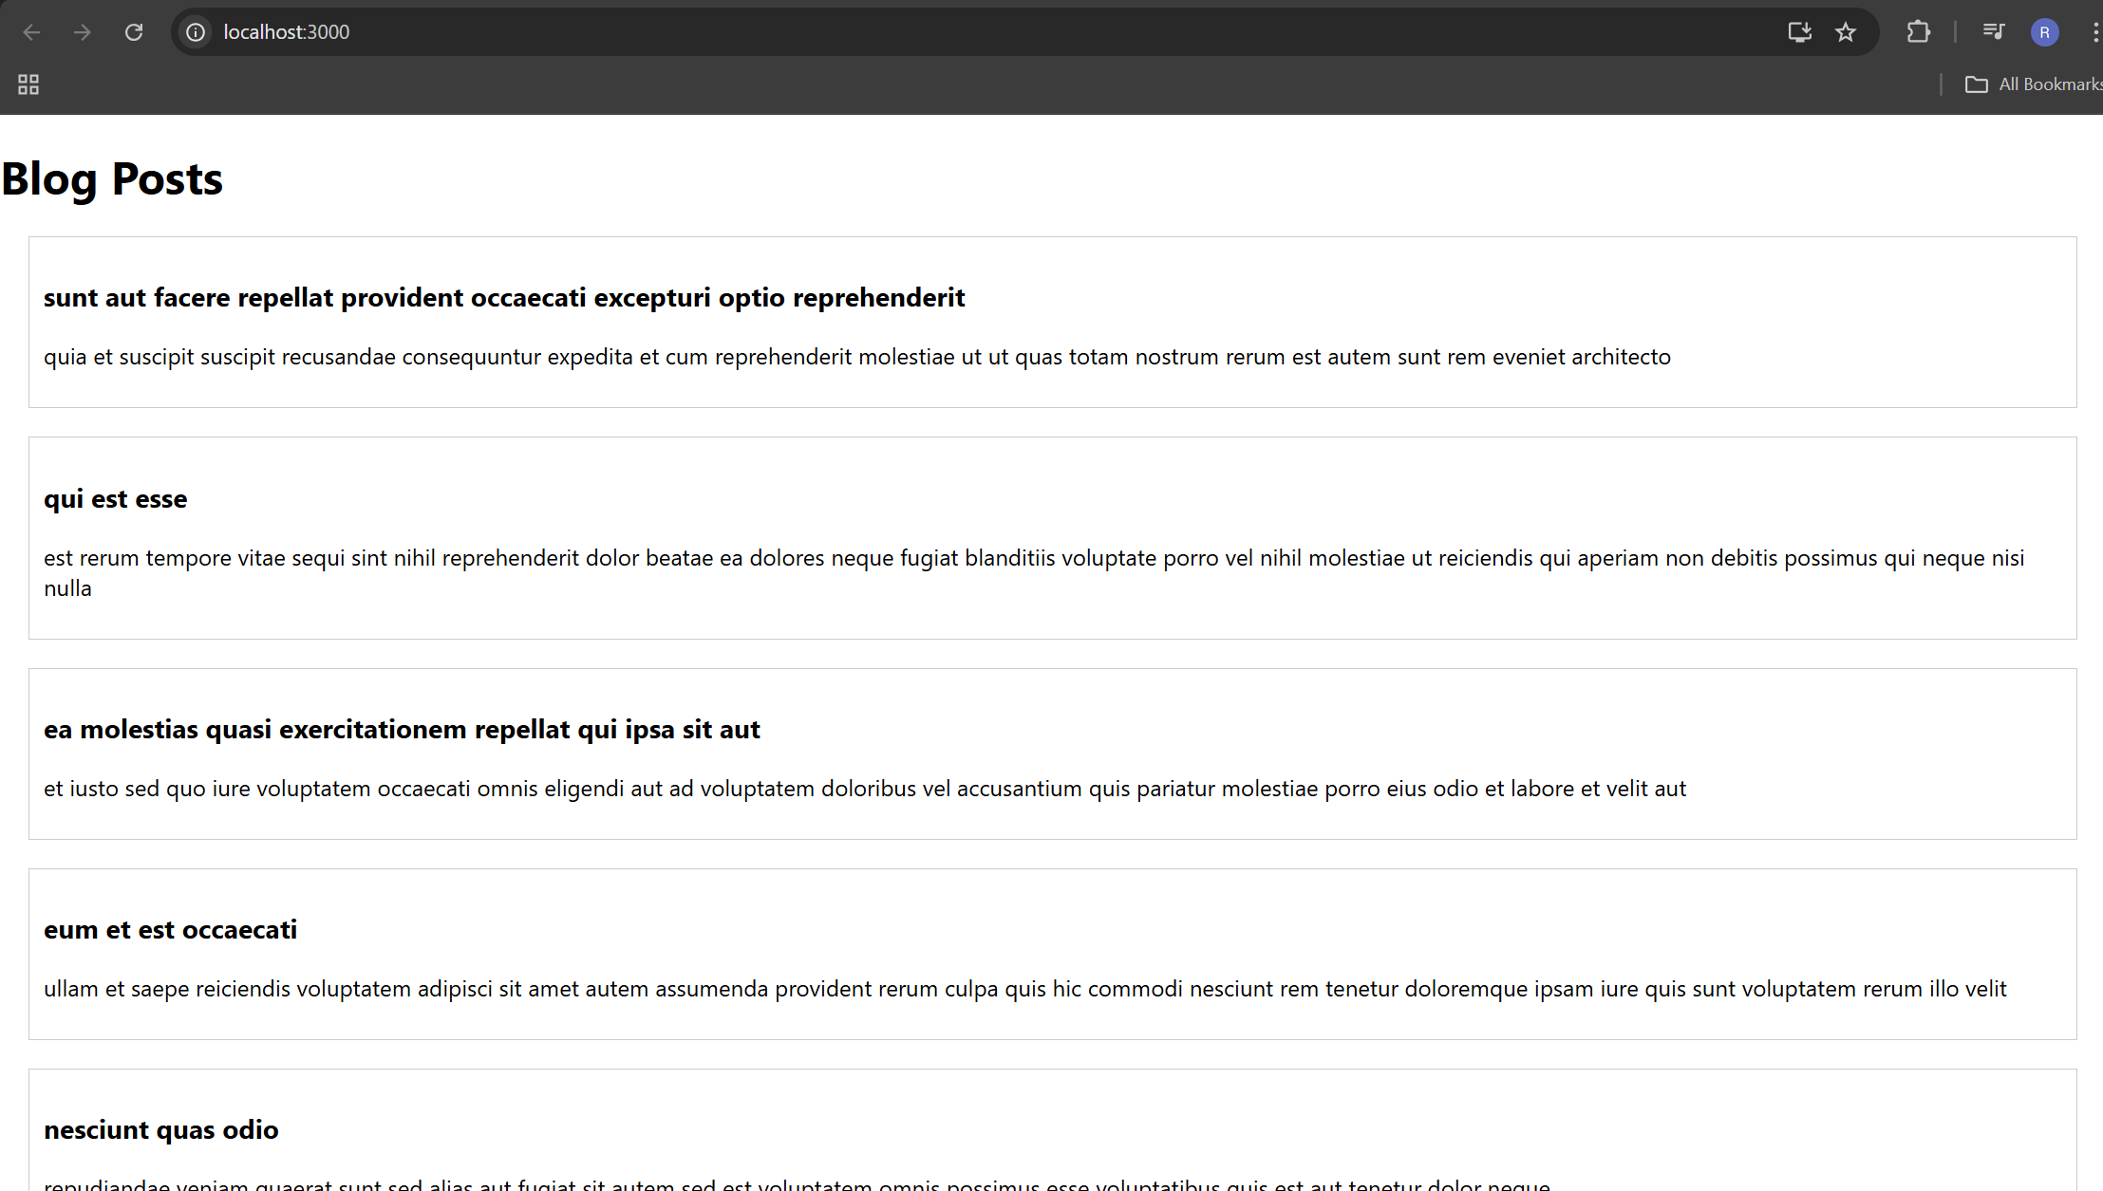

**EXERCISE-05 : ReactJS-HOL**

**CohortDetails.module.css**

.box {

  width: 300px;

  display: inline-block;

  margin: 10px;

  padding: 10px 20px;

  border: 1px solid black;

  border-radius: 10px;

}

dt {

  font-weight: 500;

}

**CohortDetails.js**

import React from 'react';

import styles from './CohortDetails.module.css';

function CohortDetails({ name, status, startDate, endDate }) {

  // Apply green for 'ongoing', blue for others

  const headingStyle = {

    color: status.toLowerCase() === 'ongoing' ? 'green' : 'blue'

  };

  return (

    <div className={styles.box}>

      <h3 style={headingStyle}>{name}</h3>

      <dl>

        <dt>Status:</dt>

        <dd>{status}</dd>

        <dt>Start Date:</dt>

        <dd>{startDate}</dd>

        <dt>End Date:</dt>

        <dd>{endDate}</dd>

      </dl>

    </div>

  );

}

export default CohortDetails;

**App.js**

import React from 'react';

import CohortDetails from './CohortDetails';

function App() {

  return (

    <div className="App">

      <CohortDetails

        name="React Fundamentals"

        status="ongoing"

        startDate="2025-06-01"

        endDate="2025-08-01"

      />

      <CohortDetails

        name="Advanced Node.js"

        status="completed"

        startDate="2025-03-01"

        endDate="2025-05-30"

      />

    </div>

  );

}

export default App;

**Output:**

