**REACT EXERCISES:**

**Exercise 1:**

**ListOfPlayers.js**

import React from 'react';

const ListofPlayers = () => {

  const players = [

    { name: "Rohit", score: 85 },

    { name: "Virat", score: 60 },

    { name: "Rahul", score: 90 },

    { name: "Shreyas", score: 45 },

    { name: "Hardik", score: 72 },

    { name: "Pant", score: 38 },

    { name: "Jadeja", score: 95 },

    { name: "Ashwin", score: 55 },

    { name: "Shami", score: 80 },

    { name: "Bumrah", score: 100 },

    { name: "Surya", score: 65 },

  ];

  const topPlayers = players.filter(player => player.score >= 70);

  return (

    <div>

      <h2>Top Performing Players (Score ≥ 70)</h2>

      <ul>

        {topPlayers.map((player, index) => (

          <li key={index}>{player.name} - {player.score}</li>

        ))}

      </ul>

    </div>

  );

};

export default ListofPlayers;

**IndianPlayers.js**

import React from 'react';

const IndianPlayers = () => {

  const T20players = ["Bumrah", "Kohli", "Surya", "Pant"];

  const RanjiTrophyPlayers = ["Prithvi", "Jadeja", "Shaw", "Gill"];

  const allPlayers = [...T20players, ...RanjiTrophyPlayers];

  const oddTeam = allPlayers.filter((_, index) => index % 2 !== 0);

  const evenTeam = allPlayers.filter((_, index) => index % 2 === 0);

  return (

    <div>

      <h2>Even Team Players</h2>

      <ul>

        {evenTeam.map((player, index) => (

          <li key={index}>{player}</li>

        ))}

      </ul>

      <h2>Odd Team Players</h2>

      <ul>

        {oddTeam.map((player, index) => (

          <li key={index}>{player}</li>

        ))}

      </ul>

    </div>

  );

};

export default IndianPlayers;

**App.js**

import React from 'react';

import ListofPlayers from './ListofPlayers';

import IndianPlayers from './IndianPlayers';

function App() {

  const flag = true; // Set this to false to show IndianPlayers

  return (

    <div className="App">

      <h1>Cricket App</h1>

      {flag ? <ListofPlayers /> : <IndianPlayers />}

    </div>

  );

}

export default App;

**Output:**

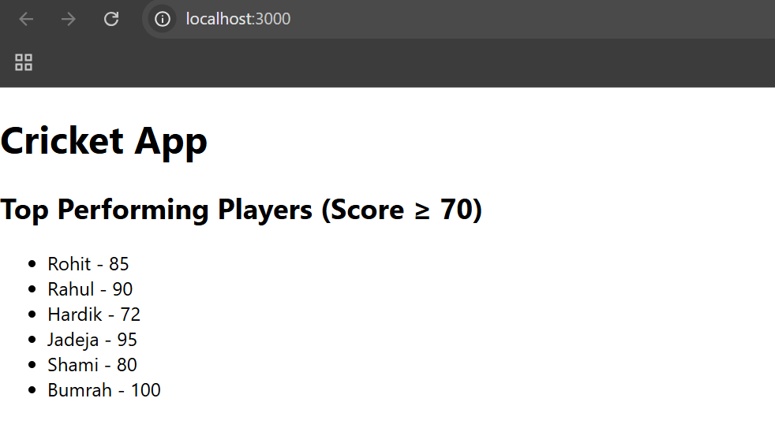

**Exercise 2:**

**App.js**

import React from 'react';

function App() {

  const office1 = {

    name: "TechPark Building",

    rent: 75000,

    address: "5th Street, Chennai"

  };

  const officeList = [

    { name: "Startup Hub", rent: 45000, address: "MG Road, Bangalore" },

    { name: "BizSpace", rent: 85000, address: "Banjara Hills, Hyderabad" },

    { name: "WorkNest", rent: 60000, address: "South Ex, Delhi" },

  ];

  const rentStyle = rent => ({

    color: rent < 60000 ? 'red' : 'green',

    fontWeight: 'bold'

  });

  return (

    <div style={{ padding: '20px', fontFamily: 'Arial' }}>

      <h1>Office Space Rental</h1>

      <img

        src="office-with-lot-desks-computers.jpg"

        alt="Office Space"

        style={{ width: '20%', borderRadius: '10px', marginBottom: '20px' }}

      />

      <h2>Featured Office</h2>

      <p><strong>Name:</strong> {office1.name}</p>

      <p><strong>Rent:</strong> <span style={rentStyle(office1.rent)}>{office1.rent}</span></p>

      <p><strong>Address:</strong> {office1.address}</p>

      <h2>Available Office Spaces</h2>

      <ul>

        {officeList.map((office, index) => (

          <li key={index} style={{ marginBottom: '15px' }}>

            <p><strong>Name:</strong> {office.name}</p>

            <p>

              <strong>Rent:</strong>{' '}

              <span style={rentStyle(office.rent)}>{office.rent}</span>

            </p>

            <p><strong>Address:</strong> {office.address}</p>

          </li>

        ))}

      </ul>

    </div>

  );

}

export default App;

**Output:**

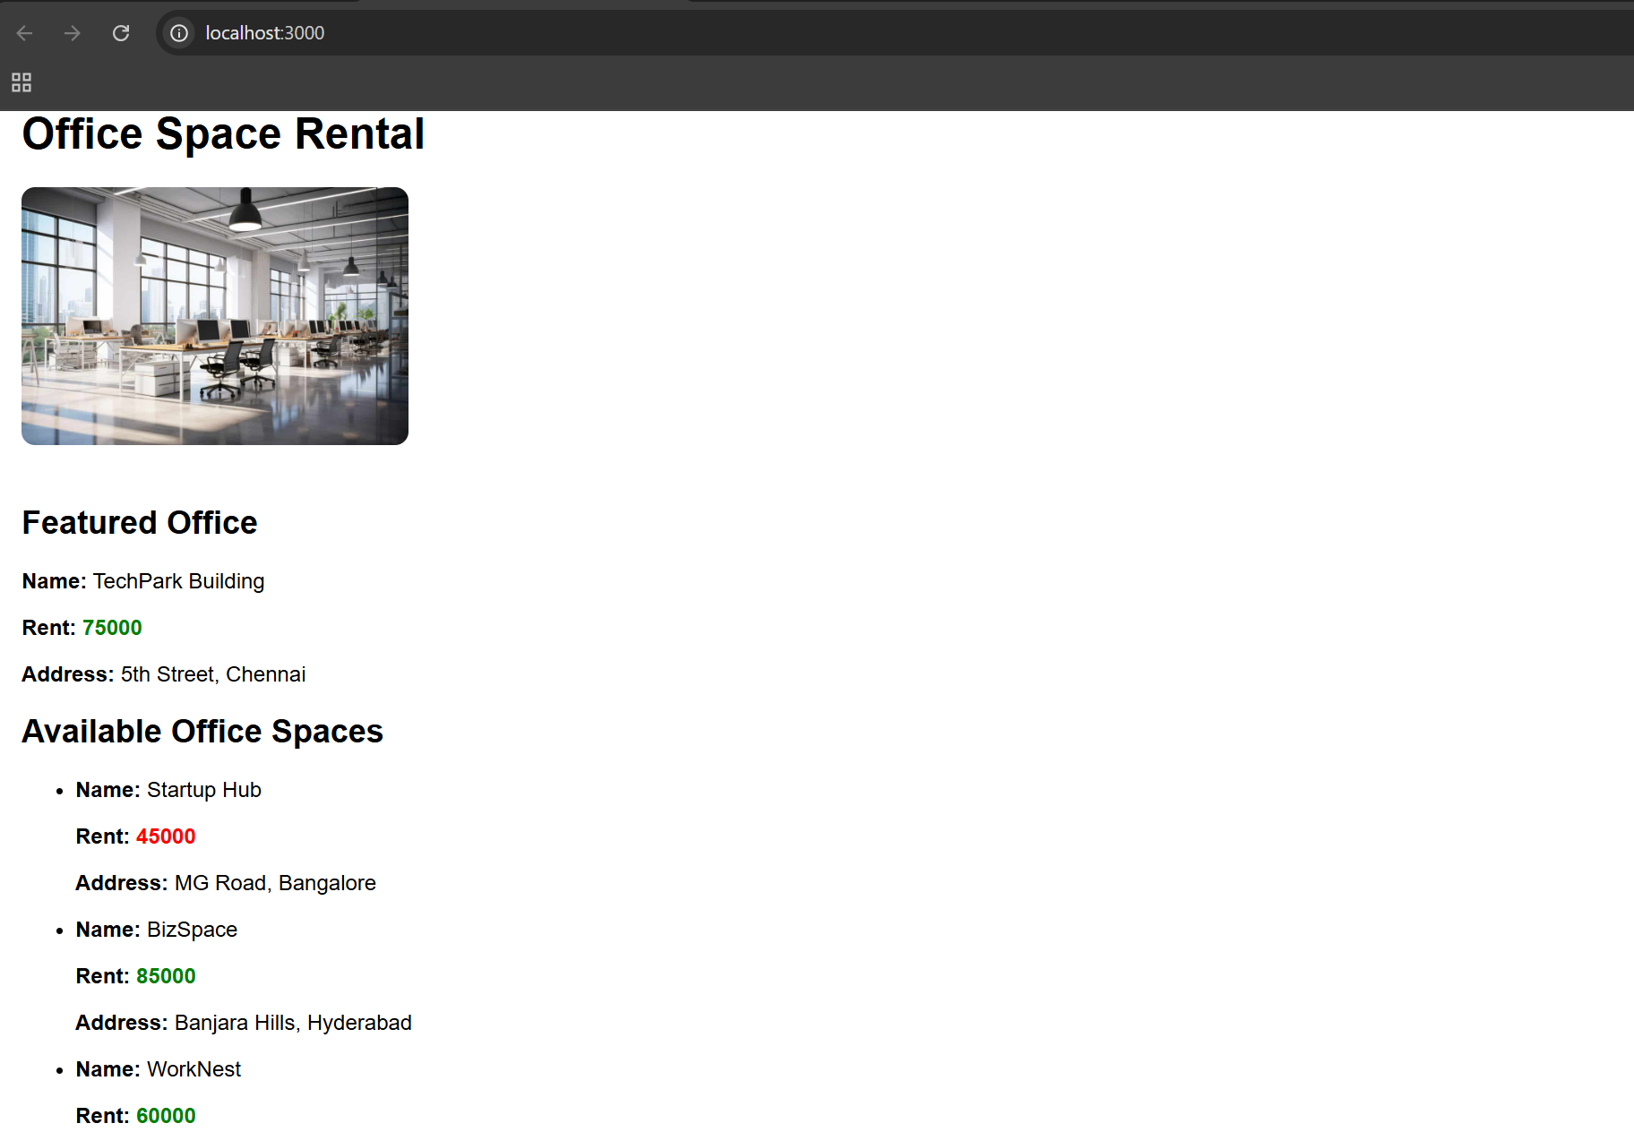

**Exercise 3:**

**Counter.js**

import React from 'react';

import Counter from './components/Counter';

import WelcomeButton from './components/WelcomeButton';

import OnPressButton from './components/OnPressButton';

import CurrencyConvertor from './components/CurrencyConverter';

function App() {

  return (

    <div className="App">

      <h1>React Event Examples App</h1>

      <Counter />

      <WelcomeButton />

      <OnPressButton />

      <CurrencyConvertor />

    </div>

  );

}

export default App;

OnPressButton.js

import React from 'react';

function OnPressButton() {

  const handlePress = (event) => {

    alert("I was clicked");

    console.log(event); // Synthetic event

  };

  return <button onClick={handlePress}>OnPress</button>;

}

export default OnPressButton;

**WelcomeButton.js**

import React from 'react';

function sayMessage(message) {

  alert(message);

}

function WelcomeButton() {

  return <button onClick={() => sayMessage("Welcome")}>Say Welcome</button>;

}

export default WelcomeButton;

**CurrencyConverter.js**

import React, { useState } from 'react';

function CurrencyConvertor() {

  const [inr, setInr] = useState('');

  const [euro, setEuro] = useState('');

  const handleSubmit = () => {

    const rate = 0.011; // INR to Euro rate

    setEuro((parseFloat(inr) * rate).toFixed(2));

  };

  return (

    <div>

      <h2>Currency Converter</h2>

      <input

        type="number"

        value={inr}

        onChange={e => setInr(e.target.value)}

        placeholder="Enter INR"

      />

      <button onClick={handleSubmit}>Convert</button>

      {euro && <p>{inr} INR = {euro} Euro</p>}

    </div>

  );

}

export default CurrencyConvertor;

**App.js**

import React from 'react';

import Counter from './components/Counter';

import WelcomeButton from './components/WelcomeButton';

import OnPressButton from './components/OnPressButton';

import CurrencyConverter from './components/CurrencyConverter';

function App() {

  return (

    <div className="App">

      <h1>React Event Examples App</h1>

      <Counter />

      <WelcomeButton />

      <OnPressButton />

      <CurrencyConverter />

    </div>

  );

}

export default App;

**Output:**

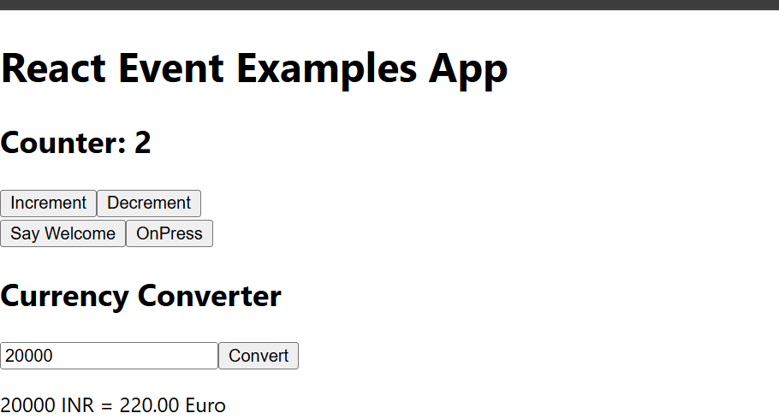

**Exercise 4:**

**GuestPage.js**

import React from 'react';

import FlightList from './FlightList';

function GuestPage() {

  return (

    <div>

      <h2>Welcome, Guest!</h2>

      <p>Please log in to book your tickets.</p>

      <FlightList />

    </div>

  );

}

export default GuestPage;

**UserPage.js**

import React from 'react';

import FlightList from './FlightList';

function UserPage() {

  return (

    <div>

      <h2>Welcome, User!</h2>

      <p>You can now book your tickets below.</p>

      <FlightList canBook={true} />

    </div>

  );

}

export default UserPage;

**FlightList.js**

import React from 'react';

function FlightList({ canBook }) {

  const flights = [

    { id: 1, from: 'Delhi', to: 'Chennai', time: '10:00 AM' },

    { id: 2, from: 'Mumbai', to: 'Kolkata', time: '2:00 PM' },

  ];

  return (

    <div>

      <h3>Available Flights</h3>

      <ul>

        {flights.map(flight => (

          <li key={flight.id}>

            {flight.from} → {flight.to} at {flight.time}

            {canBook && <button style={{ marginLeft: '10px' }}>Book</button>}

          </li>

        ))}

      </ul>

    </div>

  );

}

export default FlightList;

**App.js**

import React, { useState } from 'react';

import GuestPage from './components/GuestPage';

import UserPage from './components/UserPage';

function App() {

  const [isLoggedIn, setIsLoggedIn] = useState(false);

  const handleLogin = () => setIsLoggedIn(true);

  const handleLogout = () => setIsLoggedIn(false);

  return (

    <div className="App">

      <h1>Flight Ticket Booking</h1>

      {isLoggedIn ? (

        <>

          <button onClick={handleLogout}>Logout</button>

          <UserPage />

        </>

      ) : (

        <>

          <button onClick={handleLogin}>Login</button>

          <GuestPage />

        </>

      )}

    </div>

  );

}

export default App;

**Output:**

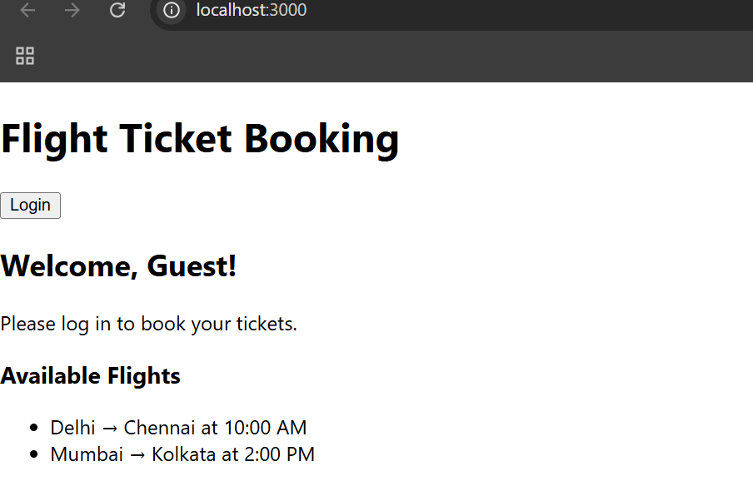

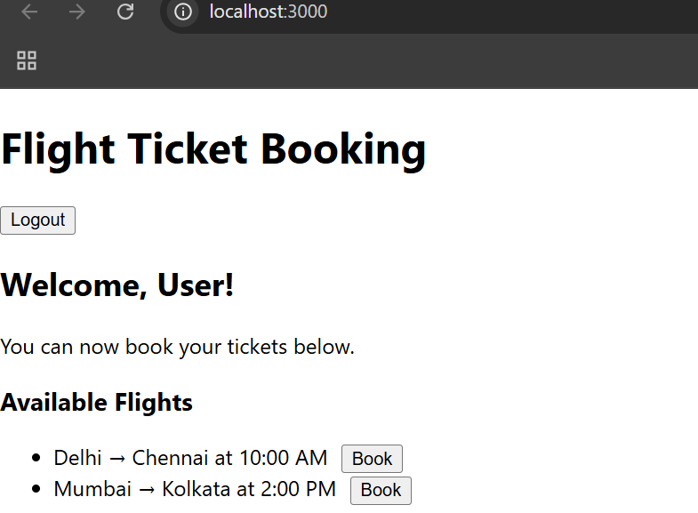

**Exercise 5:**

**BookDetails.js**

function BookDetails() {

  return <div><h2>📚 Book Details</h2><p>Title: React Essentials</p></div>;

}

export default BookDetails;

**BlogDetails.js**

function BlogDetails() {

  return <div><h2>📝 Blog Details</h2><p>Topic: React Conditional Rendering</p></div>;

}

export default BlogDetails;

**CourseDetails.js**

function CourseDetails() {

  return <div><h2>🎓 Course Details</h2><p>Course: Full Stack Development</p></div>;

}

export default CourseDetails;

**ContentList.js**

import React from 'react';

const data = [

  { id: 1, type: 'Book', title: 'Learning React' },

  { id: 2, type: 'Blog', title: 'React vs Angular' },

  { id: 3, type: 'Course', title: 'React for Beginners' }

];

function ContentList() {

  return (

    <div>

      <h2>📃 All Contents</h2>

      <ul>

        {data.map(item => (

          <li key={item.id}>

            <strong>{item.type}</strong>: {item.title}

          </li>

        ))}

      </ul>

    </div>

  );

}

export default ContentList;

**App.js**

import React, { useState } from 'react';

import BookDetails from './components/BookDetails';

import BlogDetails from './components/BlogDetails';

import CourseDetails from './components/CourseDetails';

import ContentList from './components/ContentList';

function App() {

  const [contentType, setContentType] = useState('book')

  const renderContent = () => {

    if (contentType === 'book') return <BookDetails />;

    else if (contentType === 'blog') return <BlogDetails />;

    else if (contentType === 'course') return <CourseDetails />;

    else return <p>Please select a content type</p>;

  };

  return (

    <div className="App">

      <h1>Welcome to BloggerApp</h1>

      {/* Button-based conditional rendering */}

      <div>

        <button onClick={() => setContentType('book')}>Book</button>

        <button onClick={() => setContentType('blog')}>Blog</button>

        <button onClick={() => setContentType('course')}>Course</button>

        <button onClick={() => setContentType('list')}>List View</button>

      </div>

      <hr />

      {contentType === 'list' ? <ContentList /> : renderContent()}

    </div>

  );

}

export default App;

**Output:**

