**GIT:**

**Exercise – 1:**

mkdir GitDemo

cd GitDemo

git init

echo "Welcome to Git hands-on lab!" > welcome.txt

ls

cat welcome.txt

git status

git add welcome.txt

git commit -m “first commit”

git remote add origin https://gitlab.com/refayahbtechcse-group/gitex1

git push origin master

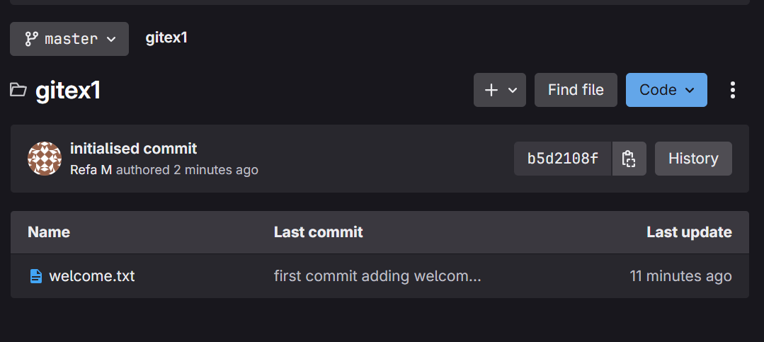

**Exercise - 2:**

echo "this is a log file" > debug.log

mkdir log

echo "some logs here" > log/app.log

notepad .gitignore

git status

git add .gitignore

git commit -m "Add .gitignore to ignore .log files and log folder"

git push

**Output:**

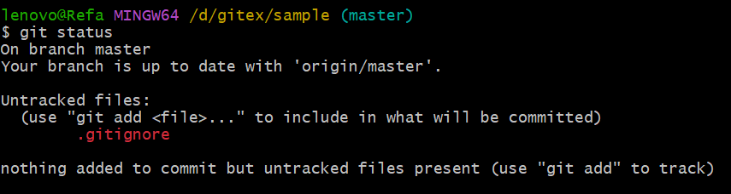

**Exercise – 3:**

git branch GitNewBranch

git branch

git checkout GitNewBranch

git branch

echo "This is from the new branch" > newbranch.txt

git add newbranch.txt

git commit -m "Added newbranch.txt in GitNewBranch"

git checkout master

git merge GitNewBranch

git log --oneline --graph –decorate

git branch -d GitNewBranch

**Output:**

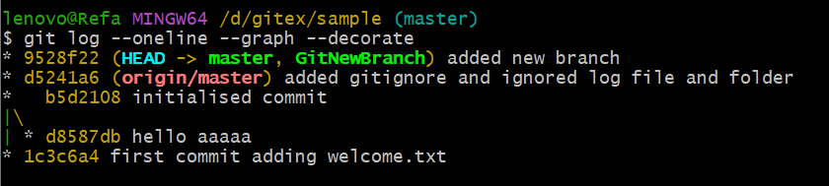

**Exercise – 4:**

git checkout -b GitWork

echo "<message>Hello from GitWork</message>" > hello.xml

git add hello.xml

git commit -m "Add hello.xml in GitWork"

git checkout master

echo "<message>Hello from master branch</message>" > hello.xml

git add hello.xml

git commit -m "Add hello.xml in master"

git log --oneline --graph --decorate –all

git merge GitWork

notepad hello.xml

git add hello.xml

git commit -m "Resolved merge conflict in hello.xml"

echo "*.orig" >> .gitignore

git add .gitignore

git commit -m "Ignore backup files"

git branch -d GitWork

git log --oneline --graph –decorate

**Output:**

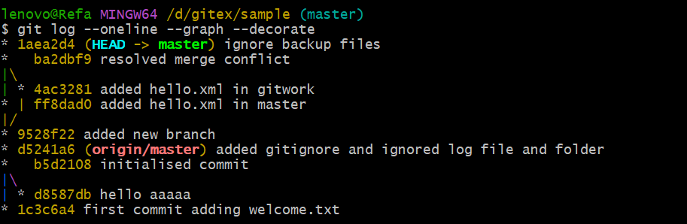

**Exercise – 5:**

git branch

git branch -a

git pull origin master

git push origin master

git status

**Output:**

