Detecting Alzheimer’s Disease using Convolutional Neural Networks

CET313 ARTIFICIAL INTELLIGENCE

Refilwe Goitsemang

  BOTSWANA ACCOUNTANCY COLLEGE

Contents

**1.Introduction** 3

**2. Literature Review** 4

**3. Methodology** 5

**4. Results and Discussion** 9

**References** 14



**Faculty: School of Computing and Information Systems**

**NAME: Refilwe Goitsemang**

**STUDENT NUMBER: bi81kn**

**MODULE CODE: CET313**

**MODULE TITLE: Artificial Intelligence**

**MODULE LEADER: Basal Bakarat**

**SUBMISSION DATE AND TIME: 06/12/2024**

**ASSIGNMENT:**

**Academic Misconduct is an offence under university regulations, and this involves:**

* **Plagiarism** – where you use information from another information source (including your previously submitted work) and pass it off as your own. This can be through direct copying, poor paraphrasing and/or absence of citations.
* **Collusion** – where you work too closely, intentionally, or unintentionally, with others to produce work that is similar in nature. This can be through loaning of materials, drafts or through unauthorised use of a fellow student’s work.
* **Asking another person to write your assignment** – where you ask another individual or company to complete your work for you, be that paid or unpaid, and submit it as if it were your own.
* **Unauthorised use of artificial intelligence** – where you use artificial intelligence tools to generate your assignment instead of completing it yourself and/or where you have not been given permission to use artificial intelligence tools by your module leader. Please complete the following declaration around you use of artificial intelligence tools in your assignment.

**STATEMENT ON USE OF ARTIFICIAL INTELLIGENCE TOOLS:**

* I have used artificial intelligence tools to generate an idea for my assignment: **NO**
* I have used artificial intelligence tools to write my assignment for me: **NO**
* I have used artificial intelligence tools to brainstorm ideas for my assignment: **NO**
* I have used artificial intelligence tools to correct my original assignment: **NO**

**DECLARATION**

* I understand that by submitting this piece of work I am declaring it to be my own work and in compliance with the university regulations on Academic Integrity.
* I confirm that I have done this work myself without external support or inappropriate use of resources.
* I understand that I am only permitted to use artificial intelligence tools in line with guidance provided by my Module Leader, and I have not used artificial intelligence tools outside this remit.
* I confirm that this piece of work has not been submitted for any other assignment at this or another institution prior to this point in time.
* I can confirm that all sources of information, including quotations, have been acknowledged by citing the source in the text, along with producing a full list of the sources used at the end of the assignment.
* I understand that academic misconduct is an offence and can result in formal disciplinary proceedings.
* I understand that by submitting this assignment, I declare myself fit to be able to complete the assignment and I accept the outcome of the assessment as valid and appropriate.

**ANY OTHER COMMENTS FROM STUDENT:**

Abstract

The main objective of this project, is to develop a model that aids in the early detection of Alzheimer’s Disease to help slow down progression which could lead to permanent memory loss which is irreversible, causing the patient to lose independence. This project explores the application of convolutional neural networks (CNN’s) in the early detection of Alzheimer’s disease using MRI scans. The model was built using data preprocessing, model optimization, and augmented datasets, which helped it achieve a test accuracy of 96.37% and validation accuracy of 95.33%. The results attained by the prototype prove that the model can make accurate predictions and assist in the early diagnosis of Alzheimer’s Disease, thus improving existing models. This study shows that AI plays a huge role in healthcare by offering an effective way of predicting Alzheimer’s Disease.

# 1.Introduction

1. Background

Alzheimer’s disease (AD), is a deadly brain disorder that gets worse overtime, causing one to have problems remembering new things. Once in the late stages, AD cannot be irreversible which is why early detection can help extend the independence of a patient longer (Ebrahimi, et al., 2024). Alzheimer’s disease a leading cause of dementia, affects millions of people all around the world, with cases to increase immensely by percentage by the year 2050 according to the Alzheimer’s Disease International (ADI) (Helaly, et al., 2022) . The biggest challenge for Alzheimer’s physicians, is that there has been no cure found till date thus emphasizing the importance of detecting it early to slow its progression. Early detection of Alzheimer’s disease, through the use of Magnetic Resonance Imaging (MRI) has proven to be a reliable approach for monitoring structural brain changes associated with AD which is non-invasive. However, manual comparison, interpretation and visualization of MRI data is tedious and time-consuming, therefore it is subject to human error, and dependent on the expertise of an AD specialist or physician, thus the need for the automated method for the detection of Alzheimer’s Disease (Al-Shoukry, et al., 2020).

1. Motivation

The motivation behind this project comes from the social and personal impact of Alzheimer’s Disease. AD is a worldwide crisis that continues to grow, causing healthcare systems to face unsurmountable pressure to come up with automatic accurate diagnostic mechanisms which are timely. The traditional way of feature extraction carried out by human AD physicians uses a lot of resources and continues to fail to meet the growing demand for faster and efficient solutions like CNN-based models used in medical imaging. The latter can get rid of these challenges by providing faster and consistent results making early detection easier (Turisi, et al., 2023). The early the detection, the faster an intervention treatment could be administered to slow down the progression of Alzheimer’s will be carried out. This is because patients with Alzheimer’s Disease experience memory loss that is irreversible once in the late stages. Early detection extends the independence of patients for a longer period. Automated CNN detection models can help the healthcare sector particularly in underdeveloped regions or countries that do not have access to hospitals and medical centres. According to global dementia statistics, by 2050, 71% of the projected 139 million people living with dementia will reside in low and middle income countries, including China, India, South Asia, and Sub-Saharan Africa, where healthcare resources for diagnosis and care are scarce.

My AI project aligns well with the objectives of the CET313 Artificial Intelligence module, it emphasizes using practical experience gained during the course to solve real-world problems. Moreover, using the knowledge I acquired during the hands-on lab tutorials with my lecturer and tutor, I gained the foundational knowledge in deep learning in image-based machine learning models. This project is inspired by the success of existing 2D CNN’s in the detection of Alzheimer’s Disease such as the ConvADD, which is a 2D CNN-based machine learning model. The practical experience from this module gave me the skill to develop prototype models that can be used to solve real world problems.

Below is a link to my e-portfolio that shows my progress throughout the course module:

[Introduction: Introduction: My portfolio](https://canvas.sunderland.ac.uk/eportfolios/18291)

1. Scope

The project aims to develop a 2D CNN-based prototype for the automated detection and classification of Alzheimer’s disease stages, using MRI slices. The choice to utilize a 2D CNN model rather than hybrid architectures, such as 2D and 3D CNN combinations, or transfer learning models, is influenced by several important considerations that have been discussed in the literature review and within this project’s objectives. Hybrid architectures like 2D and 3D CNN’s or transfer learning models, while powerful, are often computationally expensive and complex to implement, and thus not ideal for situations with limited resources. The prototype focuses on four stages of Alzheimer’s: Non-Demented, Very Mild Demented, Mild Demented, and Moderate Demented. Advanced preprocessing techniques such as data augmentation and normalization, coupled with other optimization strategies like dropout layers and learning rate scheduling, improve model accuracy and ensure the model is generalizable to new data.

Not only does this research satisfy the technical challenges of designing an accurate diagnostic model but it also focuses on accessibility and scalability of the solution. By using publicly available datasets and deploying the model on cloud-based platforms like Google Colab, the project promotes transparency and reproducibility, ensuring it can serve as a valuable resource for future studies in medical AI. Ultimately, the prototype has the potential to improve diagnostic efficiency, reduce the burden on healthcare systems, and contribute to timely interventions for Alzheimer’s disease.

# 2. Literature Review

1. ConvADD: A Lightweight 2D CNN for Alzheimer’s Disease Detection

ConvADD, as suggested by (Alsubaie, et al., 2024), is a user- friendly 2D CNN model designed and used for the classification of the Alzheimer's disease (AD) using MRI scans. The model produced an accuracy of 98.01% without misclassification for four stages of AD: Non-Demented, Very Mild Demented, Mild Demented, and Moderate Demented, which shows its efficiency. ConvADD employs 2D slices of MRI images which are much less computationally intensive when compared to heavy 3D CNN's or transfer learning models while screening with a high accuracy. The model is composed of optimized convolutional layers with back-propagated dropout to enhance generalizability. This research elaborates further on the potential of 2D CNN's to compete in environments with limited resources, where other factors such as trade-offs between complexity and diagnostic accuracy become vital. The lightweight design of ConvADD with only 2.1 million parameters illustrates how a targeted optimization can enable a high level of performance without the computational burden of methods based on other advanced architectures.

1. The Role of Data Augmentation in Enhancing 2D CNN Performance

(Reddy, et al., 2023) discussed how data augmentation and dimensionality reduction affect the performance of 2D CNN models in Alzheimer's Disease (AD) diagnosis. The workflow suggested integration of Principal Component Analysis (PCA) for feature reduction with image augmentation techniques to enhance the custom-built CNN model's strength and generalization. Data augmentation techniques to address class imbalance and increase variability include rotation, scaling, flipping, and brightness adjustment. These transformations greatly increased dataset size and variety, reducing overfitting and improving the CNN's ability to learn meaningful features from MRI images. The rest of the authors also did PCA-based dimensionality reduction, which pointed to the most important features of the brain MRI scan, thus optimizing memory use and computational power. PCA and data augmentation most likely worked in synergy with high diagnostic performance and efficient resource utilization.

1. Transfer Learning with Pre-Trained CNN’s: A Comparative Study

The authors (Kumar, et al., 2023) attempted one of the diverse aspects of transfer learning to classify Alzheimer's Disease (AD), using both a model called InceptionResNetV2 and ResNet50 which had been pre-trained, and compared them with a custom-trained Convolutional Neural Network (CNN). The paper focused on the classification of AD into four categories; Non-Demented, Very Mild Demented, Mild Demented, and Moderate Demented using 6400 MRI images from the Kaggle Alzheimer's classification dataset. Preprocessing involved resizing, normalization, flipping, zooming, and brightness modification, whereby class imbalance was taken care of within the scope of the Synthetic Minority Oversampling Technique, or SMOTE. Among the models, it was the custom CNN that outperformed them with a high accuracy of 94.76%, onwards was ResNet50 with an accuracy of 90.27%, and InceptionResNetV2 at 86.84%. ResNet50 provides better generalization than InceptionResNetV2.

1. Hybrid 2D-3D CNN Architectures: Balancing Complexity and Accuracy

(Bravo-Ortiz, et al., 2024), introduced a model to help detect Alzheimer’s Disease (AD) early using MRI scans. The model combines two types of neural networks: one that analyzes individual MRI images (2D CNNs) and another that looks at 3D details to understand changes in brain structure (3D CNNs). It achieved a high accuracy of 97.77% in identifying stages of AD, such as normal, mild impairment, and advanced disease. Using the ADNI dataset, the model also included a layer to focus on important areas of the brain. This approach provides a reliable and advanced way to detect Alzheimer’s in its early stages.

Summary

The studies reviewed show that different types of CNNs can be effective for diagnosing Alzheimer’s disease. 2D CNNs are simple to use, require less computational power, and still provide accurate results. On the other hand, transfer learning and hybrid models can achieve higher accuracy but are more complex and need more resources. This project focuses on using 2D CNNs because they are easier to implement, scalable, and practical, making them a good choice based on the findings from these studies.

# 3. Methodology

1. Benchmarks and Inspiration for Prototypes

The development of this Alzheimer’s disease detection model was inspired by the work of Saniya Korti, a computer science graduate and machine learning enthusiast. Through her github repository, Saniya showcased an effective 2D CNN-based approach to diagnosing Alzheimer’s disease using MRI images which had a training accuracy of 92.92%, a validation accuracy of 84.42% and a test accuracy of 85.31%. Based on the 85.31% test accuracy, the model faced difficulty of overfitting, therefore the goal of this research was to capitalize on new ideas or tactics such as effective code utilization, picture augmentation, early stopping, ReduceLROnPlateau callbacks, normalization and shuffling to remove bias.

Here is the link to her GitHub repository: [Saniya-Korti/Alzheimer-s-Disease-Detection-Using-Cnn](https://github.com/Saniya-Korti/Alzheimer-s-Disease-Detection-Using-CNN)

1. Procedure For Writing Code

The development for this Alzheimer’s Disease Detection model relied on Convolutional neural Networks (CNN’s) implemented in python using TensorFlow and Keras. Below is a Brief overview of the development process and dataset preparation.

1. Setting Up Datasets

The dataset for this project was obtained from Kaggle, provided by Yasir Hussein Shakir, a Ph.D. student at University Tenaga Nasional, Malaysia. Yasir has extensive experience in Machine Learning and Deep Learning, holding multiple certifications in AI, data science, and computer vision. His dataset consists of MRI brain images categorized into four classes: Non-Demented, Very Mild Demented, Mild Demented, and Moderate Demented. The data underwent a process of preprocessing before it could be used, which included loading and resizing Images to a ratio of 128 by 128 pixels.

The link to the dataset: [Dataset_Alzheimer](https://www.kaggle.com/datasets/yasserhessein/dataset-alzheimer)

1. Technology Stack

Choosing the right technology was crucial for efficiently training and deploying the Alzheimer’s disease detection model. The model was developed on Google Colab, leveraging its cloud-based resources for efficiency and scalability. A TPU runtime was selected to accelerate training, ensuring fast and efficient processing of the augmented dataset. Google Colab’s robust computational capabilities and free access to advanced hardware made it the ideal platform for this project, significantly reducing training time and ensuring smooth execution.

1. My Model Building

The CNN model for Alzheimer’s disease detection was built from scratch with a sequential architecture. It includes five convolutional layers for feature extraction, each followed by max pooling for dimensionality reduction and dropout regularization. The model concludes with a dense layer for classification into four categories. After constructing the architecture, the model was trained, evaluated, and refined to achieve optimal performance. Below is my model architecture:

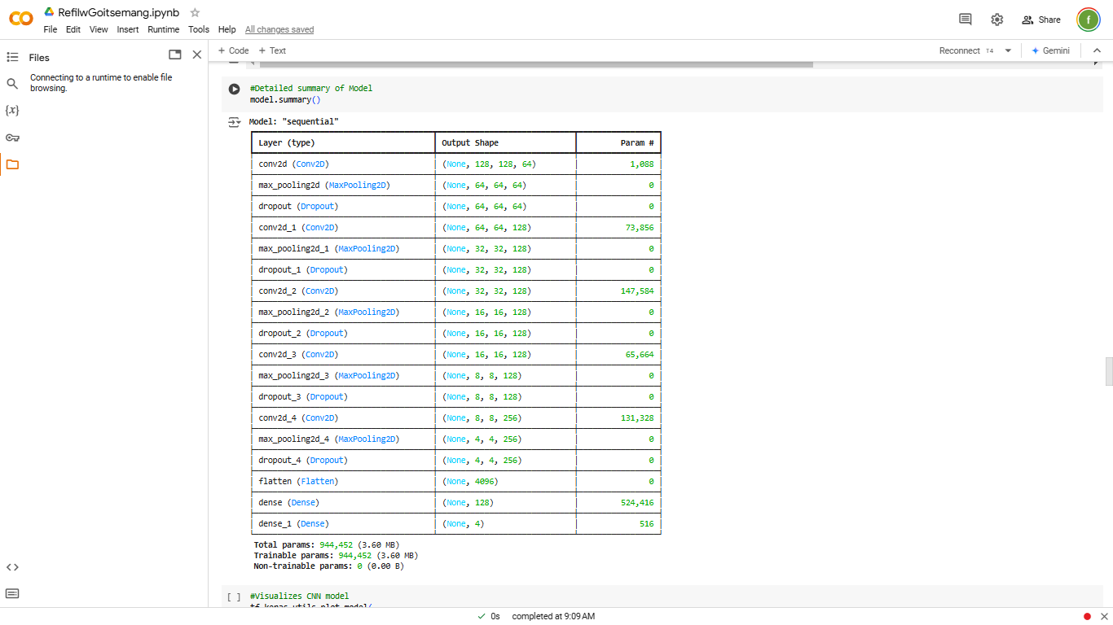

1. Preprocessing

Preprocessing for the Alzheimer’s disease detection model was conducted using a custom function that loads and processes training images. The primary goal of this function was to prepare the MRI images for input into the CNN by ensuring consistent size, format, and structure. The function’s objective was to process images into a uniform format, resize them to a standard dimension, and prepare labelled datasets for model training. The function iterates through all directories in the training dataset, skipping irrelevant folders like **.ipynb_checkpoints**. Images were loaded from their respective subdirectories using OpenCV. All images were resized to 128x128 pixels using the cv2.resize method to standardize the input dimensions for the CNN. Images were converted to grayscale using cv2.COLOR_BGR2GRAY, reducing computational complexity while preserving critical structural information. Each image was reshaped to include an additional dimension (128x128x1), which is required for compatibility with the CNN input layer. The processed images and their corresponding labels were appended to the data list for further use in training. This preprocessing pipeline ensured that the dataset was uniform, efficient for training, and compatible with the CNN architecture. By transforming raw MRI images into a structured format, the preprocessing step played a crucial role in preparing the data for accurate Alzheimer’s stage classification.

1. Balancing Dataset

A crucial step in building an effective machine learning model, particularly for medical applications like Alzheimer’s disease detection, is ensuring that the dataset is balanced. Unequal representation of classes in the training data can lead to biased predictions where the model disproportionately favours the majority class, reducing its diagnostic reliability.

The initial dataset, consisting of MRI images categorized into four classes being Non-Demented, Very Mild Demented, Mild Demented, and Moderate Demented, which were inspected for balance. The check_image_balance function was implemented to count the number of images in each class and identify any disparities.

This function iterates through each class directory in the training dataset, skipping irrelevant folders such as .ipynb_checkpoints. It calculates the number of images per class and prints these counts. For this project, the dataset was found to have unequal image counts across classes, posing a risk of bias.

Code Snippet of checking if dataset is imbalanced:



1. Augmentation

To address the class imbalance, data augmentation was employed. Augmentation artificially increases the dataset size by generating variations of the existing images. The augment_and_save_to_list_with_resize function was developed for this purpose, leveraging TensorFlow's ImageDataGenerator for image transformations. Balancing the dataset through augmentation ensured that all classes were equally represented in the training data. This improved the model's ability to generalize across classes, avoiding bias toward the majority class. By augmenting minority class data, the model became more robust in identifying subtle patterns specific to underrepresented classes, such as Very Mild Demented and Moderate Demented, enhancing its diagnostic accuracy.

Code snippet of Augmentation:



1. Normalization and One-hot encoding

Normalization and one-hot encoding are crucial preprocessing steps in preparing data for machine learning models, particularly in image-based tasks like Alzheimer's disease detection. Normalization scales the pixel values of the input images to a uniform range, typically between 0 and 1. In this project, the feature matrix x, containing pixel values of the MRI images, was normalized by dividing each value by 255. This ensured consistency in data representation and improved the model's performance during training. One-hot encoding converts categorical labels into a binary matrix format. For this project, the labels (y) represented the four Alzheimer’s disease stages: Non-Demented, Very Mild Demented, Mild Demented, and Moderate Demented. One-hot encoding transformed these categorical labels into a format suitable for multi-class classification. These steps directly contribute to the model's ability to learn patterns from the data accurately and are integral to achieving the high accuracy and generalization demonstrated in this project

Below is a code snippet of the code:

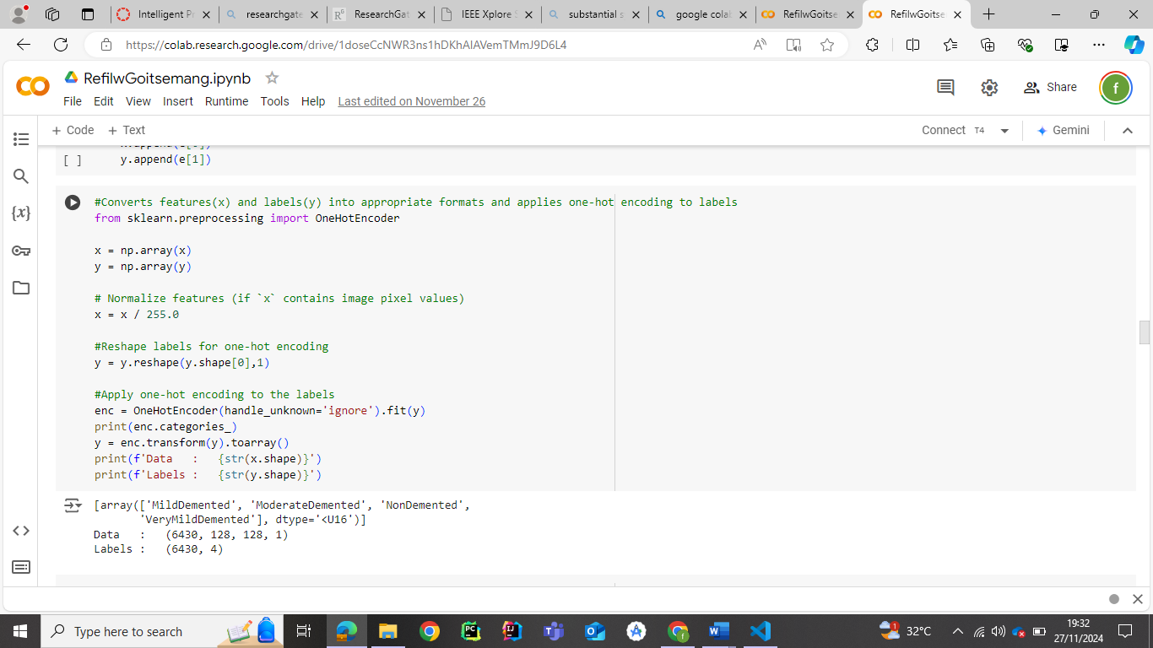

1. Learning Rate Scheduler and Early Stopping

Both the learning rate scheduler and early stopping are essential techniques used during model training to enhance performance, avoid overfitting, and ensure efficient use of computational resources. These methods were incorporated into this project using the TensorFlow/Keras framework. In this project, the ReduceLROnPlateau callback was used to reduce the learning rate when the model's performance stagnates. Moreover, Early stopping was used as a regularization technique that monitors the model's performance on validation data during training. It halts training when the model stops improving, preventing overfitting and saving computational time.

Below is a code snippet :

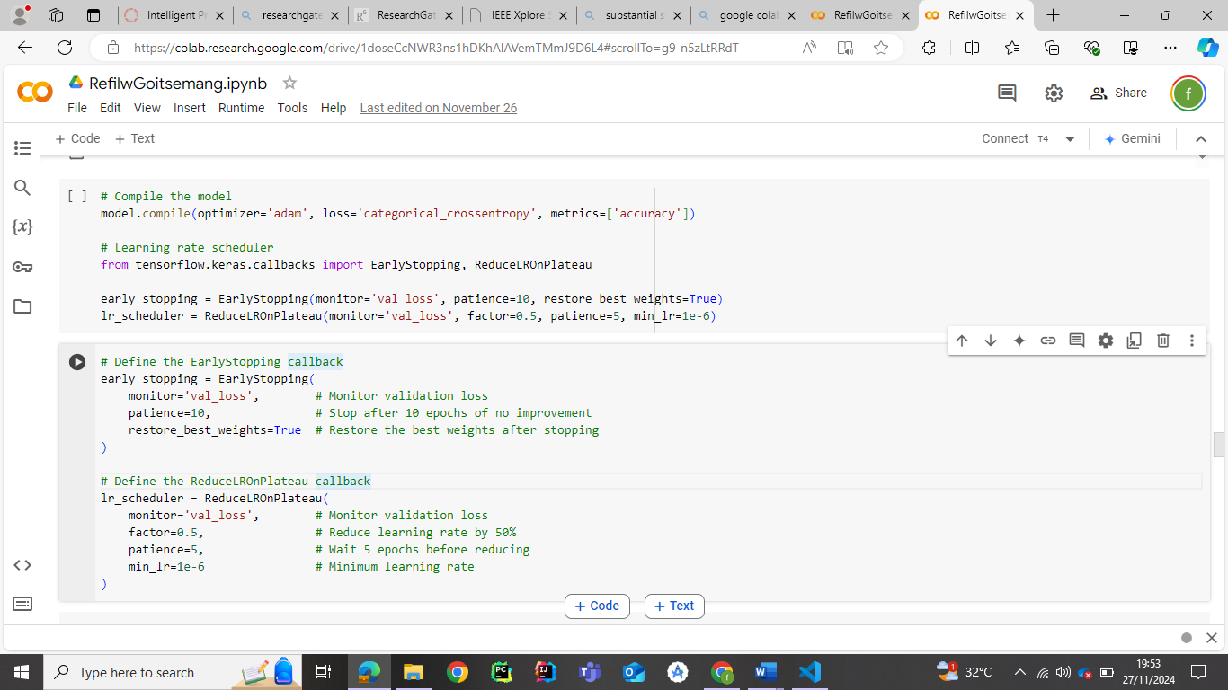

# 4. Results and Discussion

This section presents the findings of the project and discusses their implications. The outcomes are analysed in terms of model performance, observed challenges, and potential impacts of the Alzheimer’s Disease detection system. Each aspect of the results is evaluated with supporting evidence, emphasizing their significance and areas for improvement.

1. Model Performance

The developed Convolutional Neural Network (CNN) achieved remarkable results, demonstrating high accuracy and generalization across all datasets. The key performance metrics are summarized below:

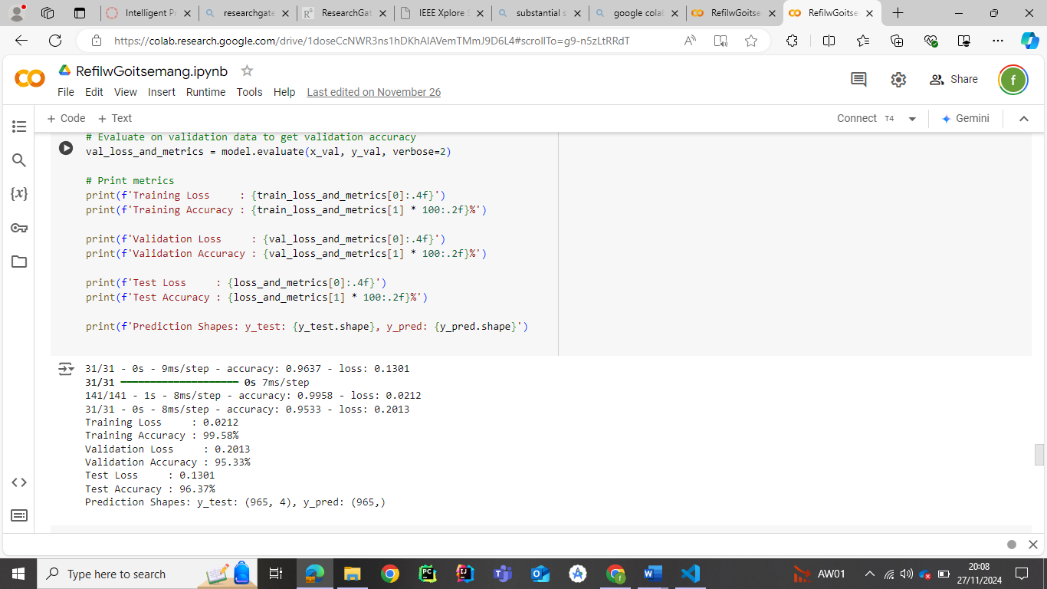

These metrics indicate that the model effectively learned meaningful patterns from the MRI images and generalized well to unseen data. The minimal gap between training and validation accuracy reflects successful prevention of overfitting, attributed to techniques such as dropout layers, data augmentation, and learning rate scheduling.

1. Confusion Matrix Analysis

The confusion matrix offers a detailed view of the model's performance for each class. The model classified images into four categories; Non-Demented, Very Mild Demented, Mild Demented, and Moderate Demented. Below is a breakdown of the matrix results:

* **Non-Demented**: Out of 108 samples, 103 were correctly classified, resulting in high precision and recall. A few misclassifications were observed, which could stem from overlaps in feature representations across classes.
* **Very Mild Demented**: This category showed slightly lower performance, with 9 correct classifications out of 11 samples. The small sample size may have contributed to this limitation, as the model had fewer opportunities to learn the distinct features of this class.
* **Mild Demented**: The largest class, with 518 samples, achieved near-perfect classification with 500 correct predictions. This highlights the model’s ability to generalize effectively for well-represented categories.
* **Moderate Demented**: With 318 correct predictions out of 328 samples, the model demonstrated strong performance, though some overlap with the Mild Demented category was observed.

These results emphasize the model's strength in handling imbalanced datasets, aided by the augmentation strategies and preprocessing techniques employed. Below is the results of the confusion matrix:

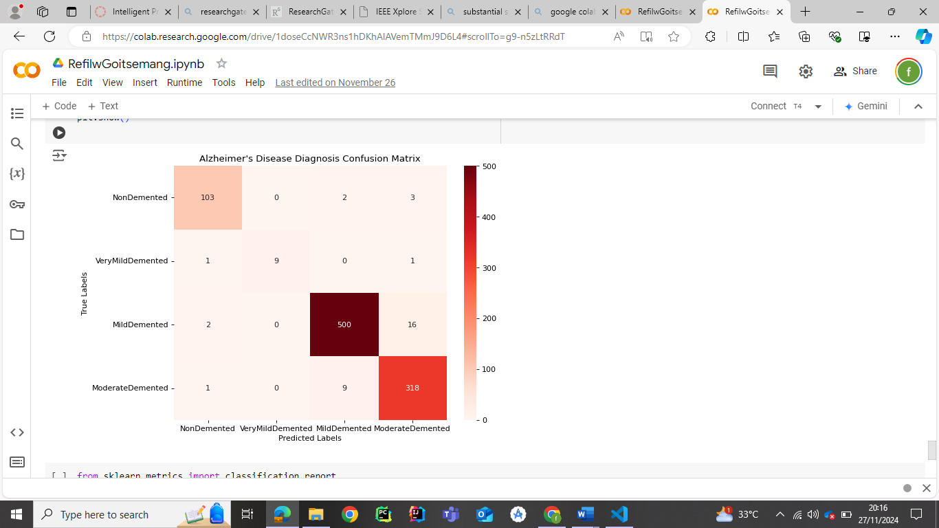

1. Classification **Metrics**

The classification report provides a comprehensive assessment of precision, recall, and F1-score for each class:

* Precision measures the proportion of true positive predictions among all positive predictions. The weighted average precision was **96%**, reflecting the model’s ability to reduce false positives.
* Recall measures the proportion of true positive predictions among actual positives. The weighted average recall was also **96%**, indicating the model’s consistency in identifying all true positives across classes.
* F1-Score, the harmonic mean of precision and recall, was **96%**, further confirming the balance between sensitivity and specificity.

The macro average F1-score of **95%** suggests slightly reduced performance for underrepresented classes, such as Very Mild Demented, but the model compensates well for these challenges overall. Below is the output of the classification Metrics:

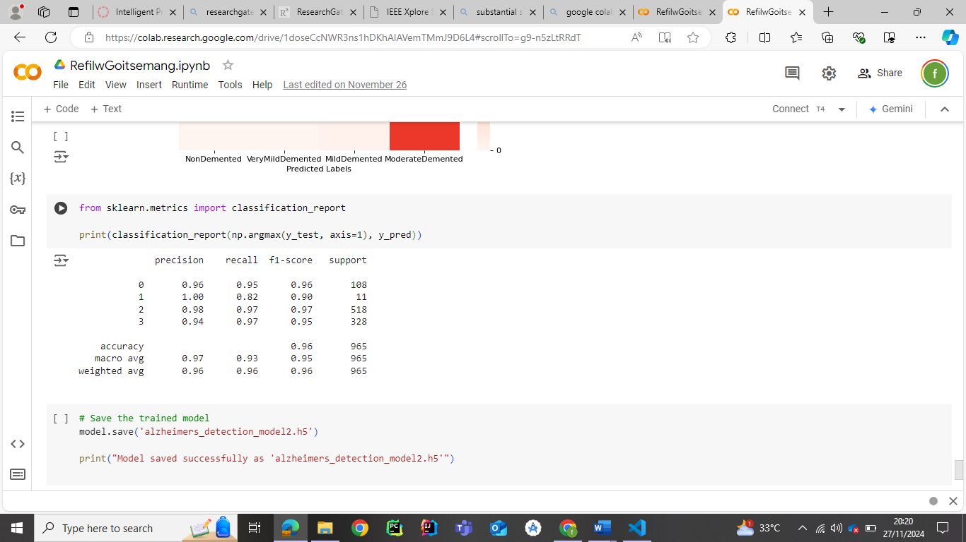

1. **Testing**

After building the Alzheimer's detection model and achieving promising performance during training and validation, testing was conducted on a randomly selected class to evaluate its ability to classify. The purpose of this testing was to ensure that the model could correctly classify a new image based on the predefined categories, such as "Non Demented", "Very Mild Demented", "Mild Demented" ,or "Moderate Demented". Using a sample image from the "Moderate Demented" category, the classification code was executed, which involved preprocessing the image ,resizing, gray-scaling, normalizing and passing it through the trained model. The successful prediction of the correct class confirmed the model's reliability.

Link to classification .ipynb: <https://colab.research.google.com/drive/1Dzu8K-AMKI8zkjHUT4KPav2336BWBVkM?usp=drive_link>

I preloaded the saved model:



Then I went on to resize to the optimum size that I used to train:

Then finally I classified:

1. Data Augmentation and Balancing Impact

The use of data augmentation to balance the dataset significantly contributed to the high performance of the model. Augmenting smaller classes, such as Very Mild Demented, with transformations like rotation, flipping, and zooming helped mitigate the effects of data imbalance, enhancing the model’s ability to generalize across all classes.

1. Limitations

Despite its strong performance, the model displayed minor misclassifications, particularly in stages of Alzheimer’s, such as Very Mild Demented and Mild Demented. This could be attributed to the subtle differences in MRI features across these stages. Additionally, the small sample size for certain classes might have constrained the model’s capacity to learn unique patterns.

1. Implications

The high accuracy and robust classification metrics suggest that this model has significant potential for real-world application in early Alzheimer’s detection. Its ability to automate diagnostic processes can assist medical professionals in making timely and accurate decisions, ultimately improving patient outcomes.

However, scalability and practical deployment considerations remain crucial. Integration into clinical workflows would require further testing, validation on larger and more diverse datasets, and adherence to ethical standards, such as patient data privacy.

1. Future Enhancements

Future scalability improvements include integrating the model with a user-friendly interface using tools like React.js, Firebase, and AWS. By deploying the model via an API connected to a dashboard, users could upload MRI images and receive real-time classification results. Such integrations would make the system accessible via web and mobile applications, enhancing its usability and impact.

This project serves as a testament to the potential of AI-driven solutions in addressing real-world challenges, paving the way for further innovations in medical imaging and disease detection.

# References

Al-Shoukry, S., Assaleh, K., Al-Nashash, H., & Marwan, N., 2020. Early Detection of Alzheimer’s Disease Using Machine Learning and MRI Imaging. *Journal of Neural Engineering*, 17(5), p. 056020.

Alzheimer's Disease International (ADI) (n.d.) *Dementia statistics*. Available at: <https://www.alzint.org/about/dementia-facts-figures/> (Accessed: 5 December 2024).

Alsubaie, M.G., Luo, S., & Shaukat, K., 2024. ConvADD: Exploring a Novel CNN Architecture for Alzheimer’s Disease Detection. *International Journal of Advanced Computer Science and Applications*, 15(4).

Bravo-Ortiz, M.A., Holguin-Garcia, S.A., Quiñones-Arredondo, S., Mora-Rubio, A., Guevara-Navarro, E., Arteaga-Arteaga, H.B., Ruz, G.A. and Tabares-Soto, R., 2024. A systematic review of vision transformers and convolutional neural networks for Alzheimer’s disease classification using 3D MRI images. *Neural Computing and Applications*, 36, pp.21985-22012

Ebrahimi, A., Luo, S., and Alzheimer’s Disease Neuroimaging Initiative (2021) ‘Convolutional neural networks for Alzheimer’s disease detection on MRI images’, *Journal of Medical Imaging*, 8(2), p. 024503.

Helaly, H.A., Badawy, M., and Haikal, A.Y. (2022) 'Deep Learning Approach for Early Detection of Alzheimer’s Disease', *Cognitive Computation*, 14(5), pp. 1711–1727.

Kumar, S., Ramesh, P., & Kannan, S., 2023. Transfer Learning with Pre-Trained CNN Models for Alzheimer’s Disease Detection. *Medical Image Analysis*, 79, p. 102481.

Reddy, T.S., Saikiran, V., Samhitha, S., Moin, S., Kumar, T.P., & Charan, V.S., 2023. Early Detection of Alzheimer Disease Using Data Augmentation and CNN. *2023 IEEE Global Conference for Advancement in Technology (GCAT)*, Bangalore, India, pp. 1-8.

Turisi, M., Sharma, P., & Wang, J., 2023. Societal Impacts of AI-Driven Diagnostic Tools: Addressing Alzheimer’s Disease. *AI in Medicine*, 142, p. 104570.