Requirements, Traceability, and Scope Lead

Problem and Business Need
The organisation manages service requests through a mix of communication methods, including phone calls, emails, WhatsApp messages, spreadsheets, and paper records. Because there is no single controlled record of a request's lifecycle, it is difficult to know where a request stands, who is handling it, what has been done, and whether it has been resolved. Complete tracking throughout a request's lifecycle is recognised as a core benefit of structured service request management, ensuring all parties stay informed of progress (ServiceNow, 2026).
This fragmentation creates real frustration on both sides. Requesters often end up sending duplicate requests or following up across multiple channels just to get an answer, wasting their time. Staff face a similar problem: the same issue may surface across several platforms, forcing them to investigate or resolve it more than once. The result is a slower, more time-consuming process with delayed resolutions all round.
What the organisation needs is a system that allows people to submit and monitor requests, directly supporting the core business need to submit, manage, and monitor service requests in one place (ServiceNow, 2026). Beyond that, the organisation needs clear ownership of every request. This includes who is responsible for it, what priority it carries, and what actions have been taken. Right now, that need isn't being met because accountability is weak for changes to request status and the actions taken. Solving this problem creates value across the organisation. Requesters gain visibility and clarity on the status of their requests. Staff save time and can delegate tasks more effectively and manage their workload with greater control. Management gains reliable, auditable data that supports accountability and service-performance reporting.
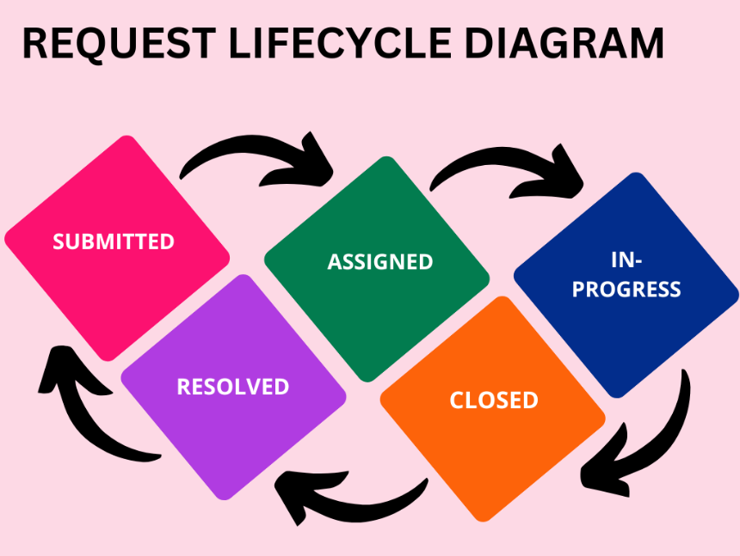

Stakeholder Analysis
Requesters need to be able to submit a new service request, categorise it, and view the status of their submitted requests. Staff need to be able to view requests and search, filter, or sort them, as well as assign or accept responsibility for a request. Management needs to be able to identify open, overdue, resolved, and closed requests.
One conflict identified is between Requesters and Staff. Requesters want the system to be fast and straightforward, allowing them to submit a request quickly and see results soon after. This may clash with Staff's needs, since resolving a request properly takes time, requires the Requester to provide sufficient detail upfront, and depends on staff having the capacity to investigate and act on it. A system optimised purely for speed on the Requester's side risks producing incomplete requests that are harder and slower for Staff to resolve. One functional requirement derived from this is that the system must allow a Requester to view, update, or delete their submitted request where appropriate.
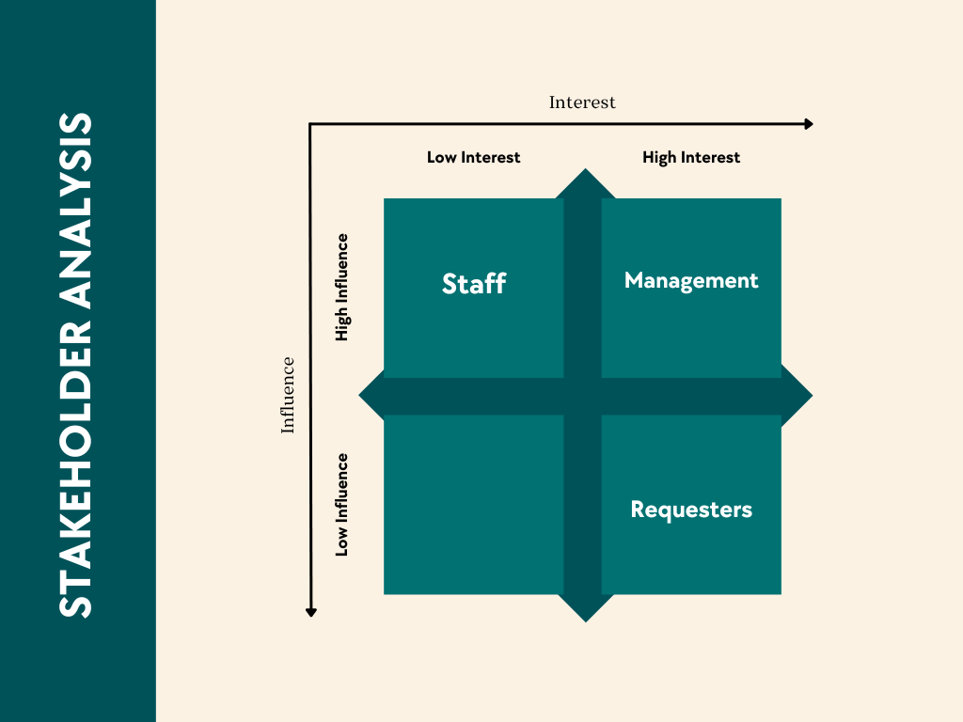

Scope Baseline
In-scope
- Requesters can submit a new service request with relevant details.
- Requesters can categorise their request using a controlled category list, for instance, assign it to maintenance or IT support.
- Requesters can view the status of their submitted request.
- Requesters can view a list of their previously submitted requests.
- Requesters receive feedback when their request is accepted or completed.
- Staff can view requests relevant to them and search/filter/sort by useful criteria.
- Staff can view full request details.
- Staff can assign or accept responsibility for a request.
- Staff can update a request status from open to in progress and so forth.
- Staff can record actions, comments, or resolution notes on a request.
- Management can view service activity, including open, overdue, resolved, and closed requests.
- Management can view requests by category for basic reporting and accountability purposes.
- Role-based access so Requesters, Staff, and Management see only what’s relevant to their role.
Out-of-scope
- Native mobile app — web-based only.
- Integration with external channels (auto-importing requests from WhatsApp, phone calls, or email into the system).
- Multi-language support.
- Advanced analytics or AI-driven prioritisation/auto-assignment of requests.
- Public API for third-party integration.
- Payment processing or billing functionality.
Deferred scope
- Automated notifications (SMS/emails) on status change.
- Advanced management dashboards/reporting beyond basic status counts,
- Public API for future integrations.
Automated notifications have been deferred, as this milestone prioritizes establishing the core, controlled lifecycle of a request. This includes submission, assignment, status tracking, and resolution. The system's primary aim is to be reliable and traceable, and this deferment protects that focus. Introducing a third-party notification service such as SMS or email would bring external dependencies, added cost, and integration risk that isn't justified until the core platform is stable. In line with the constraints, this decision protects the project's schedule and cost boundaries and reduces the risk of an unfamiliar third-party integration destabilising features more directly tied to the stated business need.

Functional Requirements
ID | Requirement | Source | Priority | Acceptance Criteria
FR-001 | Requester can submit a new service request with relevant details. | Requester in scope | Must | Request will be saved using the ID and status “Submitted” once mandatory fields are completed.
FR-002 | Requester can categorise their request. | Requester in-scope | Must | Submission will be blocked unless a category is selected.
FR-003 | Requester can view the status of their submitted request | Requester in-scope | Must | Status updates visible to Requester in real time as Staff changes it.
FR-004 | Requester can view a list of their previous requests | Requester in-scope | Should | “My Requests” list all past submissions with status and date
FR-005 | Requester can view, update or delete their submitted requests | Stakeholder Analysis- Staff/Requester conflict | Should | Editing allowed only while status is “Submitted”, locked once staff accepts it.
FR-006 | Staff can view requests relevant to them and search/filter/sort | Staff in scope | Must | Filters return only matching requests.
FR-007 | Staff can view full request details | Staff in scope | Must | All submitted fields visible on one screen
FR-008 | Staff can assign or accept responsibility for a request | Staff in scope | Must | Accepting sets status to “In progress” and records the staff member as the owner
Fr-009 | Staff can update request status through controlled transitions | Staff in scope | Must | Submitted-> In progress->Resolved->closed
FR-010 | Staff can record actions, comments or resolution notes on a request | Staff in scope | Should | Notes are timestamped
FR-011 | Management can view service activity | Management in scope | Must | Counts of open or overdue data
FR-012 | Management can view requests by category for basic reporting | Management in scope | Should | Category filter returns only matching requests
FR-013 | System enforces role-based access so each role sees only what’s relevant to them | Role-based access | Must | Requesters see only their own requests; staff cannot access Management reports

Non-functional Requirements
ID | Requirement | Source | Priority | Acceptance Criteria
NFR-001 | Pages should load within an acceptable time | Quality | Must | Submission pages should load in 3 seconds
NFR-002 | User data is protected | Security | Must | No data should be accessible without authentication
NFR-003 | Works on standard browsers | Quality | Should | Core features function on the latest two versions of Chrome, Edge

Requirements Traceability Matrix
ID | Stakeholder | Requirement Summary | Acceptance Criteria | Status
FR-001 | Requester | Submit a new service request | Saved with unique ID, status "Submitted" | Baselined
FR-002 | Requester | Categorise the request | Submission blocked without a category | Baselined
FR-003 | Requester | View request status | Status visible and updates in real time | Baselined
FR-004 | Requester | View request history | "My Requests" lists past submissions | Baselined
FR-005 | Requester | Update/withdraw a request | Editable only while "Submitted" | Baselined
FR-006 | Staff | Search/filter/sort requests | Filters return matching requests only | Baselined
FR-007 | Staff | View full request details | All fields visible on one screen | Baselined
FR-008 | Staff | Accept/assign a request | Accepting sets status to "In Progress", records owner | Baselined; traces from the Staff stakeholder need
FR-009 | Staff | Update status via controlled transitions | Only Submitted→In Progress→Resolved→Closed allowed | Baselined
FR-010 | Staff | Add notes/comments | Notes timestamped and saved to history | Baselined
FR-011 | Management | View activity by status | Counts match live data | Baselined
FR-012 | Management | View requests by category | Category filter returns matches | Baselined
FR-013 | Role-based access | Restrict view by role | Requesters/Staff/Management see only their scope | Baselined
NFR-001 | Quality | Acceptable page load time | No more than 3 seconds should be spent loading the dashboard | Baselined
NFR-002 | Security | Protect user data | Passwords hashed, no unauthenticated access | Baselined
NFR-003 | Quality | Works on standard browsers | Functions on the latest two Chrom or Edge | Baselined

References
ServiceNow, 2026. ServiceNow. [Online]
Available at: https://www.servicenow.com/products/itsm/what-is-service-request-management.html
[Accessed 8 september 2026].

