1. Product Overview

1.1 Product Features
The TS-E-A series dual-finger tactile sensor for robotic grippers is an intelligent bionic skin solution independently developed by Tashan Technology for robotic grasping perception.
It enables:
- Three-dimensional force sensing (normal and tangential forces)
- Proximity detection
- Pressure sensing
- Material recognition
The sensor mimics the physical characteristics and tactile capabilities of human finger skin and is highly compatible with a wide range of robotic grippers.
It features strong versatility, high sensing accuracy, and enables stable and precise grasping performance.

1.2 Intended Use and Application Scope
The sensor is primarily used for:
- Non-contact object position detection
- Object material identification
- Normal force and tangential force measurement
- Adaptive grasping in conjunction with robotic arms
It has broad application prospects in:
- Scientific research and education
- Biomedicine
- Space exploration
- Hazardous environment operations
- Industrial manufacturing
- Service robotics

1.3 Operating Environment
- Operating Temperature: -10°C to 45°C
- Storage Temperature: -20°C to 70°C
- Humidity: Non-condensing

1.4 Product Appearance
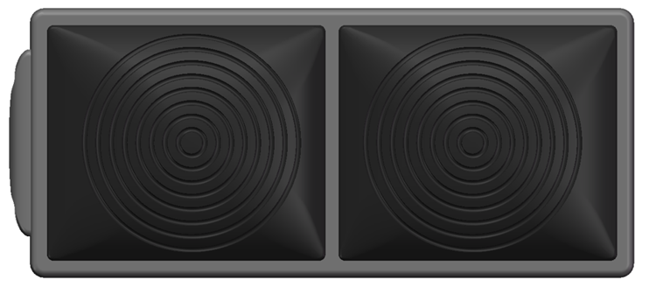

2. Structural Characteristics and Working Principle

2.1 Overall Structure and Operating Environment

Structure
The tactile sensor consists of:
- Flexible silicone skin surface
- Rigid Printed Circuit Board (PCB)
- Insulated plastic base housing

Operating Environment
The sensor utilizes non-contact capacitive detection. Since capacitance is sensitive to environmental factors such as temperature and humidity, it must be operated in a relatively stable environment within specified conditions.
Caution:
Prolonged overload pressure on the flexible silicone may lead to incomplete rebound. Long-term operation beyond the rated range must be avoided.

2.2 Functional Units and Interconnections
The system consists of:
- Sensor Units (Dual)
- Main Controller
The main controller supports up to five sensor units simultaneously. A host computer must be provided by the user.

Sensor Unit
The sensor unit transmits:
- Raw capacitance values (caused by silicone deformation)
- Calibrated force values
via the I²C protocol to the host system.

Host System
Using dedicated host software, users can:
- Monitor sensor data
- Update firmware
- Configure parameters
- Perform debugging

3. Technical Specifications

3.1 Main Functions

Sensor Unit (Dual Finger)
- Non-contact proximity detection
- Algorithm-based material recognition
- Contact-based adaptive grasping

Main Controller
- Processes and transmits finger data to the host computer

3.2 Key Parameters

Normal Force
- Range: 50 N
- Minimum Detectable Force: 0.1 N
- Resolution: 0.1 N
- Accuracy: 5% FS

Tangential Force
- Range: 20 N
- Minimum Detectable Force: 0.25 N
- Resolution: 0.25 N
- Directional Resolution: 45°
- Directional Range: 0°–359°

Sampling
- Capacitance Sampling: 24-bit (dimensionless)
- Sampling Frequency: ≥ 50 Hz

Electrical Characteristics
- Rated Voltage: 3.3V / 5V
- Maximum Static Operating Current: 20 mA

Installation
- Mounting: Bolt-fixed to robotic gripper connection plate
- Operating Position: Sensor surface

Connection
- Connector: SMD 4-Pin, 0.8 mm pitch
- Cable: 4-core, 0.0316 mm²

Mechanical Dimensions
- 46.7 mm × 20.2 mm × 12.5 mm

Environmental Conditions
- Operating Temperature: -10°C to 45°C
- Storage Temperature: -20°C to 70°C
- Humidity: Non-condensing

3.3 Dimensions and Cable Length
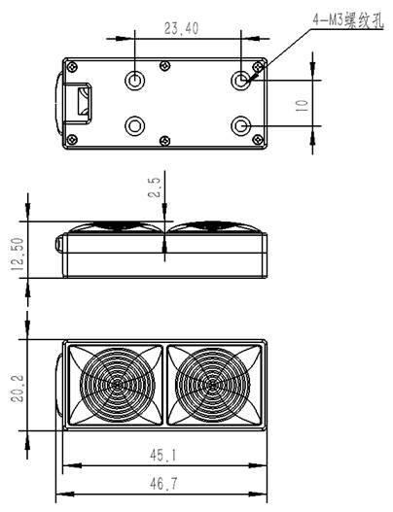
- Cable Length: 200 mm

4. Installation and Commissioning

4.1 Hardware Installation

Finger Installation
Securely mount the sensor fingers onto the robotic gripper (e.g., DH Robotics gripper or equivalent).
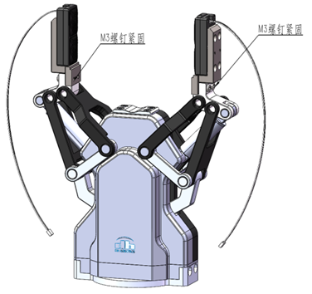

Interface Definition
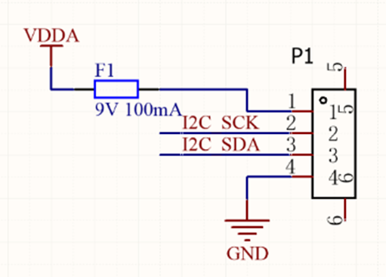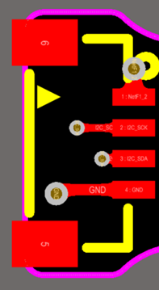
  - The internal module uses a 0.8 mm pitch IDC socket.
  - The I²C adapter board utilizes the PCA9548APWR for multi-channel I²C switching to enhance communication reliability.
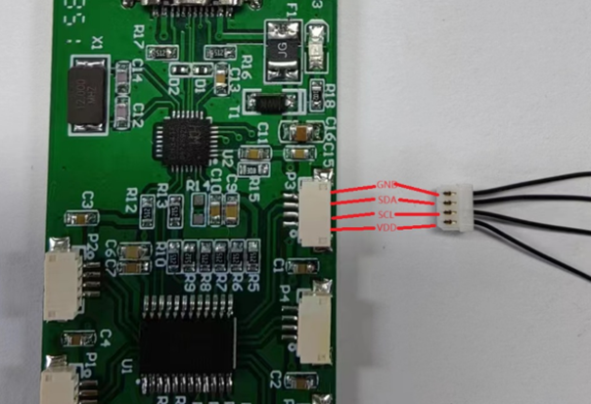
  - USB-to-I²C conversion is handled by the CH341 chip.

4.2 Software Installation

CH341 Driver Installation
- Run CH341PAR.EXE
- Click Install
- Confirm installation and close the installer

4.3 Debugging Procedure

4.3.1 Preparation
- Install USB-to-I²C driver
- Connect sensor to adapter board
- Connect adapter board to PC via USB-C

4.3.2 Adapter Board Description
The adapter board consists of:
- CH341 (USB-to-I²C interface)
- PCA9548 (I²C multi-channel switch)
- PCA9548 I²C Address: 0x70

PCB Interface (Device No.) | PCA9548 Channel | Description
Device 1 | Channel 4 | Standard Sensor Connection
Device 2 | Channel 5 | Standard Sensor Connection
Device 3 | Channel 6 | Standard Sensor Connection
Device 4 | Channel 3 | Standard Sensor Connection
Device 5 | Channel 2 | Standard Sensor Connection
Debug Port | Channel 0 | External logic analyzer connection for I²C protocol monitoring

4.3.3 Demo Host Software Operation

1. Device Connection
- Open SensorShow.exe
- Connect adapter board to PC
- Click Connect
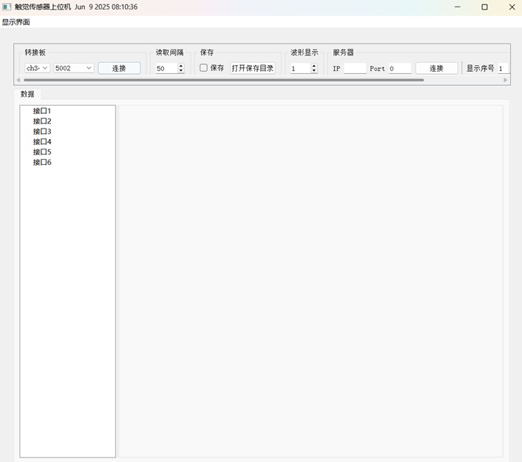
- System automatically scans and reads connected sensors
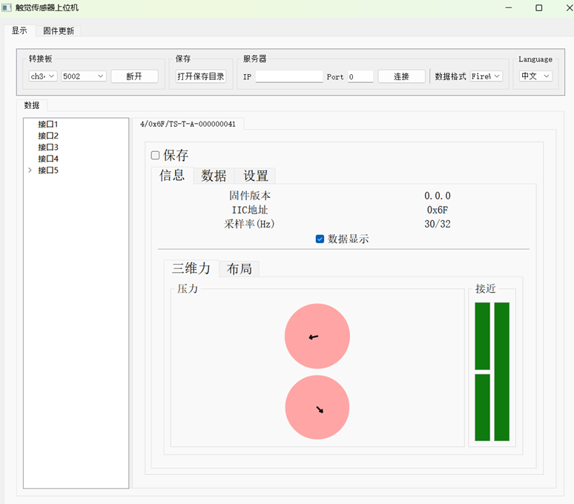

2. Finger Information Interface
Displays:
- Firmware version
- Device type
- I²C address
- Sampling rate
- 3D force results
Visualization:
- Normal Force → color intensity
- Tangential Force → arrow length
- Tangential Force Angle → arrow direction (0°–359°)
- Proximity → bar chart variation
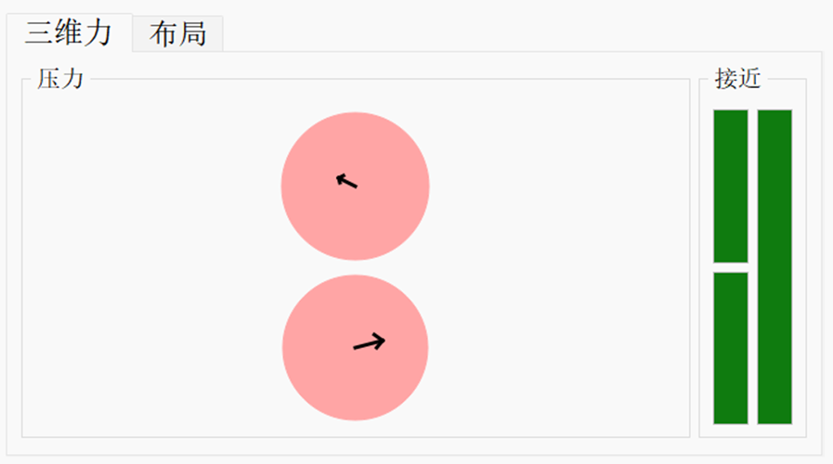

3. Data Interface
Displays real-time sampling data of all channels.
- Output modes:
  - Raw values
  - Filtered values
  - Baseline values
  - Difference values
- Channel reset allows recalibration
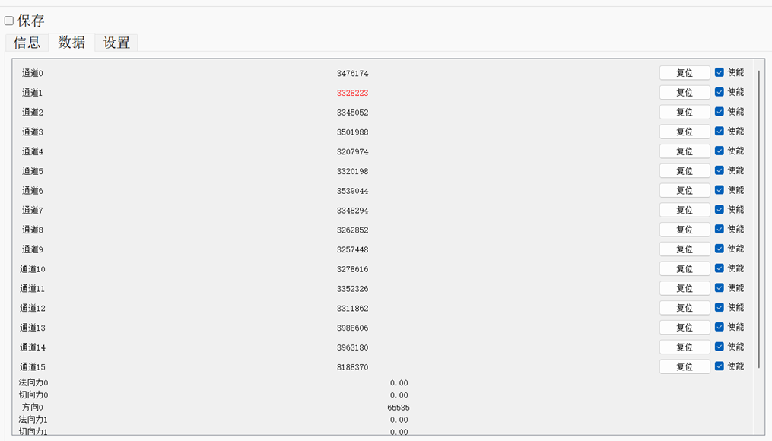
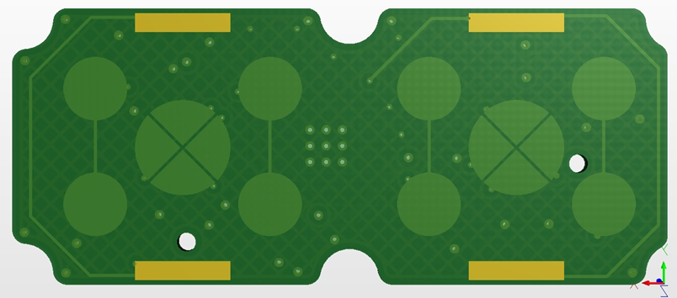

4. Settings Interface
Provides:
- Device reset
- Output type selection
- I²C address configuration (0x01–0x6F)
- Channel reset
- Channel value adjustment (~3,000,000 baseline)
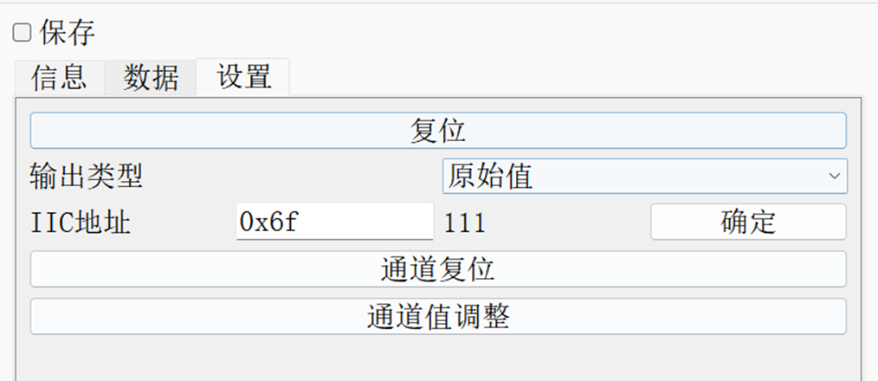

5. Data Saving
- Format: CSV
- Directory: /data folder
- Naming:
YYYY-MM-DD-HHMMSSms__sensorID.csv
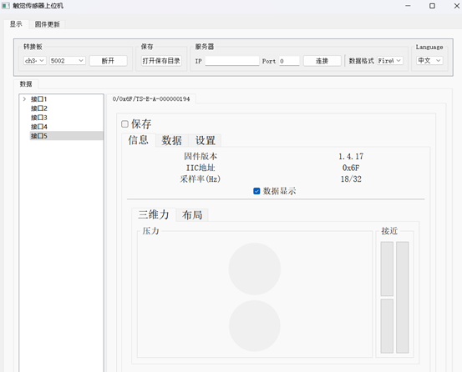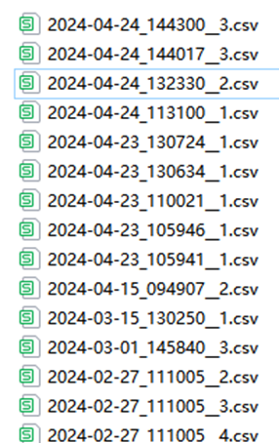

6. TCP Data Transmission
The software acts as a TCP client.
Format:
data1,data2,...,data14\r\n

7. Firmware Update
- Connect device
- Select device ID
- Select .bin file
- Enable Software Reset
- Click Start
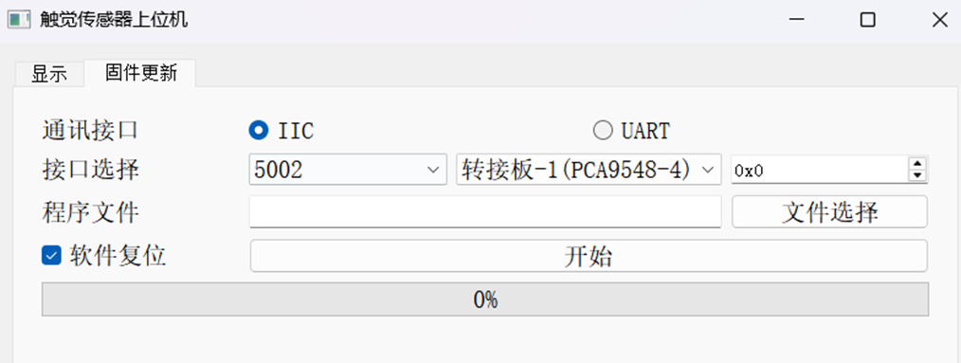

5. Operation and Use

5.1 Pre-Use Inspection
- Verify environmental conditions
- Ensure applied force is within range
- Inspect silicone surface
- Check mounting stability
- Confirm software operation

5.2 Safety Precautions
- Avoid overload
- Prevent damage from sharp objects
- Do not disassemble or modify
- Stop operation immediately if abnormal behavior occurs

5.3 Data Acquisition and Protocol

I²C Communication
- Standard Mode: 100 kHz
- Fast Mode: 400 kHz
- Default address: 0x6F
- Configurable range: 0x01–0x6F
- Broadcast address: 0x00

Checksum Calculation
Example:
Command:
aa 55 03 71 00 00 00 00 00
Checksum:
73 01
(C implementation consistent with other Tashan sensors)

6. Maintenance and Care

6.1 Storage Requirements
Store the sensor in an anti-static bag in a cool and dry environment.

6.2 Routine Maintenance
- Operated by trained personnel
- Follow product manual and procedures
- Avoid underwater or point-load usage
- Regularly tighten mechanical components
- Stop operation if abnormalities occur

7. Additional Information

7.1 Warranty
- 1-year replacement
- 2-year repair (non-human damage)

