1. Product Overview

1.1 Product Features
The TS-F-A series fingertip tactile sensor is an intelligent bionic tactile sensing solution independently developed by Tashan Technology for robotic perception.
It enables:
- Three-dimensional force sensing (normal and tangential forces)
- Proximity detection
- Pressure sensing
The sensor mimics the physical characteristics and tactile capabilities of human fingertip skin and is highly compatible with humanoid robotic hands.
It features strong versatility, high sensing accuracy, and enables stable and precise grasping performance.

1.2 Intended Use and Application Scope
The sensor is primarily used for:
- Non-contact object position detection
- Normal force and tangential force measurement
- Adaptive grasping in robotic hands
It has broad application prospects in:
- Scientific research and education
- Biomedicine
- Space exploration
- Hazardous environment operations
- Industrial manufacturing
- Service robotics

1.3 Operating Environment
- Operating Temperature: -10°C to 50°C
- Storage Temperature: -20°C to 85°C
- Humidity: Non-condensing

1.4 Product Appearance
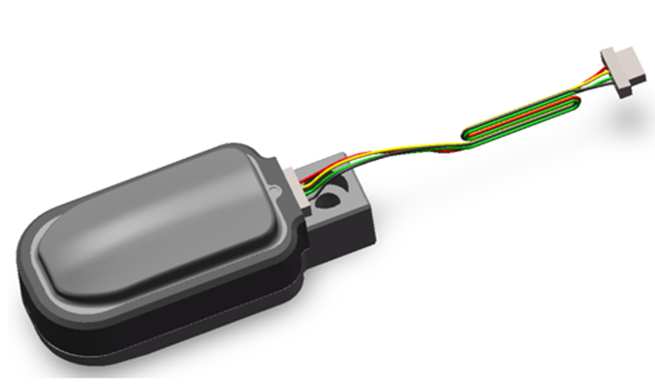

2. Structural Characteristics and Working Principle

2.1 Overall Structure and Operating Environment

Structure
The tactile sensor consists of:
- Flexible silicone skin surface
- Rigid Printed Circuit Board (PCB)
- Insulated plastic base housing
- External silicone fingertip cover

Operating Environment
The sensor utilizes non-contact capacitive detection. Since capacitance is sensitive to environmental conditions such as temperature and humidity, the sensor should be operated in a stable environment within specified conditions.
Caution:
Prolonged overload pressure on the flexible silicone may result in incomplete rebound. Long-term operation beyond the rated range must be avoided.

2.2 Functional Units and Interconnections
The sensor system consists of:
- Sensor Unit (Fingertip Module)
- Main Controller
The main controller supports up to five sensor units simultaneously. A host computer must be provided by the user.

Sensor Unit
The sensor unit transmits:
- Raw capacitance values (caused by deformation of the silicone layer)
- Calibrated force values
via the I²C protocol to the host system.

Host System
With dedicated software, users can:
- Monitor sensor data
- Update firmware
- Configure parameters
- Perform debugging

3. Technical Specifications

3.1 Main Functions

Fingertip Sensor
- Non-contact proximity detection
- Algorithm-based perception (e.g., object interaction features)
- Contact-based adaptive grasping

3.2 Key Parameters

Normal Force
- Range: 20 N
- Minimum Detectable Force: 0.1 N
- Resolution: 0.1 N
- Accuracy: 5% FS

Tangential Force
- Range: 20 N
- Minimum Detectable Force: 0.25 N
- Resolution: 0.25 N
- Directional Resolution: 45°
- Directional Range: 0°–359°

Sampling
- Capacitance Sampling: 24-bit (dimensionless)
- Sampling Frequency: ≥ 60 Hz

Electrical Characteristics
- Rated Voltage: 3.3V / 5V
- Maximum Static Operating Current: 20 mA

Installation
- Mounting: Fixed via rear mounting holes to finger joint structure
- Operating Position: Sensor surface

Connection
- Connector: SMD 4-Pin, 0.8 mm pitch
- Cable: 4-core, 0.0316 mm²

Mechanical Dimensions
- Fingertip Sensor: 32.92 × 14.6 × 12.45 mm
(excluding silicone fingertip cover)

Environmental Conditions
- Operating Temperature: -10°C to 50°C
- Storage Temperature: -20°C to 85°C
- Humidity: Non-condensing

Service Life
- 3,000,000 cycles

3.3 Dimensions and Cable Length
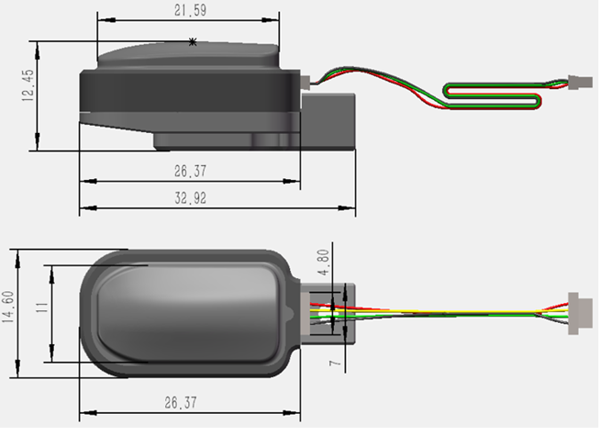
- Cable Length: 200 mm

4. Installation and Commissioning

4.1 Hardware Installation

Fingertip Sensor Installation
The sensor is mounted onto the robotic finger structure via designated mounting holes.
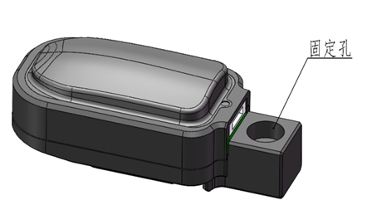

Interface Definition
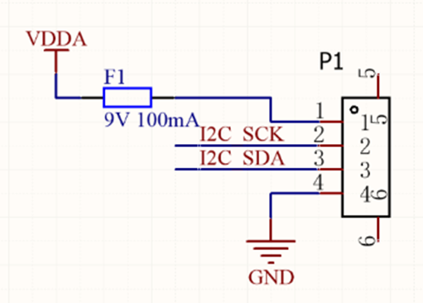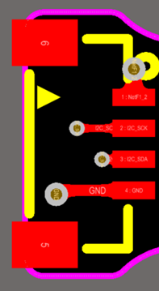
The module uses a 0.8 mm pitch IDC connector.
The I²C adapter board utilizes the PCA9548APWR for multi-channel switching to improve communication robustness.
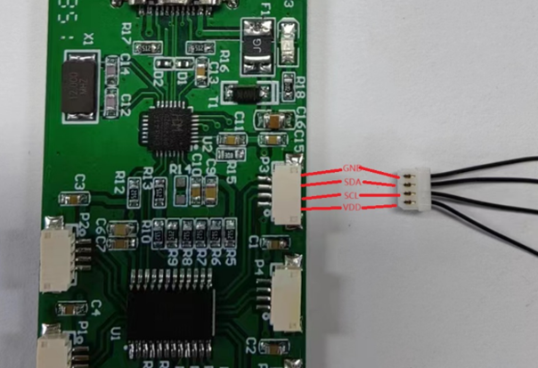
USB-to-I²C conversion is implemented using the CH341 chip.

4.2 Software Installation

CH341 Driver Installation
- Run CH341PAR.EXE
- Click Install
- Confirm installation completion

4.3 Debugging Procedure

4.3.1 Preparation
- Install USB-to-I²C driver
- Connect sensor to adapter board
- Connect adapter board to PC via USB-C
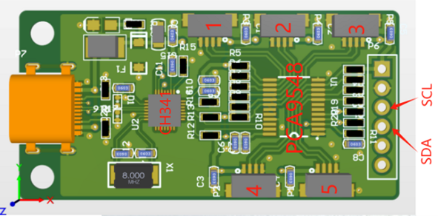

4.3.2 Adapter Board Description
The adapter board consists of:
- CH341 (USB-to-I²C)
- PCA9548 (I²C multi-channel switch)
The target sensor is selected via host software.
- PCA9548 I²C Address: 0x70

PCB Interface (Device No.) | PCA9548 Channel | Description
Device 1 | Channel 4 | Standard Sensor Connection
Device 2 | Channel 5 | Standard Sensor Connection
Device 3 | Channel 6 | Standard Sensor Connection
Device 4 | Channel 3 | Standard Sensor Connection
Device 5 | Channel 2 | Standard Sensor Connection
Debug Port | Channel 0 | External logic analyzer connection for I²C protocol monitoring

4.3.3 Demo Software Operation

1. Device Connection
- Open SensorShow.exe
- Connect adapter board to PC
- Click Connect
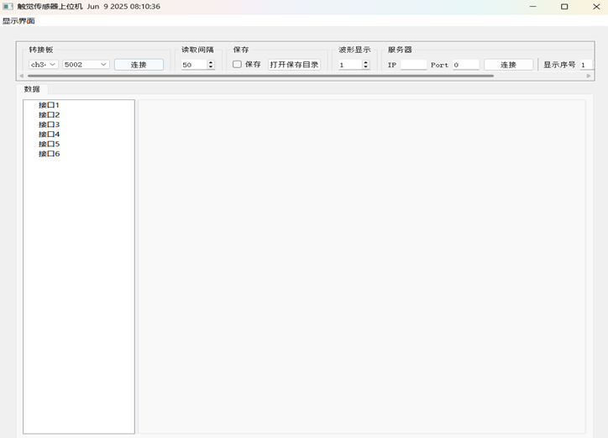
- System automatically detects connected sensors
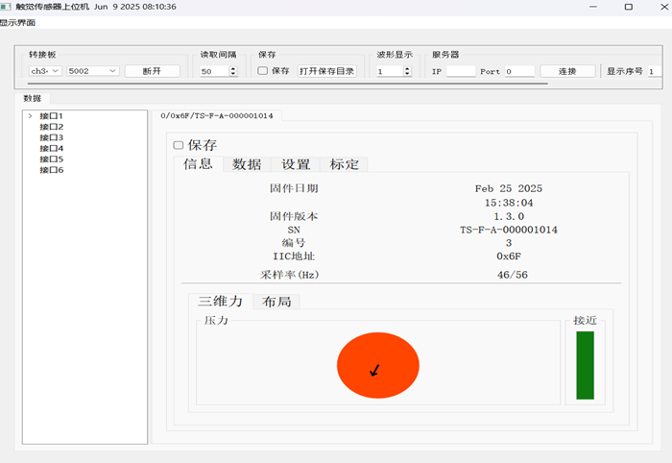

2. Finger Information Interface
Displays:
- Firmware version (compilation date)
- Device type (large/small finger)
- I²C address
- Sampling rate
- 3D force results
Visualization:
- Normal Force → color intensity
- Tangential Force → arrow length
- Tangential Force Angle → arrow direction (0°–359°)
- Proximity → bar chart variation
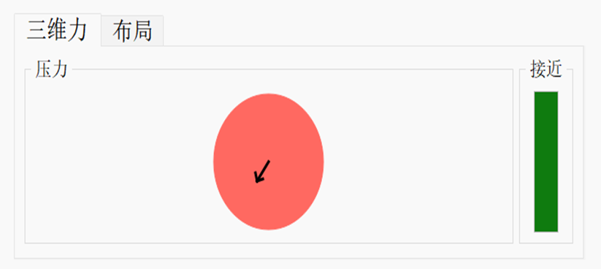

3. Data Interface
Displays real-time sampling channel values.
- Supports output modes:
  - Raw values
  - Filtered values
  - Baseline values
  - Difference values
- Channel reset allows recalibration of baseline
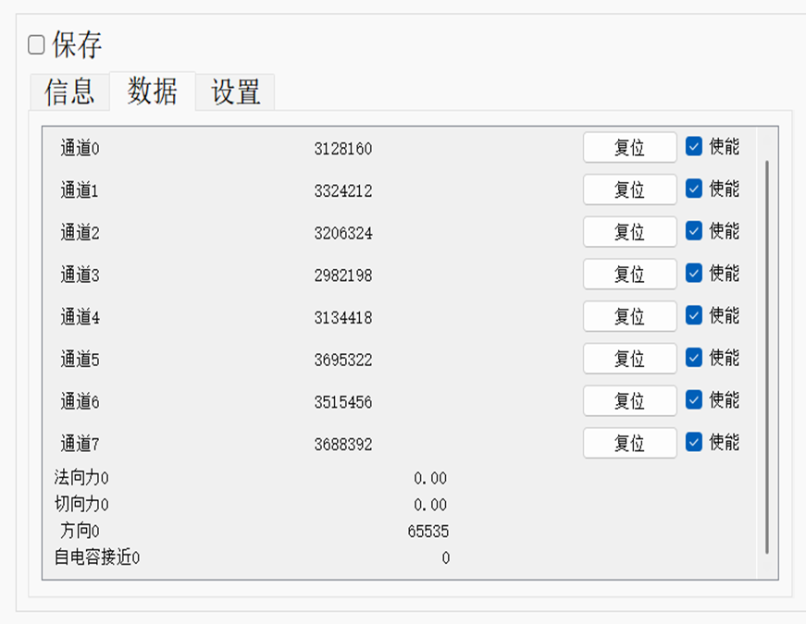
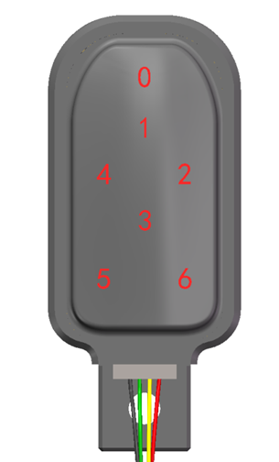

4. Settings Interface
Provides:
- Device reset
- Factory reset
- Output type selection
- I²C address configuration (range: 0x01–0x6F)
- Channel reset
- Channel value adjustment (~3,000,000 baseline)
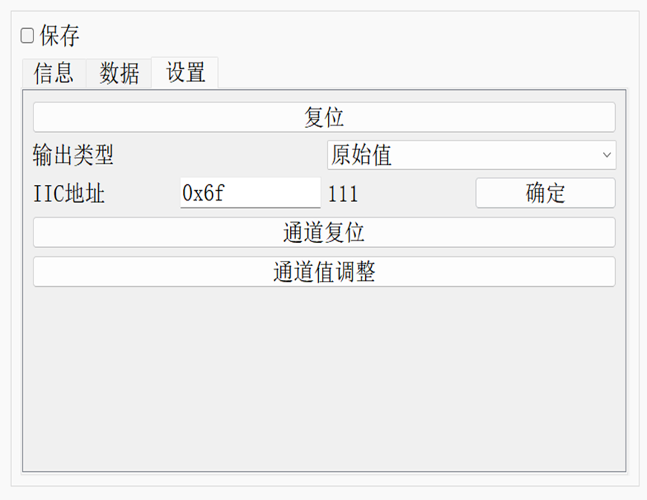

5. Data Saving
- Format: CSV
- Path: /data folder in software directory
- Naming:
YYYY-MM-DD-HHMMSS__sensorID.csv
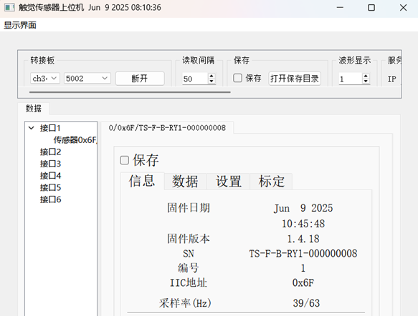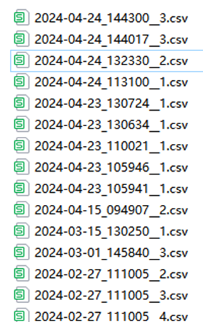

6. TCP Data Transmission
The software acts as a TCP client.
Format:
data1,data2,...,data14\r\n

7. Firmware Update
- Connect device
- Select device ID
- Select .bin file
- Enable Software Reset
- Click Start
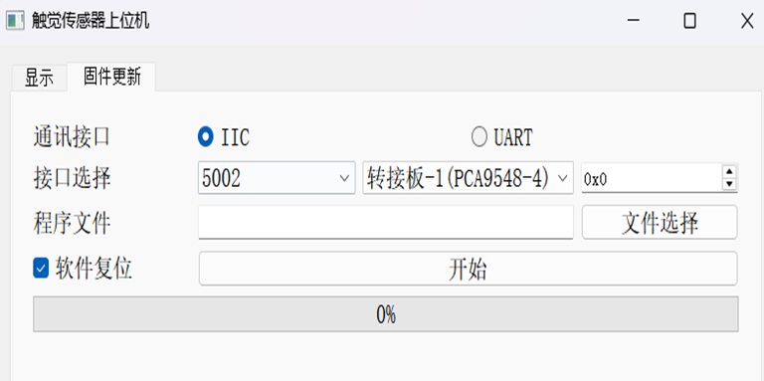

5. Operation and Use

5.1 Pre-Use Inspection
- Verify environmental conditions
- Ensure force within range
- Inspect silicone surface
- Check mounting stability
- Confirm software operation

5.2 Safety Precautions
- Avoid overload
- Prevent damage from sharp objects
- Do not disassemble
- Stop immediately if abnormal behavior occurs

5.3 Data Acquisition and Protocol

I²C Communication
- Standard Mode: 100 kHz
- Fast Mode: 400 kHz
- Default address: 0x6F
- Configurable range: 0x01–0x6F
- Broadcast address: 0x00

Checksum Calculation
Example:
Command:
aa 55 03 71 00 00 00 00 00
Checksum:
73 01
(C implementation same as TS-E-B version)

6. Maintenance and Care

6.1 Storage Requirements
Store in an anti-static bag in a cool and dry environment.

6.2 Routine Maintenance
- Operated by trained personnel
- Follow standard procedures
- Avoid underwater or point-load use
- Regularly inspect and tighten components
- Stop operation if abnormalities occur

7. Additional Information

7.1 Warranty
- 1-year replacement
- 2-year repair (non-human damage)

