4层卷积层,卷积核尺寸均为3x3,卷积核数量依次为64,128,256,512.

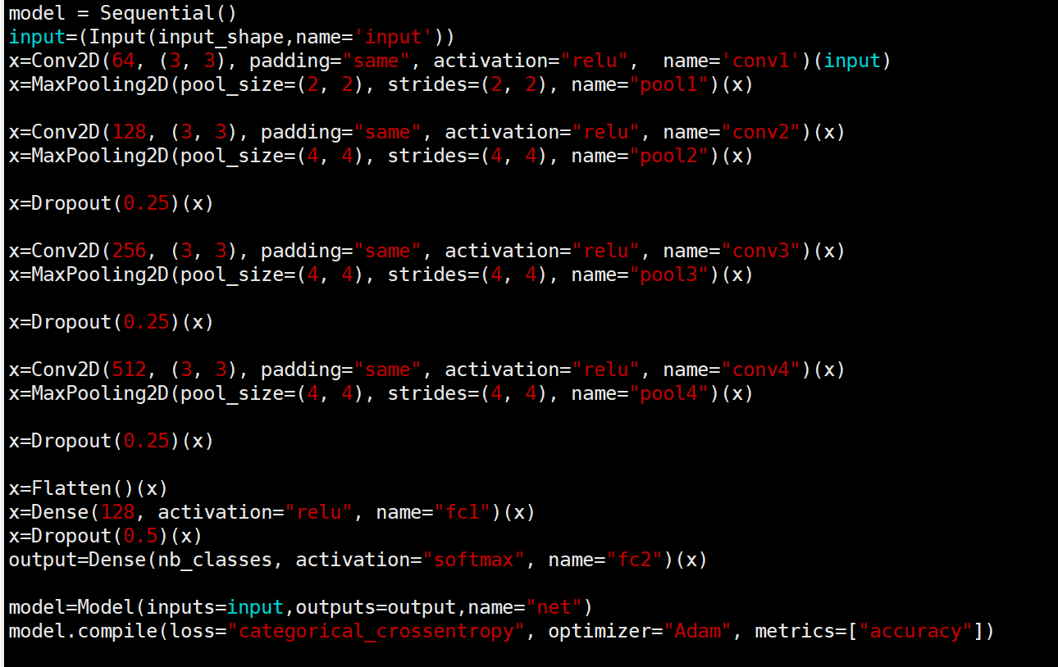

语谱图:

迭代5次,训练集准确率98%,验证集准确率92%.

MFCC:

迭代20次,训练集准确率83%,验证集准确率82%.

语谱图+mfcc：

迭代20次,训练集准确率99%,验证集准确率93%.

