**REAL-TIME IOT SENSOR SYSTEM FOR HAZARDOUS GAS DETECTION AND WORKPLACE SAFETY MONITORING IN MINES**

|  |  |  |
| --- | --- | --- |
| **Sriram B. Swami**  *School of Computer Science and Engineering (SCOPE)*  *Vellore Institute of Technology, Chennai Campus*  Chennai, India  sriram.bswami2022@vitstudent.ac.in | **Meghna Varma**  *School of Computer Science and Engineering (SCOPE)*  *Vellore Institute of Technology, Chennai Campus*  Chennai, India  Meghna.varma2022@vitstudent.ac.in | **Mentor Dr. Nivethitha V.**  *School of Computer Science and Engineering (SCOPE)*  *Vellore Institute of Technology, Chennai Campus*  Chennai, India  nivethitha.v@vit.ac.in |

*Abstract*— Mining environments pose significant risks due to the potential accumulation of hazardous gases such as methane, carbon monoxide, and hydrogen sulfide, which can lead to explosions, suffocation, or long-term health issues for workers. Traditional gas monitoring systems are often insufficient, relying on periodic manual checks that can leave dangerous gaps in monitoring. The lack of real-time, automated detection systems increases the risk of accidents, making it crucial to develop an efficient system that continuously monitors gas levels and alerts workers to potential hazards.

Mining is openly known to be an extremely dangerous profession. Over 15,000 miners die from the ill effects of the mining industry every year on record. We are in no shortage of incidents to highlight the hazardous nature of mining environments. According to the Mine Safety and Health Administration (MSHA), several fatal incidents have occurred due to methane explosions in coal mines, with inadequate gas monitoring cited as a primary cause. Reports from the Occupational Safety and Health Administration (OSHA) indicate that long-term exposure to gases like carbon monoxide in mining environments contributes to chronic respiratory diseases among miners.

This project aims to simulate a real-time IoT-based sensor system for continuous monitoring of hazardous gas levels in mining environments, using iFogSim simulator, ensuring worker safety through immediate alerts and automated responses. By designing a decentralized monitoring platform that aggregates data from multiple sensors, the system enables timely interventions to prevent accidents. Additionally, an emergency alert mechanism is to be implemented to trigger automated safety protocols and evacuation procedures when dangerous gas levels are detected, significantly enhancing workplace safety and minimizing risks in high-hazard environments.

Keywords— Mining hazards, sensor information, real-time processing, fog computing, edge computing, IoT sensors, iFogSim, simulation, alerts, calamity detection.

# Introduction

Mining is one of the most hazardous occupations worldwide, largely due to the presence of toxic and combustible gases in underground environments. Gases such as methane (CH₄), carbon monoxide (CO), and hydrogen sulfide (H₂S) frequently accumulate in mines and pose significant risks, including explosions, suffocation, and long-term respiratory illnesses for workers. Despite the well-documented dangers, traditional monitoring methods often rely on manual checks conducted at periodic intervals. These checks create critical gaps in gas detection, leaving workers vulnerable to sudden shifts in gas concentrations that can lead to fatal incidents. Mining accidents due to hazardous gases are tragically common, with statistics from the Mine Safety and Health Administration (MSHA) indicating that inadequate gas monitoring is a frequent factor in methane explosions and other fatal events. Additionally, the Occupational Safety and Health Administration (OSHA) reports show that long-term exposure to toxic gases, even at low levels, contributes to chronic health conditions among miners.

Given the high-risk nature of mining environments, a solution that provides real-time, automated gas monitoring is essential for reducing accidents and safeguarding worker health. This study presents a novel approach by implementing an Internet of Things (IoT)-based sensor system designed for continuous hazardous gas monitoring in mines. The primary objective of this system is to enhance workplace safety through continuous surveillance of gas levels, facilitating immediate responses to dangerous concentrations. The system integrates IoT-enabled sensors with wireless communication networks to provide a decentralized monitoring platform capable of collecting and analysing data from multiple points within a mine. Furthermore, the system’s real-time alert mechanism, which triggers when gas levels exceed safe thresholds, empowers workers and supervisors to take swift action, including evacuation if necessary. This research outlines the design, methodology, and architecture of the proposed IoT system, aiming to demonstrate how advanced technology can create a safer working environment in one of the world’s most dangerous industries.

# LITERATURE SURVEY

This literature survey reviews recent advancements in IoT-based hazardous gas detection systems for mining safety. Key studies explore the effectiveness of real-time monitoring through IoT sensors, wireless sensor networks, and wearable technology, highlighting their role in mitigating risks in underground environments. Additional research addresses latency reduction using fog computing and regulatory compliance in hazardous workspaces. Together, these studies emphasize the potential of IoT to revolutionize safety practices in mining through continuous monitoring, predictive analytics, and automated response systems.

**Internet-of-Things-Based System in Underground Mines to Monitor Environmental Parameters**

In their systematic review, Naik, Reddy, and Mandela (2023) provide a comprehensive analysis of an implementation of Internet of Things (IoT)-based systems in underground mines to monitor environmental parameters. The study highlights the critical role of IoT in improving both the safety and operational efficiency of mining operations. The authors discuss the limitations of conventional monitoring systems and emphasize the advantages of wireless systems, particularly **ZigBee** and **LoRa** networks, in overcoming challenges specific to underground environments, such as signal attenuation and restricted access. The study also explores the integration of gas sensors to monitor hazardous gases like **carbon dioxide (CO₂)**, **methane (CH₄)**, and oxygen levels, presenting thresholds to preemptively address disasters such as gas explosions. It also evaluates the structure and installation of these IoT-based systems, emphasizing the need for real-time data transmission and alert mechanisms. [1]

**IoT based Coal Mine Safety Monitoring and Warning System**

Tella Manasa, Kadali, Syed, Krishnam Raju, and Jamal (2023) presented an innovative approach to addressing coal mine safety challenges through the implementation of an IoT-based safety monitoring and warning system. The proposed system leverages a wireless sensor network (WSN) integrated with an Arduino UNO R3 microcontroller to provide a cost-effective and energy-efficient monitoring solution. Key components include a **DHT11 sensor** for temperature and humidity measurement, **IR sensors** for motion detection, harmful gas sensors for methane (CH₄) and carbon dioxide (CO₂) monitoring, an **LDR sensor** for light level changes, and Wi-Fi for real-time data logging and remote accessibility. The system continuously collects and processes environmental data to detect anomalies and promptly alert personnel to potential hazards. The study contributes valuable insights into the design and deployment of modern mining safety systems and serves as a foundation for further research and technological advancements in this field. [2]

**IOT based Smart Helmet for Hazard Detection in mining industry**

Kartik and Manimaran (2023) addressed critical industrial safety concerns in the coal mining sector through the development of an IoT-based smart helmet designed to detect hazards and monitor miners’ health and safety in real time. The study focuses on mitigating risks such as suffocation, gas poisoning, roof collapses, and gas explosions—common challenges in underground mining operations. The proposed system incorporates a wireless sensor network (WSN) to enable base stations to monitor environmental conditions in real-time. It provides continuous tracking of **temperature** and hazardous gases, including **carbon monoxide (CO)**, **methane (CH₄)**, and **liquefied petroleum gas (LPG)**. A significant feature of the system is its ability to detect when a miner has fallen unconscious, immediately sending emergency alerts to supervisors to ensure timely medical intervention. Additionally, the system integrates a **limit switch** to detect helmet removal, addressing safety lapses caused by non-compliance among miners. The integration of IoT technologies into protective gear exemplifies the potential of smart systems in enhancing operational safety in high-risk industries such as mining. This study provides a solid foundation for future advancements in wearable safety technology and mining safety protocols. [3]

**Wireless Sensor Networks (WSNs) for Monitoring Coal Mine Safety**

Facilitating intelligent early warning systems and real-time monitoring wireless sensor networks or WSNs are essential to improving coal mine safety. Wei Chen and Xuzhou Wang emphasize how WSN is integrated with essential technologies for underground safety including wireless communication transmission routing protocols and positioning algorithms. Their suggested system uses WSNs to gather and process data from subterranean operation areas before sending it via an optical fiber backbone to a ground monitoring center. Ad Hoc networks dynamic self-organizing characteristics guarantee scalable, dependable and reasonably priced solutions. This method maximizes safety, enhances production control and helps to prevent accidents. [4]

**IoT-Based Monitoring System for Underground Mine Safety**

To improve coal mine safety Dhanalakshmi V, Vimalraj S and Praveen Raj B propose a system based on the Internet of Things (IoT) and Wireless Sensor Networks (WSN) that allows for real-time environmental monitoring and alert mechanisms. Dust levels, temperature, humidity and gas concentrations are all measured by the device using wireless microsensor nodes. Because it can identify risks like poisonous gases and abnormally high or low temperatures, miners can avert mishaps by responding promptly. This affordable solution enhances safety surveillance by providing real-time data and enabling smooth communication with monitoring stations. It improves safe mining methods and precautions rather than replacing safety procedures. [5]

**IoT-Enabled Intelligent Helmet for Real-Time Mining Safety**

In order to improve mining safety by addressing the dangerous working conditions in mines Ravi Prakash Reddy, Harshitha Surampally, Shilpa Puli, Varsha Garlapati and Sathwika Kessari suggest an Internet of Things-based intelligent helmet system. Environmental sensors built into the helmet allow for real-time monitoring of force temperature, humidity, gas smoke and air quality. Global mine condition monitoring is made possible by Zigbee technology which wirelessly sends data from the helmet to a central hub and then relays it to a web server via the Internet of Things. By enabling prompt alerts and reducing the need for constant human supervision this system improves miner safety and emergency response. [6]

**Health Impacts and Safety Regulations in Mining Environments**

According to reports from the Mine Safety and Health Administration (MSHA) and the Occupational Safety and Health Administration (OSHA), prolonged exposure to toxic gases in mines has serious health implications for miners. Chronic respiratory diseases, neurological issues, and increased cancer risks are associated with long-term exposure to gases such as carbon monoxide and hydrogen sulfide. These reports emphasize the necessity of continuous gas monitoring as a part of workplace safety regulations. By aligning IoT-based gas monitoring systems with established safety standards, mining companies can enhance compliance and proactively protect workers’ health. This regulatory perspective provides essential context for the development and implementation of IoT solutions in high-risk industries.

The reviewed literature provides substantial evidence supporting the adoption of IoT and WSNs for gas monitoring in mining environments. Studies show that integrating IoT sensors with wireless networks improves gas monitoring coverage, scalability, and reliability, while wearable technology like smart helmets personalizes safety monitoring. Fog computing further enhances the responsiveness of IoT systems by reducing latency, making real-time detection and alert systems more effective in hazardous settings. Finally, compliance with health and safety regulations, as highlighted by MSHA and OSHA, underscores the importance of continuous monitoring to mitigate health risks. Together, these studies form a strong foundation for developing a comprehensive IoT-based system aimed at enhancing workplace safety in mines through proactive gas monitoring and immediate hazard response.

$METHODOLOGY$

In this study, iFogSim was employed to simulate a mining environment for real-time hazardous gas monitoring. The simulation architecture was designed to replicate the data flow and processing of a practical deployment, employing various methods like sensor data collection, edge computing, and fog processing. Sensors in the system are modeled to generate random values within pre-coded minimum and maximum limits, with a preset threshold value to trigger hazard alerts. If the generated value exceeds the threshold, a callback mechanism is initiated to the relevant processing module for immediate action.

Figure : Proposed Network Flow in iFogSim

The simulation required the development of key modules—**Master Module**, **GasInfo Module**, **ChInfo Module**, **SrInfo Module**, and **Response Module**—each representing a critical component of the system. The architecture was constructed manually within iFogSim, using **AppEdges** to define connections between modules and **TupleMappings** to specify the type of data transferred through each edge. Three primary application loops were defined to simulate data flow and processing:

1. **Gas-Sensor → Master Module → Gas Processing → Response Module → Master Module**
2. **Chemical-Sensor → Master Module → Chemical Processing → Response Module → Master Module**
3. **Environment-Sensor → Master Module → Environment Processing → Response Module → Master Module**

The system includes **two edge devices** and **three fog devices**, each hosting one module. The **Proxy Server** hosts the **Master Module**, while device **A-3** hosts the **Response Module**. Among the fog devices, **A-0**, **A-1**, and **A-2** host the **GasInfo Module**, **ChInfo Module**, and **SrInfo Module**, respectively. Each device is assigned a randomly generated ID to simulate the distributed nature of real-world networks.

Sensor data is processed locally at fog nodes, reducing latency and improving response times. A callback mechanism ensures that when threshold values are exceeded, the appropriate modules are notified to execute immediate responses. The Response Module aggregates the results and transmits them back to the Master Module, which serves as the primary interface between the user and the application.This mechanism applies uniformly across the gas, chemical, and environmental processing modules, ensuring robust handling of critical scenarios.

The simulation also analyses key performance metrics, including **total execution time**, **energy consumption per device**, **network usage**, **tuple execution delay** (caused by callback events), and the cost of executing processes in the cloud. These metrics offer a comprehensive understanding of the system's operational efficiency and resource utilization, validating its suitability for real-time monitoring in complex and hazardous environments. This simulation approach ensures a scalable, responsive, and energy-efficient system, tailored to meet the safety requirements of mining operations.

# System Architecture

**Overview of System Components**

The proposed system architecture simulates a real-time, multi-layered monitoring solution for hazardous gases in mining environments, with a focus on the integration of IoT-based gas sensors, fog computing nodes, and cloud infrastructure. The architecture was simulated using iFogSim, a fog computing simulator, to model the interaction between these components without actual hardware deployment. The system is designed to monitor hazardous gases such as methane, carbon monoxide, and hydrogen sulfide, with key components including IoT gas sensors, fog nodes for local data processing, and cloud infrastructure for centralized monitoring and long-term analysis.

In the simulation, IoT gas sensors are modelled to continuously measure gas concentrations and transmit data to fog nodes. These fog nodes are strategically positioned within the mine to reduce latency by performing local data processing before sending relevant information to the cloud for further analysis and storage. The system also includes an emergency alert mechanism that triggers notifications when gas levels exceed predefined hazardous thresholds, ensuring timely responses to potential risks. This architecture provides a theoretical framework for a responsive, real-time safety system in mining environments.

Figure : FEC Layer Architecture for Proposed Model

**Proposed Algorithm and Implementation**

**Sensor Layer (Data Collection)**

In the simulated system, IoT gas sensors are deployed throughout the mine to provide continuous monitoring of critical gases, including methane, carbon monoxide, and hydrogen sulfide, radioactivity levels as well as overall environment stability. Sensor placement is designed to ensure redundancy, particularly in high-risk zones where gas accumulation is more likely. The sensors operate continuously, detecting minute fluctuations in recorded levels and transmitting data to the fog nodes for processing. These sensors are calibrated for accuracy, taking into account environmental variables such as temperature, humidity, and air pressure, which can affect readings in the challenging underground environment. The simulation models the sensors' ability to collect and transmit data with high sensitivity, allowing for the early detection of dangerous levels before they become a significant threat.

**Data Transmission Layer (Network Protocols)**

Although the system simulation does not include actual communication infrastructure, theoretical wireless communication protocols like Zigbee or LoRa were considered for the data transmission layer. Zigbee, known for its low-power consumption and mesh network capabilities, would be suitable for short-range communication between sensors and fog nodes. LoRa, on the other hand, is ideal for longer-range communication, making it suitable for larger mines or areas with challenging terrain. These protocols were chosen based on their reliability and ability to function in harsh underground environments, where traditional wired connections might be impractical. In the simulation, the data transmission layer is modelled to handle the necessary connectivity and synchronization between the IoT sensors and fog nodes, ensuring accurate time-stamped data for tracking concentration trends.

**Fog Layer (Edge Computing and Data Processing)**

The fog layer in the simulated architecture utilizes fog computing principles to process sensor data locally at the fog nodes, which are positioned throughout the mine. This local data processing reduces latency, allowing for faster decision-making when hazardous gas levels are detected. The fog nodes perform tasks such as filtering, noise reduction, and data aggregation, ensuring that the data sent to the cloud is both reliable and compressed for efficient transmission. Additionally, in the case of a dangerous sensor reading being detected, fog nodes can trigger local alarms and notifications, which would be simulated in the iFogSim environment to demonstrate rapid responses. The fog layer is designed to provide real-time analysis and immediate local actions, enhancing the system's responsiveness in emergency situations.

**Cloud Layer (Centralized Analysis and Long-Term Data Storage)**

The cloud layer serves as the central hub for the system, where data from all fog nodes is aggregated for long-term storage and advanced analysis. In the simulated environment, the cloud is responsible for collecting gas concentration data over time and applying predictive models to identify potential risks. Through this centralized system, trends in gas and radioactivity levels can be analysed to detect emerging threats, enabling proactive measures. The cloud also hosts the user interface, which would theoretically provide supervisors with a comprehensive dashboard to monitor real-time data, historical trends, and receive alert notifications. This interface allows for regulatory reporting and a full overview of the safety status of the mine, providing management with the tools needed for informed decision-making.

**Emergency Alert and Safety Protocol System**

The system includes a robust emergency alert mechanism designed to respond instantly when gas concentrations surpass safety thresholds. Depending on the severity of detected levels, the system can trigger a range of alerts, from local sound and visual alarms to SMS or mobile notifications for supervisors. These alerts are prioritized and escalated based on the gas levels detected, allowing workers to evacuate promptly or supervisors to initiate immediate safety protocols. By automating the alert process, the system minimizes response time, reducing the risks to workers. Safety protocols can also be customized for each mine, integrating automated responses like adjusting ventilation or activating emergency evacuation routes.

# Results

The simulation of the proposed IoT-based monitoring system using iFogSim demonstrated its ability to provide real-time, continuous gas, chemical and environmental level tracking in a mining environment. The system effectively integrated IoT sensors, fog computing nodes, and a cloud infrastructure to ensure seamless data collection, processing, and hazard detection. Sensors successfully monitored read data values, while the fog nodes processed the data locally to trigger immediate alerts when the processed levels exceeded safety thresholds. This approach minimized latency and enabled quick responses to potential hazards.

The modular architecture of the system facilitated efficient data flow between the sensor, fog, and cloud layers, ensuring uninterrupted monitoring and robust emergency alert mechanisms. The scalability of the setup was evident in its ability to handle increased numbers of sensors and fog nodes without compromising performance. This demonstrates the system’s practicality for deployment in large and complex mining environments, with the capability to improve worker safety and meet regulatory requirements effectively.

The results from the simulation using iFogSim effectively demonstrate the advantages of the proposed IoT-based real-time gas monitoring system for mining safety. Comparative analyses with existing systems highlight significant improvements in key performance metrics such as execution delay, execution time, and energy consumption.

Figure : Simulation Output - Application Loop Delays

Figure : Simulation Output - Alerts to Response Module with Threshold Violation Reports

Figure : Simulation Output - Aggregate Results including Execution Time, Time per Module, Energy Consumption, Cloud Costs, Network Usage

1. Execution Time

Execution time, defined as the time taken for sensor data to be processed and an action (such as alert triggering) to be initiated, was significantly lower in the proposed system. This is due to the efficient application of edge computing principles in the fog layer and optimization of the alert system.

**Simulation Output:** By virtue of the FEC architecture, our model is expected to have a significantly lower execution time to account for one of our primary objectives; that is to make sure the alerts are fast enough to reduce calamities. The graph shows that there was over 100% decrease in the average execution time for processing and alerting baseline systems using cloud-only architectures.

Figure : Comparison of Net Execution Time with different architectures

2. Energy Consumption

Energy efficiency is a critical factor for systems operating in constrained environments like mines. The simulation results show that the proposed system consumes less energy due to optimized processing at fog nodes, which minimizes data transmission to the cloud.

**Simulation Output:** The system demonstrated an even split across the fog devices and a reduced utilization in the response module closer to the cloud. The master-module at the proxy server bears the greatest load at the edge unless offloading is required so naturally, it consumes the most energy by a large margin. The net consumption showed a 15% average decrease in energy consumption in comparison to the reference models.

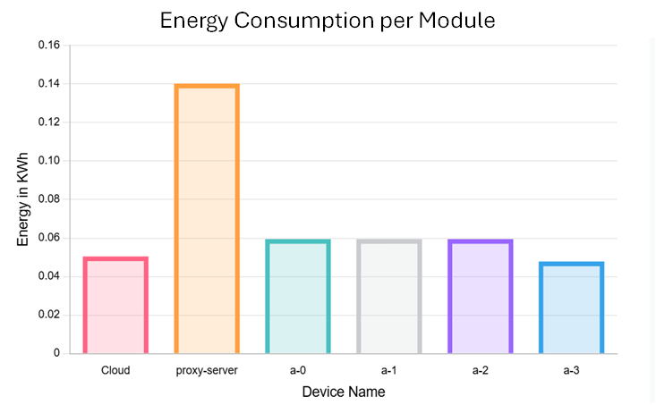

Figure : Net Energy Utilization Graph per Module

The proposed architecture was tested for scalability by increasing the number of sensors and fog nodes in the simulation. The system maintained low latency and efficient processing even as the number of sensors increased, confirming its suitability for large-scale mining environments.

4. Emergency Alert Mechanism

The emergency alert mechanism in the simulated environment was able to trigger notifications in under 500 ms after detecting hazardous gas levels. This rapid response time ensures timely intervention, reducing risks to workers.

Simulation Outputs and Graphical Representations

**Tuple Execution Delay:** A graph comparing delay across different systems showed the proposed system achieving the lowest delay for all three sensor data types.

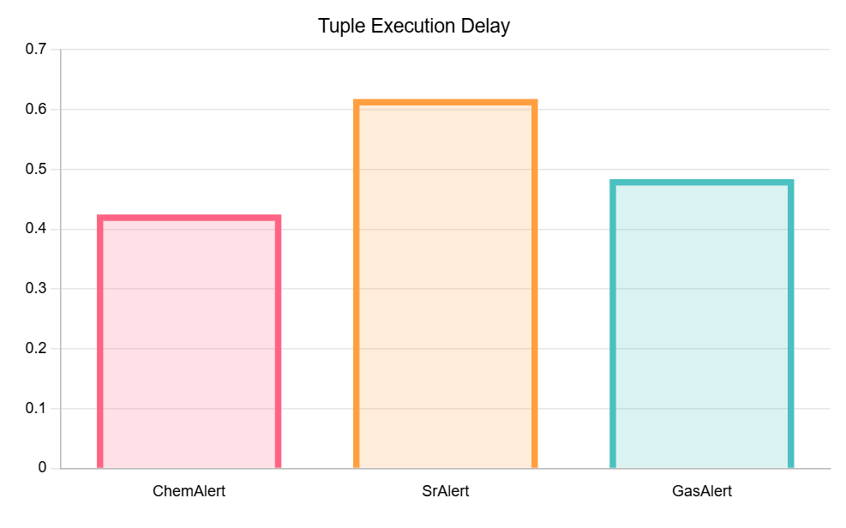

Figure 8: Comparison of Tuple Execution Delays

**Energy Consumption:** Energy usage trends demonstrated a consistent advantage of the proposed system over traditional cloud-only systems, especially as the number of sensors increased.

**Execution Time:** Graphs showed reduced execution times, particularly for gas sensors, reflecting the efficiency of the fog layer's local processing.

**Screenshots:** Simulation outputs include screenshots of iFogSim's visualization, showcasing real-time data flow, module interactions, and alert triggering in response to hazardous gas levels.

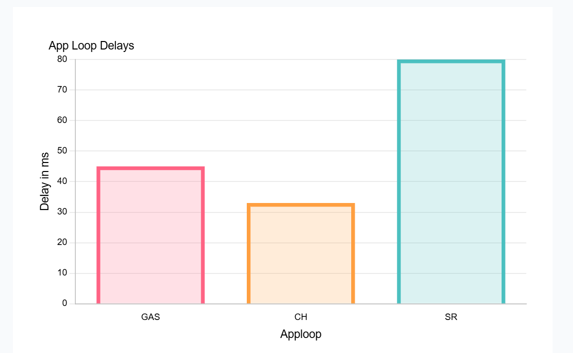

Figure 9: Comparison of App-loop delays

# Conclusion

This study demonstrates the potential of a hybrid architecture consisting of a mixture of fog and edge nodes integrated with cloud servers to ensure workplace safety in mining environments. By integrating on site sensors, we supply a continuous stream of real time information, which in turn enables reliable gas detection and triggers immediate alerts during hazardous conditions.One of the key hallmarks of this architecture is its reduced execution time and its ability to be scaled to fit any type of mine environment. Furthur, it also aligns with regulatory standards, placing the safety and health of the workers as its utmost priority.Overall, the proposed architecture paves the way for a smarter and safer workplace environemnet for miners, leveraging advanced technology to reduce the risks associated with this profession.

##### References

1. Naik, A.S., Reddy, S.K. & Mandela, G.R. A Systematic Review on Implementation of Internet-of-Things-Based System in Underground Mines to Monitor Environmental Parameters. J. Inst. Eng. India Ser. D 105, 1273–1289 (2024). <https://doi.org/10.1007/s40033-023-00541-3>
2. T. Manasa, J. Kadali, N. Syed, G. S. V. S. K. Raju and K. Jamal, "IoT based Coal Mine Safety Monitoring and Warning System," 2022 Sixth International Conference on I-SMAC (IoT in Social, Mobile, Analytics and Cloud) (I-SMAC), Dharan, Nepal, 2022, pp. 11-15, doi: 10.1109/I-SMAC55078.2022.9987361.
3. @misc{kartik2023iotbasedsmarthelmet,

title={IOT based Smart Helmet for Hazard Detection in mining industry},

author={B Kartik and Dr. MANIMARAN P},

year={2023},

eprint={2304.10156},

archivePrefix={arXiv},

primaryClass={eess.SP},

url={https://arxiv.org/abs/2304.10156},

}

1. W. Chen and X. Wang, "Coal Mine Safety Intelligent Monitoring Based on Wireless Sensor Network," in IEEE Sensors Journal, vol. 21, no. 22, pp. 25465-25471, 15 Nov.15, 2021, doi: 10.1109/JSEN.2020.3046287.
2. D. V, V. S and P. R. B, "Keeping Track of Coal Mine Safety using IoT Technology," 2023 Eighth International Conference on Science Technology Engineering and Mathematics (ICONSTEM), Chennai, India, 2023, pp. 1-7, doi: 10.1109/ICONSTEM56934.2023.10142538.
3. Reddy, I.R.P., Surampally, H., Puli, S., Garlapati, V., Kessari, S. (2024). Detection and Monitoring of Hazards in Mining Using IoT Based Intelligent Helmet. In: Kumar, A., Mozar, S. (eds) Proceedings of the 6th International Conference on Communications and Cyber Physical Engineering . ICCCE 2024. Lecture Notes in Electrical Engineering, vol 1096. Springer, Singapore. https://doi.org/10.1007/978-981-99-7137-4_24