

Central Christian Church & High Desert Church

Check-In Wizard

Administrator Guide

Version: 1.3.0 (rev )

Last updated: 3/2/2011

Maintained by  
Nick Airdo ([nick.airdo@centralaz.com](mailto:nick.airdo@centralaz.com))   
Jason Offutt ([jason.offutt@centralaz.com](mailto:jason.offutt@centralaz.com))

Daniel Hazelbaker ([daniel@highdesertchurch.com](mailto:daniel@highdesertchurch.com))

Arena Community Documentation

**Arena 2010.1**

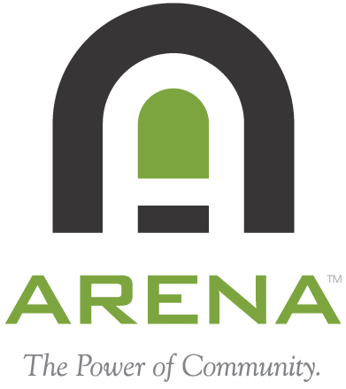

Revision History

|  |  |  |  |
| --- | --- | --- | --- |
| Version | Date | Editor(s) | Description |
| 1.0.0 | 3/03/2009 | Nick Airdo | Initial Version w/contributions by Jason Offutt |
| 1.1.0 | 5/18/2009 | Nick Airdo | Added support for Attendance Type "Membership Required for Check-In" linked to Tags. Also added a section on how to enable multiple, upcoming (future) service check-in and added an Other Things to Consider section with details about SQL jobs we run. |
| 1.2.0 | 10/19/2009 | Jason Offutt & Nick Airdo | Updating documentation for Check-In Wizard v1.2.0. |
| 1.2.1 | 5/21/2010 | Nick Airdo | Adding a dependencies section |
| 1.3.0 | 2/02/2011 | Nick Airdo, Daniel Hazelbaker, Joel L | Added new module settings, Added Kiosk Management section, include HDC as full owner of the code and project. |

Table of Contents

Release Notes 4

Introduction 5

Check-In Wizard Overview 6

How It Works 6

What Check-in Looks Like 7

Managing the Check-in System 10

Setting Up a New “Class” 10

Realistic Classroom Setup 12

Check-in For Multiple, Upcoming (Future) Services 13

Standard Check-in Labels 14

Reporting Services Attendance Label 16

Installation & First Time Setup 18

Pre Module Installation Steps 18

Check-In Wizard Module Installation Steps 18

Module Settings 19

Organization Settings 21

Configuring the Ability Level Lookup Type 23

Person Attributes: Ability Level, Special Needs, Self Check-Out 23

Locations Setup 25

Kiosk Setup 25

Other Things to Consider 26

SQL Server Agent Jobs 27

Other Custom Administrative Modules 28

Appendix 33

Arena Dependencies 33

Defining New Custom IPrintLabel Providers 33

Defining New Custom Security Code Provider 33

Logging 33

Reference 33

# **Release Notes**

v1.3.0

* Added support (via new organization settting) to designate which “inactive reasons” will still allow someone who is inactive to check-in.
* Added support for group linked “Membership Required”.
* Added support for “Membership Required” on occurrences.
* Added a Maximum Phone Number Length module setting.
* Added a Kiosk Management/Registration module and module setting.
* Added a “post-checkin” target page module setting to redirect to after a family checkin occurs.
* Layout and style changes to support mobile/iPad devices and other style cleanup.
* Temporarily added a minimum and maximum age/grade module settings which are deprecated and will be removed in next version.
* Updated to work with Arena 2010.1

v1.2.0

* Added support for “At Kiosk” and “At Location” printing.
* Added support for print labels via Reporting Services.
* New Feature: Application Logging – Will log information for each attendee and detail which Occurrences the system attempts to match them to.
* New Feature: Room Balancing – New extended attribute to denote whether or not an Attendance Type is “Room Balancing”. If an Attendance Type is flagged for room balancing and has multiple locations tied to it, the system will now check attendees into the room with the smallest head-count.
* Added support for Maximum People on Locations.
* Ctrl+Shift+R hot-key activates Family Registration page.
* Option to display room/location name on standard check-in label nametag.

v1.1.0

* Added support for Attendance Type "Membership Required for Check-In". Attendance Types linked to Tags which have 'membership required' will now only match if the person is a member of the tag.
* Bug fix for installations that do not have the GradePromotionDate org setting.

v1.0.3

* Optimized/simplified last change

v1.0.2

* Fixed bug in DateUtils.dll (GetFractionalAge) having to do with people having birthdays on or around the current day.

v1.0.1

* Now includes the SQL scripts in the zip file.

v1.0.0

* Initial version - works with Arena 2008.3

# Introduction

The Check-In Wizard is a 100% web-based, fast, self-serve (attendant-less) check-in system created by Central Christian Church and High Desert Church. It relies on much of the existing Arena system and basically adds a few new attributes to the Arena Check-in Attendance Types. These new, extended attributes are: the ability level, last name criteria, and special-needs flag.

A firm understanding of Arena’s Kiosks, Locations, and Attendance Types is still needed to successfully use the Check-In Wizard. For example, to set up a “centralized” check in system where multiple kiosks at a campus can be used to check children into the appropriate class, the following **must** be done.

1. Register each kiosk via the kiosk module in Arena or via our custom kiosk management page.
2. For each kiosk, select all the appropriate locations that may be checked in at that kiosk.
3. Define the needed Attendance Types and tie each to the appropriate location.
4. If needed, define an Extended Attribute (custom) for each Attendance Type.
5. Setup the necessary Occurrences or Frequencies for each Attendance Type.

The following diagram depicts the relationship between kiosks, locations, attendance types, and occurrences.



Kiosks

Locations

Attendance Types

Occurrences / Frequencies



Extended Attributes

For the system to function correctly, each of these pieces must be properly configured.

# Check-In Wizard Overview

## How It Works

As long as the check-in start time has begun, the Check-In Wizard matches children to a particular classroom (a.k.a. an Occurrence of an Attendance Type) based on the following:

1. The grade of the child matches the Attendance Type min/max grade **or** the age of a child matches the Attendance Type min/max age.

NOTE: as of version 1, a single Attendance Type cannot be used to match either based on grade or age. Instead, two separate Attendance Types must be used – one matching by grade the other matching by age.

1. The gender of the child matches the Attendance Type (if the Attendance Type has one gender designated).
2. The child’s ability level, last name and special needs flag match those settings on the Attribute Type’s Extended Attributes ( Figure 1).
3. Additionally, if the Attendance Type or Occurrence[[1]](#footnote-1) “requires membership” then the child must also be a member of the tag that is linked to the Attendance Type.[[2]](#footnote-2)
4. Matches are made ***from the bottom to the top***. As soon as a matching classroom is found the matching process stops.

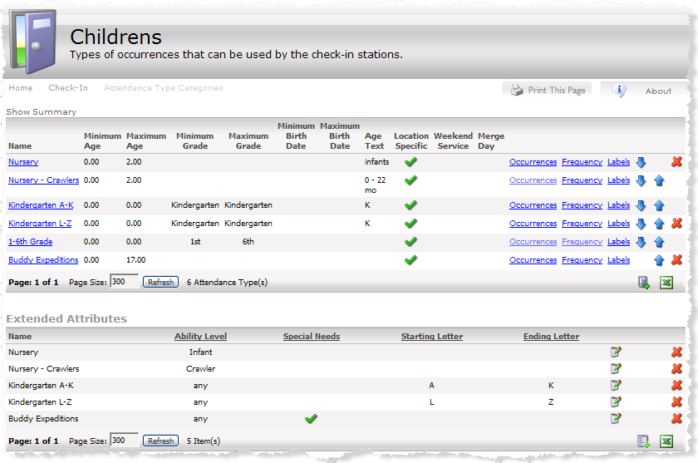

**Match from bottom to top**

Figure - Attendance Types with Extended Attributes listed below.

## What Check-in Looks Like

The flow of a family check in will look something like the following:

|  |  |
| --- | --- |
| **Pre Check-in** – count down until check-in start time. The background image is configurable to meet your needs. For Children’s ministries, we typically use a background that matches the theme of the children’s | guide_init_countdown.jpg |
| **Step 1 -** Once Check-In is active families will see this screen. Depending on your settings they can either scan an ID card or press the "Search By Phone" button on screen. | guide_init_scan_now.jpg |
| **Step 2** – if searching by phone | guide_family_search.jpg |
| **Step 3** –only shown if the family has more than one child | guide_select_family_member.jpg |
| **Step 4** – Only shown if enabled and the child is not already at the maximum ability level or not past the ability level age. The parent can set/recort the child’s ability level. Ability levels lesser than the child’s current level are not shown. See the “Configuring the Ability Level Lookup Type” section for information about how this works. | guide_select_ability.jpg |
| **Step 5** –only shown if there are multiple services (attendance type occurrences) in the system | guide_select_service.jpg |
| **Step 6 –** The confirmation screen provides an overview of who is being checked in, when and where. If somebody cannot be checked in then “Unavailable” will be displayed (along with a configurable message) instead of a room name. They also have a chance to press Cancel *to make changes to their selections* if necessary. | guide_confirm.jpg |
| **Step 7 – This final status screen will display any errors that may have occurred during check-in or printing of the labels. After a configured amount of time, this screen will automatically return back to the starting page.** | guide_results.jpg |

# Managing the Check-in System

## Setting Up a New “Class”

A “class” is simply an Attendance Type which occurs with a certain frequency (Ex., Sunday at 9am) in a particular location.

### Attendance Type

To set up a new class, create an Attendance Type as you normally would by specifying the class name, an age or grade range, a gender preference and a primary location as shown in Figure 2. Age values are always entered in years, so you will use “1.67” to represent 1 year 8 months (1 + 8/12).

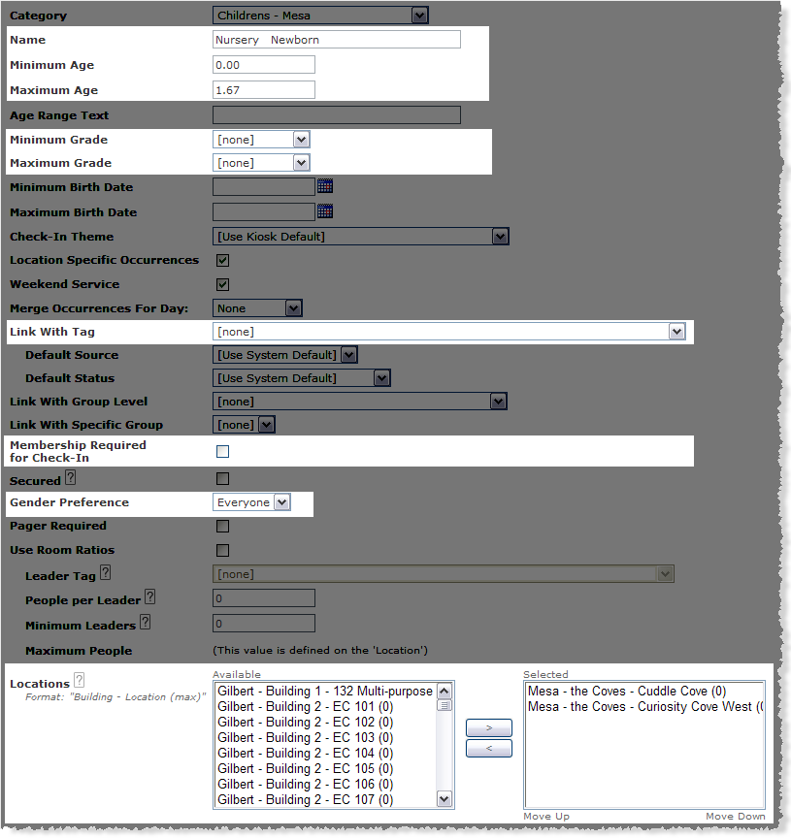

Figure – standard Arena Attendance Type

As of v1.1.0 if you want to limit a particular Attendance Type to only people who are “registered” you can use the **Link With Tag** or **Link With Specific Group**[[3]](#footnote-3) and check the **Membership Required for Check-In** checkbox. This is quite useful if you require that people pre-register for your Vacation Bible School (VBS) classes and only want registered kids to be able to check-in.

### Extended Attributes

Next, if additional filtering or room balancing is needed, create an Extended Attribute for the Attendance Type as shown in Figure 3. If this class will not use any special filtering this step may be skipped.

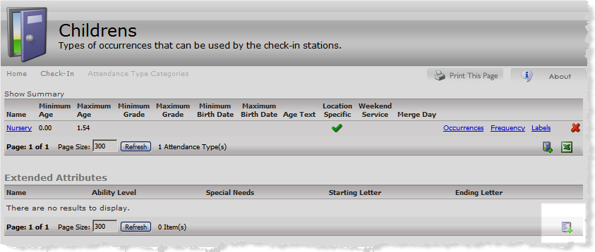

Click to add an Extended Attribute.

Figure – new, custom Extended Attribute List

Specify whether or not the class is for special needs children, optionally choose one or more ability levels, and specify a last name range if desired. As of v1.2.0, if you check the Room Balancing checkbox, each location specified for the Attendance Type will be used to automatically keep the class size balanced.

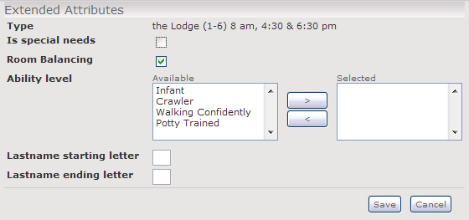

Figure - Extended Attributes for an existing Attendance Type

Now, children who have matching values will be eligible to attend this class.

Lastly, configure a frequency for occurrences of the Attendance Type.

## Realistic Classroom Setup

The following depicts an actual classroom configuration for the 9:30am service at the Central Christian Church Gilbert campus.

As you examine each row, remember that children are **matched from the bottom to the top**.

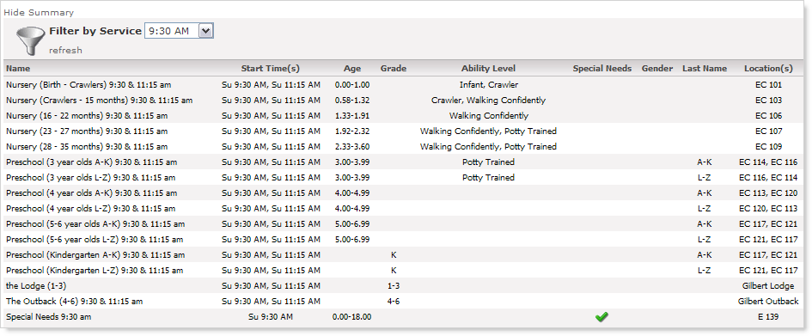

Figure - an example of a real Sunday morning class setup

Note that the Special Needs class covers a very broad age range, but because the Special Needs flag is set to true, only those kids who’s Special Needs flag (person attribute) is true will be matched to that classroom.

Note how several of the records have a second location listed. The second location is the alternate and is **only used** if the **primary location** is **closed**.

Note how the **age ranges in the first two rows overlap**. The second row will match children older than 7 months who are either crawling or walking and place them in room EC 103, while even children older than 7 months who are not crawling would be matched to the first row and be placed in room EC 101.

## Check-in For Multiple, Upcoming (Future) Services

If your church is like ours you might want to allow parents the option to check their children in for multiple services (such as the 9am service *and* the 11am service). We allow this primarily for the people who sit for one service and serve on campus for the second one.

In order for the check-in system to know about the future occurrences, we simply run an additional SQL Job using the standard core\_sp\_generate\_active\_occurrences procedure as described in the SQL Server Agent Jobs section (pg 27).

In this scenario where a child has been checked into multiple classes, our custom Print Label provider only prints *one* set of labels, however the “attendance label” includes a note indicating that the child is staying for two services. (See the Default Attendance Label section for details.)

## Standard Check-in Labels

The Check-In Wizard comes with a default component for printing check-in labels to label printers in the classrooms or at the kiosks as well as an alternative one that will work with Reporting Services. To switch to the Reporting Services component see the instructions in the section **Reporting Services Attendance Label**.

The Check-In Wizard’s printing functionality can be replaced by another community created component or your own by implementing our IPrintLabel provider. Refer to the *Central Christian Church Check-In Wizard Developer Guide* for additional details on creating new providers.

The default printer labels are a set of three labels (a nametag, a claim card, and an attendance label) and are shown below. This default provider also uses the default Security Code provider to generate the security token shown below.

Parts of the label can be customized. See Organization Settings - Cccev Check-in Labels (pg 21) for details.

### Default Attendance Label

Age Group

Services (string)

ServicesTitle

FullName

LegalNoteFlag

SelfCheckOutFlag

SecurityToken

HealthNotesTitle

ParentsInitialsTitle

***4th Grade***

Service: 4:30 PM

**Tommy Johnson**

**4236. \*!**

\_\_\_\_\_\_\_\_\_\_\_\_\_\_\_\_\_\_\_\_\_\_\_\_\_\_\_\_\_\_\_\_\_\_  
Parent’s Signature 6/30/2004

2”

2 ¼”

Claim Ticket .

6/30/04 3:59 PM

Services: 4:30 PM & 6:15 PM

Tommy  
4236

Present ticket to the classroom supervisor when picking up your child.

2’1/4

2’1/4

Health Notes: Take medication for Bipolar   
Disorder, also sensitive to heat at times.

AB

If attending multiple services, the attendance label prints like this:

***4th Grade***

**Tommy Johnson**

**4236. \*!**

\_\_\_\_\_\_\_\_\_\_\_\_\_\_\_\_\_\_\_\_\_\_\_\_\_\_\_\_\_\_\_\_\_\_  
Parent’s Signature 6/30/2004

Health Notes: Take medication for Bipolar   
Disorder, also sensitive to heat at times.

AB

*Transfer: 4:30 PM & 6:15PM*

Box around the event’s start times.

### Claim Card

2”

2 ¼”

**Claim Ticket** .

6/30/04 3:59 PM

Services: 4:30 PM & 6:15 PM

**Tommy**  
**4236**

Present ticket to the classroom supervisor when picking up your child.

**AB**

ClaimCardTitle

ClaimCardSubTitle

Date (current time)

Services (string)

ServicesTitle

First Name

SecurityToken

ClaimCardFooter

### Nametag

A name tag is to be printed as shown below. If the child’s birthday is in the upcoming week, the regular logo is to be replaced with a birthday cake logo and the day of the birthday.

2”:

2 ¼”

Room Name (optional)

Age Group

First Name

Last Name

Health Note Flag

Legal Note Flag

Self Check-Out Flag

LogoImageFile

BirthdayImageFile

Cake image w/day

of birthday (depending on child’s birthdate)

**Tommy**

**Johnson**

**4th Grade**

**\*!+**



Monday

**Room 3B**

## Reporting Services Attendance Label

The Reporting Services provider (added in v1.2.0) will work with the print labels included with Arena’s Check-In system out of the box. It integrates this functionality by passing the OccurrenceAttendanceID created when an attendee checks into the system to Arena Check-In’s Reporting Services report. Creating a custom label is as easy as copying the default Arena label and modifying it to fit your ministry needs.

To take advantage of this print provider simply set the appropriate module setting on the check-in wizard module configuration (see Module Settings).

Additionally, you’ll need to set up some Labels that are tied to each Attendance Type. From the Attendance Type List module, clicking on the “Labels” link will bring up the list of Labels associated with that Attendance Type.



When creating a new Label for an Attendance Type, you specify whether the print job should go to the Kiosk’s Default Printer or the Location’s Default Printer.

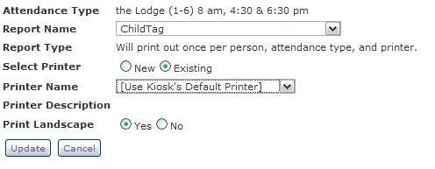

Figure - defining a label for an Attendance Type

As of version 1.3, the package also includes a few custom RDLs you can import into Reporting Services and use in place of the default Arena check-in labels:

|  |  |
| --- | --- |
| Figure - ChildNamtag.rdl | Figure - Roster.rdl |
| Figure - ClaimTicket.rdl | Figure - AdultNametag.rdl |

# Installation & First Time Setup

Unzip the CccevCheckinWizardPackage.zip to your desktop. You will use the items inside the zip during the instructions below. Also note the items listed in the Dependencies section of the Appendix.

## Pre Module Installation Steps

To install the Wizard you will need to execute the two SQL scripts found in the SQL folder:

1. cust\_cccev\_ckin\_install\_tablesAndProcs.sql – Execute this script first. It adds the required tables and stored procedures.
2. cust\_cccev\_ckin\_install\_data.sql – this script creates the necessary default data (Lookups, Person Attributes, Organization Settings, etc) used by the Check-in system.
3. As the Global Admin, go to the Person Attributes “Check-In” group and grant the proper roles view/edit access to the following new attributes:
   1. Ability Level
   2. Special Needs?
   3. Self Check-out?

## Check-In Wizard Module Installation Steps

1. Import the CheckinWizard\_Page.xml as a child page under your main Arena Check-In page.
2. Add the ~/UserControls/Custom/Cccev/Checkin/misc/BlankTemplate.ascx template (installed during the previous step) to your Template list under Administration. You can call it “Check-in Wizard Blank Template”
3. Next, change the Check-In Wizard page to use that new blank template.
4. Make a note of this pageID as you will point your kiosks to this page later.
5. This is a not a redundant step: import the CheckInWizard\_Page.xml modules under your Arena **Modules** area. Doing this will define additional modules that were not automatically defined during step 1.
6. (Optional) Setup the modules discussed in the section called (pg 28).
7. Setup the Check-In Wizard module settings as needed. These settings are described below.

## Module Settings

There are many configuration settings to help you control the behavior of the check-in system to match your church’s needs, however the system has many default values so you can get your system working without a lot of additional configuration.

| Setting | Description |
| --- | --- |
| Ability Level Attribute | Set this to be the Person **Attribute** that holds a person’s ability level. |
| Ability Level Lookup Type | Set this to be the **Lookup Type** that contains all the ability levels you want to use in the Check-in system. |
| Allow Scan By Phone | This controls whether or not you can search by phone number. |
| Asynchronous Timeout Error Message | The message to display if the client browser (kiosk) is unable to contact the server. |
| Auto Cancel/Confirm | Controls whether or not the system will perform auto-cancel and auto-confirm if the user stops interacting with the kiosk. |
| Auto Refresh Time (Long) | Time in seconds for the page to reload/reset if left inactive. |
| Auto Refresh Time (short) | Time in seconds for the system to auto cancel/confirm if no response is received. |
| Background Image Relative Path | Relative path for the init screen’s background image. |
| Bad Kiosk Message | Message to display if an unregistered kiosk attempts to access/use the Check-In Wizard. |
| CSS Relative Path | Relative path to custom CSS file for Check-In module. |
| Event is Closed Message | Message that is displayed on the kiosk when there are no open/active check-in occurrences. |
| Family Registration Page | Page setting to integrate High Desert Church’s Family Registration Module into the Check-In Wizard. If this is set to a page in Arena, pressing CTRL-SHIFT-R from within the Wizard will redirect to the configured page. |
| Ignore Check-In Start | If checked, this setting will allow members to check into services whose check-in start time has not occurred yet. Useful if members need to check their children into the service that they are attending as well as the service that they are volunteering at. |
| Kiosk Management Page | A page containing the KioskAdmin module which allows a kiosk to be registered with Arena and/or some details about the kiosk to be edited. Pressing CTRL-SHIFT-M from within the Wizard will redirect to the configured page. This is useful when setting up (or registering) new kiosks. |
| Label Print Provider | Controls which print label provider will be used when printing check-in labels. |
| Look Ahead Hours | Number of hours the check-in system should look ahead for occurrences. |
| Look Ahead Minutes | Combined with the previous setting, the number of minutes the check-in system should look ahead for occurrences. |
| Max Ability Level Age | Once a child reaches this age, the ability level selection screen will not be shown and the child will be automatically recorded at the max ability level. |
| Minimum Age | Minimum age of a child who can check in. |
| Maximum Age | Maximum age of a child who can check in. |
| Minimum Grade | Minimum grade of a child who can check in. |
| Maximum Grade | Maximum grade of a child who can check in. |
| Minimum Phone Number Length | Minimum number of digits that must be typed for a valid phone number search. |
| Maximum Phone Number Length | Maximum number of digits that can be typed before the system performs the search automatically (without the user pressing the “search” button). |
| No Eligible People for Check-in | Message to display when there are no family members eligible for check-in. |
| No Registered Occurrences Message | Message to show when no occurrences are available to check in. |
| Page Timeout | The amount of time in seconds before the system considers the check-in system to have timed-out. |
| Post-Check In Redirect Page | If set, the system will redirect to this page once the check-in process completes. Useful if you’ve integrated a Family Registration system with this check-in system and want to transfer control back to the Family Registration system after a family is checked in. |
| Relationship Type List | Allowable relationship types to check in. If the head of household has any relationships of these types, the associated people will be shown on the family member selection screen. |
| Require Attendee Abilities | Flag to control whether or not Ability Levels are used by the check-in system. |
| Scan Now Message | Text to show when check-in has started. |
| Search By Phone Message | Text to show on the search by phone button. |
| Special Needs | Set this to the person attribute that denotes whether or not a person has special needs. |
| Unavailable Occurrences Message | Message to display if no matching classroom was found for a child. |

## Organization Settings

There are a couple of categories of organization settings that are used by the Check-In Wizard. Each category and its corresponding settings are detailed below for your reference.

### Cccev Check-In Wizard

These settings are used by the Check-In Wizard Module to control how labels are printed, how security codes are determined, etc.

|  |  |
| --- | --- |
| Setting | Description |
| Cccev.AllowedInactiveReasons | This allows individuals whose record status is marked as inactive to check-in using the Check-in Wizard. LookupIDs from the Inactive Reasons lookup can be entered, separated by commas, to indicate which inactive records will be allowed to check-in. If this organization setting is empty or does not exist then inactive records will not be allowed to check-in at all. |
| Cccev.SecurityCodeDefaultSystemID | Lookup ID for CheckIn Security Code provider class. |
| GradePromotionDate | Used to determine the date which children are promoted to the next grade level (mm/dd). Default 6/1. |

### Cccev Check-in Labels

These settings control some of the properties of the standard check-in labels which are used by the default supplied IPrintLabel provider, CccevPrintLabel.

| Setting | Description |
| --- | --- |
| Cccev.AttendanceLabelTitle | The title to use on the Attendance label |
| Cccev.BirthdayImageFile | Image (.bmp) to use on the Nametag label to indicate a person's birthday occurs that week. E.g., "C:\Inetpub\wwwroot\images\cake.bmp" |
| Cccev.ClaimCardFooter | Text to use on the footer of the Claim Card. E.g., "Present this ticket when picking up your child." |
| Cccev.ClaimCardTitle | The title to use on the Claim Card label. E.g., CLAIM TICKET |
| Cccev.DisplayRoomNameOnNameTag | Set to “true” to print the room name on the nametag; otherwise set to “false” |
| Cccev.HealthNotesAttributeID | The attribute ID (string type attribute) that holds a person's health notes. |
| Cccev.HealthNotesTitle | Text to use in front of any health notes on the Attendance label. |
| Cccev.LegalNotesAttributeID | The attribute ID (string type attribute) that holds a person's legal/custody details. |
| Cccev.LogoImageFile | Logo (.bmp) to use on the Nametag label. E.g., "C:\Inetpub\wwwroot\images\logo.bmp" |
| Cccev.ParentsInitialsTitle | Text to use on the Attendance label where a parent can sign. E.g., \_\_\_\_\_\_\_\_\_\_\_\_\_\_\_\_\_\_\_\_\_\_\_\_\_\_\_\_\_\_\_\_\_\_Parent's Signature |
| Cccev.SelfCheckOutAttributeID | The attribute ID (yes/no type attribute) that indicates whether or not a person is allowed to self check-out. |
| Cccev.ServicesLabel | Text to use in front of the services/occurrence times. E.g., "Services:" |

## Configuring the Ability Level Lookup Type

The installation script adds four default lookup values (ability levels) to the Ability Level Lookup Type, but these can be renamed (or removed) to suite your needs. They are optionally defined to Attendance Type Extended Attributes to determine which children should be matched to the Attendance Type.

|  |  |
| --- | --- |
| Ability Level Lookup Type Values | Description |
| Infant | Newborns who really do nothing more than look cute. |
| Crawler | Little ones who have learned the art of hand-knee locomotion. |
| Walking Confidently | Children who need to be more closely monitored. |
| Walking and Potty Trained | Children who need less monitoring and know when to get to the bathroom. |

If you enable the “Require Attendee Abilities” module setting the check-in system will examine the ability level of each child who was selected for check-in and prompt the parent to set the child’s current ability level (until the child has the max level or the child’s age is greater than the “Max Ability Level Age” module setting). It does this by listing all ability levels which are **greater or equal to** the child’s current ability level. This way, over time, the presented list continues to shrink until only two choices remain. Once the child’s ability level is set to the maximum (the last one in the list) the system will no longer request this information be set.

## Person Attributes: Ability Level, Special Needs, Self Check-Out

The installation script adds three new person attributes to the “Check-in” attribute group: Ability Level, Special Needs, and Self Check-Out. Each is described below.

|  |  |
| --- | --- |
| Attribute | Description |
| Ability Level | A lookup value which is intended to hold the child’s current ability level such as infant, crawler, walking confidently, etc. The ability levels are used in the Attendance Type’s Extended Attributes to match children to the right classroom. They can be changed to suite the needs of your church as described in the previous section. |
| Special Needs | A yes/no flag that indicates whether the child is a “special needs” child (learning disability, autism, etc.) This attribute is used in the Attendance Type’s Extended Attributes to match children to the right classroom. |
| Self Check-Out? | A yes/no flag that indicates whether or not the child is able to check themselves out without their parent. This value is only used by the default check-in label provider. |

Once configured, the administrators with the proper role will see these new attributes when viewing a child’s record in Arena.

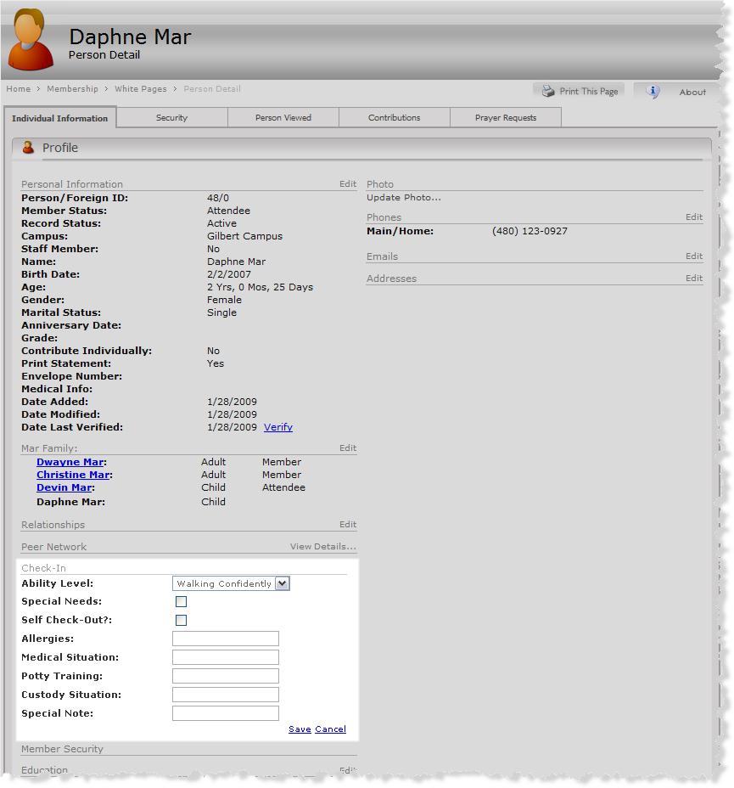

Figure - Person Details showing Check-in Person Attributes

## Locations Setup

The default print provider prints a set of three check-in labels in the classroom or at the kiosk; therefore a printer must be defined in each Location. This also means you will need to define your printers on your Arena server (unless you have a remote print server in the classroom attached to the printer). As of v1.2.0, if you name your printer “[Kiosk]” the labels will print at the kiosk.

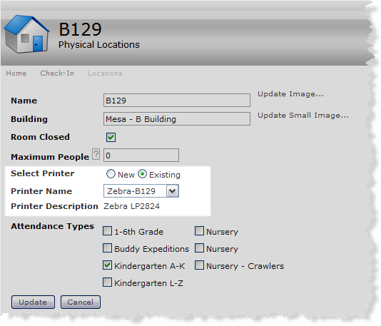

Printer name must match name as defined on the server.

Figure - Location Details with local zebra printer

Alternatively, if you define the printers on a remote server, you will use the standard “\\*<server\_name>*\*<printer\_share\_name>*” notation in the printer name of the location details panel.

Note: Generally speaking, this sort of remote print configuration will be **much, much** slower than if you defined the printers locally on the server (and have the server communicate with remote network print servers).

## Kiosk Setup

In order to register your kiosk for use with the Check-In Wizard, you will need to run either the Arena standard check-in application at least once or visit the Kiosk Management page (new as of v1.3) from the kiosk. (See the Kiosk Management Page section for more details.)

If you’ve configured the Check-In Wizard with the Kiosk Management page you can simply press “CTRL-SHIFT-M” from the Kiosk. That page will allow you to register the kiosk’s information as an item in the Arena Kiosk list.

Once the system is defined there you can bind the kiosk to your locations as needed. If you are operating in a multi campus environment, this is where you control which kiosks are used for the check-in locations of each campus.

Lastly, you’ll probably want to configure Internet Explorer to run in kiosk mode and point it to the Arena page which holds the Check-In Wizard as such:

C:\Program Files\Internet Explorer\iexplore.exe -k <http://arena/default.aspx?page=9999>

## Installing Custom Reporting Service Labels

As of v1.3, some custom labels are included in the package. You will find these under the ReportingServices folder. Follow these steps if you wish to install them into your environment:

1. In order to use the ChildNametag.rdl you must open it and modify the SQL query it performs. At the bottom of the query are two person attributes – these must be updated to use the proper attribute ID numbers on your system.
2. Each of the 4 RDL files must be loaded into your Reporting Services **server**. This can usually be accessed via <http://localhost/reports>. They should go in the /Arena/CheckIn/ folder.
3. Execute the cust\_hdc\_funct\_calc\_age.sql and cust\_hdc\_funct\_parent\_names.sql scripts **into your Arena database** to install the required SQL functions.
4. Follow the instructions in the Reporting Services Attendance Label section of this document to attach your labels to attendance types.

# Other Things to Consider

As mentioned earlier, we have a few other things to help manage the system. They are detailed in this section.

## SQL Server Agent Jobs

### Create occurrences (2 hours future)

This job creates the future occurrences that are needed for the Sunday morning and Saturday/Sunday night services. We only run it Sunday morning every 30 minutes from 7 to 9:30 AM and then on Saturday and Sunday night from 4 to 5 PM.

declare @TwoHoursFromNow datetime

set @TwoHoursFromNow = DATEADD( mi, 120, getdate() )

exec core\_sp\_generate\_active\_occurrences @TwoHoursFromNow, 30, 'OccurrenceGenerator2'

### Check-in Reset Security Codes

This job resets the numeric portion of our default Security Code provider (the records in the cust\_cccev\_ckin\_security\_code table) by running the cust\_cccev\_ckin\_sp\_update\_security\_code\_clearAssignDate procedure on Friday at 5 PM.

## Other Custom Administrative Modules

This section documents various supporting custom modules which are useful in administering the Check-In system.

### Kiosk Management Page

As of version 1.3, a page which includes our custom Kiosk Admin module is created when you install the system. This module allows a new kiosk to be registered in Arena and provides very limited edit capability of the kiosk. For anything beyond what is provided by this module please use Arena’s Kiosk administration feature.

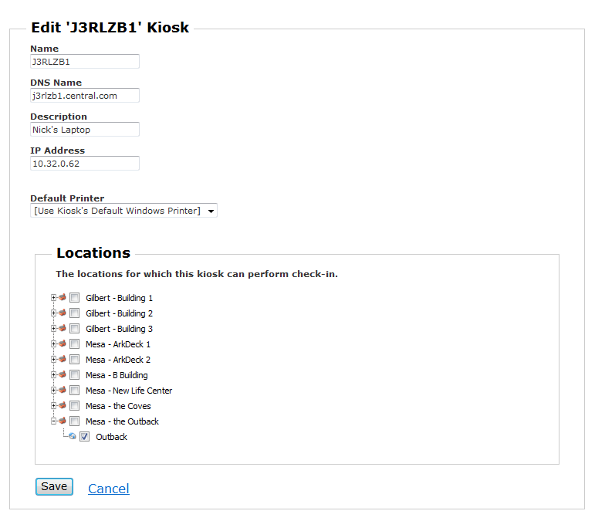

### Attendance Type List Summary

This module provides a summary view of Attendance Types and associated Extended Attributes. You’ll want to place this module at the top of your standard Attendance Types page (pageID 1432).

Using the “Show Summary” link, an alternate view shows the essential Attendance Type criteria along with the classroom locations as shown in Figure 14.

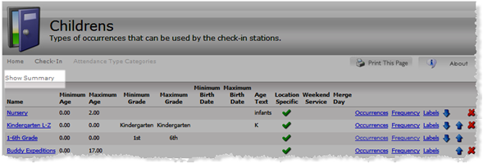

Click to display an alternate summary view

Figure - Show Summary link

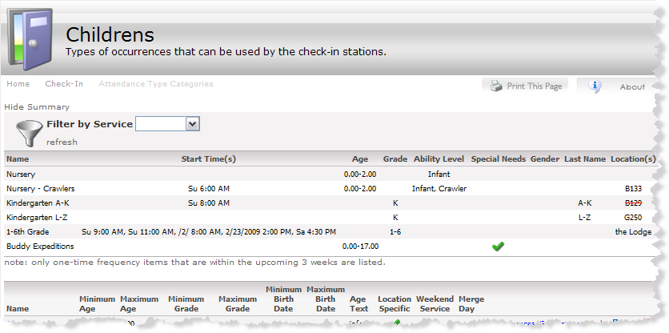

Figure – Consolidated view of Attendance Types, Extended Attributes, and Locations

The summary can also be filtered by the frequency start time. Locations which are closed will appear with a red line though them.

### Occurrence Type Attribute List

The Occurrence Type Attribute List shows an ordered list of all corresponding Extended Attributes for the *ordered* list of Attendance Types. You’ll want to place this module at the bottom of your standard Attendance Types page (pageID 1432).

Using this module you create the extended attributes (ability level, special needs, last name range) for a particular Attendance Type.

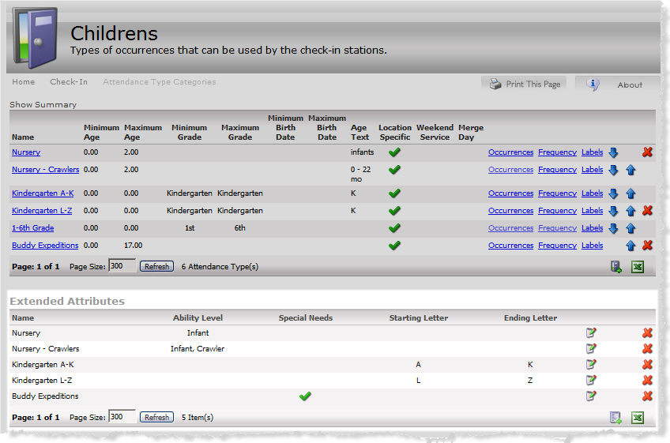

Figure - Occurrence Type Attribute List (Extended Attributes) Module

### Move Attendance

The move attendance module is nice to have if you have the need to move all the attendance records from one occurrence to another (when you want to delete the old attendance types/occurrences but don’t want to lose the attendance records tied to them).

You’ll typically want to put this module on the Attendance Occurrence page (pageID 1115). It appears as a small “Move Attendance” button as shown in Figure 16.

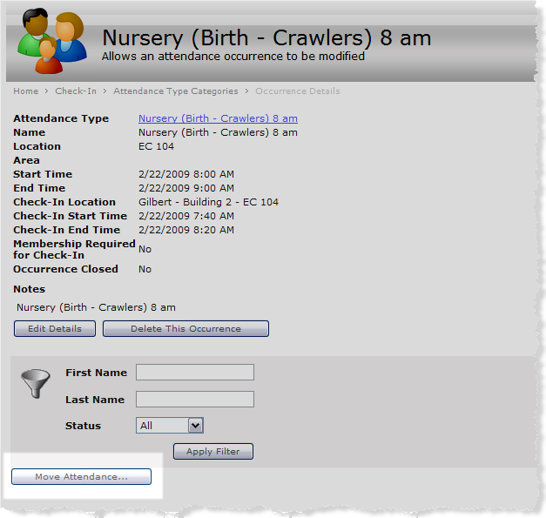

Figure - Attendance Occurrence page with the Move Attendance module

After pressing the button you can then select the new, target Attendance Type and its corresponding Occurrence to designate where you want to move the attendance records.

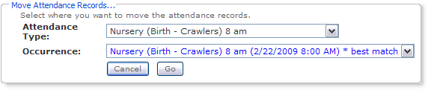

### Test Printer Labels

This utility module lets test label printing to one or more printers at the same time. Once you’ve selected some printers, you can print a single “test” label, individual parts of the label set, or if you provide a personID you can print an actual label set using your configured IPrintLabel provider.

You can install this page and module (TestPrinterLabels\_Page.xml) underneath your main Arena Check-in tab.

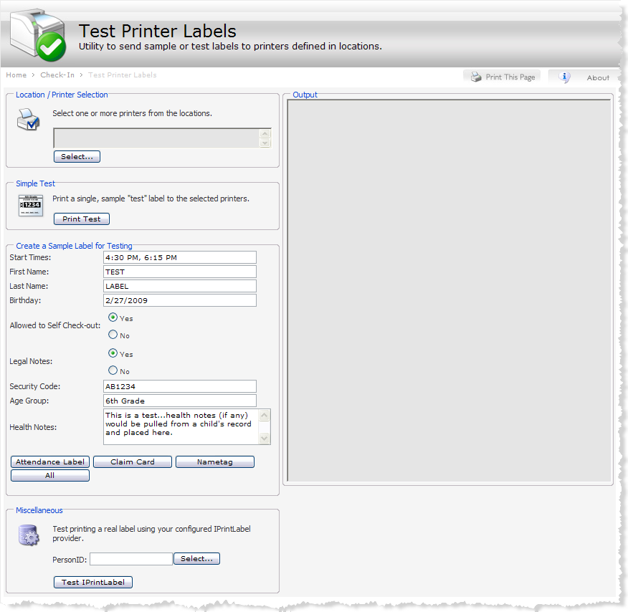

Figure - the Test Printer Labels module

# Appendix

## Arena Dependencies

The following Arena configurations are required in order for the system to work

1. Set the “GradePromotionDate” Organization setting

## Defining New Custom IPrintLabel Providers

1. Edit the “CheckIn Print Label System” Lookup Type and add your own lookup. Put the value of your namespace and fully qualified classname into the respective fields. Make note of the ID of this new lookup.
2. To use a new label provider simply change the value in the appropriate module setting (see Module Settings).

## Defining New Custom Security Code Provider

1. Edit the “CheckIn Security Code System” Lookup Type and add your own lookup. Put the value of your namespace and fully qualified classname into the respective fields. Make note of the ID of this new lookup.
2. Change the value in the SecurityCodeDefaultSystemID Organization setting to be the ID of the new lookup.

## Logging

As of v1.2.0, the attendance type (class) matching process can be logged to the database for troubleshooting purposes. To enable logging, change the value of the IsEnabled qualifier of the Cccev App Log Type -> Check-in lookup to true. The cust\_cccev\_applog table will hold an entry for each child being checked in to the system as seen in this example:

Attendee: 78829 - Maddox White Attempting match: 6:30 PM (24) the Lodge (1-6) 8 am, 4:30 & 6:30 pm Attempting match: 6:30 PM (24) the Lodge (1-6) 8 am, 4:30 & 6:30 pm Attempting match: 6:30 PM (155) Preschool - Kindergarten 6:30 pm Attempting match: 6:30 PM (154) Preschool - 3, 4, 5 & 6 year olds 6:30 pm Attempting match: 6:30 PM (95) Nursery (19 - 35 months) 4:30 & 6:30 pm - Matched Age, Grade, Gender - FOUND MATCH!

## Reference

See the *Central Christian Church Check-In Wizard Developer’s Guide* for additional details not covered in this manual.

1. as of version 1.3.0 [↑](#footnote-ref-1)
2. as of version 1.1.0 [↑](#footnote-ref-2)
3. as of version 1.3.0 [↑](#footnote-ref-3)