Family Registration Module
Version 1.0
Daniel Hazelbaker @ High Desert Church
08/04/2009

Table of Contents
Configuration 3
Module Settings 3
Add More Count 3
Allow Searching 3
Country Code 3
Email Family Roles 4
Field Security 4
Friend Relationship 4
Grade Family Roles 5
New Family Size 5
New Member Campus 5
New Member Status 6
Person Attributes 6
User Interface 7
Searching For Families 7
Search Results 7
Family Information 8
Person Attributes 9
Add Family Friend 9
Support 11
Arena Versions 11
Known Bugs 11

Configuration

Module Settings

Add More Count

This option determines the number of blank family member positions that will be added each time the “Add More” button is clicked when adding a new family. If this setting is left blank, the default of “2” will be used.

Allow Searching

If this option is turned on then people will be allowed to search for, and edit, existing families. If this option is off then users will only be able to add new families and not update existing families; including those just created if they need to fix a typo.

Country Code

You may enter your country code here to have your country automatically selected when entering a family’s address. If this field is left blank then no default country will be selected and you will be required to select one each time. I highly recommend entering your country code.

Email Family Roles

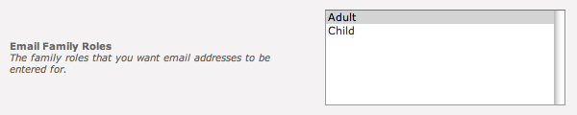

Select which family roles will be provided with a space to enter their e-mail address. The module will automatically show and hide the e-mail address field at runtime depending on the family role for that person.

Field Security

Enable field level security. If set to false then anybody who has access to this module may modify every field made available to them. If this setting has been set to true then each time a field is going to be updated the module will verify the user has permission to edit that field. This setting also enforces the View permissions, so if the user does not have view permissions to an item (or person attribute) they will not be able to even see the current value.

Friend Relationship

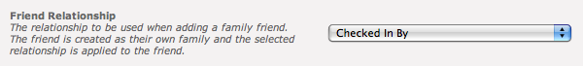

This option enables an "Add Family Friend" link on the edit family screen. To enable this, create a relationship called "Can Checkin" with an inverse relationship of "Checked In By" in your system (note: if using CCCEV's check-in you can call these relationships anything you want). This option will then allow quick entry of a family friend to be checked in and will automatically assign the appropriate relationships (the relationship selected here will be applied to the friend entered on the page, and the inverse relationship will be applied to the head of the family currently being edited). These are used in conjunction with the Check-In applications to let you enter your phone number and see not only your own children but any children you have permission to check-in.

Grade Family Roles

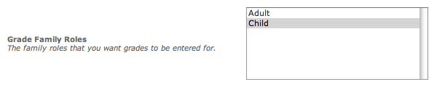

Select which family roles will be provided with the space to enter their grade. If you have not customized your family roles then you should select Child only. The module will automatically show and hide the grade drop down list depending on this setting and what family role is currently selected for an individual. Only the grade can be entered, not a graduation year.

New Family Size

When adding a new family, space is provided for this many people in the family. If no value is entered then the default value of 4 is used. If the user needs to enter more family members than space has been provided for they will need to use the Add More button to provide more space. If you commonly have to enter families with more than 4 individuals then you may want to increase this value.

New Member Campus

This setting controls which campus new individuals are to be assigned to when they are created. There is no place to override this at runtime if you have people from different campuses using this module, you should build a set of pages for each campus with the module set for the appropriate campus.

New Member Status

When a new individual is created their member status will be set to this value. There is no place to override this at runtime.

Person Attributes

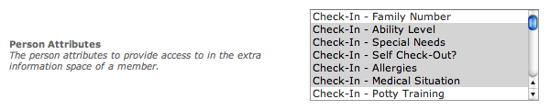

You may select as many or as few person attributes as you wish to be available. These attributes are accessed by clicking on the blue info button to the right of each individual.

Note: Not all attribute types are currently supported as of this writing.

User Interface

Searching For Families

If the Allow Searching module setting has been turned on then you will be presented with a Find Family panel. You can search by name or by phone number, but not both at the same time. If you enter both a name and phone number it will search only by name.

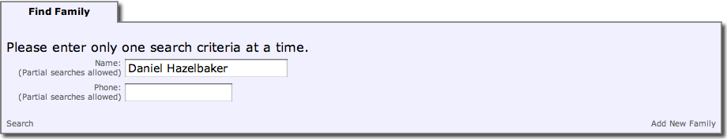

The module allows you to search by partial matches. So you can enter a partial name or phone number. If you search for a one-word name it will search by both first name and last name and list results that match what you entered to either first name or last name.

If you enter two words (as shown above) it will split the string by the space character and search using first name as the first word and last name as the second word. Partial searches in this manner are still supported, so if you enter “Dan Haz” it would still match my record.

This panel also allows you to add a new family by clicking the Add New Family link in the lower right corner of the panel. This will hide the Find Family panel and show the Family Information panel with blank entries ready to be filled in.

Search Results

After searching you will see a screen with the Find Family panel collapsed and a new Search Results panel shown. If the person you are looking for is not listed you may click on the Find Family panel to expand it and either search again or add a new family.

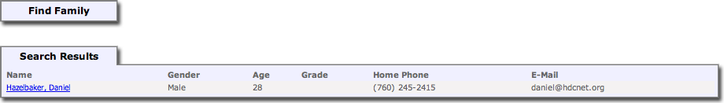

The results panel shows some minimal information about each person to help you determine if that is the person you are looking for. If a phone number is marked as unlisted then (unlisted) will be displayed instead of the actual phone number.

When you have found the person you are looking for you may click on their name to view and/or begin editing the family information via the Family Information panel.

Note: As of this writing there is no paging, so if you do a search that matches 1,000 records then all 1,000 records will be displayed. I do not recommend large searches.

Family Information

By either searching for a person by name or by selecting the Add New Family link in the search panel you will be taken to the Family Information panel. If you need to begin another search or begin adding a new family you can click the Find Family panel header to expand that panel.

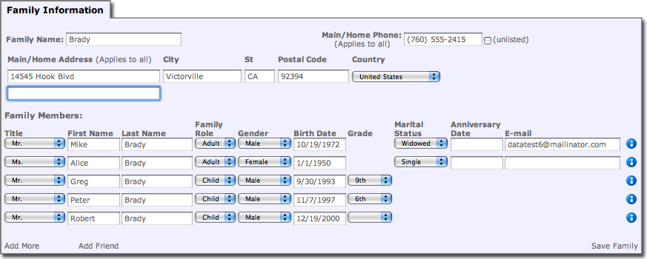

The Family Information panel allows you to either edit or add new family information. There are no “required” fields currently. Phone number and Address are not required to save. Family name must be entered, though currently it will not require it and I do not honestly know what will happen if you leave it blank.

When you click the Add More link to get more family members to enter information for the Family Name value will be automatically used for the Last Name of the new individuals. All individual rows are ignored unless both a First Name and Last Name are supplied.

If Family Role is set to Adult then the Marital Status and Anniversary Date fields will be available, otherwise they will not show up. The Grade and E-mail fields will show or hide automatically depending on the module settings Email Family Roles and Grade Family Roles.

Person Attributes

If you click the blue information icon to the right of the individual row then you will gain access to person attributes that have been selected in the module’s Person Attributes setting.

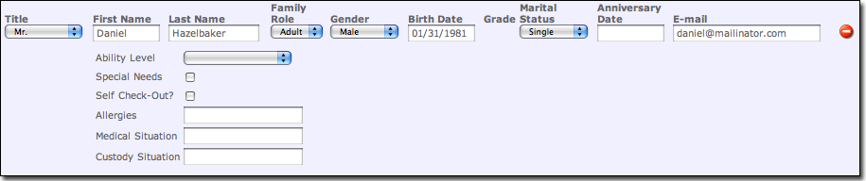

This area provides a place to edit information that is less common. As of this writing only some attribute types are supported (Text fields, Check boxes, drop down lists, date fields). In later versions this area will be improved to support things like personal phone numbers.

After you are done making changes in this section you can click the red minus icon to collapse the information back into the individual.

Add Family Friend

If the module setting Friend Relationship has been set then when editing an existing family, there is a link at the bottom of the Family Information panel called Add Friend. Clicking this link will bring up the Add Family Friend panel which will let you add a new record to the system and mark them as a friend of the family.

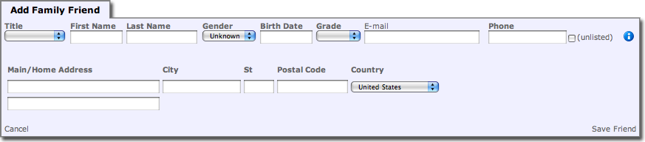

The same rules apply to adding a family friend as they do for adding or editing a person above. For security reasons, there is no way to add an existing record to the system by searching for it and having the relationship added. You must add a new record and then follow whatever procedures your church has in place for determining if the records should be merged together.

After you click the Save Friend link the record will be created and the appropriate relationship setup between the friend and the family being edited. The Add Family Friend panel will then re-appear with all the fields blanked out, ready to add another friend. A message will appear at the top of the panel informing you that the friend has indeed been saved successfully. When you are done adding friends you may click the Cancel link to close the panel.

Support

Arena Versions

This module has been tested and known to work on 2008.3.100 and 2009.1.100.

Known Bugs

- Fields that should be required in Family Information may currently be left blank. The Family Name should either be required or automatically use the last name of the first person listed in the family.
- Entering a birth date with a 2-digit year causes a JavaScript exception, which will prevent the save from completing, it will also leave the page in a state where you can not fix the problem and click Save again. This is a known bug to Arena’s Portal DLL and they have a fix planned for 2009.1.200 that we have already verified will fix the problem. Current work-around is to either enter dates as 4-digit years or click Add More if the Save button has already been clicked.

