HDC Check-in Modules
Version 2.2
Daniel Hazelbaker @ High Desert Church
07/05/2011

Table of Contents

Installation 5
Import Arena Pages 5
Pages 5
Modules 5
Run SQL Scripts 5
Set Required Module Settings 5
Family Registration 7
Overview 7
Configuration 7
Module Settings 7
Add More Count 7
Allow Searching 7
Country Code 8
Email Family Roles 8
Field Security 8
Friend Relationship 9
Grade Family Roles 9
Member Phone Types 10
New Family Size 10
New Member Campus 10
New Member Status 11
Person Attributes 11
Source ID 12
Status ID 12
User Interface 13
Searching For Families 13
Search Results 13
Family Information 14
Person Attributes 15
Add Family Friend 15
Attendance Overview 17
Overview 17
Configuration 17
Module Settings 17
Attendance Detail Page 17
Default Attendance Group 17
User Interface 17
Filter 18
Total Attendance 18
Location Results 18
Occurrence Results 19
Close Occurrences 20
Attendance Details 21
Overview 21
Configuration 21
Module Settings 21
Ability Level Attribute 21
Campus 21
Default Attendance Group 22
Display Group ID 22
Person Detail Page 22
Topic Area 22
User Interface 23
Filter 23
Attendees 23
Display Board 25
Overview 25
Configuration 25
Module Settings 25
Campus 25
Topic Areas 25
User Interface 26
Checkin Number Board 28
Overview 28
Configuration 28
Module Settings 28
Campus 28
Topic Area 28
User Interface 29
Numbers 29
Post Number 29
Frequency Locations 30
Overview 30
Configuration 30
Module Settings 30
SQL Server Agent 30
User Interface 31
Locations 31
Edit Locations 31
Family Numbers 33
Overview 33
Configuration 33
Arena Setup 33
SQL Server Agent 34
CCCEV Check-in 34
Service Builder 36
Overview 36
Configuration 36
Module Settings 36
User Interface 36
Service Information 36
Service Layout 36
Attendance Types 37
Locations 37
Build Service 37
Support 38
Arena Versions 38
Known Bugs 38
Family Registration 38
Frequency Locations 38

Installation

Import Arena Pages

Pages

To begin the installation of the HDC Check-in Modules, go to your Arena Administration section and enter the Pages module. Navigate to your Check-In page. This is usually page #1430. Click over to the Child Pages tab and click the Choose File button. Find and select the HDCCheckinModules.xml file that came with this bundle. Click the Upload button to have Arena begin importing the modules and pages.

Upgrade Notes: If you are upgrading from a previous version and already have these pages, you still need to perform this step. You may do this import anywhere and then delete the new pages after the import is done. This step is needed for Arena to import certain files that have been updated.

Modules

Next go to the Arena Administration section and enter the Modules page. At the bottom of the list click the Choose File button. Find and select the same HDCCheckinModules.xml file that came with the bundle. Click the Upload button to have Arena import the final modules. This step is required to import extra modules that are not included on the imported pages above.

Run SQL Scripts

Before you can configure the new modules you must run the SQL scripts. If this is your first time installing this package, run all the SQL scripts in version order. If you are upgrading from a previous version run all the SQL scripts, in version order, after the version you are currently running. If you are not sure which version you have, it should be safe to re-run all the scripts.

NOTE: Not every release will have a new script. For example the 2.1 release does not make any changes to the database, therefore there is only the 2.0 script and not a 2.1 script.

Set Required Module Settings

Before you can use the Manage Display Board or the Display Board pages you must set the Topic Area and Topic Areas settings respectively. If you do not plan to use either of these modules (they are used together as a pair) then you can either delete these two pages or mark them both as not displayed in navigation.

Family Registration

Overview

The Family Registration module was built to provide our check-in volunteers a quick and easy way to register new or visiting families in our system. Our check-in system is Web based (see CCCEV’s check-in system for details) and our computers are Mac, so using the Arena Family Registration application was not an option.

The concept of this module is to get a visiting family into the system as quickly as possible so they can get into church with very little delay. As such, the information gathered is extremely limited. A family is more likely to be annoyed at having to sit and answer a bunch of personal questions on their first visit than they are after they have come a few times and have been asked to provide more information. Therefore, we chose to limit the information displayed.

Configuration

Module Settings

Add More Count

This option determines the number of blank family member positions that will be added each time the “Add More” button is clicked when adding a new family. If this setting is left blank, the default of “2” will be used.

Allow Searching

If this option is turned on then people will be allowed to search for, and edit, existing families. If this option is off then users will only be able to add new families and not update existing families; including those just created if they need to fix a typo.

Country Code

You may enter your country code here to have your country automatically selected when entering a family’s address. If this field is left blank then no default country will be selected and you will be required to select one each time. I highly recommend entering your country code.

Email Family Roles

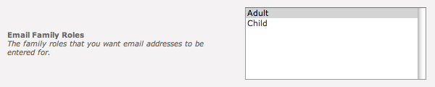

Select which family roles will be provided with a space to enter their e-mail address. The module will automatically show and hide the e-mail address field at runtime depending on the family role for that person.

Field Security

Enable field level security. If set to false then anybody who has access to this module may modify every field made available to them. If this setting has been set to true then each time a field is going to be updated the module will verify the user has permission to edit that field. This setting also enforces the View permissions, so if the user does not have view permissions to an item (or person attribute) they will not be able to even see the current value.

Friend Relationship

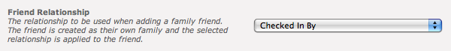

This option enables an "Add Family Friend" link on the edit family screen. To enable this, create a relationship called "Can Checkin" with an inverse relationship of "Checked In By" in your system (note: if using CCCEV's check-in you can call these relationships anything you want). This option will then allow quick entry of a family friend to be checked in and will automatically assign the appropriate relationships (the relationship selected here will be applied to the friend entered on the page, and the inverse relationship will be applied to the head of the family currently being edited). These are used in conjunction with the Check-In applications to let you enter your phone number and see not only your own children but also any children you have permission to check-in.

Grade Family Roles

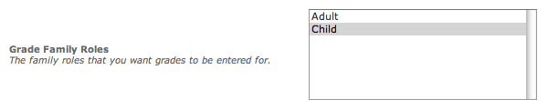

Select which family roles will be provided with the space to enter their grade. If you have not customized your family roles then you should select Child only. The module will automatically show and hide the grade drop down list depending on this setting and what family role is currently selected for an individual. Only the grade can be entered, not a graduation year.

Member Phone Types

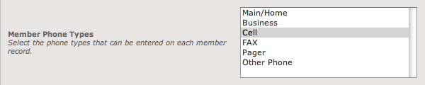

You can select which phone types to be available with the other member attributes. This will allow you to set specific phone numbers for each individual family member.

New Family Size

When adding a new family, space is provided for this many people in the family. If no value is entered then the default value of 4 is used. If the user needs to enter more family members than space has been provided for they will need to use the Add More button to provide more space. If you commonly have to enter families with more than 4 individuals then you may want to increase this value.

New Member Campus

This setting controls which campus new individuals are to be assigned to when they are created. There is no place to override this at runtime if you have people from different campuses using this module, you should build a set of pages for each campus with the module set for the appropriate campus.

New Member Status

When a new individual is created their member status will be set to this value. There is no place to override this at runtime.

Person Attributes

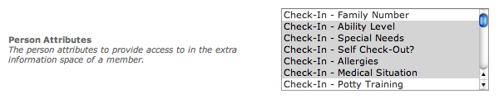

You may select as many or as few person attributes as you wish to be available. These attributes are accessed by clicking on the blue info button to the right of each individual.

Note: Not all attribute types are currently supported as of this writing. Test before you deploy to be sure the attributes you selected are supported.

Source ID

This specifies the Profile Source used when adding a person to a tag. The Profile Source is used to identify how a person became a member of a tag and its value will depend on the setup of your Arena server. As an example value, however, you might create a lookup value of “Check-in” to distinguish the fact that this person was added at a check-in kiosk.

If you enable the Source ID setting and the Status ID setting (see below) then your users will be able to modify the tag membership of a person. This is especially useful if you use Require Membership during check-in so that new people can be added to the proper tag and check-in.

When both settings have valid lookups associated with them, a new icon () will appear on existing person records. Clicking this icon will allow you to remove the person from tags as well as add them to new tags. When adding a new family or new people to an existing family this icon will not appear until you click Save Family.

Note: Due to this, in order to edit the tag membership when adding a family friend to a family, you will need to save the family friend and then search for and edit their record before you can click the tag icon.

Status ID

This specifies the Status of the person when they are added to a tag. Generally you will probably want to select the Connected value so that they are fully connected to the tag. For further discussion on this value see the Source ID section above.

User Interface

Searching For Families

If the Allow Searching module setting has been turned on then you will be presented with a Find Family panel. You can search by name or by phone number, but not both at the same time. If you enter both a name and phone number it will search only by name.

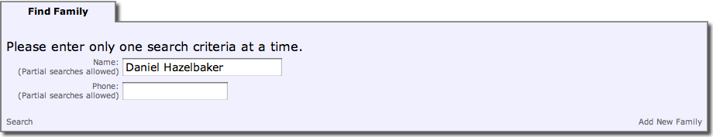

The module allows you to search by partial matches. So you can enter a partial name or phone number. If you search for a one-word name it will search by both first name and last name and list results that match what you entered to either first name or last name.

If you enter two words (as shown above) it will split the string by the space character and search using first name as the first word and last name as the second word. Partial searches in this manner are still supported, so if you enter “Dan Haz” it would still match my record.

This panel also allows you to add a new family by clicking the Add New Family link in the lower right corner of the panel. This will hide the Find Family panel and show the Family Information panel with blank entries ready to be filled in.

Search Results

After searching you will see a screen with the Find Family panel collapsed and a new Search Results panel shown. If the person you are looking for is not listed you may click on the Find Family panel to expand it and either search again or add a new family.

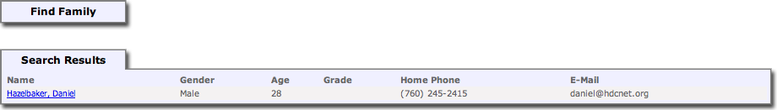

The results panel shows some minimal information about each person to help you determine if that is the person you are looking for. If a phone number is marked as unlisted then (unlisted) will be displayed instead of the actual phone number.

When you have found the person you are looking for you may click on their name to view and/or begin editing the family information via the Family Information panel.

Note: As of this writing there is no paging, so if you do a search that matches 1,000 records then all 1,000 records will be displayed. I do not recommend large searches.

Family Information

By either searching for a person by name or by selecting the Add New Family link in the search panel you will be taken to the Family Information panel. If you need to begin another search or begin adding a new family you can click the Find Family panel header to expand that panel.

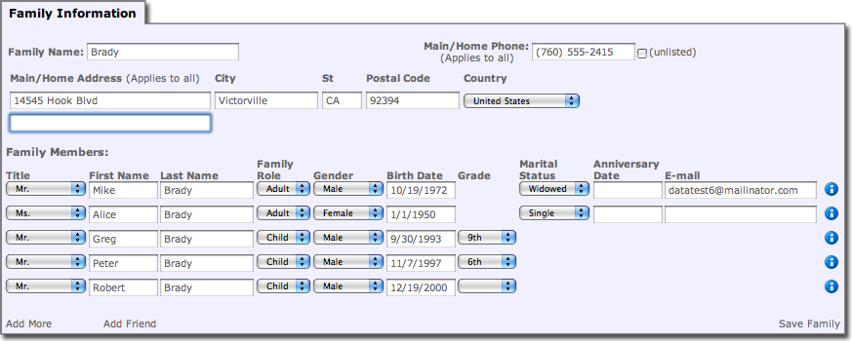

The Family Information panel allows you to either edit or add new family information. There are no “required” fields currently. Phone number and Address are not required to save. Family name must be entered, though currently it will not require it and I do not honestly know what will happen if you leave it blank.

When you click the Add More link to get more family members to enter information for the Family Name value will be automatically used for the Last Name of the new individuals. All individual rows are ignored unless both a First Name and Last Name are supplied.

If Family Role is set to Adult then the Marital Status and Anniversary Date fields will be available, otherwise they will not show up. The Grade and E-mail fields will show or hide automatically depending on the module settings Email Family Roles and Grade Family Roles.

Person Attributes

If you click the blue information icon to the right of the individual row then you will gain access to person attributes that have been selected in the module’s Person Attributes setting.

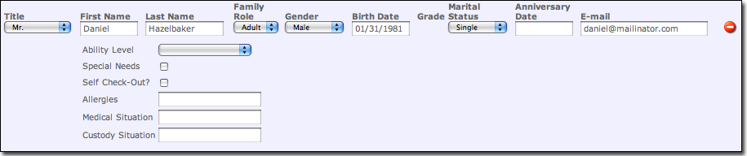

This area provides a place to edit information that is less common. As of this writing only some attribute types are supported (Text fields, Check boxes, drop down lists, date fields). In later versions this area will be improved to support things like personal phone numbers.

After you are done making changes in this section you can click the red minus icon to collapse the information back into the individual.

Add Family Friend

If the module setting Friend Relationship has been set then when editing an existing family, there is a link at the bottom of the Family Information panel called Add Friend. Clicking this link will bring up the Add Family Friend panel which will let you add a new record to the system and mark them as a friend of the family.

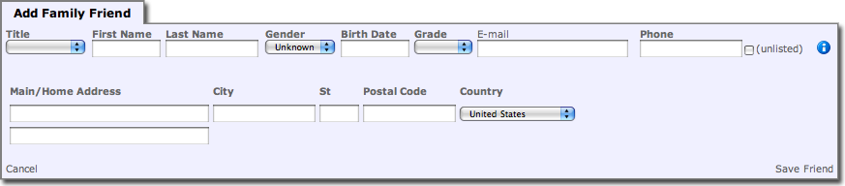

The same rules apply to adding a family friend as they do for adding or editing a person above. For security reasons, there is no way to add an existing record to the system by searching for it and having the relationship added. You must add a new record and then follow whatever procedures your church has in place for determining if the records should be merged together.

After you click the Save Friend link the record will be created and the appropriate relationship setup between the friend and the family being edited. The Add Family Friend panel will then re-appear with all the fields blanked out, ready to add another friend. A message will appear at the top of the panel informing you that the friend has indeed been saved successfully. When you are done adding friends you may click the Cancel link to close the panel.

Attendance Overview

Overview

This module is designed to give a quick overview of an entire church service, or any other program with multiple locations and occurrences.

Configuration

Module Settings

Attendance Detail Page

When clicking on a Location, Occurrence or Attendance Type, this is the page that will be used to view the details of that item. If this not set then clicking to view the details of an item will not be permitted.

Default Attendance Group

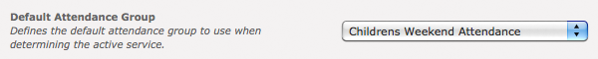

When the Attendance Overview module is first activated it will make a best guess at which service you wish to view based upon the current time. If there are multiple programs happening in different attendance types (for example, a small group that meets at the same time as your church service) you can set the default attendance group to limit that best guess to. In this example, only service times (occurrences) in the Childrens Weekend Attendance group will be searched.

User Interface

When viewing a service, it is important to understand the differences in the results. The number of attendees shown is a total count. It does not mean how many people are currently in the room. It is the number of people checked into any occurrences that match your filter selection. So as people are checked into an occurrence the number of attendees will increase. Once the service has ended the number is not reset. This means you can go back and view previous services to see the counts and compare different services.

In contrast, the number of active occurrences (only shown in the Location Results) shows as of “right now”. Meaning before the service starts, and after the service ends, the number of Active Occurrences should always be zero.

Filter

The filter window lets you select what service you want to look at. Services are grouped inside an Attendance Group by occurrence start time. In this case we are looking at all occurrences that start at 6pm on 12/13/09 and are a part of the Childrens Weekend Attendance group.

When this module is first loaded it will make a best guess at the current service. If no default group is set it will pick the first occurrence it finds that is active at the current time. If a default group has been set the module will limit its occurrence search to only that attendance grouping.

Total Attendance

Just below the filter is a line of text that will tell you the total number of people that have attended this service as well as a link to view the details for this service (only shows up if the Attendance Detail Page module setting has been set).

Location Results

The first set of results is by location. All attendees are organized by what location (room) they are checked into. The columns show the number of attendees in each location, how many occurrences are currently active in the location and an option to close the room. The last column, “Close” will only appear if there are any active occurrences.

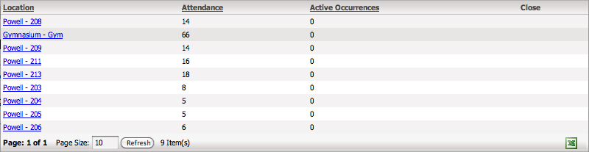

When you click the Close link you will be taken to a new screen that lets you close all occurrences for that location (see the Close Occurrences section below. You can also click on the Location name and you will be sent to the Attendance Details page to view all attendees that are checked into that location.

Occurrence Results

The second set of results is organized by occurrences. Each item shows the name of the occurrence, the attendance type, check-in start and end times and the location of the occurrence. Additionally, the number of people checked into that occurrence is displayed (Attendance) and, if the occurrence is currently active, and optional Close link to close down the occurrence (see the Close Occurrences section below).

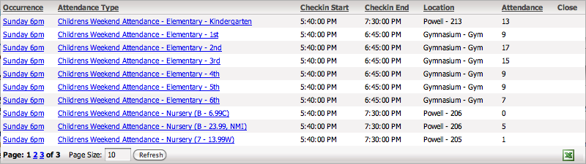

Clicking on the occurrence name will take you to the Attendance Details page and show you all attendees for the given occurrence. Clicking on the attendance type will also take you to the Attendance Details page, but will show you all attendees for all occurrences of the given type for this service. For example, if you have 1st graders going into multiple locations (and as such, multiple occurrences) you can click the attendance type for 1st graders and see all attending 1st graders across all occurrences for the currently viewed service.

Close Occurrences

When clicking the Close link of a single occurrence you will be taken to a new screen that allows you to close down just that one occurrence. If you click the Close link for a location you will be taken to the same screen but all occurrences that are currently active in that location will be listed for closing.

When closing a location, you are not permanently closing the location (like in Arena Check-in where you must remember to open the room again before the next service), you are only closing the occurrences currently active in that location.

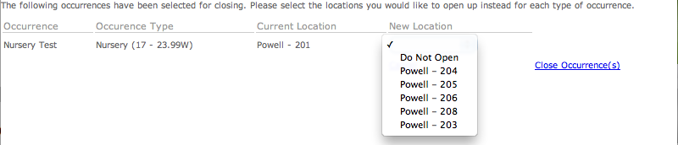

Each occurrence listed shows the name of the occurrence, the attendance type and the current location of that occurrence. It then requires that you select a new location for that occurrence. Only locations that are valid for that attendance type are listed in the drop-down selection for each occurrence.

This allows you to effectively move an occurrence from one room to another (the occurrence itself is not moved, it is marked as closed and a new occurrence is created with the same information in the new location). There is also a choice of “Do Not Open.” If this choice is selected the occurrence will be closed instead of moved.

Attendance Details

Overview

The Attendance Details module provides a detailed list of attendees for a given service. The list can be limited to a specific attendance type, a specific occurrence or a single location. You can also do a quick search by name to look up a specific person. As with the Attendance Overview module, this module considers a service to be any group of occurrences which have the same start time in a given attendance group.

Configuration

Module Settings

Ability Level Attribute

If your check-in system uses ability levels (as the CCCEV Check-in system does) to help determine which location to send a child to you should select the person attribute used to define ability levels here. If this setting is not set then the Ability Level column in the Attendees results will not be displayed.

Campus

This specifies the campus to use for the number board system. It is used in conjunction with the Topic Area (see below) module setting. If no campus is selected then a security number is posted for all campuses to display. Otherwise it is tied to just the selected campus.

Default Attendance Group

As with the Attendance Overview module, the details module will make a best guess as to which service you want to view the details of. This guess is only performed if the module is loaded without any information passed to it from the Attendance Overview module. For more details see that module’s description of the same setting.

Display Group ID

This module setting is required when using the Display Board module for post security numbers for alerting parents that they are needed. It tells the system which display group to use when posting a security number (or when determining if a security number has already been posted). If this setting is 0 or not provided then the option to post/remove a security number will not be given to the end user.

Person Detail Page

If this module setting is provided then the attendees will be shown as a hyperlink that can be clicked to view the person details. At HDC we do not use this, as we don’t want our volunteers to be able to view any details of a person. However, this option is available for use if your volunteers are trusted to see more detailed information about a person or you have your own custom person details page that has limited information provided.

Topic Area

If this setting is defined, when a user hovers over the person the popup window will include a command to post (or remove) the security number from the display board system. This system utilizes the Promotions system and must have at-least one topic area configured. If this setting is not defined the functionality is disabled.

User Interface

Filter

The filter window lets you select what service you want to look at. Services are grouped inside an Attendance Group by occurrence start time. In this case we are looking at all occurrences that start at 6pm on 12/13/09 and are a part of the Childrens Weekend Attendance group. For how the default service is chosen see the Filter user interface element of the Attendance Overview module.

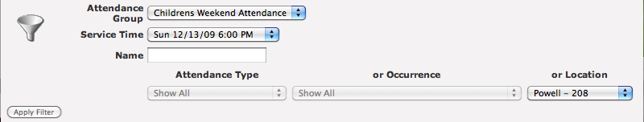

Along with choosing which service to look at, you can also limit the results to one of the following three elements: Attendance Type, Occurrence or Location. Only one of those three limits can be selected. As seen in the picture selecting a Location to limit by disables the other two. In this example we want to see all children who attended the Sunday 6pm service and were placed in room 208 of the Powell building. A full or partial name can also be entered to quickly find a specific person in the list of the results.

Attendees

The list of results includes the attendees name, gender, age, grade (if applicable), ability level (if applicable), what time they checked-in, the attendance type they were checked-in with, the specific occurrence they were checked-into and the location they are in. If the age of the person is less than 1 month old, the age is listed as “x days”. If the age of the person is less than 1 year old, the age is listed as “x months”. Otherwise the age is listed as just the number of years old.

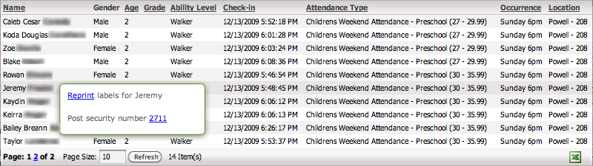

Hovering the mouse over a specific name allows the user to perform a number of actions.
- If the CCCEV check-in system is in use and the Arena.Custom.Cccev.Checkin DLL is detected, an option to reprint the labels for the currently selected person is provided. If the DLL is not detected then the command does not appear.
- If the Topic Area module setting has been set then the security number can be posted to the display board system. If the security number has already been posted then the command provided allows you to remove the security number from display. This module currently assumes you are using the CCCEV check-in system as it strips the first two characters from the security code to leave you with just the number. This will likely be changed into a module setting later.

Display Board

Overview

The display board module is used to display custom notes (generally security numbers) to a screen. Notes are stored as a promotion for a specific topic area. If you want to post security numbers to different areas (on the same campus) you must create a promotion topic for each area. All items are displayed in sequence and will loop when the last note has been displayed. The stock JavaScript has a 7.5 second delay between items.

A Display Board module can display items for multiple topic areas at the same time. Items are displayed in order from all topic areas defined for the module.

For this module to be useful it should be used with a “blank” template, otherwise you will get all the menu stuff showing up on your display board.

At HDC we use this module with Mac Mini’s connected to Samsung LCD TV’s via DVI. The computer is set to turn off the display after 3 hours of inactivity. The Display Board module includes some JavaScript that, by using a custom build of Safari, resets the inactivity timer each time an item is displayed. In this fashion the monitors automatically turn themselves off and on as needed. We are looking for a way to provide a custom build of Firefox that would do the same thing and be able to run on either Windows or Mac, but currently you will have to either turn your monitors off or let them run 24/7.

Configuration

Module Settings

Campus

If you want this module to only display security numbers for a specific campus then set the campus here. Otherwise all security numbers for the given topic areas will be listed.

Topic Areas

Enter the topic areas you wish to be used for displaying security numbers here. If you want to display numbers for more than one area you can separate them by commas.

User Interface

The stock user interface is extremely simple. Whatever security code has been posted is displayed in the upper center section of the screen. Optionally, the name is displayed smaller in the bottom section. The name is only displayed when turned on by a volunteer; it does not get automatically displayed (see the Manage Number Board module).

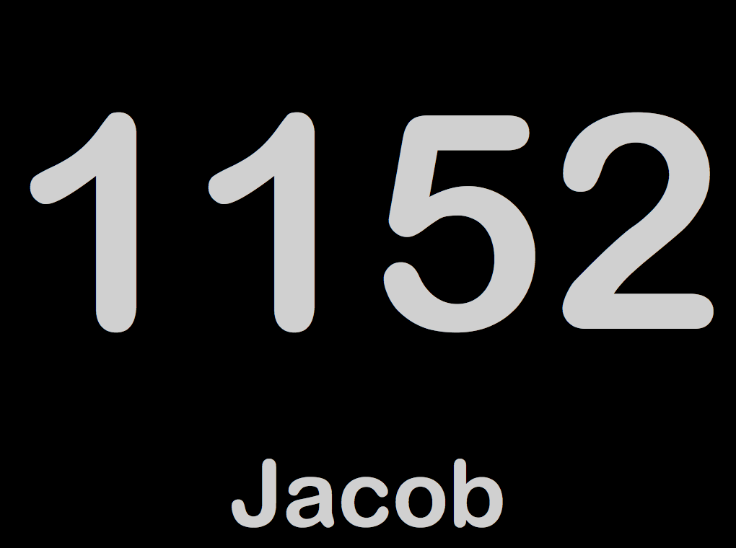

The default CSS/JavaScript is resolution independent. It divides the screen by percentage and then automatically sizes the contents to fit. In the example above, I used a 4:3 aspect ratio screen for the screen shot. In reality we use 16:9 screens. Two are running at 1920x1080 and two are running at 1280x720. The sample shot above was performed at 1024x768. All five are using the same module and same CSS/JavaScript. If you customize the content to fit your needs you should plan on making it resolution independent. This will allow text and images of any size to be displayed properly.

The text is off-white, towards the gray, due to the fact that the displays we use are too bright. Even with the backlight turned all the way down the white text was still distracting so we shifted the color towards the gray.

Checkin Number Board

Overview

The Checkin Number Board module is used in conjunction with the Display Board and Attendance Detail modules. The recommended way to post and remove numbers is via the Attendance Detail module to ensure that the information about which person the number is for, what location they are in, etc. is available.

This module provides a central place for managing all security numbers that have been posted. You can post a custom code if necessary, delete numbers and modify a posted number to include the child’s name.

Configuration

Module Settings

Campus

If you have multiple campuses and you want to limit this management screen to a single campus you can select it here. This also controls what campus a new item is posted to when you post manually.

Topic Area

This setting tells the module what topic area to use for looking for posted numbers and posting new numbers. If you have multiple topic areas you wish to manage you will need to create multiple management screens.

User Interface

Numbers

The number results area shows all currently posted numbers. It will always show the number being displayed, the date and time it was posted and who posted it. If the number was posted via the Attendance Details module then it will also display the person this security number is for and the location the person has been checked into. It will also show a green checkbox if the name is currently being displayed along with the number.

By clicking the red “X” delete button, you have the ability to remove numbers from a central location. This is useful if a number is up and nobody knows who posted it or whom it is for. You can also click the edit button to turn on or off the Show Name option (this is only available if the number was posted via the Attendance Details module).

If a number was posted manually (see below) the person’s name and location is not displayed since the system has no way to know whom the number is for.

Post Number

If a number needs to be posted manually, for example a child was checked in manually or you need to post pre-determined informational numbers, you can do so from this module. We use pre-determined numbers to alert the crowd before a service that we need extra help in childcare, or during a service we have a specific number that is posted to call for one of the registered nurses.

Once a number is posted it will show up in the Numbers section above and can be deleted from there. Any string can be posted, so there is no reason you cannot put in a short (as in one or two word) statement as well. Remember it will be automatically sized so anything more than about 8 or 9 characters total will be difficult to read on your display boards.

Frequency Locations

Overview

This administrative check-in module is designed to make setting up your check-in occurrences location specific.

This module, along with the cust_hdc_checkin_sp_generate_active_occurrences stored procedure, allow you to configure your occurrence frequencies to only generate for specific locations instead of all possible locations. This had reduced the number of occurrences we need as well as let the workers close locations/occurrences and have them be given a list of new locations to move that occurrence to.

For example, in our Nursery (birth – 1.99 year olds) all occurrences for that age range are allowed to use any of the nursery rooms (Powell 201 – Powell 207). By default they are placed on specific locations, Birth – 9 months goes in Powell 201. If room 201 needs to be closed because a teacher did not show up or there just are not enough kids to keep it open then it can be closed by a worker who has no knowledge of all the intricacies involved in setting up check-in. When they close the room they will be given a list of rooms (Powell 202 – Powell 207) to “move” all new check-ins into. This is easier for them to work with than a list of occurrences and having to find the right occurrence for the right room.

The custom stored procedure will behave the same as the original Arena stored procedure if you do not set any locations for a frequency, it will create the occurrence for all available locations of that attendance type. NOTE: Please test this before you go live. It works for us, but it was a large SQL script to modify. This is similar to the request in Arena: CAS-4660-H8V0KJ.

Configuration

Module Settings

There are no module settings to configure for this module. The module should be placed on your “Attendance Frequency” page (this is page #1438 on a default Arena install).

SQL Server Agent

To finish setup you need to install a SQL Server Agent job to automatically create occurrences each day. If you currently use Arena’s occurrence generator you can just modify that one to run the new SQL code. Otherwise follow these steps to create a new job:
- General
  - Name: Create Occurrences
  - Description: Create occurrences for check-in.
- Steps
  - Step 1
    - Step Name: Create Occurrences
    - Type: Transact-SQL script
    - Database: ArenaDB
    - Command: declare @now datetime
set @now = getdate()
exec cust_hdc_checkin_sp_generate_active_occurrences @now, 60, 'OccurrenceGenerator'
- Schedules
  - Name: Constantly
  - Schedule type: Recurring
  - Occurs: Daily
  - Recurs every: 1 day
  - Occurs every: 1 minute
  - Starting at: 12:00:00 AM
  - Ending at: 11:59:59 PM
  - Start date: (today’s date)
  - Select No end date.

User Interface

Locations

Once the module has been installed (I recommend below the existing Arena module) you will see the following view. For every frequency you see in the Arena view you should see a frequency in the Locations view, that also shows the location generated:

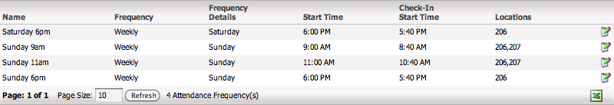

Be aware there is a known bug. If you create (or delete) a frequency you must reload the page for the change to be reflected in the Frequency Locations module. Until I find a way to detect such changes in another module I don’t know how to work around this. Clicking the edit button of a frequency will take you to the Edit Locations view for that frequency.

Edit Locations

Once you have clicked the edit button for a frequency you will see the following view:

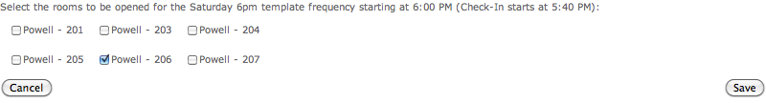

On this view you can select which locations you want occurrences created for the given frequency you are editing. If you select no locations then it will revert to the original behavior of generating occurrences for all rooms. This is different then selecting all locations! If you select all locations and then add a new location to the attendance type it will not have an occurrence generated until you go back into the frequency location editor and select the new location. If you deselect all locations and then add a new location to the attendance type it will have an occurrence created for it automatically.

Family Numbers

Overview

While not specifically a module, this grouping of SQL scripts provides a way to setup permanent family numbers to be used with check-in. The script is highly configurable to how and when these numbers are assigned.

When running the script you specify the maximum age of a person to be considered for being assigned a family number. You also specify the minimum number of attendances that person must have in the specified number of months. Finally, you identify the person attribute ID that the family number will be assigned to.

For every person that matches the criteria the script will check to see if that person, or anybody else in their family, already has a family number. If so that number is used for the matching person. Otherwise a new number is generated and assigned to the matched person and all other members of that person’s family.

After the modifications to the CCCEV Check-in system have been made as well, the check-in system will use the family number if available before generating the next sequential security code. The 2-character random code will still be generated so tickets cannot be generated ahead of time by somebody else, nor can tickets be used from week to week.

By default, family numbers are assigned starting at 2,000. If you wish to have a different starting number you must modify the cust_hdc_checkin_family_number table and change the family_number identity column.

Configuration

Arena Setup

To setup Arena for using Family Numbers, go to your Person Attributes page under Administration. Edit the attributes for the Check-In attribute group. Add a new attribute with the following information:
- Name: Family Number
- Type: Int
- Visible: Checked
- Read Only: Clear
- Required: Clear

Once this attribute has been saved you can then configure the SQL Server Agent job.

SQL Server Agent

To finish setup you need to install a SQL Server Agent job to automatically create occurrences each day. Follow these steps to create a new job:
- General
  - Name: Assign Family Numbers
  - Description: Assign family numbers for check-in.
- Steps
  - Step 1
    - Step Name: Assign Family Numbers
    - Type: Transact-SQL script
    - Database: ArenaDB
    - Command: DECLARE @maxAge int
DECLARE @minAttendance int
DECLARE @attendanceMonths int
DECLARE @attribute_id int
SET @maxAge = 12
SET @minAttendance = 3
SET @attendanceMonths = 3
SET @attribute_id = 87
EXECUTE cust_hdc_checkin_sp_assign_family_numbers
@maxAge
,@minAttendance
,@attendanceMonths
,@attribute_id
GO
- Schedules
  - Name: Friday 2am
  - Schedule type: Recurring
  - Occurs: Weekly
  - Recurs every: 1 week on Friday
  - Occurs once at: 2:00:00 AM
  - Start date: (today’s date)
  - Select No end date.

CCCEV Check-in

The final step to configure Family Numbers is to configure the CCCEV Check-in system, if you use it. To do this go to your Lookups page in the Administration section. Edit the Cccev CheckIn Security Code Providers and add a new lookup value with the following information:
- Value: HDC Family Number Provider
- Namespace: Arena.Custom.HDC.CheckIn
- Class: Arena.Custom.HDC.CheckIn.HDCSecurityCode
- Active: Checked

Once this has been done, load in the Arena.Custom.HDC.CheckIn.DLL file into your Arena\bin folder and then Refresh Cache. The CCCEV Check-In Wizard should now use the family number if available and if not, it will revert to the old method of generating sequential security codes.

Service Builder

Overview

This module exists to help you, and your check-in administrative users, in building services that will use check-in. It is designed to alleviate some of the reoccurring tedium while building occurrence after occurrence and the errors that creeps in while doing so. It also includes some error checking to catch the most common errors that happen when putting together all the occurrences that make up a whole service.

The user interface uses a drag-and-drop interaction, which makes the work much easier. It also provides a type of graphical overview that allows the user to see what they have put together and know they have everything linked correctly.

Configuration

Module Settings

There are currently mo module settings to configure for this module. Simply add it to a new page and it is ready to go.

User Interface

Service Information

Enter in all the general information about the service here. The information entered here will be applied to each occurrence generated when you click the Create button. The name and all four date/time fields are required.

The Link To Tag field is used when an attendance type is not linked to either a tag or small group. When an occurrence is created, it is linked to either the tag or small group that it’s attendance type is linked to. If the attendance type is not linked to anything then it is linked to the selected tag, as such this field is only required if a used attendance type is not linked to anything. If the Use For All checkbox is checked, then all generated occurrences are linked to the selected tag regardless of the settings in the associated Attendance Type.

Service Layout

Attendance Types

This is a list of all your defined Attendance Type Groups and the Attendance Types in the selected group. You may change between groups while building your service without fear of losing any of the work you have already done to this point. After you have dropped a location onto the Build Service section to make it active you may drag an attendance type onto the now active location to attach the attendance type to that location.

Locations

This are provides a list of available locations you have defined. You may drag and drop these onto the Build Service section to make the room active for your new service.

Build Service

The Build Service area provides a place to drop locations you wish to make active onto. It also gives you a visual view of the service you are building. To remove an active attendance type, simply click the “x” next to it. You can similarly remove an entire location by clicking the “x” next to the name of the location (this will of course remove the attendance types for that location as well). As you drag attendance types into an active location, they are automatically sorted by minimum age.

When you are satisfied with your service click the Create button above and if everything is successful it will clear this area and display the number of occurrences that were created. If there are any errors in your service they will be displayed above and you will have to fix them before trying to create the service again.

Support

Arena Versions

The Family Registration module has been tested and known to work on 2008.3.100 and 2009.1.100 – 2010.2.300.

The Attendance Overview, Attendance Details, Display Board, Manage Number Board, and Frequency Locations modules have all been tested and known to work on 2009.1.300 – 2010.2.300.

The Service Builder module has been tested and known to work on 2010.2.300.

Known Bugs

Family Registration

- Fields that should be required in Family Information may currently be left blank. The Family Name should either be required or automatically use the last name of the first person listed in the family.
- [2008.3.100 – 2009.1.100] Entering a birth date with a 2-digit year causes a JavaScript exception, which will prevent the save from completing, it will also leave the page in a state where you can not fix the problem and click Save again. This is a known bug to Arena’s Portal DLL and they have fixed it in 2009.1.200. Current work-around is to either enter dates as 4-digit years or click Add More if the Save button has already been clicked.

Frequency Locations

- Frequencies created or deleted will not be reflected in the frequency location list until you fully reload the page. This is due to not being able to detect when another module on the same page has gone through an edit cycle.

