SECC Monitor Screen

[Document Revisions 3](#_Toc289085849)

[Description 3](#_Toc289085850)

[Features 3](#_Toc289085851)

[Screens 4](#_Toc289085852)

[1. Monitor 4](#_Toc289085853)

[1.1. Header Buttons 4](#_Toc289085854)

[1.2. Attendance Type Categories / Attendance Types 5](#_Toc289085855)

[1.3. Occurrence Rows 5](#_Toc289085856)

[2. Search 6](#_Toc289085857)

[2.1. Search 6](#_Toc289085858)

[2.2. Search Results 7](#_Toc289085859)

[3. Attendance 7](#_Toc289085860)

[3.1. Show Active Only 7](#_Toc289085861)

[3.2. Results 7](#_Toc289085862)

[3.3. Room Stats 8](#_Toc289085863)

[3.4. Move All 8](#_Toc289085864)

[4. Move 9](#_Toc289085865)

[4.1. Currently In 9](#_Toc289085866)

[4.2. Move To 9](#_Toc289085867)

[5. Tag Reprint 10](#_Toc289085868)

[5.1. Tag 10](#_Toc289085869)

[5.2. Member Dropdown 10](#_Toc289085870)

[5.3. Tag Dropdown 10](#_Toc289085871)

[Installation 10](#_Toc289085872)

[Module Settings 11](#_Toc289085873)

[1. Additional Tags 11](#_Toc289085874)

[2. Allow Bulk Move 11](#_Toc289085875)

[3. Attendance Type Ratio Lookup Type ID 11](#_Toc289085876)

[4. Open/Close All Rooms 11](#_Toc289085877)

[5. Decrease Image Path 11](#_Toc289085878)

[6. Increase Image Path 12](#_Toc289085879)

[7. Open/Close Individual Room 12](#_Toc289085880)

[8. Occurrence Detail Page 12](#_Toc289085881)

[9. Person Detail Page 12](#_Toc289085882)

[10. Phantom Volunteer 12](#_Toc289085883)

[11. Refresh Timer 12](#_Toc289085884)

[12. Show Details 12](#_Toc289085885)

[13. Show Panic 13](#_Toc289085886)

[14. Visible Attendance Type Categories 13](#_Toc289085887)

[15. Panic Tag 13](#_Toc289085888)

[About Panic Mode 13](#_Toc289085889)

[About Attendance Type Ratios 13](#_Toc289085890)

# Document Revisions

|  |  |  |  |
| --- | --- | --- | --- |
| **Revision Date** | **Revised By** | **Version** | **Comments** |
|  | Joshua Martin | 1.0 | Initial Version |
| 03/25/2011 | Chris Funk | 1.1 |  |

# Description

The Check-In Monitor module is used for near real-time monitoring of daily check-in activities and gives you full control of the active check-ins.

# Features

* Displays important occurrence information such as the name, location, attendee and volunteer count, room capacity, and valid check-in times on one screen for all active occurrences.
* Automatically groups occurrences by attendance type and attendance type categories, allowing you to easily collapse the attendance type categories you don’t want to see.
* Near real-time data of attendee and volunteer count per occurrence.
* Highlights occurrences when attendee or volunteer counts change and displays the change.
* Open or close occurrences in one click on the same screen.
* Informs you why occurrences close, such as for room capacity, room ratios, etc.
* Displays message when occurrences near capacity or room ratio.
* Open or Close all occurrences in one click.
* Panic button toggles between ‘Connected’ and ‘Inactive’ statuses for all members of specific serving tag. When the serving tag is connected with attendance types for room ratio, it is a great last minute resort when additional assistance is needed.
* Search functionality allows you to easily search by name or security code for anyone who has checked into any of the day’s occurrences, while also displaying relevant information such as a complete trail of all locations the person has checked into, security code, check-in and check-out times, and the kiosk they checked in from.
* Displays occurrence capacity based on the capacity of the occurrence’s location capacity. Also configurable to display capacity based on occurrence type ratio set in a custom lookup (occurrence will not close based on ratio being met or exceed as this is for display purposes only).
* Attendance screen displays everyone who has checked into a single occurrence, with an easy way to filter by those who have checked out and those who haven’t, while providing a sortable list of information, such as check-in time, check-out time, security code, kiosk (that was checked in from.)
* Attendance screen allows you to check-in a ‘phantom’ volunteer, in the event you can take extra kids.
* Attendance screen allows you to update the room capacity.
* Attendance screen and search screen gives you the ability to move, check-out, or reprint tags on specific individuals.
* Move screen allows you to move either one attendee from one occurrence to another or move all attendees from one occurrence to another by using configurable “bulk move” functionality.
* Tags screen allows you to reprint any tag associated with that attendance type, or any other additional tags specified in the module settings.

# Screens

1. Monitor  
   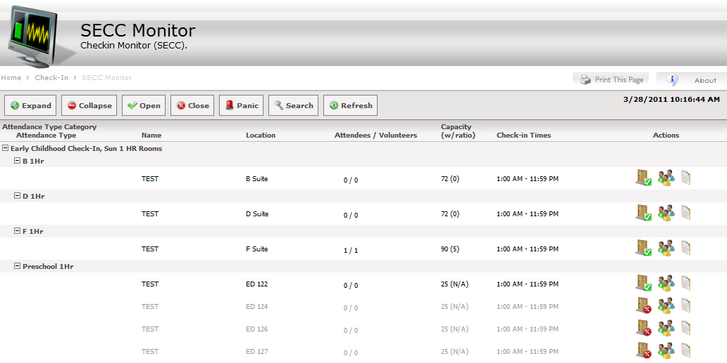
   1. Header Buttons   
      Methods: HeaderCommands.
      1. **Expand**  
         Expands all Attendance Type Categories and Attendance Types.   
         Clears all data from HiddenAttendanceTypeCategories and HiddenAttendanceTypes properties. Methods: ExpandCollapse.
      2. **Collapse**  
         Collapses all Attendance Type Categories and Attendance Types.   
         Adds all unique Attendance Type Category and Attendance Type ID’s to the respective HiddenAttendanceTypeCategories and HiddenAttendanceTypes properties. Methods: ExpandCollapse.
      3. **Open**  
         Opens all occurrences that are listed on this monitor screen.
      4. **Close**  
         Closes all occurrences that are listed on this monitor screen
      5. **Panic**  
         Toggles ON or OFF Panic Mode.  
         When turning panic mode ON, all members of the Serving Tag referenced in the Panic Tag module setting are set to ‘Connected’.   
         When turning Panic Mode OFF, all members of the Serving Tag referenced in the Panic Tag module setting are set to ‘Inactive’.  
         NOTE: Panic Mode is only useful if you use room ratios. See About Panic Mode.  
         Methods: UpdatePanicStatus.
      6. **Search**  
         Opens the Search Screen.
      7. **Refresh**  
         Refreshes the screen (using AJAX.)
   2. Attendance Type Categories / Attendance Types   
      These rows can be collapsed / expanded.   
      Page will retain the state of these rows via the HiddenAttendanceTypeCategories and HiddenAttendanceTypes properties which are integer lists of ID’s that are collapsed, all rows not in these properties are visible. These properties store their values in the Page ViewState.  
      Methods: ExpandCollapse.
   3. Occurrence Rows  
      Displays the occurrence name, location, attendees, volunteers, capacity, check-in times, and actions.
      1. **Participant Count**  
         An up or down arrow will appear next to the attendee or volunteer number whenever a person checks in or checks out.
      2. **Statuses**Status message appears next to the attendee / volunteer count, if applicable.
         1. **[room closed]**  
             No one can check in, location closed. Click the open door button to open.
         2. **[x over]**
         3. **[cap reached]**
         4. **[ratio reached]**  
             Only applies to room ratios. Only leaders can check in.
         5. **[too few leaders]**  
             Only applies to room ratios. Only leaders can check in.
         6. **[x remaining]**  
             3 or less positions remaining.
      3. **Occupancy**
         1. **Location Capacity**

Displays capacity based on the capacity of the occurrence’s location.

* + - 1. **Ratio based Capacity**

Southeast’s Children’s ministry wanted an option to be able to display the maximum number of attendees that can be checked into an occurrence based on the attendee to leader ratio, but didn’t want to have Arena automatically close the occurrence to additional attendees. This label will display the current maximum number based on an occurrence type and attendees to leader value in a specified lookup. *See Attendance Type Ratio Lookup for more details*

* + 1. **Actions**   
       Methods: Occurrence\_Command
       1. **Toggle Room**  
           Only visible if module setting Open/Close Individual Room is True.
       2. **Show Attendees** Opens Attendance screen.
       3. **Occurrence Properties**  
           Only visible if module setting Show Details is True.

1. Search  
   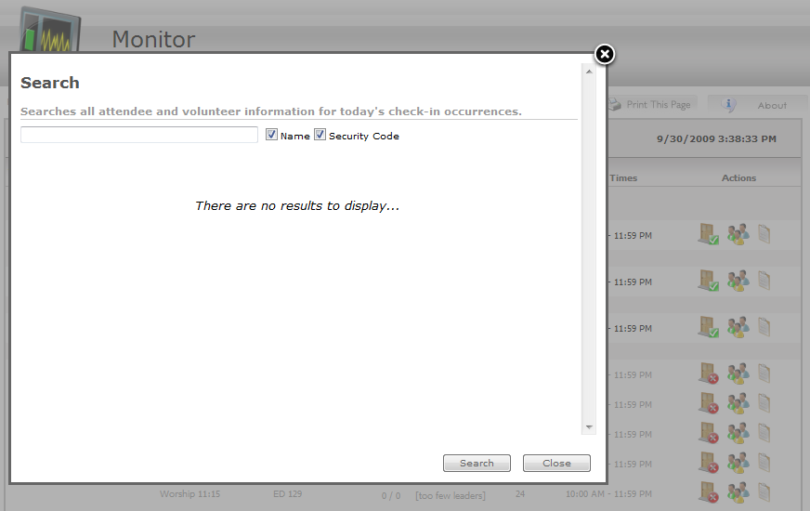
   1. Search   
      Splits search query by space and comma, and is then used to search by name and/or security code (depending on what is checked.) Matches would include: “Josh Martin”, “Josh”, “Martin”, “Josh, Martin”, “Martin, Josh”, etc.  
      NOTE: people who have checked out and/or participated in a previous occurrence on that day are included in the results and their row is disabled.  
      Methods: PopupButton\_Command
   2. Search Results  
      Provides a list of people who match the query with sortable header columns including: Name, Location, Check-in [time], Check-Out [time if applicable], Security Code, Kiosk, and Actions.
      1. **Actions**  
         Methods: Attendee\_Command
         1. **Move**  
             Opens Move Screen.
         2. **Tags**  
             Opens Tag Reprint Screen.
         3. **Checkout**  
             Checks person out of occurrence (row will then become disabled.)
2. Attendance  
   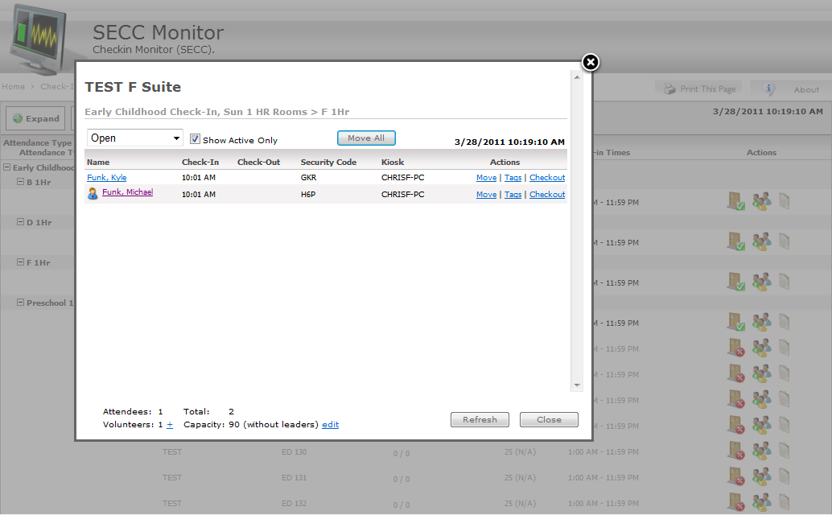
   1. Show Active Only  
      If Checked, only displays people who have NOT checked out.  
      If Unchecked, includes people who have checked out.  
      Methods: ShowActiveCheck\_CheckChanged, ShowAttendees.
   2. Results  
      Provides a list of people who are checked into this occurrence with sortable header columns including: Name, Check-in [time], Check-Out [time if applicable], Security Code, Kiosk, and Actions.
      1. **Actions**  
         Methods: Attendee\_Command
         1. **Move**  
             Opens Move Screen.
         2. **Tags**  
             Opens Tag Reprint Screen.
         3. **Checkout**  
             Checks person out of occurrence (row will then become disabled.)
   3. Room Stats   
      Methods: PopupButton\_Command
      1. **Check-in Phantom Volunteer**  
         Checks in the member who is referenced in the Phantom Volunteer module setting as a volunteer.   
         If the setting is not set, this link button is hidden.   
         If the referenced member is already checked in to this occurrence, the button is disabled (the person can check into multiple occurrences, but never one occurrence multiple times.)  
         NOTE: Only useful if you use room ratios.
      2. **Edit Capacity**  
         Allows you to modify the room capacity.   
         NOTE: Use 0 for infinity.
   4. Move All

Methods: btnMoveAll\_Click

Opens move screen to move all people (attendees and volunteers) that are checked in to one occurrence to another occurrence.

1. Move  
   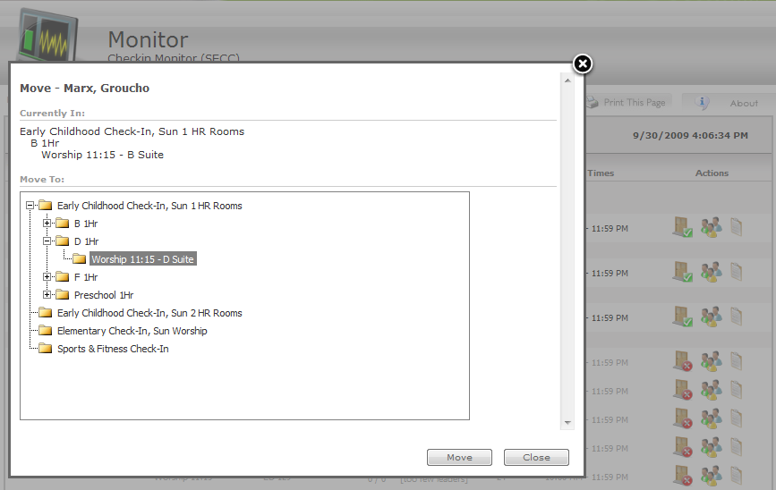
   1. Currently In  
      Displays the Attendance Type Category, Attendance Type, Occurrence Name, and Location the member is checked in to.
   2. Move To  
      To move to another occurrence, must first click the desired Attendance Type Category, then Attendance Type, then the Occurrence.   
      Methods: PopupButton\_Command
2. Tag Reprint  
   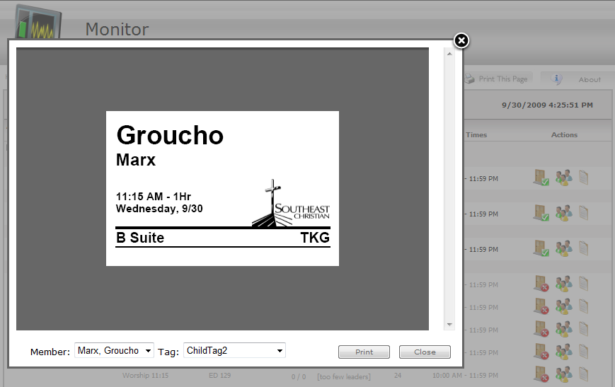
   1. Tag  
      References through an OBJECT tag the following URL: report.ashx?<tagpath>,<occurrenceattendanceID>,<orgID>,#toolbar=0&navpanes=0&scrollbar=0&zoom=100
   2. Member Dropdown  
      List of members of the same family who have checked in today.
   3. Tag Dropdown  
      Lists tags that can be re-printed based on what Labels are associated with the Attendance Type they are checked in to, and also lists any tags defined in the Additional Tags module setting.  
      NOTE: All underscores in the tag names are replaced with a space in the text value of the option tag for readability.

# Installation

1. Run SECC\_Monitor\_Schema\_Deploy.sql located in the SQL\Deploy folder against your Arena database.
2. Import Package.xml into your module list.

# Module Settings

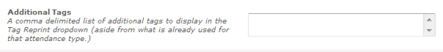

1. Additional Tags  
   This setting will add any additional labels specified in this setting to the dropdown list on the Tags Reprint screen. For example, there may be some tags not associated with an attendance type that you want to print from the monitor screen. Just list each report path to each tag separated by a comma. Begin with “/Arena”, such as: “/Arena/Checkin/report1,/Arena/Checkin/report2.” Default is empty.

setting_allow_bulk_move.png

1. Allow Bulk Move

This setting displays and enables the Bulk Move button on the Attendance screen

setting_attendance_type_ratio_lookup.png

1. Attendance Type Ratio Lookup Type ID

This setting contains the Lookup Type ID associated with the Attendance Type Ratios. If this field is blank, only the location capacity will display in the capacity column (if configured).

**setting_open_close_all_rooms.png**

1. Open/Close All Rooms  
   This setting is for security, and sets the visibility of the ‘Open All’ and ‘Close All’ buttons. Default is true.

**setting_decrease_image_path.png**

1. Decrease Image Path  
   Used if you would like to override the default decrease arrow image. Default is empty.

setting_increase_image_path.png

1. Increase Image Path  
   Used if you would like to override the default increase arrow image. Default is empty.

setting_open_close_individual_room.png

1. Open/Close Individual Room  
   This setting is for security, and sets the visibility of the individual ‘Open’ and ‘Close’ button. Default is true.

setting_occurrence_detail_page.png

1. Occurrence Detail Page  
   The page ID of which to navigate to when the details image link is clicked.

setting_person_detail_page.png

1. Person Detail Page  
   The page ID of which to navigate to when the person’s name is clicked.

setting_phantom_volunteer.png

1. Phantom Volunteer  
   The person ID of whom you will use as a check-in volunteer phantom. Default is empty.

setting_refresh_timer.png

1. Refresh Timer  
   The refresh rate of the occurrence list page. Default is empty.

setting_show_details.png

1. Show Details  
   This setting is for security, and sets the visibility of the details image link. Default is true.

setting_show_panic.png

1. Show Panic  
   This setting is for security, and sets the visibility of the panic image button. Default is true.

setting_visibile_attendance_type_categories.png

1. Visible Attendance Type Categories  
   If set, the Monitor page will only display the Attendance Type Categories specified in this setting. If left empty, the Monitor screen will show all active Attendance Type Categories. To specify Attendance Type Categories, use a comma delimited list of Attendance Type Category ID’s. Default is empty.

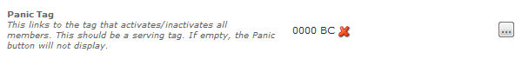

1. Panic Tag  
   This setting should reference the tag where emergency volunteers are held. Must be a Serving tag. If this setting is left blank, the Panic Button will not be displayed.

# About Panic Mode

Panic Mode is only useful when using room ratios. Panic Mode allows you to check-in ‘emergency’ volunteer’s, or people asked to serve as a last resort if additional help is needed. These people are placed in a serving tag, where all the members are set to inactive (this prevents their name from appearing on the check-in screen.) When Panic Mode is enabled, all member status of the serving tag is set to connected, thus allowing them to check-in as volunteers.

To set up Panic Mode:

1. Create Serving Tag “Emergency Volunteers” (the name can be anything.)
2. Populate tag with members.
3. Set the Panic Tag module setting to the Emergency Volunteers tag.
4. You may want to browse to the Monitor Screen, and turn Panic Mode ON, and then OFF, to ensure that all members of the serving tag are inactive.

# About Attendance Type Ratios

The Attendance Type Ratio Lookup values are used to display the maximum number of attendees on the monitor screen for the number of volunteers that are currently checked in to a specific occurrence. This functionality is useful when you want to be able to view an occurrence’s ratio status without it being directly tied to the open/close status of an occurrence. If this is enabled on a monitor screen but an occurrence type does not have a ratio assigned to it (N/A) will display next to the location capacity.

To Setup Attendance Type Ratios:

1. Create Lookup Type “Attendance Type Ratios” (the name can be anything).
2. Set the Qualifier 1 Title to “Attendees Per Leader” (again this can be anything).
3. Click on the newly created lookup to go to the values screen.
4. Populate the Occurrence Type ID as the value and the ratio under the qualifier field for each occurrence type that you want to setup ratios for.
5. If a page has not been setup for the monitor screen, create a new page and add the Check-In Monitor (SECC) module.
6. In Module Properties set the value of the “Attendance Type Ratio Lookup Type ID” setting to equal the new lookup that you have created.