## 1. Abstract

The aim of this project is to create an energy monitoring and management system using Indoor Positioning technique and power measuring circuit to solve the increase usage of electric appliances making energy monitoring and cost saving possible. This system consists of three components, android phone, server, and wireless switches. An indoor position tracking app will be install into the android phone to calculate the position of the user. The tracking app require the phone's WIFI sensor to be turned on to read receive signal strength (RSS) of surrounding WIFI access point and perform Bayesian algorithm to calculate the user location. The calculated position will be sent to the Intel Edison Board that running with MQTT (formerly MQ Telemetry Transport) protocol and will publish the data to all connected switches. All of the switches can be setup through a designed app interface giving a few operating mode option to pick. The switch will be turned on or off automatically according to the selected mode and the user position, in the same time the server will be updated with the operated time and power consumption of the connected load on switches and display on the phone interface. In the end, the user able to determine their daily power consumption and also automated system on manage switching on and off of their electric appliances.

## 2. Introduction

The large amount of electric appliances in home environment making the power management process challenging. User often carelessly leaving the switch on after using the appliances causing waste of electricity. Moreover, most of the user are not aware of the power consumption of an individual electric appliances lead to expensive electricity bill. The Internet of Things (IoT) trend currently possible solve all the problems by monitoring and manage the electric appliances on internet.

Cooling appliance was one of the high power consumption device. Research conducted by Centre for Environment, Technology and Development Malaysia (Cetdem) with Petaling Jaya City Council found that 67 per cent of average household electricity consumption is cooling appliances [1]. During hot weather season, the electricity will be unpredictable high due to unmonitored use of air conditioner.

Managing home appliances through manually control are not efficient. User tends to make careless mistake leaving the appliances switching on and unattended. This make the management of many electric appliances in multiple room a challenging task.

Indoor Positioning feature app will be developed using Android Studio and installed to an android phone. Custom WiFi Access Point (AP) beacons will installed in each room. RSS of beacons and the accuracy of position tracking will be tested. MQTT will be setup on Intel Edison Board. The switch will be designed to measure the power consumption and remotely switching on and off. The final phase of the project is developing an interface app on phone.

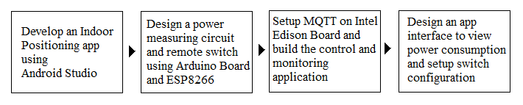

**Fig. 1** Overall Flow of project

The objective of this project is to improve the home living style by letting user fully monitor the power consumption of home appliances and switch automation according to user's location.

In this project, Intel Edison Board will be used as intercommunication tool between android phone and custom designed switches. The reason of choosing Intel Edison Board, it has WiFi module which a crucial element for IoT.

This application was expected to let user to monitor the power consumption of all electric appliances through designed app interface, the application also has a similar function like laptop, it will switch off the room specific electric appliances when the room is inactive and switch back on when the user come back.

## 3. Design Methodology

### 3.1 Concept of Indoor Positioning System

In this project, the Indoor Positioning method was based on Bayesian rules. It performs statistic on real time measure of RSS and perform algorithm with build-in radio map to pin point the location [2]. WIFI sensor of an android phone will be used to detect the surrounding RSS. A radio map was an offline map database that sampled the WIFI-fingerprint in each position of the map. Therefore, WIFI AP beacons were deployed in each of the room to increase the accuracy of the radio mapping. Fig. 2 shows a radio map with sampled fingerprint of each position in a room.

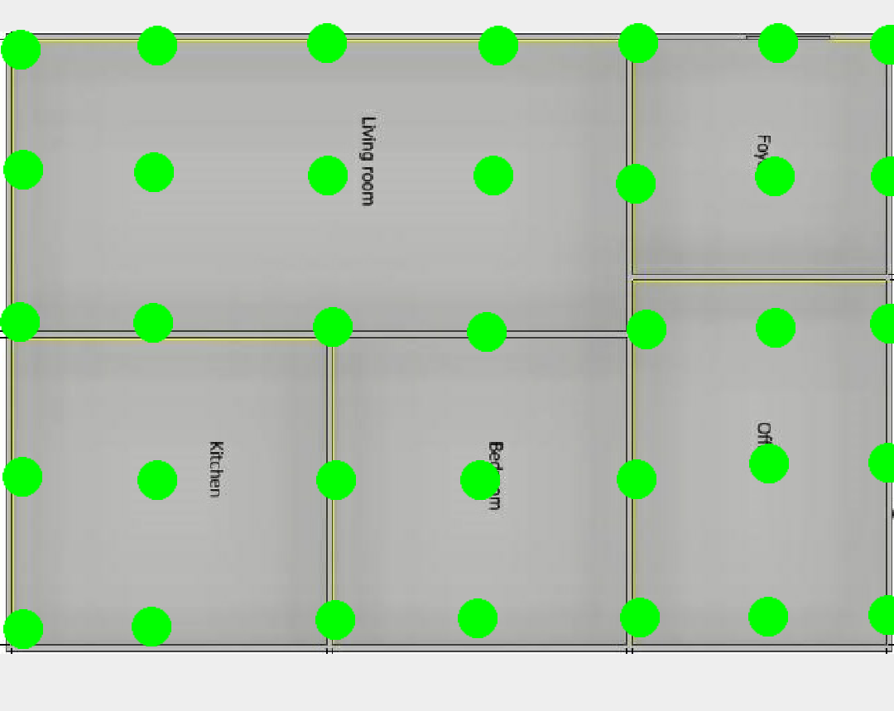

**Fig. 2** Radio Mapping

### 3.2 Phase 1: Develop an Indoor Positioning feature app

An app will be designed using Android Studio to perform a background process of indoor positioning. WiFi beacons were deployed to each of the room and radio map was recorded for the location that want to be tracked. The developed app will then perform Bayesian analysis and measured position will be sent to the Intel Edison Board in every 30 seconds.

### 3.3 Phase 2: Design of switches

A power measuring circuit will be constructed to measure the voltage and current of the connected load to measure power consumption. The voltage will be measured by stepping down using transformer in Arduino Board. Current will be measured using current transformer and read by Arduino Board. Both current and voltage will be measured 50 times in 20 milliseconds and calculate the average true power [3]. ESP8266 was used to receive the calculated power value from the Arduino Board and the value will be sent to the Intel Edison Board. Simultaneously, ESP8266 will retrieve the position of user from Intel Edison Board and performed conditional power switching according to received user position. Fig. 3 shows the design of switch.

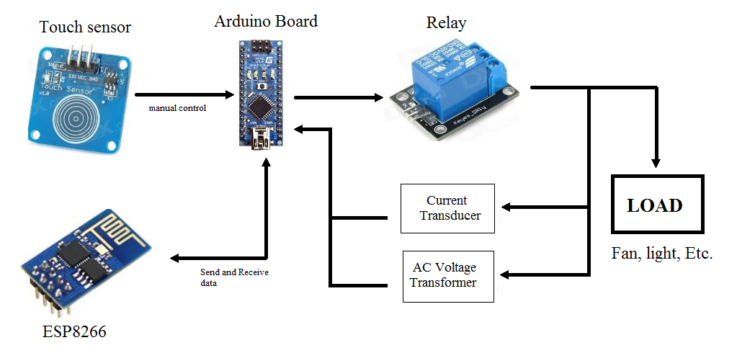

**Fig. 3** Switch Design

### 

### **3.4 Phase 3: Setup the application system**

Intel Edison Board will be used as MQTT broker, both android phone and custom switches are MQTT clients and will be subscribed to MQTT broker. The tracked position data will be published to all switches and cloud. All measured power and the amount of power consumption time of the load will be published to the cloud. Switch operation setting will be published to the specified switch. All the data on the cloud will be analysed and display on an app interface. Fig. 4 shows the flow of the application system.

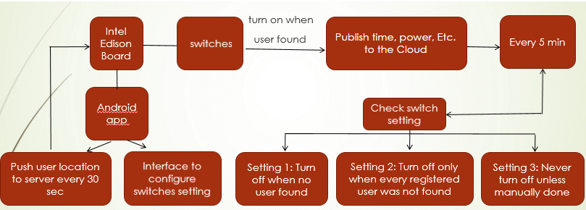

**Fig. 4** Flow of the application system

### 3.5 Phase 4: Design the App Interface

An android app interface was designed to display the total power consumption. A graph of total power versus time will be plotted for user to monitor the monthly overall power usage. Fig. 5 shows a concept design of the interface. Switch control setup will be designed in the interface to configure the switch operation mode.

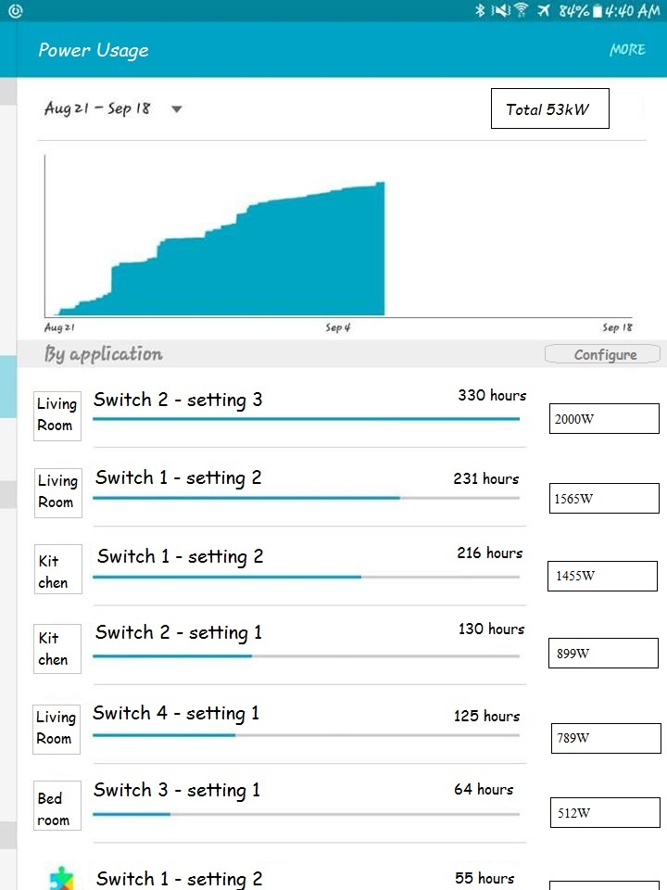

**Fig. 5** Interface Design Concept

### 3.6 Improvement of System

The design of switch has a lot more improvement to be considered such as safety measurement. Additional feature can be added such as alert the user when detected plug-in power going to be overloaded.

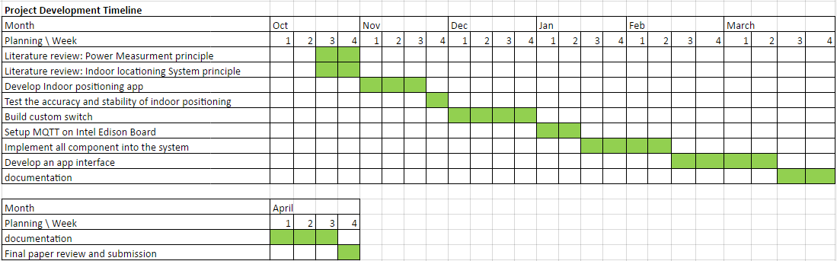

**Fig. 6** Gantt Chart

### References

1. Ali, I.M.N. (2012). Cooling Appliances Uncool For Environment. Retrieved September 26, 2016, from <http://www.bernama.com/bernama/v3/printable.php?id=676828>
2. Roos, Teemu, et al. "A probabilistic approach to WLAN user location estimation." International Journal of Wireless Information Networks 9.3 (2002): 155-164
3. Robin, E. Different ways of Measuring Voltage and Current. Retrieved September 26,2016, from <https://openenergymonitor.org/emon/mk2/vimeasurement>