

2-Bit binary adder

[Document subtitle]



February 9, 2024

[Company name]

[Company address]

CHAKA C.R 202201097

CHAKA R.C 202201061

LIEAO T.L 202201086

NTOKO H.E.N 202201130

THAHANYANE T.T 202201136

**A 2-Bit Binary Adder**

**Objective:**

This report is about the construction of a digital circuit involving its design, testing and implementation. The aim is to construct a circuit that performs an addition of 2-bit binary numbers with 3-bit total made up of a carry-bit (the first bit) and the sum (constitutes the last two bits).

To achieve this, the circuit will have four inputs, the first and second bit of each number and will have three outputs, being the two bits that will make up the sum and the other for the carry-bit.

**Design**:

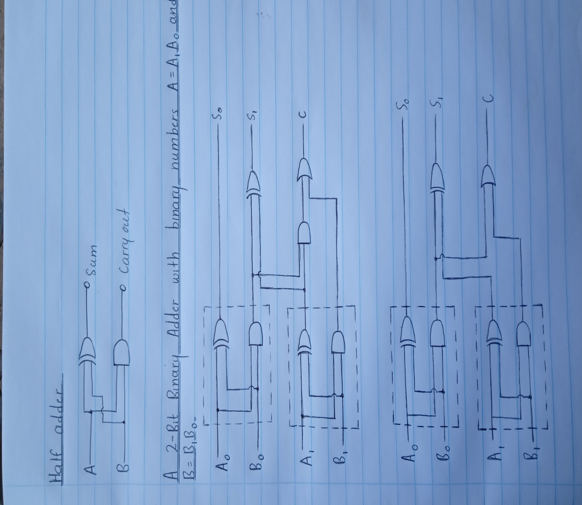

The adder was designed by constructing two half adders, the first adder sums up the less significant bit(LSBs) to give S0 and the second one sums up the most significant bits(MSBs) to give S1. The final carry denoted “C” is generated from the sum of the MSBs and the carry from the LSBs.

**Simulation:**

The circuit was simulated using an online simulator named “Circuit Verse” and it indicated that the adder works as expected. The following are screenshots taken during this simulation.

01+01=010

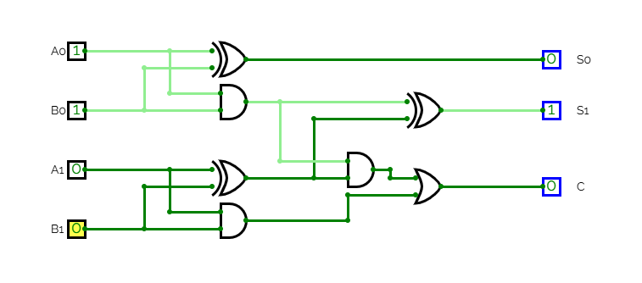

11+11=110

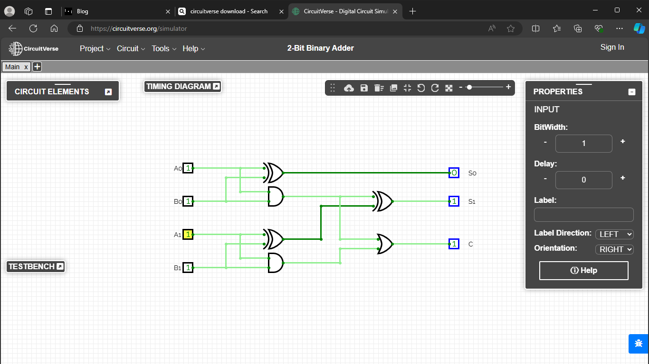

11+10=101

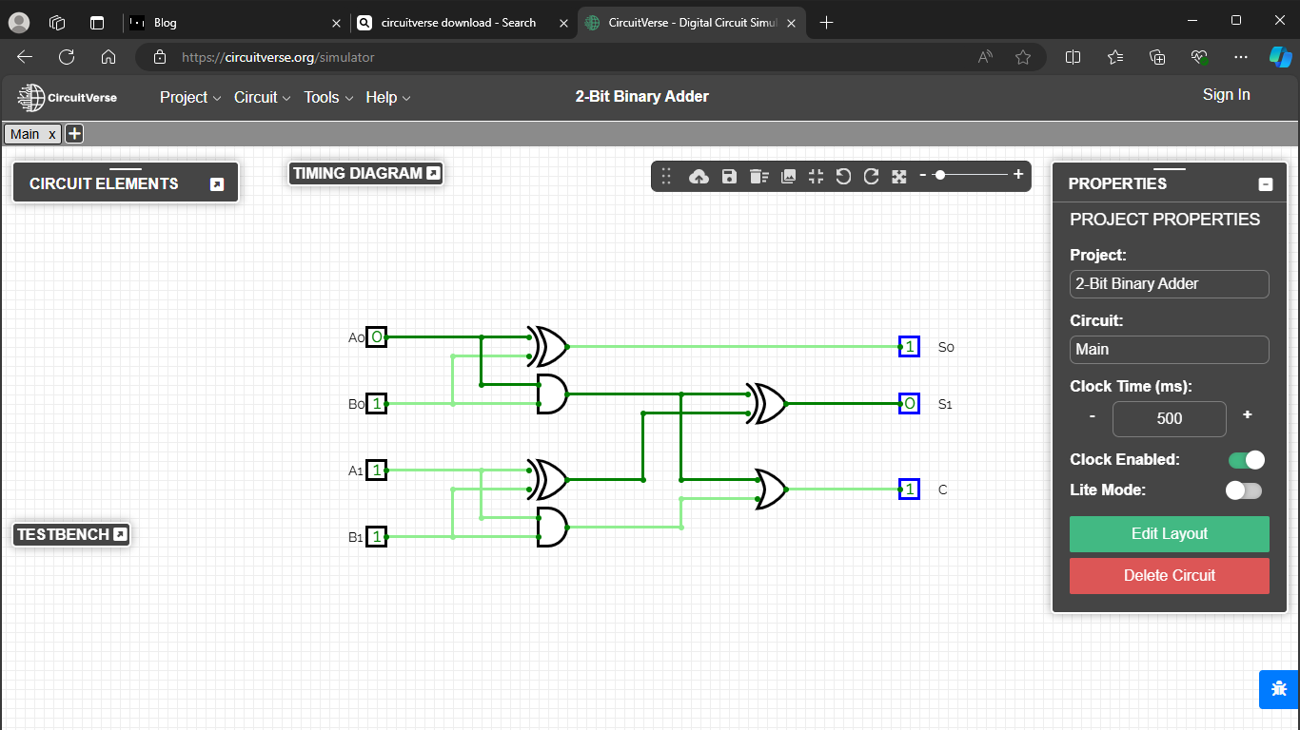

11+01+100

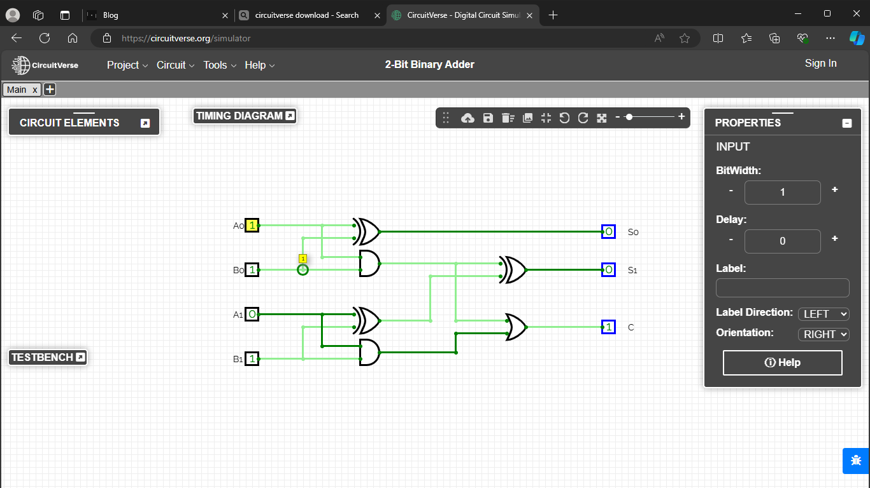

**Testing:**

Here we were adding 3 and 0, which is 11 and 00 in binary and we were expecting 3 which is 011 in binary. The circuit output is 011 so the circuit works.

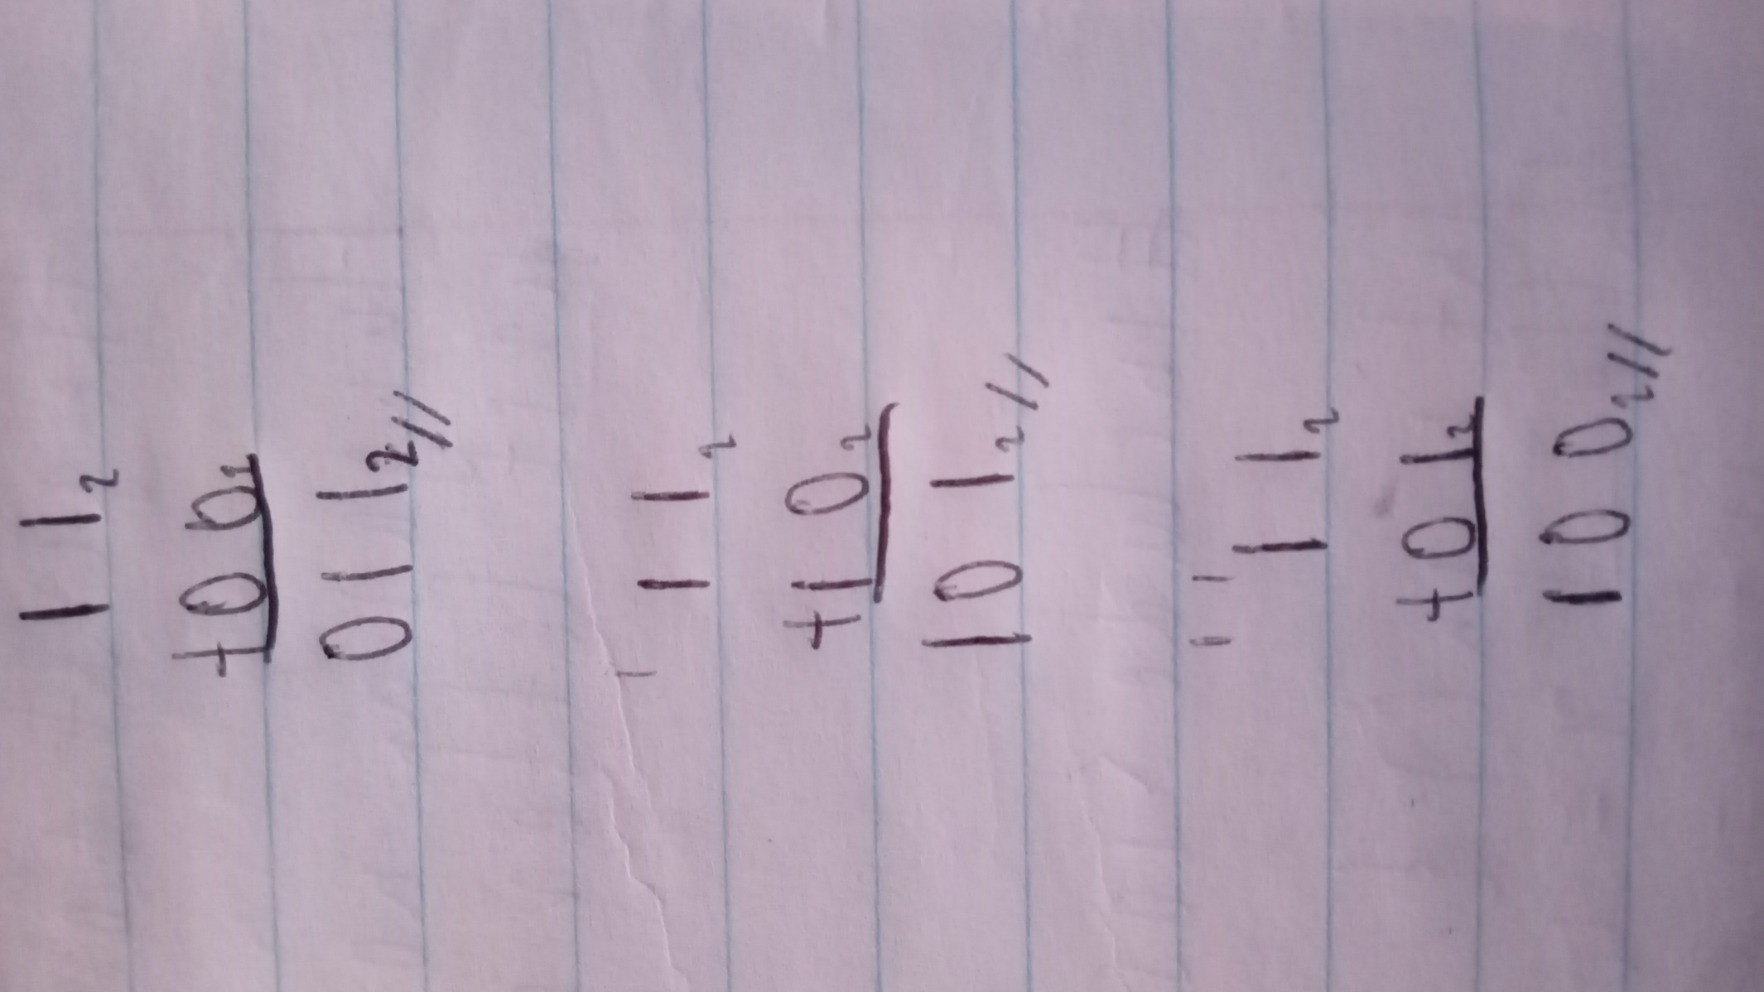

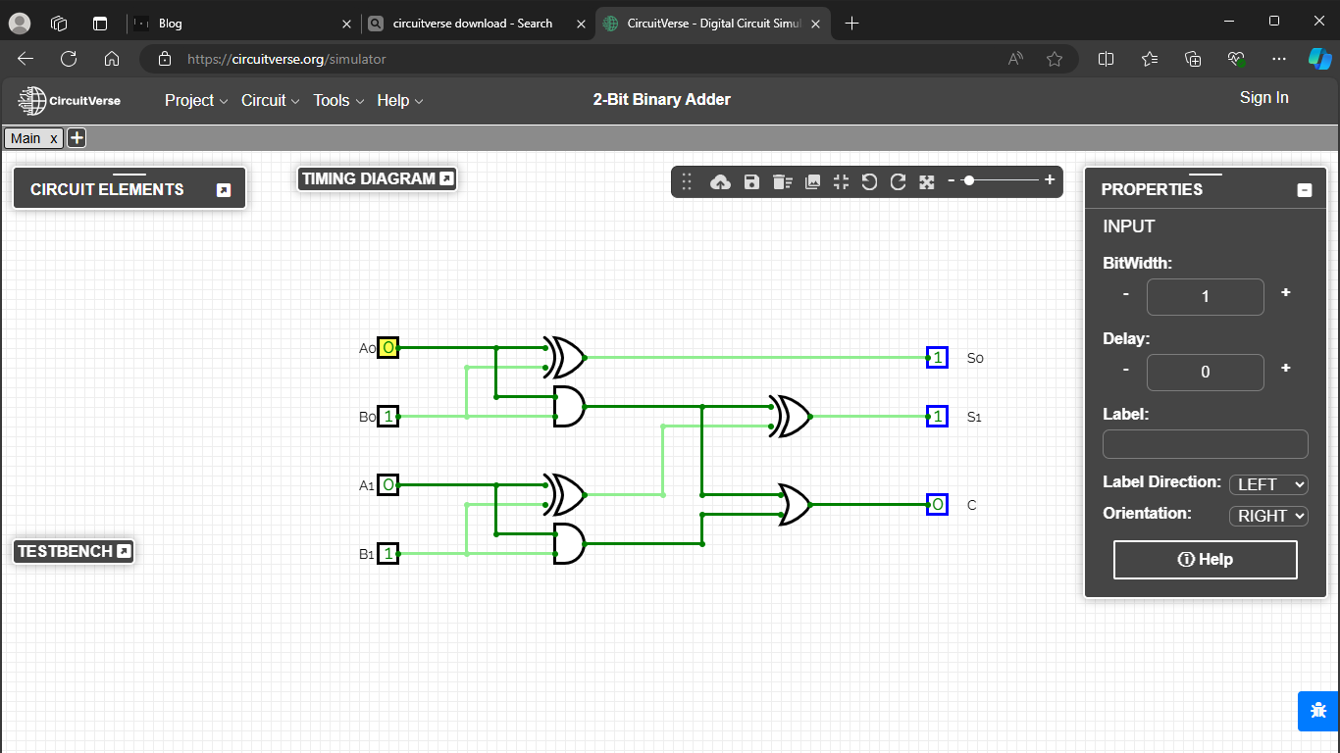

Here we were adding 3 and 2, which is 11 and 10 in binary and we were expecting 5 which is 101 in binary. The circuit output is 101 so the circuit works.



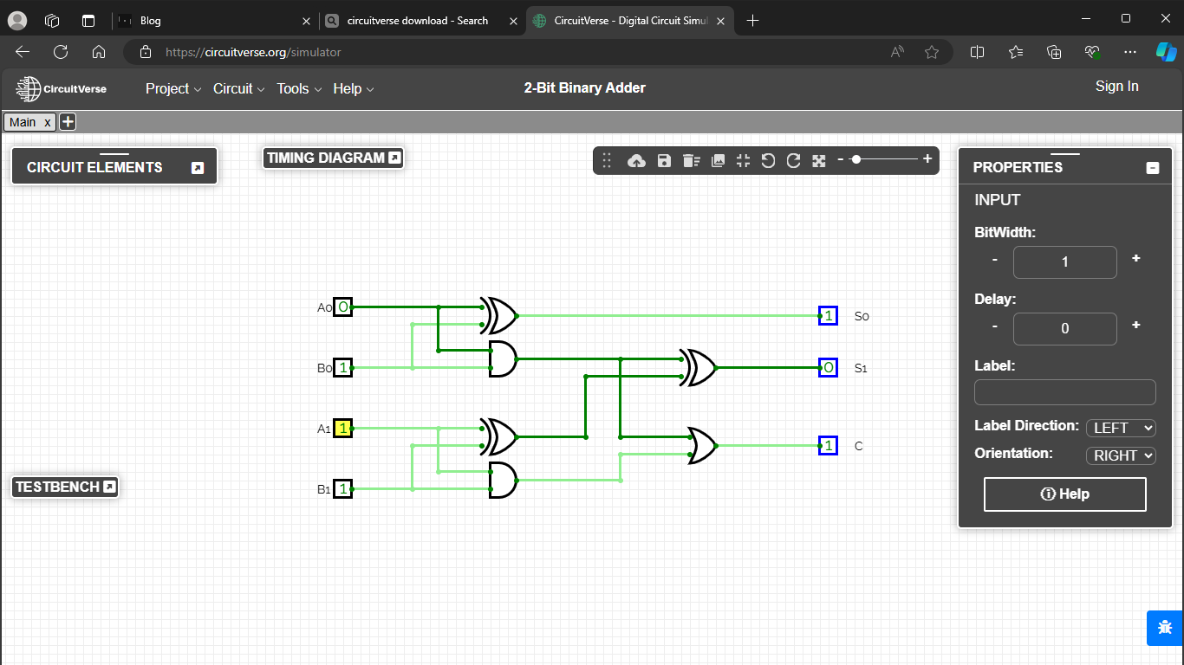

Here we were adding 2 and 1, which is 10 and 01 in binary and we were expecting 3 which is 011 in binary. The circuit output is 011 so the circuit works.

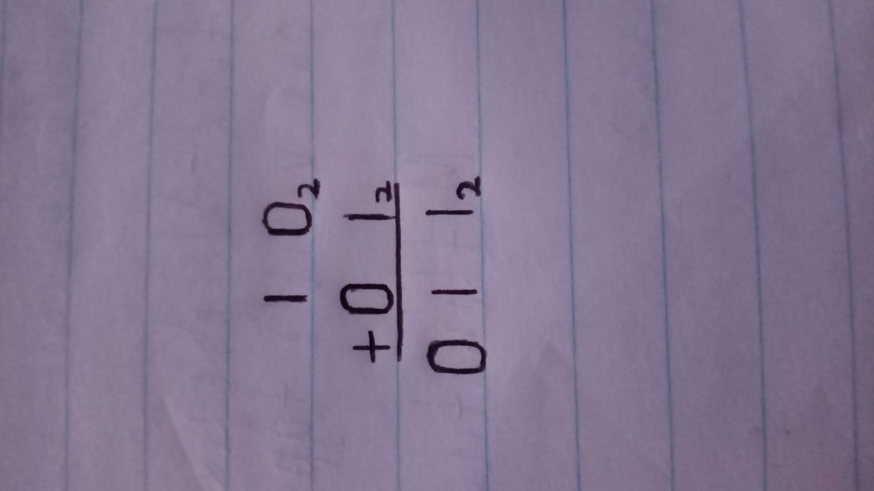

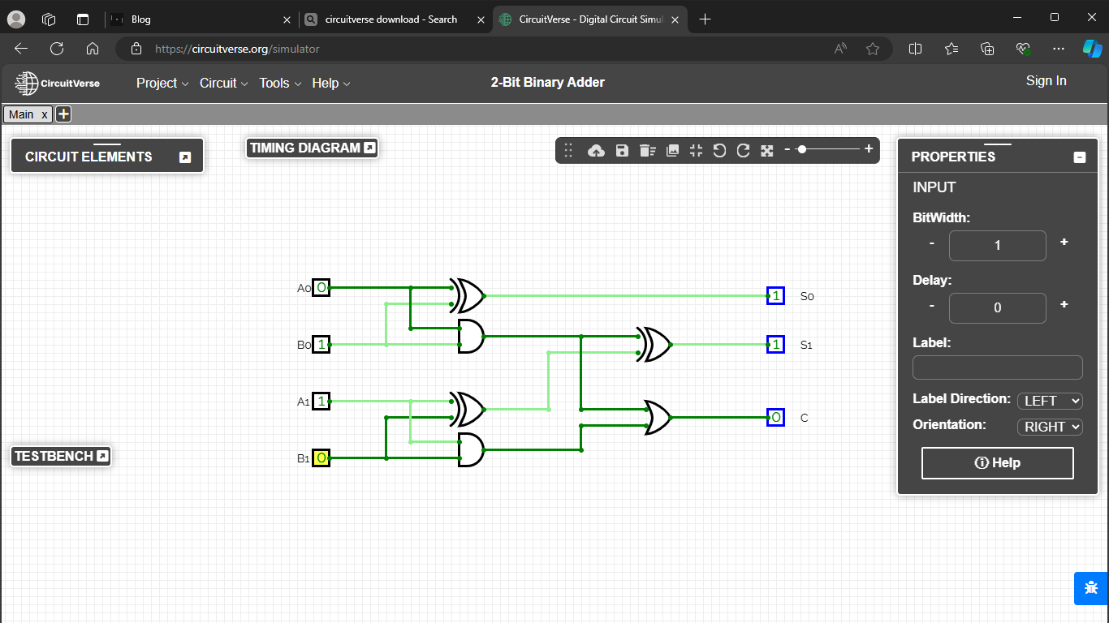

**Problems encounters:**

The main challenge was to have the final carry generated from the carries of the two half adders connected by the OR gate. When adding 01 and 01, the resulting sum was 110 as shown in the circuit below.

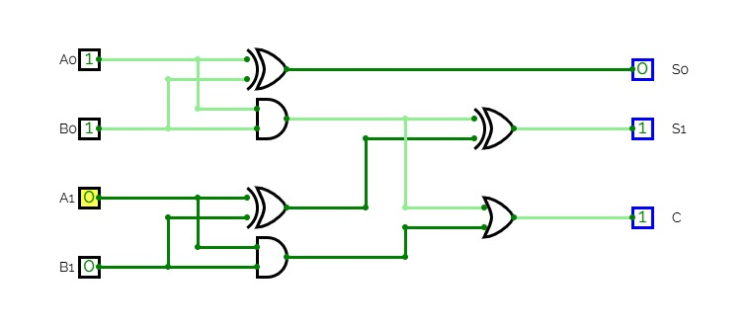

But this problem was avoided by implementing the circuit to have the final carry as 0 when adding 01 and 01 to have 010 which is 2. Here is the correct and final circuit.

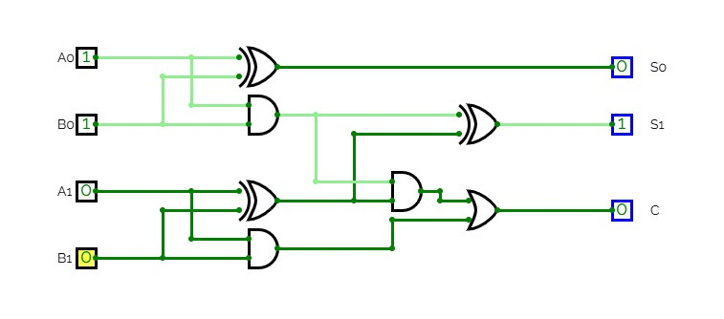

And so the circuit works properly.

Another challenging experience was the use of new and unfamiliar platform which in this case is GitHub. But with proper research and motivation the problem was overcome.