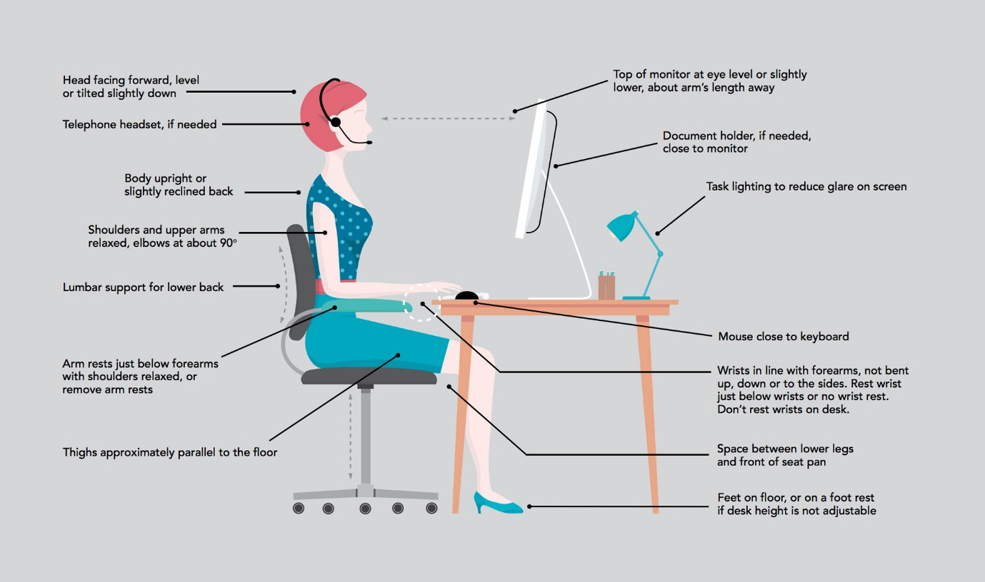

<https://www.citihealth.co.uk/workstation-assessments>

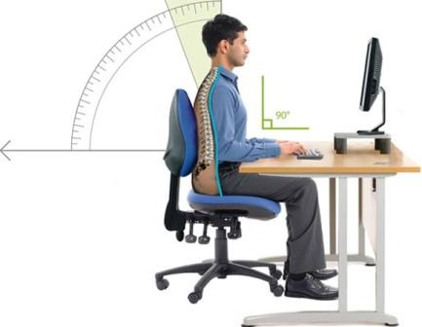

<https://www.hsl.gov.uk/dse-assessments-and-healthy-working>

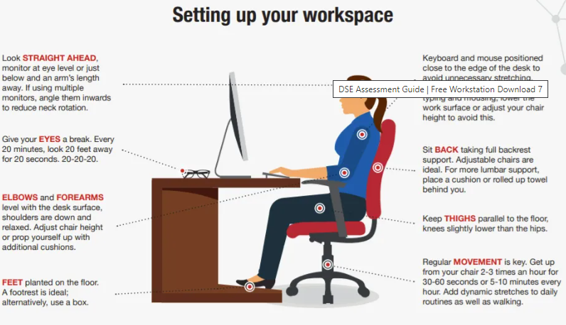

<https://safeti.com/dse-assessment-guide/>

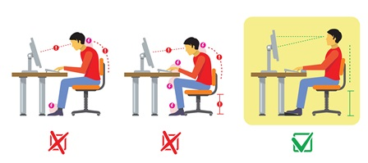

<https://www.essentialvitality.co.uk/what-is-a-dse-assessment-and-why-is-it-important/>

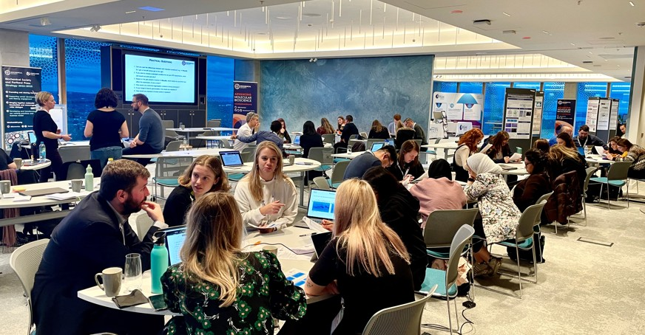https://www.txtacc.com/blog/2018/09/tips-for-organizing-your-next-training-session/

<https://www.biochemistry.org/events-and-training/>

[127959905](https://www.dreamstime.com/illustration-reindeer-snowman-chritmas-reindeer-snowman-chritmas-free-stock-photo-image-free-127959905) © [Adrenalinapura](https://www.dreamstime.com/adrenalinapura_info) | [Dreamstime.com](https://www.dreamstime.com/stock-photos)

<a href="https://www.dreamstime.com/illustration-reindeer-snowman-chritmas-reindeer-snowman-chritmas-free-stock-photo-image-free-127959905">127959905</a> © <a href="https://www.dreamstime.com/adrenalinapura_info">Adrenalinapura</a> | <a href="https://www.dreamstime.com/stock-photos">Dreamstime.com</a>

[14169451](https://www.dreamstime.com/digital-world-stock-image-image-free-14169451) © [Ajv123ajv](https://www.dreamstime.com/ajv123ajv_info) | [Dreamstime.com](https://www.dreamstime.com/stock-photos)

<a href="https://www.dreamstime.com/digital-world-stock-image-image-free-14169451">14169451</a> © <a href="https://www.dreamstime.com/ajv123ajv_info">Ajv123ajv</a> | <a href="https://www.dreamstime.com/stock-photos">Dreamstime.com</a>

[2580147](https://www.dreamstime.com/red-map-world-free-stock-photography-image-free-2580147) © [Oleksandr Svitlovskyi](https://www.dreamstime.com/svetlovskiy_info) | [Dreamstime.com](https://www.dreamstime.com/stock-photos)

<a href="https://www.dreamstime.com/red-map-world-free-stock-photography-image-free-2580147">2580147</a> © <a href="https://www.dreamstime.com/svetlovskiy_info">Oleksandr Svitlovskyi</a> | <a href="https://www.dreamstime.com/stock-photos">Dreamstime.com</a>

[120433161](https://www.dreamstime.com/healthy-food-background-concept-fruit-vegetable-pulses-grain-high-antioxidants-anthocyanins-vitamins-rustic-stock-image-image-free-120433161) © [Marilyn Barbone](https://www.dreamstime.com/marilyna_info) | [Dreamstime.com](https://www.dreamstime.com/stock-photos)

<a href="https://www.dreamstime.com/healthy-food-background-concept-fruit-vegetable-pulses-grain-high-antioxidants-anthocyanins-vitamins-rustic-stock-image-image-free-120433161">120433161</a> © <a href="https://www.dreamstime.com/marilyna_info">Marilyn Barbone</a> | <a href="https://www.dreamstime.com/stock-photos">Dreamstime.com</a>

[82890165](https://www.dreamstime.com/fields-heart-no-not-all-can-share-accept-do-you-want-to-receive-special-things-re-able-faithfully-free-stock-photo-image-free-82890165) © [publicdomainstockphotos](https://www.dreamstime.com/publicdomainstockphotos_info) | [Dreamstime.com](https://www.dreamstime.com/stock-photos)

<a href="https://www.dreamstime.com/fields-heart-no-not-all-can-share-accept-do-you-want-to-receive-special-things-re-able-faithfully-free-stock-photo-image-free-82890165">82890165</a> © <a href="https://www.dreamstime.com/publicdomainstockphotos_info">publicdomainstockphotos</a> | <a href="https://www.dreamstime.com/stock-photos">Dreamstime.com</a>

Image by <a href="https://www.freepik.com/free-vector/international-group-women-with-flat-design_3253680.htm#from_view=detail_alsolike">Freepik</a>

<https://www.dreamstime.com/photos-images/training.html>