
GANDAKI UNIVERSITY
BIT PROGRAM
Gyankunja-32, Pokhara

A
Project Proposal on
“AgriSathi: AI-Powered Agricultural Intelligence for Gandaki Province”
Submitted By:
Aswin Panta
Shadbhav Regmi
Salina Kunwar
Submitted To:
BIT Program, 2026

Table of Contents
TITLE PAGE NO.
- Introduction
  - Background 1
  - The Solution: AgriSathi 1
  - Statement of Problem 1-2
  - Objectives 2
  - Scope of Project 2
  - Limitations 2
- Literature Review 3
- Methodology 4-5
- Project Schedule 6
- Expected Outcome 7
- References 8
List of Tables
2.1 Literature Review Table 3
List of Figures
Fig 3.1. Flowchart of the User Side of the System 5
Fig 4.1. Gantt Chart 6

- Introduction
  - Background
Agriculture is the backbone of Nepal’s economy, employing a majority of the population. In Gandaki Province, however, the sector faces a critical junction between traditional practices and the urgent need for digital modernization. Currently, farmers grapple with devastating crop diseases (e.g., Late Blight, Bacterial Wilt), climate vulnerability, and limited market access. Simultaneously, governance bodies struggle with a lack of real-time data, often relying on outdated annual reports for policy-making. There is an urgent demand for a unified, smart system that bridges the gap between field-level realities and regional planning.

  - The Solution: AgriSathi
AgriSathi is an AI-powered agricultural intelligence platform designed for Gandaki Province. It consists of:
- A Mobile Application for Farmers
- A Web Dashboard for Government and Administrators
The system integrates AI-based disease detection, real-time climate analytics, and market intelligence. AgriSathi creates a continuous feedback loop between farmers and policymakers, enabling sustainable farming and evidence-based governance.

  - Statement of Problem
The agricultural ecosystem in Gandaki Province currently faces the following critical challenges:
- Crop Health & Yield Loss: Farmers suffer substantial economic losses due to the inability to diagnose crop diseases (like Rice Blast) early. The lack of immediate expert consultation leads to preventable yield reductions.
- Digital Divide & Generic Advisories: Existing systems provide generic advisories rather than location-specific recommendations. A digital divide exists where rural farmers lack access to complex data tools.
- Climate Vulnerability: There is an absence of localized early warning systems for floods, droughts, and frost, leaving farmers unprepared against climate variability.
- Market Inefficiency: Weak market linkages force farmers to depend on middlemen, reducing their profits. There is no mechanism for price prediction or cost-benefit analysis.
- Governance Gaps: Policymakers lack a centralized system to track live crop patterns or yield trends, resulting in delayed interventions and subsidy distribution based on assumptions rather than evidence.
OR :
The major problems in the current agricultural ecosystem are:
- Farmers cannot diagnose crop diseases early, leading to severe yield loss
- Existing advisory systems are generic and not location-specific
- There is no localized early warning system for floods, frost, or drought
- Farmers lack transparent market price information and predictions
- Government agencies lack centralized, real-time agricultural data

  - Objectives
General Objective:
- To develop a smart agricultural intelligence platform that supports sustainable farming, enhances commercialization, and enables evidence-based governance in Gandaki Province.
Specific Objective:
- To empower farmers with “AI-driven disease detection” (achieving 95%+ accuracy) for instant diagnosis and treatment.
- To provide “localized, real-time weather and climate advisories” based on altitude and traditional calendars.
- To centralize agricultural data into a “government web dashboard” for real-time monitoring of crop patterns and climate stress zones.
- To support policymakers with “evidence-based insights” for planning interventions and allocating subsidies.
- To enhance “market intelligence” by offering price predictions and cost-benefit analysis to optimize selling decisions.
- To ensure “multi-modal accessibility” (Mobile Web, WhatsApp, SMS, Voice) to bridge the digital divide.

  - Scope of Project
The scope of the project includes:
    - Mobile Application (Farmer Interface):
The mobile application supports farmers in managing crops and farming activities.
- AI Diagnostics: Detects crop diseases using plant images and suggests treatments.
- Climate Adaptation: Provides weather updates and alerts for floods, frost, and drought.
- Market Intelligence: Displays current market prices and demand trends.
- Data Input: Allows farmers to enter crop details and yield information.
- Communication: Uses WhatsApp, SMS, and voice calls for easy access, even without internet.
    - Web Application (Government/Admin Interface):
The web application helps government officials monitor and manage agriculture data.
- Live Dashboard: Shows real-time information on crops grown by farmers.
- Data Analytics: Analyzes crop, soil, and climate data to identify risk areas.
- Market Analysis: Predicts crop shortages and surpluses for planning.
- Governance Tools: Supports subsidy planning, tracking, and reporting.
- Early Warning System: Monitors climate risks and sends alerts to affected regions.

  - Limitations
- AI accuracy depends on the quality of training datasets
- Internet connectivity is required for real-time features
- Initial version supports limited crop varieties
- Performance may vary on low-end smartphones

- Literature Review
S.N. | Study | Findings
1 | Digital Nepal Framework (GoN, 2019) | - Identifies smart agriculture and real-time data systems as national priorities
2 | FAO – ICT in Agriculture (2021) | - Early warning systems reduce crop losses by 30–40%
3 | KU Study on Digital Agriculture (2022) | - Farmers prefer localized advisories over generic ones
4 |  | - AI improves disease detection and yield forecasting
  McKinsey – AI in Agriculture (2023)

Fig. 2.1. Literature Review Table

- Methodology
- Research and Planning:
- Conduct surveys and interviews with farmers and government officials to identify key challenges in crop management, climate adaptation, and market access.
- Analyze existing agricultural platforms and government reports to find gaps and opportunities for AI-based solutions.
- Define system architecture, select technology stack, and plan multi-modal accessibility (mobile, WhatsApp, SMS, voice).
Tools:
- Frontend: HTML, CSS, JavaScript, Bootstrap
- Mobile App: React Native or Flutter
- Backend: PHP or Node.js/Express
- AI/ML: Python (TensorFlow, OpenCV, scikit-learn)
- Database: MySQL or MongoDB

- Data and AI Development:
- Collect datasets on crop diseases, images, climate patterns, and market prices.
- Preprocess images and tabular data for training AI and ML models.
- Train AI models for plant disease detection using image recognition.
- Develop ML models for market price prediction and crop yield forecasting.
- Validate models with real-world data and iterative testing.

- Application Development
- Build responsive mobile application for farmers with AI diagnostics, climate alerts, and market information.
- Develop web dashboard for government officials with live crop monitoring, analytics, and early warning systems.
- Integrate AI/ML engines with the mobile app and web dashboard for real-time predictions.
- Implement data input, tracking, and multi-modal communication (WhatsApp, SMS, voice).

- Testing and Launch
- Conduct functional testing for all modules (mobile and web).
- Perform AI accuracy testing for disease detection, yield prediction, and market forecasting.
- Test UI/UX and accessibility for farmers with varying tech literacy.
- Deploy the system on cloud servers and monitor performance.
- Collect feedback from farmers and officials for future improvements.

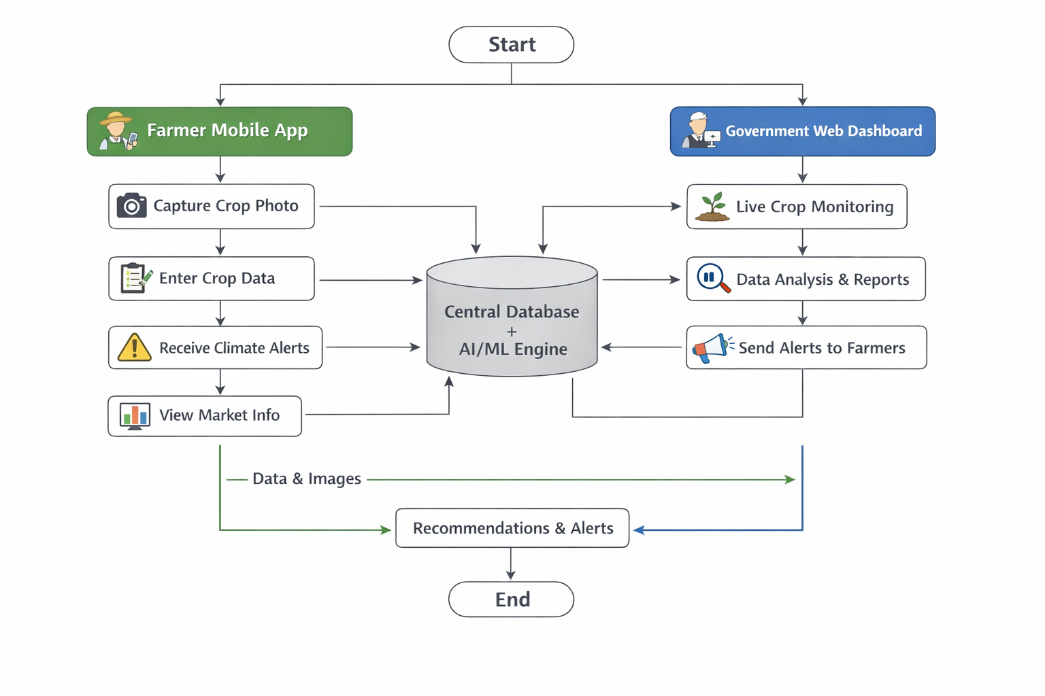
Fig.3.1 AgriSathi System Flowchart: : Shows the overall workflow between the Farmer Mobile App, Central Database/AI Engine, and Government Web Dashboard.
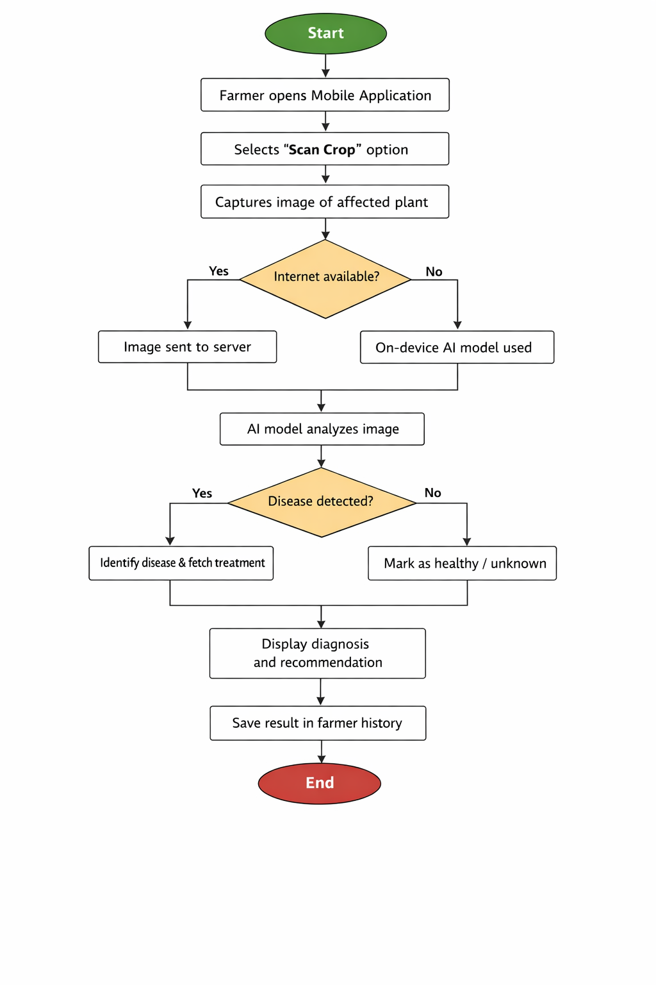
Fig.3.2 AI-Based Crop Disease Detection Flowchart: Shows the step-by-step process of disease detection in the mobile app, including offline/online analysis and treatment recommendation.

- Project Schedule
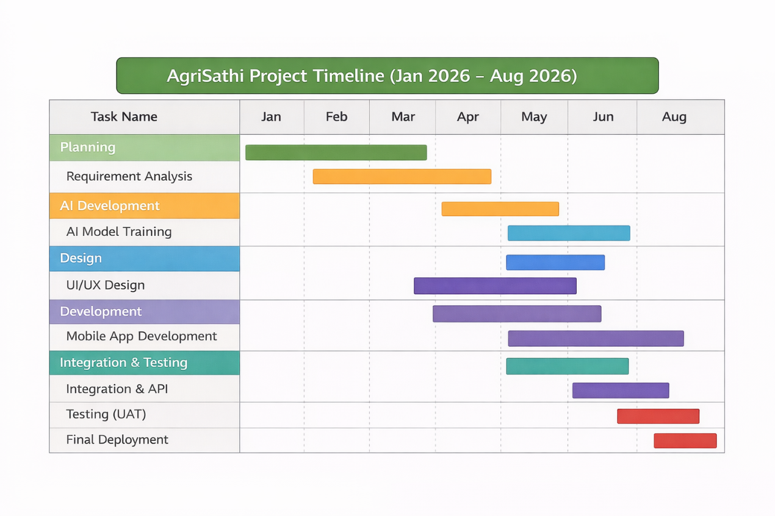
Fig 4.1. Gantt Chart

- Expected Outcome
- Reduced crop losses through early detection
- Increased farmer income through market intelligence
- Improved climate resilience
- Evidence-based agricultural governance
- Strengthened agricultural value chain

- References
- Government of Nepal. (2019). Digital Nepal Framework
- FAO. (2021). Adoption of ICT in Agriculture
- Kathmandu University. (2022). Digital Agriculture in Nepal
- McKinsey & Company. (2023). AI in Agriculture Applications

