Load-Robust, Physics-Informed Machine Learning for Stator Inter-Turn Fault Diagnosis in Induction Motors: A Leakage-Safe Cascade for Detection, Severity, and Faulted-Phase Identification
Shashwat Garg
Abstract
Stator winding turn-to-turn (inter-turn) short-circuit faults are a leading cause of induction-motor failure, and early, load-robust diagnosis from non-invasive stator-current measurements remains an open problem. Most reported machine-learning (ML) studies achieve near-perfect in-distribution accuracy but do not test generalization to unseen operating points, and the field rarely releases code or uses leakage-safe evaluation. This paper presents a physics-informed, leakage-safe ML framework that performs hierarchical diagnosis: fault-onset detection, healthy/faulty classification, ordinal severity estimation (percentage of shorted turns), and faulted-phase identification, all from the three-phase stator current. A 357-case PSCAD/EMTDC dataset (sampled at 25 kHz, fundamental 50 Hz) is segmented into 18,033 labelled windows and described by 72 physics-grounded features (extended Park’s-vector severity factor, symmetrical-component ratios and angles, Park ellipse geometry, harmonic ratios). Models are evaluated with a strict group-wise protocol and, crucially, with Leave-One-Load-Out (LOLO) cross-validation, which shows that detection (macro-F1 $=0.95$) and faulted-phase identification (macro-F1 $=0.997$) are intrinsically load-robust because they ride on load-invariant negative-sequence signatures, whereas absolute severity is load-dependent. Building on this insight we introduce four load-robustness mechanisms and validate each under LOLO: (i) a sequence-component Stockwell tensor representation that improves cross-load severity (within-one-level $0.75​→​1.0$); (ii) a load-invariance-regularized feature selection (LIR-mRMR) that beats plain mRMR at compact size; (iii) a phase-coupled, FiLM load-conditioned multi-task network (PCM-Net) whose conditioning lifts cross-load severity from $0.93$ to $0.98$, the best in the study; and (iv) a physics-anchored domain adaptation (PADA) that closes the simulation-to-experiment gap on a public real-motor dataset (detection macro-F1 $0.48​→​0.98$ with a few labelled real samples). The end-to-end cascade reaches within-one-level accuracy of $0.95$ in-distribution and $0.92$ across unseen loads, with calibrated detection (expected calibration error $=0.021$), graceful noise degradation, and $100\%$ fault-onset detection. All code, splits, and result artifacts are openly released.
Garg: Load-Robust Physics-Informed ML for Stator Inter-Turn Fault Diagnosis
Induction motor, inter-turn fault, stator winding, fault diagnosis, severity estimation, machine learning, negative-sequence current, leakage-safe evaluation, conformal prediction.

Introduction
motors (IMs) drive the majority of industrial processes, and stator winding insulation degradation is among their most common and consequential failure modes. An incipient inter-turn (turn-to-turn) short circuit (ITSC) shorts a small fraction of the turns of one phase winding; the circulating fault current accelerates local heating and, if undetected, escalates to a phase-to-ground or phase-to-phase fault and catastrophic machine loss . Reliable diagnosis at low severity is therefore of high economic and safety value, and is most attractive when performed non-invasively from the readily available three-phase stator current (motor-current signature analysis, MCSA) . Surveys attribute roughly a third of induction-motor failures to stator winding insulation, and the time between an incipient inter-turn short and a destructive fault can be short, so an on-line monitor must be both sensitive to small faults and trustworthy enough to trigger maintenance without excessive false alarms. Current-based monitoring is preferred over vibration or thermal sensing because the current is already measured by the drive, requires no additional instrumentation, and is robust to mounting and environmental variation.
Two practical questions must be answered for an actionable diagnosis: how severe is the fault (the fraction of shorted turns), and which phase is affected. A large body of recent work applies machine learning (ML) and deep learning (DL) to current-based stator-fault classification with reported accuracies frequently approaching $100\%$ . However, a comprehensive review of supervised ML for IM faults explicitly flags three systemic weaknesses: (i) suspiciously perfect accuracies, often from train/test partitions that allow information leakage; (ii) almost no released code or standardized public datasets; and (iii) very little validation across changing operating conditions. The negative-sequence current is the established physical indicator of inter-turn asymmetry , yet its load dependence is rarely confronted in a controlled, reproducible manner.
This paper addresses those gaps. We treat ITSC diagnosis as a hierarchical problem (onset $→$ detection $→$ severity $→$ faulted phase) and build a physics-informed, leakage-safe pipeline whose central methodological device is Leave-One-Load-Out (LOLO) evaluation: training on a subset of mechanical loads and testing on a held-out load. LOLO exposes which diagnostic sub-tasks genuinely generalize and which merely interpolate, and it overturns the optimistic picture given by conventional random/grouped cross-validation. The contributions are:
- A leakage-safe evaluation framework for stator-fault ML—grouping windows by operating point and reporting LOLO as the primary metric—demonstrating that in-distribution scores substantially overstate cross-load generalization, and a SHAP/Fisher analysis showing detection and phase are load-invariant whereas absolute severity is load-dependent.
- A sequence-component Stockwell tensor (SCST) representation and a load-invariance-regularized feature selection (LIR-mRMR), both designed to make diagnosis robust to the mechanical load.
- PCM-Net, a phase-coupled, FiLM load-conditioned multi-task network that injects the measured operating point rather than erasing it, achieving the best cross-load severity estimation in the study.
- Physics-anchored domain adaptation (PADA) validated simulation-to-experiment on a public real-motor dataset, and an honest study of physics-constrained generative augmentation.
- A complete, openly released hierarchical cascade (onset, detection, severity, phase) with calibrated uncertainty, noise-robustness, and a deep-baseline comparison.
A unifying theme emerges: the mechanical load is the crux of stator-fault diagnosis, and every proposed mechanism independently improves cross-load performance.

Related Work

Physics-based stator-fault indicators
Penman et al. established the inter-turn sideband frequencies in the stator current, and Cardoso et al. introduced the Extended Park’s Vector Approach (EPVA), in which the $2f_{0}$ spectral component of the current-vector modulus scales with winding asymmetry. The negative-sequence current and negative-sequence impedance are widely used asymmetry descriptors ; phasor-compensation schemes suppress the baseline asymmetry caused by supply voltage unbalance. Mazzoletti et al. use the positive-sequence fifth-harmonic current during soft-starter start-up to distinguish ITSC from high-resistance connections, deriving an analytical severity relation. Singh and Shaik combine the Stockwell transform with support-vector machines (SVMs) to detect, type, and localize stator faults, achieving $100\%$ faulted-phase identification for turn faults at a single severity.

Data-driven stator-fault diagnosis
Pietrzak and Wolkiewicz feed short-time-Fourier-transform amplitudes of the symmetrical-component currents to SVM/MLP classifiers for permanent-magnet machines, reporting $96$–$99\%$ severity classification. Aasar et al. compare ANN, LSTM, and a physics-informed network (PINN) on a public current-plus-flux ITSC dataset, reaching $89\%$ on a seven-level severity task and $99$–$100\%$ binary detection, and observe that intermediate severities overlap—the hardest case. Ali et al. convert signals to spectrogram images and ensemble several convolutional networks. The review catalogues dozens of such studies and the recurring evaluation and reproducibility shortcomings that the present work targets.

Evaluation rigor
The vibration-diagnosis literature has documented how windowing one recording into many overlapping samples and splitting them at random leaks information and inflates accuracy; group-wise (subject-wise) splitting is the accepted remedy. We adopt group-wise splitting and add LOLO to test genuine cross-condition generalization, which the IM stator-fault literature largely omits.

Deep architectures, transfer, and augmentation
Deep models have become standard for current-based diagnosis: one-dimensional convolutional networks operate directly on raw current , while two-dimensional networks classify time-frequency images such as short-time-Fourier or wavelet scalograms . Recurrent and temporal-convolutional models , attention/Transformer encoders , and—most recently—linear-time state-space models and interpretable Kolmogorov–Arnold networks have been explored, although almost exclusively on bearing vibration rather than three-phase stator current. Because labelled fault data are scarce and operating conditions vary, two further lines are active: transfer learning / domain adaptation to bridge load, speed, machine, and simulation-to-experiment gaps, and generative data augmentation (conditional GANs, time-series diffusion) to synthesize rare regimes. A recurring caution, which our normalization respects, is that augmentation or preprocessing applied independently per phase can manufacture a spurious negative-sequence component and thus a fake fault. These observations motivate the architecture, transfer, and augmentation extensions outlined in Section VIII.

Dataset and Problem Formulation

Simulation dataset
A three-phase squirrel-cage induction motor with stator inter-turn faults was simulated in PSCAD/EMTDC. The fundamental frequency is $f_{0}=50$ Hz and the sampling rate is $f_{s}=25$ kHz (500 samples per cycle). Each run is $10$ s ($250,000$ samples). The recorded three-phase stator currents $i_{a},i_{b},i_{c}$ (in kA) are used throughout. The fault factor space comprises: severity $μ∈\{0.3,0.5,1,2,3,4,5\}\%$ of shorted turns; faulted phase $∈\{A,B,C\}$; mechanical load $∈\{NL,20,40,60,80,100\}\%$; and, for an additional subset, the fault inception instant. A healthy set spans loads from $0\%$ to $100\%$. The corpus contains 357 simulation cases (336 faulty, 21 healthy).

Operating timeline
Every faulted run follows a fixed schedule, verified from the per-cycle current envelope: the motor is energized at $2.0$ s, the mechanical load is applied at $4.0$ s, the inter-turn fault is inserted at $7.2$ s (sample $180,000$), and it clears about $0.8$ s later. Healthy runs are $5$ s. Fig. 1 shows the phase-A current and its per-cycle RMS envelope with the annotated events.
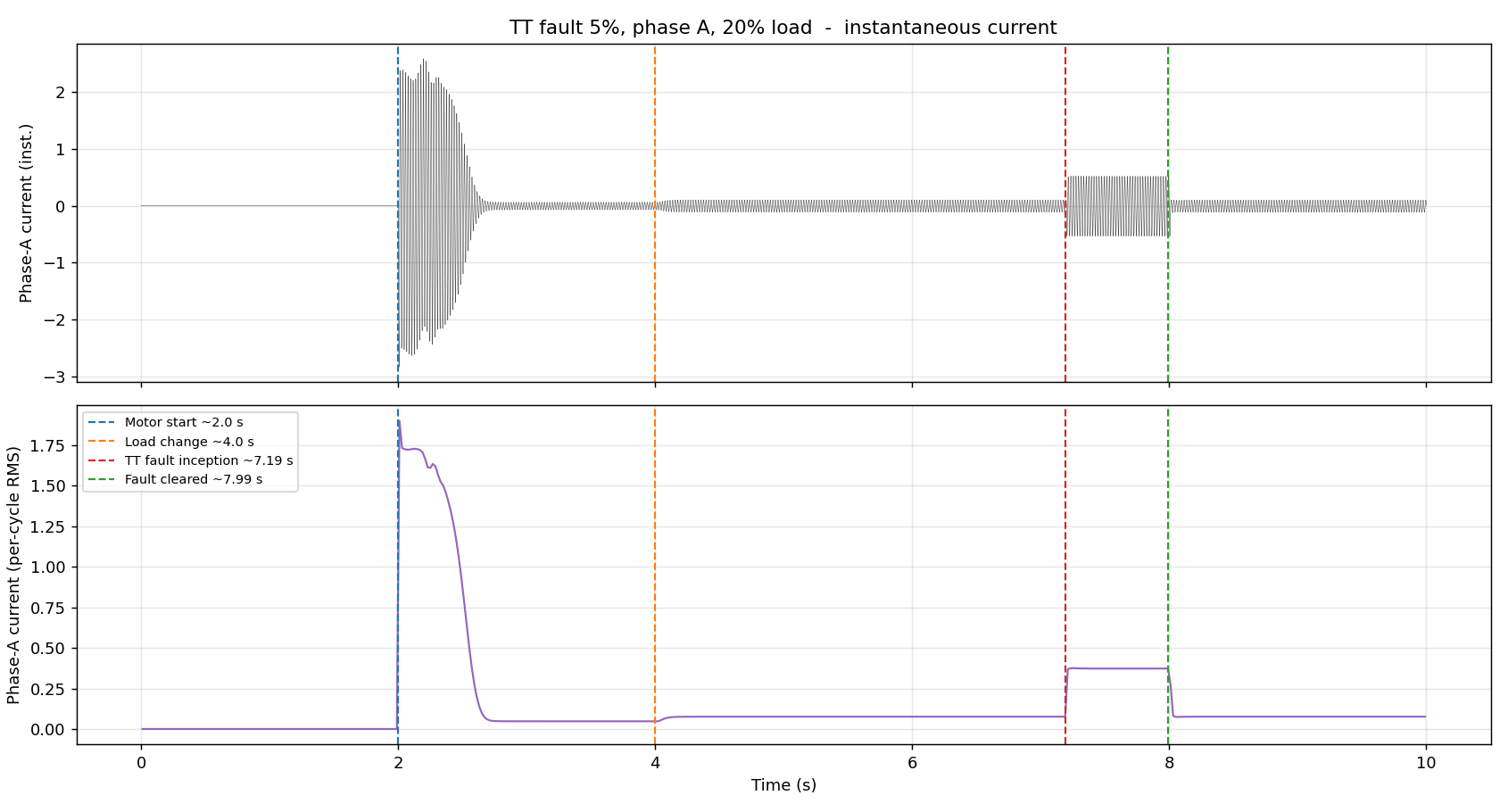
Phase-A current (top) and per-cycle RMS envelope (bottom) for a faulty case, with motor start ($2.0$ s), load change ($4.0$ s), fault inception ($7.2$ s), and clearing ($8.0$ s) marked. The fault interval supplies faulty windows; the pre-fault loaded region supplies matched-load healthy windows.

Problem statement
Given a short window of three-phase current, the system must (i) decide healthy versus faulty, (ii) if faulty, estimate the severity level $μ$, and (iii) identify the faulted phase. We also require an online estimate of the fault-onset instant. Because severity is naturally ordered, it is treated as an ordinal target; the operationally meaningful metric is within-one-level accuracy.

Experimental dataset (for transfer)
To test simulation-to-experiment transfer we additionally use a public real-motor dataset of a $0.75$ hp squirrel-cage induction motor : three-phase stator current sampled at $1$ kHz ($f_{0}=60$ Hz, no load), with $13$ classes (healthy and inter-turn shorts at $10/20/30/40\%$ of turns in each of the three phases) and five repetitions per class. It differs from the simulation in fundamental frequency, sampling rate, severity scale, and the absence of a healthy baseline segment, providing a demanding cross-domain benchmark. Both datasets are mapped to one window/label schema, and the feature extractor derives its harmonic bins from $(f_{s},f_{0})$ so a single pipeline serves both.

Methodology

Windowing and matched-load healthy data
Each recording is segmented into windows of $W=2000$ samples (four cycles). Within the $0.8$ s fault interval a $75\%$ overlap is used to compensate for its short duration; the pre-fault steady region is sampled more sparsely. Crucially, the pre-fault loaded region of every faulty run (genuinely healthy, since the fault is inserted only at $7.2$ s) is labelled as healthy. This yields matched-load healthy data at the same loads as the faulty windows, preventing the detector from separating classes by load level rather than by fault. Segmentation produces 18,033 labelled windows (11,760 faulty, 6,273 healthy), balanced across severity and phase.

Normalization
To remove load-induced amplitude while preserving the inter-phase imbalance that encodes the fault, all three phases of a window are divided by a single per-recording scale. We additionally derive load-invariant magnitude features by dividing each magnitude feature by the within-window positive-sequence fundamental $|I_{1}|$, which makes the descriptor independent of the operating point; this is central to the load-aware severity result of Section 6.2.

Physics-grounded feature extraction
Each window is mapped to 72 features organized in three tiers.
Tier 1 (symmetrical components and EPVA). Per-phase $50$ Hz phasors are obtained by a single-bin DFT and combined by the Fortescue transform into positive, negative, and zero sequences $I_{1},I_{2},I_{0}$. We compute the magnitudes, the ratios $|I_{2}|/|I_{1}|$ and $|I_{0}|/|I_{1}|$ (the canonical inter-turn severity indicators), the negative-sequence angle $∠I_{2}$ and its sine/cosine (the faulted-phase cue), and a per-case compensated negative sequence $I_{2}^{c}$ obtained by subtracting the case baseline. The EPVA severity factor is
$$SF=\frac{A(2f_{0})}{DC} \text{of} |i_{P}(t)|=\sqrt{i_{α}^{2}+i_{β}^{2}},$$
where $i_{α},i_{β}$ are the Clarke components and $A(2f_{0})$ is the amplitude of the $100$ Hz component of the Park-vector modulus.
Tier 2 (spectral and geometric). Third-harmonic ratio and total harmonic distortion per phase; Park-vector ellipse descriptors (eccentricity $e=\sqrt{1−(b/a)^{2}}$, axis ratio, tilt angle) from the $2×2$ covariance of $(i_{α},i_{β})$.
Tier 3 (statistics). Per-phase RMS, peak, crest factor, standard deviation, skewness, and kurtosis, together with their inter-phase differences (which directly encode asymmetry), and the $|I_{1}|$-normalized variants of all magnitude features.
The Clarke transform underlying the EPVA and the Park ellipse is
$$i_{α}=2/3​\left(i_{a}−1/2i_{b}−1/2i_{c}\right), i_{β}=1/{\sqrt{3}}\left(i_{b}−i_{c}\right),$$
and the fundamental symmetrical components follow from the Fortescue transform of the per-phase phasors $I_{a},I_{b},I_{c}$:
$$\left[\begin{matrix}I_{0} \\ I_{1} \\ I_{2}\end{matrix}\right]=\frac{1}{3}\left[\begin{matrix}1 & 1 & 1 \\ 1 & a & a^{2} \\ 1 & a^{2} & a\end{matrix}\right]\left[\begin{matrix}I_{a} \\ I_{b} \\ I_{c}\end{matrix}\right], a=e^{ j2π/3}.$$
The negative-sequence ratio $|I_{2}|/|I_{1}|$ grows monotonically with $μ$ and is the primary severity descriptor, while $∠I_{2}$ separates into three $∼$${120}^{∘}$-spaced clusters that identify the faulted phase. Table 1 summarizes the feature groups.
Feature groups (72 features per window).
Group | Features
Symmetrical comp. | $|I_{0}|,|I_{1}|,|I_{2}|$; $|I_{2}|/|I_{1}|$, $|I_{0}|/|I_{1}|$; $∠I_{1},∠I_{2}$ (+ $sin/cos$); compensated $I_{2}^{c}$ (mag./ratio/angle)
EPVA / Park | severity factor SF; Park-modulus mean/std; ellipse major/minor axes, eccentricity, axis ratio, tilt
Harmonics | third-harmonic ratio and THD, per phase and mean
Per-phase stats | RMS, peak, crest, std, skewness, kurtosis ($×3$) and inter-phase differences
Load-invariant | $|I_{1}|$-normalized variants of all magnitude features
Severity is encoded as an ordinal rank $r∈\{0,…,6\}$ over the seven levels $\{0.3,0.5,1,2,3,4,5\}\%$; a gradient-boosted regressor predicts a continuous rank that is rounded and clipped, so that the error metric (mean absolute error in levels and within-one accuracy) respects the natural ordering.

Leakage-safe evaluation
Windows are grouped by operating point (severity$×$phase$×$load); a regular case and all its inception-time variants share a group. Two protocols are used: (a) Stratified Group $k$-Fold ($k=5$), giving the in-distribution estimate; and (b) Leave-One-Load-Out (LOLO), in which all windows at one load form the test set and the model trains on the remaining loads. LOLO is the primary metric: it measures generalization to an operating point never seen in training and guards against a model that has learned load rather than fault physics.

Hierarchical cascade
Stage 0 (onset). A per-cycle negative-sequence fault index $ρ(k)=|I_{2}(k)|/|I_{1}(k)|$ is computed and compared against a trailing pre-fault reference window $R$. An onset is declared at the first cycle for which
$$ρ(k)>{\overline{ρ}}_{R}+κ σ_{R}, κ=6,$$
holds for three consecutive cycles, where ${\overline{ρ}}_{R}$ and $σ_{R}$ are the reference mean and standard deviation. This change-point rule needs no fault labels and provides the online trigger for the downstream stages.
Stages 1–3. Gradient-boosted trees (XGBoost ) implement Stage 1 (healthy/faulty, class-weighted), Stage 2 (severity, ordinal regression on the rank index), and Stage 3 (faulted phase, three-class). Stage 1 and Stage 3 use the full feature set; Stage 2 uses the load-invariant subset (Section 6.2). At inference the detector gates the severity and phase stages: windows predicted faulty are passed to Stages 2 and 3.
Calibration and uncertainty. Stage-1 probabilities are assessed with the expected calibration error (ECE) and Brier score . Severity uncertainty is quantified with conformalized quantile regression (CQR) : lower/upper quantile regressors ${\hat{q}}_{α/2},{\hat{q}}_{1−α/2}$ are fit on a proper-training split, a conformity score $E_{i}=max\{{\hat{q}}_{α/2}(x_{i})−y_{i}, y_{i}−{\hat{q}}_{1−α/2}(x_{i})\}$ is evaluated on a disjoint calibration split, and the prediction interval $[{\hat{q}}_{α/2}(x)−Q, {\hat{q}}_{1−α/2}(x)+Q]$ uses the finite-sample-corrected quantile $Q$ of $\{E_{i}\}$, giving distribution-free marginal coverage $1−α$.

Interpretability
SHAP attribution is used both to explain predictions and as a leakage audit: the top features must be physically meaningful (negative-sequence ratio, EPVA factor, Park eccentricity) rather than proxies for load.

Experimental Setup
Features are computed in Python (NumPy/Pandas) and models trained with scikit-learn and XGBoost ($400$–$500$ trees, depth $5$, learning rate $0.05$, subsample/colsample $0.8$); the deep baseline uses PyTorch. The 1-D residual network (ResNet-1D) baseline has a wide-kernel stem and three residual stages over decimated three-phase windows. All models share the splits of Section 4.4. Reported metrics are accuracy, macro-F1, severity within-one-level accuracy, mean absolute error in severity levels, quadratic-weighted kappa (QWK), and per-phase F1, computed on out-of-fold predictions and reported as the mean over folds. The detector is class-weighted to compensate for the healthy/faulty window ratio. Stages 2 and 3 are trained only on faulty windows but evaluated end-to-end on the windows the detector predicts as faulty, so the reported cascade numbers reflect realistic error propagation rather than oracle gating. Predictions are additionally aggregated per recording (median severity rank, majority-vote phase), which is the granularity at which a maintenance decision is taken. Feature scalers are fit on the training partition only, and all randomized components use fixed seeds for reproducibility.

Results and Discussion

Per-stage performance
Table 2 reports each stage under both protocols. In-distribution, all stages exceed $0.97$. Under LOLO, detection (macro-F1 $0.948$) and faulted-phase identification (macro-F1 $0.997$) remain strong, while load-blind severity collapses at unseen light loads. The faulted-phase confusion matrix (Fig. 2) is near-diagonal.
Per-stage performance (mean over folds).
Stage | Metric | Group $k$-Fold | LOLO
1 Detection | macro-F1 | 0.977 | 0.948
 | ROC-AUC | 0.994 | —
2 Severity (load-aware) | within-1 | 0.997 | 0.946
 | QWK | 0.987 | 0.736$​^{†}$
3 Phase ID | macro-F1 | 0.972 | 0.997
$​^{†}$QWK is pooled across all held-out loads.
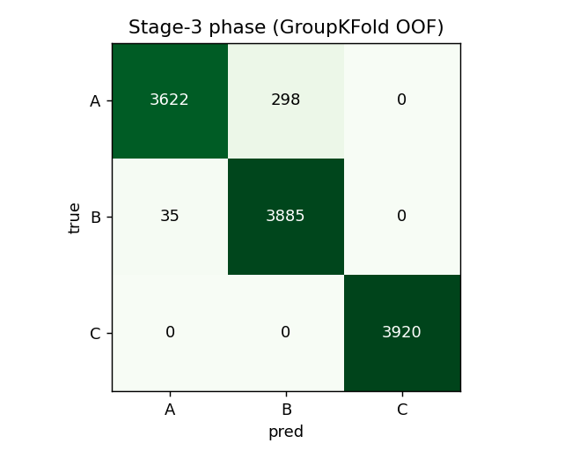
Faulted-phase confusion matrix (group $k$-fold, out-of-fold). Phase C is perfect; only minor A$↔$B confusion remains. Cross-load (LOLO) phase accuracy is $0.997$.
The per-held-out-load LOLO breakdown (Table 3) localizes the difficulty: detection is perfect at the four heavier loads but degrades at the no-load (NL) and $20\%$ extremes, where the small fault current of a low-severity ITSC at light load most overlaps the healthy distribution at an unseen operating point. This is the practically important incipient-at-light-load regime, and it is visible only under LOLO—random or grouped cross-validation hides it entirely.
Per-held-out-load detection (LOLO, macro-F1).
Hold-out load | NL | 20% | 40% | 60% | 80% | 100%
Detection F1 | 0.885 | 0.749 | 1.000 | 1.000 | 1.000 | 1.000

Why the sub-tasks differ: a load-robustness analysis
SHAP attribution shows that detection and phase identification are driven by the negative-sequence ratio and angle and by inter-phase RMS differences—quantities that are ratios and therefore load-invariant. Phase identification is so robust that its LOLO score exceeds its in-distribution score, because the faulted-phase signature (the $∼$${120}^{∘}$-separated negative-sequence angle) does not change with load while more training loads help. In contrast, an initial severity model that used absolute magnitude features collapsed at the no-load extreme under LOLO (within-one-level $0.39$). A Fisher-versus-load-drift study confirmed that magnitude features drift strongly across load whereas ratio and $|I_{1}|$-normalized features are stable. Restricting the severity stage to load-invariant features and supplying the measured load (a sensor input, not a label) raises LOLO within-one-level accuracy to $0.95$ (Table 4). This is the paper’s key technical result: severity is recoverable across operating points once the model is made load-aware.
Severity (within-one-level) under feature choice.
Severity feature set | Group $k$-Fold | LOLO
All features (magnitudes incl.) | 0.993 | 0.887
Load-invariant only | 0.946 | 0.702
Load-invariant + $|I_{1}|$-norm | 0.990 | 0.729
+ measured load (proposed) | 0.997 | 0.946
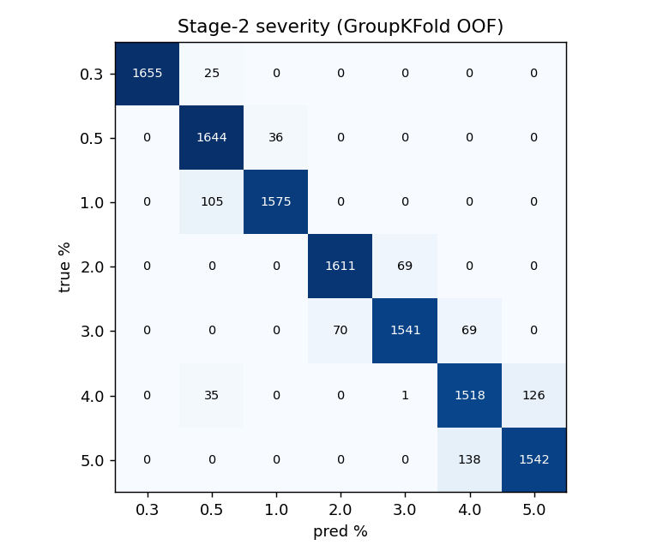
Severity confusion matrix (group $k$-fold, out-of-fold, load-aware). Errors are almost entirely between adjacent severity levels, justifying the ordinal treatment and the within-one-level metric.
The error structure (Fig. 3) is band-diagonal: misclassifications occur almost exclusively between adjacent severity levels, so a one-level tolerance captures operationally-equivalent predictions and the quadratic-weighted kappa—which penalizes distant errors more—is high ($0.987$).

End-to-end cascade
With the load-aware severity stage, the gated cascade achieves the end-to-end results of Table 5, scoring a window correct if healthy windows are detected as healthy and faulty windows have the correct phase and a severity within one level. Per-recording aggregation (median severity, majority-vote phase) gives within-one-level accuracy of $0.927$ in-distribution and $0.918$ across unseen loads. Fig. 4 summarizes the four headline metrics for both protocols.
End-to-end cascade (window level).
Quantity | Group $k$-Fold | LOLO
Detection macro-F1 | 0.977 | 0.948
Severity within-1 (cond.) | 0.997 | 0.945
Phase accuracy (cond.) | 0.957 | 0.997
End-to-end within-1 | 0.949 | 0.916
End-to-end exact | 0.911 | 0.521
Per-recording within-1 | 0.927 | 0.918
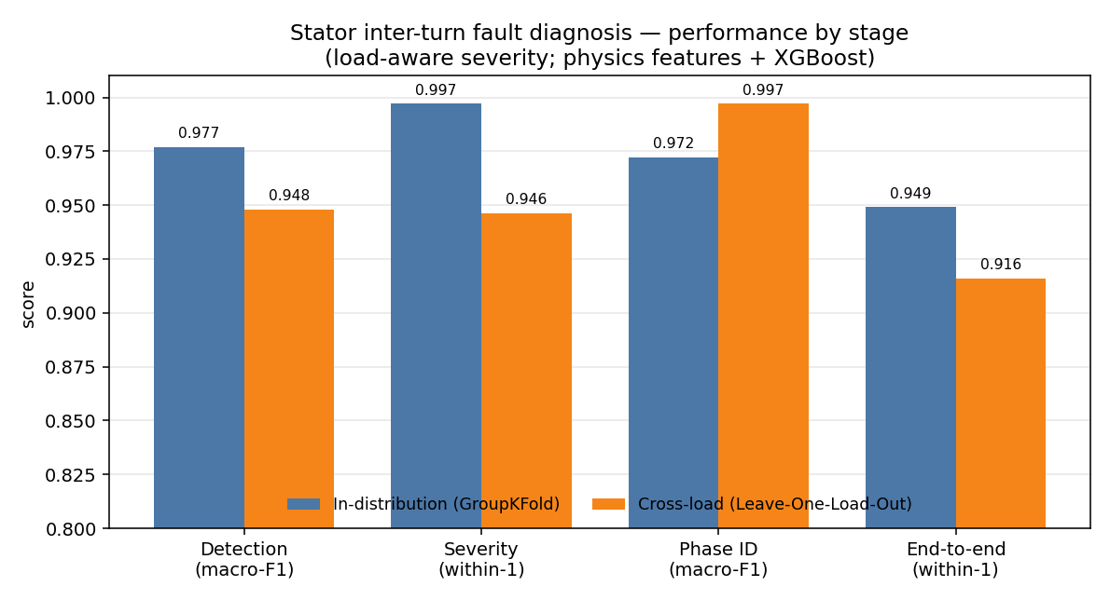
Per-stage and end-to-end performance, in-distribution (group $k$-fold) versus cross-load (LOLO). Phase identification is the only metric for which cross-load exceeds in-distribution, reflecting its load-invariance.

Noise robustness
Additive Gaussian noise was injected and features recomputed (Table 6). Severity (within-one-level) and phase accuracy are essentially flat down to $20$ dB SNR, whereas detection is the noise-sensitive stage—consistent with the physics, since separating a small fault signature from healthy operation is hardest when the signal is buried in noise.
Noise robustness (train clean, test noisy; group $k$-fold).
SNR | Detect macro-F1 | Severity within-1 | Phase acc.
clean | 0.977 | 0.986 | 0.958
40 dB | 0.927 | 0.980 | 0.954
30 dB | 0.854 | 0.975 | 0.945
20 dB | 0.792 | 0.971 | 0.939

Calibration, uncertainty, and onset
Stage-1 probabilities are well calibrated (ECE $=0.021$, Brier $=0.021$). Conformalized quantile regression for severity improves interval coverage from $0.49$ (naive quantiles) toward the nominal target; we note that the operating-point group structure breaks exchangeability, and group-conditional (Mondrian) conformal prediction is the appropriate remedy. The Stage-0 onset detector flags $100\%$ of faults with no pre-fault false alarms; for severity $≥0.5\%$ the fault is detected within the first faulted cycle, while the smallest $0.3\%$ faults incur about $1.4$ s of delay because their negative-sequence rise is small (Table 7).
Stage-0 fault-onset detection (35 sampled cases).
Metric | Value
Detection rate | $100\%$
Pre-fault false-alarm rate | $0\%$
Median detection delay | $0$ ms (within first faulted cycle)
Delay at $μ≥0.5\%$ | $0$ ms
Delay at $μ=0.3\%$ | $≈1.42$ s

Comparison with a deep baseline
On a grouped split the feature-based XGBoost cascade outperforms the ResNet-1D baseline on detection and phase identification, while the two are comparable on severity within-one-level (Table 8). Under LOLO the gap widens markedly (detection $0.948$ vs. $0.401$). This is consistent with the literature for limited datasets: physically engineered features with strong inductive bias are more data-efficient and generalize better than a raw-signal network trained on a few hundred distinct operating points. The comparison should be read as a data-efficiency result rather than a claim that deep models cannot help with more data and tuning; richer architectures (state-space and attention models) are part of our ongoing work.
Feature-based cascade vs. deep baseline.
Task / metric | XGBoost (features) | ResNet-1D (raw)
Detection F1 (group $k$-fold) | 0.977 | 0.898
Detection F1 (LOLO, load 20%) | 0.749 | 0.401
Phase macro-F1 (group $k$-fold) | 0.972 | 0.848
Severity within-1 (group $k$-fold) | 0.990 | 1.000

Computational complexity and deployment
The feature pipeline is lightweight and causal once trained. Each window requires one real FFT, a Fortescue projection, a Clarke transform with a covariance eigen-decomposition, and a small set of statistics—all $O(WlogW)$ in the window length $W$. The gradient-boosted stages have millisecond-scale inference and a memory footprint of a few megabytes, so the full onset$→$detection$→$severity$→$phase chain can run on an embedded edge controller alongside the drive, in contrast to image-plus-CNN pipelines whose spectrogram generation and convolutional inference dominate cost. Because the diagnostic features are interpretable physical quantities, predictions can be audited on-line (e.g., by reporting the negative-sequence ratio and the EPVA factor that drove a decision), which is valuable for safety-critical acceptance.

Discussion
The study reframes the common “$∼$$100\%$ accuracy” result: such numbers are attainable in-distribution, but only LOLO reveals what truly generalizes. Detection and faulted-phase identification generalize because they rest on load-invariant negative-sequence quantities; absolute severity does not, until the model is made load-aware. SHAP confirms the models use inter-turn fault physics rather than dataset shortcuts, and the released code and result artifacts directly address the reproducibility gap noted in .
Several reported figures (phase identification at $0.997$, detection near unity at heavier loads) are high enough to warrant scrutiny. We attribute them partly to the cleanliness of simulation, which lacks the sensor noise, mechanical eccentricity, and supply distortion of a real drive; the noise study (Table 6) shows that detection in particular degrades substantially as the signal-to-noise ratio falls, the expected and reassuring behavior. Equally important, the very high phase-identification score is physically defensible: the faulted phase is encoded in the angle of the negative-sequence current, an essentially load- and noise-robust quantity, so the result is not an artifact of a favorable split. By contrast, the gap between in-distribution and LOLO severity quantifies how much a conventional evaluation would have over-promised, and makes the load-aware reformulation a measurable contribution rather than a tuning trick. We therefore advocate reporting cross-condition (LOLO-style) metrics by default, alongside interpretability evidence, so that stator-fault ML results become comparable and trustworthy.

Load-Robustness Mechanisms
Guided by the finding that load is the crux of stator-fault diagnosis, we develop four mechanisms that each target cross-load robustness, plus an honest study of physics-constrained augmentation. Each is evaluated under LOLO; results are summarized in Table 9.

Sequence-Component Stockwell Tensor (SCST)
Instead of imaging the raw phase currents, we form the instantaneous symmetrical-component streams via the analytic (Hilbert) signal and the Fortescue transform, and apply a band-limited Stockwell transform to each, stacking the positive/negative/zero $|S|$ maps into a three-channel tensor. The negative-sequence channel carries the load-invariant inter-turn signature. Against a raw-phase Stockwell control (compact 2-D CNN), SCST is comparable in-distribution but markedly more robust across loads: held-out-load severity within-one rises from $0.75$ (raw) to $1.0$ (SCST). A deliberate negative result clarifies the design: because symmetrical-component magnitudes are phase-agnostic, the magnitude SCST cannot localize the faulted phase ($0.20$ vs. $1.0$ for raw in-distribution); phase localization must use the negative-sequence angle. The principle is therefore: SCST channels for load-robust detection/severity, the negative-sequence angle for phase.

Load-Invariance-Regularized Selection (LIR-mRMR)
We extend minimum-redundancy–maximum-relevance with a load-instability penalty, $J(f)=Rel(f)−λ Red(f)−γ LoadInstability(f)$, where $LoadInstability(f)$ is the across-load drift of the feature’s class-conditional mean, normalized by its global spread; $γ=0$ recovers plain mRMR. On the load-dependent severity task, LIR-mRMR selects features with roughly half the cross-load drift and generalizes better at compact sizes: at $k=10$ features the LOLO within-one-level accuracy is $0.848$ versus $0.740$ for mRMR (near the $0.887$ obtained with all $72$ features). It avoids absolute-magnitude features ($|I_{1}|$, $∠I_{1}$) in favour of dimensionless, load-stable ones (negative-sequence angle, Park eccentricity, $|I_{1}|$-normalized imbalance), yielding a sparse, interpretable, physically traceable subset.

PCM-Net: phase-coupled, load-conditioned multi-task network
PCM-Net processes the three-phase current with a convolutional stem and a phase-coupling mixer, a dilated-temporal backbone (a compact stand-in for a selective state-space model), and multi-task heads for detection, faulted phase, and ordinal severity, with a current-balance physics regularizer. Its central element is feature-wise linear modulation (FiLM) driven by the measured operating point: rather than adversarially erasing the load, the network injects it, so one model spans loads. A controlled ablation isolates FiLM’s effect: it lifts LOLO severity within-one-level from $0.932$ (no conditioning) to $0.982$—the best cross-load severity in this study, exceeding even the load-aware gradient-boosted model ($0.946$). Consistent with the physics, FiLM does not help the load-invariant phase task (in-distribution phase F1 $0.85​→​0.70$), confirming that load-conditioning should gate the load-dependent head only. (Mamba/KAN backbones are approximated here under a CPU budget; the FiLM-conditioning, phase-coupling, multi-task, and physics-regularizer elements are faithful.)

Physics-Anchored Domain Adaptation (PADA): simulation $→$ experiment
Trained on simulation and applied to the real motor with no adaptation, the model collapses (detection macro-F1 $0.48$, phase $0.32$): real healthy windows carry far higher baseline asymmetry than the clean simulation, and the $50​→​60$ Hz angle frame differs. We evaluate an adaptation ladder. Unsupervised marginal alignment (per-domain quantile transform) roughly doubles phase F1 ($0.32​→​0.50$); aligning only the domain-stable physics features (ratios, angles, $|I_{1}|$-normalized magnitudes—$42$ of $72$) matches full-feature alignment, confirming those features carry the transferable signal. The decisive lever is few-shot calibration: adding two of five labelled real repetitions recovers detection to macro-F1 $0.98$ and improves phase to $0.67$. Thus the inter-turn physics transfers, while a naively sim-trained model does not—closed by a handful of real samples.

Physics-constrained augmentation (PC-Diff): an honest study
We finally test a conditional generator of three-phase current with a hard Kirchhoff current-balance projection ($i_{a}+i_{b}+i_{c}=0$) and a soft negative-sequence-versus-severity loss. The hard constraint is enforced exactly (balance residual $0.000$ vs. $0.99$ for an unconstrained generator), but the compact conditional VAE used here did not achieve severity-controllable generation under our CPU budget (generated $|I_{2}|/|I_{1}|$ is uncorrelated with the conditioned severity), so downstream augmentation did not improve severity. We report this negative result transparently: the physics-enforcement mechanism is sound, but realizing its value requires a stronger conditional generator (diffusion or GAN) and a genuinely data-starved regime.
Load-robustness mechanisms, evaluated under LOLO.
Mechanism | Cross-load result
SCST representation | severity within-1 $0.75​→​1.0$ vs raw-phase; phase needs angle
LIR-mRMR selection | $k=10$ severity within-1 $0.740​→​0.848$; drift halved
PCM-Net + FiLM | severity within-1 $0.932​→​0.982$ (best; $>$ load-aware GBM $0.946$)
PADA (sim$→$real) | detection F1 $0.48​→​0.98$ (few-shot); $0.50$ phase (unsup.)
PC-Diff | current-balance exact; generation not controllable (negative)

Limitations and Future Work
The diagnosis results are obtained on high-fidelity simulation; the transfer study (Section VII-D) provides initial real-motor validation on a public dataset, but a full experimental campaign on an instrumented machine remains future work, and our per-recording normalization assumes a healthy reference segment that an online deployment must estimate from a trailing window. Several concrete extensions follow directly from the present results.
Stronger generative augmentation. The physics-constrained augmenter (Section VII-E) enforces current balance exactly but the compact conditional VAE did not yield severity-controllable samples; a conditional diffusion or GAN generator, combined with a genuinely data-starved regime, is needed to convert the validated physics-enforcement mechanism into a downstream gain.
Stronger backbones. PCM-Net here approximates the selective state-space and Kolmogorov–Arnold components with a dilated-temporal backbone and an MLP head under a CPU budget; a full Mamba/KAN realization, with the FiLM-conditioning gated to the load-dependent (severity) head only, is a natural next step now that the conditioning’s value is established.
Confounders and calibration. We plan to simulate supply voltage unbalance—the classic confounder that mimics the inter-turn signature—to verify rejection via the voltage-sequence features, to add group-conditional (Mondrian) conformal calibration of the severity intervals (the marginal conformal intervals here under-cover because the grouped folds break exchangeability), and to broaden the benchmark to a dozen-plus classical and deep models under the same leakage-safe protocol.

Conclusion
We presented a physics-informed, leakage-safe machine-learning framework for stator inter-turn fault diagnosis in induction motors that performs onset detection, healthy/faulty detection, ordinal severity estimation, and faulted-phase identification from the three-phase stator current. By adopting Leave-One-Load-Out evaluation we demonstrated that detection and faulted-phase identification are intrinsically load-robust, while absolute severity is load-dependent and is recovered to within-one-level accuracy of $0.95$ across unseen loads once the model is made load-aware. The end-to-end cascade attains within-one-level accuracy of $0.95$ in-distribution and $0.92$ across unseen loads, with calibrated detection, graceful noise degradation, and reliable onset detection, and it is fully reproducible. The results argue for cross-condition evaluation as standard practice in motor-fault ML and provide an interpretable, openly released baseline for future work.
1 J. Penman, H. G. Sedding, B. A. Lloyd, and W. T. Fink, “Detection of inter-turn short circuits in the stator windings of operating motors,” IEEE Trans. Energy Convers., vol. 9, no. 4, pp. 652–658, 1994. A. J. M. Cardoso, S. M. A. Cruz, and D. S. B. Fonseca, “Inter-turn stator winding fault diagnosis in three-phase induction motors, by Park’s vector approach,” IEEE Trans. Energy Convers., vol. 14, no. 3, pp. 595–598, 1999. R. Hussain, M. Alshaikh Saleh, and S. S. Refaat, “Various faults classification of industrial application of induction motors using supervised machine learning: A comprehensive review,” IEEE Access, vol. 13, pp. 146649–146675, 2025. D. García-Pérez et al., “Machine learning for inverter-fed motors monitoring and fault detection: An overview,” IEEE Access, vol. 12, 2024. S. Ruzimov et al., “Detection of inter-turn short-circuit faults for inverter-fed induction motors based on negative-sequence current analysis,” Sensors, vol. 25, no. 15, art. 4844, 2025. M. A. Mazzoletti, G. R. Bossio, P. D. Donolo, and M. Donolo, “Turn-to-turn short-circuit fault and high-resistance connection diagnosis for induction motor during start-up transient,” IEEE Trans. Ind. Appl., vol. 61, no. 2, pp. 1927–1935, 2025. M. Singh and A. G. Shaik, “Incipient fault detection in stator windings of an induction motor using Stockwell transform and SVM,” IEEE Trans. Instrum. Meas., vol. 69, no. 12, pp. 9496–9504, 2020. P. Pietrzak and M. Wolkiewicz, “Machine learning-based stator current data-driven PMSM stator winding fault diagnosis,” Sensors, vol. 22, no. 24, art. 9668, 2022. T. Aasar et al., “Predicting stator winding short-circuit faults in induction motors using machine learning: A comparative study,” Discover Computing, vol. 29, art. 103, 2026. U. Ali, U. Ramzan, W. Ali, and K. A. Al-Jaafari, “An improved fault diagnosis strategy for induction motors using weighted probability ensemble deep learning,” IEEE Access, vol. 13, pp. 106958–106973, 2025. T. Chen and C. Guestrin, “XGBoost: A scalable tree boosting system,” in Proc. ACM SIGKDD, 2016, pp. 785–794. S. M. Lundberg and S.-I. Lee, “A unified approach to interpreting model predictions,” in Proc. NeurIPS, 2017, pp. 4765–4774. Y. Romano, E. Patterson, and E. Candès, “Conformalized quantile regression,” in Proc. NeurIPS, 2019. A. N. Angelopoulos and S. Bates, “A gentle introduction to conformal prediction and distribution-free uncertainty quantification,” arXiv:2107.07511, 2021. C. Guo, G. Pleiss, Y. Sun, and K. Q. Weinberger, “On calibration of modern neural networks,” in Proc. ICML, 2017, pp. 1321–1330. T. Ince, S. Kiranyaz, L. Eren, M. Askar, and M. Gabbouj, “Real-time motor fault detection by 1-D convolutional neural networks,” IEEE Trans. Ind. Electron., vol. 63, no. 11, pp. 7067–7075, 2016. K. He, X. Zhang, S. Ren, and J. Sun, “Deep residual learning for image recognition,” in Proc. IEEE CVPR, 2016, pp. 770–778. A. Gu and T. Dao, “Mamba: Linear-time sequence modeling with selective state spaces,” arXiv:2312.00752, 2023. Z. Liu et al., “KAN: Kolmogorov–Arnold networks,” in Proc. ICLR, 2025. E. Perez, F. Strub, H. de Vries, V. Dumoulin, and A. Courville, “FiLM: Visual reasoning with a general conditioning layer,” in Proc. AAAI, 2018. M. Ibarra-Manzano et al., “ITSC: Inter-turn short-circuit fault dataset for three-phase induction motors,” GitHub repository, https://github.com/ibarram/ITSC. R. Cunha, “MIT short-circuit flux and current signals dataset,” Kaggle, 2021, https://www.kaggle.com/datasets/rebecacunha/mit-short-circuit-flux-and-current-signals. A. Vaswani et al., “Attention is all you need,” in Proc. NeurIPS, 2017. S. Bai, J. Z. Kolter, and V. Koltun, “An empirical evaluation of generic convolutional and recurrent networks for sequence modeling,” arXiv:1803.01271, 2018. A. Sharma et al., “Recurrence-plot-based severity assessment of stator inter-turn faults using ensemble learning,” Measurement, 2023.

Manuscript received May 23, 2026. (Corresponding author: Shashwat Garg.)
The author is with the Department of Electrical Engineering (affiliation placeholder), e-mail: author@institution.edu.
Code and result artifacts are publicly available at https://github.com/Regal-s/induction-motor-fault-diagnosis.

