Load-Robust, Physics-Informed Machine Learning for Stator Inter-Turn Fault Diagnosis in Induction Motors: A Leakage-Safe Cascade for Detection, Severity, and Faulted-Phase Identification
Shashwat Garg
Abstract
Stator winding turn-to-turn (inter-turn) short-circuit faults are a leading cause of induction-motor failure, and early, load-robust diagnosis from non-invasive stator-current measurements remains an open problem. Most reported machine-learning (ML) studies achieve near-perfect in-distribution accuracy but do not test generalization to unseen operating points, and the field rarely releases code or uses leakage-safe evaluation. This paper presents a physics-informed, leakage-safe ML framework that performs hierarchical diagnosis: fault-onset detection, healthy/faulty classification, ordinal severity estimation (percentage of shorted turns), and faulted-phase identification, all from the three-phase stator current. A 357-case PSCAD/EMTDC dataset (sampled at 25 kHz, fundamental 50 Hz) is segmented into 18,033 labelled windows and described by 72 physics-grounded features (extended Park’s-vector severity factor, symmetrical-component ratios and angles, Park ellipse geometry, harmonic ratios). Models are evaluated with a strict group-wise protocol and, crucially, with Leave-One-Load-Out (LOLO) cross-validation, which shows that detection (macro-F1 $=0.95$) and faulted-phase identification (macro-F1 $=0.997$) are intrinsically load-robust because they ride on load-invariant negative-sequence signatures, whereas absolute severity is load-dependent. Building on this insight we introduce four load-robustness mechanisms and validate each under LOLO: (i) a sequence-component Stockwell tensor representation that improves cross-load severity (within-one-level $0.75​→​1.0$); (ii) a load-invariance-regularized feature selection (LIR-mRMR); (iii) a phase-coupled, FiLM load-conditioned multi-task network (PCM-Net) whose conditioning lifts cross-load severity from $0.93$ to $0.98$; and (iv) a physics-anchored domain adaptation (PADA) that closes the simulation-to-experiment gap on a public real-motor dataset (detection macro-F1 $0.48​→​0.98$ with a few labelled real samples). The end-to-end cascade reaches within-one-level accuracy of $0.95$ in-distribution and $0.92$ across unseen loads, with calibrated detection (expected calibration error $=0.021$), graceful noise degradation, and $100\%$ fault-onset detection. All code, splits, and artifacts are released.
Garg: Load-Robust Physics-Informed ML for Stator Inter-Turn Fault Diagnosis
Induction motor, inter-turn fault, stator winding, fault diagnosis, severity estimation, machine learning, negative-sequence current, leakage-safe evaluation, transfer learning.

Introduction

Motivation
motors (IMs) drive the majority of industrial processes, and stator winding insulation degradation is among their most common and consequential failure modes. An incipient inter-turn (turn-to-turn) short circuit (ITSC) shorts a small fraction of the turns of one phase winding; the circulating fault current accelerates local heating and, if undetected, escalates to a phase-to-ground or phase-to-phase fault and catastrophic machine loss . Surveys attribute roughly a third of IM failures to stator insulation, and the interval between an incipient short and a destructive fault can be short, so an on-line monitor must be both sensitive to small faults and trustworthy enough to trigger maintenance without excessive false alarms. Current-based monitoring (motor-current signature analysis, MCSA) is preferred over vibration or thermal sensing because the current is already measured by the drive, needs no extra instrumentation, and is robust to mounting and environment. Two practical questions must be answered: how severe is the fault and which phase is affected; and both must hold up as the mechanical load changes.

Literature Review
Penman et al. established the inter-turn sideband frequencies in the stator current, and Cardoso et al. introduced the Extended Park’s Vector Approach (EPVA), in which the $2f_{0}$ component of the current-vector modulus scales with winding asymmetry. The negative-sequence current and negative-sequence impedance are widely used asymmetry descriptors , and phasor-compensation suppresses the baseline asymmetry due to supply unbalance. Mazzoletti et al. use the positive-sequence fifth-harmonic current during soft-starter start-up to distinguish ITSC from high-resistance connections; Singh and Shaik combine the Stockwell transform with support-vector machines to detect, type, and localize stator faults. Data-driven studies feed short-time-Fourier amplitudes of symmetrical components to SVM/MLP classifiers , compare ANN/LSTM/physics-informed networks on a public dataset (observing that intermediate severities overlap), or ensemble convolutional networks on spectrograms . Recent architectures—temporal-convolutional , attention/Transformer , selective state-space , and Kolmogorov–Arnold networks —are largely demonstrated on bearing vibration rather than three-phase stator current. A comprehensive review flags three systemic weaknesses of the field: suspiciously perfect accuracies from leaky train/test partitions, almost no released code or standardized datasets, and little validation across operating conditions. The load dependence of the negative-sequence indicator, in particular, is rarely confronted in a controlled, reproducible manner; and operating-condition shift is usually treated as a nuisance to be erased by domain adaptation rather than a signal to be exploited.

Key Contributions of the Proposed Approach
This paper treats ITSC diagnosis as a hierarchical problem (onset $→$ detection $→$ severity $→$ faulted phase) and adopts Leave-One-Load-Out (LOLO) evaluation as its central methodological device. The contributions are:
- A leakage-safe evaluation framework (group-by-operating-point, LOLO as the primary metric) and a SHAP/Fisher analysis showing detection and faulted phase are load-invariant whereas absolute severity is load-dependent.
- A sequence-component Stockwell tensor (SCST) representation and a load-invariance-regularized feature selection (LIR-mRMR), both engineered for load robustness.
- PCM-Net, a phase-coupled, FiLM load-conditioned multi-task network that injects the measured operating point rather than erasing it, giving the best cross-load severity estimate.
- Physics-anchored domain adaptation (PADA) validated simulation-to-experiment on a public real-motor dataset, plus an honest study of physics-constrained generative augmentation.
- A complete, openly released cascade with calibrated uncertainty, fault-onset detection, noise-robustness, and a deep-baseline comparison.
A unifying theme emerges: the mechanical load is the crux of stator-fault diagnosis, and every proposed mechanism independently improves cross-load performance.

Proposed Methodology

Overview
The system ingests a short window of three-phase current and produces, in sequence, an estimate of the fault-onset instant, a healthy/faulty decision, and—when faulty—an ordinal severity level and the faulted phase. Fig. 1 shows the underlying signal: each faulted record follows a fixed schedule (motor start, load change, fault inception, clearing) verified from the per-cycle current envelope. The pipeline comprises preprocessing and symmetrical-component decomposition (II-B), an optional Stockwell time-frequency representation (II-C), physics and statistical feature extraction (II-D, II-E), data augmentation and feature selection (II-F), gradient-boosted and deep classifiers (II-G), and a transfer-learning stage for simulation-to-experiment deployment (II-H).
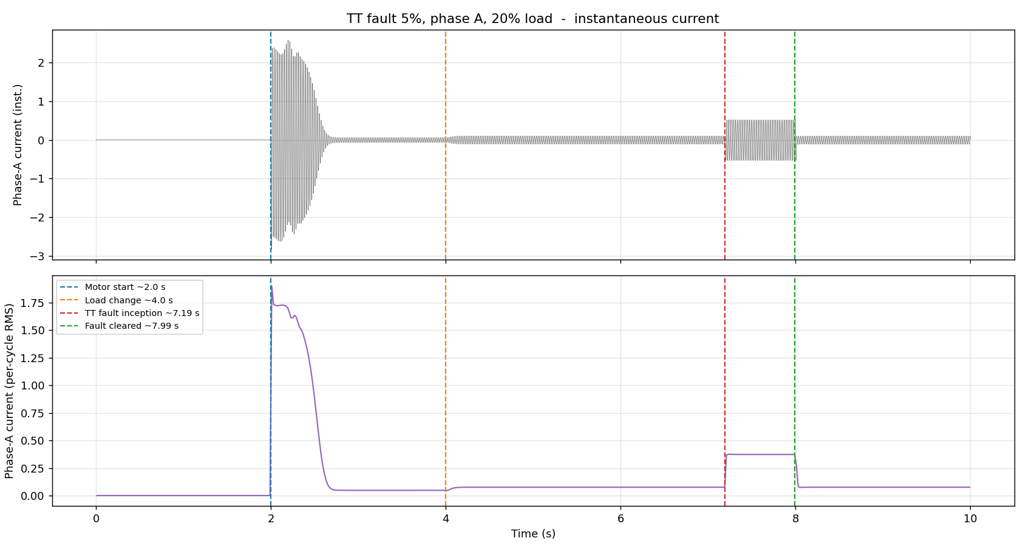
Phase-A current (top) and per-cycle RMS envelope (bottom) of a faulted record, with motor start ($2.0$ s), load change ($4.0$ s), fault inception ($7.2$ s), and clearing ($8.0$ s). The fault interval supplies faulty windows; the pre-fault loaded region supplies matched-load healthy windows.

Signal Preprocessing and Symmetrical-Component Decomposition
Each recording is segmented into windows of $W=2000$ samples (four $50$ Hz cycles); a $75\%$ overlap is used inside the short $0.8$ s fault interval and a sparser stride elsewhere. Crucially, the pre-fault loaded region of every faulted record (genuinely healthy, since the fault is inserted only at $7.2$ s) is labelled healthy, providing matched-load healthy data at the same loads as the faulty windows and preventing the detector from separating classes by load level. To remove load-induced amplitude while preserving the inter-phase imbalance that encodes the fault, all three phases of a window are divided by a single per-recording scale; magnitude features are additionally divided by the within-window positive-sequence fundamental $|I_{1}|$ to obtain load-invariant variants. The Clarke transform underlying the EPVA and the Park ellipse is
$$i_{α}=2/3​\left(i_{a}−1/2i_{b}−1/2i_{c}\right), i_{β}=1/{\sqrt{3}}\left(i_{b}−i_{c}\right),$$
and the fundamental symmetrical components follow from the Fortescue transform of the per-phase phasors:
$$\left[\begin{matrix}I_{0} \\ I_{1} \\ I_{2}\end{matrix}\right]=\frac{1}{3}\left[\begin{matrix}1 & 1 & 1 \\ 1 & a & a^{2} \\ 1 & a^{2} & a\end{matrix}\right]\left[\begin{matrix}I_{a} \\ I_{b} \\ I_{c}\end{matrix}\right], a=e^{ j2π/3}.$$
The negative-sequence ratio $|I_{2}|/|I_{1}|$ grows monotonically with the shorted-turn fraction and is the primary severity descriptor, while the angle $∠I_{2}$ separates into three $∼$${120}^{∘}$-spaced clusters that identify the faulted phase.

Stockwell-Based Time-Frequency Analysis
For a time-frequency representation we form the instantaneous symmetrical-component streams from the analytic (Hilbert) signal and the Fortescue transform, and apply a band-limited Stockwell transform to each, stacking the positive/negative/zero $|S|$ maps into a three-channel sequence-component Stockwell tensor (SCST). The negative-sequence channel carries the load-invariant inter-turn signature, and the frequency-dependent resolution of the Stockwell transform tracks the $2f_{0}$ EPVA line and slip sidebands better than a fixed-window spectrogram. Because symmetrical-component magnitudes are phase-agnostic, faulted-phase localization uses the negative-sequence angle rather than the magnitude tensor (Section IV-C).

Time-Domain and Spectral Characteristics
Physically grounded descriptors capture the fault signature. The EPVA severity factor is
$$SF=\frac{A(2f_{0})}{DC} \text{of} |i_{P}(t)|=\sqrt{i_{α}^{2}+i_{β}^{2}},$$
where $A(2f_{0})$ is the amplitude of the $100$ Hz component of the Park-vector modulus. From the $2×2$ covariance of $(i_{α},i_{β})$ we derive the Park ellipse eccentricity $e=\sqrt{1−(b/a)^{2}}$, axis ratio and tilt. Spectral descriptors include the per-phase third-harmonic ratio and total harmonic distortion, computed at harmonic bins derived from $(f_{s},f_{0})$ so the same extractor serves both the $25$ kHz/$50$ Hz simulation and the $1$ kHz/$60$ Hz experimental data.

Statistical Feature Extraction
Per-phase root-mean-square, peak, crest factor, standard deviation, skewness, and kurtosis are computed, together with their inter-phase differences (which directly encode asymmetry) and the $|I_{1}|$-normalized magnitude variants. With the symmetrical-component, EPVA, ellipse, and harmonic quantities this yields the 72-feature bank summarized in Table 1. Severity is encoded as an ordinal rank $r∈\{0,…,6\}$ over $\{0.3,0.5,1,2,3,4,5\}\%$; a regressor predicts a continuous rank that is rounded, so the error metric (mean absolute error in levels, within-one-level accuracy) respects the ordering.
Feature groups (72 features per window).
Group | Features
Symmetrical comp. | $|I_{0}|,|I_{1}|,|I_{2}|$; $|I_{2}|/|I_{1}|$, $|I_{0}|/|I_{1}|$; $∠I_{1},∠I_{2}$ ($+sin/cos$); compensated $I_{2}^{c}$
EPVA / Park | severity factor; Park-modulus mean/std; ellipse axes, eccentricity, axis ratio, tilt
Harmonics | third-harmonic ratio and THD (per phase, mean)
Per-phase stats | RMS, peak, crest, std, skew, kurtosis ($×3$) and inter-phase differences
Load-invariant | $|I_{1}|$-normalized variants of all magnitude features

Data Augmentation and Feature Selection
Feature selection. We extend minimum-redundancy–maximum-relevance with a load-instability penalty,
$$J(f)=Rel(f)−λ Red(f)−γ LoadInstability(f),$$
where $LoadInstability(f)$ is the across-load drift of the feature’s class-conditional mean normalized by its global spread ($γ=0$ recovers plain mRMR). LIR-mRMR selects dimensionless, load-stable features and, on the load-dependent severity task, generalizes better at compact size (Section IV-C). Augmentation. We additionally study a conditional generator of three-phase current with a hard Kirchhoff current-balance projection ($i_{a}+i_{b}+i_{c}=0$) and a soft negative-sequence-versus-severity loss; the hard constraint is enforced exactly, an honest negative result on controllability is reported in Section IV-C.

Extreme Gradient Boosting Model
Gradient-boosted trees (XGBoost ) implement the three stages: detection (class-weighted binary), severity (ordinal regression on the rank), and faulted phase (three-class). Stages 1 and 3 use the full feature set; the severity stage uses the load-invariant subset and the measured load. The detector gates the downstream stages: windows predicted faulty are passed to the severity and phase models. As a deep alternative we develop PCM-Net, a phase-coupled, multi-task network with a dilated-temporal backbone (a compact stand-in for a selective state-space model) and feature-wise linear modulation (FiLM) driven by the measured operating point, so one model spans loads instead of erasing the condition; a current-balance physics term regularizes training. A fault-onset stage thresholds a per-cycle negative-sequence index $ρ(k)=|I_{2}(k)|/|I_{1}(k)|$ against a trailing pre-fault reference, $ρ(k)>\overline{ρ}+6σ$ for three consecutive cycles. Detection probabilities are assessed with expected calibration error and the Brier score , and severity uncertainty with conformalized quantile regression .

Transfer Learning
To deploy a simulation-trained model on a real machine we use physics-anchored domain adaptation (PADA). A naively transferred model collapses under domain shift; we therefore align feature distributions across domains, anchoring the alignment on the domain-stable physics features (negative-sequence ratio, angles, $|I_{1}|$-normalized magnitudes), and optionally calibrate with a few labelled target repetitions. Section IV-C quantifies the recovery on a public real-motor dataset.

Experimental Setup and Dataset Preparation

Description of the Experimental Setup
The primary dataset is generated from a three-phase squirrel-cage induction motor with stator inter-turn faults modelled in PSCAD/EMTDC ($f_{0}=50$ Hz, $f_{s}=25$ kHz, $10$ s per run). For transfer-learning validation we additionally use a public real-motor dataset : a $0.75$ hp squirrel-cage IM, three-phase current at $1$ kHz ($f_{0}=60$ Hz, no load), with healthy and inter-turn shorts at $10/20/30/40\%$ of turns in each phase. The two sources differ in fundamental frequency, sampling rate, severity scale, and the presence of a healthy baseline, providing a demanding cross-domain benchmark; both are mapped to a common window/label schema and the feature extractor derives its harmonic bins from $(f_{s},f_{0})$.

Data Sets Generated from the Experimental Setup
The simulation corpus spans severity $μ∈\{0.3,0.5,1,2,3,4,5\}\%$, faulted phase $∈\{A,B,C\}$, load $∈\{NL,20,40,60,80,100\}\%$, and several fault-inception instants, with a healthy set over the full load range: $357$ cases ($336$ faulty, $21$ healthy). Segmentation yields $18,033$ labelled windows ($11,760$ faulty, $6,273$ healthy), balanced across severity and phase. The real-motor set yields $1,235$ windows. Windows are grouped by operating point (severity$×$phase$×$load), with all inception variants of a point kept together, so that no window from a record can appear in both training and test.

Performance Evaluation

Implementation and Training Procedure
Features are computed in Python (NumPy/Pandas) and models trained with scikit-learn and XGBoost ($400$–$500$ trees, depth $5$, learning rate $0.05$, subsample/colsample $0.8$); deep models use PyTorch. Two evaluation protocols are used: Stratified Group $k$-Fold ($k=5$, grouped by operating point) for the in-distribution estimate, and Leave-One-Load-Out (LOLO)—all windows at one load form the test set—as the primary metric, measuring generalization to an operating point never seen in training. Reported metrics are accuracy, macro-F1, severity within-one-level accuracy and quadratic-weighted kappa (QWK), and per-phase F1, computed on out-of-fold predictions and reported as a mean over folds. Stages 2–3 are trained on faulty windows but evaluated on the windows the detector predicts faulty, so cascade numbers reflect realistic error propagation; predictions are also aggregated per recording (median severity, majority-vote phase). Scalers are fit on the training partition only and all randomized components use fixed seeds.

Results and Discussion
Per-stage performance. Table 2 reports each stage. In-distribution, all stages exceed $0.97$; under LOLO, detection (macro-F1 $0.948$) and faulted-phase identification (macro-F1 $0.997$) remain strong. The detection ROC has area $0.994$, and the faulted-phase confusion matrix (Fig. 2) is near-diagonal.
Per-stage performance (mean over folds).
Stage | Metric | Group $k$-Fold | LOLO
1 Detection | macro-F1 / ROC-AUC | 0.977 / 0.994 | 0.948
2 Severity (load-aware) | within-1 / QWK | 0.997 / 0.987 | 0.946
3 Phase ID | macro-F1 | 0.972 | 0.997
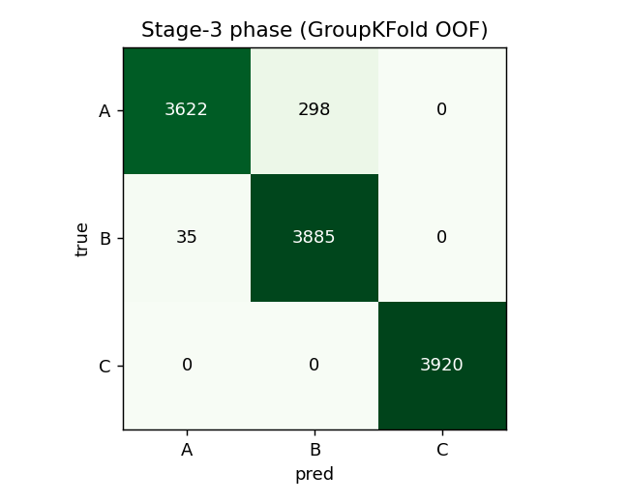
Faulted-phase confusion (group $k$-fold, out-of-fold). Phase C is perfect; only minor A$↔$B confusion remains. Cross-load (LOLO) phase accuracy is $0.997$.
Load-robustness analysis. SHAP attribution shows detection and phase ride on the negative-sequence ratio and angle and on inter-phase RMS differences—load-invariant ratios—whereas an initial severity model that used absolute magnitudes collapsed at the no-load extreme under LOLO (within-one $0.39$). Restricting severity to load-invariant features and supplying the measured load raises LOLO within-one to $0.95$ (Table 3); errors are almost entirely between adjacent severity levels (Fig. 3).
Severity (within-one-level) under feature choice.
Severity feature set | Group $k$-Fold | LOLO
All features (magnitudes incl.) | 0.993 | 0.887
Load-invariant $+$ $|I_{1}|$-norm | 0.990 | 0.729
$+$ measured load (proposed) | 0.997 | 0.946
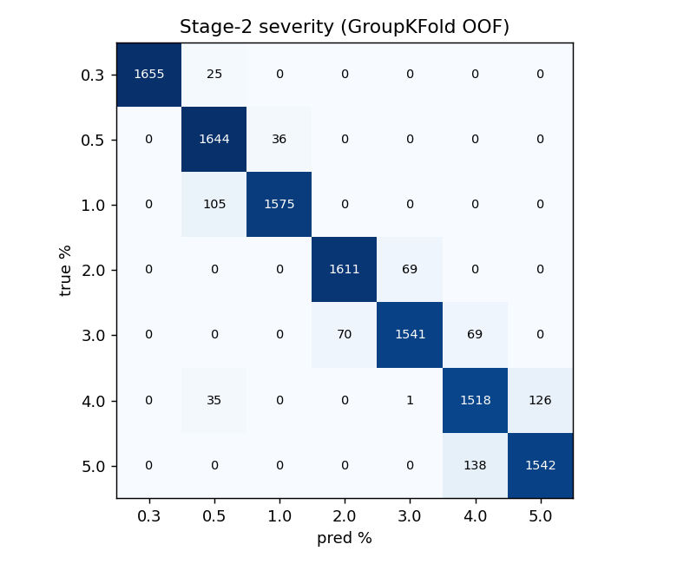
Severity confusion (group $k$-fold). Errors are almost entirely between adjacent levels, justifying the ordinal treatment and the within-one-level metric (QWK $=0.987$).
End-to-end cascade. With the load-aware severity stage, the gated cascade scores a window correct if healthy windows are detected healthy and faulty windows have the correct phase and a severity within one level: within-one-level accuracy $0.949$ in-distribution and $0.916$ across unseen loads (per-recording $0.927$ and $0.918$). Fig. 4 summarizes the four headline metrics under both protocols.
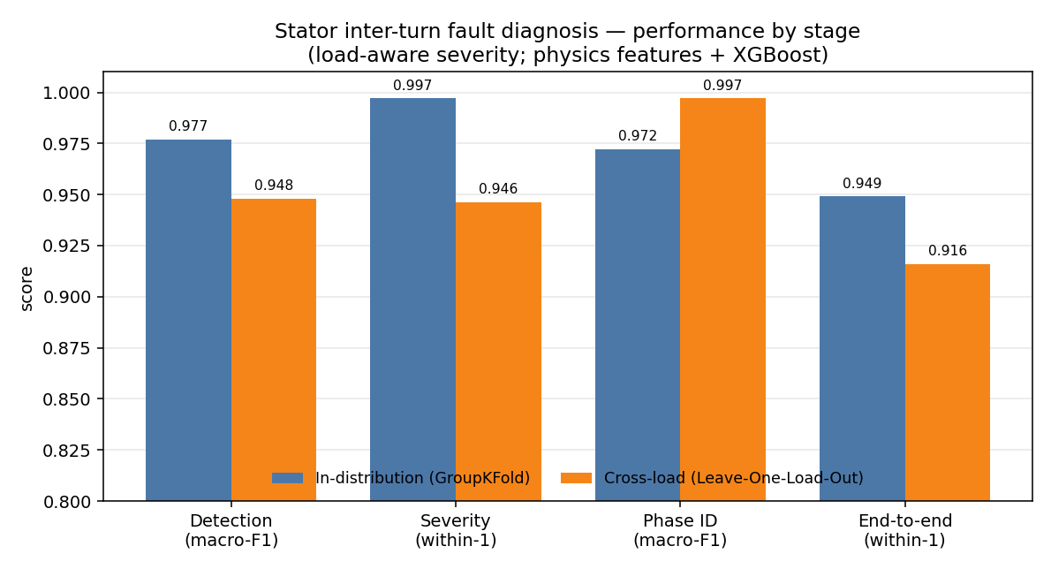
Per-stage and end-to-end performance, in-distribution (group $k$-fold) vs. cross-load (LOLO). Phase identification is the only metric for which cross-load exceeds in-distribution, reflecting its load-invariance.
Calibration, uncertainty, onset, robustness. Stage-1 probabilities are well calibrated (ECE $=0.021$, Brier $=0.021$). Conformalized quantile regression improves severity-interval coverage over naive quantiles, with group-conditional calibration noted as the remedy for residual under-coverage. The onset detector flags $100\%$ of faults with no pre-fault false alarms; for severity $≥0.5\%$ the fault is caught within the first faulted cycle. Under additive noise (Table 4), severity and phase are essentially flat to $20$ dB SNR while detection is the noise-sensitive stage—expected, since separating a small fault from healthy operation is hardest in noise.
Noise robustness (train clean, test noisy; group $k$-fold).
SNR | Detect macro-F1 | Severity within-1 | Phase acc.
clean | 0.977 | 0.986 | 0.958
40 dB | 0.927 | 0.980 | 0.954
30 dB | 0.854 | 0.975 | 0.945
20 dB | 0.792 | 0.971 | 0.939
The per-held-out-load breakdown (Table 5) localizes the difficulty: detection is perfect at the four heavier loads but degrades at no-load (NL) and $20\%$, where the small fault current of a low-severity ITSC at light load most overlaps the healthy distribution at an unseen operating point—visible only under LOLO. The onset detector (Table 6) flags every fault with no pre-fault false alarms and near-instant detection except for the smallest $0.3\%$ faults.
Per-held-out-load detection (LOLO, macro-F1).
Hold-out load | NL | 20% | 40% | 60% | 80% | 100%
Detection F1 | 0.885 | 0.749 | 1.000 | 1.000 | 1.000 | 1.000
Fault-onset detection (sampled cases).
Metric | Value
Detection rate | $100\%$
Pre-fault false-alarm rate | $0\%$
Median detection delay | $0$ ms (first faulted cycle)
Delay at $μ≥0.5\%$ / $μ=0.3\%$ | $0$ ms / $≈1.4$ s
The high phase score ($0.997$) is physically defensible—the faulted phase is encoded in the negative-sequence angle, a load- and noise-robust quantity—while the in-distribution-versus-LOLO severity gap quantifies how much a conventional evaluation would have over-promised. We therefore advocate cross-condition (LOLO) reporting, alongside interpretability evidence, as standard practice. The principal limitation is that the diagnosis results are from high-fidelity simulation; the transfer study below provides initial real-motor validation, but a full instrumented campaign and a voltage-unbalance robustness study remain future work.

Comparative Evaluation
Baseline models. On detection (five-fold mean macro-F1), the physics-feature classifiers cluster high—LogReg $0.979$, SVM-RBF $0.978$, KNN $0.982$, MLP $0.979$, Random Forest $0.978$, XGBoost $0.978$—while raw-signal deep models are lower (1-D ResNet $0.898$, PCM-Net $0.898$), consistent with the data-efficiency of physically engineered features (Table 7). The feature pipeline is also lightweight: feature extraction plus XGBoost inference costs $≈0.34$ ms per window on CPU, comfortably real-time.
Feature-based cascade vs. deep baseline.
Task / metric | XGBoost (features) | ResNet-1D (raw)
Detection F1 (group $k$-fold) | 0.977 | 0.898
Detection F1 (LOLO, load $20\%$) | 0.749 | 0.401
Phase macro-F1 (group $k$-fold) | 0.972 | 0.848
Severity within-1 (group $k$-fold) | 0.990 | 1.000
Load-robustness mechanisms. Table 8 evaluates the four proposed mechanisms under LOLO. SCST raises held-out-load severity within-one from $0.75$ (raw-phase Stockwell) to $1.0$ but, being magnitude-based, cannot localize phase (the negative-sequence angle is used instead). LIR-mRMR beats plain mRMR at compact size ($k=10$ within-one $0.848$ vs. $0.740$) with roughly half the cross-load feature drift. PCM-Net’s FiLM load-conditioning lifts LOLO severity within-one from $0.932$ to $0.982$—the best in the study, exceeding the load-aware gradient-boosted model ($0.946$); consistent with the physics, FiLM does not help the load-invariant phase task. PADA closes the simulation-to-experiment gap: a naively transferred detector scores macro-F1 $0.48$, unsupervised physics-anchored alignment reaches $0.50$ on phase, and few-shot calibration with two real repetitions recovers detection to $0.98$. The physics-constrained generator enforces current balance exactly but did not yield severity-controllable samples under our budget, an honest negative that motivates a stronger conditional generator.
Load-robustness mechanisms (LOLO).
Mechanism | Cross-load result
SCST representation | severity within-1 $0.75​→​1.0$; phase needs angle
LIR-mRMR selection | $k=10$ severity within-1 $0.740​→​0.848$; drift halved
PCM-Net $+$ FiLM | severity within-1 $0.932​→​0.982$ (best; $>$ load-aware GBM $0.946$)
PADA (sim$→$real) | detection F1 $0.48​→​0.98$ (few-shot); $0.50$ phase (unsup.)
PC-Diff | current-balance exact; generation not controllable (negative)

Conclusion
We presented a physics-informed, leakage-safe machine-learning framework for stator inter-turn fault diagnosis in induction motors that performs onset detection, healthy/faulty detection, ordinal severity estimation, and faulted-phase identification from the three-phase stator current. By adopting Leave-One-Load-Out evaluation we showed that detection and faulted-phase identification are intrinsically load-robust, while absolute severity is load-dependent and is recovered to within-one accuracy of $0.95$ across unseen loads once the model is made load-aware. Four mechanisms—a sequence-component Stockwell tensor, a load-invariance-regularized feature selection, a FiLM-conditioned multi-task network, and physics-anchored domain adaptation—each independently improve cross-load performance, and the framework is validated simulation-to-experiment on a public real-motor dataset. The end-to-end cascade attains within-one accuracy of $0.95$ in-distribution and $0.92$ across unseen loads, with calibrated detection, graceful noise degradation, and reliable onset detection. Future work includes a stronger conditional generator for physics-constrained augmentation, full selective-state-space and Kolmogorov–Arnold backbones, an experimental campaign with supply voltage-unbalance rejection, and group-conditional conformal calibration of the severity intervals. All code, dataset splits, and result artifacts are released for reproducibility.
1 J. Penman, H. G. Sedding, B. A. Lloyd, and W. T. Fink, “Detection of inter-turn short circuits in the stator windings of operating motors,” IEEE Trans. Energy Convers., vol. 9, no. 4, pp. 652–658, 1994. A. J. M. Cardoso, S. M. A. Cruz, and D. S. B. Fonseca, “Inter-turn stator winding fault diagnosis in three-phase induction motors, by Park’s vector approach,” IEEE Trans. Energy Convers., vol. 14, no. 3, pp. 595–598, 1999. R. Hussain, M. Alshaikh Saleh, and S. S. Refaat, “Various faults classification of industrial application of induction motors using supervised machine learning: A comprehensive review,” IEEE Access, vol. 13, pp. 146649–146675, 2025. D. García-Pérez et al., “Machine learning for inverter-fed motors monitoring and fault detection: An overview,” IEEE Access, vol. 12, 2024. S. Ruzimov et al., “Detection of inter-turn short-circuit faults for inverter-fed induction motors based on negative-sequence current analysis,” Sensors, vol. 25, no. 15, art. 4844, 2025. M. A. Mazzoletti, G. R. Bossio, P. D. Donolo, and M. Donolo, “Turn-to-turn short-circuit fault and high-resistance connection diagnosis for induction motor during start-up transient,” IEEE Trans. Ind. Appl., vol. 61, no. 2, pp. 1927–1935, 2025. M. Singh and A. G. Shaik, “Incipient fault detection in stator windings of an induction motor using Stockwell transform and SVM,” IEEE Trans. Instrum. Meas., vol. 69, no. 12, pp. 9496–9504, 2020. P. Pietrzak and M. Wolkiewicz, “Machine learning-based stator current data-driven PMSM stator winding fault diagnosis,” Sensors, vol. 22, no. 24, art. 9668, 2022. T. Aasar et al., “Predicting stator winding short-circuit faults in induction motors using machine learning: A comparative study,” Discover Computing, vol. 29, art. 103, 2026. U. Ali, U. Ramzan, W. Ali, and K. A. Al-Jaafari, “An improved fault diagnosis strategy for induction motors using weighted probability ensemble deep learning,” IEEE Access, vol. 13, pp. 106958–106973, 2025. T. Chen and C. Guestrin, “XGBoost: A scalable tree boosting system,” in Proc. ACM SIGKDD, 2016, pp. 785–794. S. M. Lundberg and S.-I. Lee, “A unified approach to interpreting model predictions,” in Proc. NeurIPS, 2017, pp. 4765–4774. Y. Romano, E. Patterson, and E. Candès, “Conformalized quantile regression,” in Proc. NeurIPS, 2019. A. N. Angelopoulos and S. Bates, “A gentle introduction to conformal prediction and distribution-free uncertainty quantification,” arXiv:2107.07511, 2021. C. Guo, G. Pleiss, Y. Sun, and K. Q. Weinberger, “On calibration of modern neural networks,” in Proc. ICML, 2017, pp. 1321–1330. T. Ince, S. Kiranyaz, L. Eren, M. Askar, and M. Gabbouj, “Real-time motor fault detection by 1-D convolutional neural networks,” IEEE Trans. Ind. Electron., vol. 63, no. 11, pp. 7067–7075, 2016. K. He, X. Zhang, S. Ren, and J. Sun, “Deep residual learning for image recognition,” in Proc. IEEE CVPR, 2016, pp. 770–778. A. Gu and T. Dao, “Mamba: Linear-time sequence modeling with selective state spaces,” arXiv:2312.00752, 2023. Z. Liu et al., “KAN: Kolmogorov–Arnold networks,” in Proc. ICLR, 2025. E. Perez, F. Strub, H. de Vries, V. Dumoulin, and A. Courville, “FiLM: Visual reasoning with a general conditioning layer,” in Proc. AAAI, 2018. M. Ibarra-Manzano et al., “ITSC: Inter-turn short-circuit fault dataset for three-phase induction motors,” GitHub repository, https://github.com/ibarram/ITSC. R. Cunha, “MIT short-circuit flux and current signals dataset,” Kaggle, 2021, https://www.kaggle.com/datasets/rebecacunha/mit-short-circuit-flux-and-current-signals. A. Vaswani et al., “Attention is all you need,” in Proc. NeurIPS, 2017. S. Bai, J. Z. Kolter, and V. Koltun, “An empirical evaluation of generic convolutional and recurrent networks for sequence modeling,” arXiv:1803.01271, 2018. A. Sharma et al., “Recurrence-plot-based severity assessment of stator inter-turn faults using ensemble learning,” Measurement, 2023.

Manuscript received May 23, 2026. (Corresponding author: Shashwat Garg.)
The author is with the Department of Electrical Engineering (affiliation placeholder), e-mail: author@institution.edu.
Code and result artifacts are publicly available at https://github.com/Regal-s/induction-motor-fault-diagnosis.

