Software Architecture Description

I have a main class called App, this runs a single game with the provided input. This is the central controlling class which calls methods of other classes for modularity. Station class has been added which holds all the data that is useful for a station. Stations are needed for

Drone Class is an abstract class that is then extened by Stateless and StateFull Drone. Each of the drones was going to have to be similar so making a base class that would be built up in either case made logical sense. It provided ease of implementation, abstract class was decided because there would be no need to implement the actual drone class.

Class Documentation
Position
Global Variables
Public double latitude
Public double longitude

Constructor
Position is instantiated by providing two doubles
public Position(double latitude, double longitude) {

}

Methods
nextPosition(Direction d):
This will return the new position once the object has moved in the direction d.

inPlayArea():
Returns a boolean as to whether the current latitude and longitude is within the designated zone

Direction
Global Variables
Public double latitude – This is the change in latitude for the direction supplied
Public double longitude – This is the change in longitude for the direction supplied
Public string name – The direction in sea bearings (N, NE, NW...)

Constructor
Position is instantiated by providing one double and a string name
public Direction (double d, String s) {

}

Drone – abstract class
Global Variables
Private Position pos – Current position of the drone
Private double charge – Current charge of the drone
Private double coins – Current coins of the drone
Private int seed – Int to serve as base for random number

Constructor
Position is instantiated by providing:
public Drone (Position p, double ch, double co, int seed) {

}

Methods
nextMove(HashMap<String, Station> s):
Returns nulll, to be overwritten by extended classses.
updateStats(HashMap<String, Station> s):
Will find the closest station that is in range of transfer and will update the drone and station’s coin and charge values accordingly. Returns the updated HashMap.

Stateless Drone – extends Drone
Global Variables
Private final List<Direction> directions – List of all possible direction

Constructor
Variables are instantiated by superclass Drone
public StatelessDrone(Position p, double ch, double co, int seed) {
super(p, ch, co, seed);
}

Methods
nextMove(HashMap<String, Station> s):
Will move in the best direction to obtain coins if any are in it’s range, otherwise will choose a random direction to go whilst avoiding negative stations.
Return target string of the change in posistion

inrange(HashMap<String, Station> s):
Checks whether there are any stations in transfer range and returns a hashmap of the direction and what they are in range of.

Statefull Drone – extends Drone
Global Variables
Private final List<Direction> directions – List of all possible direction
See Drone

Constructor
Variables are instantiated by superclass Drone
public Station (String i, double ch, double co, Position p ) {
}

Methods
nextMove(HashMap<String, Station> s):
Will move in the best direction to get to the closest positive station, will take a random move if there are no positive station or if there has been too much repetition in the flight path.

nonegative(Position p, HashMap<String, Station> s):
Check that the position p would not result in a negative transfer. Return true if not, false otherwise.

Station
Global Variables
Private final string id – Unique id for a station
Private double charge – The amount of charge the station has
Private double coin – The amount of coins the station has
Private final Position pos – The position of the station

Constructor
public Station (String i, double ch, double co, Position p ) {
}

Methods
Getters and Setters

App

Main class of the project, takes list of arguments day, month, year, latitude. Lo

Gets a map and finds all the stations on the map, creates a hashmap of the stations and instantiates a class of drone that is called. Plays the game and then calls the method to output to file.
Constructor
public static void main( String[] args ) throws IOException
}
Methods
geooutput( ArrayList<Position> p, List<Features> features):
Writes the changes of the positions in the arraylist as a line string and adds the features(Stations) to the file.

Statefull Drone Strategy
The main idea behind the drone’s is that it is possible to loop multiple times around the map without collecting any coins or charge provided that the drone also doesn’t run into anything negative. Due to this, this drone just focuses on the closest station relative to it’s own position and doesn’t worry about the efficiency it which it collects the coins.
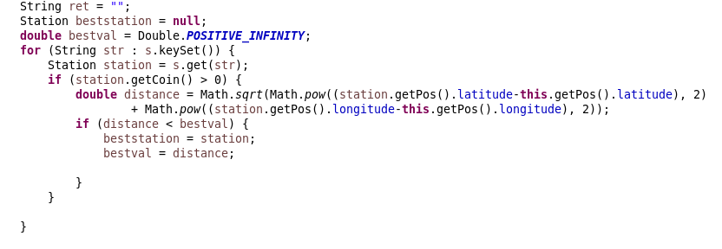

The drone first finds the closest positive station relative to it using euclidean distance.
It then checks the direction that covers the most distance to the best station, the direction is considered if the move is in the play area and does not go in range of a negative station.

The drone remembers the direction that it has previously gone, this is used to make sure that it does not get stuck in a loop. A counter is incremented every time that

If the counter is 10 or over or there is not best direction the drone chooses a random move that once again doesn’t fall into the radius of a negative station. If the counter was the cause of the random direction it is reset.

Otherwise the drone goes in the best direction and updates the drones stats.

