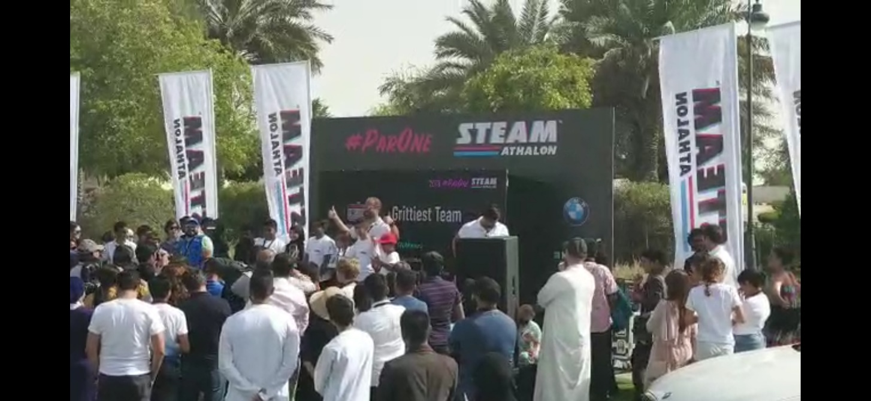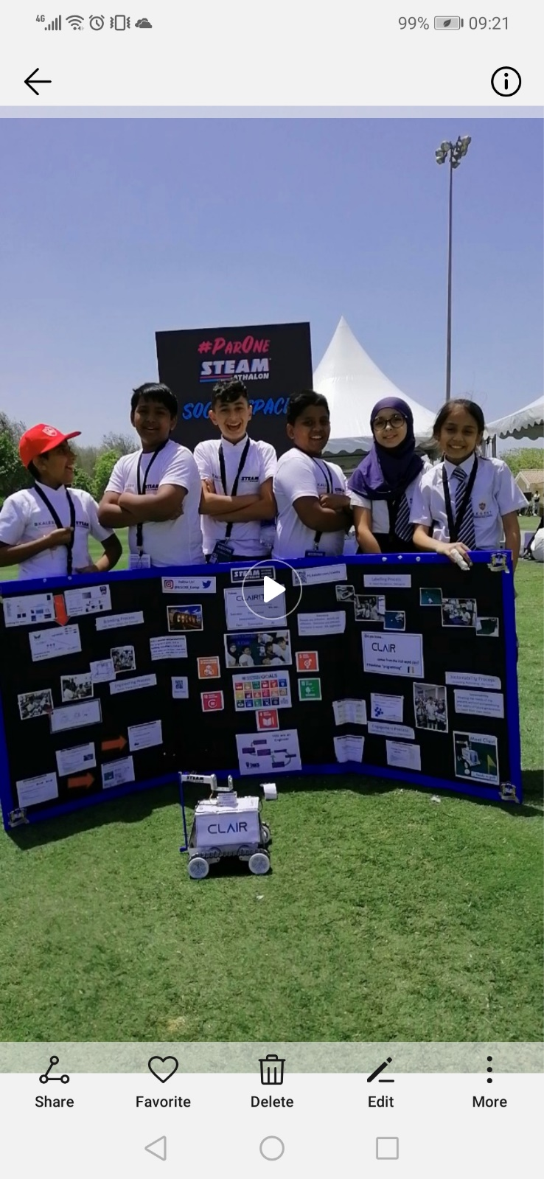

Students:

600 AED Emaar Vouchers

Teacher:

500 AED Emaar Vouchers

**Tie Winner:**

**Grittiest Team**