**Project Design & Proposal**

0503 Group08

1. **Brand Name:** Career4ISers
2. **Mission Statement and Objective**:

Mission Statement:

We intend to create a database system that will not only optimally maintain records for all IS internships and opportunities but will also provide students up-to-date results for all job, internship, and event inquiries.

Mission Objective:

The database will maintain records of all internship and job posts submitted by the Smith school to students; the recorded data will also include job source data (i.e. company name, source of post). The database will also maintain preference records for all students based on their search results for job and internship posts. All posted events will be recorded in database, along with students who registered for said events.

1. **Business Functions**

* Maintain records of all students enrolled with Career4ISers systems.
* Maintain records of all job posts, events posts, company and source.
* Provide jobs, internship opportunities and events listings to students.
* Allow students to search active jobs, internship and events posts.
* Maintain students job search and event search records.

1. **ERD**

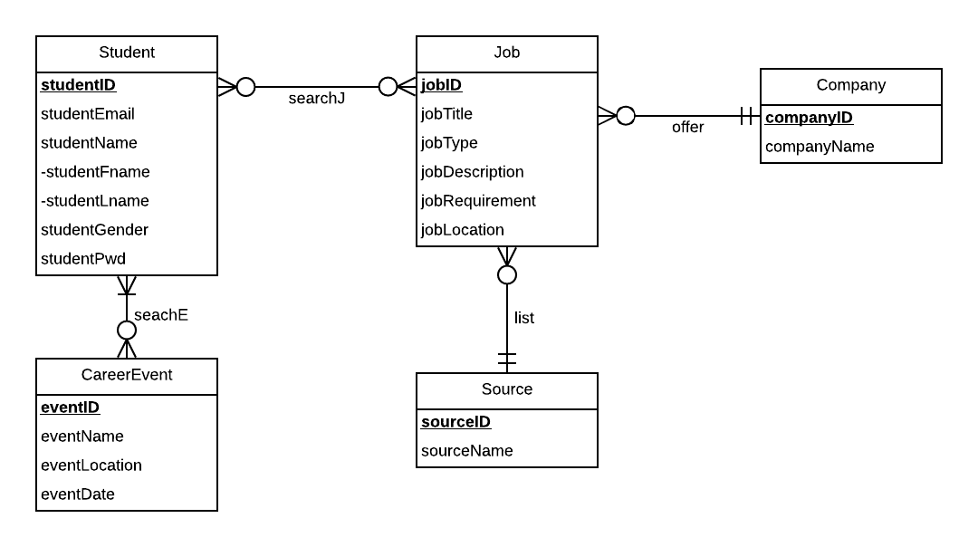

1. **Relational Schema**

Job(**jobId**, jobTitle, jobType, jobDescription,jobRequirement, jobLocation, *sourceId*, *companyId*)

Student(**studentId**, studentEmail,studentFname, studentLname, studentGender, pwd)

Company(**companyId**,companyName)

CareerEvent(**eventId**, eventName,eventLocation, eventDate)

Source(**sourceId**,sourceName)

SearchJ(***studentId***, ***jobId***)

SearchE(***studentId****,* ***eventsId***)

1. **Relationships, Attributes, Degrees, Participating Entities and Constraints**

SearchedBy : binary relationship

1 Student to 0 or more Job

1 Job to 0 or more Student

AttendedBy : binary relationship

1 Student to 0 or more CarrerEvent

1 CarrerEvent to 1 or more Student

OfferedBy: binary relationship

1 Company to 0 or more Job

1 Job to 1 Company

ListedFrom: binary relationship

1 Job to 1 Source

1 Source to 0 or more Job

1. **Normalization（3NF）**

Job(**jobId**, jobTitle, jobType, jobDescription,jobRequirement, jobLocation, *sourceId*, *companyId*) = 3NF

Student(**studentId**, studentEmail,studentFname, studentLname, studentGender, pwd) = 3NF

Company(**companyId**,companyName) =3NF

CareerEvent(**eventId**, eventName,eventLocation, eventDate) =3NF

Source(**sourceId**,sourceName) =3NF

SearchJ(***studentId***, ***jobId***) =3NF

SearchE(***studentId****,* ***eventId***) =3NF

1. **Functional Dependencies**

jobId → jobTitle, jobType, jobDescription,jobRequirement, jobLocation

studentId → studentEmail,studentFname, studentLname, studentGender, pwd

companyId → companyName

eventsId → eventsName,eventLocation, eventsDate

sourceId → sourceName

1. **Business Rules**

[R1] When the information of a source is deleted from the database, the job information from this source should be deleted from the database.

[R2] When a company is deleted from the database, jobs that the company offers should be deleted from the database.

[R3] When the information of a source is changed in the database, the job information from this source should be changed accordingly.

[R4] When the information of a company is changed in the database, the according job information should be changed in the database.

[R5] When the information of student is deleted from the database, the corresponding searching information of the student cannot be deleted.

[R6] When the information of student is changed from the database, the corresponding searching information for job and events of the student should be changed accordingly.

[R7] When the information of job is deleted from the database, the corresponding searching information of the job cannot be deleted.

[R8] When the information of career event is deleted from the database, the corresponding information of the event cannot be deleted.

[R9] When the information of job is changed from the database, the corresponding searching information of the job should be changed accordingly.

[R10] When the information of career event is changed from the database, the corresponding searching information of the event should be changed accordingly.

1. **Referential Integrity**

|  |  |  |  |  |  |  |  |
| --- | --- | --- | --- | --- | --- | --- | --- |
| Relation | Foreign key | Base relation | Primary key | Business rule | Constraint:  On delete | Business rule | Constraint:  On update |
| job | sourceId | Source | sourceId | R1 | CASCADE | R3 | CASCADE |
| job | companyId | Company | companyId | R2 | CASCADE | R4 | CASCADE |
| SearchJ | studentId | Student | studentId | R5 | NO ACTION | R6 | CASCADE |
| SearchJ | jobId | Job | jobId | R7 | NO ACTION | R9 | CASCADE |
| SearchE | studentId | Student | studentId | R5 | NO ACTION | R6 | CASCADE |
| SearchE | eventId | CareerEvent | eventId | R8 | NO ACTION | R10 | CASCADE |

1. **Describe sample data for every relation**

Job(“3333333”, “Data Analyst”, “full-time”, “work on data mining projects”, “proficient with R and python”, “Baltimore, MD”, “12345”, “12345”)

Student(“111111111”, “aaa@umd.edu”, “Jame”, “Lee”, “male”)

Company(“12345”, “Facebook”)

CareerEvent(“12323”, “Career Fair”, “Mc Building, UMD”, “03-23-2019”)

Source(“12345”, “Indeed”)

SearchJ(“111111111”, “3333333”)

SearchE(“111111111”*, “*12323”)