1. Download server application from <https://www.apachefriends.org/download.html> , you can download either Windows or Mac version.

2. After you downloaded the application, open it and run MySQL Database and Apache Web Server.

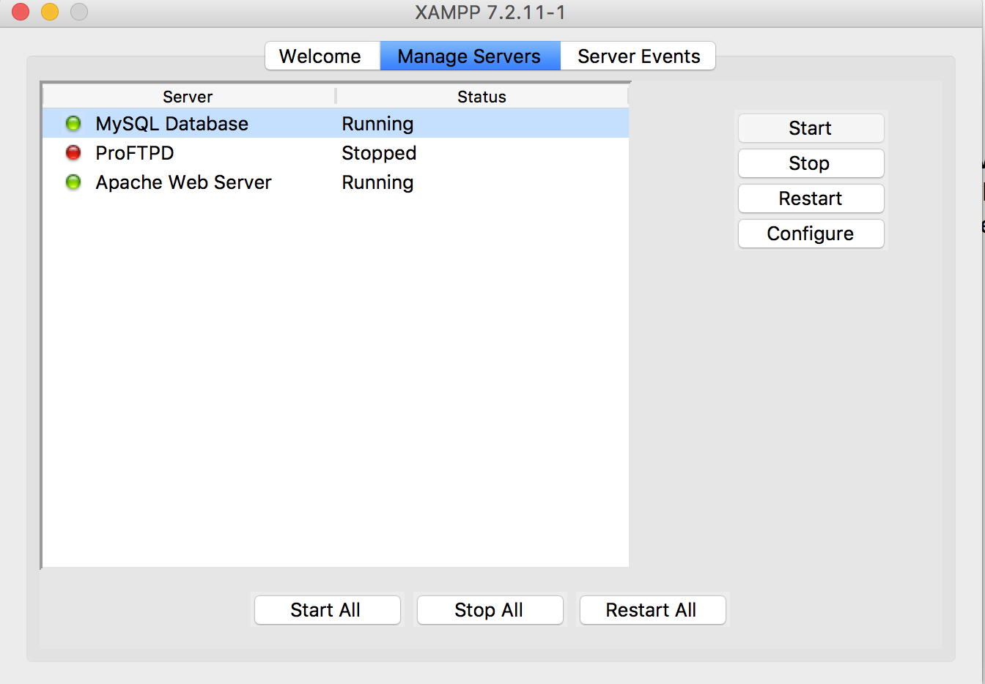

Then go to local host <http://localhost/phpmyadmin/> and create database C4IS. After that, you can import C4IS.sql to create tables and insert data for each table.

3. After you finish all the above steps. Go to XAMPP and click the “Open application folder”, and copy paste our php folder “Career4ISers” to Application folder “htdocs”.

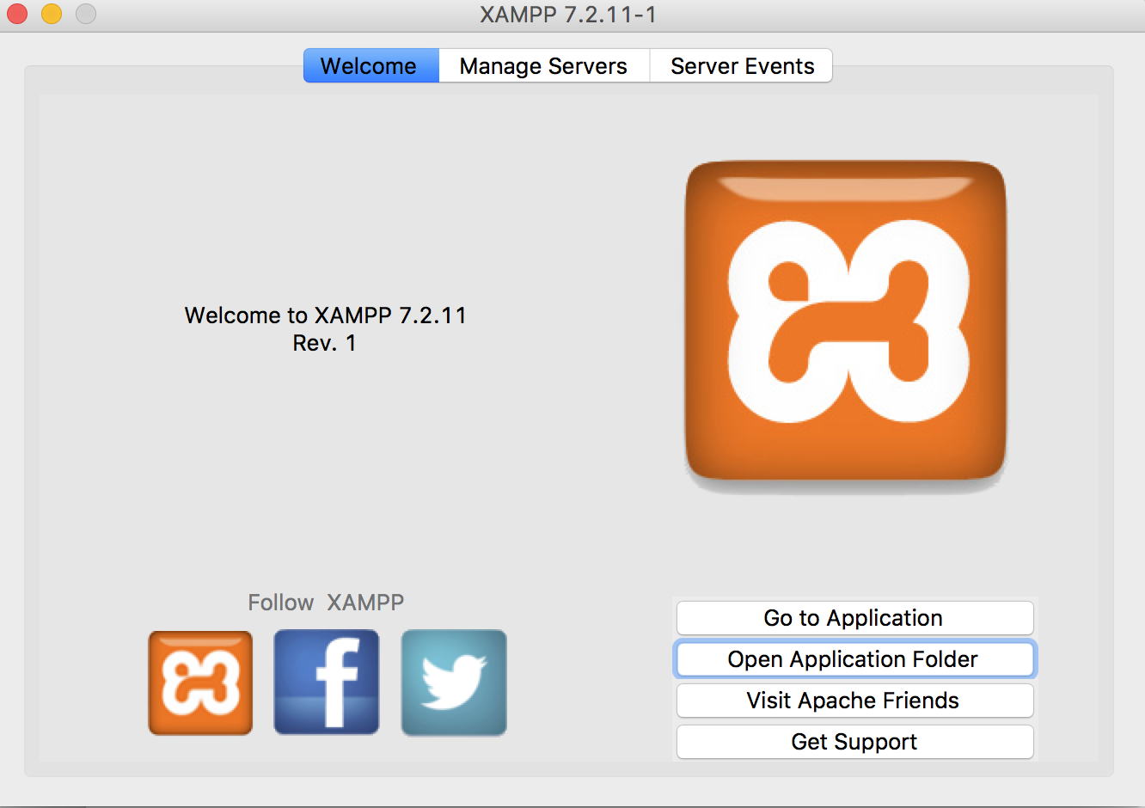

Then open you browser and go to <http://localhost/Career4ISers>

and click main.php , then you will see our application login page.

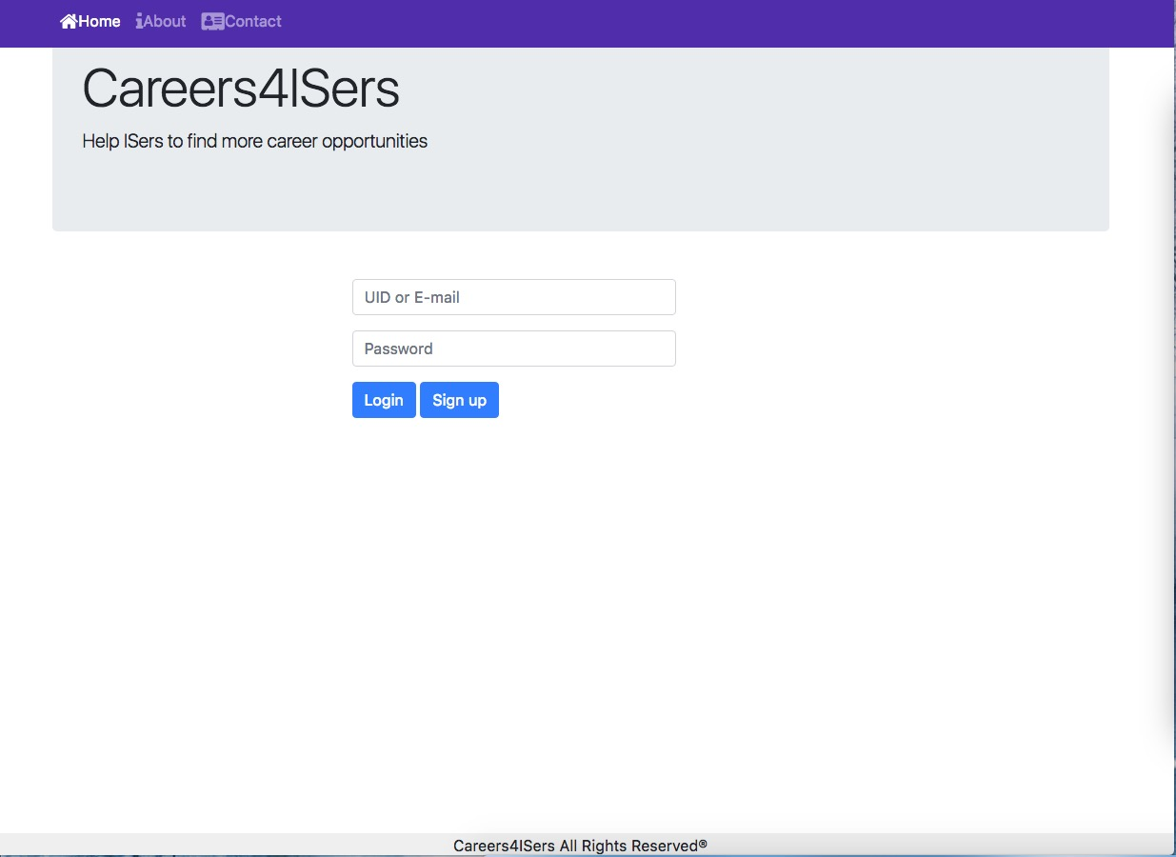

You can use UID: 123456789 Password:123

to login to our application. Then you will see search Page.

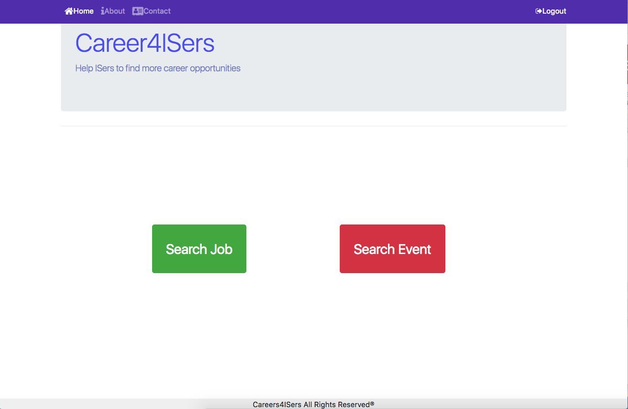

You can click Search Job, then you can specify what types of job you like to search.

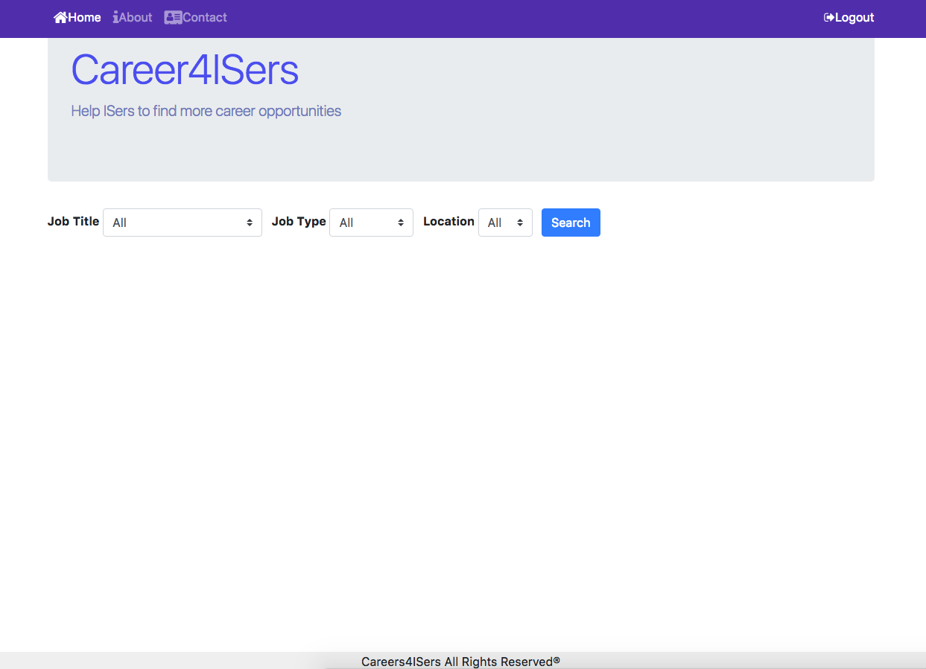

If you click “search” button, it will show all the job lists:

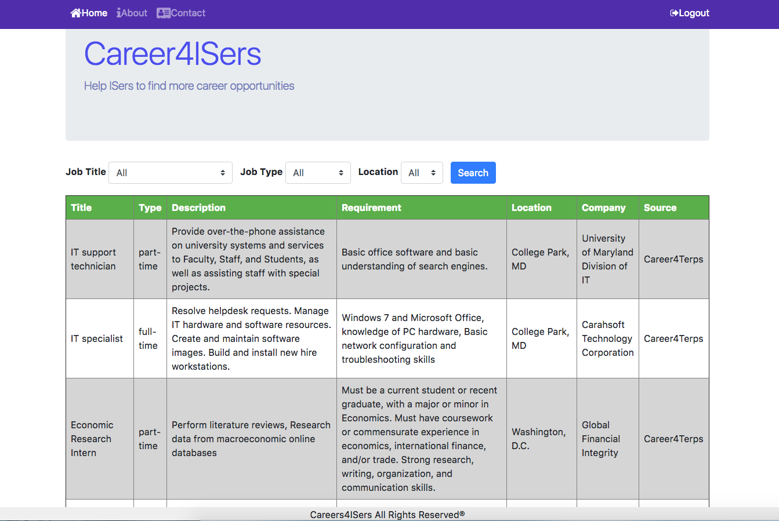

Also you can click job tye “full-time” or job title “Data Scientist”, and it will show detailed job list:

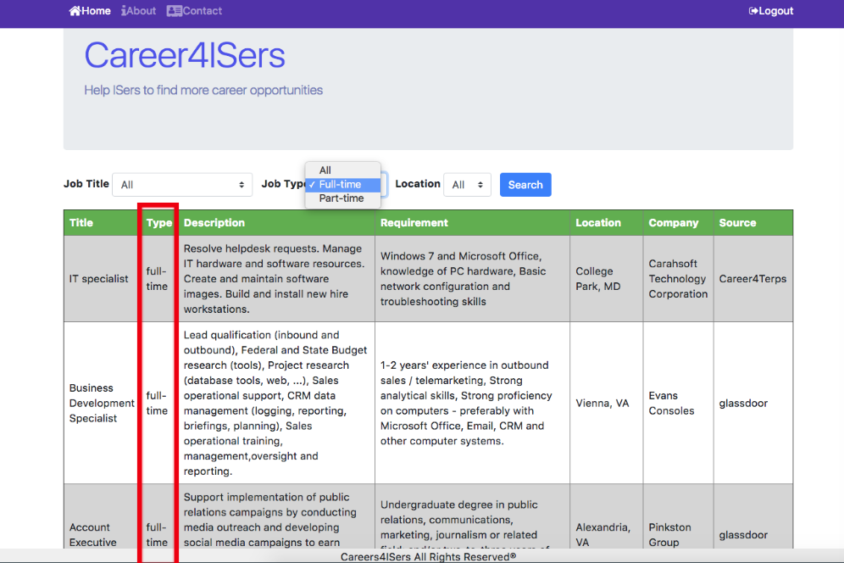

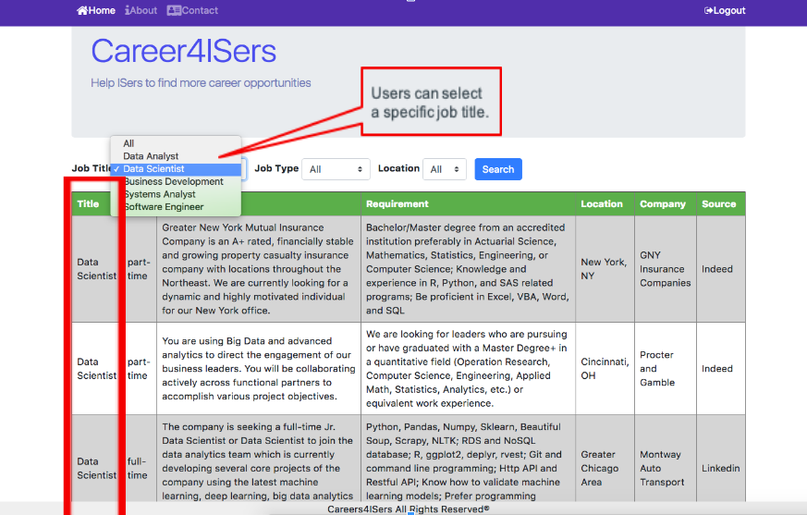

In addition, users also can search events.

