Exchange application testing

Test case 1

I was able to log to the directory containing the data base and verify the records exist.

Jasons-MacBook-Pro:seg0 jasondudash$ ls -l

total 2240

-rw-r--r-- 1 jasondudash staff 533 Apr 25 10:21 README_DO_NOT_TOUCH_FILES.txt

-rw-r--r-- 1 jasondudash staff 8192 Apr 25 20:35 c10.dat

-rw-r--r-- 1 jasondudash staff 8192 Apr 25 10:21 c101.dat

-rw-r--r-- 1 jasondudash staff 8192 Apr 25 10:21 c111.dat

-rw-r--r-- 1 jasondudash staff 8192 Apr 25 10:21 c121.dat

-rw-r--r-- 1 jasondudash staff 8192 Apr 25 10:21 c130.dat

-rw-r--r-- 1 jasondudash staff 8192 Apr 25 10:21 c141.dat

-rw-r--r-- 1 jasondudash staff 8192 Apr 25 10:21 c150.dat

-rw-r--r-- 1 jasondudash staff 8192 Apr 25 10:21 c161.dat

-rw-r--r-- 1 jasondudash staff 8192 Apr 25 10:21 c171.dat

-rw-r--r-- 1 jasondudash staff 36864 Apr 25 10:21 c180.dat

-rw-r--r-- 1 jasondudash staff 16384 Apr 25 10:21 c191.dat

-rw-r--r-- 1 jasondudash staff 16384 Apr 25 10:21 c1a1.dat

-rw-r--r-- 1 jasondudash staff 16384 Apr 25 10:21 c1b1.dat

-rw-r--r-- 1 jasondudash staff 8192 Apr 25 10:21 c1c0.dat

-rw-r--r-- 1 jasondudash staff 8192 Apr 25 10:21 c1d1.dat

-rw-r--r-- 1 jasondudash staff 8192 Apr 25 10:21 c1e0.dat

-rw-r--r-- 1 jasondudash staff 8192 Apr 25 10:21 c1f1.dat

-rw-r--r-- 1 jasondudash staff 32768 May 1 19:55 c20.dat

-rw-r--r-- 1 jasondudash staff 8192 Apr 25 10:21 c200.dat

-rw-r--r-- 1 jasondudash staff 8192 Apr 25 10:21 c211.dat

-rw-r--r-- 1 jasondudash staff 8192 Apr 25 10:21 c221.dat

-rw-r--r-- 1 jasondudash staff 245760 Apr 25 20:35 c230.dat

-rw-r--r-- 1 jasondudash staff 20480 Apr 25 20:35 c241.dat

-rw-r--r-- 1 jasondudash staff 20480 Apr 25 20:35 c251.dat

-rw-r--r-- 1 jasondudash staff 8192 Apr 25 10:21 c260.dat

-rw-r--r-- 1 jasondudash staff 8192 Apr 25 10:21 c271.dat

-rw-r--r-- 1 jasondudash staff 8192 Apr 25 10:21 c281.dat

-rw-r--r-- 1 jasondudash staff 8192 Apr 25 10:21 c290.dat

-rw-r--r-- 1 jasondudash staff 8192 Apr 25 10:21 c2a1.dat

-rw-r--r-- 1 jasondudash staff 8192 Apr 25 10:21 c2b1.dat

-rw-r--r-- 1 jasondudash staff 8192 Apr 25 10:21 c2c1.dat

-rw-r--r-- 1 jasondudash staff 8192 Apr 25 10:21 c2d0.dat

-rw-r--r-- 1 jasondudash staff 8192 Apr 25 10:21 c2e1.dat

-rw-r--r-- 1 jasondudash staff 8192 Apr 25 10:21 c2f0.dat

-rw-r--r-- 1 jasondudash staff 8192 Apr 25 10:21 c300.dat

-rw-r--r-- 1 jasondudash staff 16384 May 1 19:55 c31.dat

-rw-r--r-- 1 jasondudash staff 8192 Apr 25 10:21 c311.dat

-rw-r--r-- 1 jasondudash staff 8192 Apr 25 10:21 c321.dat

-rw-r--r-- 1 jasondudash staff 8192 Apr 25 10:21 c331.dat

-rw-r--r-- 1 jasondudash staff 8192 Apr 25 10:21 c340.dat

-rw-r--r-- 1 jasondudash staff 8192 Apr 25 10:21 c351.dat

-rw-r--r-- 1 jasondudash staff 8192 Apr 25 10:21 c361.dat

-rw-r--r-- 1 jasondudash staff 8192 Apr 25 10:21 c371.dat

-rw-r--r-- 1 jasondudash staff 8192 Apr 25 10:21 c380.dat

-rw-r--r-- 1 jasondudash staff 8192 Apr 25 10:21 c391.dat

-rw-r--r-- 1 jasondudash staff 8192 Apr 25 10:21 c3a1.dat

-rw-r--r-- 1 jasondudash staff 8192 Apr 25 10:21 c3b1.dat

-rw-r--r-- 1 jasondudash staff 8192 Apr 25 10:21 c3c0.dat

-rw-r--r-- 1 jasondudash staff 8192 Apr 25 10:21 c3d1.dat

-rw-r--r-- 1 jasondudash staff 8192 Apr 25 10:21 c3e1.dat

-rw-r--r-- 1 jasondudash staff 8192 Apr 25 10:21 c3f1.dat

-rw-r--r-- 1 jasondudash staff 8192 Apr 25 10:21 c400.dat

-rw-r--r-- 1 jasondudash staff 16384 May 1 19:55 c41.dat

-rw-r--r-- 1 jasondudash staff 8192 Apr 25 10:21 c411.dat

-rw-r--r-- 1 jasondudash staff 8192 Apr 25 10:21 c421.dat

-rw-r--r-- 1 jasondudash staff 8192 Apr 25 10:21 c430.dat

-rw-r--r-- 1 jasondudash staff 8192 Apr 25 10:21 c441.dat

-rw-r--r-- 1 jasondudash staff 8192 Apr 25 10:21 c451.dat

-rw-r--r-- 1 jasondudash staff 8192 Apr 25 10:21 c461.dat

-rw-r--r-- 1 jasondudash staff 8192 Apr 25 10:21 c470.dat

-rw-r--r-- 1 jasondudash staff 8192 Apr 25 10:21 c481.dat

-rw-r--r-- 1 jasondudash staff 16384 May 1 19:55 c51.dat

-rw-r--r-- 1 jasondudash staff 147456 May 1 19:55 c60.dat

-rw-r--r-- 1 jasondudash staff 16384 May 1 19:55 c690.dat

-rw-r--r-- 1 jasondudash staff 8192 May 1 19:55 c71.dat

-rw-r--r-- 1 jasondudash staff 8192 May 1 19:55 c81.dat

-rw-r--r-- 1 jasondudash staff 24576 May 1 19:55 c90.dat

-rw-r--r-- 1 jasondudash staff 24576 May 1 19:55 ca1.dat

-rw-r--r-- 1 jasondudash staff 8192 May 1 19:55 cb1.dat

-rw-r--r-- 1 jasondudash staff 8192 Apr 25 10:21 cc0.dat

-rw-r--r-- 1 jasondudash staff 8192 Apr 25 10:21 cd1.dat

-rw-r--r-- 1 jasondudash staff 8192 Apr 25 10:21 ce1.dat

-rw-r--r-- 1 jasondudash staff 8192 Apr 25 10:21 cf0.dat

Jasons-MacBook-Pro:seg0 jasondudash$ pwd

/Users/jasondudash/Documents/GIT/CMSC495/Exchange/exchangedb/seg0

Jasons-MacBook-Pro:seg0 jasondudash$

Test Case 2

I ran the application and clicked on the drop down box for the from rate to see the list of currency codes.

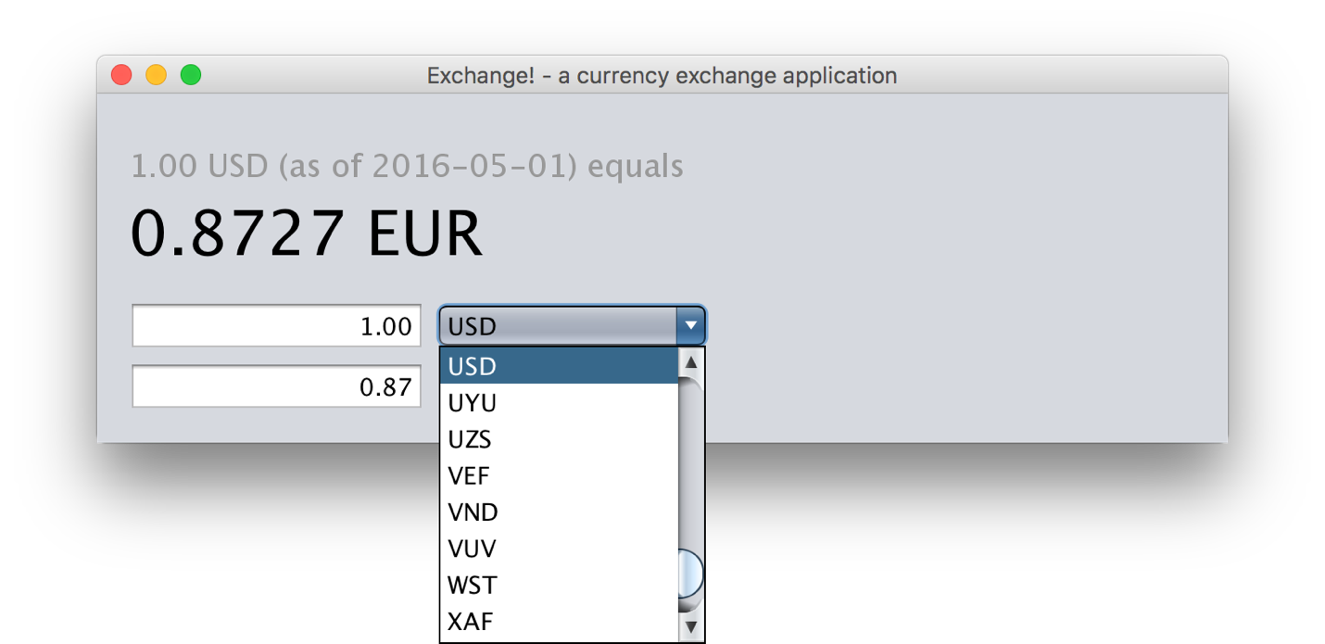

Test Case 3

I ran the application and clicked on the drop down box for the to rate to see the list of codes.

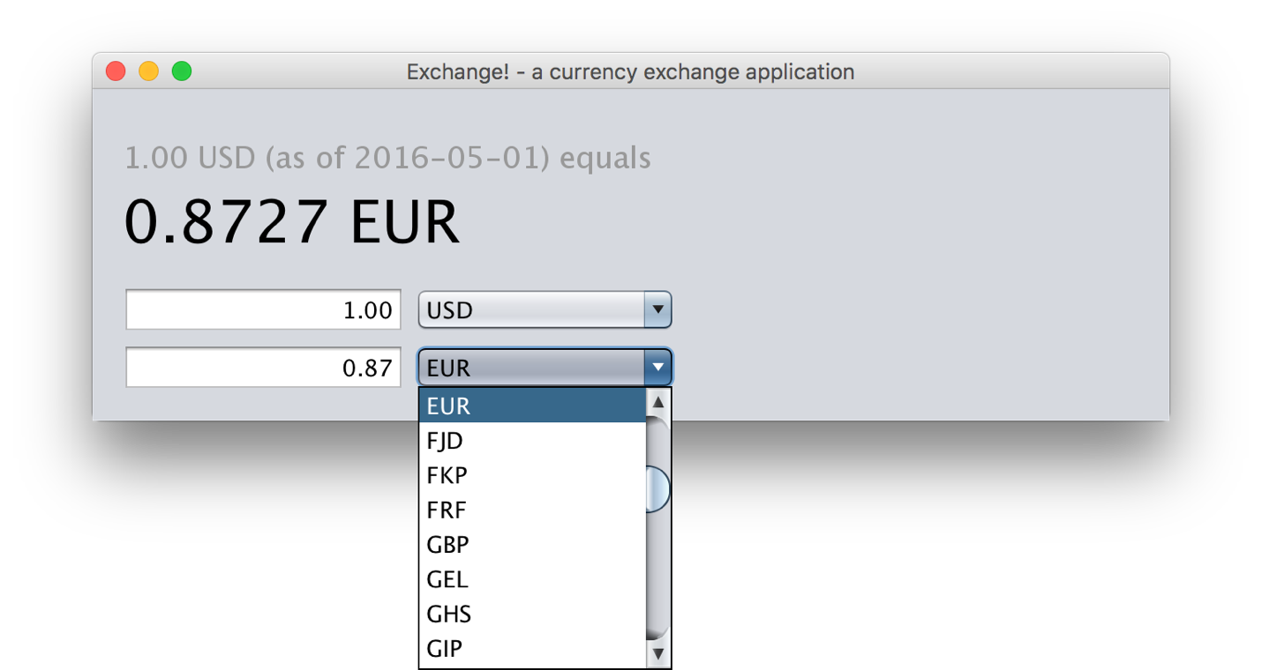

Test Case 4

Entered a from rate of 10.00 and converted rate was displayed.

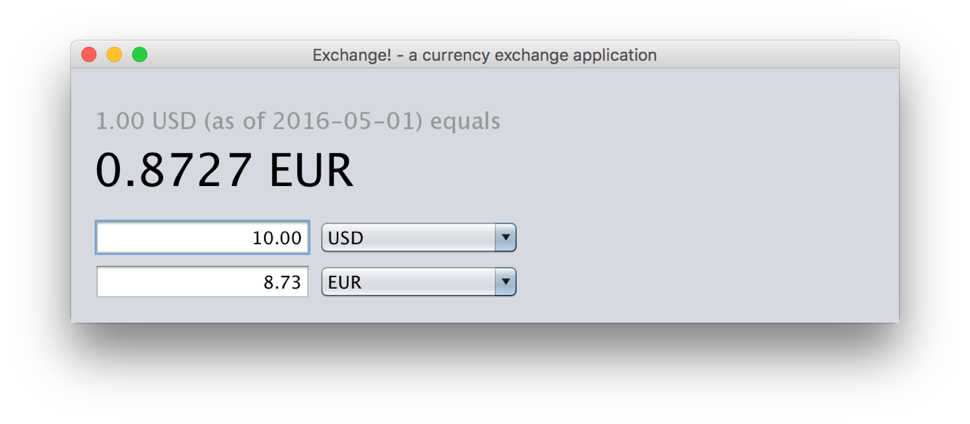

Test Case 5

Entered a from rate of 10.50 and converted rate was displayed.

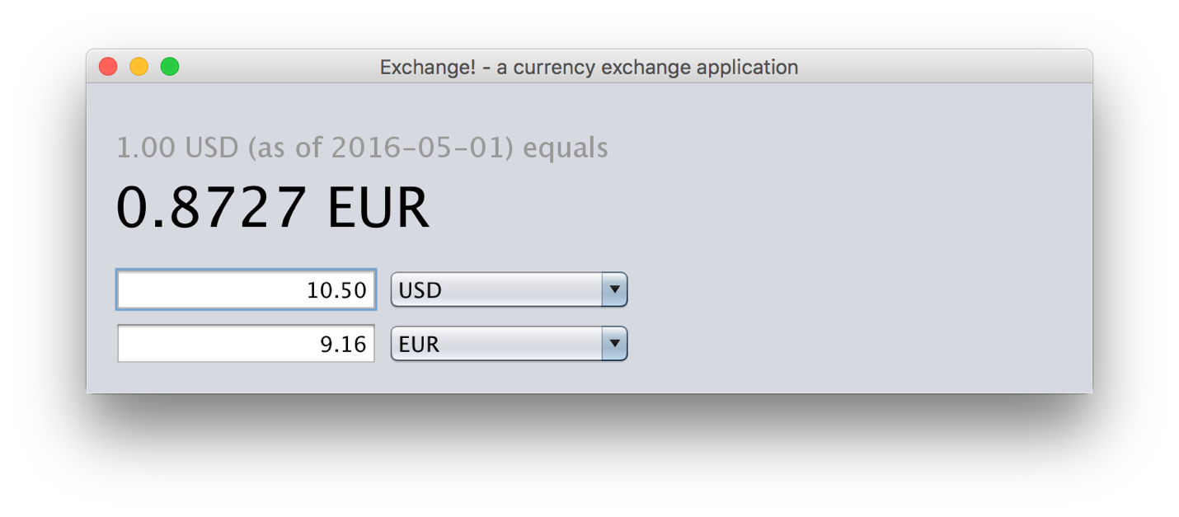

Test Case 6

Test Case 7

Entered a from rate of 5.0 and converted rate was displayed. I am including a screenshot from the Exchange app plus a screenshot from the Google site.

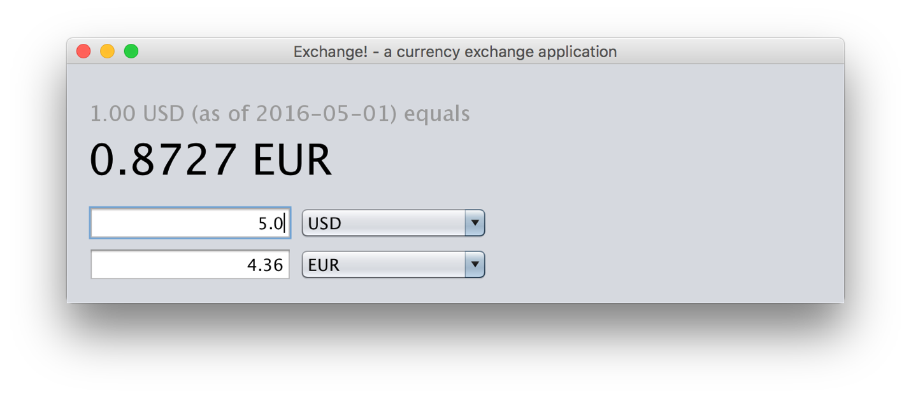

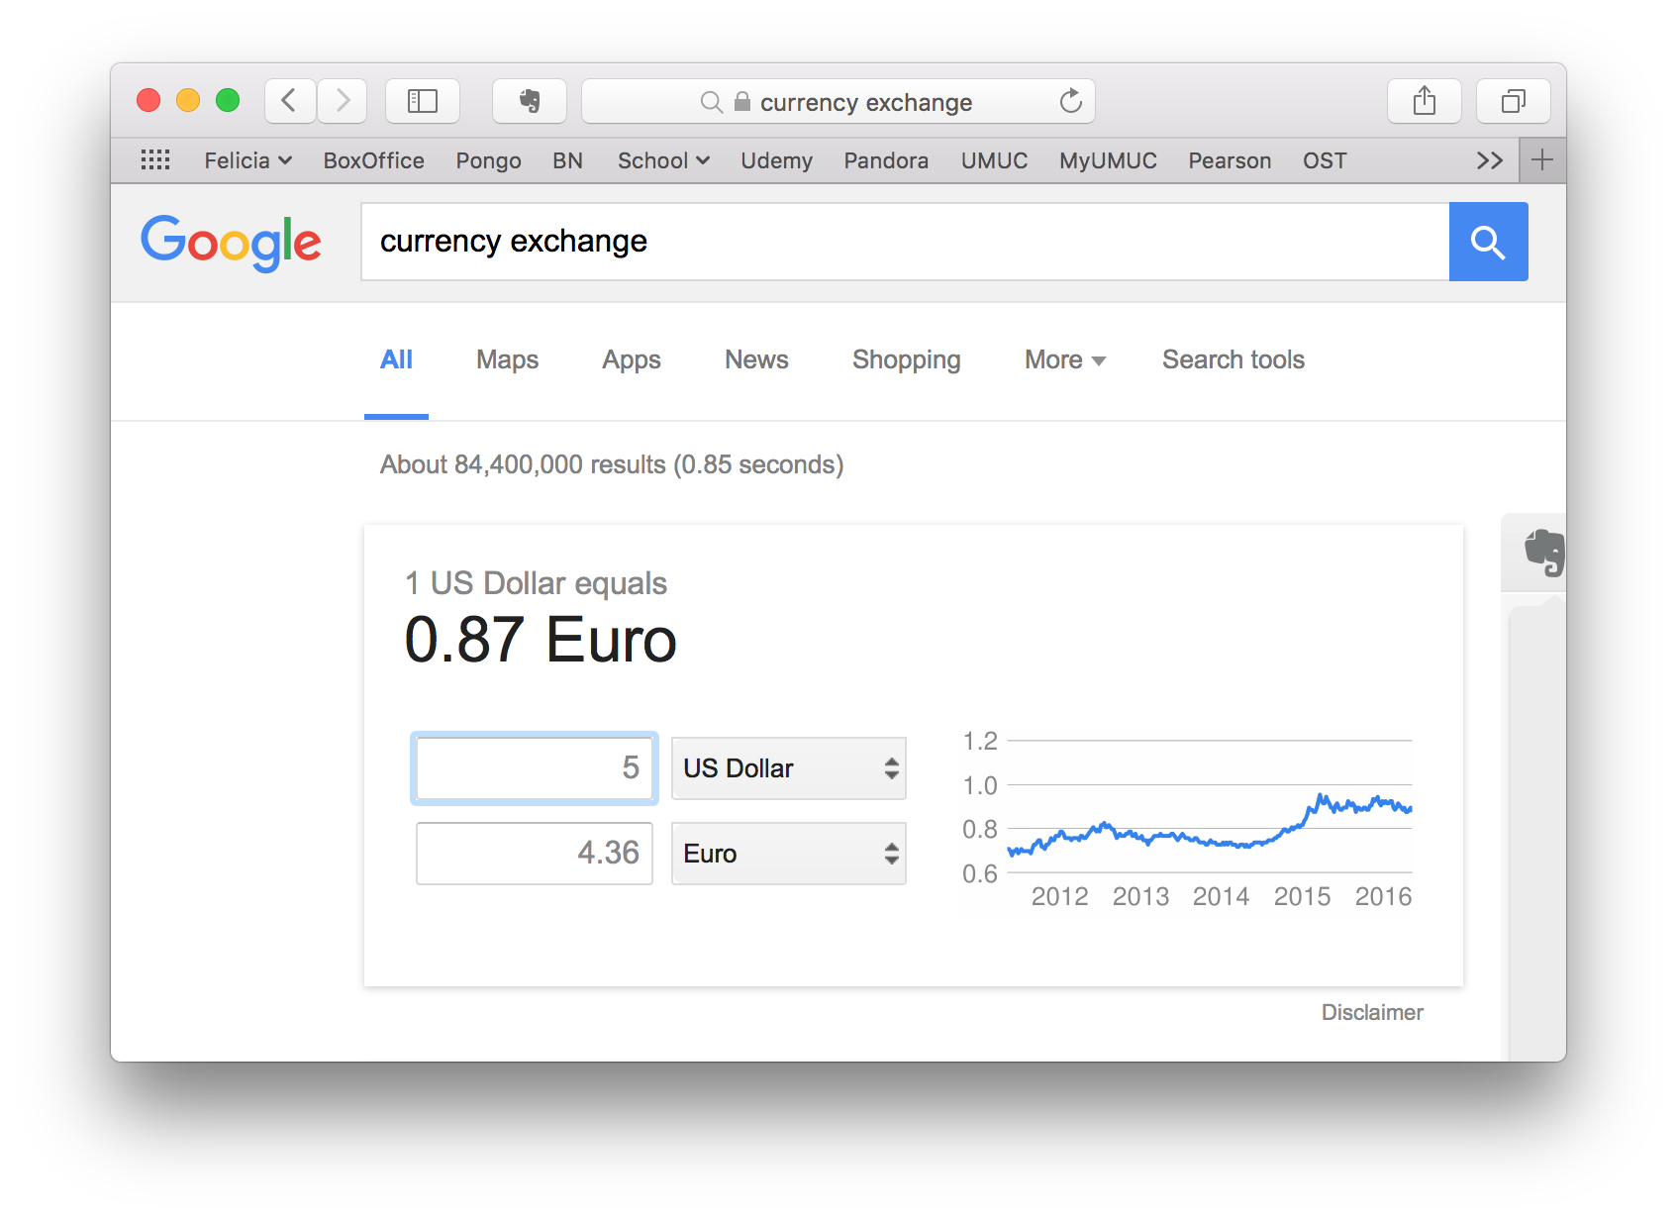

Test Case 8

I entered 100 and did a screenshot after each number to show that the converted amount shows for each entry. Note when the field is blank it shows red.

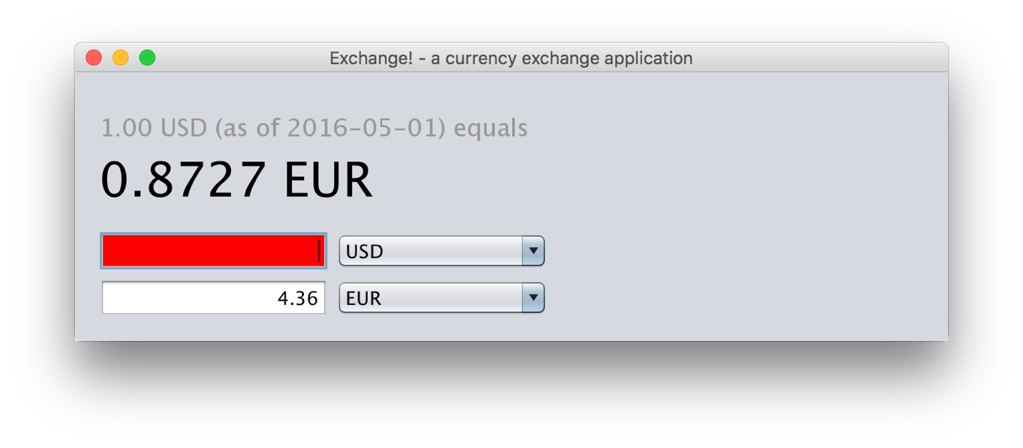

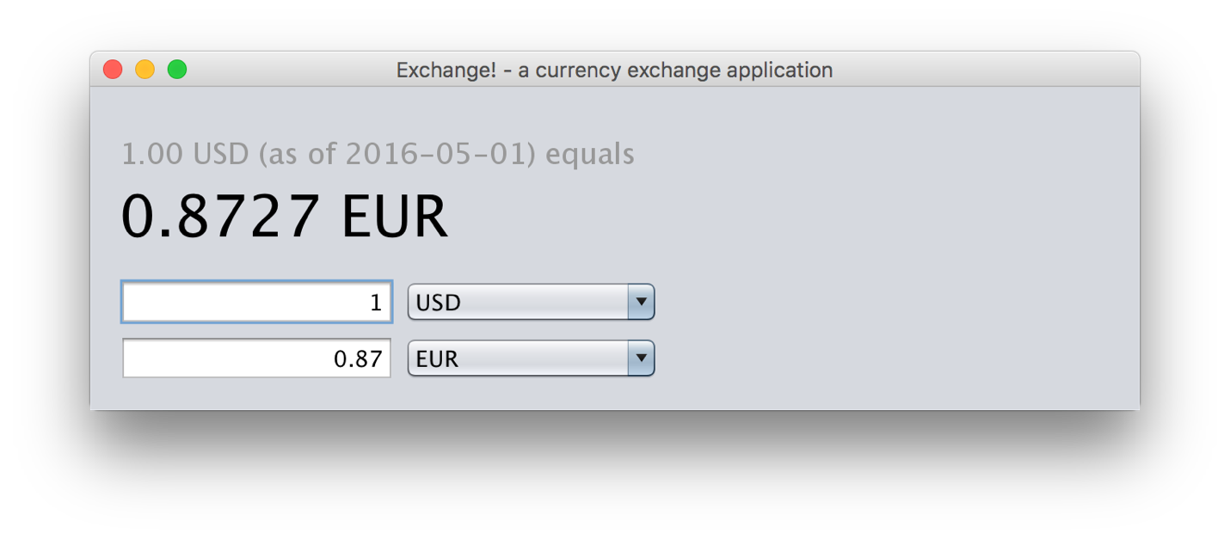

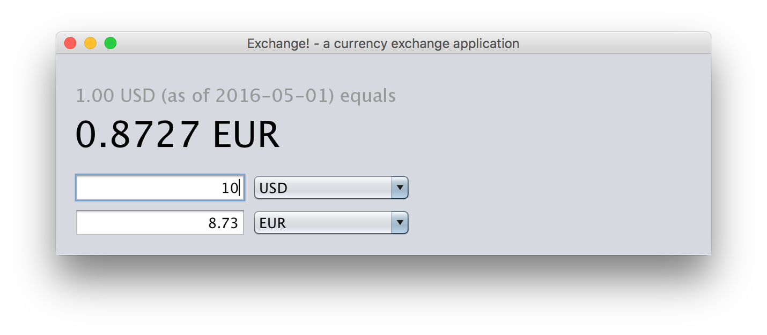

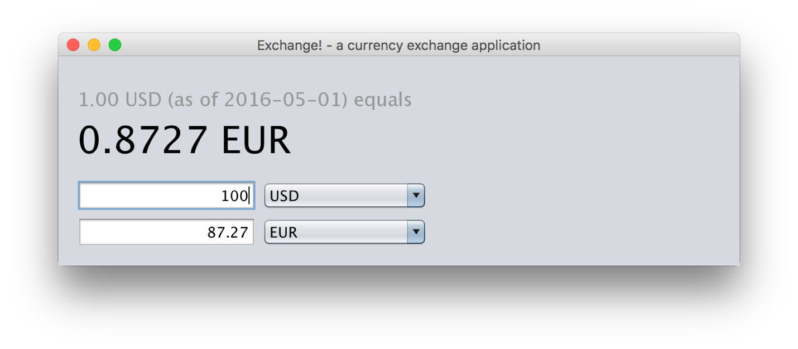

Test Case 9

Turned off WiFi and tried the application.

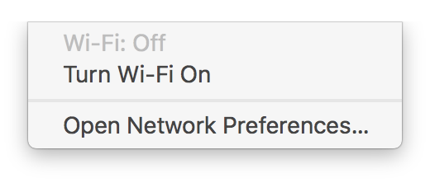

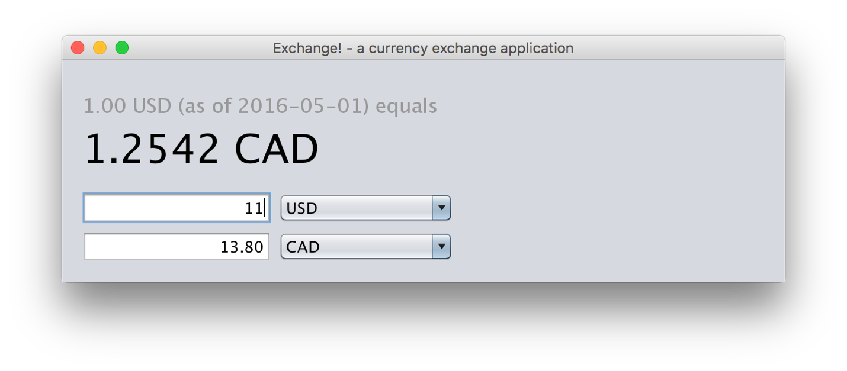

Test Case 10

Deleted all data from database. Ran application. No error message. Application blew up.

Jasons-MacBook-Pro:seg0 jasondudash$ rm *.*

Jasons-MacBook-Pro:seg0 jasondudash$ ls

Jasons-MacBook-Pro:seg0 jasondudash$ pwd

/Users/jasondudash/Documents/GIT/CMSC495/Exchange/exchangedb/seg0

Jasons-MacBook-Pro:seg0 jasondudash$

May 01, 2016 8:32:44 PM exchangecurrency.ExchangeRateDB getConnection

SEVERE: null

java.sql.SQLException: Failed to start database 'exchangedb' with class loader sun.misc.Launcher$AppClassLoader@7440e464, see the next exception for details.

at org.apache.derby.impl.jdbc.SQLExceptionFactory40.getSQLException(Unknown Source)

at org.apache.derby.impl.jdbc.Util.newEmbedSQLException(Unknown Source)

at org.apache.derby.impl.jdbc.Util.seeNextException(Unknown Source)

at org.apache.derby.impl.jdbc.EmbedConnection.bootDatabase(Unknown Source)

at org.apache.derby.impl.jdbc.EmbedConnection.<init>(Unknown Source)

at org.apache.derby.impl.jdbc.EmbedConnection40.<init>(Unknown Source)

at org.apache.derby.jdbc.Driver40.getNewEmbedConnection(Unknown Source)

at org.apache.derby.jdbc.InternalDriver.connect(Unknown Source)

at org.apache.derby.jdbc.Driver20.connect(Unknown Source)

at org.apache.derby.jdbc.AutoloadedDriver.connect(Unknown Source)

at java.sql.DriverManager.getConnection(DriverManager.java:664)

at java.sql.DriverManager.getConnection(DriverManager.java:270)

at exchangecurrency.ExchangeRateDB.getConnection(ExchangeRateDB.java:199)

at exchangecurrency.ExchangeRateDB.updateRates(ExchangeRateDB.java:31)

at exchangecurrency.CurrencyConversionLogic.<init>(CurrencyConversionLogic.java:31)

at exchangecurrency.Gui.init(Gui.java:51)

at exchangecurrency.Gui.<init>(Gui.java:47)

at exchangecurrency.Gui.lambda$main$3(Gui.java:324)

at exchangecurrency.Gui$$Lambda$7/2094548358.run(Unknown Source)

at java.awt.event.InvocationEvent.dispatch(InvocationEvent.java:311)

at java.awt.EventQueue.dispatchEventImpl(EventQueue.java:749)

at java.awt.EventQueue.access$500(EventQueue.java:97)

at java.awt.EventQueue$3.run(EventQueue.java:702)

at java.awt.EventQueue$3.run(EventQueue.java:696)

at java.security.AccessController.doPrivileged(Native Method)

at java.security.ProtectionDomain$1.doIntersectionPrivilege(ProtectionDomain.java:75)

at java.awt.EventQueue.dispatchEvent(EventQueue.java:719)

at java.awt.EventDispatchThread.pumpOneEventForFilters(EventDispatchThread.java:201)

at java.awt.EventDispatchThread.pumpEventsForFilter(EventDispatchThread.java:116)

at java.awt.EventDispatchThread.pumpEventsForHierarchy(EventDispatchThread.java:105)

at java.awt.EventDispatchThread.pumpEvents(EventDispatchThread.java:101)

at java.awt.EventDispatchThread.pumpEvents(EventDispatchThread.java:93)

at java.awt.EventDispatchThread.run(EventDispatchThread.java:82)

Caused by: java.sql.SQLException: Failed to start database 'exchangedb' with class loader sun.misc.Launcher$AppClassLoader@7440e464, see the next exception for details.

at org.apache.derby.impl.jdbc.SQLExceptionFactory.getSQLException(Unknown Source)

at org.apache.derby.impl.jdbc.SQLExceptionFactory40.wrapArgsForTransportAcrossDRDA(Unknown Source)

... 33 more

Caused by: java.sql.SQLException: Container Container(0, 161) cannot be opened; it either has been dropped or does not exist.

at org.apache.derby.impl.jdbc.SQLExceptionFactory.getSQLException(Unknown Source)

at org.apache.derby.impl.jdbc.SQLExceptionFactory40.wrapArgsForTransportAcrossDRDA(Unknown Source)

at org.apache.derby.impl.jdbc.SQLExceptionFactory40.getSQLException(Unknown Source)

at org.apache.derby.impl.jdbc.Util.generateCsSQLException(Unknown Source)

... 30 more

Caused by: ERROR 40XD2: Container Container(0, 161) cannot be opened; it either has been dropped or does not exist.

Test Case 11

It is not possible to not select a To currency code so all is good.

Test Case 12

Entered an amount and saw the converted amount show for each digit.

Test Case 13

Tried to enter a non-numeric amount. The text box turns red and the converted amount does not change.

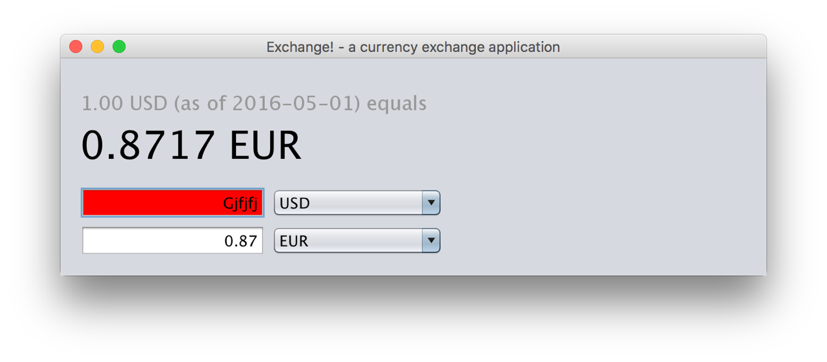

Test Case 14

First thing is to find a currency that does not do decimals. Change the To currency code to one of the currencies that does not allow decimals.

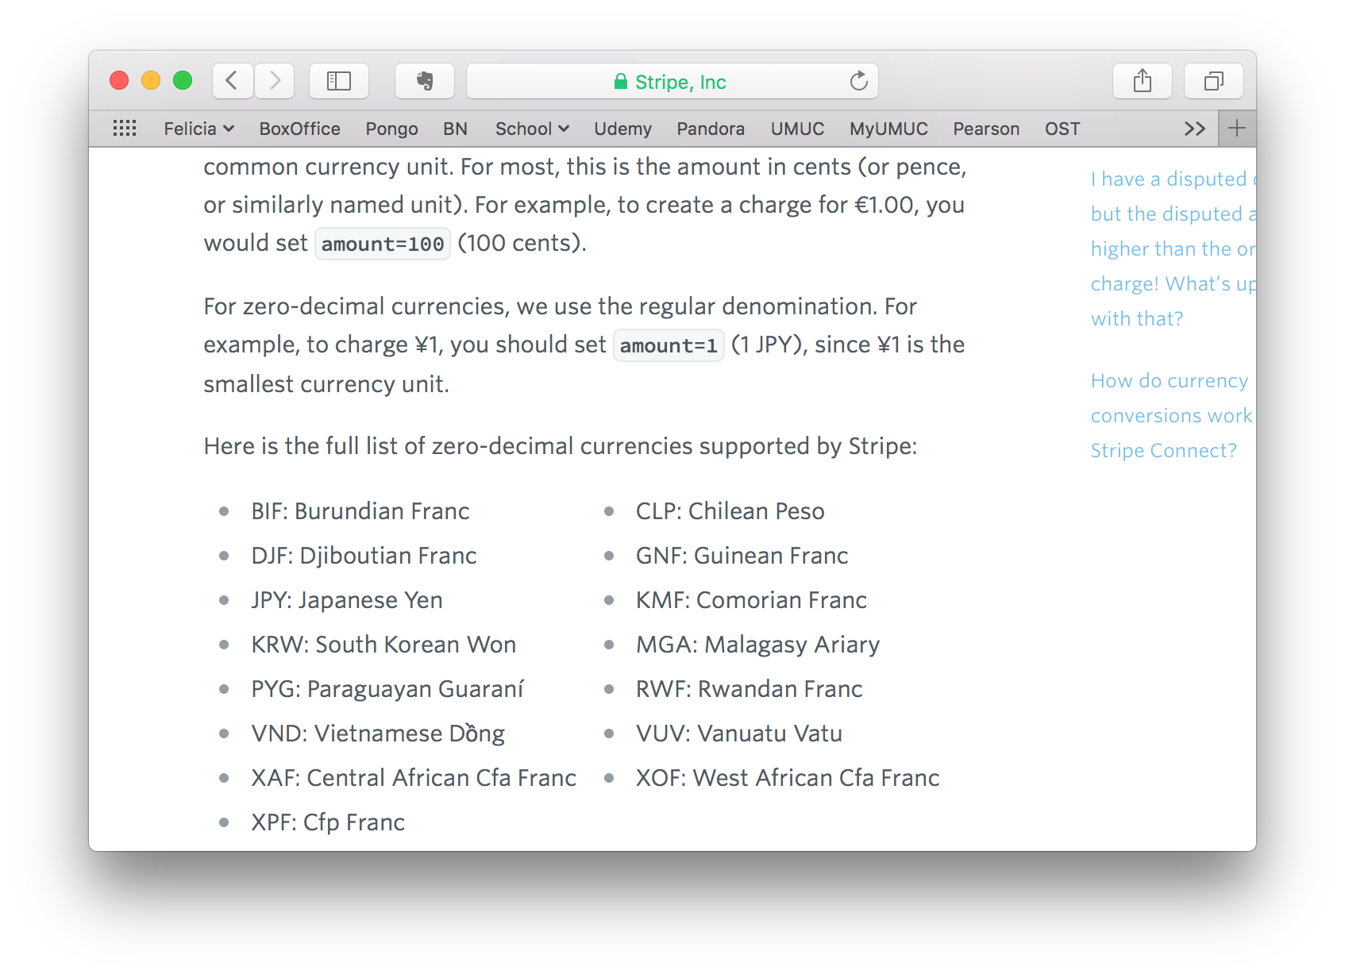

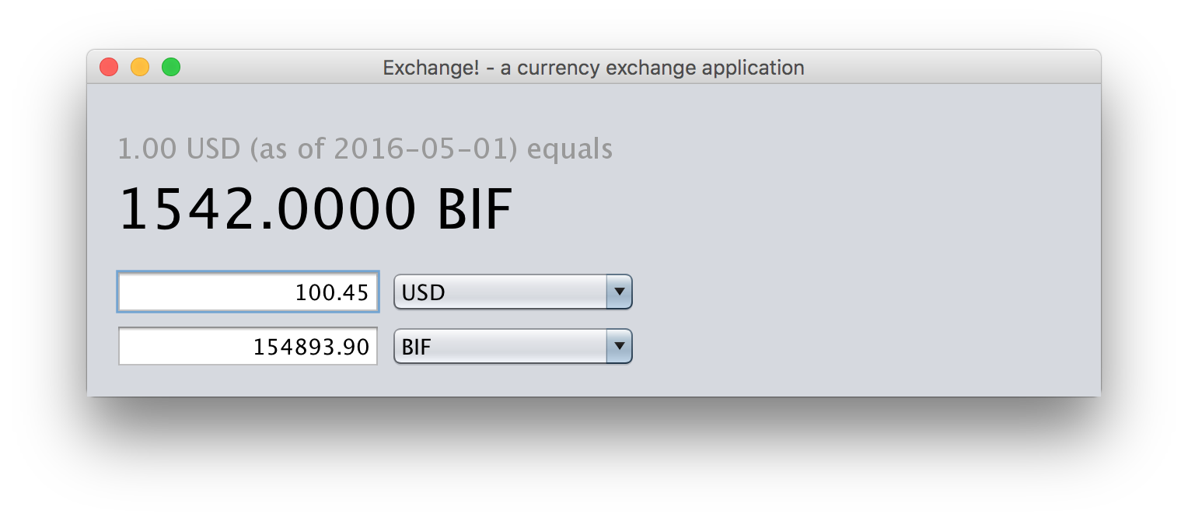

Test Case 15

Entered an amount with 3 decimal places.

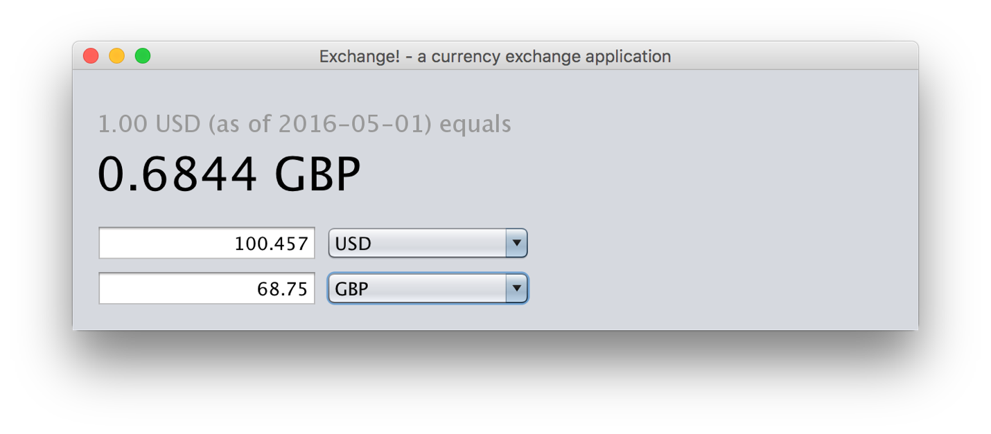

Test Case 16