Exchange application testing

Test case 1

I was able to log to the directory containing the data base and verify the records exist.

Jasons-MacBook-Pro:seg0 jasondudash$ ls -l

total 1712

-rw-r--r-- 1 jasondudash staff 533 May 3 18:09 README_DO_NOT_TOUCH_FILES.txt

-rw-r--r-- 1 jasondudash staff 8192 May 3 18:09 c10.dat

-rw-r--r-- 1 jasondudash staff 8192 May 3 18:09 c101.dat

-rw-r--r-- 1 jasondudash staff 8192 May 3 18:09 c111.dat

-rw-r--r-- 1 jasondudash staff 8192 May 3 18:09 c121.dat

-rw-r--r-- 1 jasondudash staff 8192 May 3 18:09 c130.dat

-rw-r--r-- 1 jasondudash staff 8192 May 3 18:09 c141.dat

-rw-r--r-- 1 jasondudash staff 8192 May 3 18:09 c150.dat

-rw-r--r-- 1 jasondudash staff 8192 May 3 18:09 c161.dat

-rw-r--r-- 1 jasondudash staff 8192 May 3 18:09 c171.dat

-rw-r--r-- 1 jasondudash staff 36864 May 3 18:09 c180.dat

-rw-r--r-- 1 jasondudash staff 16384 May 3 18:09 c191.dat

-rw-r--r-- 1 jasondudash staff 16384 May 3 18:09 c1a1.dat

-rw-r--r-- 1 jasondudash staff 16384 May 3 18:09 c1b1.dat

-rw-r--r-- 1 jasondudash staff 8192 May 3 18:09 c1c0.dat

-rw-r--r-- 1 jasondudash staff 8192 May 3 18:09 c1d1.dat

-rw-r--r-- 1 jasondudash staff 8192 May 3 18:09 c1e0.dat

-rw-r--r-- 1 jasondudash staff 8192 May 3 18:09 c1f1.dat

-rw-r--r-- 1 jasondudash staff 32768 May 4 02:21 c20.dat

-rw-r--r-- 1 jasondudash staff 8192 May 3 18:09 c200.dat

-rw-r--r-- 1 jasondudash staff 8192 May 3 18:09 c211.dat

-rw-r--r-- 1 jasondudash staff 8192 May 3 18:09 c221.dat

-rw-r--r-- 1 jasondudash staff 118784 May 3 18:09 c230.dat

-rw-r--r-- 1 jasondudash staff 8192 May 3 18:09 c241.dat

-rw-r--r-- 1 jasondudash staff 20480 May 3 18:09 c251.dat

-rw-r--r-- 1 jasondudash staff 8192 May 3 18:09 c260.dat

-rw-r--r-- 1 jasondudash staff 8192 May 3 18:09 c271.dat

-rw-r--r-- 1 jasondudash staff 8192 May 3 18:09 c281.dat

-rw-r--r-- 1 jasondudash staff 8192 May 3 18:09 c290.dat

-rw-r--r-- 1 jasondudash staff 8192 May 3 18:09 c2a1.dat

-rw-r--r-- 1 jasondudash staff 8192 May 3 18:09 c2b1.dat

-rw-r--r-- 1 jasondudash staff 8192 May 3 18:09 c2c1.dat

-rw-r--r-- 1 jasondudash staff 8192 May 3 18:09 c2d0.dat

-rw-r--r-- 1 jasondudash staff 8192 May 3 18:09 c2e1.dat

-rw-r--r-- 1 jasondudash staff 8192 May 3 18:09 c2f0.dat

-rw-r--r-- 1 jasondudash staff 8192 May 3 18:09 c300.dat

-rw-r--r-- 1 jasondudash staff 16384 May 4 02:21 c31.dat

-rw-r--r-- 1 jasondudash staff 8192 May 3 18:09 c311.dat

-rw-r--r-- 1 jasondudash staff 8192 May 3 18:09 c321.dat

-rw-r--r-- 1 jasondudash staff 8192 May 3 18:09 c331.dat

-rw-r--r-- 1 jasondudash staff 8192 May 3 18:09 c340.dat

-rw-r--r-- 1 jasondudash staff 8192 May 3 18:09 c351.dat

-rw-r--r-- 1 jasondudash staff 8192 May 3 18:09 c361.dat

-rw-r--r-- 1 jasondudash staff 8192 May 3 18:09 c371.dat

-rw-r--r-- 1 jasondudash staff 8192 May 3 18:09 c380.dat

-rw-r--r-- 1 jasondudash staff 8192 May 3 18:09 c391.dat

-rw-r--r-- 1 jasondudash staff 8192 May 3 18:09 c3a1.dat

-rw-r--r-- 1 jasondudash staff 8192 May 3 18:09 c3b1.dat

-rw-r--r-- 1 jasondudash staff 8192 May 3 18:09 c3c0.dat

-rw-r--r-- 1 jasondudash staff 8192 May 3 18:09 c3d1.dat

-rw-r--r-- 1 jasondudash staff 8192 May 3 18:09 c3e1.dat

-rw-r--r-- 1 jasondudash staff 8192 May 3 18:09 c3f1.dat

-rw-r--r-- 1 jasondudash staff 8192 May 3 18:09 c400.dat

-rw-r--r-- 1 jasondudash staff 16384 May 4 02:21 c41.dat

-rw-r--r-- 1 jasondudash staff 8192 May 3 18:09 c411.dat

-rw-r--r-- 1 jasondudash staff 8192 May 3 18:09 c421.dat

-rw-r--r-- 1 jasondudash staff 8192 May 3 18:09 c430.dat

-rw-r--r-- 1 jasondudash staff 8192 May 3 18:09 c441.dat

-rw-r--r-- 1 jasondudash staff 8192 May 3 18:09 c451.dat

-rw-r--r-- 1 jasondudash staff 8192 May 3 18:09 c461.dat

-rw-r--r-- 1 jasondudash staff 8192 May 3 18:09 c470.dat

-rw-r--r-- 1 jasondudash staff 8192 May 3 18:09 c481.dat

-rw-r--r-- 1 jasondudash staff 16384 May 4 02:21 c4b0.dat

-rw-r--r-- 1 jasondudash staff 16384 May 4 02:21 c51.dat

-rw-r--r-- 1 jasondudash staff 12288 May 4 02:21 c60.dat

-rw-r--r-- 1 jasondudash staff 8192 May 4 02:21 c71.dat

-rw-r--r-- 1 jasondudash staff 8192 May 4 02:21 c81.dat

-rw-r--r-- 1 jasondudash staff 24576 May 4 02:21 c90.dat

-rw-r--r-- 1 jasondudash staff 24576 May 4 02:21 ca1.dat

-rw-r--r-- 1 jasondudash staff 8192 May 4 02:21 cb1.dat

-rw-r--r-- 1 jasondudash staff 8192 May 3 18:09 cc0.dat

-rw-r--r-- 1 jasondudash staff 8192 May 3 18:09 cd1.dat

-rw-r--r-- 1 jasondudash staff 8192 May 3 18:09 ce1.dat

-rw-r--r-- 1 jasondudash staff 8192 May 3 18:09 cf0.dat

-rw-r--r-- 1 jasondudash staff 4096 May 4 02:21 d4a0.dat

Jasons-MacBook-Pro:seg0 jasondudash$ pwd

/Users/jasondudash/Documents/GIT/CMSC495/Exchange/exchangedb/seg0

Jasons-MacBook-Pro:seg0 jasondudash$

Test Case 2

I ran the application and clicked on the drop down box for the from rate to see the list of currency codes.

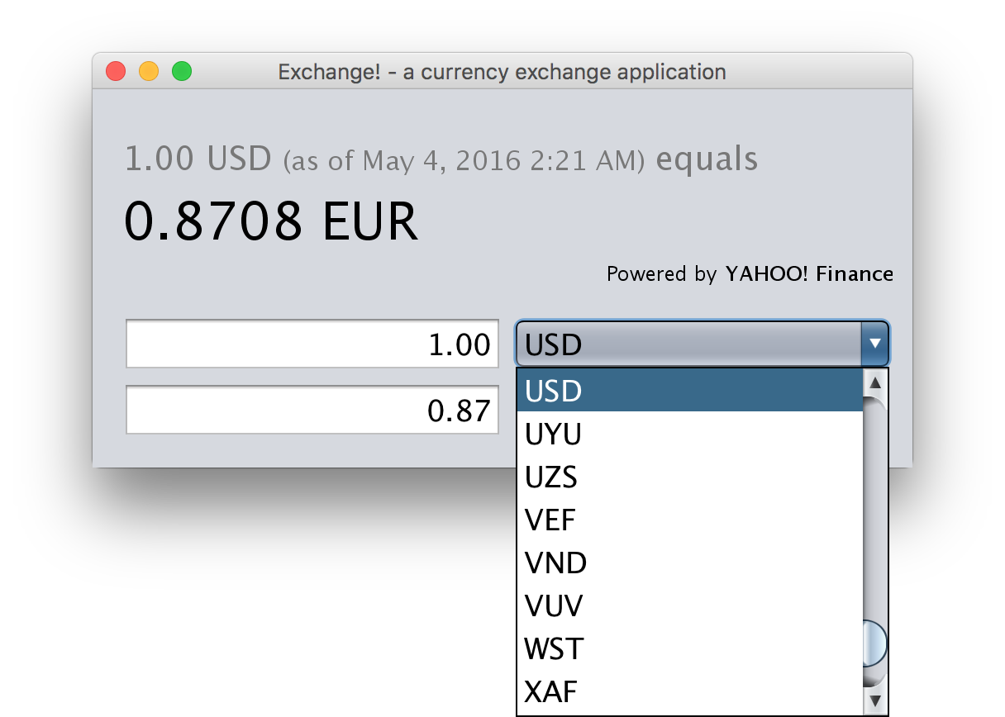

Test Case 3

I ran the application and clicked on the drop down box for the to rate to see the list of codes.

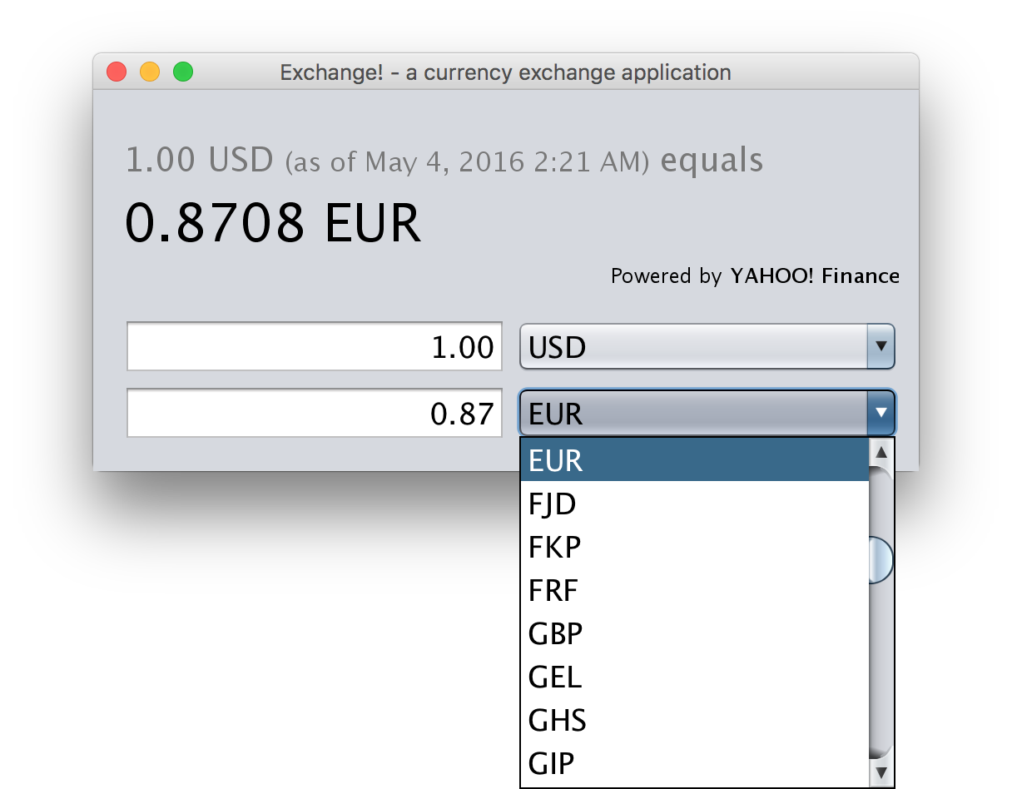

Test Case 4

Entered a from rate of 10.00 and converted rate was displayed.

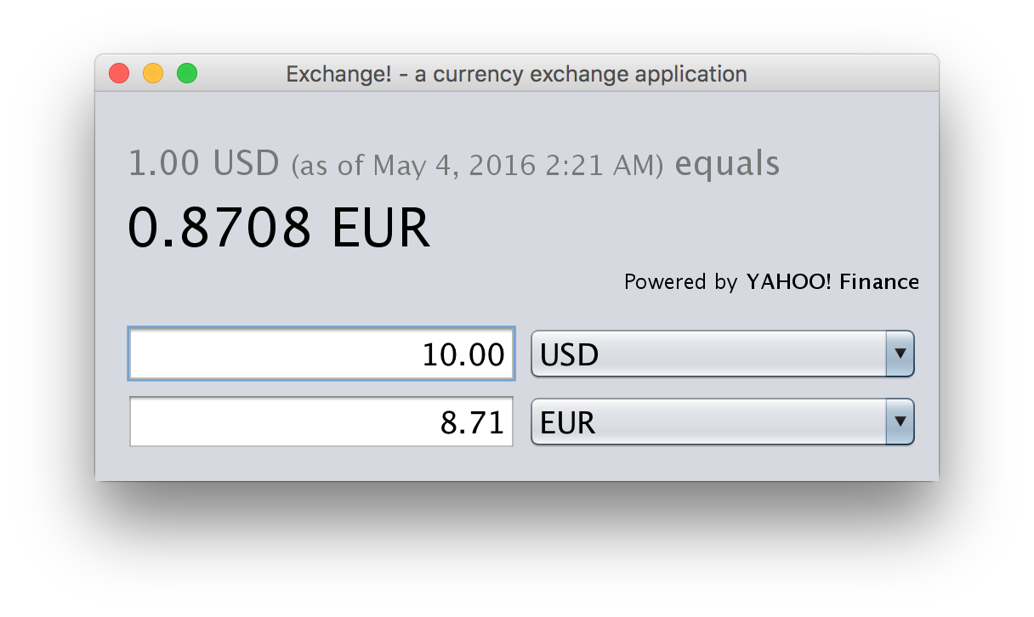

Test Case 5

Entered a from rate of 10.50 and converted rate was displayed.

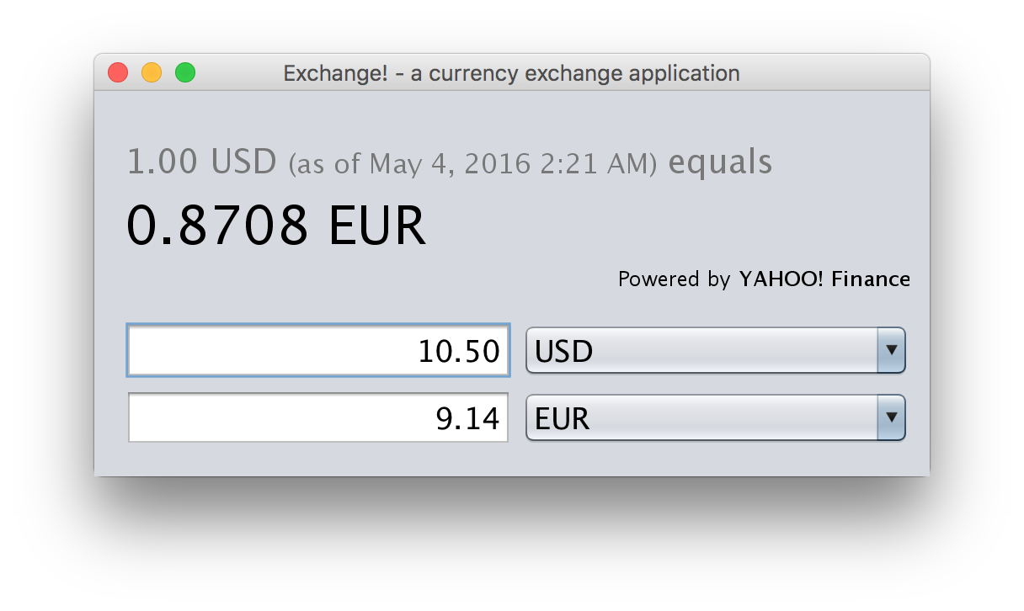

Test Case 6

Entered the amount of 2.0 and the appropriate converted amount displayed. The source and age of the data was displayed.

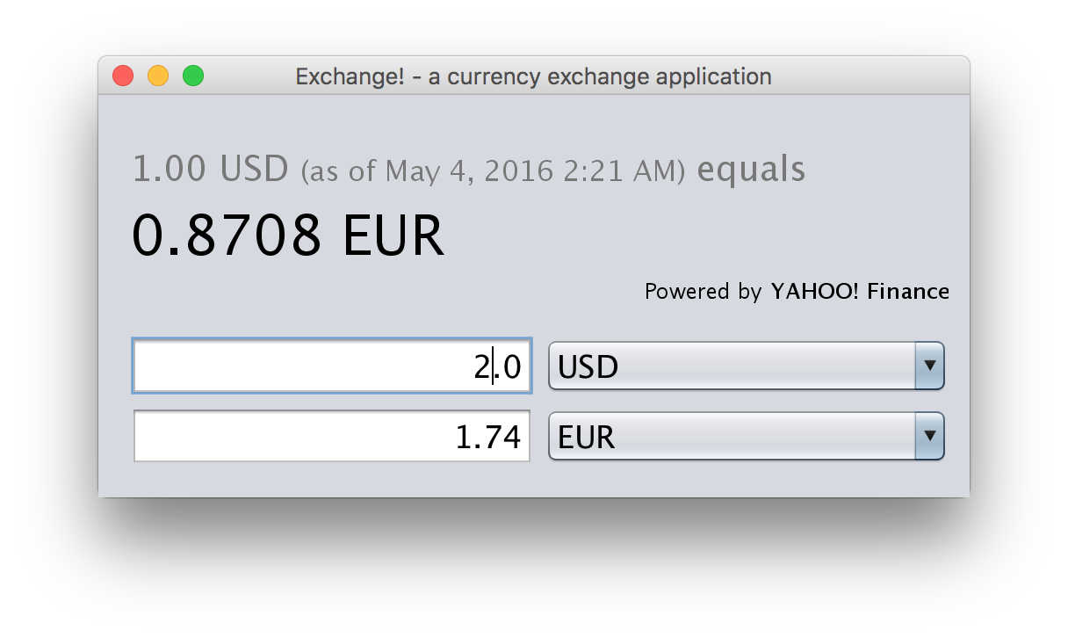

Test Case 7

Entered a from rate of 5.0 and converted rate was displayed. I am including a screenshot from the Exchange app plus a screenshot from the Google site.

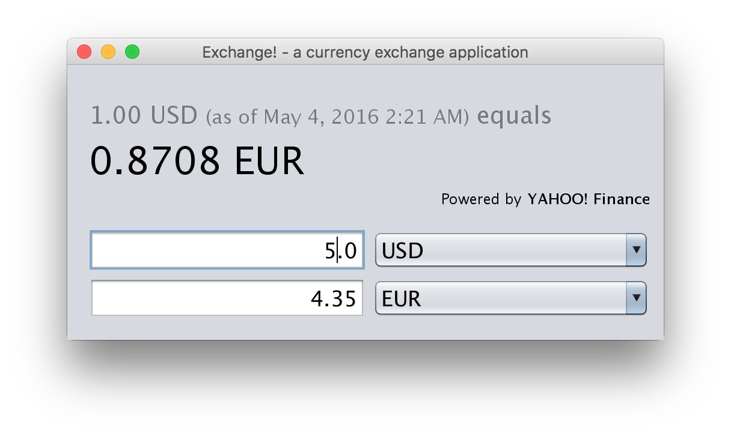

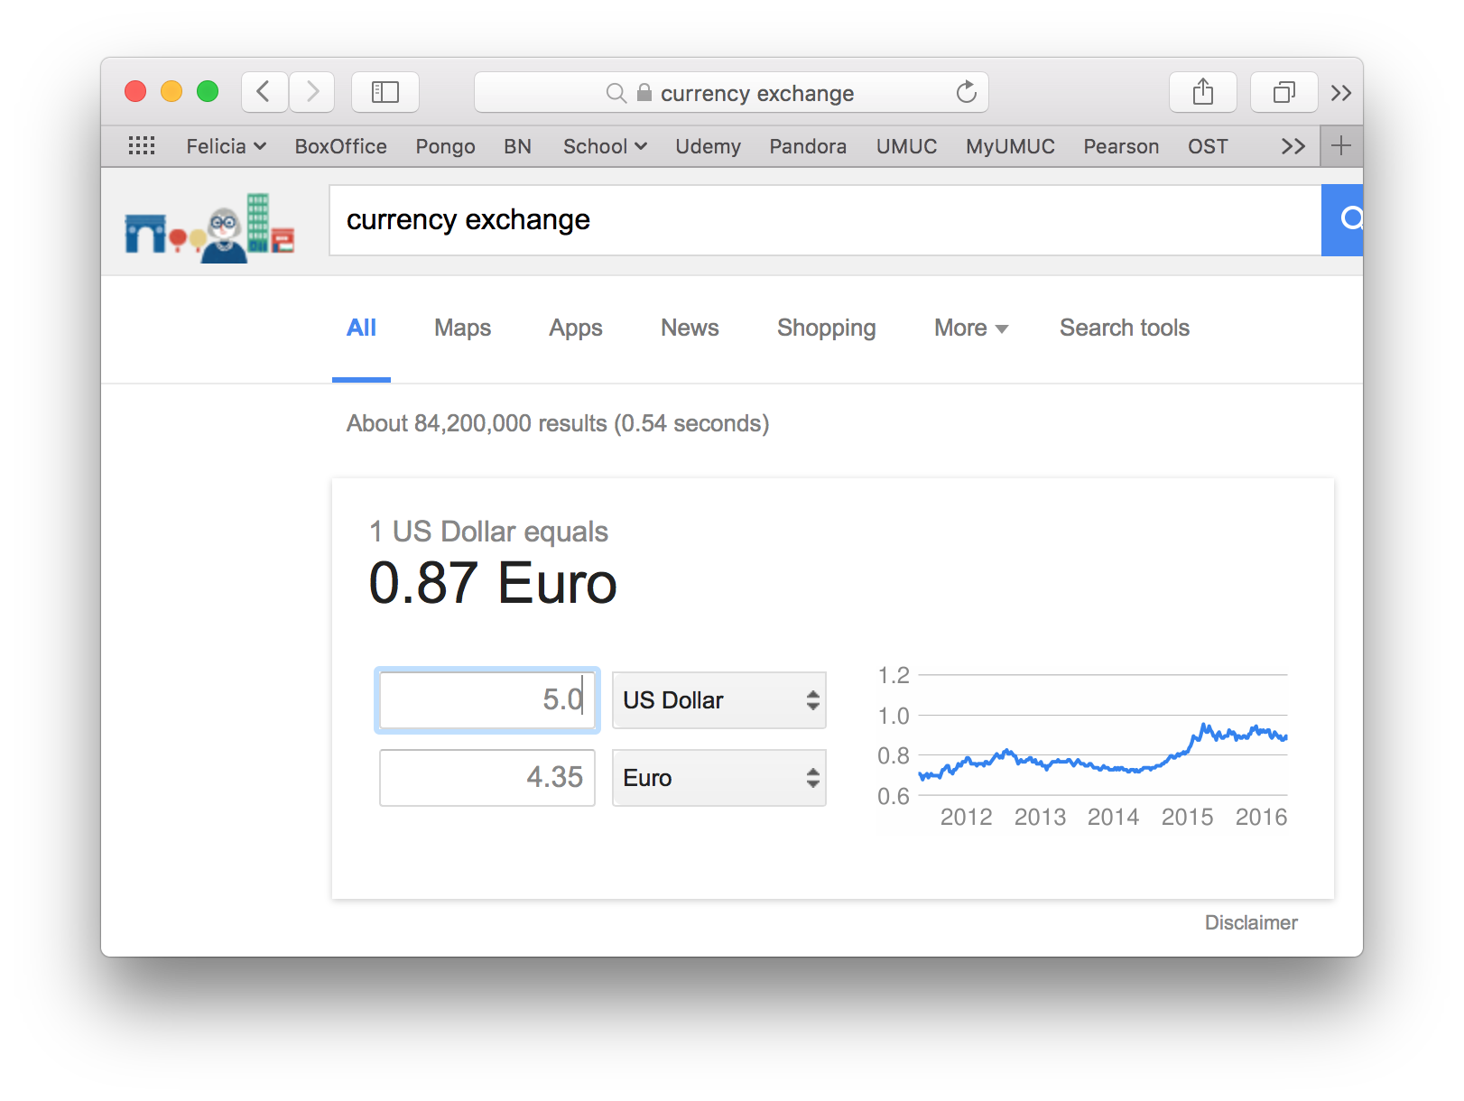

Test Case 8

I entered 100 and did a screenshot after each number to show that the converted amount shows for each entry. Note when the field is blank it shows red.

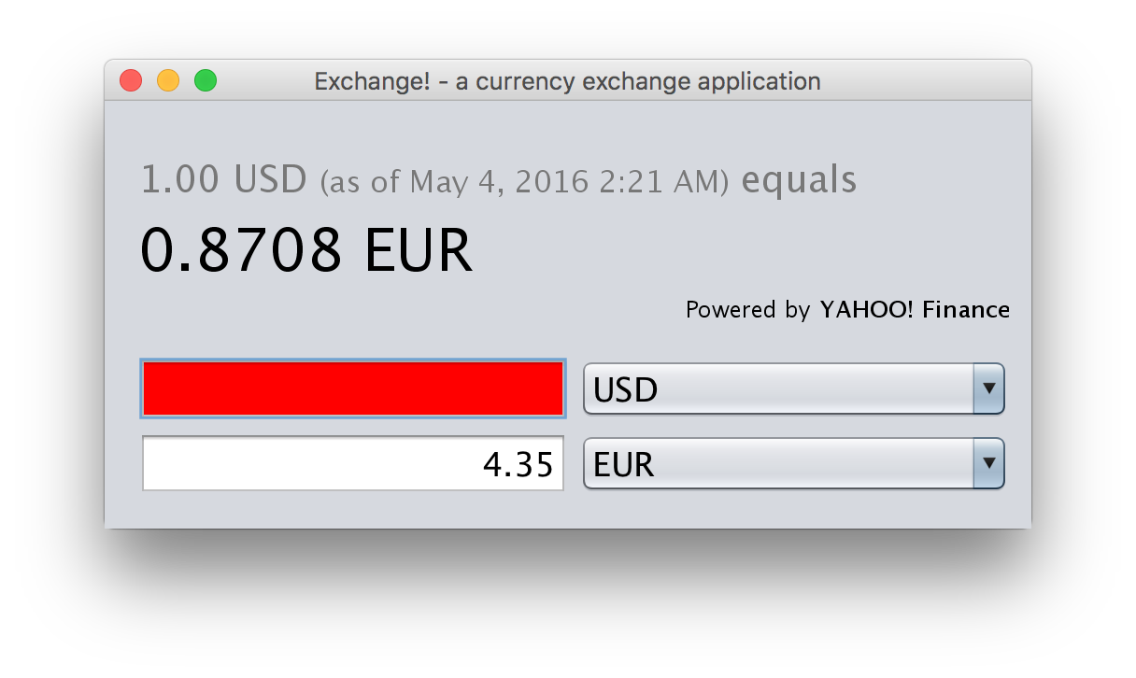

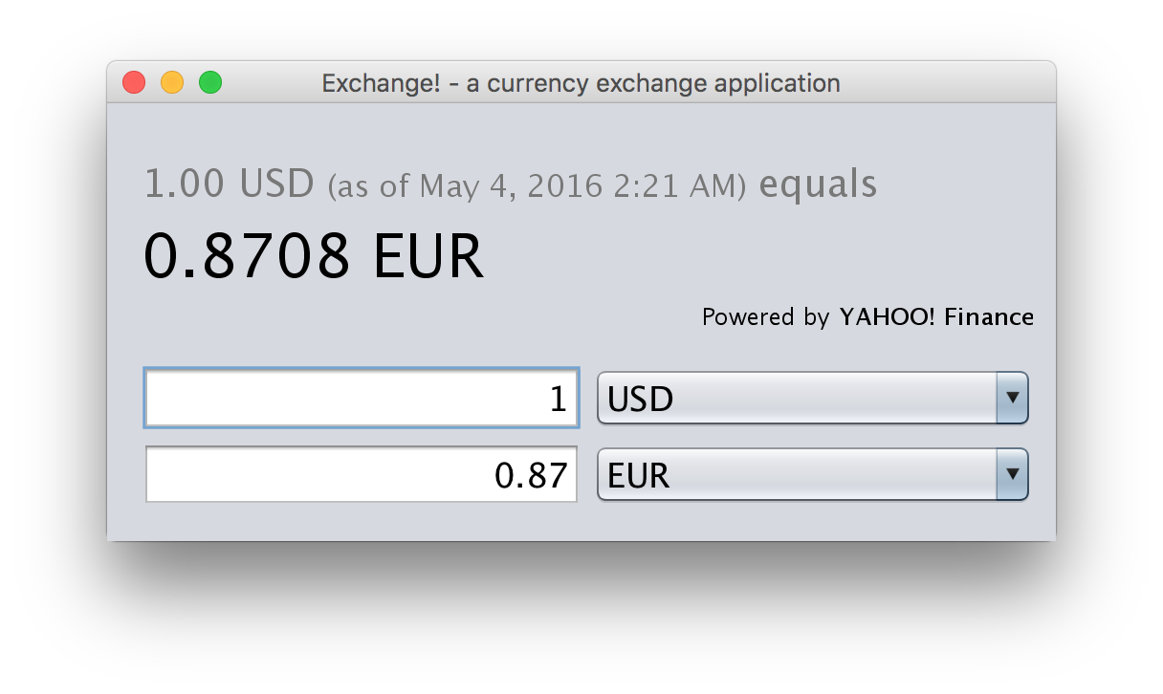

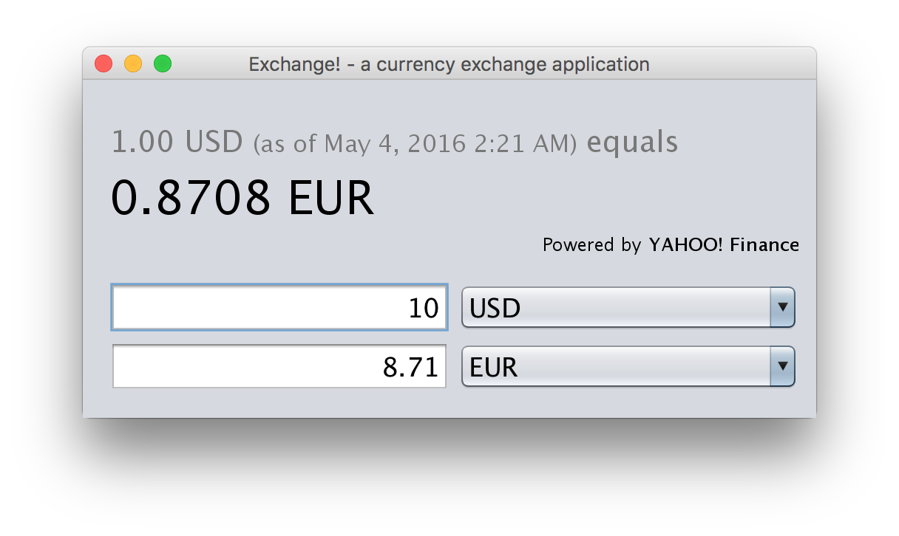

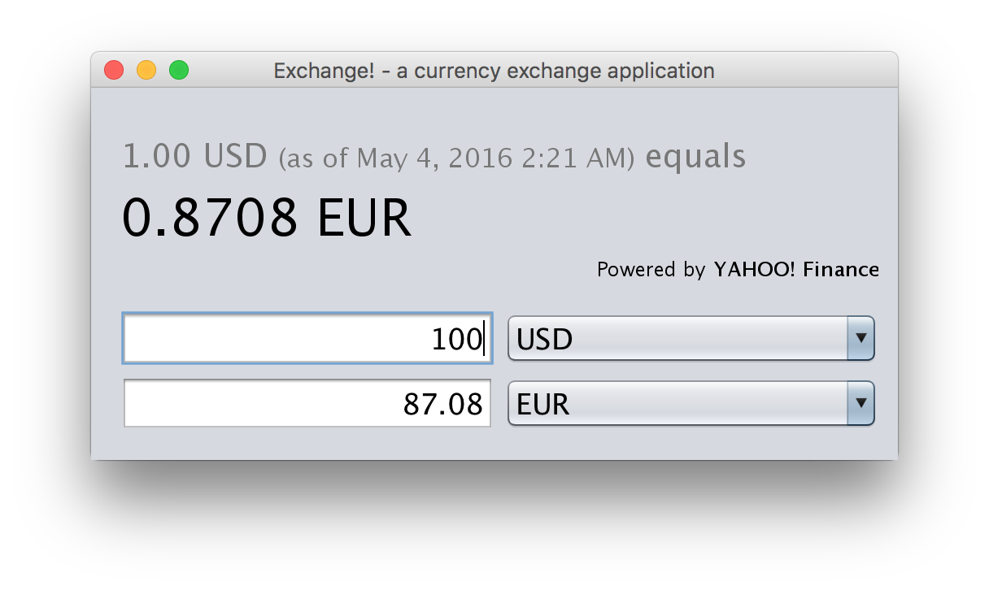

Test Case 9

Turned off WiFi and tried the application.

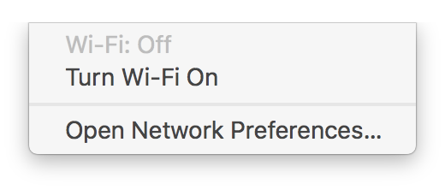

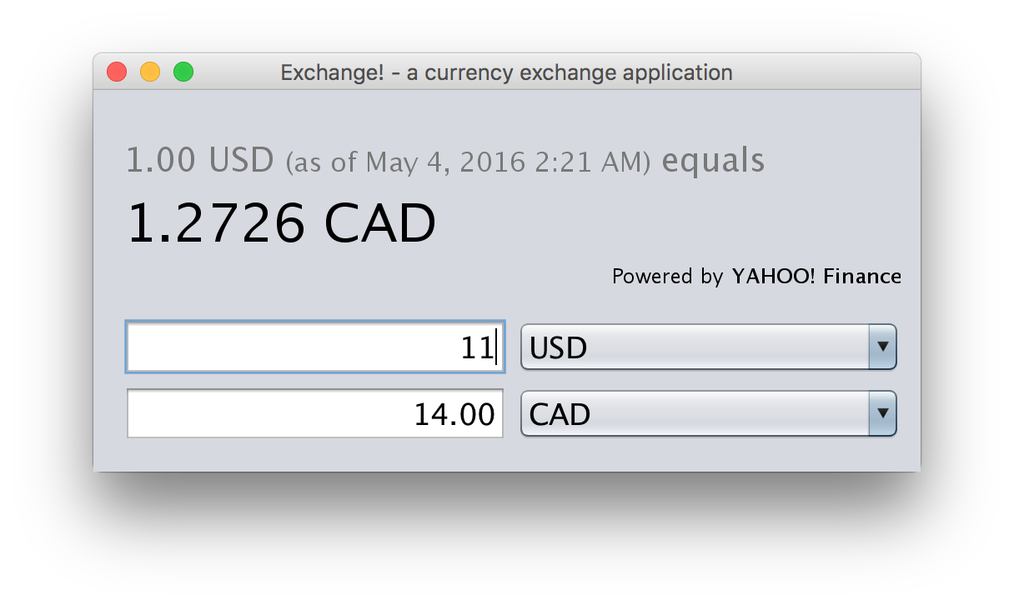

Test Case 10

Turned off WiFi. Deleted all data from database. Ran application. Received a warning message about not being to download data from internet. Also received a message that the database was empty and the app will now close. Application closed cleanly.

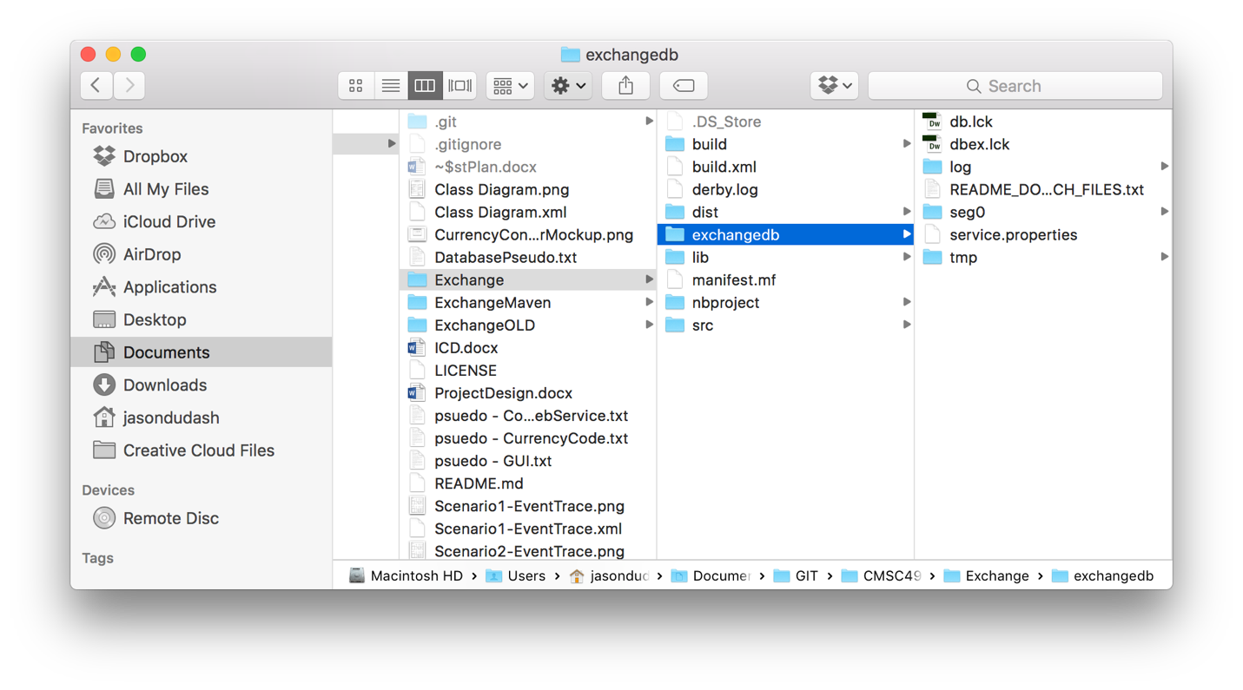

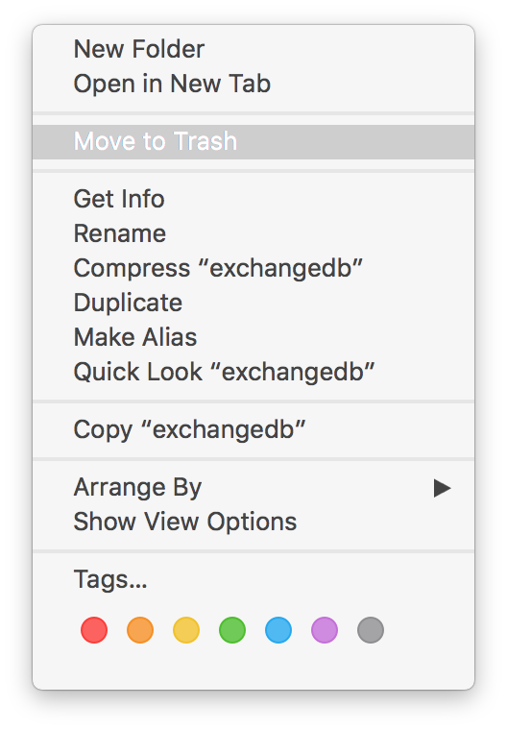

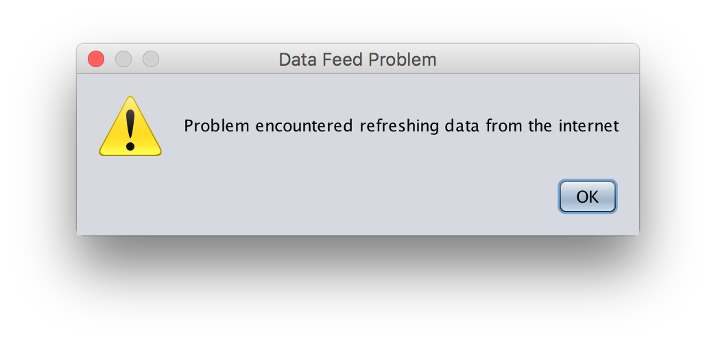

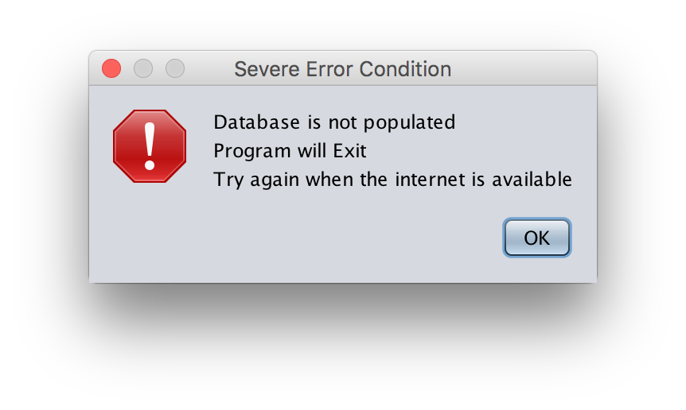

Test Case 11

It is not possible to not select a To currency code so all is good.

Test Case 12

Entered an amount and saw the converted amount show for each digit.

Test Case 13

Tried to enter a non-numeric amount. The text box turns red and the converted amount does not change. Only able to enter numbers, one decimal point, and two numbers after the decimal

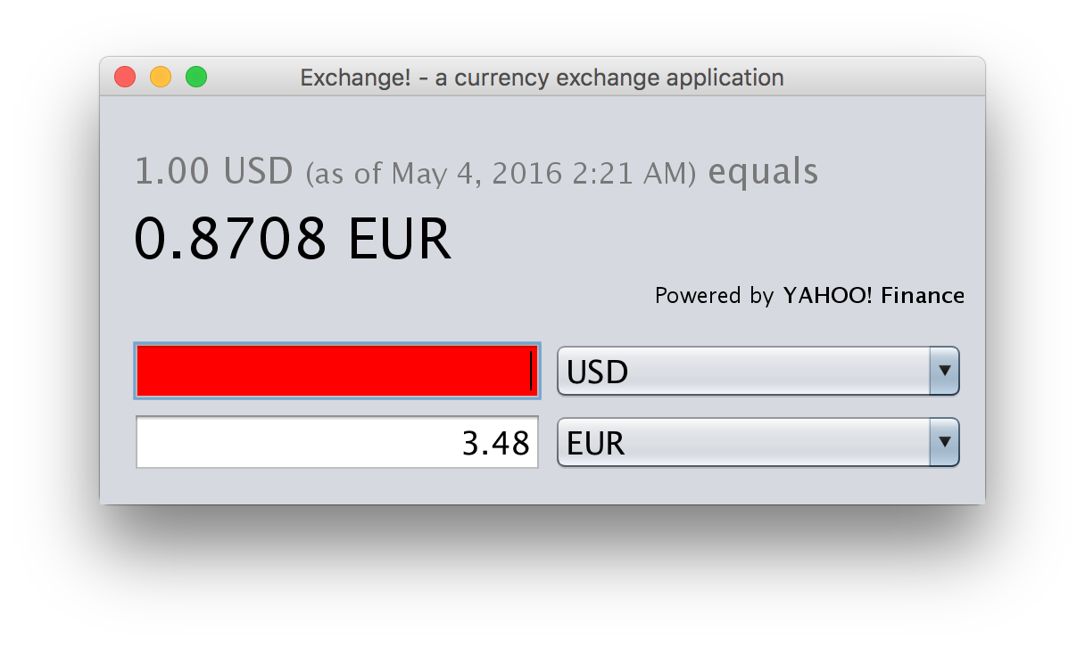

Test Case 14

First thing is to find a currency that does not do decimals. Change the To currency code to one of the currencies that does not allow decimals.

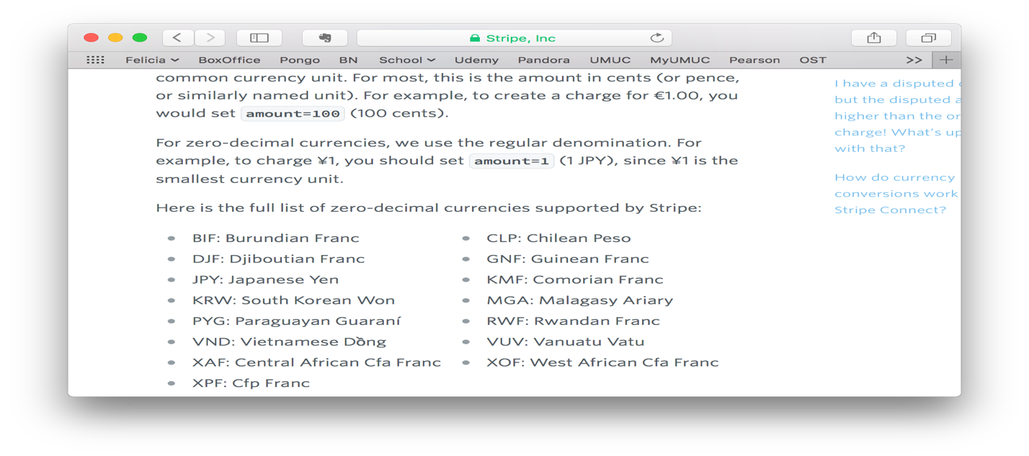

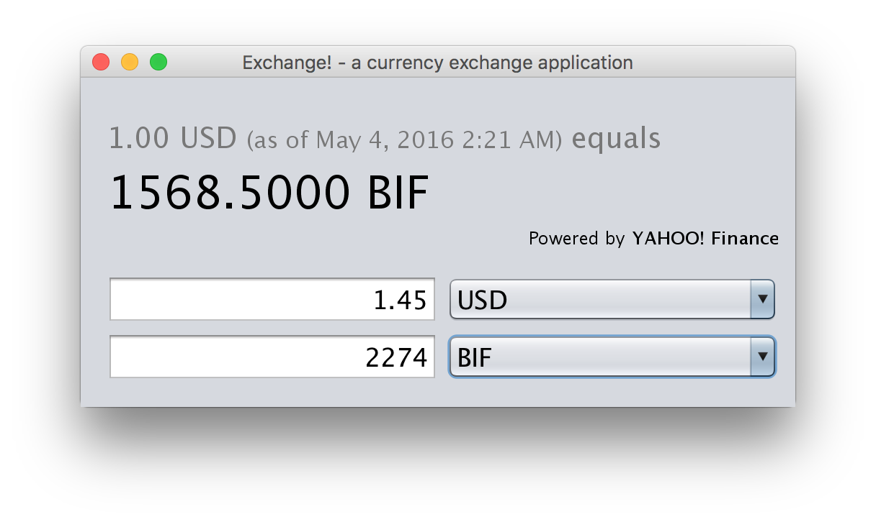

Test Case 15

Entered an amount with 3 decimal places.

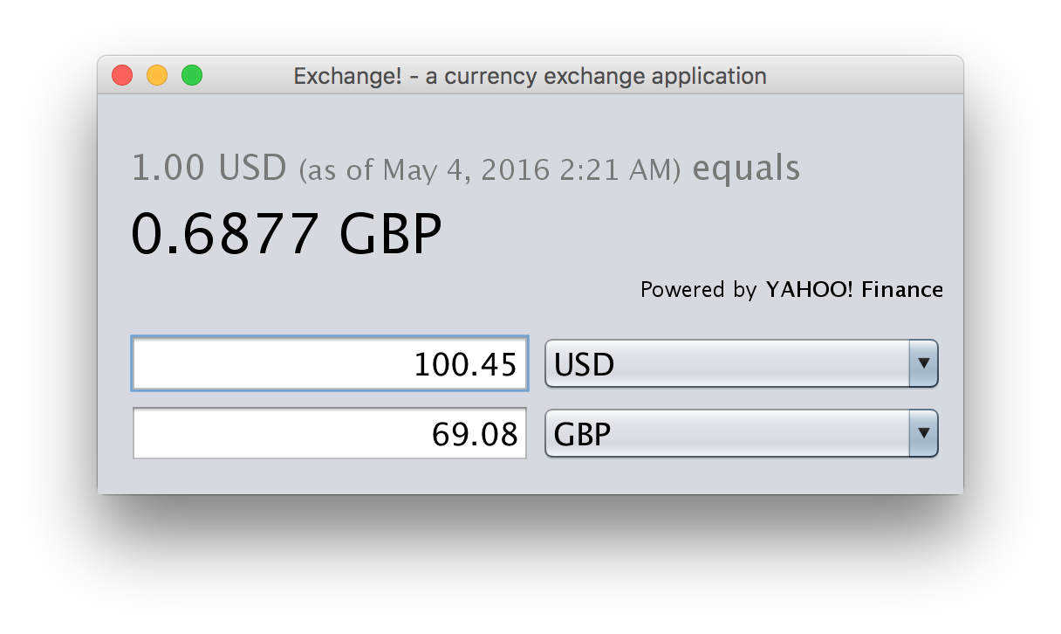

Test Case 16

Downloaded rates then shut down application. Turned off internet and opened application a day later and the rate is red and a message appears noting that the rate is older than 1 day.

