INF 275a Project
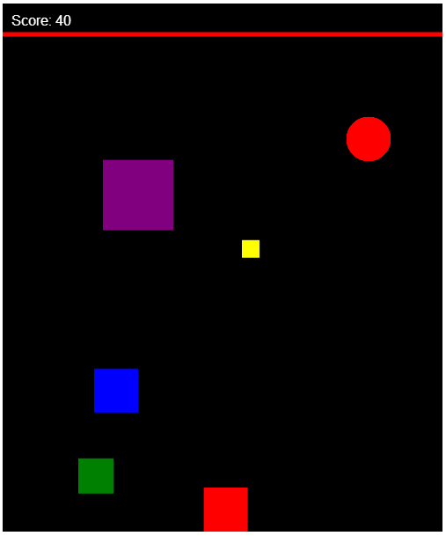
FALLING OBJECTS
JAVASCRIPT GAME

Regi Shehi

INF275a Web Client Technologies
Project 1 – Falling Objects JavaScript Game
March, 2014

The assignment is complete and neither compiling nor run-time errors are present. The game performs entirely all its functionalities as described below.

“I hereby declare that the submitted assignment is all my own work. I did not copy the program from someone else. No one but me developed the program.”

03/10/2014 Regi Shehi

Contents
GENERAL INFORMATION 4
Purpose 4
Introduction 4
Important information 4
Basic Functionalities 4
FUNCTIONALITIES 6
Canvas definition 6
Object definition 7
Event listener method 9
Update1() method 10
Render() function 11
Refresh()/CloseWin() function 13
Appendix 15
Additional Screenshots 15
Outside links 15
Code 16
Code for the game 17

GENERAL INFORMATION

Purpose
The aim of this game is to have some randomly falling objects from the top of the screen and have a user-controlled object moving through these objects at the bottom of the screen. The user controlled-object should avoid collision with the falling objects and score points.

Introduction
The purpose of this project is to develop a JavaScript game with several single blocks falling from the top of the screen to the bottom. A user-controlled block slides along the bottom of the screen, moving left-to-right, and right-to-left. The user-controlled block should make a complete pass of the screen (left-to-right or right-to-left) without being hit by a falling block. If the user-controlled block manages a complete pass unscathed, then points are awarded, but if the user-controlled block is hit by a falling block then the game is over.

Important information
To create the project I made use of my knowledge in HTML/CSS. However, the use of these two languages is kept to a minimum. They are used to define canvas and the style/properties of the buttons that are necessary to play the game. The game is timer controlled. By using the setinterval() method I have made sure that the game runs every 10milliseconds, so the game runs smoothly

var collision = setInterval(run, 10);

Basic Functionalities
The main functionalities of the game are listed below
Canvas definition
Canvas is the main element of the game. It is where all the other elements are drawn.
Object definition
Defines the user controlled – object and the falling objects. These are the objects that give meaning to the game and make it playable.

Event listener method
This is the method that allows the user to control the moving object at the bottom of the screen. It also detects if the object made a full trip from left to right and vice-versa.

Update1() function
This is the function that makes it possible for the randomly falling objects to move vertically in the screen (from top to the bottom of the screen)
Render() function
It is the main function of the game. Draws every object on the canvas and also it is responsible for detecting collision.
Refresh()/CloseWin() function
These are the two functions that give the user the ability to replay or terminate a game once the previous game is over.

FUNCTIONALITIES

Canvas definition
Everything related to my game is drawn on the canvas. Falling objects, user-controlled object and the white line separating the score from the rest of the canvas. Canvas is the central element of my game.

//this script defines canvas and its properties

var canvas = document.getElementById('canvas');
var ctx = canvas.getContext('2d');
canvas.width = 500;
canvas.height = 600;

//function to draw canvas
function paintCanvas()
{
ctx.fillStyle = "black";
ctx.fillRect(0,0,500,600);
}

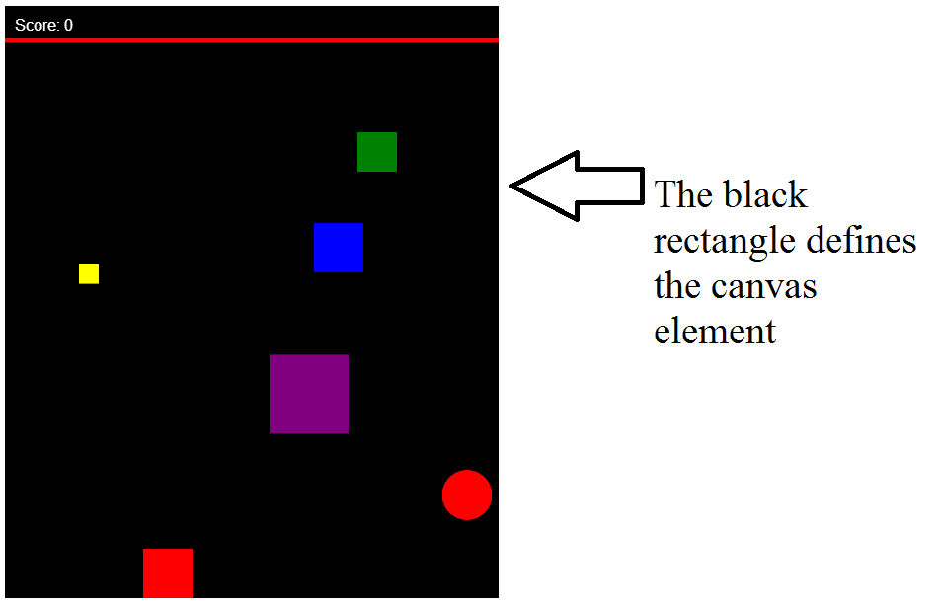
Figure 1 Home page (canvas element)

Object definition
There are two types of objects that make up the game. The randomly falling objects and the user-controlled object that is moves left-right and right-left at the bottom of the screen.
//object definition for user controlled block
var mySprite = {
x: 0,
y: 550,
width: 50,
height: 50,
speed: 200,
color: 'red'
};

//object Sprites defines all the other square falling objects and its properties
var Sprites = {
mySprite1: {
x: Math.floor(0 + (1+450-0)*Math.random()),
y: 35,
width: 50,
height: 50,
speed: 200,
color: 'blue'
},

mySprite2: {
x: Math.floor(0 + (1+460-0)*Math.random()),
y: 35,
width: 40,
height: 40,
speed: 100,
color: 'green'
},

mySprite3: {
x: Math.floor(0 + (1+480-0)*Math.random()),
y: 35,
width: 20,
height: 20,
speed: 120,
color: 'yellow'
},

mySprite4: {
x: Math.floor(0 + (1+420-0)*Math.random()),
y: 35,
width: 80,
height: 80,
speed: 220,
color: 'purple'
}
};

//circle falling object
var ball = {
x: Math.floor(0 + (1+475-0)*Math.random()),
y: 50, r: 25, width: 20, height: 20,
c: "red",
speed: 150,
draw: function(){
ctx.beginPath();
ctx.fillStyle = this.c;
ctx.arc(this.x, this.y, this.r, 0, Math.PI*2, false);
ctx.fill();
}};

As it can be seen each object has its width, height, color, speed and Y coordinate property. For each falling object the X coordinate is defined in a random way because we want the objects to appear randomly. While the Y coordinate is the same for all objects because they all start from the top of the screen. For the circle we use R for radius and beginPath(), arc(), fill() methods to draw it.

For the user-controlled object the initial coordinates are defined X=0 and Y=550 because I wanted its initial position to be the left lower corner of the canvas.

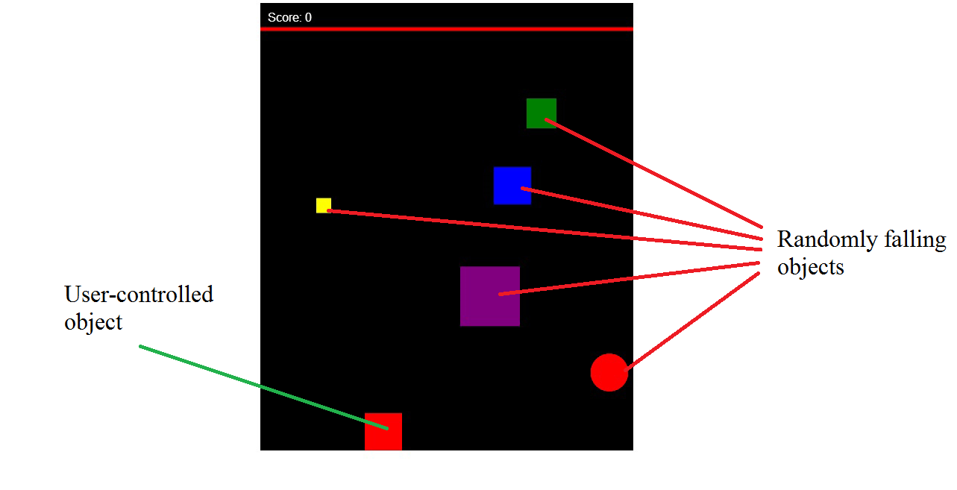
Figure 2 Objects (falling & user-controlled object)

Event listener method
//definition for event listener
var keysDown = {};
window.addEventListener('keydown', function (e)
{
keysDown[e.keyCode] = true;
});

window.addEventListener('keyup', function (e)
{
delete keysDown[e.keyCode];
});

//function to recognize the key pressed and update score each time the moving block makes a full trip from side to side
function update(mod)
{
if (37 in keysDown)
{
mySprite.x -= mySprite.speed * mod;
if(mySprite.x<0)
mySprite.x = 0;

if(mySprite.x == 0 && !touchleft)
{
count+=10;
var alert1 = document.getElementById("score");

updateScore();
touchright=false;
touchleft=true;
}
}

if (39 in keysDown)
{
mySprite.x += mySprite.speed * mod;
if(mySprite.x>450)
mySprite.x = 450;

if(mySprite.x == 450 && !touchright)
{
count+=10;
var alert1 = document.getElementById("score");

updateScore();
touchright=true;
touchleft=false;
}}
}
Since we have a user-controlled object I have used buttons to allow the user to control the movement of the object left or right. The two buttons I have used are the left and right button in the keyboard and the key codes for these two buttons are: 37 for left arrow and 39 for right arrow. The first part of the script displayed above represents the eventListener (when a certain key is pressed and when it is released).
The second part of the script (function update()) makes possible for the user-controlled object to move left or right. Furthermore, it does not allow this object to step out of bound (outside of canvas with the limits being 0 and 450 for the X-coordinate). Its third function is to keep track when the object makes a full trip left-right and vice-versa. Each time this happens it updates the general score by 10 by calling the updateScore() function.
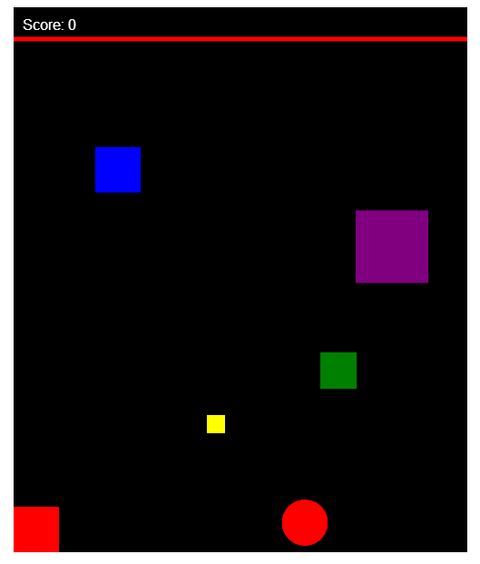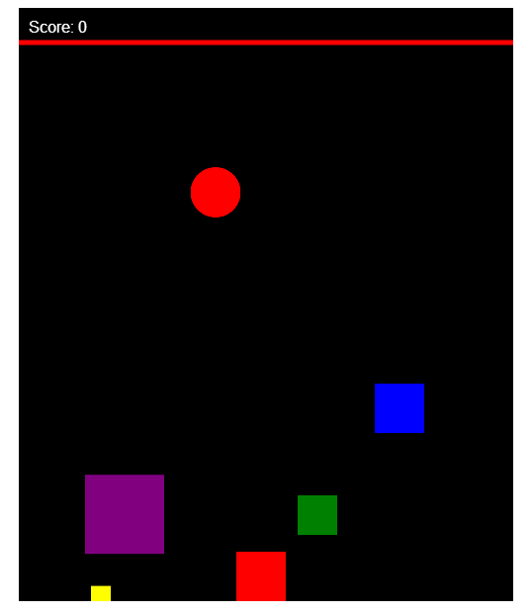
Figures 3-4 Moving Objects (User-controlled object in its final position (3) and after moving right (4))

Update1() function
Update1() function is responsible for making the falling objects fall from the top to the bottom of the screen.
function update1(mod)
{
for (index in Sprites)
{
if (Sprites.hasOwnProperty(index))
{
Sprites[index].y += Sprites[index].speed * mod;
}
}
ball.y += ball.speed * mod;
}
By calling the Sprites object using the ‘for in’ statement we can define the movement of the falling objects in the Y direction and furthermore we can define the speed using the ‘mod’ variable.
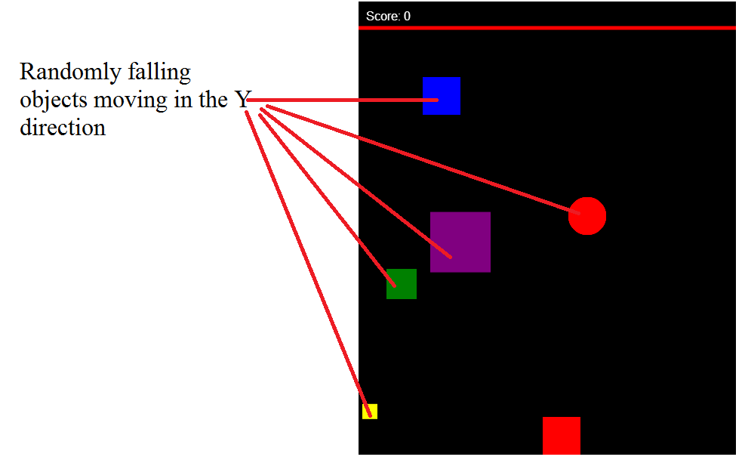
Figure 5 Moving Objects (Randomly falling objects from top to the bottom of the screen)

Render() function
Render() function is the main function of my game.
function render()
{
playsound.play();

//canvas
paintCanvas();

//moving red object
player();
updateScore();

//falling objects
for (index in Sprites)
{
fallingObjects();

if (Sprites[index].y > 600) //Repeat the object when it falls out of view
{
Sprites[index].y = 30; //Account for the image size
Sprites[index].x = Math.floor(0 + (1+420-0)*Math.random()); //Make it appear randomly along the width
}

//if condition to detect collision for falling rectangle objects
if (Sprites[index].x < mySprite.x + mySprite.width && Sprites[index].x + Sprites[index].width > mySprite.x && Sprites[index].y < mySprite.y + mySprite.height && Sprites[index].y + Sprites[index].height > mySprite.y)
{
playsound.pause();
clearInterval(collision);
id1.style.display = "block";
id1.innerHTML = "Game Over" + "<br/>" + "You scored " + count + " points" + "<button class = \"button2\" id=\"btn2\" onclick=\"refresh()\">Replay</button>"
+ "<button class = \"button3\" id=\"btn2\" onclick=\"closeWin()\">Close</button>"
endsound.play();
}

if (ball.y > 600) //Repeat the object when it falls out of view
{
ball.y = 50; //Account for the image size
ball.x = Math.floor(0 + (1+475-0)*Math.random()); //Make it appear randomly along the width
}

//if condition to detect collision for falling circle object
if (ball.x < mySprite.x + mySprite.width && ball.x + ball.width > mySprite.x && ball.y < mySprite.y + mySprite.height && ball.y + ball.height > mySprite.y)
{
playsound.pause();
clearInterval(collision);
id1.style.display = "block";
id1.innerHTML = "Game Over" + "<br/>" + "You scored " + count + " points" + "<button class = \"button2\" id=\"btn2\" onclick=\"refresh()\">Replay</button>"
+ "<button class = \"button3\" id=\"btn2\" onclick=\"closeWin()\">Close</button>"
endsound.play();
}
}
}

Render() function calls the playSound(), paintCanvas(), player() and updateScore() functions. However, its main function is to redraw the randomly falling objects at the top of the screen once they go outside of the canvas. This is done by using the if condition and checking if the Y coordinate is outside the canvas (bigger than 600).

The second function of render() is to detect collision. This is done by comparing the moving object size with those of the falling objects. If the coordinates are the same than there is a collision. If there is collision the “gave over” music starts playing and the “game over” screen appears.

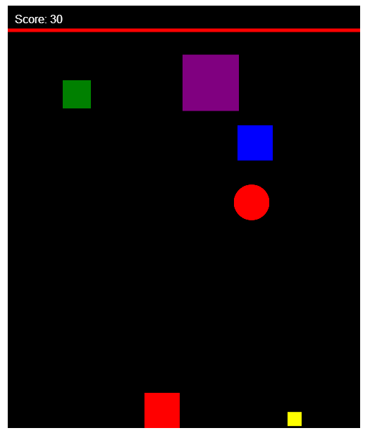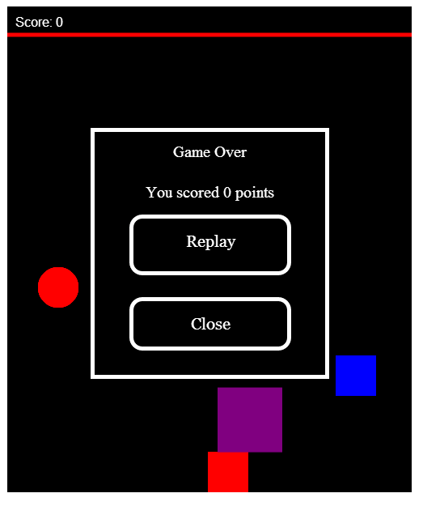
Figure 6-7 Moving Objects (Objects reappearing on top of the screen after falling out of bound (6) “Game over” screen (7))

Refresh()/CloseWin() function
These two functions provide the player with the ability to replay or terminate the game once their previous game has ended (game over).
function refresh()
{
window.location.reload();
}

//function to end game
function closeWin()
{
window.close();
}

Refresh() function is responsible for starting a new game. What it does is that it reloads the page, bringing the player at the starting screen of the game.

CloseWin() function is responsible for terminating the game. What it does is that is closes the current window where the game is being played.
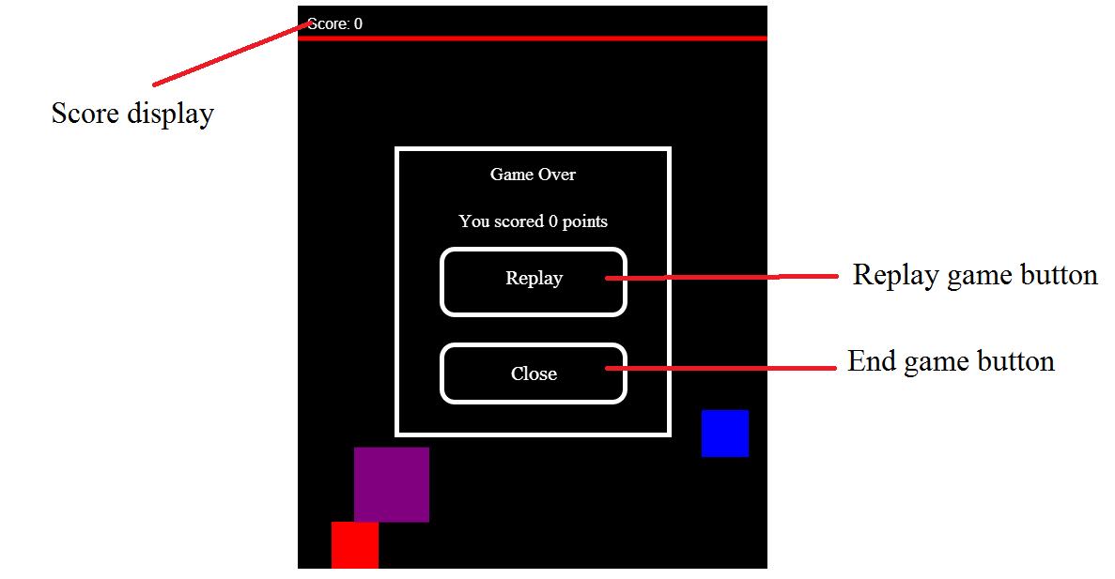
Figure 8 End-game screen (picture displays the end screen of the game with the replay, close button and total amount of points)

Appendix

Additional Screenshots

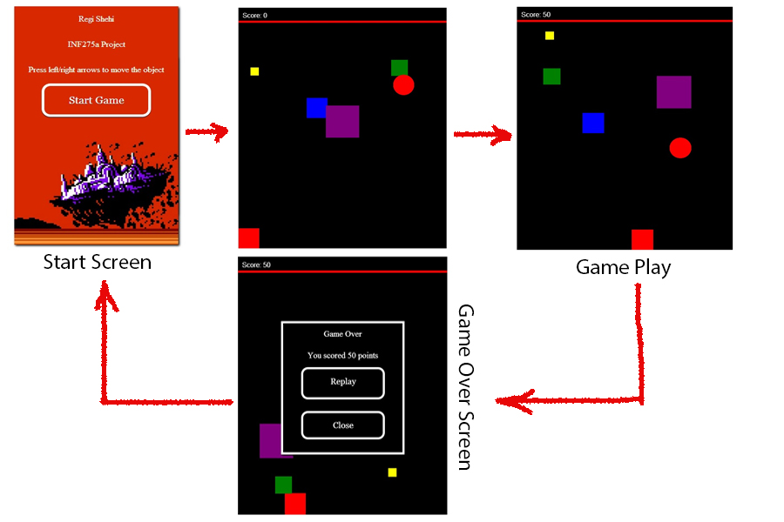

This picture shows the cycle of the game. 1) Start screen (player gets info on how to play the game and it is presented with the start game button) 2) The game has just started (the user-controlled is located in its initial position) 3) Game play and the updated score 4) End screen (displays the replay/end game button and the total amount of points)

Links for the picture and audio used in my project:

http://www.trendhunter.com/slideshow/pixel-art1 (start screen picture)
http://www.8bit.com/everything/spaceinvaders.html (music that plays in the background)
https://www.youtube.com/watch?v=5Wc3kwv0Ddw (game over music)

CODE

