**Hackathon**

**Groepsnaam:** Renew Studios

**Team:**

1. Sohil Alami
2. Salentino Bommel
3. Flint Naafs
4. Regilio Spee **(tel - 06 40991644)**
5. Salentino Bommel
6. Tom Higginson

**Skype ID**

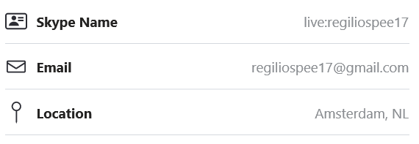

**Casuskeuze:**

Casus 4B: **ESBACO**