Эффективное программирование современных микропроцессоров и мультипроцессоров

Практическое задание 3

Выполнила:

…

Группа …

Преподаватель:

…

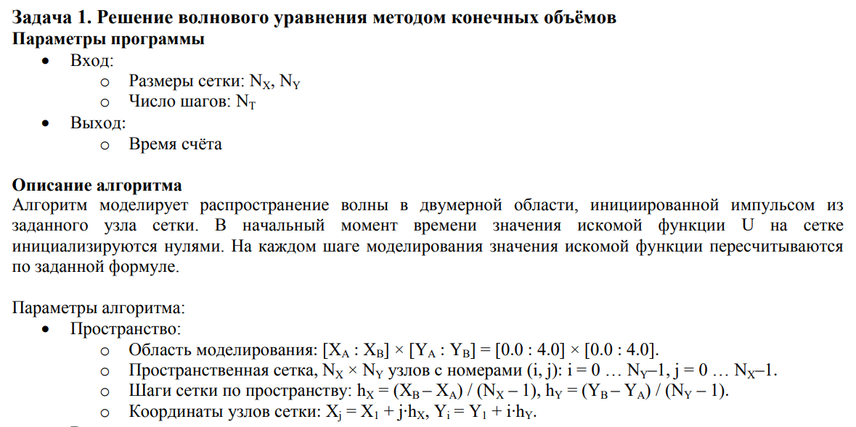

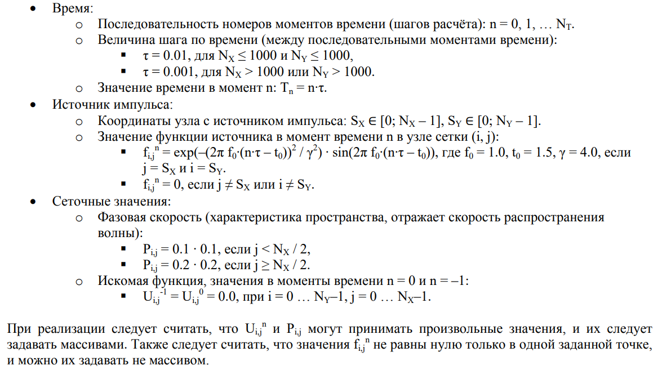

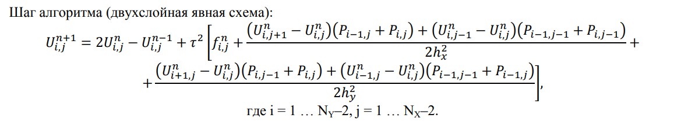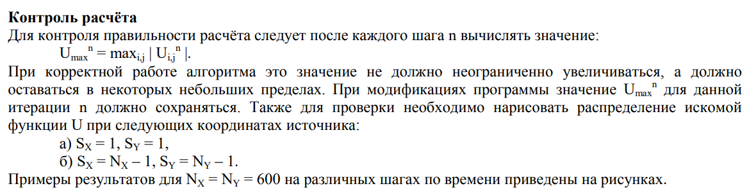

**Результаты тестирования различных версий программы**

Nx = Ny = 8000, Nt = 100;

1. Изначальный вариант программы

|  |  |  |  |
| --- | --- | --- | --- |
| Без оптимизации | -О1 | -О3 | -Ofast |
| 204.2 | 47.2 | 37.5 | 22.9 |

1. Исключение повторяющихся вычислений

|  |  |  |  |
| --- | --- | --- | --- |
| Без оптимизации | -О1 | -О3 | -Ofast |
| 203.0 | 42.6 | 34.6 | 22.3 |

1. Замена всех операций деления на умножение

|  |  |  |  |
| --- | --- | --- | --- |
| Без оптимизации | -О1 | -О3 | -Ofast |
| 195.2 | 42.0 | 33.4 | 21.9 |

1. Заблаговременное обращение к массиву

|  |  |  |  |
| --- | --- | --- | --- |
| Без оптимизации | -О1 | -О3 | -Ofast |
| 139.7 | 38.7 | 32.9 | 22.4 |

1. Заблаговременное вычисление индекса элемента массива

|  |  |  |  |
| --- | --- | --- | --- |
| Без оптимизации | -О1 | -О3 | -Ofast |
| 102.8 | 31.5 | 24.5 | 23.7 |

1. Векторизация (n+=1)

|  |  |  |  |
| --- | --- | --- | --- |
| Без оптимизации | -О1 | -О3 | -Ofast |
| 101.2 | 18.2 | 15.9 | 15.4 |

1. n+=2

|  |  |  |  |
| --- | --- | --- | --- |
| Без оптимизации | -О1 | -О3 | -Ofast |
| 112.5 | 17.6 | 12.7 | 12.8 |

1. n+=3

|  |  |  |  |
| --- | --- | --- | --- |
| Без оптимизации | -О1 | -О3 | -Ofast |
| 110.1 | 16.0 | 10.5 | 10.7 |

1. n+=4

|  |  |  |  |
| --- | --- | --- | --- |
| Без оптимизации | -О1 | -О3 | -Ofast |
| 109.2 | 15.6 | 10.4 | 10.3 |

**Вывод**

Оптимизация по памяти ускорила программу в 1.5 раза. Лучшее время достигается при выполнении четырёх итераций за проход по сетке. Теперь результаты вычислений используются сразу, а не при следующем обходе массива, когда они могли бы уже не быть в кэш-памяти. Это привело к существенному уменьшению количества кэш-промахов и обращений к оперативной памяти. Профилирование также показывает, что нагрузка на память сократилась.

**Профилирование perf**

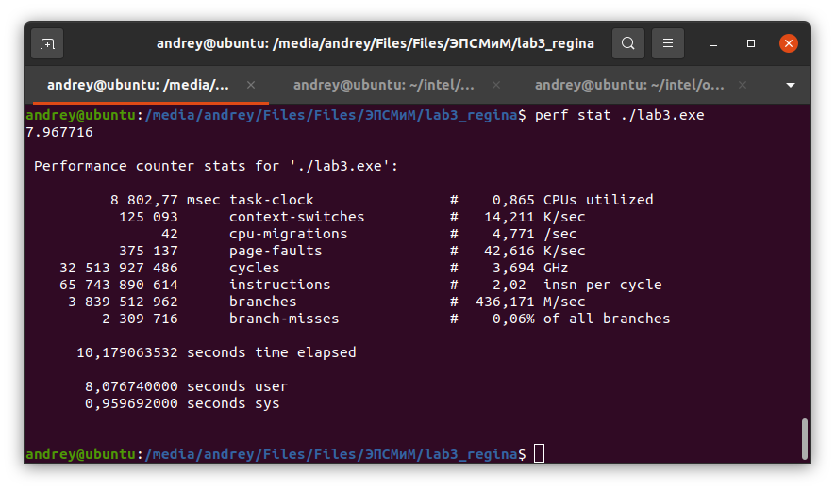

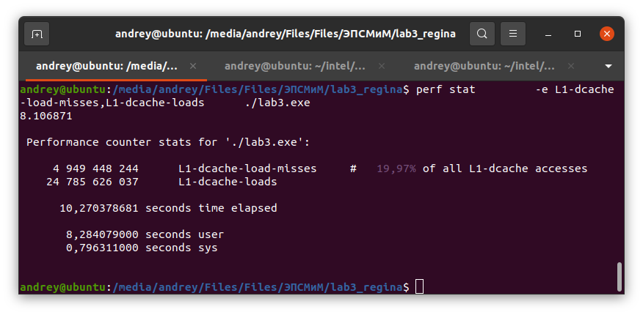

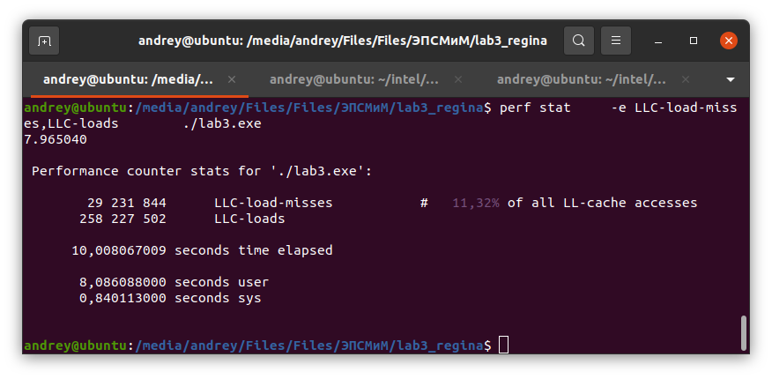

**Граф вызовов**

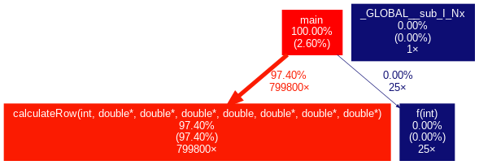

**Профилирование Vtune**

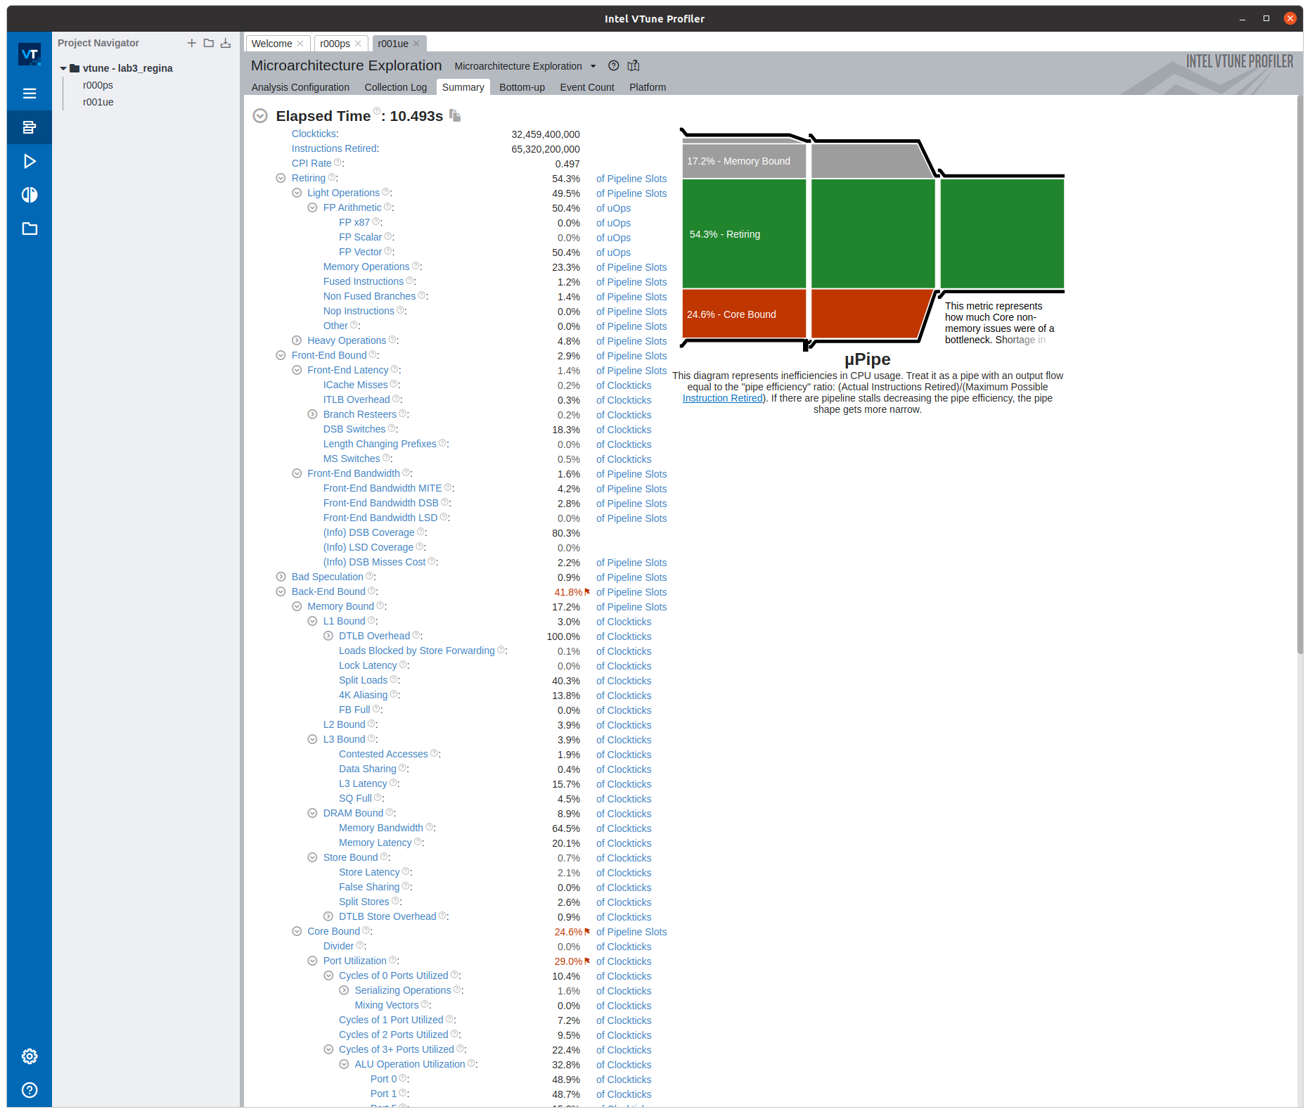

**Roofline-модель**

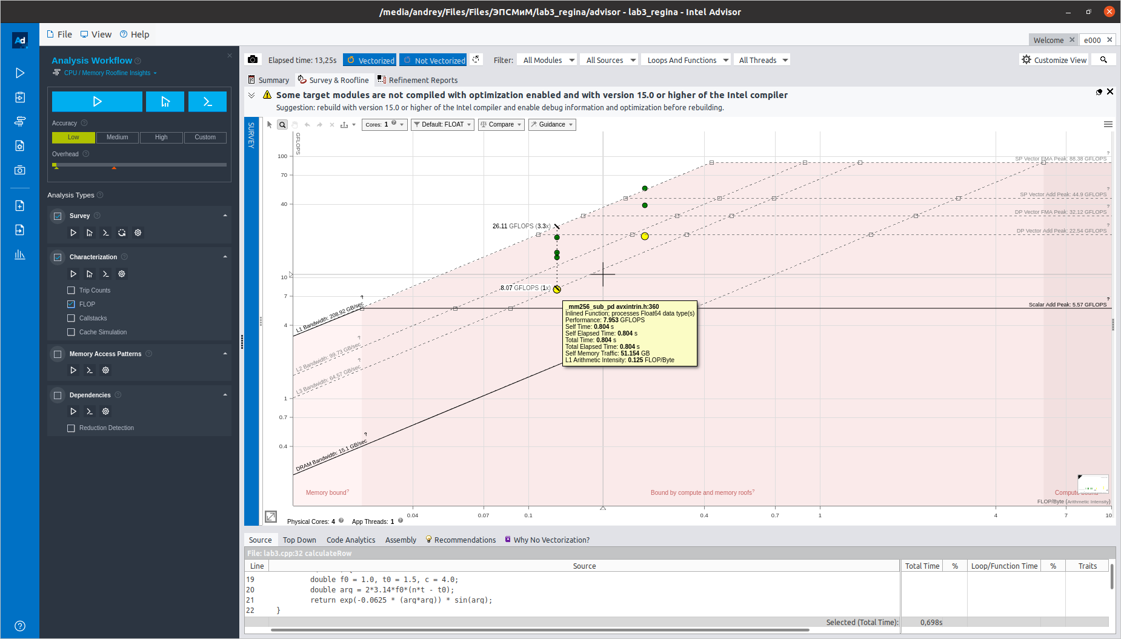

#include <iostream>

#include <math.h>

#include <cstdlib>

#include <ctime>

#include <stdio.h>

#include <cstring>

#include <memory>

#include <xmmintrin.h>

#include <immintrin.h>

using namespace std;

int Nx = 8000, Ny = 8000, Nt = 100;

int Sx = 1, Sy = 1;

double t;

const int ALIGN_INDENT = 64;

const int VECTOR_SIZE = 4;

double f (int n) {

double f0 = 1.0, t0 = 1.5, c = 4.0;

double arg = 2*3.14*f0*(n*t - t0);

return exp(-0.0625 * (arg*arg)) * sin(arg);

}

void calculateRow(int i, double *U_prv, double *U_new, double *P,

double f_value, double *d_x_arr, double *d_y_arr, double *t2_arr) {

double two_arr[VECTOR_SIZE] = {2.0, 2.0, 2.0, 2.0};

double f_arr[VECTOR_SIZE];

int row = i * Nx, row_ = (i - 1) * Nx, row1 = (i + 1) * Nx;

for (int j = 1; j < Ny - 3; j += VECTOR_SIZE) {

int rowcol = row + j, rowcol_ = row + j - 1, rowcol1 = row + j + 1,

row_col = row_ + j, row1col = row1 + j, row_col_ = row_col - 1;

if (i == Sx && (Sy - j) < VECTOR_SIZE && (Sy - j) >=0)

f_arr[(Sy - j)] = f_value;

else

memset(f_arr, 0, 4 * sizeof(double));

__m256d first = _mm256_loadu_pd(U_prv+rowcol1);

__m256d second = _mm256_loadu_pd(U_prv+rowcol);

__m256d res1 = _mm256_sub_pd(first, second);

first = _mm256_loadu_pd(P+row_col);

second = _mm256_loadu_pd(P+rowcol);

__m256d res2 = _mm256_add_pd(first, second);

__m256d firstPath = _mm256_mul_pd(res1, res2);

first = _mm256_loadu_pd(U_prv+rowcol_);

second = _mm256_loadu_pd(U_prv+rowcol);

res1 = _mm256_sub_pd(first, second);

first = _mm256_loadu_pd(P+row_col_);

second = _mm256_loadu_pd(P+rowcol_);

res2 = _mm256_add_pd(first, second);

__m256d secondPath = _mm256_mul_pd(res1, res2);

__m256d lineDividend = _mm256_add_pd(firstPath, secondPath);

first = _mm256_loadu_pd(d_x_arr);

__m256d firstLineResult = _mm256_mul_pd(lineDividend, first);

first = _mm256_loadu_pd(U_prv+row1col);

second = _mm256_loadu_pd(U_prv+rowcol);

res1 = _mm256_sub_pd(first, second);

first = _mm256_loadu_pd(P+rowcol_);

second = _mm256_loadu_pd(P+rowcol);

res2 = _mm256_add_pd(first, second);

firstPath = _mm256_mul_pd(res1, res2);

first = _mm256_loadu_pd(U_prv+row_col);

second = _mm256_loadu_pd(U_prv+rowcol);

res1 = _mm256_sub_pd(first, second);

first = _mm256_loadu_pd(P+row_col_);

second = _mm256_loadu_pd(P+row_col);

res2 = _mm256_add_pd(first, second);

secondPath = _mm256_mul_pd(res1, res2);

lineDividend = _mm256_add_pd(firstPath, secondPath);

first = _mm256_loadu_pd(d_y_arr);

__m256d secondLineResult = _mm256_mul_pd(lineDividend, first);

__m256d sumOfTwoLines = _mm256_add_pd(firstLineResult, secondLineResult);

__m256d impulseVector = _mm256_loadu_pd(f_arr);

__m256d bracketResult = _mm256_add_pd(sumOfTwoLines, impulseVector);

first = _mm256_loadu_pd(two_arr);

second = _mm256_loadu_pd(U_prv+rowcol);

__m256d totalResult = _mm256_mul_pd(first, second);

second = _mm256_loadu_pd(U_new+rowcol);

totalResult = _mm256_sub_pd(totalResult, second);

__m256d tauSquareVector = _mm256_loadu_pd(t2_arr);

__m256d mulResult = _mm256_mul_pd(tauSquareVector, bracketResult);

totalResult = _mm256_add_pd(totalResult, mulResult);

_mm256_storeu_pd(U_new+rowcol, totalResult);

}

}

int main(int argc, char** argv) {

double Xa = 0.0, Ya = 0.0, Xb = 4.0, Yb = 4.0;

double hx = (Xb - Xa) / (Nx - 1), hy = (Yb - Ya) / (Ny - 1);

if (Nx <= 1000 && Ny <= 1000) t = 0.01;

else t = 0.001;

double* P = (double*)_mm_malloc(Nx * Ny * sizeof(double), ALIGN_INDENT);

for (int i = 0; i < Ny; i++)

for (int j = 0; j < Nx; j++) {

if (j < Nx/2) P[i*Nx + j] = 0.1*0.1;

else P[i*Nx + j] = 0.2*0.2;

}

double** U = (double**)malloc(2 * sizeof(double*));

U[0] = (double*)_mm_malloc(Nx * Ny * sizeof(double), ALIGN_INDENT);

U[1] = (double*)_mm_malloc(Nx * Ny * sizeof(double), ALIGN_INDENT);

for (int i = 0; i < Ny; i++)

for (int j = 0; j < Nx; j++) {

U[0][i*Nx + j] = 0.0;

U[1][i*Nx + j] = 0.0;

}

double d_x = 0.5 / (hx * hx), d_y = 0.5 / (hy * hy), t2 = t * t;

double t2_arr[VECTOR_SIZE] = {t2, t2, t2, t2};

double d_x_arr[VECTOR_SIZE] = {d_x, d_x, d_x, d_x};

double d_y_arr[VECTOR_SIZE] = {d_y, d_y, d_y, d_y};

struct timespec start, end;

clock_gettime(CLOCK_MONOTONIC_RAW, &start);

for (int n = 1; n < Nt; n += 2) {

double* U_new = U[n%2];

double* U_prv = U[(n+1)%2];

double f_value = f(n);

calculateRow(1, U_prv, U_new, P, f_value, d_x_arr, d_y_arr, t2_arr);

for (int i = 2; i < Ny - 1; i++) {

calculateRow(i, U_prv, U_new, P, f_value, d_x_arr, d_y_arr, t2_arr);

calculateRow(i-1, U_new, U_prv, P, f_value, d_x_arr, d_y_arr, t2_arr);

}

calculateRow(Ny-2, U_new, U_prv, P, f_value, d_x_arr, d_y_arr, t2_arr);

}

/*for (int n = 1; n < Nt; n += 3) {

double* U_new = U[n%2];

double* U_prv = U[(n+1)%2];

double f_value = f(n);

calculateRow(1, U_prv, U_new, P, f_value, d_x_arr, d_y_arr, t2_arr); //n=1 i=1

calculateRow(2, U_prv, U_new, P, f_value, d_x_arr, d_y_arr, t2_arr); //n=1 i=2

calculateRow(1, U_new, U_prv, P, f_value, d_x_arr, d_y_arr, t2_arr); //n=2 i=1

for (int i = 3; i < Ny - 1; i++) {

calculateRow(i, U_prv, U_new, P, f_value, d_x_arr, d_y_arr, t2_arr);

calculateRow(i-1, U_new, U_prv, P, f_value, d_x_arr, d_y_arr, t2_arr);

calculateRow(i-2, U_prv, U_new, P, f_value, d_x_arr, d_y_arr, t2_arr);

}

calculateRow(Ny-2, U_new, U_prv, P, f_value, d_x_arr, d_y_arr, t2_arr); //n=2 i = Ny-2

calculateRow(Ny-3, U_prv, U_new, P, f_value, d_x_arr, d_y_arr, t2_arr); //n=3 i = Ny-3

calculateRow(Ny-2, U_prv, U_new, P, f_value, d_x_arr, d_y_arr, t2_arr); //n=3 i = Ny-2

}*/

/*for (int n = 1; n < Nt; n += 4) {

double* U_new = U[n%2];

double* U_prv = U[(n+1)%2];

double f_value = f(n);

calculateRow(1, U_prv, U_new, P, f_value, d_x_arr, d_y_arr, t2_arr); //n=1 i=1

calculateRow(2, U_prv, U_new, P, f_value, d_x_arr, d_y_arr, t2_arr); //n=1 i=2

calculateRow(1, U_new, U_prv, P, f_value, d_x_arr, d_y_arr, t2_arr); //n=2 i=1

calculateRow(3, U_prv, U_new, P, f_value, d_x_arr, d_y_arr, t2_arr); //n=1 i=3

calculateRow(2, U_new, U_prv, P, f_value, d_x_arr, d_y_arr, t2_arr); //n=2 i=2

calculateRow(1, U_prv, U_new, P, f_value, d_x_arr, d_y_arr, t2_arr); //n=3 i=1

for (int i = 4; i < Ny - 1; i++) {

calculateRow(i, U_prv, U_new, P, f_value, d_x_arr, d_y_arr, t2_arr);

calculateRow(i-1, U_new, U_prv, P, f_value, d_x_arr, d_y_arr, t2_arr);

calculateRow(i-2, U_prv, U_new, P, f_value, d_x_arr, d_y_arr, t2_arr);

calculateRow(i-3, U_new, U_prv, P, f_value, d_x_arr, d_y_arr, t2_arr);

}

calculateRow(Ny-2, U_new, U_prv, P, f_value, d_x_arr, d_y_arr, t2_arr); //n=2 i = Ny-2

calculateRow(Ny-3, U_prv, U_new, P, f_value, d_x_arr, d_y_arr, t2_arr); //n=3 i = Ny-3

calculateRow(Ny-2, U_prv, U_new, P, f_value, d_x_arr, d_y_arr, t2_arr); //n=3 i = Ny-2

calculateRow(Ny-4, U_new, U_prv, P, f_value, d_x_arr, d_y_arr, t2_arr); //n=4 i = Ny-4

calculateRow(Ny-3, U_new, U_prv, P, f_value, d_x_arr, d_y_arr, t2_arr); //n=4 i = Ny-3

calculateRow(Ny-2, U_new, U_prv, P, f_value, d_x_arr, d_y_arr, t2_arr); //n=4 i = Ny-2

}*/

clock_gettime(CLOCK_MONOTONIC_RAW, &end);

double time = end.tv_sec-start.tv_sec + 0.000000001*(end.tv_nsec-start.tv_nsec);

printf("%lf\n", time);

FILE* file = fopen("file.dat", "wb");

fwrite(U[1], sizeof(double), Nx * Ny, file);

fclose(file);

return 0;

}