Эффективное программирование современных микропроцессоров и мультипроцессоров

Практическое задание 4

Выполнила:

…

Группа …

Преподаватель:

…

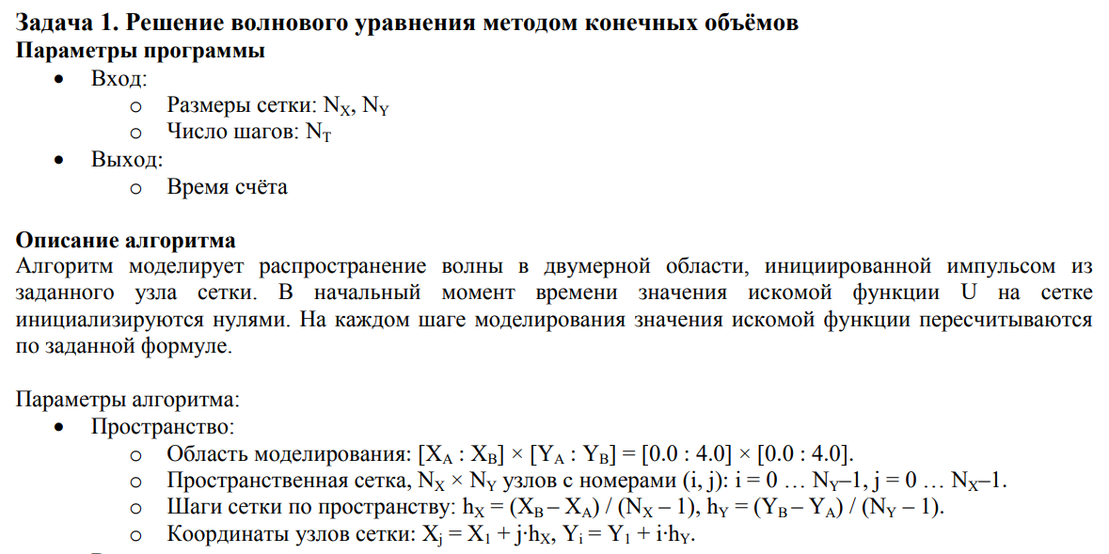

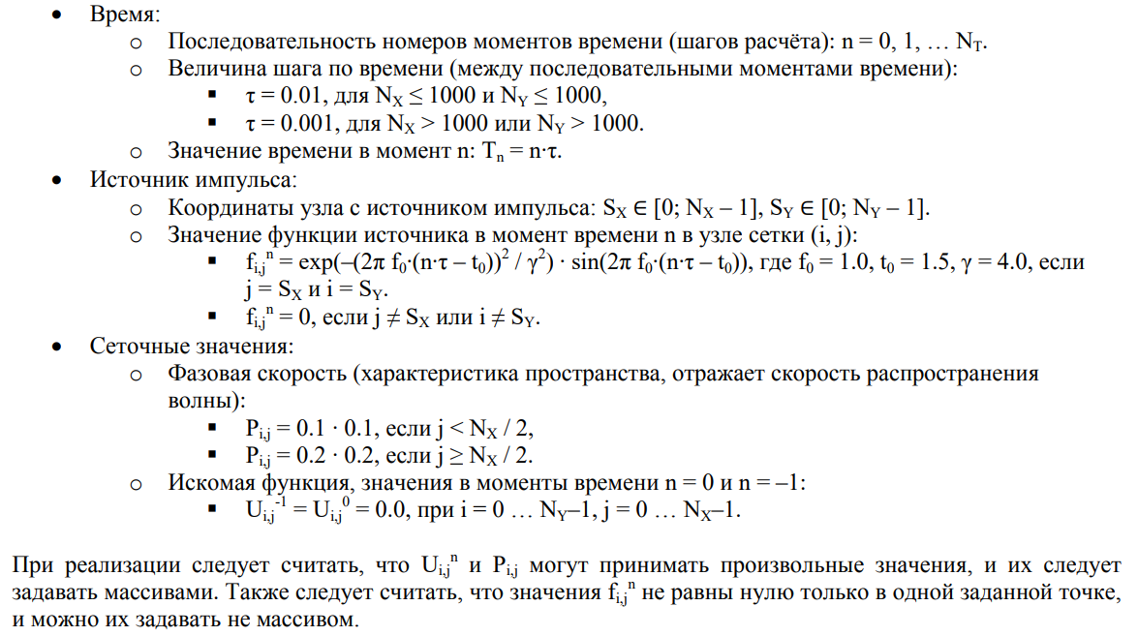

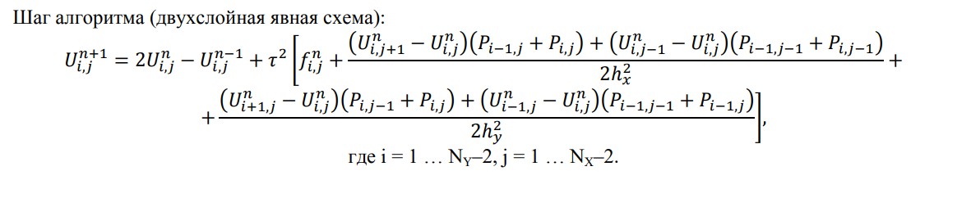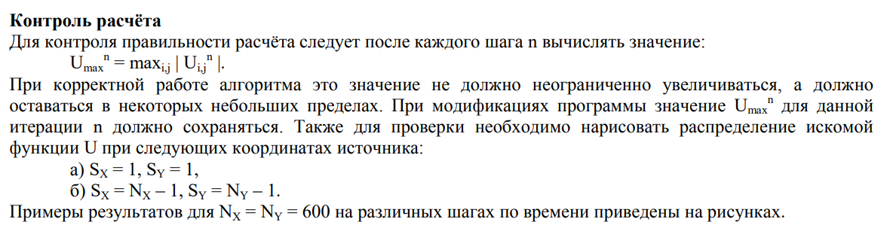

**Результаты тестирования различных версий программы**

Nx = Ny = 8000, Nt = 100;

1. Изначальный вариант программы

|  |  |  |  |
| --- | --- | --- | --- |
| Без оптимизации | -О1 | -О3 | -Ofast |
| 204.2 | 47.2 | 37.5 | 22.9 |

1. Исключение повторяющихся вычислений

|  |  |  |  |
| --- | --- | --- | --- |
| Без оптимизации | -О1 | -О3 | -Ofast |
| 203.0 | 42.6 | 34.6 | 22.3 |

1. Замена всех операций деления на умножение

|  |  |  |  |
| --- | --- | --- | --- |
| Без оптимизации | -О1 | -О3 | -Ofast |
| 195.2 | 42.0 | 33.4 | 21.9 |

1. Заблаговременное обращение к массиву

|  |  |  |  |
| --- | --- | --- | --- |
| Без оптимизации | -О1 | -О3 | -Ofast |
| 139.7 | 38.7 | 32.9 | 22.4 |

1. Заблаговременное вычисление индекса элемента массива

|  |  |  |  |
| --- | --- | --- | --- |
| Без оптимизации | -О1 | -О3 | -Ofast |
| 102.8 | 31.5 | 24.5 | 23.7 |

1. Векторизация (n+=1)

|  |  |  |  |
| --- | --- | --- | --- |
| Без оптимизации | -О1 | -О3 | -Ofast |
| 101.2 | 18.2 | 15.9 | 15.4 |

1. n+=4

|  |  |  |  |
| --- | --- | --- | --- |
| Без оптимизации | -О1 | -О3 | -Ofast |
| 109.2 | 15.6 | 10.5 | 10.7 |

1. threads = 2

|  |  |  |  |
| --- | --- | --- | --- |
|  |  | -Оfast без барьеров | -Ofast с барьерами |
|  |  | 6.0 | 6.5 |

1. threads = 3

|  |  |  |  |
| --- | --- | --- | --- |
|  |  | -Оfast | -Ofast |
|  |  | 5.5 | 5.9 |

1. threads = 4

|  |  |  |  |
| --- | --- | --- | --- |
|  |  | -Оfast | -Ofast |
|  |  | 5.7 | 6.0 |

1. threads = 5

|  |  |  |  |
| --- | --- | --- | --- |
|  |  | -Оfast | -Ofast |
|  |  | 6.4 | 6.8 |

**Вывод**

Распараллеливание в потоках ускорило выполнение программы в 1.6 раз. Из приведённых выше результатов видно, что при барьерной синхронизации итоговое время получается хуже, чем при попарной синхронизации между потоками с помощью флаговых переменных и атомарных операций с ними, ведь каждый поток теперь должен ждать завершение вычислений не всех остальных, а только двух своих соседей. Также видно, что несмотря на четырехъядерность системы, лучшее время достигается на трёх потоках. Это связано с ограниченностью пропускной способностью памяти, то есть потоки хотят получать больше данных, чем память способна предоставить единовременно, и вынуждены ждать.

**Профилирование perf**

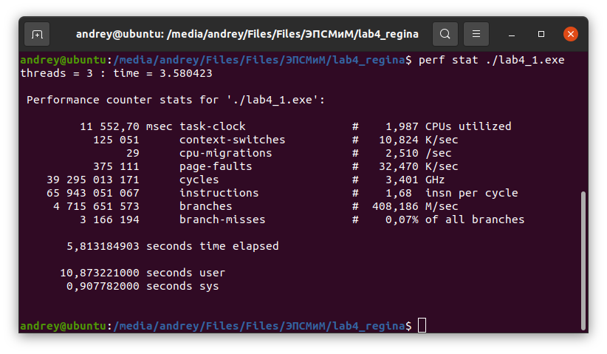

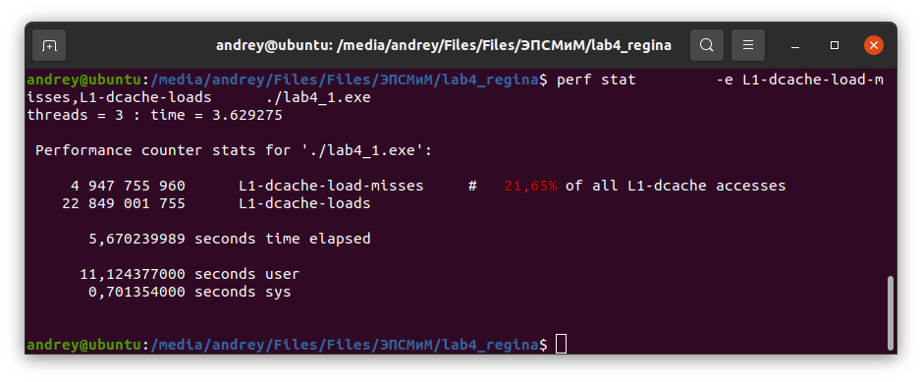

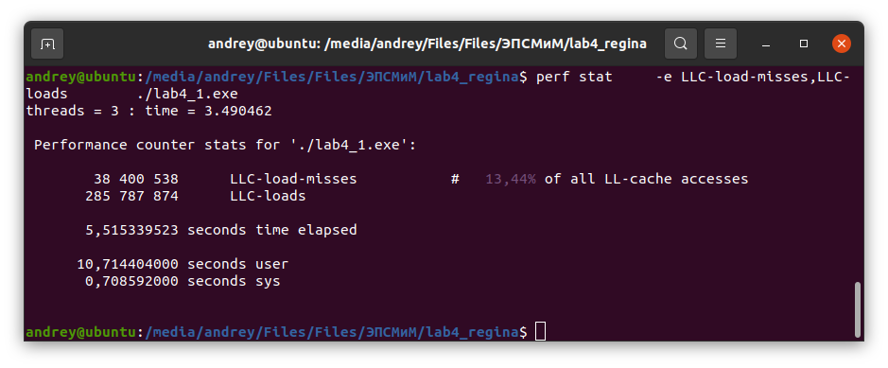

**Граф вызовов**

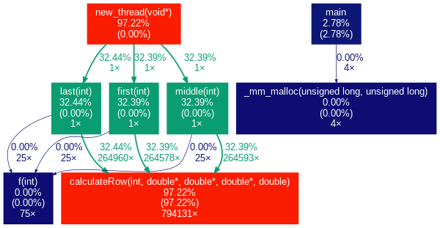

**Профилирование Vtune**

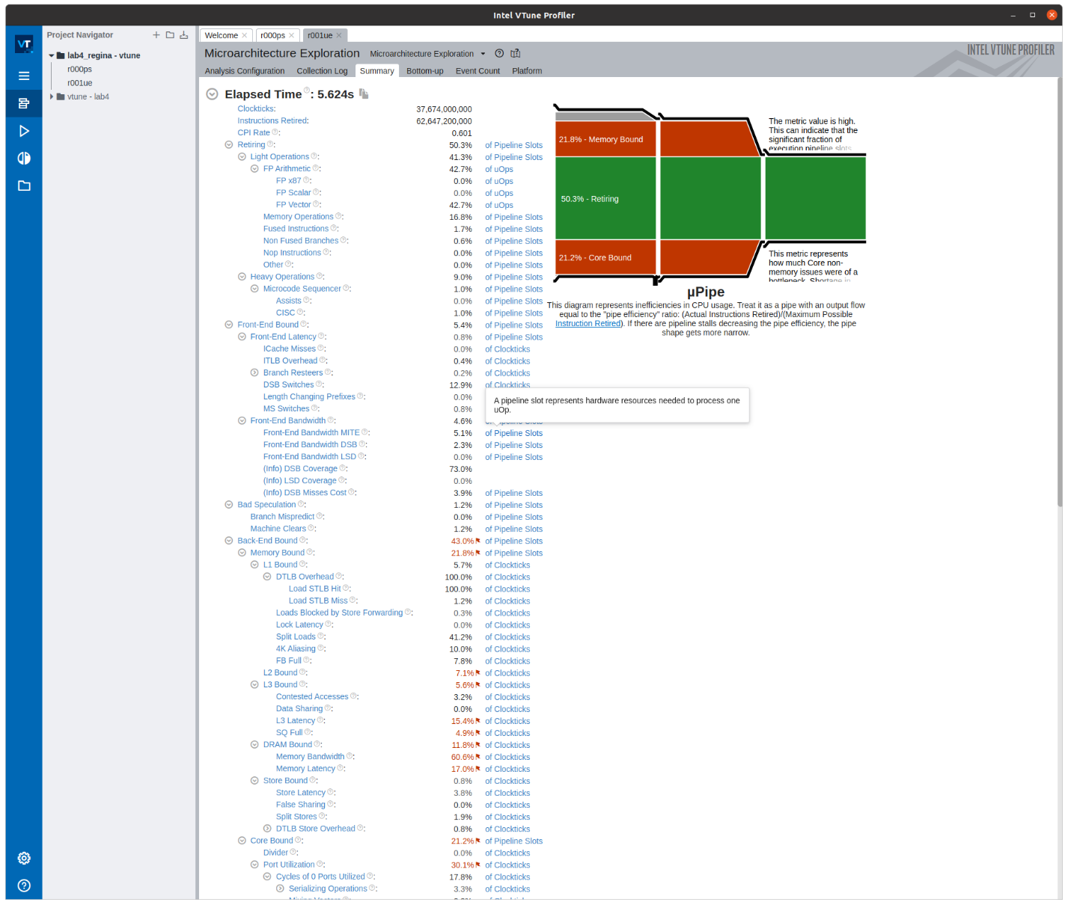

**Roofline-модель**

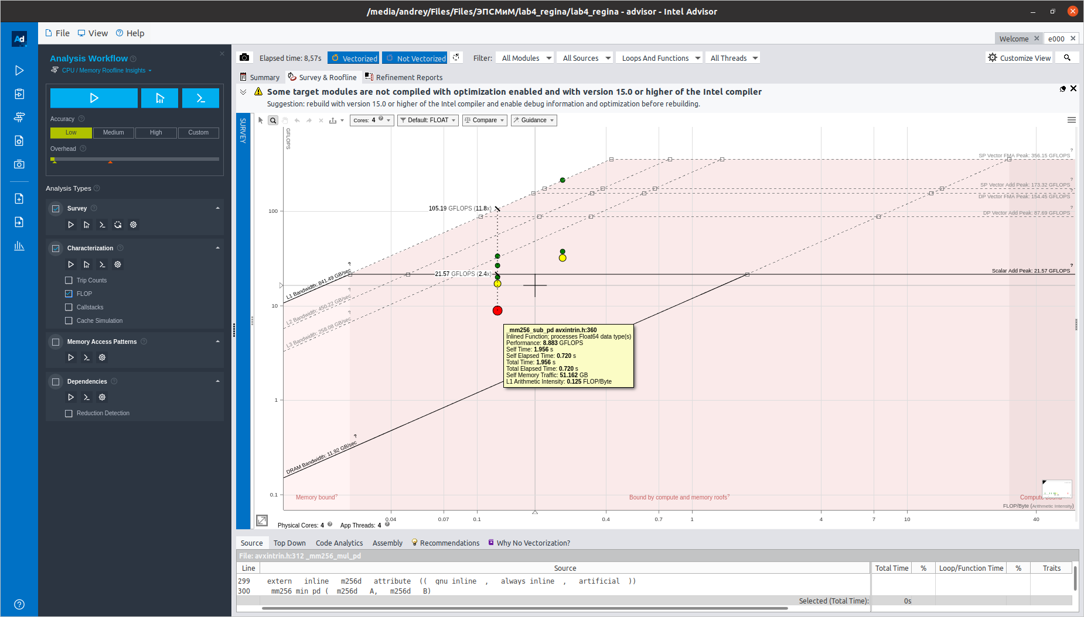

#include <stdio.h>

#include <stdlib.h>

#include <memory.h>

#include <math.h>

#include <time.h>

#include <immintrin.h>

#include <pthread.h>

const int r = 4;

const int threads = 3;

pthread_t* thread;

double** U;

double* P;

const int Nx = 8000, Ny = 8000, Nt = 100;

const int Sx = 1, Sy = 1;

const double Xa = 0.0, Xb = 4.0, Ya = 0.0, Yb = 4.0;

double hx, hy;

double t;

const int ALIGN_INDENT = 64;

const int VECTOR_SIZE = 4;

double t2_arr[VECTOR_SIZE];

double d_x_arr[VECTOR_SIZE];

double d_y_arr[VECTOR_SIZE];

const double two_arr[VECTOR_SIZE] = {2.0, 2.0, 2.0, 2.0};

int* green;

int* red;

int* blue;

volatile int green_wait_blue[16 * 32];

volatile int blue_wait_green[16 * 32];

double f (int n) {

double f0 = 1.0, t0 = 1.5, c = 4.0;

double arg = 2*3.14*f0*(n*t - t0);

return exp(-0.0625 * (arg*arg)) * sin(arg);

}

void calculateRow(int i, double *U_prv, double *U_new, double *P, double f_value) {

double f_arr[VECTOR_SIZE];

int row = i * Nx, row_ = (i - 1) * Nx, row1 = (i + 1) * Nx;

for (int j = 1; j < Ny - 3; j += VECTOR_SIZE) {

int rowcol = row + j, rowcol_ = row + j - 1, rowcol1 = row + j + 1,

row_col = row_ + j, row1col = row1 + j, row_col_ = row_col - 1;

if (i == Sx && (Sy - j) < VECTOR_SIZE && (Sy - j) >=0)

f_arr[(Sy - j)] = f_value;

else

memset(f_arr, 0.0, 4 * sizeof(double));

__m256d first = _mm256_loadu_pd(U_prv+rowcol1);

__m256d second = _mm256_loadu_pd(U_prv+rowcol);

__m256d res1 = _mm256_sub_pd(first, second);

first = _mm256_loadu_pd(P+row_col);

second = _mm256_loadu_pd(P+rowcol);

__m256d res2 = _mm256_add_pd(first, second);

__m256d firstPath = _mm256_mul_pd(res1, res2);

first = _mm256_loadu_pd(U_prv+rowcol_);

second = _mm256_loadu_pd(U_prv+rowcol);

res1 = _mm256_sub_pd(first, second);

first = _mm256_loadu_pd(P+row_col_);

second = _mm256_loadu_pd(P+rowcol_);

res2 = _mm256_add_pd(first, second);

__m256d secondPath = _mm256_mul_pd(res1, res2);

__m256d lineDividend = _mm256_add_pd(firstPath, secondPath);

first = _mm256_loadu_pd(d_x_arr);

__m256d firstLineResult = _mm256_mul_pd(lineDividend, first);

first = _mm256_loadu_pd(U_prv+row1col);

second = _mm256_loadu_pd(U_prv+rowcol);

res1 = _mm256_sub_pd(first, second);

first = _mm256_loadu_pd(P+rowcol_);

second = _mm256_loadu_pd(P+rowcol);

res2 = _mm256_add_pd(first, second);

firstPath = _mm256_mul_pd(res1, res2);

first = _mm256_loadu_pd(U_prv+row_col);

second = _mm256_loadu_pd(U_prv+rowcol);

res1 = _mm256_sub_pd(first, second);

first = _mm256_loadu_pd(P+row_col_);

second = _mm256_loadu_pd(P+row_col);

res2 = _mm256_add_pd(first, second);

secondPath = _mm256_mul_pd(res1, res2);

lineDividend = _mm256_add_pd(firstPath, secondPath);

first = _mm256_loadu_pd(d_y_arr);

__m256d secondLineResult = _mm256_mul_pd(lineDividend, first);

__m256d sumOfTwoLines = _mm256_add_pd(firstLineResult, secondLineResult);

__m256d impulseVector = _mm256_loadu_pd(f_arr);

__m256d bracketResult = _mm256_add_pd(sumOfTwoLines, impulseVector);

first = _mm256_loadu_pd(two_arr);

second = _mm256_loadu_pd(U_prv+rowcol);

__m256d totalResult = _mm256_mul_pd(first, second);

second = _mm256_loadu_pd(U_new+rowcol);

totalResult = _mm256_sub_pd(totalResult, second);

__m256d tauSquareVector = _mm256_loadu_pd(t2_arr);

__m256d mulResult = _mm256_mul_pd(tauSquareVector, bracketResult);

totalResult = _mm256_add_pd(totalResult, mulResult);

_mm256_storeu_pd(U_new+rowcol, totalResult);

}

}

void one_thread(int thread_id){

for (int n = 1; n < Nt; n += 4) {

double* U_new = U[n%2];

double* U_prv = U[(n+1)%2];

double f_value = f(n);

calculateRow(1, U_prv, U_new, P, f_value);

calculateRow(2, U_prv, U_new, P, f_value);

calculateRow(1, U_new, U_prv, P, f_value);

calculateRow(3, U_prv, U_new, P, f_value);

calculateRow(2, U_new, U_prv, P, f_value);

calculateRow(1, U_prv, U_new, P, f_value);

for (int i = 4; i < Ny - 1; i++) {

calculateRow(i, U_prv, U_new, P, f_value);

calculateRow(i-1, U_new, U_prv, P, f_value);

calculateRow(i-2, U_prv, U_new, P, f_value);

calculateRow(i-3, U_new, U_prv, P, f_value);

}

calculateRow(Ny-2, U_new, U_prv, P, f_value);

calculateRow(Ny-3, U_prv, U_new, P, f_value);

calculateRow(Ny-2, U_prv, U_new, P, f_value);

calculateRow(Ny-4, U_new, U_prv, P, f_value);

calculateRow(Ny-3, U_new, U_prv, P, f_value);

calculateRow(Ny-2, U_new, U_prv, P, f_value);

}

}

void first(int thread_id){

for (int it = 1; it < Nt; it += r){

int f_value = f(it);

for (int k = 1; k < r; k++)

{

for (int p = green[thread_id * 16] + (k - 1), l = 1; l <= k; p--, l++)

calculateRow(p, U[(it + l) % 2], U[(it + l - 1) % 2], P, f_value);

}

for (int p = red[thread_id * 16]; p < green[(thread_id + 1) * 16]; p++)

{

for (int l = 1; l <= r; l++)

calculateRow(p - (l - 1), U[(it + l) % 2], U[(it + l - 1) % 2], P, f_value);

}

while(blue_wait_green[(thread_id + 1) * 16] < it);

for (int k = 2; k <= r; k++)

{

for (int p = blue[thread_id * 16] + (k - 2), l = k; l <= r; p--, l++) {

calculateRow(p, U[(it + l) % 2], U[(it + l - 1) % 2], P, f_value);

calculateRow(p + 1, U[(it + l) % 2], U[(it + l - 1) % 2], P, f_value);

}

}

green_wait_blue[thread_id * 16] = it;

}

}

void middle(int thread_id){

for (int it = 1; it < Nt; it += r){

int f_value = f(it);

while (green_wait_blue[(thread_id - 1) * 16] < it - r);

for (int k = 1; k < r; k++)

{

for (int p = green[thread_id * 16] + (k - 1) * 2, l = 1; l <= k; p--, l++) {

calculateRow(p, U[(it + l) % 2], U[(it + l - 1) % 2], P, f_value);

calculateRow(p+1, U[(it + l) % 2], U[(it + l - 1) % 2], P, f_value);

}

}

blue_wait_green[thread_id * 16] = it;

for (int p = red[thread_id * 16]; p < green[(thread_id + 1) * 16]; p++)

{

for (int l = 1; l <= r; l++)

calculateRow(p - (l - 1), U[(it + l) % 2], U[(it + l - 1) % 2], P, f_value);

}

while(blue_wait_green[(thread_id + 1) * 16] < it);

for (int k = 2; k <= r; k++)

{

for (int p = blue[thread_id * 16] + (k - 2), l = k; l <= r; p--, l++) {

calculateRow(p, U[(it + l) % 2], U[(it + l - 1) % 2], P, f_value);

calculateRow(p + 1, U[(it + l) % 2], U[(it + l - 1) % 2], P, f_value);

}

}

green_wait_blue[thread_id * 16] = it;

}

}

void last(int thread_id){

for (int it = 1; it < Nt; it += r){

int f_value = f(it);

while (green_wait_blue[(thread_id - 1) * 16] < it - r);

for (int k = 1; k < r; k++)

{

for (int p = green[thread_id * 16] + (k - 1) * 2, l = 1; l <= k; p--, l++) {

calculateRow(p, U[(it + l) % 2], U[(it + l - 1) % 2], P, f_value);

calculateRow(p + 1, U[(it + l) % 2], U[(it + l - 1) % 2], P, f_value);

}

}

blue_wait_green[thread_id * 16] = it;

for (int p = red[thread_id * 16]; p <= Nx - 2; p++)

{

for (int l = 1; l <= r; l++)

calculateRow(p - (l - 1), U[(it + l) % 2], U[(it + l - 1) % 2], P, f_value);

}

for (int k = 2; k <= r; k++)

{

for (int p = blue[thread_id * 16], l = k; l <= r; p--, l++)

calculateRow(p, U[(it + l) % 2], U[(it + l - 1) % 2], P, f_value);

}

}

}

void* new_thread(void* param) {

int thread_id = *((int*)param);

free((int*)param);

if (threads == 1)

one_thread(thread_id);

else

if (thread_id == 0)

first(thread_id);

else

if (thread_id == threads - 1)

last(thread_id);

else

middle(thread_id);

pthread_exit(NULL);

}

int main(){

hx = (Xb - Xa) / (Nx - 1), hy = (Yb - Ya) / (Ny - 1);

if (Nx <= 1000 && Ny <= 1000) t = 0.01;

else t = 0.001;

P = (double*)_mm_malloc(Nx * Ny * sizeof(double), ALIGN_INDENT);

for (int i = 0; i < Ny; i++)

for (int j = 0; j < Nx; j++) {

if (j < Nx/2) P[i*Nx + j] = 0.1*0.1;

else P[i*Nx + j] = 0.2*0.2;

}

U = (double**)_mm_malloc(2 * sizeof(double*), ALIGN_INDENT);

U[0] = (double*)_mm_malloc(Nx * Ny * sizeof(double), ALIGN_INDENT);

U[1] = (double*)_mm_malloc(Nx * Ny * sizeof(double), ALIGN_INDENT);

for (int i = 0; i < Ny; i++)

for (int j = 0; j < Nx; j++) {

U[0][i*Nx + j] = 0.0;

U[1][i*Nx + j] = 0.0;

}

double d_x = 0.5 / (hx * hx), d_y = 0.5 / (hy * hy), t2 = t * t;

for (int i = 0; i < VECTOR_SIZE; i++) {

t2_arr[i] = t2;

d_x_arr[i] = d_x;

d_y_arr[i] = d_y;

}

green = (int*)calloc(threads * 16, sizeof(int));

red = (int*)calloc(threads * 16, sizeof(int));

blue = (int*)calloc(threads * 16, sizeof(int));

memset(green, 0, threads * 16* sizeof(int));

memset(red, 0, threads * 16 * sizeof(int));

memset(blue, 0, threads * 16 * sizeof(int));

for (int i = 0; i < threads; i++) {

green[i * 16] = i * (Ny / threads) - (r - 1);

red[i * 16] = i * (Ny / threads) + (r - 1);

blue[i * 16] = (i + 1) * (Ny / threads) - r;

}

green[0] = 1;

red[0]++;

blue[(threads - 1) * 16] = Ny - r;

for (int i = 0; i < 16 * 32; i++) {

green_wait_blue[i] = 0;

blue_wait_green[i] = 0;

}

struct timespec start, finish;

clock_gettime(CLOCK_MONOTONIC_RAW, &start);

thread = (pthread_t*)calloc(threads, sizeof(pthread_t));

for (int i = 0; i < threads; i++) {

int* thread_ID = (int*)malloc(sizeof(int));

(*thread_ID) = i;

int error_code = pthread_create(&thread[i], NULL, new_thread, thread_ID);

if (error_code != 0)

printf("[MAIN | Waring] Error in create thread.");

}

for (int i = 0; i < threads; i++)

pthread_join(thread[i], NULL);

clock_gettime(CLOCK_MONOTONIC_RAW, &finish);

double time = finish.tv_sec - start.tv_sec + 0.000000001 * (finish.tv_nsec - start.tv_nsec);

printf("threads = %d : time = %lf\n", threads, time);

FILE* file = fopen("file.dat", "wb");

fwrite(U[1], sizeof(double), Nx * Ny, file);

fclose(file);

free(U[0]);

free(U[1]);

free(P);

free(green);

free(red);

free(blue);

free(thread);

return 0;

}