**10-02-2019 Capacity test (150 vu)**

**Test purpose**

The purpose of the test was to find the capacity of the BlogEngine application for 2 different scenarios of using the application by clients with Anonymous role. The number of generated blog posts for both scenarios is 100.

**Environment:** Analysis was performed on TEST environment.

General info:

|  |  |  |  |  |  |
| --- | --- | --- | --- | --- | --- |
|  | **Host** | **Type** | **IP** | **Hosted Applications** | **Ports** |
| STAGING | EPUAKIYW1844T2 | VM | 10.17.175.58 | EPUAKIYW1844T2.kyiv.epam.com | 80, 443 |

System resources (TEST env):

|  |  |  |  |  |
| --- | --- | --- | --- | --- |
|  | **Operational System** | **CPU, GHz** | **Memory, Mb** | **Disk size, Gb** |
| **DGL** | Win Server 2010 R2 SP1 64bit | 2 | 6215 | 50 |

**Test status**

Successful - tests were stopped on 8th and 6th minutes for the first and second type of scenarios respectively as the application became unresponsive.

**Test scenario**

There are considered Main script for Anonymous user scenario for two type of probability usage where

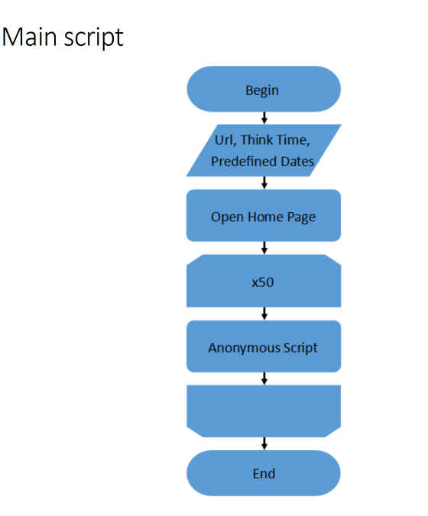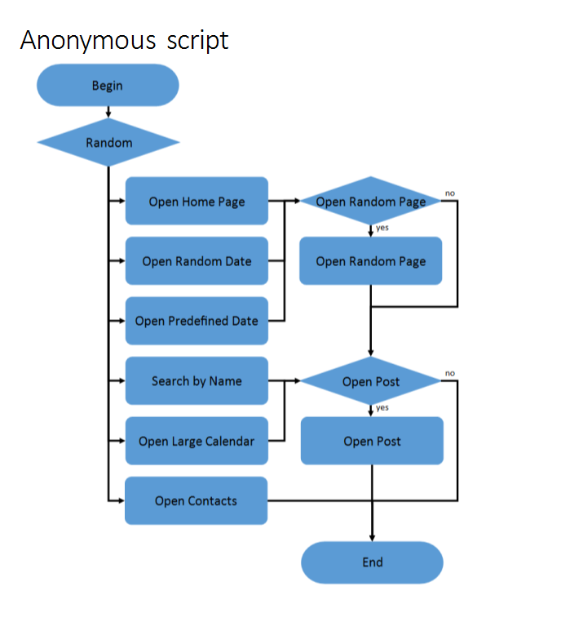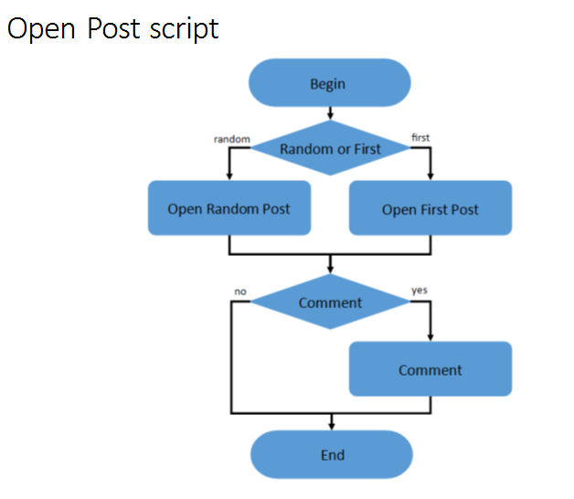

**Test conditions**

|  |  |  |
| --- | --- | --- |
| Transaction | First Condition | Second Condition |
| open home page | random | 16% |
| open random date | random | 10% |
| open prediction date | random | 30% |
| search by name | random | 30% |
| open large calendar | random | 10% |
| open contacts | random | 4% |
| open random page | 50% | 50% |
| open post | 50% | 80% |
| open random post | 50% | 66% |
| open first post | 50% | 34% |
| add comment | 50% | 20% |

**Test Setup**

|  |  |
| --- | --- |
| number of virtual users | 150 |
| ramp-up period | 1000 |
| think time between transactions(sec) | 3-5 |
| count of posts | 100 |

**Note**: here random date is from 2019-02-01 to 2019-02-05.

**Test Results**

|  |  |  |
| --- | --- | --- |
| KPI | First Condition | Second Condition |
| number of estimated transactions/sec (max) | up to 716 | up to 551 |
| requests/sec (max) | up to 43 | up to 51 |
| CPU | up to 100% | up to 100% |
| saturation point (users) | 25 | 35 |
| crash point (min) | 8 | 6 |
| crash point (users) | 72 | 50 |
| average median response time (ms) | 150 | 160 |
| average 95% response time (ms) | 4396 | 522 |

**Test Summary**

1. The maximum capacity of the application usage by Anonymous clients is found. For both scenarios it is restricted by the 100% CPU usage. Adding more load leads to the application becomes unresponsive.

2. Saturation point is 25 users and crash point is 72 for the 1st scenario. Saturation point is 35 users and crash point is 50 for the 2d scenario.

**Issues found**

"Comment" transaction showed nearly 0.08% error rate during the test.

**Recommendation**

Possibility to increasing CPU power.

**Result detail**

There is suppose that these results depend from random date value, it will be good to execute the addition test with another random date for comparison the results.

**Results: graphs and tables**

1. Aggregate Reports

**The 1st scenario**

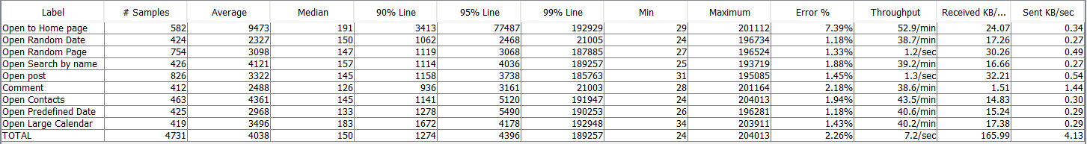

**The 2st scenario**

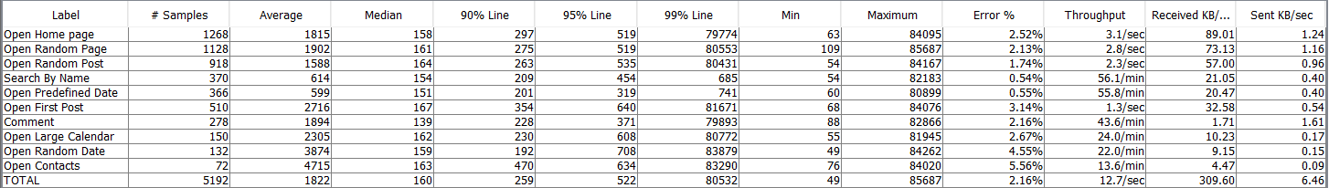

1. Number of active threads graph

**The 1st scenario**

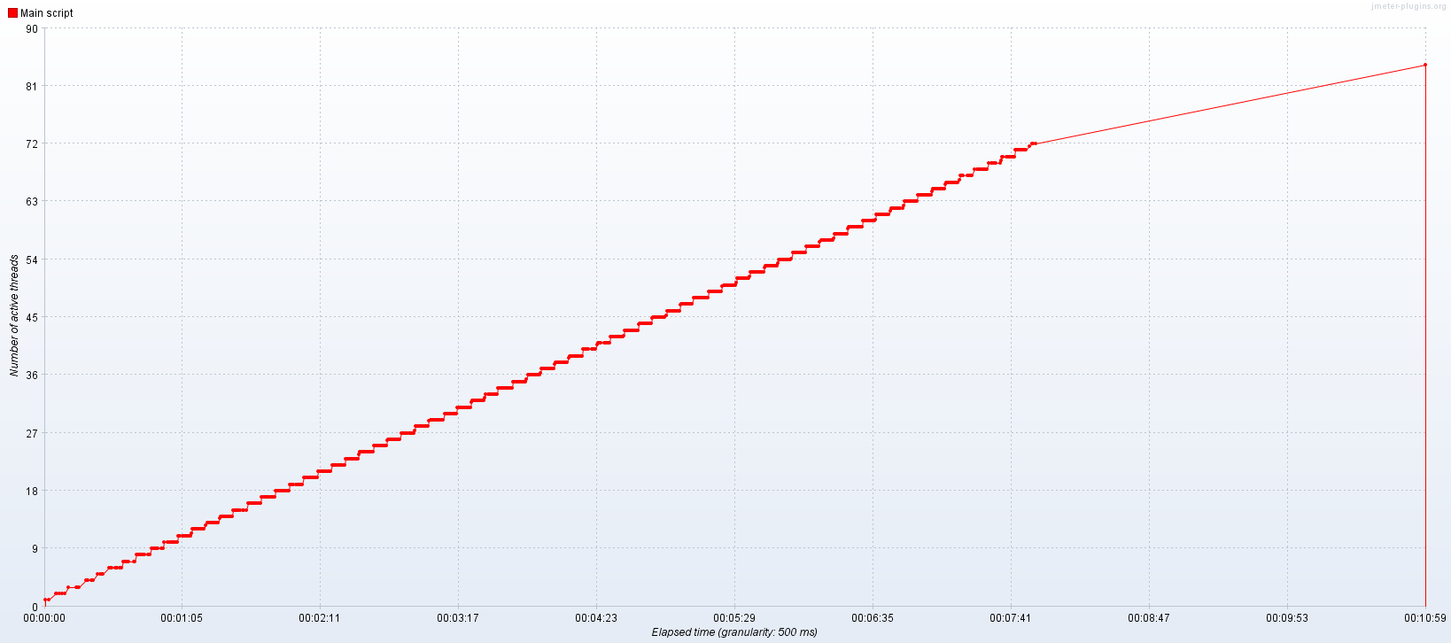

**The 2st scenario**

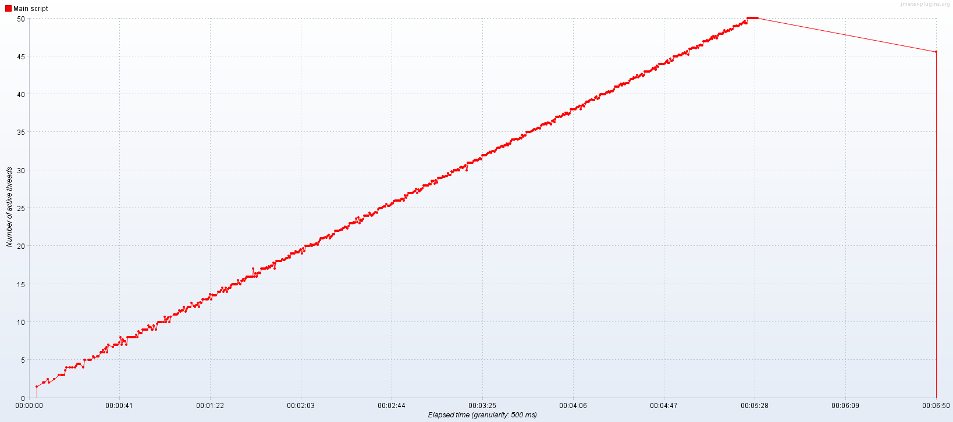

1. PerfMon Metrics (CPU and Memory) graphs

**The 1st scenario**

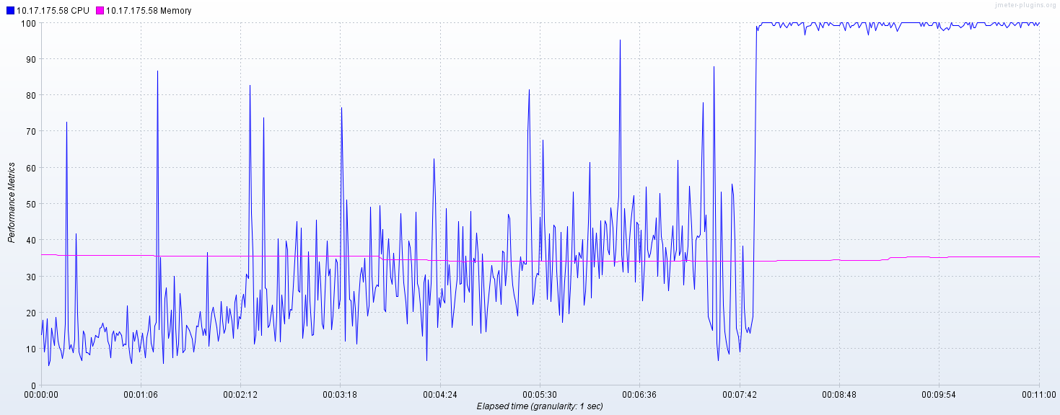

**The 2st scenario**

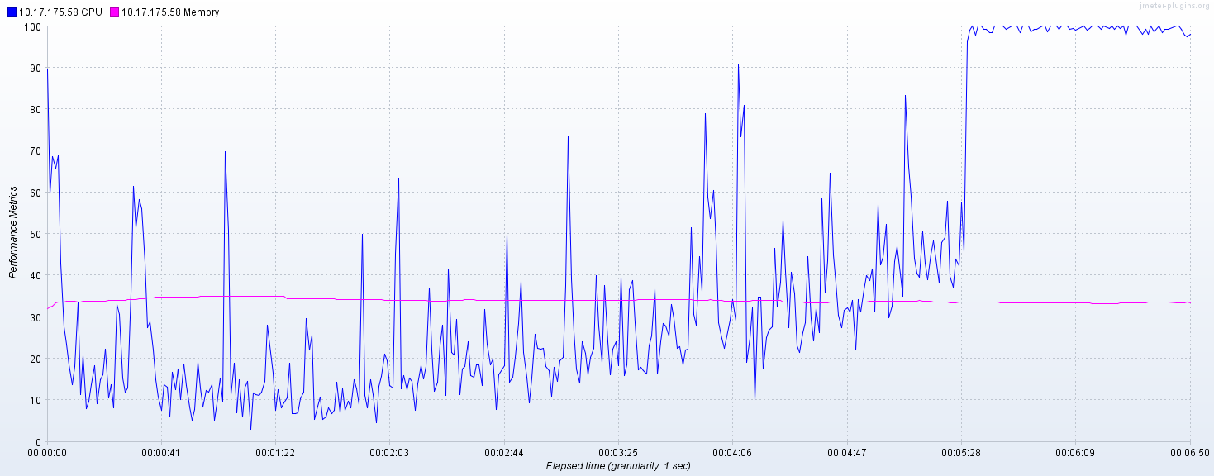

From the graphs above we can find the crash points for two types of Anonymous script conditions. For first condition the crash point is 7 min 50 sec and for second condition – 5 min 30 sec.

1. Transaction Throughput vs Threads graphs

**The 1st scenario**

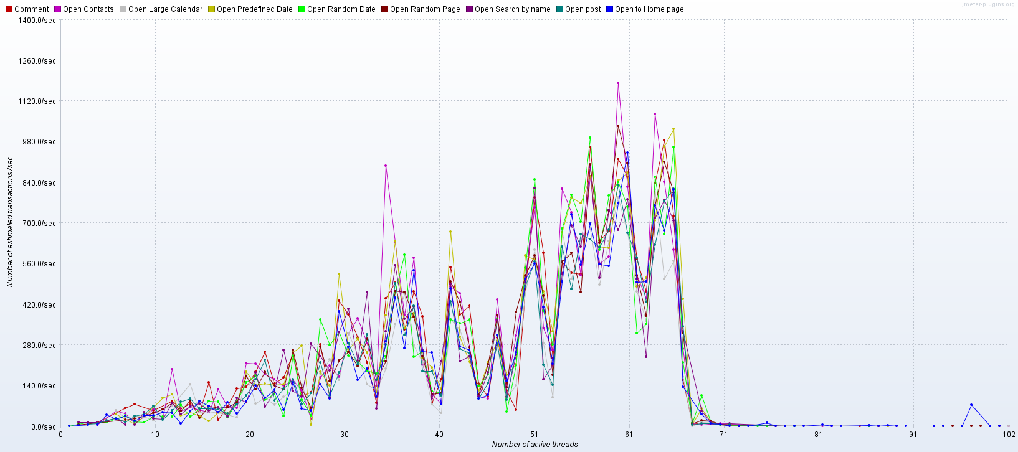

**The 2st scenario**

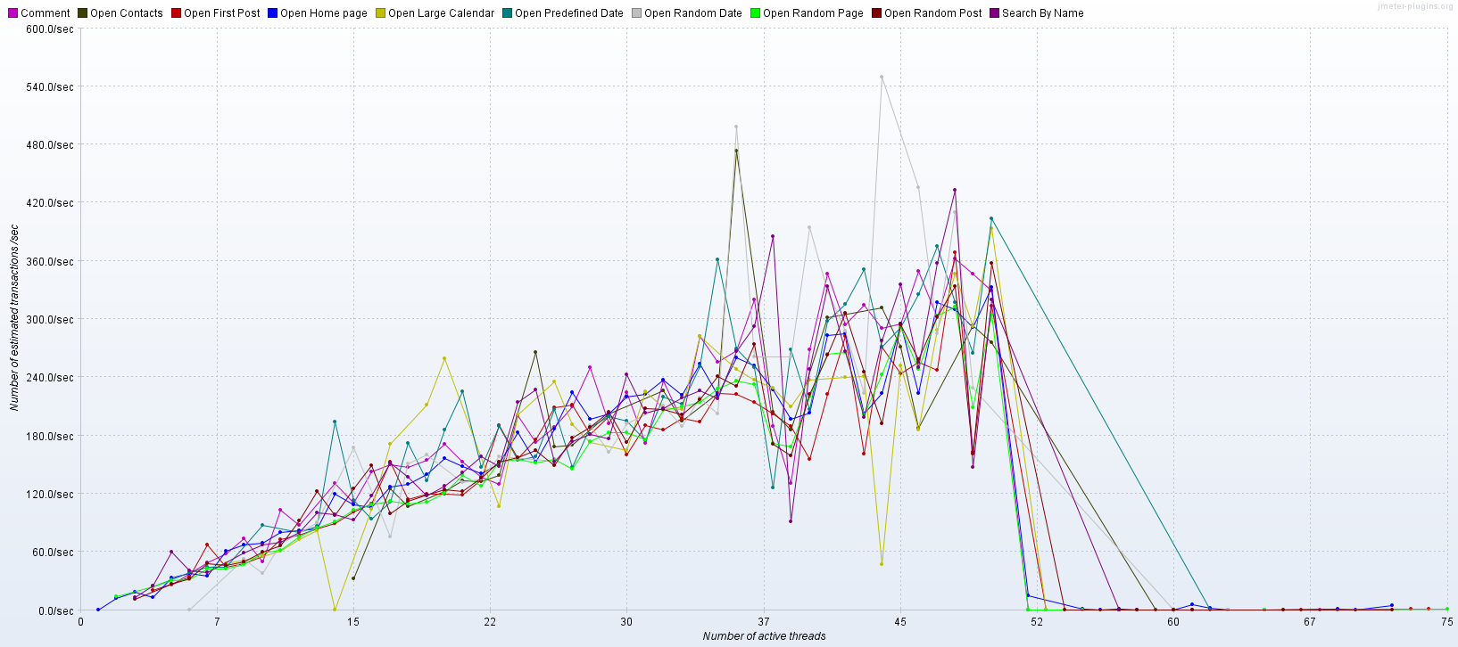

From these graphs we obtained saturation points. For first condition saturation point is 25 users and for second condition – 35 users.

1. Response codes per Second graphs

**The 1st scenario**

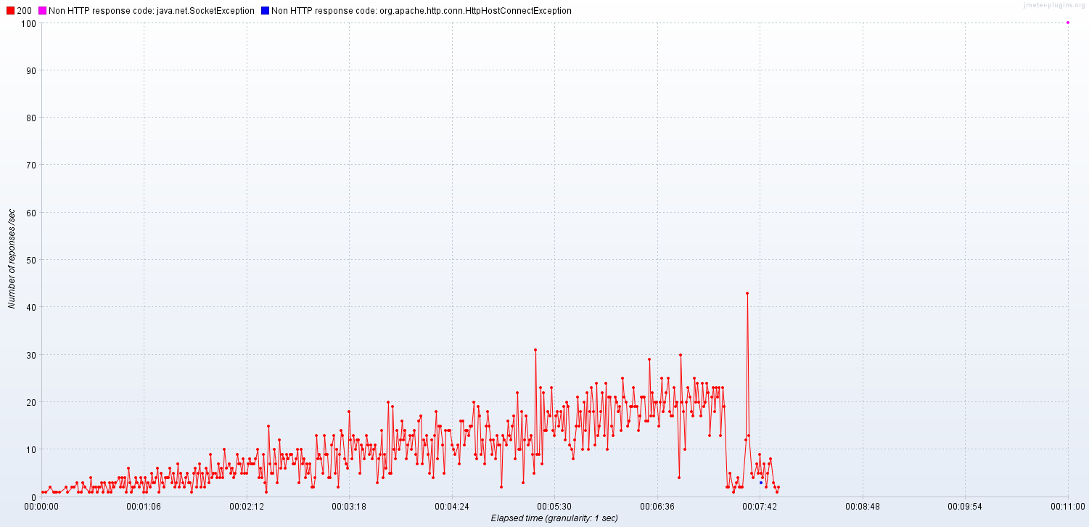

**The 2st scenario**

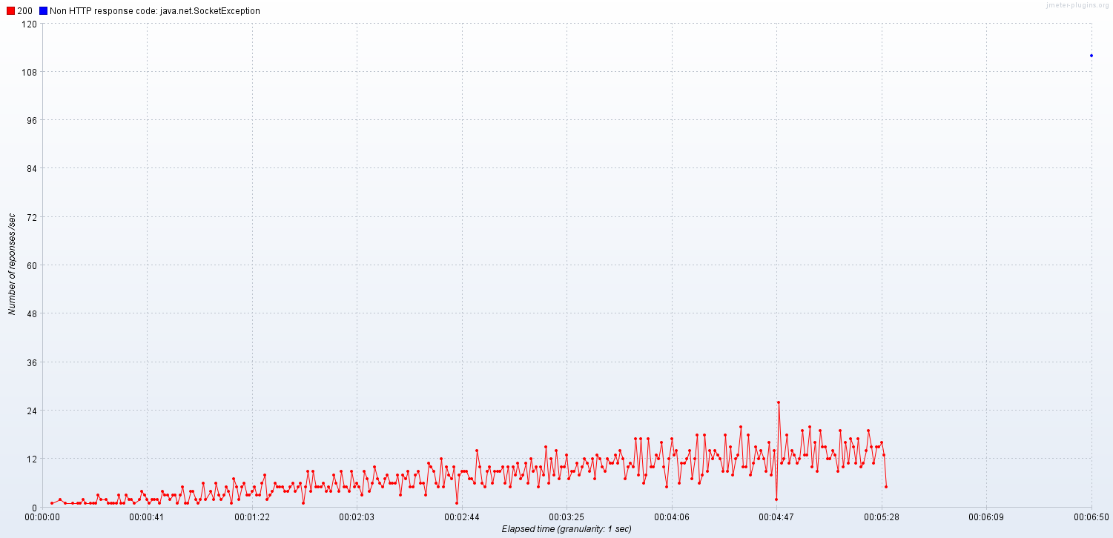

1. Response Time Over Time

**The 1st scenario**

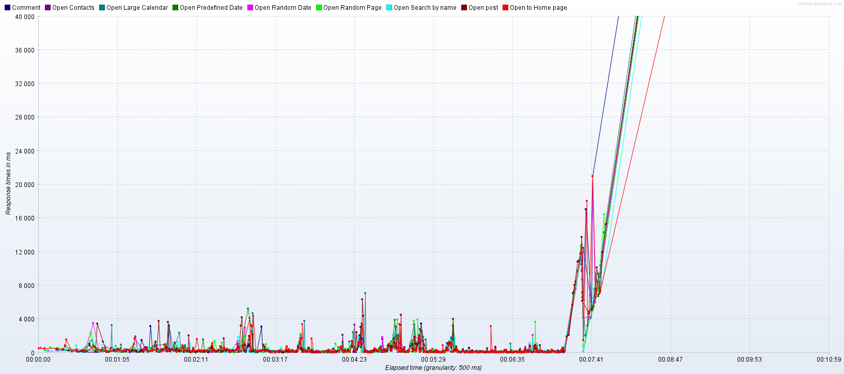

**The 2st scenario**

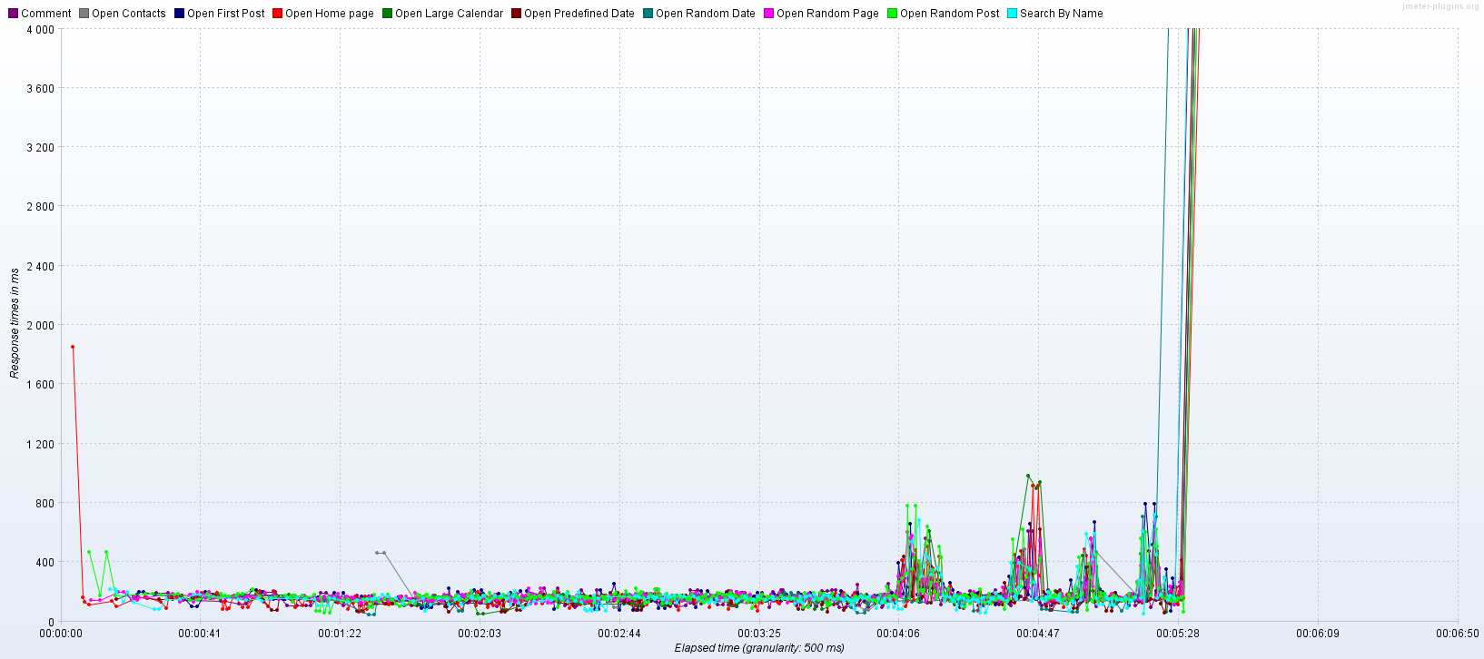

1. Error details

**The 1st scenario**

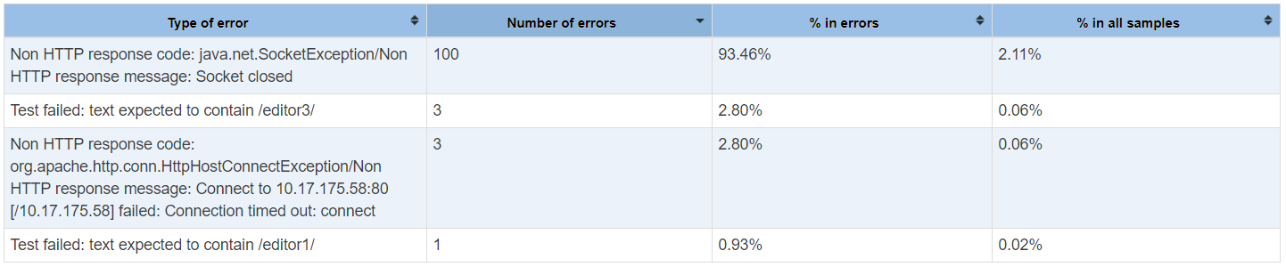

"Comment" transaction showed nearly 0.08% error rate during the test.

**The 2st scenario**

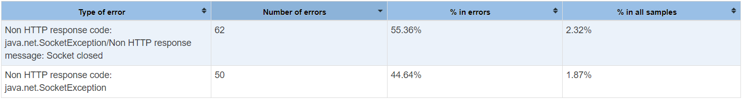

All errors were due to CPU crash.