**Capacity test (80 vu)**

**Test purpose**

The purpose of the test was to find the capacity of the BlogEngine application for 2 different scenarios of using the application by clients with Anonymous role and also Admin and Editor roles.. The number of generated blog posts for both scenarios is 1000.

**Application Overview**

BlogEngine.NET is an open source ASP.NET project that was born out of desire for a better blogging platform. Developers focused on simplicity, ease of use, extendibility and innovative design while taking advantage of the latest .NET features.

**Testing Scope**

Performance Testing for the following modules are in Scope of Testing

1. Home page
2. Calendar
3. Post page
4. Create comment
5. Contact page
6. Search by Name
7. Edit post
8. Admin page
9. Add user
10. Delete user
11. Login
12. Logout

**Test scenario**

There are considered Main script for Anonymous user scenario where

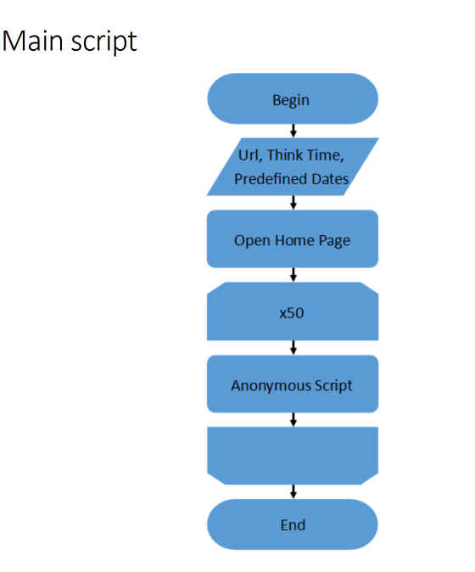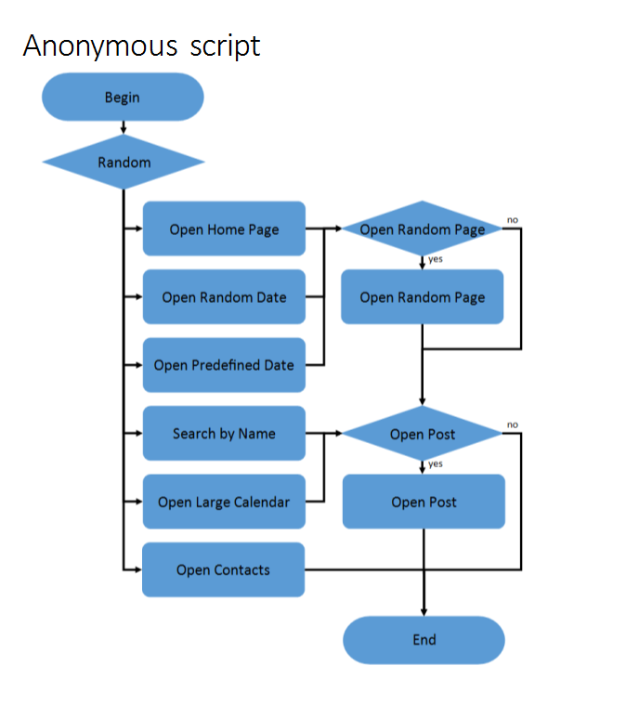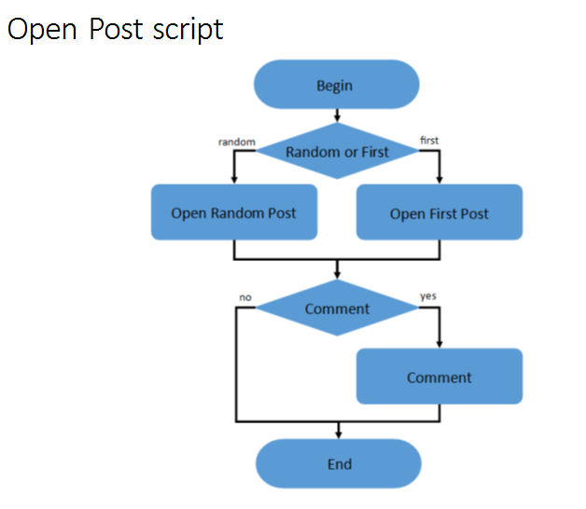

Also there are scenarios for Admin and Editor users where

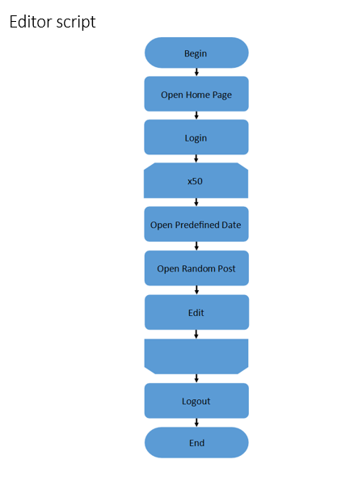 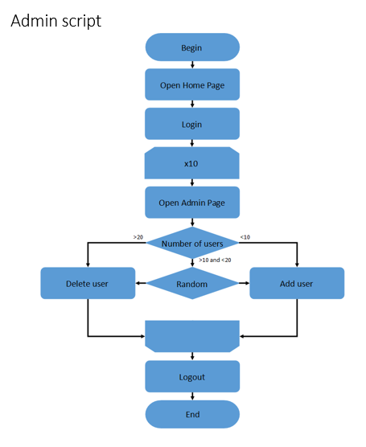

**Test Environment & Tools**

**Environment:** Analysis was performed on TEST environment.

General info:

|  |  |  |  |  |  |
| --- | --- | --- | --- | --- | --- |
|  | **Host** | **Type** | **IP** | **Hosted Applications** | **Ports** |
| STAGING | EPUAKIYW1844T2 | VM | 10.17.175.4 | EPUAKIYW1844T2.kyiv.epam.com | 80 |

System resources (TEST env):

|  |  |  |  |  |
| --- | --- | --- | --- | --- |
|  | **Operational System** | **CPU, GHz** | **Memory, Gb** | **Disk size, Gb** |
| **DGL** | Win Server 2010 R2 SP1 64bit | 2 | 4 | 50 |

**Tools:**

|  |  |
| --- | --- |
| Creating and executing tests | Apache JMeter v5.0 |
| Storing test results and application indicators | InfluxDB 1.7.3 |
| Collecting application metrics | Telegraf 1.10 |
| Visualizing metrics, creating dashboards | Grafana 5.4.3 |

**Test conditions**

|  |  |  |
| --- | --- | --- |
| Condition | Transaction | Probabilities usage |
| 1 | open home page | 15% |
| open random date | 10% |
| open prediction date | 30% |
| search by name | 30% |
| open large calendar | 10% |
| open contacts | 5% |
| 2 | open random page | 50% |
| 3 | open post | 80% |
| 4 | open random post | 65% |
| open first post | 35% |
| 5 | add comment | 20% |

**Test Setup**

|  |  |  |
| --- | --- | --- |
|  | First test | Second test |
| number of virtual users | 80 Anonymous, 2 Admins, 2 Editors | 60 Anonymous, 2 Admins, 2 Editors |
| ramp-up period | 800; 20;20 | 600; 20;20 |
| think time between transactions(sec) | 3-5 | 3-5 |
| count of posts | 1000 | 1000 |

Note: here random date is from 2019-02-01 to 2019-02-11.

**Test Results**

**Test Summary**

1. The maximum capacity of the application usage by Anonymous clients is found. For scenario it is restricted by the 100% CPU usage. Adding more load leads to the application becomes unresponsive.

2. Crash point is 68 users (2 Admin users, 2 Editor users, 64 Anonymous users). Saturation point is 64 users (2 Admin users, 2 Editor users, 60 Anonymous users).

**Issues found**

There were Internal Server Errors for Edit post transaction.

**Recommendation**

Possibility to increasing CPU power. To fix problem with response time of opening Home page and internal server error for Edit post transaction.

**Results: graphs and tables**

**First test**

1. Aggregate Reports

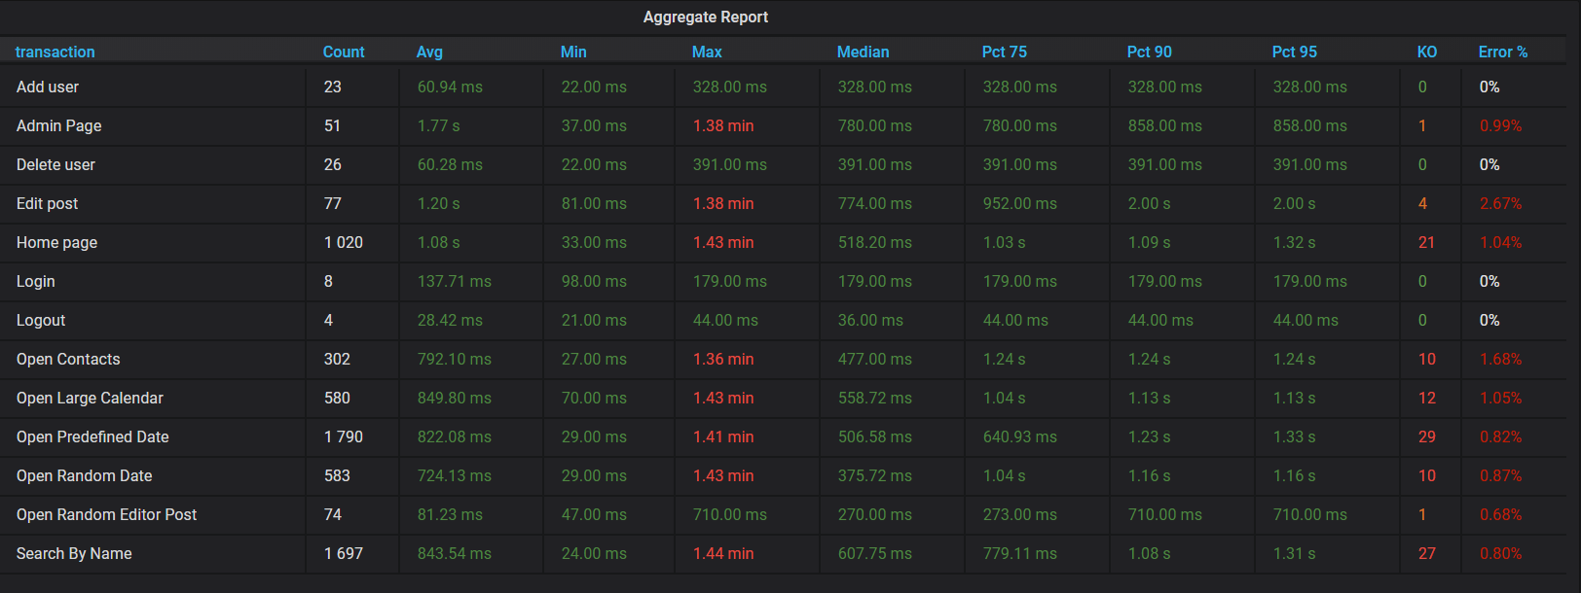

1. Total Response Time vs Threads

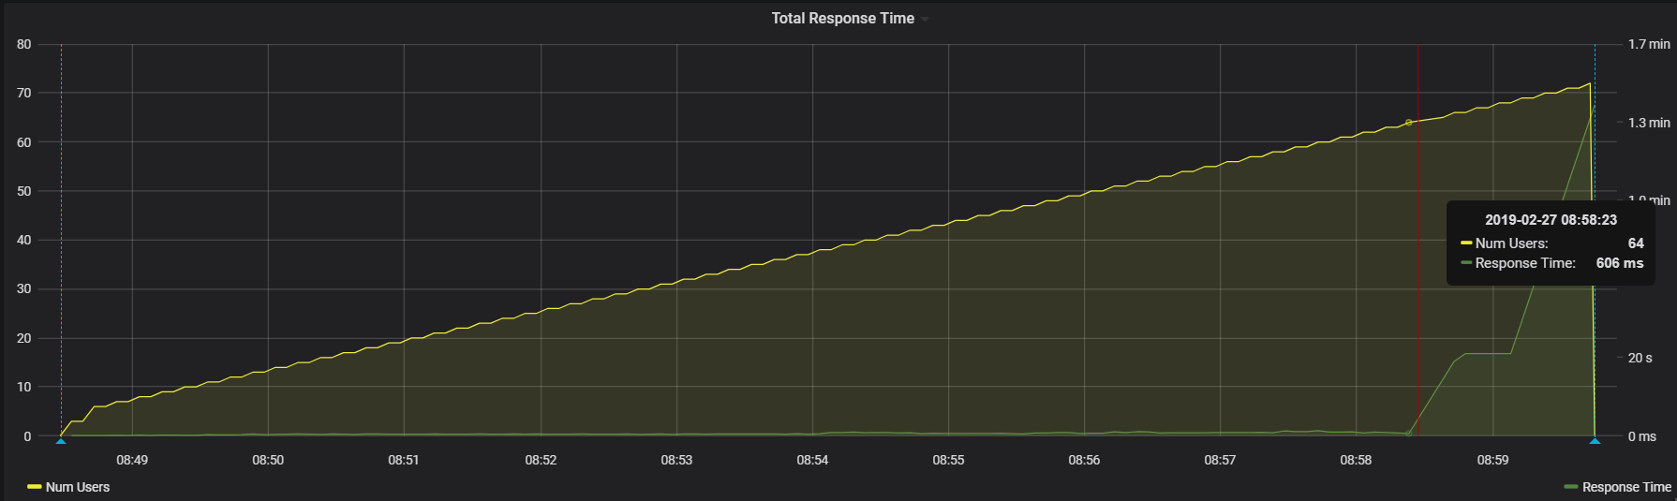

1. Transaction Response Times

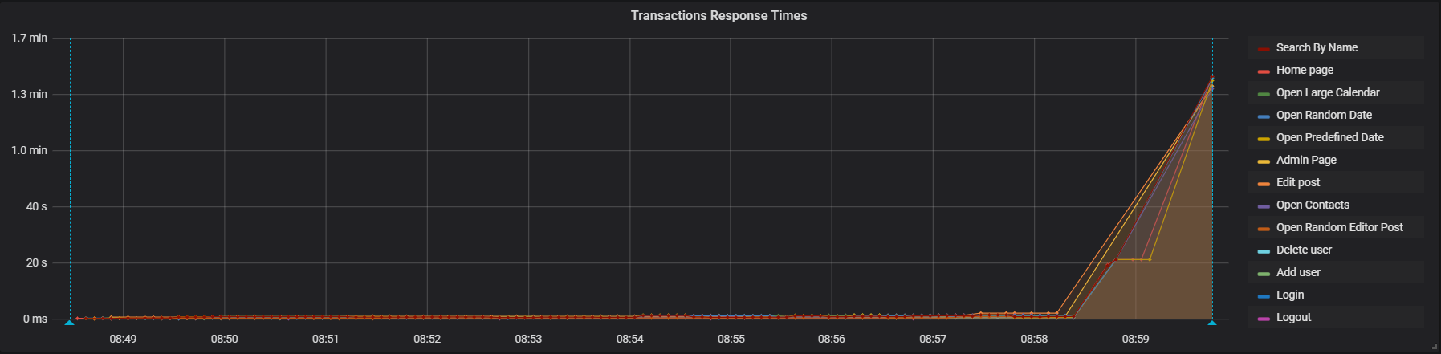

1. Total Throughput vs Threads

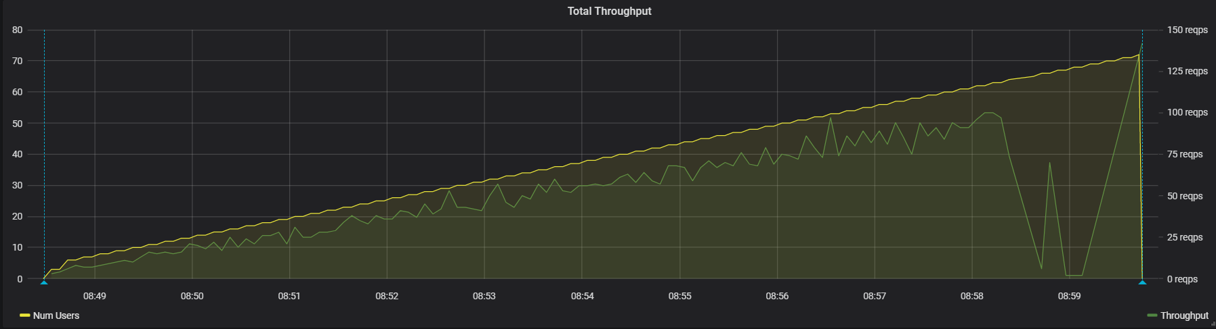

1. Transaction Throughput

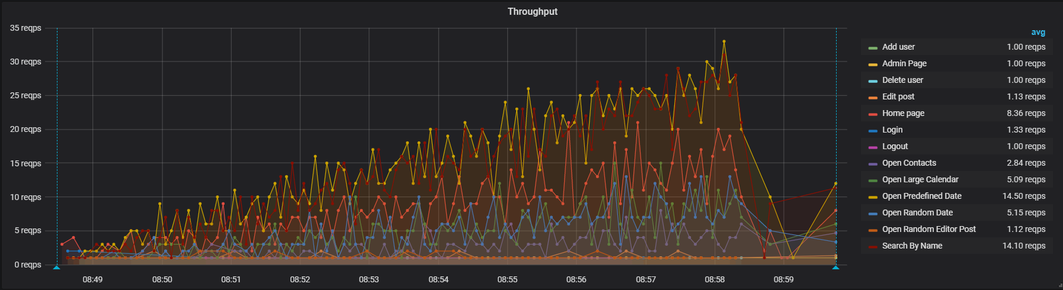

1. CPU

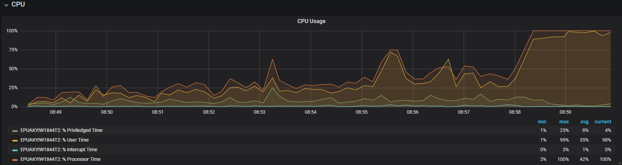The indicators of CPU increased stability during the test up to crash.

1. Memory

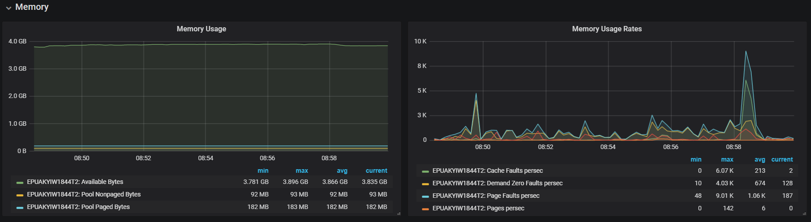

1. Disk C

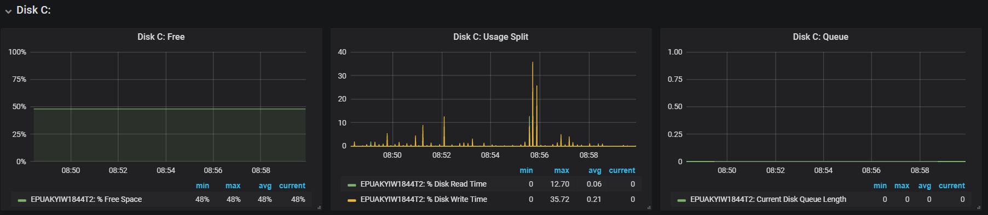

1. Errors

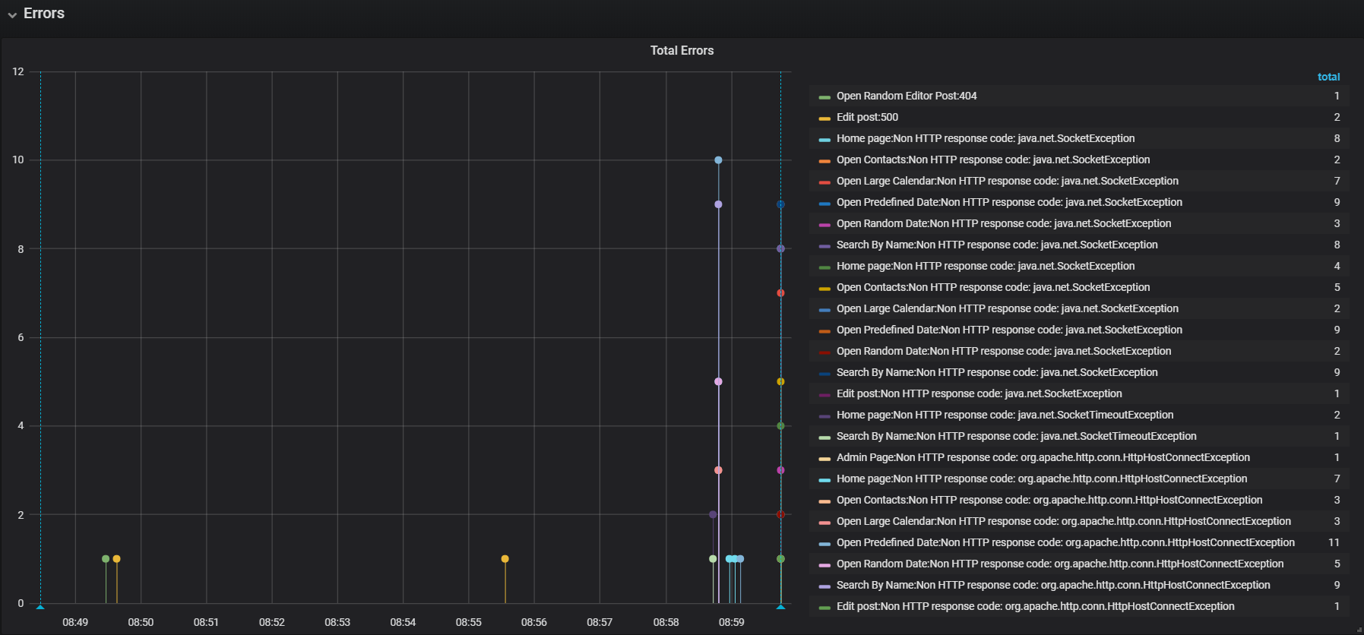

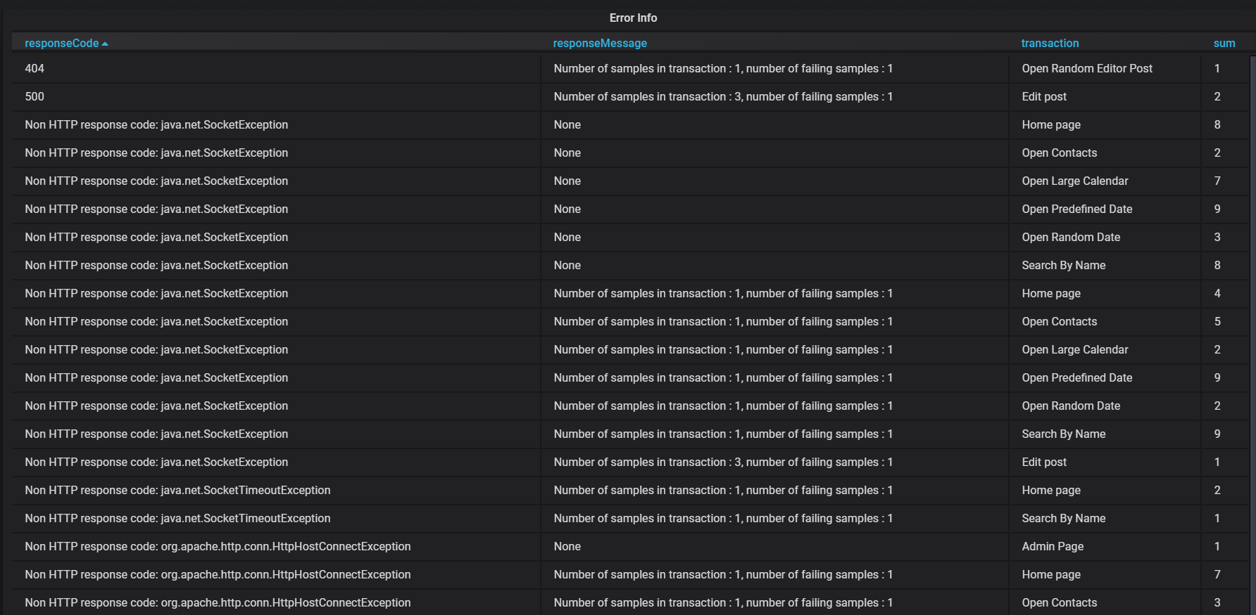

404 error for Open Random Editor Post was probably due some mistake in script. 500 errors for Edit post transaction needs to be investigated. Probably it can relate memory usage.

Other errors relate to server stopped to response.

**Second test**

Second test was for checking saturation point.

1. Aggregate Reports

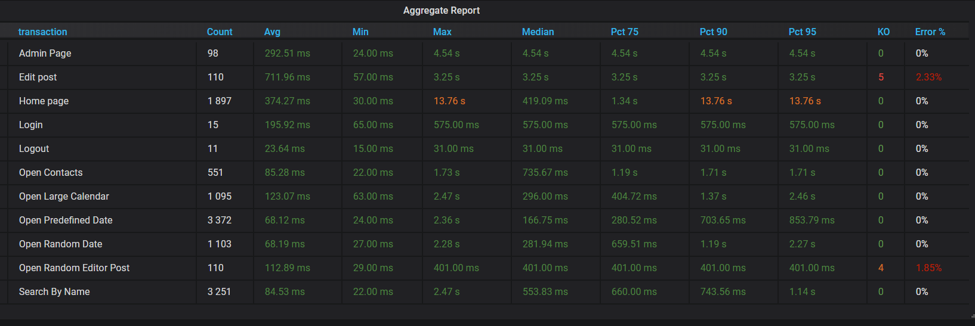

1. Total Response Time vs Threads

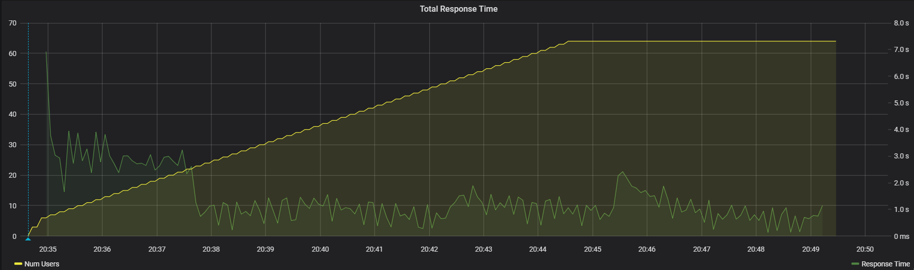

1. Transaction Response Times

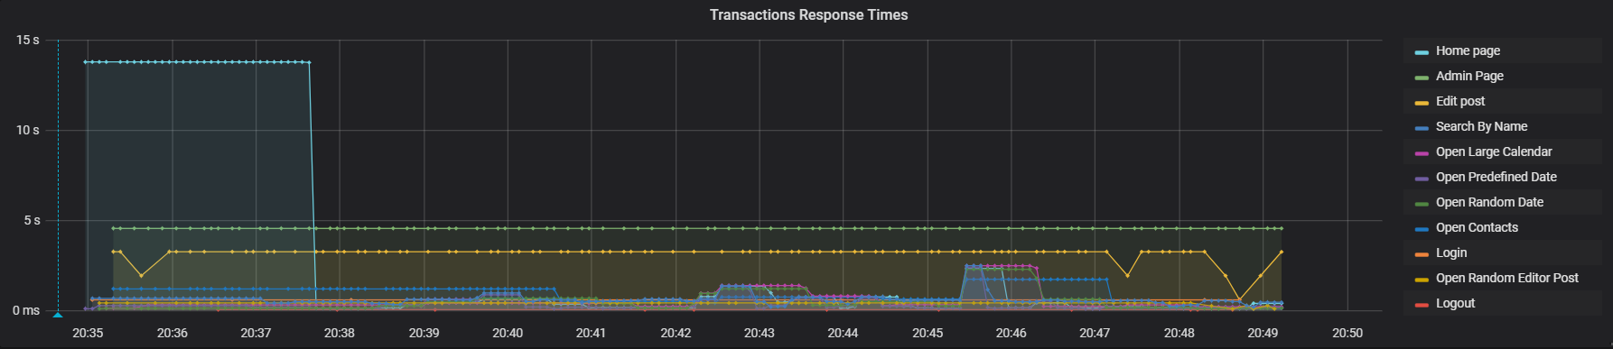

The average of response time in second test was more than in first one. First 3 minutes of test Home page transaction had response time 13.76 sec. Also, Admin page and Edit post transactions had higher response time than in first test. For 4.5 min after 64 users were logged server stopped to response.

1. Total Throughput vs Threads

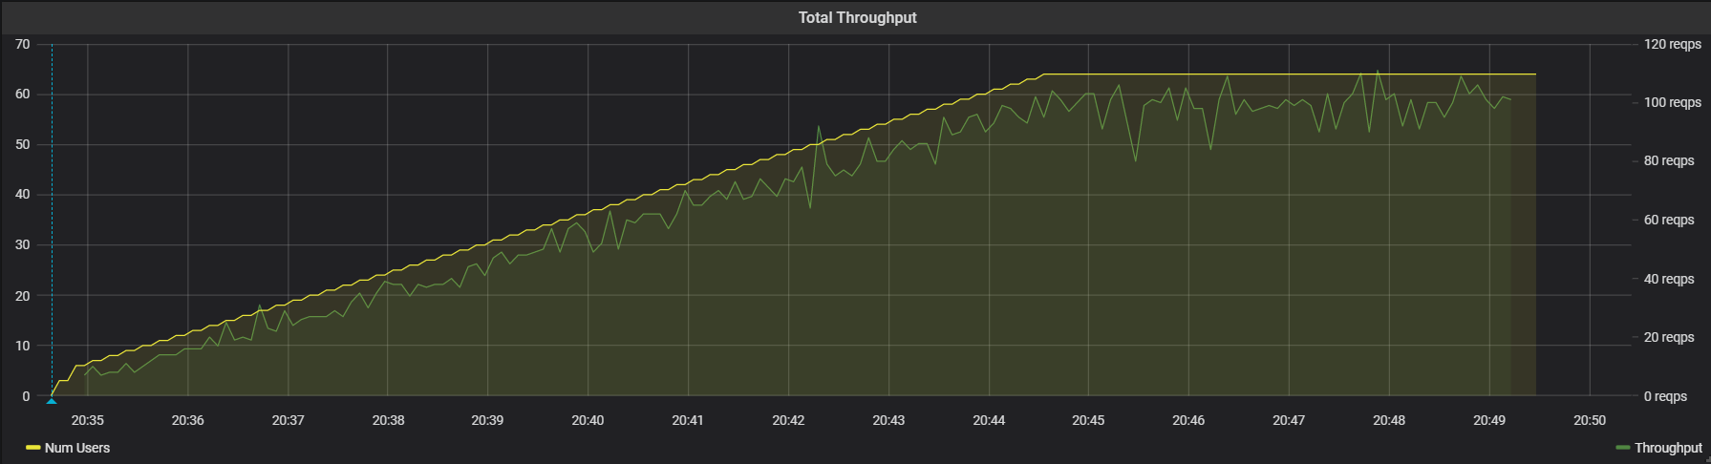

1. Transaction Throughput

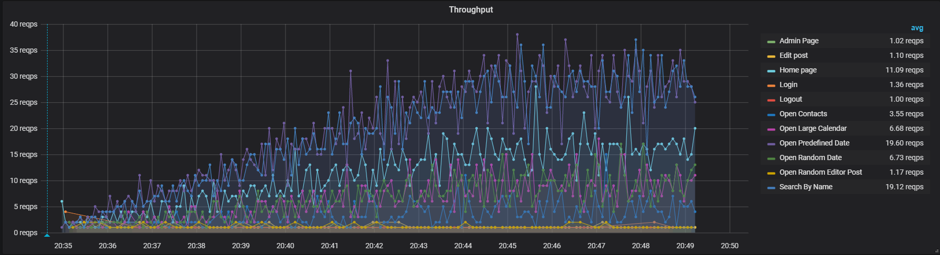

1. CPU

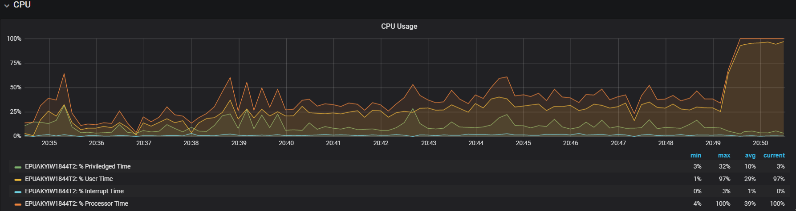In the The indicators of CPU were stable during the test up to crash.

1. Memory

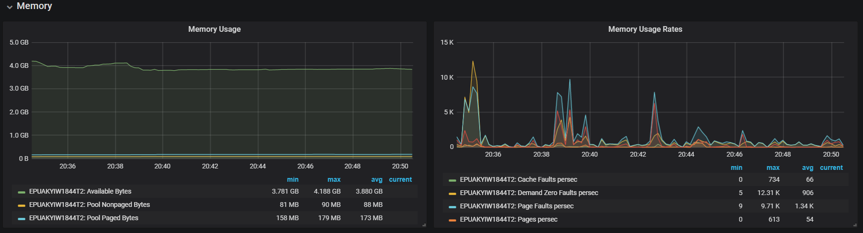

1. Disk C

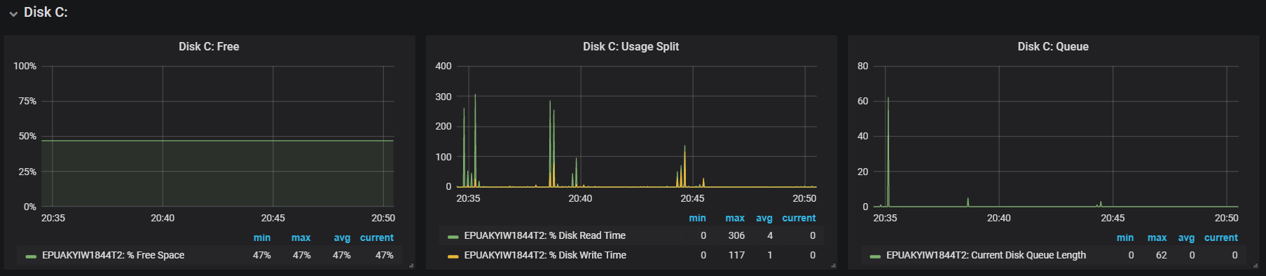

1. Errors

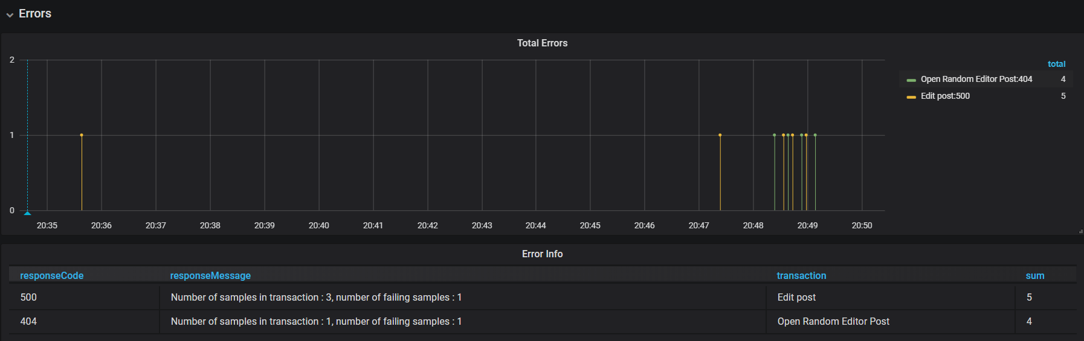Almost the same situation was for errors like in first test.