**27-02-2019 Smoke test (10 vu)**

**Test purpose**

The purpose of the test was to check that the functionalities of the BlogEngine application are working correct and environment is working stably during using the application by clients with Anonymous role. The number of generated blog posts is 100.

**Environment:** Analysis was performed on TEST environment.

General info:

|  |  |  |  |  |
| --- | --- | --- | --- | --- |
| **Host** | **Type** | **IP** | **Hosted Applications** | **Ports** |
| EPUAKIYW1844T2 | VM | 10.17.175.58 | EPUAKIYW1844T2.kyiv.epam.com | 80, 443 |

System resources (TEST env):

|  |  |  |  |  |
| --- | --- | --- | --- | --- |
|  | **Operational System** | **CPU, GHz** | **Memory, Gb** | **Disk size, Gb** |
| **DGL** | Win Server 2010 R2 SP1 64bit | 2 | 4 | 50 |

**Test status**

Successful – all functionalities of the application are working correct, сhanges in CPU usage occurred regardless of application load.

**Test scenario**

There are considered Main script for Anonymous user scenario where

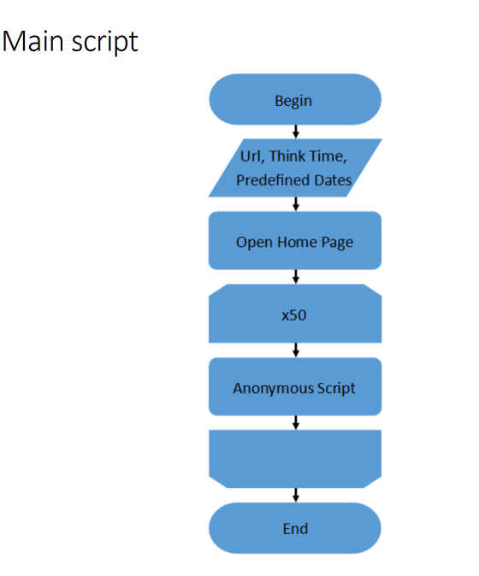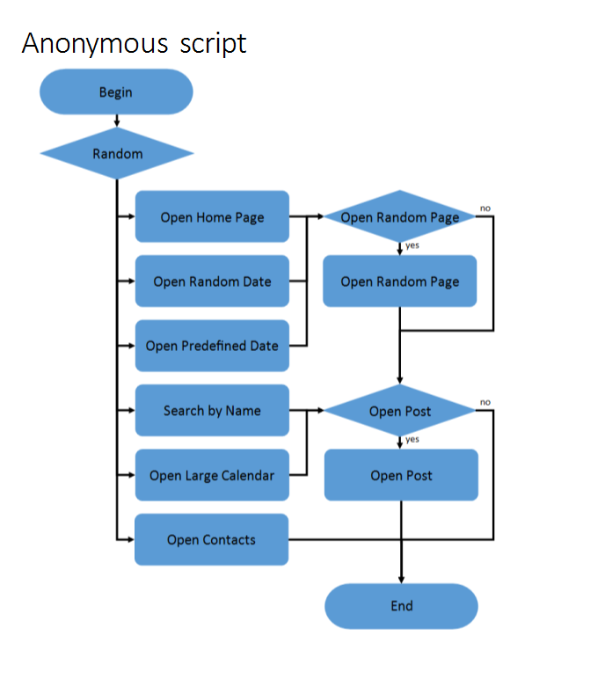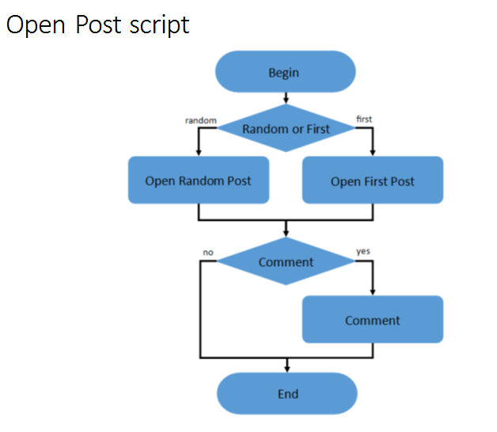

**Test conditions**

|  |  |  |
| --- | --- | --- |
| Condition | Transaction | Probabilities usage |
| 1 | open home page | 15% |
| open random date | 10% |
| open predefined date | 30% |
| search by name | 30% |
| open large calendar | 10% |
| open contacts | 5% |
| 2 | open random page | 50% |
| 3 | open post | 80% |
| 4 | open random post | 65% |
| open first post | 35% |
| 5 | add comment | 20% |

**Test Setup**

|  |  |
| --- | --- |
| number of virtual users | 10 |
| ramp-up period | 100 |
| think time between transactions(sec) | 3-5 |
| count of posts | 100 |

Note: here random date is from 2019-02-01 to 2019-02-11.

**Test Results**

|  |  |
| --- | --- |
| KPI |  |
| Max requests/sec | up to 20 |
| Average requests/sec | 9 |
| average response time (ms) | 1000 |
| CPU | up to 69% |

**Test Summary**

A test was performed to check the functionality of the application. No errors were reproduced during the test. The environment indicators were normal considering that there is not only an application on the host. Test results are satisfactory.

**Result detail**

There is suppose that these results depend from random date value, it will be good to execute the addition test with another random date for comparison the results.

**Recommendation**

Check Home page work because 100% of transaction have response time 4.13 second.

**Results: graphs and tables**

Test result dashboard: <https://snapshot.raintank.io/dashboard/snapshot/XU36XTWie1PGH2oqJvYNAJ00pJLoUHLI>

Host monitoring dashboard: <https://snapshot.raintank.io/dashboard/snapshot/Kwh7EeJeP6egAkEyW6e9Bzjv3LMSn9Oo>

1. Aggregate Reports

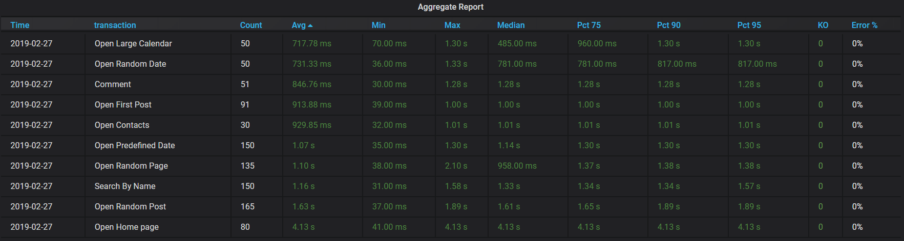

1. Total Response Time vs Threads

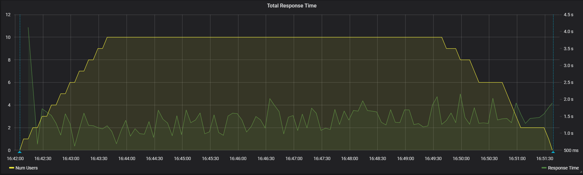

1. Total Throughput vs Threads

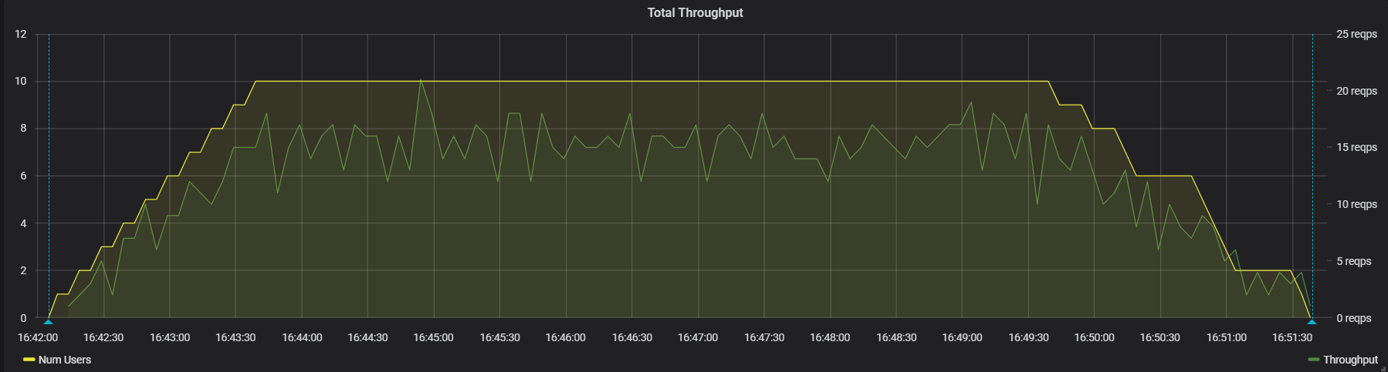

1. CPU

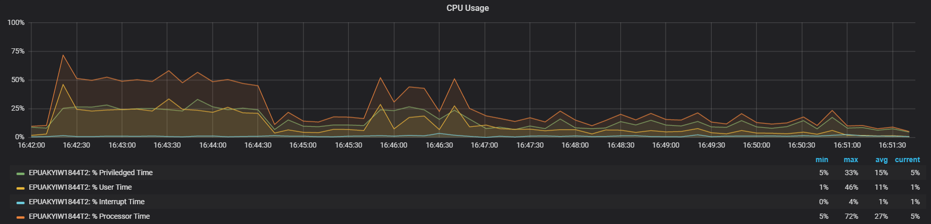

1. Memory

