**Smoke test**

**Test purpose**

The purpose of the test was to check that the functionalities of the BlogEngine application are working correct and environment is working stably during using the application by clients with Anonymous role and also Admin and Editor roles. The number of generated blog posts is 1000.

**Application Overview**

BlogEngine.NET is an open source ASP.NET project that was born out of desire for a better blogging platform. Developers focused on simplicity, ease of use, extendibility and innovative design while taking advantage of the latest .NET features.

**Testing Scope**

Performance Testing for the following modules are in Scope of Testing

1. Home page
2. Calendar
3. Post page
4. Create comment
5. Contact page
6. Search by Name
7. Edit post
8. Admin page
9. Add user
10. Delete user
11. Login
12. Logout

**Test scenario**

There are considered Main script for Anonymous user scenario where

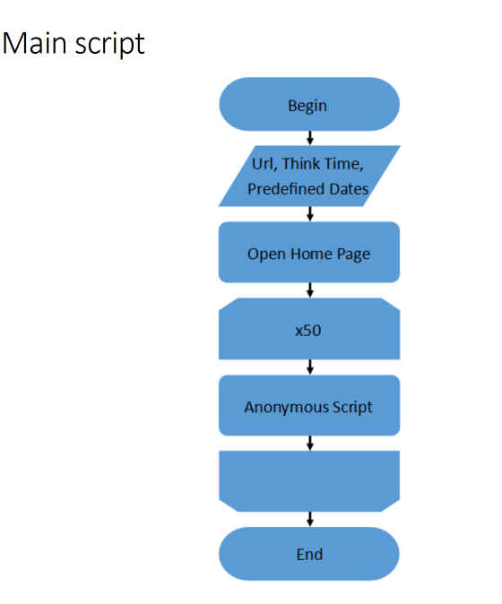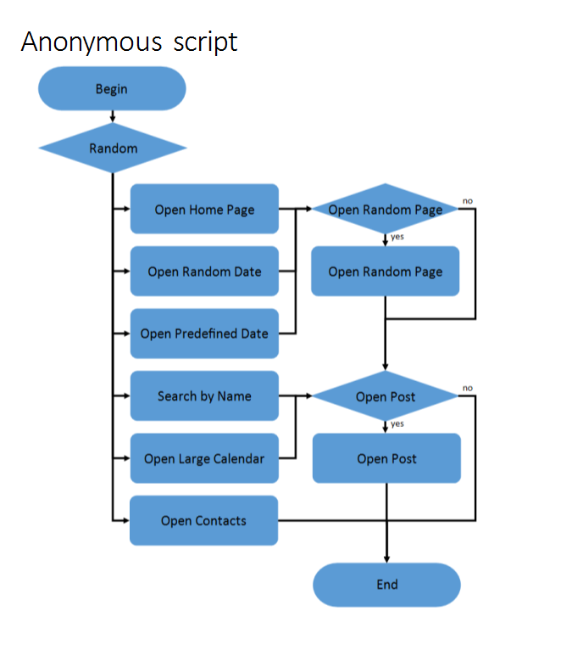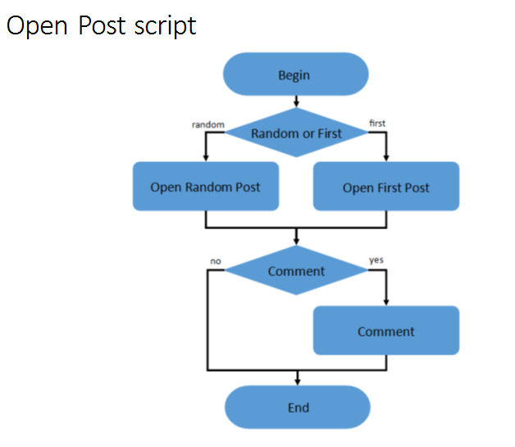

Also there are scenarios for Admin and Editor users where

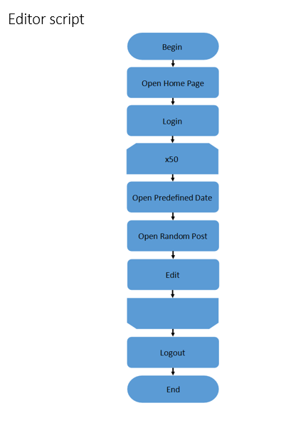 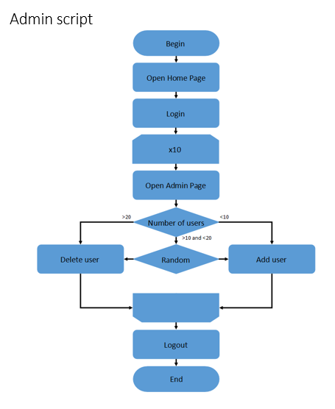

**Test Environment & Tools**

**Environment:** Analysis was performed on TEST environment.

General info:

|  |  |  |  |  |  |
| --- | --- | --- | --- | --- | --- |
|  | **Host** | **Type** | **IP** | **Hosted Applications** | **Ports** |
| STAGING | EPUAKIYW1844T2 | VM | 10.17.175.4 | EPUAKIYW1844T2.kyiv.epam.com | 80 |

System resources (TEST env):

|  |  |  |  |  |
| --- | --- | --- | --- | --- |
|  | **Operational System** | **CPU, GHz** | **Memory, Gb** | **Disk size, Gb** |
| **DGL** | Win Server 2010 R2 SP1 64bit | 2 | 4 | 50 |

**Tools:**

|  |  |
| --- | --- |
| Creating and executing tests | Apache JMeter v5.0 |
| Storing test results and application indicators | InfluxDB 1.7.3 |
| Collecting application metrics | Telegraf 1.10 |
| Visualizing metrics, creating dashboards | Grafana 5.4.3 |

**Test conditions**

|  |  |  |
| --- | --- | --- |
| Condition | Transaction | Probabilities usage |
| 1 | open home page | 15% |
| open random date | 10% |
| open prediction date | 30% |
| search by name | 30% |
| open large calendar | 10% |
| open contacts | 5% |
| 2 | open random page | 50% |
| 3 | open post | 80% |
| 4 | open random post | 65% |
| open first post | 35% |
| 5 | add comment | 20% |

**Test Setup**

|  |  |
| --- | --- |
| number of virtual users | 10 Anonymous, 2 Admins, 2 Editors |
| ramp-up period | 100; 20;20 |
| think time between transactions(sec) | 3-5 |
| count of posts | 1000 |

Note: here random date is from 2019-02-01 to 2019-02-11.

**Test Results**

**Test Summary**

During test the indicators of server were stable. Found server issue related Edit post transaction.

**Issues found**

There were 3 Internal Server Errors for Edit post transaction.

**Results: graphs and tables**

1. Aggregate Reports

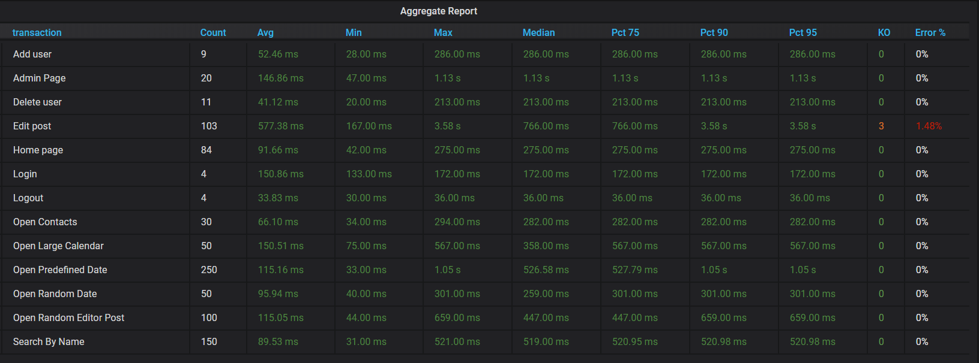

1. Total Response Time vs Threads

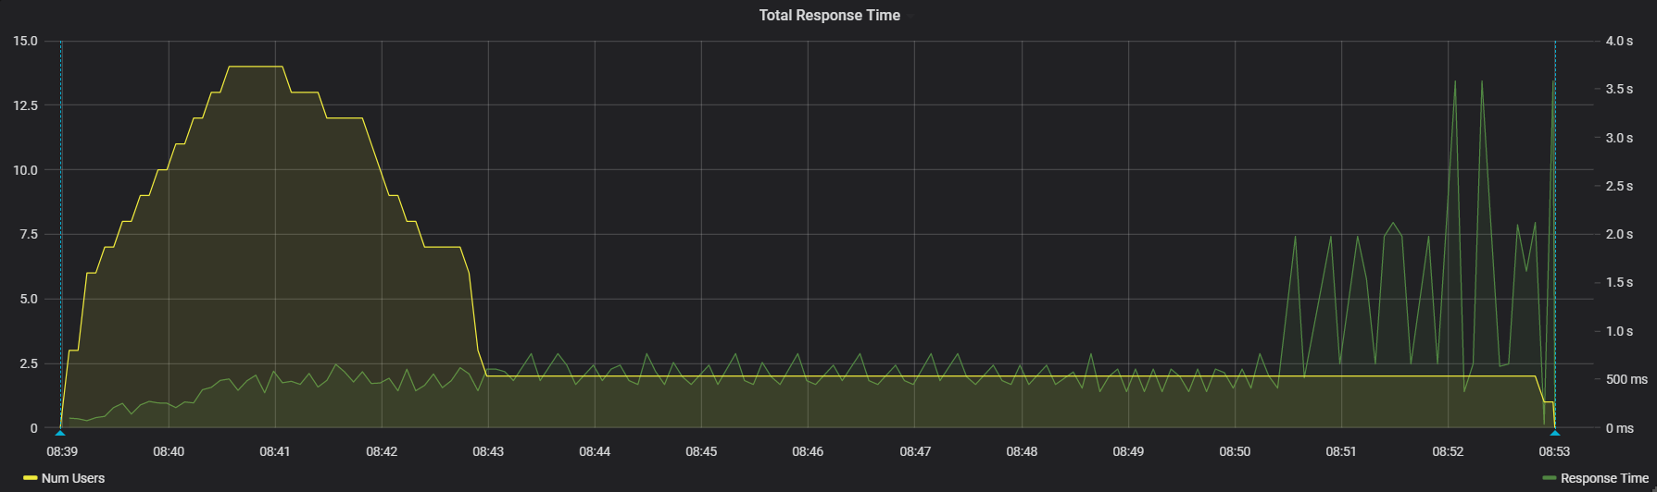

1. Transaction Response Times

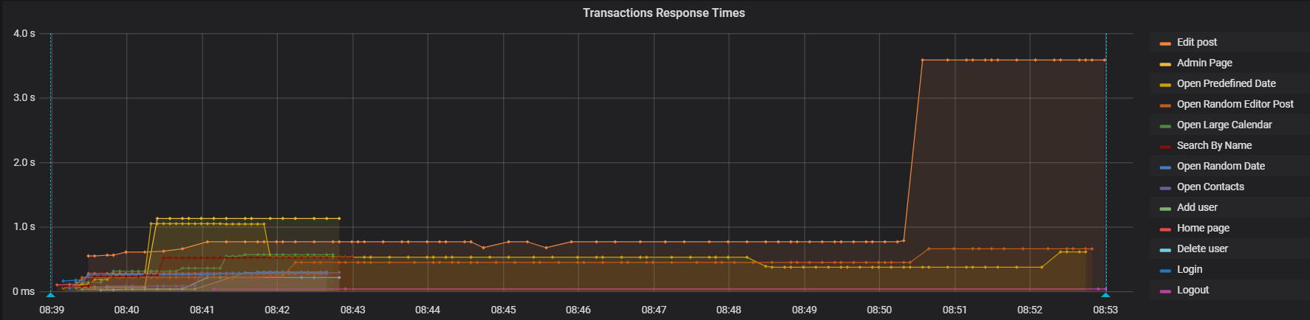

During each type of users was in system the average of response time was less than 0.5 sec.The average of response time was 500 ms when in system only Editor users acted. Last 3 min “Edit post” transaction response time was 3.58 s.

1. Total Throughput vs Threads

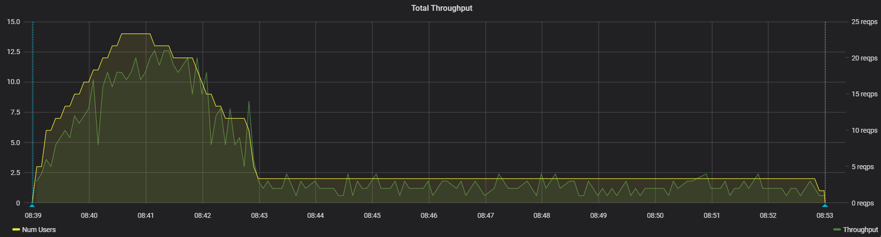

1. Transaction Throughput

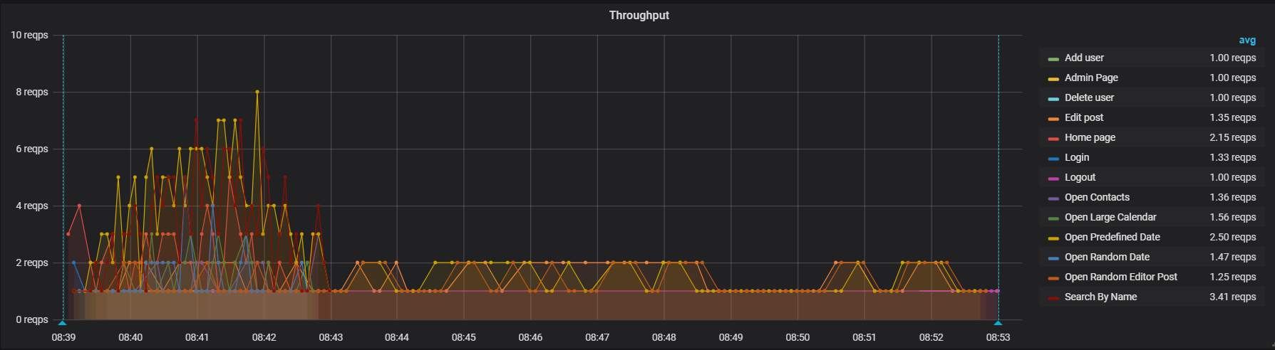

1. CPU

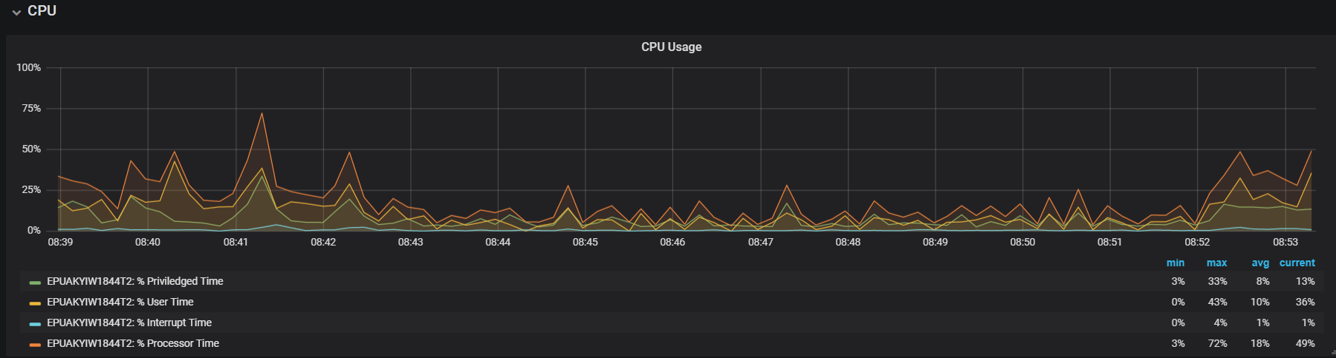Indicators of CPU were stable during the test.

1. Memory

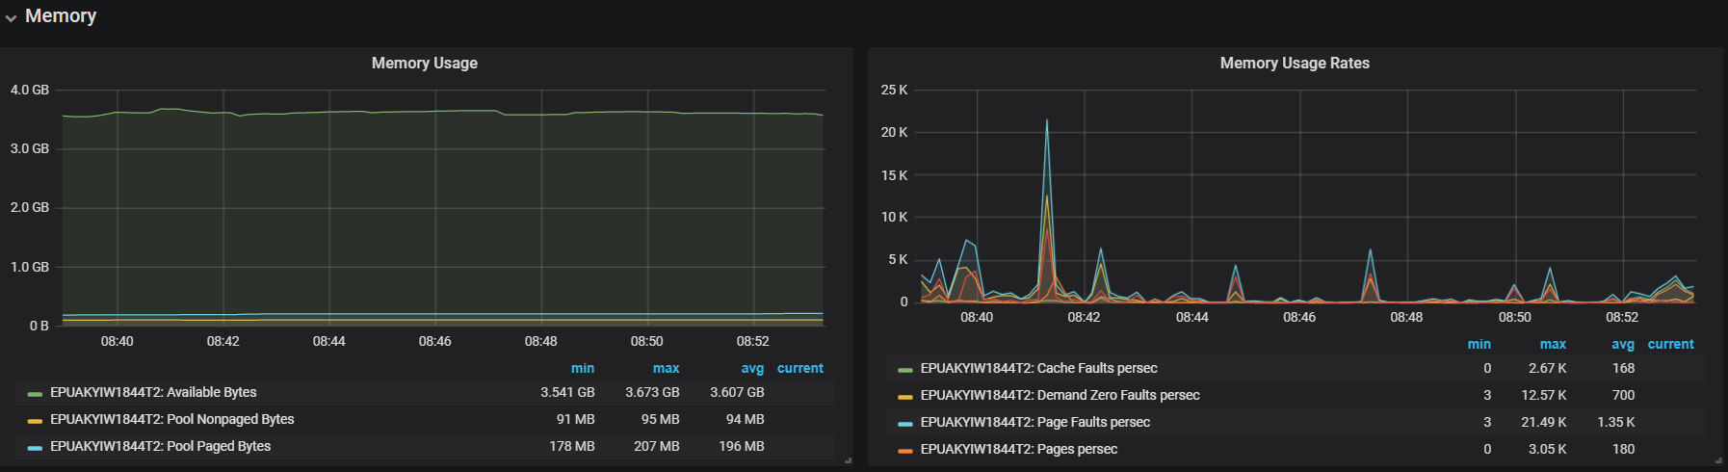

1. Disk C

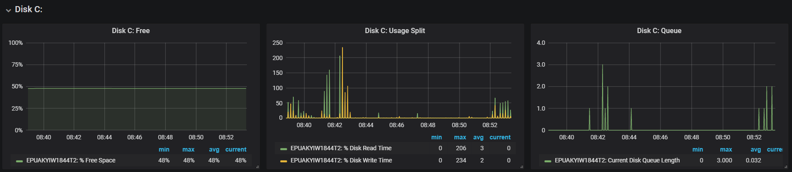

1. Errors

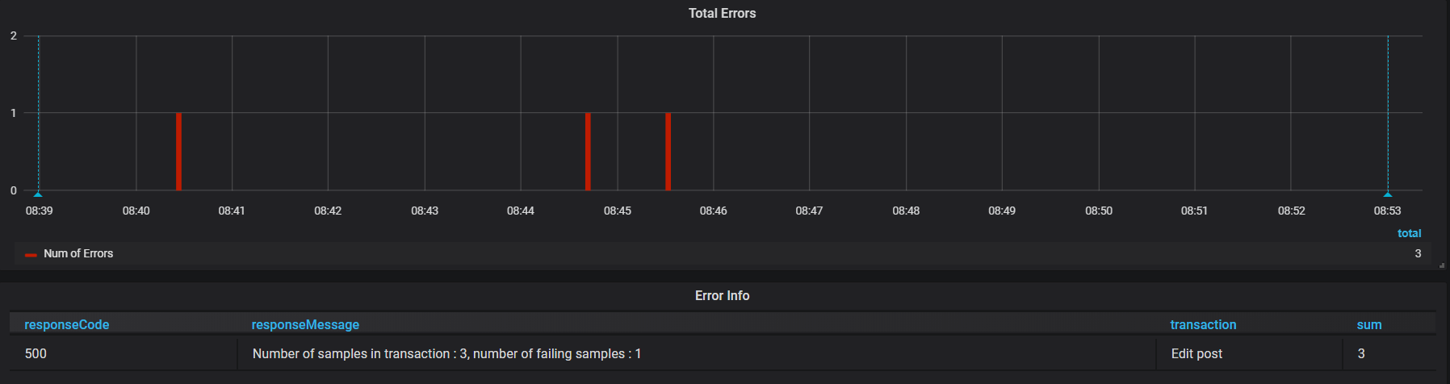There were 3 Internal Server Errors during the test. Need to investigate issue.