Step 1:

**Skills Needed for a Systems Analyst in this Project:**

Travis Fox and Riley Johnson

To be useful in this project, a system analyst that is brought on would need a broad set of soft skills and a relatively narrow set of domain-specific skills. The soft skills needed are mainly useful about facilitating collaboration between non-technical and technical positions. This is primarily useful in regard to, but not limited to, communicating with people in non-technical positions about technical concepts. Expertise in the technical skills and systems utilized by developers are especially important. Though people in non-technical roles may have experienced communicating with people in technical roles from the past about other technologies, they likely have not experienced communicating about the types of technologies used in this project.

It is extremely vital that any systems analysts brought on to have strong soft skills because it is the foundation for communicating the development techniques and technologies utilized and how those can impact non-technical parts of the project.

It is equally necessary for a systems analysts brought on has knowledge of the technical skills and technologies used in developing the project, it will have an impact on the non-technical roles. This includes having knowledge of the technologies used, but especially understanding how a microservice architecture is laid out, and the impact that architecture has on the rest of the project.

In summary, all systems analysts included in this project would need to have a set of soft skills that allow for proper communication of technical systems and technologies utilized in developing the project, as well as an understanding of how the technologies are used and impact non-technical parts of the project.

**Project Team:**

***Developer:***

Vinnan Muralikrishnan

A developer brought on to the project would need to have an understanding of microservices, containers, and container orchestration and a firm grasp on most of the technologies leveraged in the project. Microservices, containers, and container orchestration are core to the project's technical structure. The learning curve for those concepts is steep relative to the learning curve for the technologies used, therefore those skillsets are prioritized over knowing the technologies used.

***Systems Lead:***

Riley Johnson

A systems lead brought on to the project would need to have an understanding of the systems that would be hosting services, as well as the inner workings of the system itself. This person would work hand in hand with the developer to maintain and organize the system and its containers.

***Project Lead:***

Regina Van Driel

A project manager will create a work plan for the team, help the team to control and direct the project, and to staff the project team. The project manager is also in charge of making sure that the project if finished within the approved budget and that it is completed on time. Some other roles of the project manager include assigning resources and for being a primary contact when people outside the project have questions about the project.

***Quality Assurance:***

Travis Fox

A quality assurance person would be responsible for being the “worst possible end user” in order to try and break the system. This person would need to try their best to make the system on the user end not work to show what needs to be fixed by the developer in order to make it as perfect a system as possible. Not only would they be responsible to “break the system” they would also need technical skills in order to help the developer fix the broken aspect of the system.

Step 2:

**System Request**

**Project Name:**

*shortstop.news*

**Project Sponsor:**

Name:

Bennie Factor (C.E.O)

Dinah Mite (VP Marketing)

May B. Dunn (VP PR)

Department:

Development and Marketing

Organization:

XYZ News Corp

Phone:

605 The Best [(605) 843-2378]

E-mail:

Bennie.Factor@XYZ.news.co

**Business Need:**

To stay informed in the best, most user-friendly way possible by collecting and utilizing all news sources tailored to specific users interests, tags, and search options. Global, National, and Local news all at the click of a button.

**Functionality:**

This project needs to display news from a variety of news sources concisely to users in a functional manner and allow them to vote on that news. Users should be able to view news in subcategories and sublocations.

**Expected Value:**

Tangible:

Provide an outlet for helping users stay informed.

Intangible:

Improving society by making people more informed on a local, regional, national, and global level.

**Special Issues or Constraints:**

Collecting and displaying news sources in an efficient manner.

Step 3:

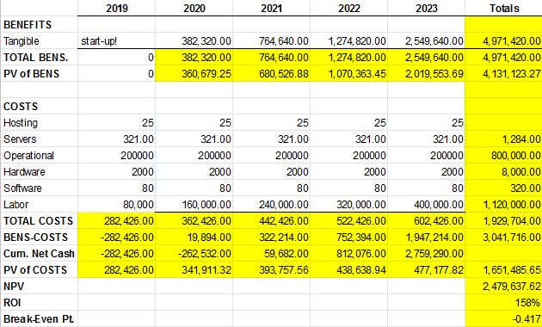

Step 4:

**Clarity of User Requirements**

The User Requirements are not totally opaque but are very close. The experience the User desires from our platform and the requirements that are required to deliver that experience are fairly rigid. However, User Requirements may shift over time. For that reason, utilizing an Agile development methodology will allow us to react to such changes much faster than would be possible than with other development methodologies.

**Familiarity with Technology**

In developing the platform, we aim to leverage newer technologies which will ultimately make the platform more robust, such as containers, container orchestration, and a single-page-application front-end architecture. The main issue with using these technologies is their age. These technologies are relatively new, inherently reducing the pool of analysts and programmers for which we can pick from. Additionally, because these are newer technologies, there is more technical risk in using them because they have not had as much time to become robust relative to competing legacy solutions. However, we have ultimately decided in using these technologies after in weighing these detriments the benefits these technologies offer. Fundamentally, because of the issues that we will be facing by leveraging these technologies, it is best to use an Agile development methodology because it will allow the inexperienced analysts and programmers to learn from mistakes faster and gain a better understanding of them.

**System Complexity**

The of the back-end of the platform aims to utilize microservices. Though great for scaling and platform resilience, microservices also introduce more complexity than a monolithic system would. Because each service in the back-end will be roughly independent of one another, programmers can comfortably prototype and build off of services to produce more robust services. Thus, allowing the same system to evolve from its initial point, effectively reducing complexity because there are no radical system changes. Because there will be a tendency for the system to change, using an Agile development methodology will allow for those changes to go more smoothly overall in comparison to the other methodologies.

**System Reliability**

Though staying informed is important to consumers, if the system fails to provide news it will not be dire. For that reason, programmers can comfortably take risks and make rapid changes while prototyping. Leveraging an Agile development methodology will allow those risks and rapid changes to happen not only initially, but later on, with little fear for long term consequences.

**Short Time Schedules**

Requesting functionality changes can potentially throw off a project’s delivery date significantly. Schedule changes will almost always occur, however, the degree to which the schedule is thrown off can be mitigated by the selected development methodology. For this reason, though the delivery schedule will most certainly change, using an Agile development methodology will allow for the delivery date for a given feature to be pushed back significantly less than other development methodologies.

**Schedule Visibility**

Schedule visibility has great importance when holding developers accountable for delivering on features. The schedule can change rapidly when using an Agile development methodology. Though the schedule may not stay consistent throughout the whole software development lifecycle, by staying attentive to the schedule throughout the process, it can remain up to date. Overall, though more difficult, a robust and accurate schedule can very well be maintained throughout the software development lifecycle with an Agile development methodology.

Step 5:

