DetailHOI: Human Skeletal Priors for Positional Query Refinement in Human–Object Interaction Detection
Chunyu Jiang^{a,*}, Chao Chenª, Michael Yu Wangª
ª Department of Mechanical and Aerospace Engineering, Monash University, Clayton, VIC 3800, Australia
* Corresponding author.
E-mail addresses: reginaldjcy@gmail.com (C. Jiang), [e-mail] (C. Chen), [e-mail] (M.Y. Wang).
ORCID: [ORCID] (C. Jiang); [ORCID] (C. Chen); [ORCID] (M.Y. Wang).
Declarations of interest: none.

Abstract
Human–Object Interaction (HOI) detection localises people and objects and names the action that binds them, producing triplets of the form ⟨human, action, object⟩. The strongest and most training-efficient detectors are two-stage transformers built on a frozen DETR, in which a learnable interaction query attends over image features under the guidance of a positional query derived from the detected boxes. That positional query treats a person exactly as it treats a chair: a centre and a size. We argue this discards the single most informative signal a two-stage detector already has access to for free—the geometry of the human body itself.
We present DetailHOI, which re-expresses the human half of the interaction query's positional embedding in the body's own coordinate frame. A frozen top-down pose estimator supplies K skeletal keypoints per detected person; each keypoint receives a sinusoidal positional embedding, the stack is modulated by a learned, content-conditioned estimate of the skeleton's spatial extent, and a single linear map compresses it into the Dₕ dimensions previously occupied by the human box centre. The object half is compressed into the remaining Dₒ = 512 − Dₕ. The change is confined to the construction of the positional query: the detector, the decoder, the loss and the inference cost of the pipeline are untouched, and it adds 1.77M parameters (0.6% of the model).
On V-COCO and HICO-DET, DetailHOI improves over a PViC baseline trained under identical settings, reaching 71.42 mAP on V-COCO and 33.74 mAP on HICO-DET against 71.28 and 33.35 respectively, with the gain concentrated on non-rare classes (34.77 → 35.39). Our ablations report a result we believe is more useful than the headline: denser skeletons are worse. Interpolating additional points along the skeleton graph (K = 23, K = 31) costs accuracy relative to the 17 native COCO joints, and how the fixed 512-dimensional positional budget is split between the human and the object matters as much as what is put into it.
Keywords: human–object interaction detection, transformers, positional encoding, human pose priors, DETR.
1. Introduction
Human–Object Interaction detection asks a model to go beyond naming the objects in a scene and to state how a person is engaging with them. The output is a set of triplets ⟨human, action, object⟩, each grounded by a pair of boxes. The task underpins a wide range of downstream systems—collaborative robotics, driver and pedestrian intent modelling, surveillance analytics, and augmented-reality assistants—because knowing that a person and a cup are co-present is far less useful than knowing that the person is about to drink from it.
Progress on the task has been rapid but uneven. Two obstacles dominate. The first is the extreme long tail of interaction categories: HICO-DET's 600 interaction classes follow a distribution in which a large fraction of classes are observed a handful of times. The second is spatial ambiguity. A single image may contain several people and a dozen objects; the number of candidate pairs grows quadratically, and most of them are not interacting at all. A detector that cannot decide which object a given person is oriented towards will spend its capacity discriminating actions for pairs that should never have been scored.
Transformer-based detectors address the second problem with attention. The DETR family [1] recast detection as set prediction over learnable queries, and HOI detectors inherited the idea, either end-to-end [5, 6, 7] or in a two-stage form that reuses a frozen detector and learns only an interaction head [2, 3]. The two-stage route has proven both more accurate and dramatically cheaper to train, and the reason is now well understood: a query that starts from an explicit spatial anchor converges far faster than one initialised at random, an observation first made for object detection [8, 9] and then carried into HOI detection by PViC [2]. In PViC, each interaction query is paired with a positional query built from the two boxes of the candidate pair: sinusoidal embeddings of the human box centre and the object box centre are concatenated and used as the query-side positional term in cross-attention, so the query is told where to look before it has learned what to look for.
The gap. That positional query is object-centric in a literal sense—it is built from box geometry, and a box is the same primitive whether it contains a person or a fire hydrant. Yet the human in an HOI triplet is not an interchangeable box. Its pose is a structured, low-dimensional signal that already encodes the reachable workspace of the hands, the direction the torso faces, and the stage of the action being performed. Two people whose boxes are identical can be reaching in opposite directions. A positional prior that collapses a person to a centre point throws that information away at exactly the moment it would be most useful: when the query is deciding which region of the feature map to attend to.
Our approach. We keep everything about the two-stage recipe and change one component. For every detected person we obtain K skeletal keypoints from a frozen, off-the-shelf top-down pose estimator, embed each keypoint with the same sinusoidal function the baseline applies to box centres, modulate the stack by a learned estimate of the skeleton's own spatial extent (the pose analogue of the box-size modulation used in DAB-DETR [9] and PViC), and project the result into the Dₕ dimensions that the human box centre used to occupy. The object retains the remaining Dₒ = 512 − Dₕ. The positional query therefore carries a posture on the human side and a location on the object side, within an unchanged budget and an unchanged decoder. Fig. 1 reproduces the pipeline as presented in the candidature review; Section 3 gives the notation-precise version of what is actually implemented and evaluated.
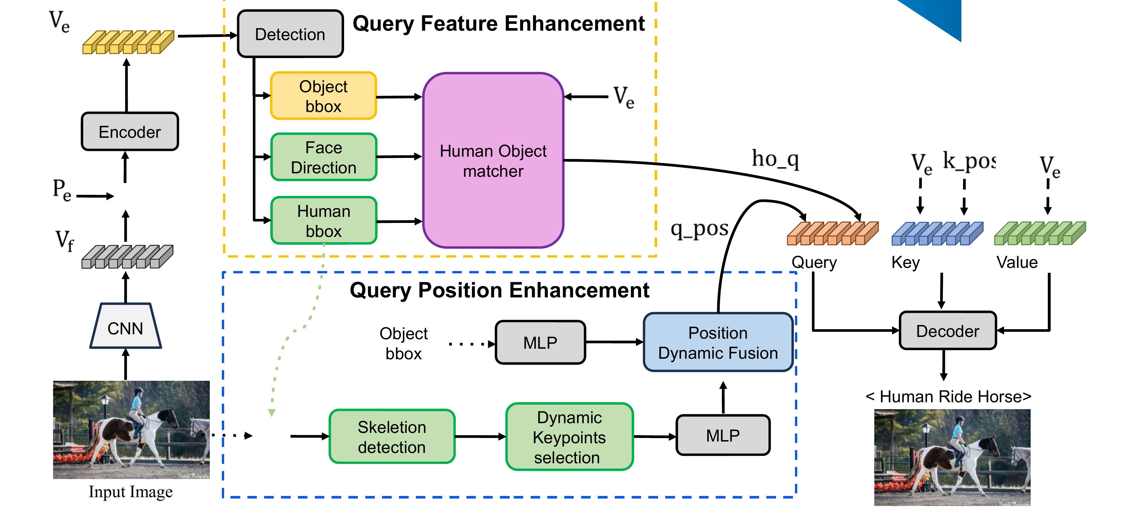
Fig. 1. Pipeline flow chart, reproduced from the candidature-review presentation. A frozen CNN/encoder produces global image features V_e (positionally encoded by P_e); detection yields object and human boxes. The Query Feature Enhancement branch (top) combines the object box, the human box and V_e through a Human–Object matcher into the content query ho_q. The Query Position Enhancement branch (bottom) runs skeleton detection and dynamic keypoint selection on the human box, fuses this with the object box through an MLP and a Position Dynamic Fusion module into the positional query q_pos. Query, key (V_e with k_pos) and value (V_e) feed a shared decoder that outputs the interaction triplet. Two things this figure shows that the evaluated system does not have: the Face Direction input to the matcher is the head-orientation extension discussed as future work in Section 6 and is not part of any result in this paper; and the input/output photographs are the presentation's own examples, credited “Mustafa Photography”—that credit is not yet cleared for publication and must be resolved (author permission or a licensed substitute) before submission.
Contributions.
1. Skeleton-conditioned positional query refinement. We replace the human half of the interaction query's positional embedding with a confidence-aware, extent-modulated embedding of the human skeleton. The modification is local, adds 1.77M parameters (≈0.6%), and leaves the detector, decoder, loss and inference schedule untouched (Section 3).
2. An asymmetric positional budget. Because the human and object halves of the positional query no longer carry the same kind of information, there is no reason for them to be the same size. We treat the split (Dₕ, Dₒ) as a design variable and show it matters: 384/128 beats 256/256 under an identical keypoint set (Section 5.2).
3. A negative result on skeletal density. We densify the skeleton by interpolating points along the COCO skeleton graph, reaching K = 23 and K = 31. Both are worse than the 17 native joints. Interpolated points are deterministic functions of the joints they lie between; they add parameters and dilute the projection without adding information (Section 5.2).
4. A human-clarity evaluation protocol. We isolate the subset of each benchmark in which instances are large and unambiguous enough for pose estimation to be reliable, and report a controlled comparison on it, which separates the merit of the prior from the noise of the pose estimator (Sections 4.2 and 5.2).
2. Related Work
2.1. Two-stage and one-stage HOI detection
Early HOI detectors were two-stage by necessity: an off-the-shelf object detector such as Faster R-CNN [11] produced instances, and a second network classified the interaction for each human–object pair [12, 13, 14]. The design is modular but pays a quadratic cost in the number of instances and suffers from a representational mismatch: features optimised for object identity are not necessarily the features that discriminate verbs.
One-stage transformer detectors removed the pairing bottleneck by predicting triplets directly from a set of learnable queries [5, 6, 7]. They are elegant and fast at inference, but they inherit DETR's slow convergence and typically require long schedules.
The current strongest configuration is a hybrid: keep a frozen pretrained DETR as the instance source and train only a lightweight interaction head. UPT [3] showed that unary and pairwise representations of the frozen detector's own decoder embeddings are sufficient to reach competitive accuracy at a fraction of the training cost. PViC [2] added a small cross-attention decoder that lets each pair query re-read the backbone feature map, with box-derived positional embeddings steering where it reads. Our work sits squarely in this line and modifies precisely the steering signal.
2.2. What a query is, and why its prior matters
In DETR [1], a query is a learnable slot that interacts with image features through cross-attention,
Attn(Q, K, V) = softmax( Q Kᵀ / √dₖ ) V (1)
and decodes one object hypothesis. The original formulation initialises those slots randomly, with no spatial meaning, and needs on the order of 500 epochs to converge. The remedy discovered independently by several groups is to give each query an explicit positional identity: Conditional DETR [8] decouples content from spatial attention; DAB-DETR [9] makes the query a literal 4-D anchor box and modulates its positional embedding by the anchor's width and height; Deformable DETR [10] restricts attention to a learned set of offsets around a reference point. All three share the same insight: a query that knows where it is converges much faster than one that does not.
PViC [2] transplants this into HOI detection. Each candidate pair (i, j) carries a positional query [PE(cᵢ); PE(cⱼ)] ∈ ℝ⁵¹² built from the two box centres, plus a box-level term used in the query self-attention. The paper shows that this anchoring lets the decoder “pin-point” body parts and auxiliary objects relevant to the verb. Our contribution is to observe that the human half of this pair of anchors is describing the wrong kind of object: the person, unlike the object, has an internal structure that a single point cannot represent.
2.3. Priors in HOI detection
Prior knowledge has been injected into HOI detectors from three directions. Spatial priors encode the relative geometry of the two boxes—centre offsets, aspect ratios, intersection-over-union—and are typically appended to the pair representation [4, 3]. Semantic priors import knowledge from vision–language models such as CLIP [19] to transfer to rare and unseen compositions [16, 17, 18]. Structural priors model the scene as a graph and reason over it [4]. More recent work has explored 3-D and attentional priors: HORP [28] adds 3-D location cues to resolve depth ambiguity in 2-D images together with a text-expressed “gaze area” cue, and generative approaches such as VRDiff [33] learn dense visual relation representations. What these share is a focus on the object or the scene; the human is treated as one more detected entity.
2.4. Human-centric and pose-aware modelling
A parallel line of work has long argued that pose is the natural prior for HOI. PMFNet [15] routes attention through pose-aware multi-level features; TIN [13] learns a transferable notion of “interactiveness” partly from human appearance; pose-attention networks such as PAIN [31] and geometric–visual graph models such as GeoVis-GNN [32] combine skeletal keypoints with object geometry through graph convolutions. Beyond the body, gaze is a strong leading indicator of intent, and recent work estimates it from head orientation in egocentric and hand–object settings [29, 30].
Almost all of this work injects pose into the content pathway—as extra features to be fused, or as nodes in a graph. Our proposal is different and, we think, simpler: pose enters the positional pathway, replacing the anchor that tells the query where to attend, and never touches the content representation at all. This keeps the interaction head's feature dimensionality, parameter count and runtime essentially unchanged, and it makes the ablations interpretable, because any change in accuracy is attributable to the geometry of attention rather than to added representational capacity.
3. Method
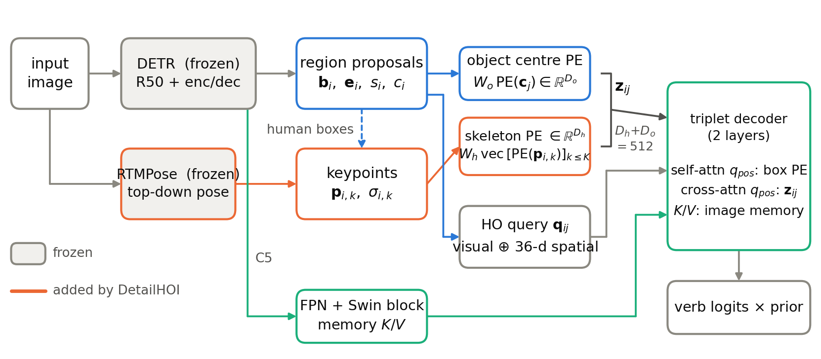
Fig. 2. DetailHOI. The detector and the pose estimator are frozen; only the interaction head is trained. The path drawn in orange is what we add. Instead of embedding the human box centre, we embed all K keypoints of the detected skeleton, modulate the stack by a content-conditioned estimate of the skeleton's spatial extent, and compress it to Dₕ dimensions. The object centre is compressed to Dₒ = 512 − Dₕ. Their concatenation z_ij is the positional query of the decoder's cross-attention—the same slot, the same width, and the same decoder as the baseline.
3.1. Preliminaries: positional queries in a two-stage detector
A frozen DETR produces, for image I, a set of instances {(bᵢ, cᵢ, sᵢ, eᵢ)}: a box, a category, a score and the 256-dimensional decoder embedding that generated it. Instances are ordered so that the Nₕ humans precede the objects. Every ordered pair (i, j) with a human in the first slot and i ≠ j becomes a candidate interaction.
Let cᵢ ∈ [0,1]² be the normalised centre of bᵢ and (wᵢ, hᵢ) its normalised size. Let PE : ℝ² → ℝ²⁵⁶ be the sinusoidal embedding that maps a 2-D point to a 256-vector by stacking the 128-dimensional codes of its two coordinates. The baseline builds a centre embedding uᵢ, a size embedding vᵢ and their concatenation gᵢ,
uᵢ = PE(cᵢ), vᵢ = PE(wᵢ, hᵢ), gᵢ = [ uᵢ ; vᵢ ] ∈ ℝ⁵¹² (2)
and modulates the centre term by a content-conditioned reference size, following DAB-DETR. Writing uᵢʸ and uᵢˣ for the first and second halves of uᵢ,
(rᵢʷ, rᵢʰ) = σ( MLP_anc(eᵢ) ), uᵢʸ ← (rᵢʰ / hᵢ) uᵢʸ, uᵢˣ ← (rᵢʷ / wᵢ) uᵢˣ (3)
The interaction query itself is a content vector q_ij ∈ ℝ³⁸⁴ produced by fusing the pair's visual embeddings with a 36-dimensional hand-crafted spatial encoding of the two boxes. The decoder then runs L = 2 layers of self-attention over queries followed by cross-attention into a Swin-processed backbone feature map, with two positional terms:
z_ij^box = [ gᵢ ; gⱼ ] ∈ ℝ¹⁰²⁴, z_ij = [ uᵢ ; uⱼ ] ∈ ℝ⁵¹² (4)
the former added to queries and keys in self-attention, the latter concatenated head-wise to the query in cross-attention. Equation (4) is the object of this paper: z_ij is the signal that decides where each pair query reads the image, and its first half describes a person by a single point.
Why the positional term is the right place to intervene. Cross-attention with additive positional encodings is a sum of four terms, a decomposition made explicit by Conditional DETR [8]. Writing k_l for the content key at memory location l and k_l^pos for its positional encoding, the pre-softmax score for pair query (i, j) expands as:
score_ij,l ∝ q_ij·k_l^T + q_ij·k_l^posT + z_ij·k_l^T + z_ij·k_l^posT (5)
The content query q_ij is untouched by this paper, and so is the content–position term, which depends on q_ij alone. Replacing the human half of z_ij therefore acts only on the position–content and position–position terms: it changes which locations a pair query prefers a priori, not what the query recognises once it attends there. This is the formal statement of the claim we return to in Section 6—the mechanism is geometric, not semantic, by construction.
3.2. Skeleton-conditioned positional embedding
Keypoints. For each detected human box we run a frozen top-down pose estimator (RTMPose-L [20], a SimCC-style model [21] trained on COCO) and obtain K keypoints p_ik ∈ ℝ² with confidences σ_ik ∈ [0,1]. Object instances receive an all-zero keypoint tensor and are never used on the human side of a pair. Detection and pose estimation are both performed under no_grad: no gradient flows into either frozen module, so the pose estimator is a fixed feature extractor, not a jointly-trained branch.
Per-keypoint embedding. Each keypoint is normalised by the image size and embedded with the same sinusoidal function the baseline applies to box centres, PE(p_ik) ∈ ℝ²⁵⁶ for k = 1 … K. Reusing PE is deliberate: it keeps the human and object halves of the positional query in a common frequency basis, so the decoder's positional projection does not have to reconcile two unrelated encodings.
Extent modulation. Equation (3) rescales the box centre embedding by the box's own size, which makes the embedding's effective frequency adapt to how large the instance is. The skeleton needs the same treatment, but its natural scale is not the box—a seated person and a standing person with the same box height have very different joint spreads. We therefore compute the extent of the confident joints,
(ŵᵢ, ĥᵢ) = max_{k∈Vᵢ} p_ik − min_{k∈Vᵢ} p_ik , Vᵢ = { k : σ_ik > τ } (6)
with τ = 0.3, falling back to (1,1) when no joint is confident, and modulate against a learned reference derived from the instance's own content embedding:
(sᵢʷ, sᵢʰ) = σ( MLP_kpt(eᵢ) ), m_ik^y ← (sᵢʰ / ĥᵢ) m_ik^y, m_ik^x ← (sᵢʷ / ŵᵢ) m_ik^x (7)
where m_ik = PE(p_ik) and the superscripts again denote its two halves. This is the mechanism by which the confidence scores enter the model. They are not used as a soft mask over keypoints—they define which joints are allowed to set the skeleton's scale, so that a spurious low-confidence ankle in the corner of the crop cannot stretch the whole embedding.
Compression. The modulated stack is flattened and projected by a single linear map W_h ∈ ℝ^(Dₕ × 256K), the object side is compressed by W_o ∈ ℝ^(Dₒ × 256) applied to the modulated box-centre embedding, and the positional query of the cross-attention becomes
hᵢ = W_h vec[ m_i1 ; … ; m_iK ], oⱼ = W_o uⱼ, z_ij = [ hᵢ ; oⱼ ] ∈ ℝ⁵¹², Dₕ + Dₒ = 512 (8)
Comparing (8) with (4): the width is identical, the consumer is identical, and the self-attention term z_ij^box is left exactly as the baseline defines it. Only the semantics of the first Dₕ dimensions have changed—from “the person is here” to “the person is shaped like this, here.”
3.3. The positional budget is a design variable
The baseline splits its 512 positional dimensions evenly by construction: 256 for the human centre, 256 for the object centre, because both are PE outputs. Once the human half carries a K-joint skeleton and the object half carries a single point, symmetry is no longer justified—the two halves have very different intrinsic dimensionality. We therefore treat (Dₕ, Dₒ) as a hyper-parameter subject to Dₕ + Dₒ = 512, and evaluate 384/128 against 256/256 in Section 5.2—shorthand ratio3 and ratio1 below, after the multiple of 128 each gives the human half. This is a free variable in the sense that changing it does not change the decoder, the query width, or the number of attention heads; it only re-partitions a vector that already exists. At the sparse end of K the split need not even be a multiple of 128: Table 1's K = 6 row uses a variable split (439/73) chosen by the same criterion, giving more of the budget than either fixed ratio would to a six-joint skeleton.
3.4. Skeletal density: interpolating the skeleton graph
If 17 joints help, do more points help further? The COCO skeleton defines a graph over the 17 joints—four torso edges, four arm edges, four leg edges and two neck edges, E = 14 in total. We densify by placing m evenly-spaced points along each edge,
p_i,(u,v)^(t) = (1 − t) p_iu + t p_iv , t = 1/(m+1), … , m/(m+1) (9)
assigning each interpolated point the confidence min(σ_iu, σ_iv) so that a limb with one unreliable endpoint does not inject confident-looking phantom points. With m = 1 this yields K = 17 + 14 = 31. We also evaluate a lighter variant that interpolates only the six most action-relevant edges (upper arms, thighs, and the shoulder and hip lines), giving K = 23, and two coarse variants at the opposite end: K = 6 (head centroid, both wrists, both ankles, torso centre) and K = 3 (head centroid and the two wrists). Section 5.2 reports what happens.
3.5. Cost
Table 1 lists the parameters introduced by Equation (8). The dominant term is W_h, whose size grows linearly in K. At our default setting (K = 17, Dₕ = 384) the head grows by 1.77M parameters, about 0.6% of the full pipeline, and no term scales with image resolution or with the number of candidate pairs. The frozen pose estimator adds one forward pass per image over the detected human crops; because it is frozen and batched per image, it does not enter the backward pass at all.
Configuration | W_h | W_o + MLP_kpt | Total added
K = 3, 256/256 | 0.20 M | 0.13 M | 0.33 M
K = 6, 439/73 | 0.67 M | 0.09 M | 0.76 M
K = 17, 256/256 | 1.11 M | 0.13 M | 1.25 M
K = 17, 384/128 (default) | 1.67 M | 0.10 M | 1.77 M
K = 23, 256/256 | 1.51 M | 0.13 M | 1.64 M
K = 31, 256/256 | 2.03 M | 0.13 M | 2.16 M
Table 1. Parameters added to the interaction head. W_h dominates and grows linearly in the number of keypoints K; nothing else in the model changes.
4. Experimental Setup
4.1. Datasets
V-COCO [23] is built on MS-COCO 2014 [22] and annotates 24 action classes over 80 object categories. After discarding images without an annotated human–object pair we use 4,969 trainval images and 4,532 test images. HICO-DET [24] is the larger and harder benchmark: 38,118 training and 9,658 test images, 117 verbs, 80 objects and 600 interaction classes, with a standard partition into 138 rare and 462 non-rare classes.
4.2. The human-clarity subset
A pose-based prior can only be as good as the pose. On both benchmarks a substantial fraction of images contain people who are heavily occluded, motion blurred, or a few dozen pixels tall—cases in which a top-down pose estimator returns joints that are confidently wrong. Averaging over such images conflates two questions: whether the skeletal prior helps, and how often the skeleton is recoverable at all.
To separate them we construct a human-clarity subset of each benchmark. An off-the-shelf YOLOv8-n detector [27] is run over every image and an image is retained only if it yields at least one detection at confidence ≥ 0.8. This is a deliberately cheap, model-agnostic proxy for “the instances in this image are large and unambiguous”; it is not a person-specific test, and we return to that limitation in Section 6.1. The resulting subsets are listed in Table 2. Roughly one image in eight is removed from V-COCO and one in five from HICO-DET.
Dataset | Split | All images | Clear | Kept
V-COCO | trainval | 4,969 | 4,404 | 88.6%
 | test | 4,532 | 3,971 | 87.6%
HICO-DET | train2015 | 38,118 | 30,083 | 78.9%
 | test2015 | 9,658 | 7,658 | 79.3%
Table 2. The human-clarity subset. “All images” counts images with at least one annotated interaction; “Clear” counts those retained by the confidence filter of Section 4.2.
4.3. Metrics
We report mean average precision over interaction classes, with a detection counted as correct when both boxes reach IoU ≥ 0.5 with a ground-truth pair and the interaction label matches. AP is computed with 11-point interpolation. On HICO-DET we report the standard full / rare / non-rare breakdown over the 600 interaction classes.
A note on the V-COCO protocol. Our V-COCO numbers are produced by the in-repository evaluator over the 24 action classes, not by the official V-COCO AP_role script. The two protocols differ in how they handle the no-object actions and in their AP interpolation, and the in-repository numbers run substantially higher. They are therefore valid for comparing configurations trained and evaluated identically, which is the purpose they serve here, and are not comparable to published AP_role figures. All V-COCO comparisons in this paper are internal.
4.4. Implementation details
The instance detector is DETR-R50 [1] fine-tuned on the respective dataset and frozen throughout. Region proposals are kept above a score of 0.05, with between 3 and 15 instances per image. Pose comes from frozen RTMPose-L at 256 × 192, run top-down on the detected human boxes, so keypoints are associated with their proposals by construction. The interaction head uses a query width of 384, one Swin encoder block over the C5 feature map, and a two-layer triplet decoder with 8 heads and dropout 0.1. Training uses AdamW [26] with learning rate 1e−4, weight decay 1e−4, batch size 92 over two RTX A6000 GPUs (DDP, world size 2), for 30 epochs with the learning rate dropped by 0.2× at epoch 20. The classification loss is a binary focal loss [25] with α = 0.5, γ = 0.1, combined multiplicatively with the detector's prior scores raised to λ = 2.8. The random seed is fixed at 140. One V-COCO epoch takes approximately 19 minutes in this configuration.
5. Results
5.1. Main comparison
Table 3 compares DetailHOI at its default setting (K = 17, Dₕ/Dₒ = 384/128) against the PViC baseline trained under identical settings. On V-COCO the skeletal prior improves the internal mAP from 71.28 to 71.42. On HICO-DET it improves full mAP from 33.35 to 33.74, an increase of 0.39 points.
The breakdown is more informative than the aggregate. The gain is carried entirely by the non-rare classes, 34.77 → 35.39 (+0.62), while rare classes decline slightly, 28.59 → 28.23 (−0.36). This is what one should expect from a geometric prior rather than a semantic one. A skeleton tells the decoder where to look; it says nothing about what a rarely seen verb looks like. Classes with enough examples to learn an attention-to-verb mapping benefit; classes seen a handful of times do not have enough signal to exploit a sharper attention pattern, and pay the small cost of a positional query whose object half has been compressed from 256 to 128 dimensions. Methods that improve the rare split do so by importing external semantics [16, 17, 18]; that is an orthogonal and complementary axis to ours.
Configuration | V-COCO mAP † | HICO-DET Full | Rare | Non-rare
PViC baseline | 71.28 | 33.35 | 28.59 | 34.77
DetailHOI (K = 17) | 71.42 | 33.74 | 28.23 | 35.39
+ human-clarity training set | 71.33 | 33.51 | 28.79 | 34.92
Table 3. Main results at epoch 30, identical schedules throughout. † V-COCO numbers use the in-repository diagnostic evaluator and are internally comparable only (Section 4.3). The skeletal prior helps the aggregate and the non-rare split; it does not help rare classes.
5.2. Ablations on the human-clarity subset
The main comparison mixes the effect of the prior with the frequency of images in which pose is unreliable. To isolate the prior we retrain every configuration on the human-clarity subset of V-COCO and evaluate on its test split, so that every model sees only images in which the skeleton is recoverable. Figure 3 shows the training curves and Table 4 the final numbers.
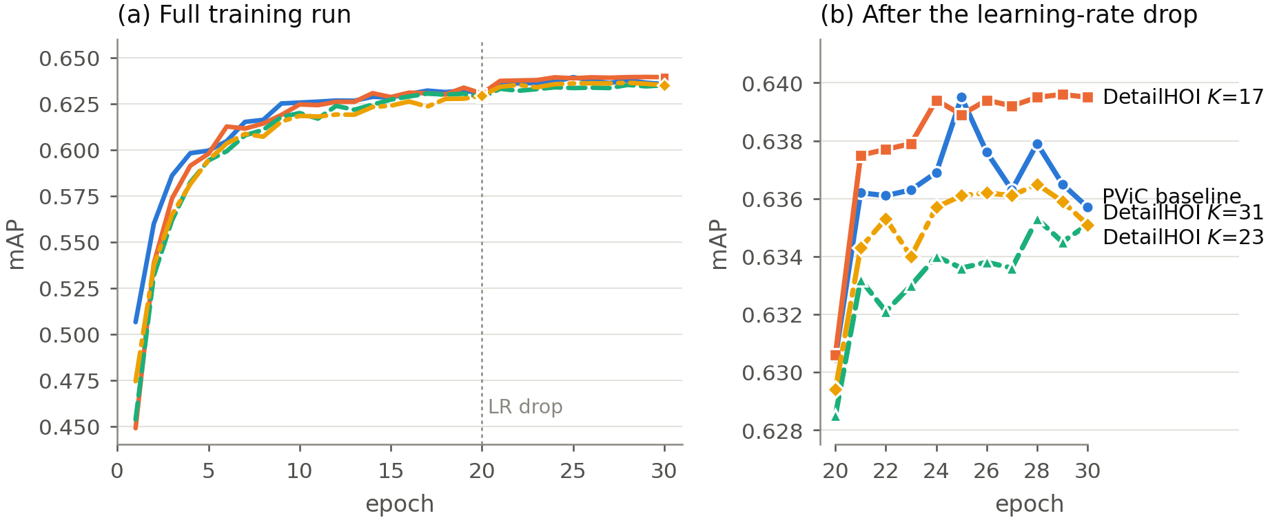
Fig. 3. Convergence on the human-clarity subset of V-COCO. All configurations share a schedule; the learning-rate drop at epoch 20 is marked. Panel (b) magnifies the post-drop region where the configurations separate. Denser skeletons (K = 23, K = 31) sit consistently below both the baseline and K = 17 for the whole of the second phase—the ordering is stable, not a single-epoch fluctuation.
Configuration | Dₕ / Dₒ | Best mAP | Epoch 30
PViC baseline (no keypoints) | 256/256 | 63.95 | 63.57
K = 17 COCO joints | 384/128 | 63.96 | 63.95
K = 23 interpolated | 256/256 | 63.63 | 63.44
K = 31 interpolated | 256/256 | 63.65 | 63.51
Table 4. Keypoint granularity and positional budget, V-COCO human-clarity subset. All rows are trained and evaluated on the same subset under the same schedule. The two interpolated skeletons are clearly worse; the 17 native joints with an asymmetric budget are best, and are markedly more stable across the final ten epochs.
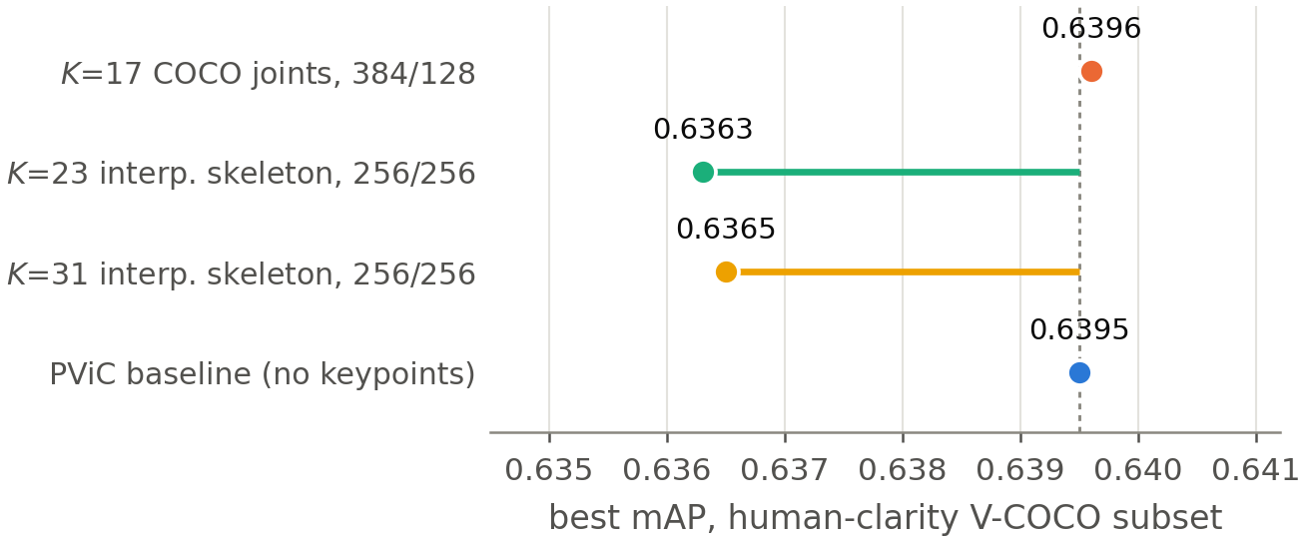
Fig. 4. Best subset mAP per configuration, relative to the baseline (dashed). Adding interpolated points along the skeleton graph costs roughly 0.3 mAP.
Denser skeletons are worse. K = 23 and K = 31 both land around 63.6, roughly 0.3 points below the 17-joint model and below the baseline. We think the reason is structural rather than a tuning artefact. An interpolated point is an exact convex combination of two joints that are already in the stack, so it carries no information the projection did not already have. What it does carry is cost: W_h grows from 1.67M to 2.03M parameters, the sinusoidal stack is diluted by redundant rows, and the extent statistic (ŵ, ĥ) is computed over a set whose interior is now densely populated, making it less sensitive to the extremities that actually define reach. The lesson generalises beyond this architecture: when a prior is compressed by a single linear map, adding deterministic functions of existing inputs is not free.
The budget split matters. The K = 17 model runs at 384/128 and the interpolated models at 256/256; the 17-joint configuration is the only one that gives the human side more than half the positional budget, and it is the only one that improves on the baseline. This is consistent with the intuition that a K-joint skeleton has genuinely more spatial degrees of freedom than a single point and needs more room to survive compression, while the object's centre needs very little—128 dimensions of a 256-dimensional sinusoidal code are apparently enough to localise a box centre. We regard the split as a first-class hyper-parameter of this design rather than an implementation detail.
Stability, not just peak. The final-epoch column of Table 4 is worth reading alongside the best column. The baseline peaks at 63.95 but ends at 63.57, oscillating by nearly 0.4 points over the last ten epochs (Figure 3b). DetailHOI peaks at 63.96 and ends at 63.95. On the peak metric the two are tied; on the end-of-schedule metric—the one that matters if you are not selecting checkpoints on the test set—the skeletal prior is worth 0.38 points and removes most of the late-training variance. A positional query anchored to a stable body geometry appears to give the decoder a less noisy target than one anchored to a box centre that shifts with every detector jitter.
Filtering as a training strategy. Training on the human-clarity subset and evaluating on the full benchmark (last row of Table 3) lands between the baseline and full DetailHOI on the aggregate, but is the best of the three on rare classes (28.79). Removing noisy images helps precisely where data is scarcest and a few corrupted examples do the most damage; it hurts elsewhere, simply because 11%–21% of the training data is gone. Filtering is therefore better understood as a diagnostic instrument—which is how we use it in this section—than as a way to gain accuracy.
5.3. Qualitative: what the positional term attends to
Equation (5) splits the cross-attention score of a trained DetailHOI model into four terms; Figure 5 renders each of them separately for the same query on the same image, alongside the full score the decoder actually uses. The content–content term (1) is diffuse—it is the same regardless of where any instance sits, so it lights up anything that looks like the query's target class. The position–position term (2), built purely from z_ij, is by contrast sharply concentrated on the annotated human–object pair even with the content pathway switched off, which is the qualitative counterpart of the claim in Section 6: the skeletal prior alone is informative about where to look. The two cross terms (3, 4) are weaker than either diagonal term, and the full score (5) inherits its spatial concentration mainly from term (2). This single-example view should not be read as a quantitative claim, but it is consistent with the ablation result above—on this query, the positional term is not a minor conditioning signal but appears to be the dominant source of spatial selectivity in the head.
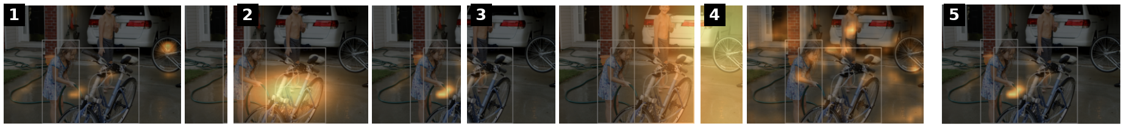
Fig. 5. Decomposing the attention score. Panels correspond to the four terms of Eq. (5) for one human–object query—(1) content–content q_ij·k_l^T, (2) position–position z_ij·k_l^posT, (3) content–position q_ij·k_l^posT, (4) position–content z_ij·k_l^T—and (5) the full, summed score the decoder attends with. Boxes mark the annotated human and object.
5.4. Context
Table 5 places our numbers among published HICO-DET results. Our baseline reproduces PViC at 33.35 rather than the published 34.69; the gap is a training-budget difference, not a claim about the method—we train for 30 epochs at batch 92 with a frozen detector and no schedule search, whereas the published figure uses the authors' full recipe. The comparison that carries weight in this paper is the internal one of Tables 3 and 4, where every row shares a schedule, a seed and an evaluator.
Method | Backbone | Full | Rare | Non-rare
QPIC [5] | R50 | 29.07 | 21.85 | 31.23
UPT [3] | R50 | 31.66 | 25.94 | 33.36
PViC [2] | R50 | 34.69 | 32.14 | 35.45
PViC (our schedule) | R50 | 33.35 | 28.59 | 34.77
DetailHOI (ours) | R50 | 33.74 | 28.23 | 35.39
Table 5. HICO-DET in context. Rows above the rule are quoted from the respective papers under their own training recipes; rows below share ours.
6. Discussion
What the result does and does not say. The honest summary is that a skeletal positional prior buys a small, consistent improvement—about 0.4 mAP on HICO-DET, concentrated on non-rare classes, plus a noticeable gain in end-of-training stability—for 0.6% more parameters and no change to the decoder or the inference schedule. It is not a large gain, and on the human-clarity subset the peak accuracy is a tie. What makes the result interesting is where it comes from: not from adding features to the content pathway, which is what pose-aware HOI models have traditionally done, but from changing the geometry of attention while holding representational capacity essentially fixed. That the change registers at all is evidence that the positional query, not just the content query, is a productive place to inject human structure.
Why interpolation fails, and what would not. The density ablation should not be read as “more keypoints cannot help.” It shows that deterministic elaborations of an existing keypoint set cannot help, because a linear projection can already form any convex combination of its inputs. Points that would carry new information—dense body-part segmentations, contact points predicted by a separate model, or a 3-D lift of the skeleton—are a different proposition, because they are not functions of the 17 joints.
Toward head-orientation priors. The natural extension of this work, and the one we originally set out to build, is to add head orientation and gaze to the human half of the positional query. The architecture accommodates it without modification: a head-pose feature would be projected and concatenated into the same Dₕ block that currently holds the skeleton, subject to the same Dₕ + Dₒ = 512 budget, and would give the decoder an attentional direction rather than only a body configuration—plausibly reaching interactions that have not yet begun, which is exactly where a purely kinematic prior has nothing to say. Related evidence from the gaze literature is encouraging [28, 29, 30]. We stress that this component is not part of the system evaluated here, and that no result in this paper depends on it.
6.1. Limitations
Three caveats bound the claims above.
The clarity filter is a proxy. As implemented, the filter keeps an image if any object is detected with confidence ≥ 0.8, not specifically a person. It correlates with image quality and instance scale, which is what we needed, but a person-specific criterion—a minimum human box area, or a minimum mean keypoint confidence—would isolate the intended variable more sharply. We expect the qualitative conclusions to hold, since the failure modes it removes (blur, extreme scale) are not person-specific, but the exact subset would differ.
One seed, and one confounded baseline. All ablations use a single seed (140). The margins in Table 4 are a few tenths of a point, which is the same order as the epoch-to-epoch oscillation visible in Figure 3b; the ordering is stable across the final ten epochs, which is our evidence that it is real, but multi-seed variance is not measured. Separately, the subset baseline was trained at batch size 64 against 92 for the DetailHOI rows, a confound we did not control.
V-COCO numbers are internal. As noted in Section 4.3, they come from the diagnostic evaluator, not the official AP_role protocol, and should not be compared against published V-COCO figures.
7. Conclusion
We asked what happens if the positional prior of an interaction query stops treating a person as a box. DetailHOI replaces the human half of that prior—and only that half—with a confidence-aware, extent-modulated embedding of the human skeleton, compressed into the same dimensions the box centre used to occupy. The change costs 1.77M parameters, touches neither the frozen detector nor the decoder, and improves HICO-DET full mAP from 33.35 to 33.74, with the gain concentrated on non-rare classes and a marked reduction in late-training instability.
The ablations are the more transferable part of the result. Densifying the skeleton by interpolating along its graph makes things worse, because a single linear projection can already form those combinations; and how the fixed positional budget is split between the human and the object matters as much as what is put into the human half. Both findings apply to any design that compresses a structured prior into a positional query. The clearest next step is to add a signal that is genuinely new rather than derived—head orientation being the obvious candidate—within the same budget, and to test whether it reaches the interactions a kinematic prior cannot see: the ones that have not started yet.
CRediT authorship contribution statement
Chunyu Jiang: Conceptualization, Methodology, Software, Validation, Formal analysis, Investigation, Data curation, Visualization, Writing – original draft.
Declaration of competing interest
The authors declare that they have no known competing financial interests or personal relationships that could have appeared to influence the work reported in this paper.
Declaration of generative AI and AI-assisted technologies in the writing process
During the preparation of this work the authors used [tool name] in order to [reason]. After using this tool, the authors reviewed and edited the content as needed and take full responsibility for the content of the published article.
Funding
This research did not receive any specific grant from funding agencies in the public, commercial, or not-for-profit sectors.
Data availability
The V-COCO and HICO-DET datasets used in this study are publicly available and remain subject to their original licences. The code, trained checkpoints and evaluation logs supporting the findings of this study will be made available at [repository URL] upon acceptance.
Acknowledgements
[Acknowledgements, if any.]
References
[1] N. Carion, F. Massa, G. Synnaeve, N. Usunier, A. Kirillov, and S. Zagoruyko. End-to-end object detection with transformers. In ECCV, 2020.
[2] F. Z. Zhang, Y. Yuan, D. Campbell, Z. Zhong, and S. Gould. Exploring predicate visual context in detecting human–object interactions. In ICCV, 2023.
[3] F. Z. Zhang, D. Campbell, and S. Gould. Efficient two-stage detection of human–object interactions with a novel unary–pairwise transformer. In CVPR, 2022.
[4] F. Z. Zhang, D. Campbell, and S. Gould. Spatially conditioned graphs for detecting human–object interactions. In ICCV, 2021.
[5] M. Tamura, H. Ohashi, and T. Yoshinaga. QPIC: Query-based pairwise human–object interaction detection with image-wide contextual information. In CVPR, 2021.
[6] B. Kim, J. Lee, J. Kang, E.-S. Kim, and H. J. Kim. HOTR: End-to-end human–object interaction detection with transformers. In CVPR, 2021.
[7] C. Zou, B. Wang, Y. Hu, J. Liu, Q. Wu, Y. Zhao, B. Li, C. Zhang, C. Zhang, Y. Wei, and J. Sun. End-to-end human object interaction detection with HOI transformer. In CVPR, 2021.
[8] D. Meng, X. Chen, Z. Fan, G. Zeng, H. Li, Y. Yuan, L. Sun, and J. Wang. Conditional DETR for fast training convergence. In ICCV, 2021.
[9] S. Liu, F. Li, H. Zhang, X. Yang, X. Qi, H. Su, J. Zhu, and L. Zhang. DAB-DETR: Dynamic anchor boxes are better queries for DETR. In ICLR, 2022.
[10] X. Zhu, W. Su, L. Lu, B. Li, X. Wang, and J. Dai. Deformable DETR: Deformable transformers for end-to-end object detection. In ICLR, 2021.
[11] S. Ren, K. He, R. Girshick, and J. Sun. Faster R-CNN: Towards real-time object detection with region proposal networks. In NeurIPS, 2015.
[12] G. Gkioxari, R. Girshick, P. Dollár, and K. He. Detecting and recognizing human–object interactions. In CVPR, 2018.
[13] Y.-L. Li, S. Zhou, X. Huang, L. Xu, Z. Ma, H.-S. Fang, Y. Wang, and C. Lu. Transferable interactiveness knowledge for human–object interaction detection. In CVPR, 2019.
[14] T. Gupta, A. Schwing, and D. Hoiem. No-frills human–object interaction detection: Factorization, layout encodings, and training techniques. In ICCV, 2019.
[15] B. Wan, D. Zhou, Y. Liu, R. Li, and X. He. Pose-aware multi-level feature network for human object interaction detection. In ICCV, 2019.
[16] Y. Liao, A. Zhang, M. Lu, Y. Wang, X. Li, and S. Liu. GEN-VLKT: Simplify association and enhance interaction understanding for HOI detection. In CVPR, 2022.
[17] S. Ning, L. Qiu, Y. Liu, and X. He. HOICLIP: Efficient knowledge transfer for HOI detection with vision–language models. In CVPR, 2023.
[18] Y. Cao, Q. Tang, X. Su, C. Song, S. You, X. Lu, and C. Xu. Detecting any human–object interaction relationship: Universal HOI detector with spatial prompt learning on foundation models. In NeurIPS, 2023.
[19] A. Radford, J. W. Kim, C. Hallacy, A. Ramesh, G. Goh, S. Agarwal, G. Sastry, A. Askell, P. Mishkin, J. Clark, G. Krueger, and I. Sutskever. Learning transferable visual models from natural language supervision. In ICML, 2021.
[20] T. Jiang, P. Lu, L. Zhang, N. Ma, R. Han, C. Lyu, Y. Li, and K. Chen. RTMPose: Real-time multi-person pose estimation based on MMPose. arXiv:2303.07399, 2023.
[21] Y. Li, S. Yang, P. Liu, S. Zhang, Y. Wang, Z. Wang, W. Yang, and S.-T. Xia. SimCC: A simple coordinate classification perspective for human pose estimation. In ECCV, 2022.
[22] T.-Y. Lin, M. Maire, S. Belongie, J. Hays, P. Perona, D. Ramanan, P. Dollár, and C. L. Zitnick. Microsoft COCO: Common objects in context. In ECCV, 2014.
[23] S. Gupta and J. Malik. Visual semantic role labeling. arXiv:1505.04474, 2015.
[24] Y.-W. Chao, Y. Liu, X. Liu, H. Zeng, and J. Deng. Learning to detect human–object interactions. In WACV, 2018.
[25] T.-Y. Lin, P. Goyal, R. Girshick, K. He, and P. Dollár. Focal loss for dense object detection. In ICCV, 2017.
[26] I. Loshchilov and F. Hutter. Decoupled weight decay regularization. In ICLR, 2019.
[27] G. Jocher, A. Chaurasia, and J. Qiu. Ultralytics YOLOv8. https://github.com/ultralytics/ultralytics, 2023.
[28] S. Liu et al. HORP: 3D location and gaze priors for human–object interaction detection. 2023. [DETAILS TO VERIFY]
[29] Z. Hu et al. HOIGaze: Gaze estimation during hand–object interactions learned from eye–head coordination. 2025. [DETAILS TO VERIFY]
[30] Z. Hu et al. HAGI++: Multi-modal gaze imputation from head orientation. 2025. [DETAILS TO VERIFY]
[31] PAIN: Pose-attention interaction network for human–object interaction detection. [DETAILS TO VERIFY]
[32] GeoVis-GNN: Geometric visual fusion graph neural network for human–object interaction. [DETAILS TO VERIFY]
[33] VRDiff: Learning visual relation representations with generative diffusion. [DETAILS TO VERIFY]

