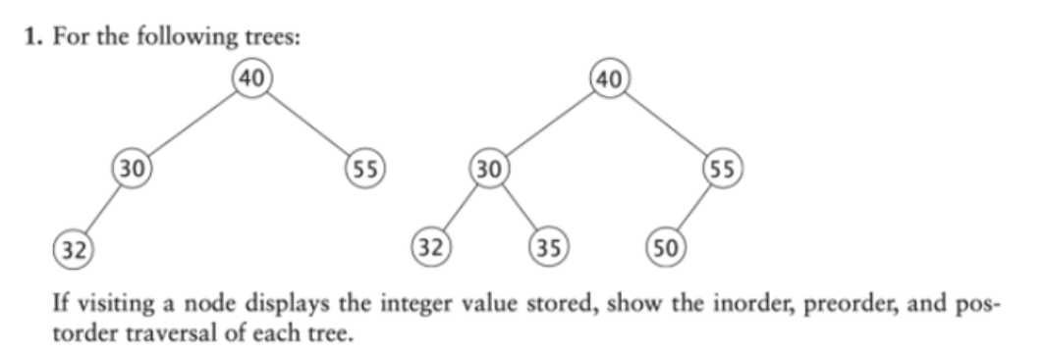

preorder – 40 30 32 55

inorder – 32 30 40 55

postorder – 32 30 55 40

preorder – 40 30 32 35 55 50

inorder – 32 30 35 40 55 50

postorder – 32 30 35 50 55 42

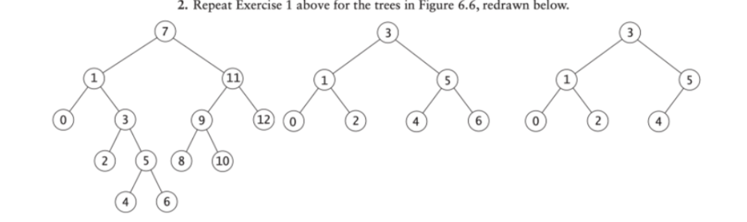

1. Preorder – 7 0 1 2 3 4 5 6 8 9 10 11 12 Inorder – 0 1 2 3 4 5 6 7 8 9 10 11 12 Postorder – 0 1 2 3 4 5 6 8 9 10 11 12 7
2. Preorder – 3 0 1 2 4 5 6 Inorder – 0 1 2 3 4 5 6 Postorder – 0 1 2 4 5 6 3
3. Preorder – 3 0 1 2 4 5 Inorder – 0 1 2 3 4 5 Postorder – 0 1 2 4 5 3

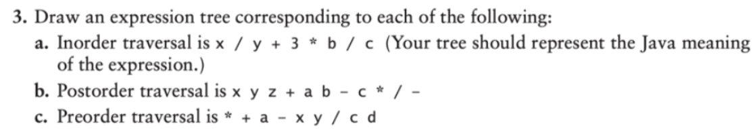

a.



b.



c.





1. This is because part a has numerical values, while in b and c there are only variables / algebraic expressions.

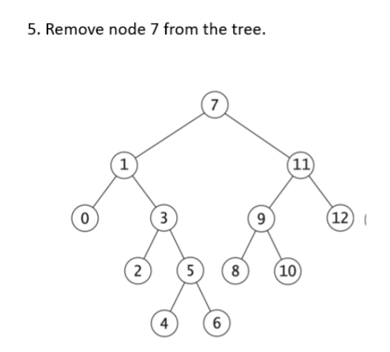

4.

