Rwanda ICT Chamber

Hang Hub Program

Muhanga

IRADUKUNDA Regis

[Regisiradukunda50@gmail.com](mailto:Regisiradukunda50@gmail.com)

ASSIGMNET 1 ON GIT&GITHUB

1. **Create a simple project and track changes using Git**

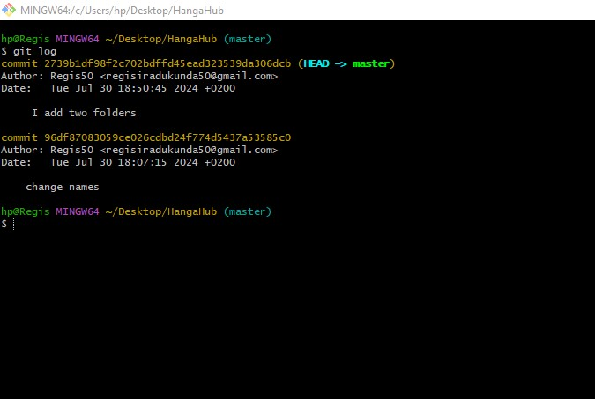

1. **Write a summary of what version control is and why it is important.**

Version control, also known as source control, is the practice of tracking and managing changes to software code. Version control systems are software tools that help software teams manage changes to source code over time

allows you to monitor and track the different versions of a document over time. It helps you to keep on top of how a document has changed and developed. Each time the document is modified, the version control number is updated, which lets you know that you're looking at the latest version.