Rwanda ICT Chamber

Hang Hub Program

Muhanga

IRADUKUNDA Regis

[Regisiradukunda50@gmail.com](mailto:Regisiradukunda50@gmail.com)

ASSIGMNET 2 ON GIT&GITHUB

1. **Create a GitHub repository and add a README file.**

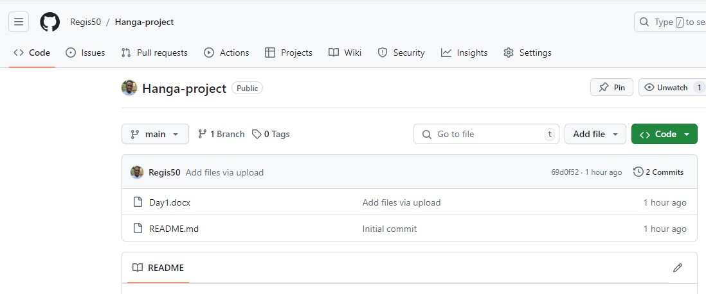

1. Document the process of creating and cloning the repository.

Cloning a repository pulls down a full copy of all the repository data that GitHub.com has then, including all versions of every file and folder for the project. You can push your changes to the remote repository on GitHub.com, or pull other people's changes from GitHub.com. For more information.

1. On GitHub.com, navigate to the main page of the repository.
2. Above the list of files, click  **Code**.

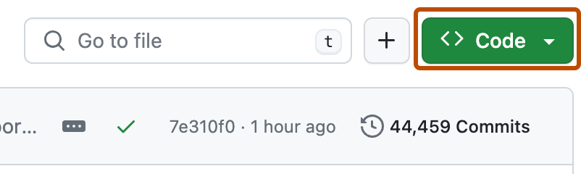

1. Copy the URL for the repository.
   * To clone the repository using HTTPS, under "HTTPS", click .
   * To clone the repository using an SSH key, including a certificate issued by your organization's SSH certificate authority, click **SSH**, then click .
   * To clone a repository using GitHub CLI, click **GitHub CLI**, then click .

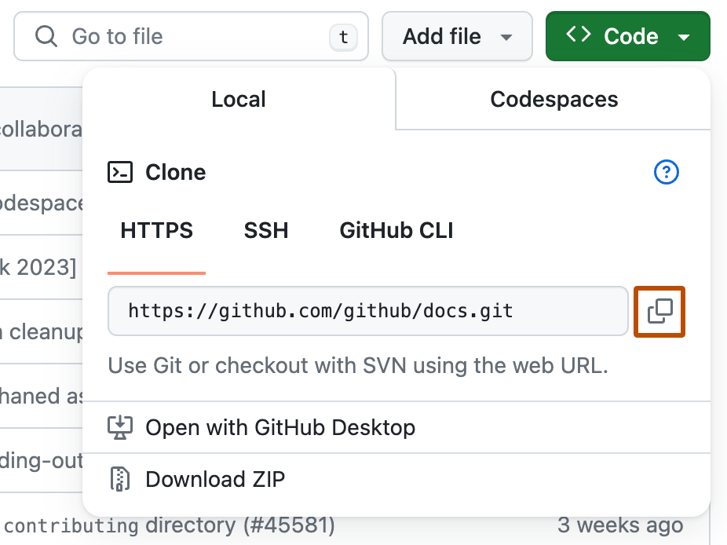

1. Open Git Bash.
2. Change the current working directory to the location where you want the cloned directory.
3. Type git clone, and then paste the URL you copied earlier.
4. git clone https://github.com/YOUR-USERNAME/YOUR-REPOSITORY
5. Press **Enter** to create your local clone.
6. $ git clone https://github.com/YOUR-USERNAME/YOUR-REPOSITORY
7. > Cloning into `Spoon-Knife`...
8. > remote: Counting objects: 10, done.
9. > remote: Compressing objects: 100% (8/8), done.
10. > remove: Total 10 (delta 1), reused 10 (delta 1)
11. > Unpacking objects: 100% (10/10), done.

## [Cloning an empty repository](https://docs.github.com/en/repositories/creating-and-managing-repositories/cloning-a-repository#cloning-an-empty-repository)

An empty repository contains no files. It's often made if you don't initialize the repository with a README when creating it.

1. On GitHub.com, navigate to the main page of the repository.
2. To clone your repository using the command line using HTTPS, under "Quick setup", click . To clone the repository using an SSH key, including a certificate issued by your organization's SSH certificate authority, click **SSH**, then click .

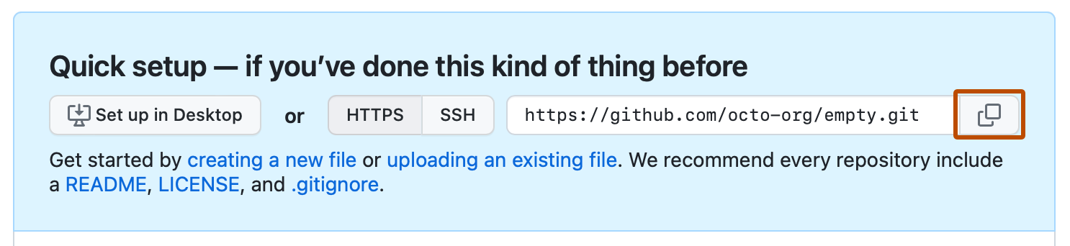

Alternatively, to clone your repository in Desktop, click  **Set up in Desktop** and follow the prompts to complete the clone.

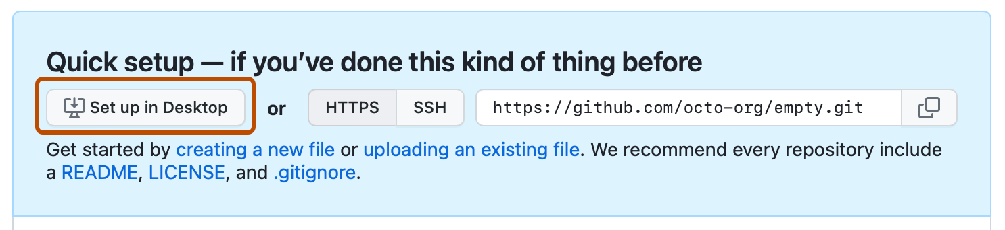

1. Open Git Bash.
2. Change the current working directory to the location where you want the cloned directory.
3. Type git clone, and then paste the URL you copied earlier.
4. git clone https://github.com/YOUR-USERNAME/YOUR-REPOSITORY
5. Press **Enter** to create your local clone.
6. $ git clone https://github.com/YOUR-USERNAME/YOUR-REPOSITORY
7. > Cloning into `Spoon-Knife`...
8. > remote: Counting objects: 10, done.
9. > remote: Compressing objects: 100% (8/8), done.
10. > remove: Total 10 (delta 1), reused 10 (delta 1)

> Unpacking objects: 100% (10/10), done.

**Cloning From my local computer**

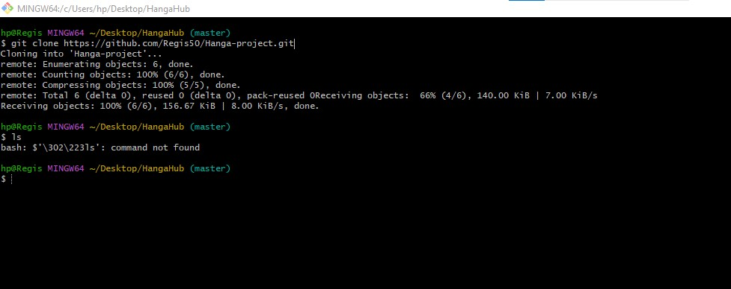

**References :**

**https://docs.github.com/en/repositories/creating-and-managing-repositories/cloning-a-repository**