lab12_stat3333

Elizabeth Flores, Regis Ouedraogo, Yohari Hernandez, Richard Sauve

2022-10-28

library(testequavar)

## Warning: package 'testequavar' was built under R version 4.1.3

Verizon <- resampledata::Verizon  
Time.ILEC <-subset(Verizon, select = Time, Group=="ILEC", drop = TRUE)  
Time.CLEC <-subset(Verizon, select = Time, Group=="CLEC", drop = TRUE)  
#lets check fo normality  
qqnorm(Time.CLEC)  
qqline(Time.CLEC)

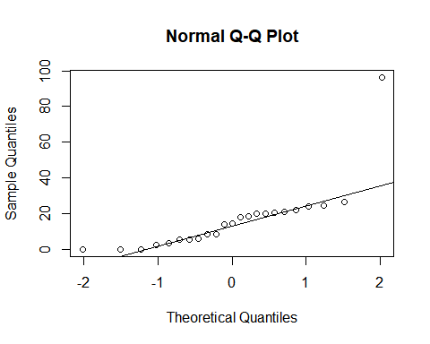

#lets check fo normality

qqnorm(Time.ILEC)  
qqline(Time.ILEC)

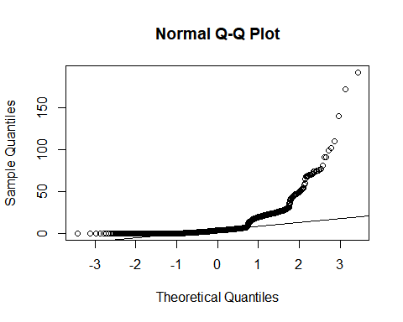 lets perform a ttest mu1-mu2>0

Tstat =t.test(Time.ILEC, Time.CLEC, mu=0, alternative="greater",var.equal = TRUE)  
Tstat

##   
## Two Sample t-test  
##   
## data: Time.ILEC and Time.CLEC  
## t = -2.6125, df = 1685, p-value = 0.9955  
## alternative hypothesis: true difference in means is greater than 0  
## 95 percent confidence interval:  
## -13.19855 Inf  
## sample estimates:  
## mean of x mean of y   
## 8.411611 16.509130

p-value = 0.9955

equa2vartest(Time.ILEC, Time.CLEC, .05, 1000)

## [[1]]  
## [1] "Decision: Fail to Reject the Null"  
##   
## $Alpha  
## [1] 0.05  
##   
## $NumberOfBootSamples  
## [1] 1000  
##   
## $BootPvalue  
## [1] 0.713