Pulse Diagnostics — Business Justification for packagedServices
  - Business Justification for packagedServices
Pulse Diagnostics
August 06, 2026
Table of Contents

Pulse Diagnostics — Business Justification for packagedServices
Audience: Microsoft Store / Partner Center certification (restricted capability review) Product: Pulse Diagnostics (Regncreative.PulseDiagnostics, Store ID 9PNDTLNTJ82T) Capability requested: packagedServices only Capability not requested: localSystemServices Service account: Local Service (desktop6:Service StartAccount="localService") Package service binary: service\PulseService.exe Document type: Restricted capability business justification (code-backed) Distribution channels: Microsoft Store (MSIX) and GitHub/Inno (classic) Document version: 1.3 Generation date: August 06, 2026

Executive Business Justification
Pulse Diagnostics is a professional, read-only Windows observability application for IT professionals, developers, and system administrators. It presents Event Log activity, system health, hardware/software inventory, and diagnostics status in a modern desktop UI, as defined by product architecture (AGENTS.md, docs/architecture/decisions/ADR-002-windows-service.md).

Business problem this capability solves
Pulse is designed as a two-process product: a Flutter UI (Pulse.exe) and a Windows Service observation host (PulseService.exe). Architecture requires diagnostic collection to run in the service, not in the UI (docs/architecture/01-system-overview.md). That host must remain available under Service Control Manager (SCM) after the UI exits and after interactive logoff—the same model already shipping on GitHub/Inno.
On the GitHub / Inno channel, PulseService.exe registers as NT AUTHORITY\LocalService via CreateServiceW (service/pulse_service/src/service_core/service_core.cpp). On the Microsoft Store channel, the same Local Service must be registered from the MSIX via desktop6:Service. Windows requires the restricted capability packagedServices for that registration. Without it, the Store edition cannot register the service host and cannot match the GitHub product’s observation architecture.
Store packaging validates that service\PulseService.exe is embedded and that packagedServices is declared (tools/scripts/validate_msix_store.ps1, docs/guides/microsoft-store.md). A UI-only Store package is treated as an incomplete/unusable core feature in that packaging guidance.

What we are requesting
Item | Request
Capability | packagedServices only
Not requested | localSystemServices
Service | PulseService
Account | Local Service (StartAccount="localService")
Startup | Automatic (StartupType="auto")
Binary | service\PulseService.exe inside the Store package
runFullTrust, StartupTask, Scheduled Tasks, user-mode background processes, and relocating collectors into the UI cannot provide this Local Service host model. Classic CreateService from the Store app is refused under package identity. Details below.

Why Local Service — and explicitly not Local System
Pulse uses least privilege. Local Service is the account already used by the classic installer and is sufficient for the read-oriented Event Log, health, and inventory work implemented in service/pulse_service. We intentionally do not request localSystemServices. See the LocalService capability matrix.

Approval request
Approve packagedServices so the Microsoft Store edition can register the existing Local Service observation host via desktop6:Service and achieve feature parity with the GitHub/Inno edition—without elevating to Local System.

Observation model (precise, code-backed)
Microsoft reviewers should distinguish three layers. The document does not claim that every collector is actively subscribed for every second the UI is closed.
Layer | What runs | When it starts (code) | Survives UI close?
Persistent service host | PulseService under SCM; named-pipe accept loop | Service start → IpcServer::Start() (service/pulse_service/src/ipc/ipc_server.cpp) | Yes — UI exit does not stop the service
Health infrastructure | Health collector initialize + health push thread | IpcServer::Start() calls EnsureHealthCollector() and starts HealthPushLoop | Yes — initialized with the service; client push is gated per connected client
Event Log live subscription | EvtSubscribe on accessible diagnostics channels | Lazy: StartLiveMonitoring → EnsureLiveSubscriber() (service/pulse_service/src/ipc/ipc_server.cpp) | Host yes; live subscribe only after enabled — snapshot/detail remain available on demand when the UI reconnects
Accurate product claim: With packagedServices, the Store edition keeps a durable Local Service host and IPC endpoint (and health infrastructure started with that host). Event Log live streaming starts when the product enables live monitoring; it is not asserted as always-on solely because the service process exists.

Store vs GitHub feature parity
This request is primarily a Store-compatible registration path for an observation architecture that already ships on GitHub—not a request for new privileges beyond Local Service.
Product capability | GitHub / Inno (shipping) | Store without packagedServices | Store with packagedServices
Durable Local Service observation host | Yes — PulseService | No package-owned service registration | Yes — desktop6:Service
Named-pipe IPC server available after UI exit | Yes | No durable host | Yes
Health infrastructure starts with service | Yes (IpcServer::Start) | N/A / UI-only incomplete | Yes
Event Log live subscribe (when enabled) | Yes (lazy in service) | No service host | Yes (same lazy model)
Survives user logoff (service session) | Yes | No (UI/session-only designs) | Yes
Auto-start under SCM | Yes (SERVICE_AUTO_START) | No | Yes (StartupType=auto)
Service account | NT AUTHORITY\LocalService | N/A | localService
How registered | Elevated --install-start / CreateServiceW | Blocked under package identity | MSIX desktop6:Service
UI as presentation client only | Yes | Incomplete vs architecture | Yes
Evidence: classic LocalService install in service/pulse_service/src/service_core/service_core.cpp and tools/installer/Pulse.iss; Store declaration in tools/scripts/package_msix_store.ps1; packaged builds refuse classic install (IsRunningAsPackagedApp (service/pulse_service/src/service_core/service_core.cpp); Store UI hides Repair/--install-start in apps/pulse_app/lib/application/service_lifecycle_controller.dart).
Without packagedServices, Store customers cannot receive the same Local Service observation host that GitHub customers already have.

Why StartupTask, runFullTrust, scheduled tasks, and background processes are insufficient
For Pulse, each alternative fails a product requirement encoded in architecture and code, not a preference.

runFullTrust alone (UI process only)
The Store package already uses runFullTrust for Pulse.exe (pubspec.yaml msix_config (apps/pulse_app/pubspec.yaml)). That is necessary for the desktop UI. It is not sufficient:
- Closing Pulse.exe ends the UI process; collectors hosted there would stop with it.
- Architecture forbids calling Event Log / health / inventory collection APIs from the UI (docs/architecture/01-system-overview.md).
- The named-pipe server lives in PulseService (service/pulse_service/src/ipc/ipc_server.cpp); the UI is a CreateFile client (apps/pulse_app/lib/ipc/pulse_ipc_client.dart).
Impact: a Store build limited to runFullTrust cannot implement the shipping two-process observation model and fails Store packaging validation that requires an embedded PulseService.exe (tools/scripts/validate_msix_store.ps1).

StartupTask
- Runs in the interactive user session, not as Local Service.
- Ends at logoff; does not provide the machine Local Service session used by the GitHub build.
- Does not create an SCM service with StartupType=auto / SERVICE_AUTO_START.
- Does not replace StartServiceCtrlDispatcherW / ServiceMain (service/pulse_service/src/service_core/service_core.cpp).
Impact: would produce a session-bound helper, not the Local Service host already shipping on GitHub.

Scheduled Task
- Pulse’s IPC accept loop, health push thread, and (when enabled) Event Log live subscribe are long-running service paths, not periodic batch jobs (service/pulse_service/src/ipc/ipc_server.cpp).
- Task Scheduler does not provide the SCM service contract Pulse implements (STOP/SHUTDOWN handling, auto-start service registration).
- Rebuilding as a scheduled executable would abandon the architecture validated on GitHub (docs/architecture/decisions/ADR-002-windows-service.md).
Impact: cannot host the implemented service + named-pipe server model.

User-mode background / tray process
- Remains a user-session process; ends at logoff.
- Does not use the Local Service identity that creates the pipe under the service SDDL (LS ACE in shared/pulse_common/include/pulse/constants.hpp).
- Does not provide SCM install/uninstall/start/stop lifecycle as implemented for PulseService.
Impact: not equivalent to the GitHub Local Service product.

Classic CreateService from the Store package
Under package identity, --install / --uninstall are refused; Store UI hides Repair/--install-start (service/pulse_service/src/service_core/service_core.cpp, apps/pulse_app/lib/application/service_lifecycle_controller.dart). Package-owned desktop6:Service registration is the Store-compatible mechanism—and requires packagedServices.

Why moving collectors into the UI is not a valid Store replacement
A common review question is whether Pulse could avoid packagedServices by calling Wevtapi/PDH/SetupAPI directly from Pulse.exe.
Objection | Code-backed response
“Put collectors in the UI” | Violates normative architecture: Flutter must not call Windows diagnostic collection APIs for Event Log / health / inventory (docs/architecture/01-system-overview.md, docs/architecture/decisions/ADR-002-windows-service.md).
“UI can stay running in background” | Closing the Store app still ends the UI process; the product requires an SCM Local Service host independent of that process.
“Snapshots on UI open are enough” | The product also implements a durable pipe server, health infrastructure started with the service, and live Event Log subscribe when enabled—all inside PulseService (service/pulse_service/src/ipc/ipc_server.cpp). Relocating that surface into the UI would redesign the shipping GitHub architecture and break Store↔GitHub parity.
“Then use StartupTask for the UI” | Still user-session, not Local Service; fails logoff/SCM requirements above.
Conclusion: UI-hosted collectors are not a Store-compatible substitute for the existing Local Service observation host. packagedServices is the registration capability that host requires on Store.

Exact responsibilities of PulseService
PulseService is the product’s observation host. Responsibilities below are required for the Store app to deliver advertised diagnostics through the existing IPC protocol.
Responsibility | What the UI presents | Why a Windows Service host is required
Named-pipe IPC server | Connected diagnostics session | Pipe server must outlive UI process exit/relaunch (service/pulse_service/src/ipc/ipc_server.cpp)
Event Log snapshot / detail | Timeline views on demand | Implemented in the service; UI is IPC client only
Event Log live subscribe (when enabled) | Live timeline updates after StartLiveMonitoring | Subscribe runs in the service host, not in Flutter
System health monitoring | CPU, memory, disk, adapter, process health | Health collector initializes at service IPC start (EnsureHealthCollector)
Hardware / software inventory | Device, driver, service, software catalogs | Inventory collectors run under the service (inventory/ (service/pulse_service/src/inventory))
Diagnostics identity / status | Service running/version/path status | Meaningful only if an SCM service exists
Local logs & config under ProgramData | Stable local config/logs across updates | Service owns %ProgramData%\Pulse\ (service/pulse_service/src/util/config.cpp)

What PulseService is not responsible for
Non-responsibility | Why it matters to this review
UI rendering, settings, export dialogs | Remain in Pulse.exe
Remote management / cloud agent | Not implemented
Plugin hosting or script execution | Not implemented (docs/architecture/decisions/ADR-006-plugin-deferral.md)
Antivirus, cleaner, optimizer, or booster | Out of product scope (AGENTS.md)
Classic SCM self-install when packaged | Refused under package identity

Why LocalService is required — and why LocalSystem is not requested

Why LocalService is required
Requirement | Why LocalService
Durable host after logoff | Machine service identity, not an interactive user process
Least privilege for implemented collectors | Sufficient for System/Application and other accessible channels; Security is probe-open and skipped when denied (service/pulse_service/src/collectors/event_log_channels.cpp)
Feature parity with GitHub | Classic installer already uses NT AUTHORITY\LocalService
Store packaging model | desktop6:Service StartAccount="localService" → packagedServices
Named-pipe ownership | Service process creates the pipe with LS full access in SDDL

LocalService capability matrix
Based on the current service/pulse_service implementation (not a request for additional rights):
Capability / operation | Under LocalService in Pulse | Notes
Open/query/subscribe System Event Log | Yes (required channel) | service/pulse_service/src/collectors/event_log_channels.cpp
Open Application / Setup / selected Operational logs | Yes when accessible (optional) | Skipped/warned if open fails at use time
Open Security Event Log | Often no | ProbeOpen; ACL failure accepted—not used to justify LocalSystem
PDH / health counters, process limited query | Yes | Health collectors
SetupAPI / inventory reads; HKLM Uninstall read | Yes (read-oriented) | No RegSet* / RegCreate* / RegDelete* found in service src
Create local named pipe \\.\pipe\PulseService | Yes | Service owns pipe; SDDL includes LS
Listen on remote TCP/HTTP | No | Not implemented
Execute PowerShell / cmd / arbitrary processes | No | No spawn APIs found in service
Process injection / security-policy changes | No | Not implemented; forbidden by AGENTS.md
Download plugins / load plugin DLLs | No | Not implemented
Credential APIs | No | Not found

Why LocalSystem is intentionally NOT requested
Concern | Pulse position
Privilege | Above what the implemented read-oriented collectors require
Restricted capability | Would require localSystemServices — not requested
Product policy | AGENTS.md requires least privilege
Security Event Log | Denied access is accepted under LocalService rather than elevating
Trust boundary | LocalSystem would expand machine trust beyond product need
Clear statement for Partner Center: Pulse Diagnostics requests packagedServices only, with StartAccount="localService". We do not request Local System or localSystemServices.

Customer value

Who the product is for
Intended audience from product positioning (AGENTS.md, Store listing as Pulse Diagnostics):
- IT professionals — Event Log and system health in one tool
- Developers — process, service, and Event Log behavior on development PCs
- System administrators — inventory and diagnostics with a local-first, read-only design

What the Store SKU loses without this capability
Product requirement (from architecture/code) | If packagedServices is denied
Durable Local Service host after UI exit | No package-owned service; UI-only process ends with the app
Health infrastructure started with the service | No service IpcServer::Start host
Event Log live subscribe in the service (when enabled) | No service-side subscribe path
Same Local Service model as GitHub | Store edition cannot register that host
Least-privilege background host on Store | No supported Store registration path for Local Service
Closing Pulse.exe does not stop PulseService when the service is registered. The UI reconnects on next launch (apps/pulse_app/lib/ipc/pulse_ipc_client.dart).

IPC security
Communication between UI and service is a local named pipe only—not a remote network service.

Transport
Property | Implementation
Name | \\.\pipe\PulseService (shared/pulse_common/include/pulse/constants.hpp)
Scope | Same machine (\\.\pipe\...); no TCP/HTTP listener found in service sources
Framing | Length-prefixed Protobuf (PULS magic + payload) (shared/pulse_protocol/proto/pulse.proto)
Protocol check | ClientHello.protocol_version must match; mismatch returns an error

SDDL (explicit)
Pipe security descriptor applied at CreateNamedPipeW (service/pulse_service/src/ipc/ipc_server.cpp):
D:(A;;GA;;;SY)(A;;GA;;;LS)(A;;GRGW;;;BA)(A;;GRGW;;;BU)
ACE | Meaning
SY (Local System) | Generic all
LS (Local Service) | Generic all — service account that owns the pipe
BA (Built-in Administrators) | Generic read/write
BU (Built-in Users) | Generic read/write

Honest disclosure: Built-in Users access
Any local process running as a normal user that passes this ACL can open the pipe and send protobuf requests the server understands (timeline, health, inventory, diagnostics). There is no client process-ID allowlist, named-pipe impersonation gate, or mutual TLS in the current code.
Impact bound: that surface is local diagnostics RPC only. The service does not expose arbitrary command execution, script host, plugin load, or remote administration APIs. This is a same-machine diagnostics bus, not a remote management endpoint.

What IPC is and is not
Is | Is not
Local named pipe on the same PC | Remote TCP/HTTP/WebSocket endpoint
Diagnostics schema RPCs (snapshot, live monitor, health, inventory, diagnostics status) | Shell/PowerShell/cmd execution channel
Protocol version check on hello | Cryptographic client attestation (not implemented)
SDDL-restricted local principals | Internet-facing listener

Security commitments
Statements below apply to PulseService.exe under service/pulse_service, and to Store packaging gates.
Commitment | Meaning for this review
No arbitrary command execution | Diagnostics RPCs only; no shell-command API
No PowerShell / cmd.exe launch | No process-spawn APIs found in the service
No process injection | No OS injection APIs; AGENTS.md forbids injection
No download of executables or plugins | No download client; no plugin host
No Windows security-policy changes | No security-setting or registry-write APIs found in service sources
No remote telemetry / C2 channel | No HTTP(S)/WinHTTP client or upload worker in the service
No credential harvesting | No credential APIs found
Persistence only via SCM registration | Store desktop6:Service or classic CreateService — no Run-key persistence code in the service

Scope clarifications
- Start/Stop/Restart from the UI may prompt UAC (runas) to launch PulseService.exe with --start / --stop / --restart after explicit user action (apps/pulse_app/lib/platform/pulse_service_launcher.dart).
- Store updates are delivered by the Microsoft Store; PulseService does not download binaries.
- See UI internetClient capability for the UI package network declaration.

UI internetClient capability
Finding (code review): the Store Flutter package currently declares internetClient alongside runFullTrust and packagedServices (apps/pulse_app/pubspec.yaml msix_config.capabilities).
Check | Result
HTTP client dependency in app pubspec.yaml | None (no http, dio, url_launcher, etc.)
First-party telemetry/analytics SDK | None found
Outbound network client in apps/pulse_app/lib | None found
GitHub releases URL in Settings | Displayed as text only (SettingsController.releasesUrl); not launched via a URL launcher API in code reviewed
PulseService remote client | None — service has no HTTP/WinHTTP client
Recommendation for Store submission: remove internetClient from the Store MSIX capability list unless/until a concrete UI feature requires it and is documented. It is not required for packagedServices or for PulseService. Leaving an unused network capability next to a packaged service weakens the least-privilege story for reviewers.
This justification does not claim internetClient is needed for the service.

Capability request summary
Item | Value
Capability | packagedServices
Not requested | localSystemServices
Service name | PulseService
Start account | localService
Startup | auto
Binary | service\PulseService.exe inside the MSIX
Business purpose | Register the existing Local Service observation host on Store for GitHub feature parity
Related packaging note | Remove unused UI internetClient unless a documented UI feature needs it

Executive Certification Checklist
Microsoft Question | Short Answer | Reference
Why is StartupTask or runFullTrust insufficient? | They cannot provide an SCM Local Service host that outlives the UI and matches GitHub. | Why alternatives are insufficient
Why not put collectors in the UI? | Architecture forbids it; would break the shipping two-process model. | Why moving collectors into the UI is not a valid Store replacement
Why is LocalService required? | Least-privilege durable service identity; matches GitHub; sufficient for implemented collectors. | LocalService capability matrix
Why not LocalSystem? | Not needed; Security log denial accepted; localSystemServices not requested. | Why LocalSystem is intentionally NOT requested
What are PulseService responsibilities? | IPC host, Event Log snapshot/live-when-enabled, health, inventory, ProgramData logs/config. | Exact responsibilities of PulseService
Does Event Log collect continuously with UI closed? | Host persists; live subscribe is lazy after StartLiveMonitoring; snapshots on demand. | Observation model
How is IPC secured? | Local named pipe; explicit SDDL (incl. BU); diagnostics RPCs only; no remote endpoint. | IPC security
Does the service execute arbitrary commands? | No. | Security commitments
Does the service download or load plugins? | No. | Security commitments
Does the service expose remote management? | No — local named pipe only. | IPC security
Does the service collect telemetry? | No first-party telemetry. | Privacy
Why is internetClient declared? | Currently unused in UI code review; recommend removal from Store package. | UI internetClient capability
Why is packagedServices required? | Only Store-compatible way to register the Local Service host already used on GitHub. | Store vs GitHub feature parity
Is localSystemServices requested? | No. | Capability request summary
What happens when the UI closes? | Service host continues; UI reconnects later. | Observation model

Product architecture (summary)
Process | Role | Technology
Pulse.exe | Presentation client | Flutter Desktop
PulseService.exe | Observation host (SCM Local Service) | C++ Windows Service
Store packaging embeds the service binary and declares:
<desktop6:Extension Category="windows.service"
Executable="service\PulseService.exe"
EntryPoint="Windows.FullTrustApplication">
<desktop6:Service Name="PulseService"
StartupType="auto"
StartAccount="localService" />
</desktop6:Extension>
(tools/scripts/package_msix_store.ps1, tools/scripts/validate_msix_store.ps1).

Security model

Where data lives
Path | Purpose
%ProgramData%\Pulse\config.json | Local service configuration
%ProgramData%\Pulse\logs\... | Local structured service logs
%ProgramData%\Pulse\data\ | Local data layout
Resolved via SHGetKnownFolderPath(FOLDERID_ProgramData) (service/pulse_service/src/util/config.cpp). The service does not write into the MSIX install directory.

Least privilege in practice
- Account = LocalService (not LocalSystem) — see capability matrix.
- Observation APIs are read-oriented.
- Day-to-day observation does not require admin after install.
- Packaged builds refuse classic SCM self-install.
- Start/Stop/Restart from the UI use explicit UAC when the user chooses those actions.

Privacy
Topic | Statement
Collected categories | Event Log (accessible channels), health metrics, inventory, Pulse diagnostics status — local only
Sensitivity | May include hostnames, executable paths, Event Log message text, and process metadata exposed to LocalService
Network rates | Health may use local ETW/PDH-style rate metrics; not HTTPS payload inspection / MITM
Storage | %ProgramData%\Pulse\ (service); local UI preferences
Telemetry | No first-party telemetry / analytics / tracking
Service network | No remote upload client in service sources
Store updates | Via Microsoft Store for the Store edition
Optional GitHub-only PulseMCP is not included in the Store MSIX.

Architecture diagrams

Process architecture
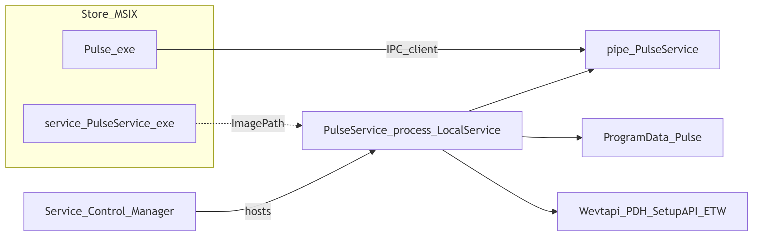
Architecture diagram 1

IPC
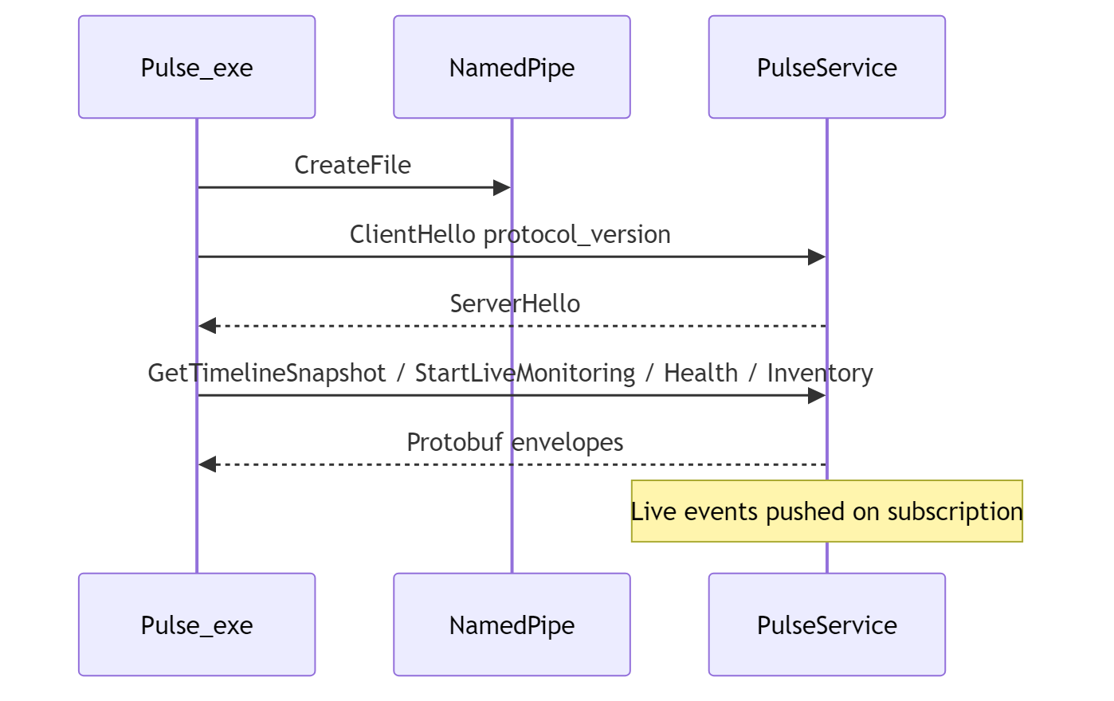
Architecture diagram 2

Data flow (Event Log path)
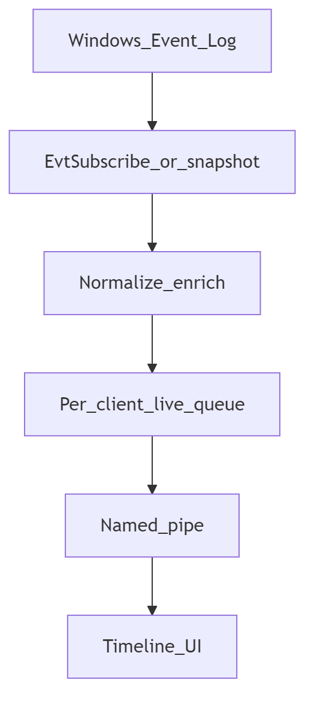
Architecture diagram 3

Service lifecycle (Store)
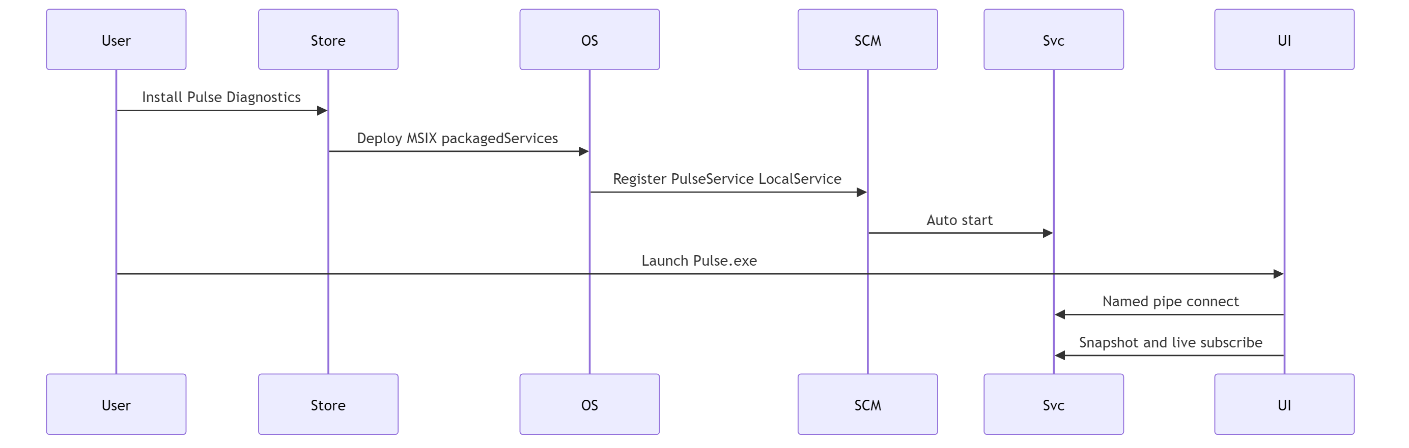
Architecture diagram 4

Closing request to Microsoft
Pulse Diagnostics is already a two-process product on GitHub/Inno: a Flutter UI plus PulseService running as Local Service.
For the Microsoft Store edition, Windows cannot register that Local Service from the AppxManifest unless the package is granted packagedServices. Classic CreateService / --install-start is refused under package identity, so there is no alternative Store-legal path to the observation host architecture already shipping on GitHub.

What approval enables
- Feature parity between Store and GitHub for the Local Service observation host and IPC endpoint
- Health infrastructure and pipe server that outlive UI process exit
- Event Log live subscription when enabled, hosted in the service—not in the UI
- Least-privilege Local Service operation — not Local System

What we are not asking for
- localSystemServices
- Broader privileges than Local Service
- Remote management, plugins, scripting, or telemetry capabilities
- Retention of unused UI internetClient (recommend removal)
We respectfully request approval of packagedServices for Pulse Diagnostics (Regncreative.PulseDiagnostics, Store ID 9PNDTLNTJ82T) so the Store package can declare desktop6:Service with StartAccount="localService" and ship the same core observation-host experience as the classic installer.
This justification reflects the repository as implemented for the Store packaged-service edition.

Appendix A — Alternative analysis (implementation evidence)

1. runFullTrust UI only
Store package declares runFullTrust for Pulse.exe (pubspec.yaml msix_config (apps/pulse_app/pubspec.yaml)). UI is an IPC client (apps/pulse_app/lib/ipc/pulse_ipc_client.dart); pipe server is in service/pulse_service/src/ipc/ipc_server.cpp. Architecture keeps collectors out of the UI (docs/architecture/01-system-overview.md).

2. StartupTask
User-session launch only; no LocalService SCM model (StartServiceCtrlDispatcherW / ServiceMain in service/pulse_service/src/service_core/service_core.cpp).

3. Scheduled Task
IPC accept loop, health push thread, and lazy Event Log live subscribe are long-running service paths in IpcServer, not periodic batch work.

4. User-mode background process
No SCM STOP/SHUTDOWN contract; no LocalService identity used by the shipping service.

5. Classic CreateService from Store
--install / --uninstall refused when packaged; Store UI hides Repair/--install-start (service/pulse_service/src/service_core/service_core.cpp, apps/pulse_app/lib/application/service_lifecycle_controller.dart).

Appendix B — PulseService responsibilities (source map)
Responsibility | Primary code
Named-pipe IPC server | service/pulse_service/src/ipc/ipc_server.cpp
Event Log timeline | service/pulse_service/src/collectors/event_log_channels.cpp, live/snapshot paths in ipc_server.cpp
System health | service/pulse_service/src/collectors/health_metrics_collector.cpp, service/pulse_service/src/collectors/network_etw_engine.cpp
Inventory | service/pulse_service/src/inventory/ (service/pulse_service/src/inventory)
Diagnostics identity / status | diagnostics/ (service/pulse_service/src/diagnostics)
Local logging | service/pulse_service/src/logging/logger.cpp
Local configuration | service/pulse_service/src/util/config.cpp
Conditional behaviors: Security channel is probe-opened and skipped if ACL-denied under LocalService; network ETW is used for local per-process rate metrics only; IPC InjectDiagnosticsTestEvent synthesizes a timeline test event (not OS injection).
Not in Store MSIX: PulseMCP (PulseMCP.exe) — GitHub-only today.

Appendix C — Service lifecycle

GitHub / Inno (classic)
- Installer deploys PulseService.exe.
- Elevated --install-start → CreateServiceW with NT AUTHORITY\LocalService, auto-start.
- Service started to SERVICE_RUNNING.

Microsoft Store
- Customer installs MSIX.
- Windows registers desktop6:Service (PulseService, auto, localService).
- App/service do not call CreateService when packaged.
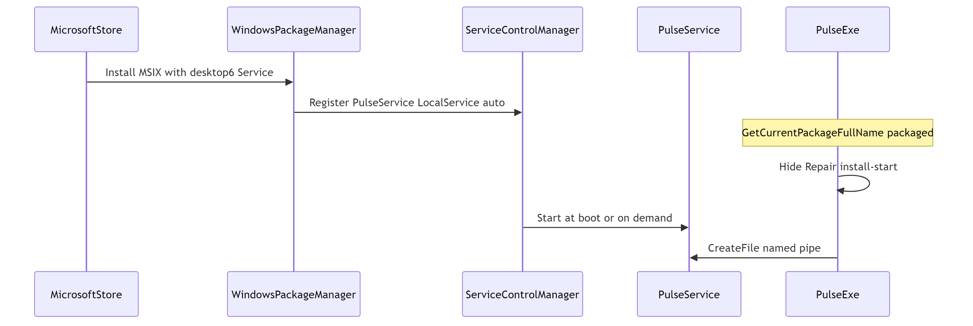
Architecture diagram 5

Runtime notes
- SCM launches service → ServiceMain → IPC accept loop; IpcServer::Start initializes health infrastructure.
- Event Log live subscribe starts on StartLiveMonitoring (lazy).
- UI close does not stop the service; UI reconnects later.
- Custom SCM failure-action timers are not configured in the current Store manifest; we do not claim custom crash-restart scheduling beyond Windows defaults.
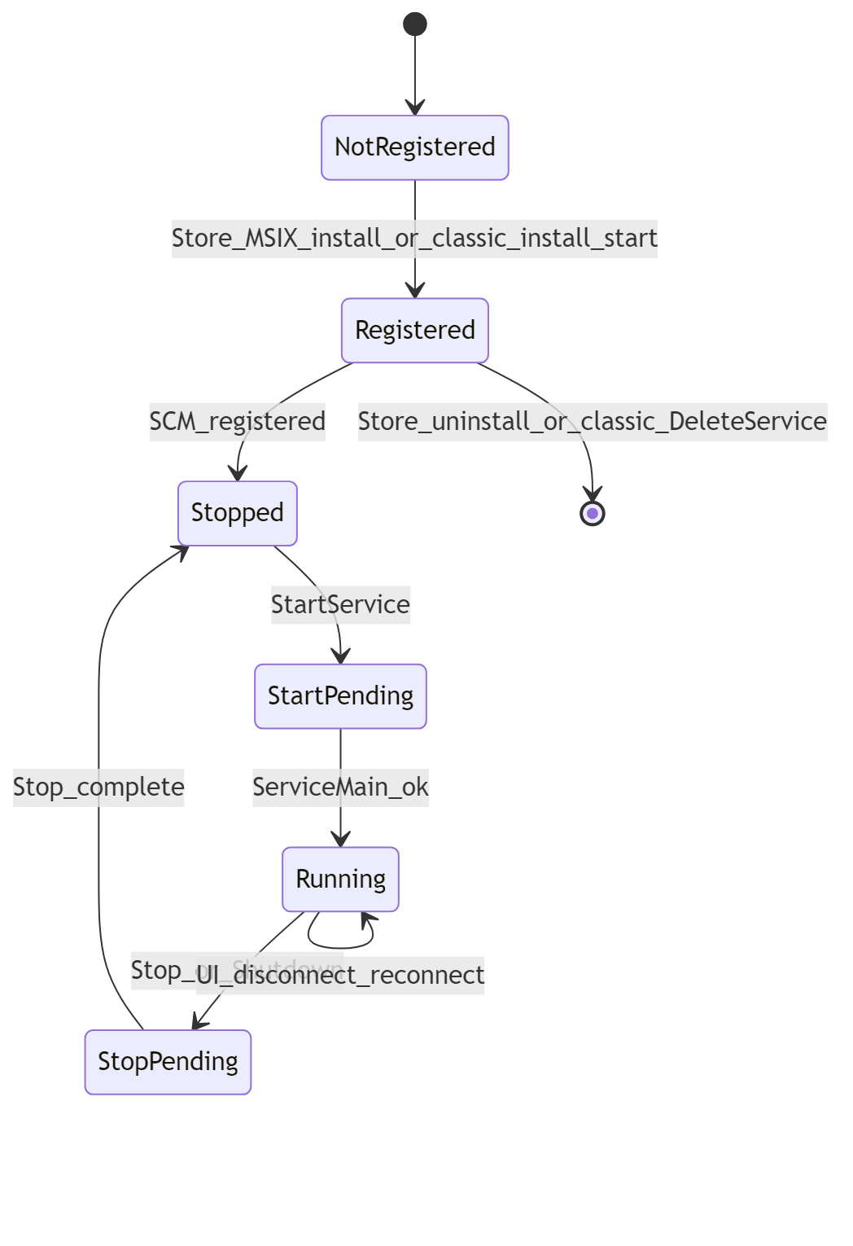
Architecture diagram 6

Appendix D — IPC (additional evidence)
See main section IPC security for SDDL, BU disclosure, and diagnostics-only bounds.
Additional notes:
- Max pipe instances default 32 (config clamp 2–64)
- Clients: Store UI (Pulse.exe); optional GitHub-only PulseMCP; engineering tools
- Not implemented: mutual TLS, PID allowlists, pipe impersonation tokens

Appendix E — Limits and threat model
Limit | Status
Cannot execute arbitrary commands / scripts | True
Cannot launch PowerShell / cmd.exe | True
Cannot download or load plugins | True
Cannot modify Windows security settings | True
Cannot expose a remote API | True — local named pipe only
Cannot perform OS code injection | True
Cannot capture credentials | True
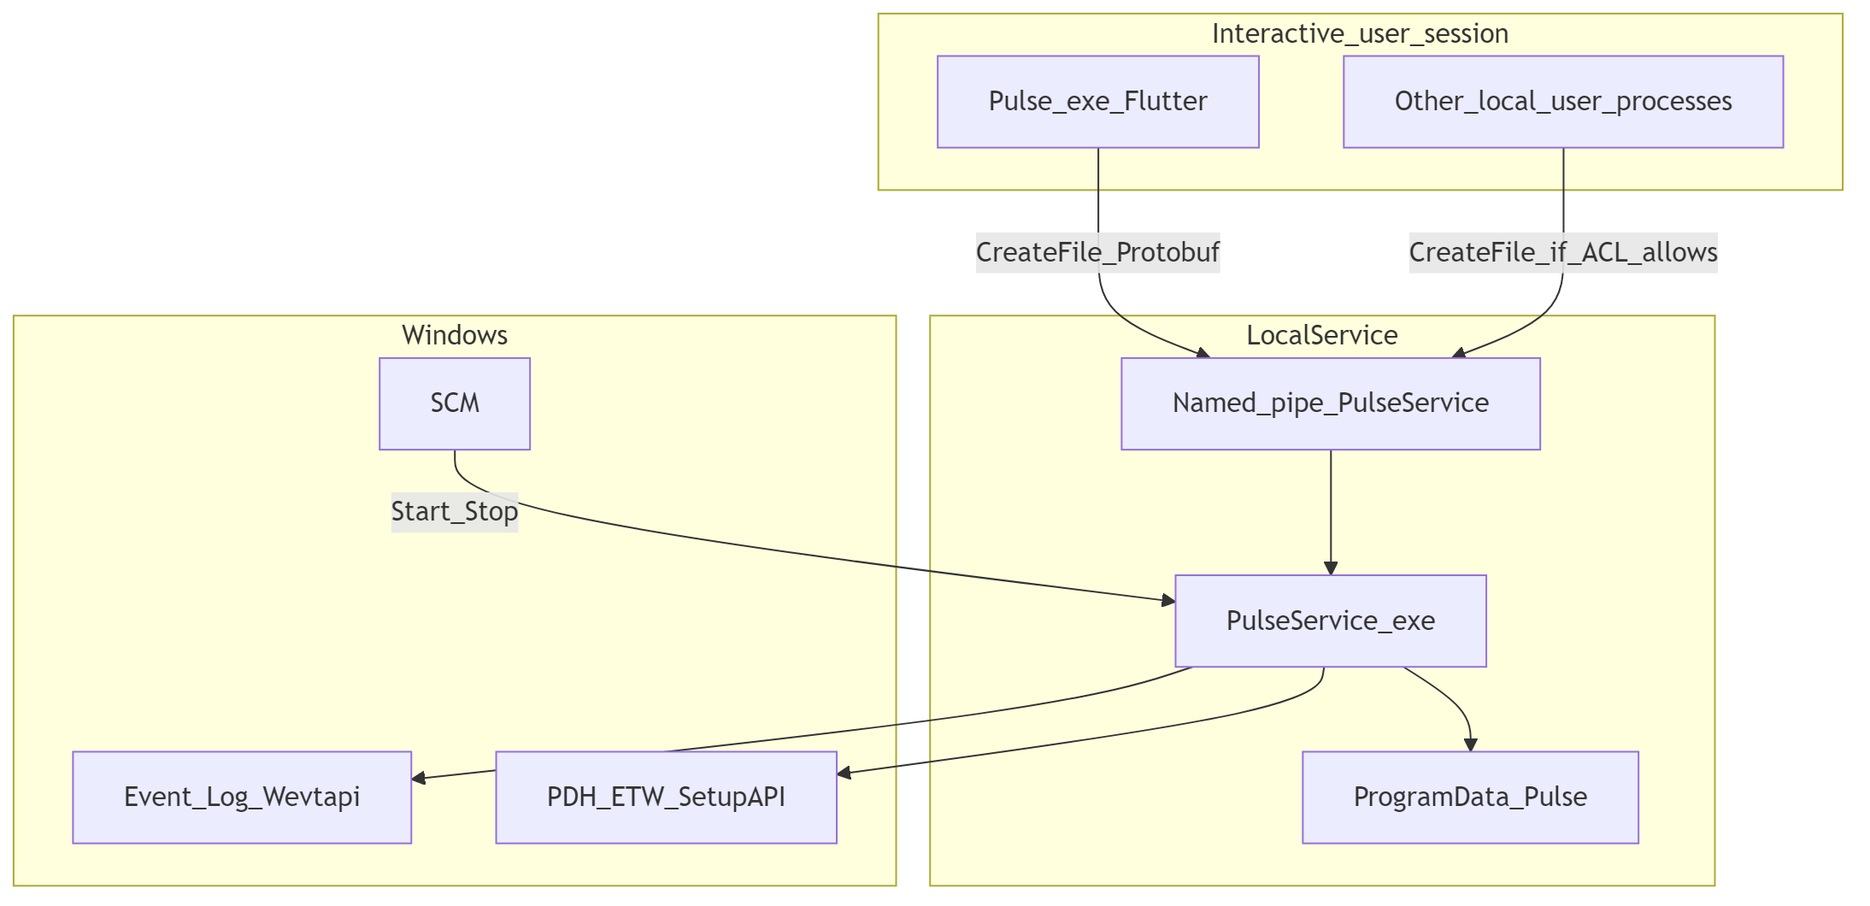
Architecture diagram 7
Risk | Mitigation
Store app recreating classic services | Package identity refuses --install / --uninstall
LocalSystem privilege creep | Not used; localSystemServices not requested
Remote exploitation | No remote listener found
Local pipe access by BU | Disclosed; diagnostics RPCs only; no command execution
Plugin malware | No plugin loader
Silent elevation | Start/Stop uses interactive UAC

Appendix F — Source index
Topic | Artifacts
Product constitution | AGENTS.md
Service decision | docs/architecture/decisions/ADR-002-windows-service.md
IPC decision | docs/architecture/decisions/ADR-003-named-pipe-ipc.md
SCM + package gate | service/pulse_service/src/service_core/service_core.cpp
IPC server | service/pulse_service/src/ipc/ipc_server.cpp
Event Log channels | service/pulse_service/src/collectors/event_log_channels.cpp
Pipe SDDL | shared/pulse_common/include/pulse/constants.hpp
Store packaging | tools/scripts/package_msix_store.ps1, tools/scripts/validate_msix_store.ps1
Store UI gates | apps/pulse_app/lib/application/service_lifecycle_controller.dart, apps/pulse_app/lib/platform/pulse_deployment.dart
Classic installer | tools/installer/Pulse.iss
Store vs classic notes | docs/architecture/41-store-packaged-service.md, docs/guides/microsoft-store.md
Plugin deferral | docs/architecture/decisions/ADR-006-plugin-deferral.md
UI capabilities | apps/pulse_app/pubspec.yaml

