WebATLAS — Use-case status report
Region of Interest and the Analysis Toolbar (Phase 4): use cases and user flows checked against the running system
Source document: docs/superpowers/specs/2026-09-30-roi-analysis-toolbar-design.md, Part 1 (§2 Use cases, §3 User flows)
System under test: Branch feat/registry-plan-b at f67f25e (contains Phase 4, merged to main as 5ac6c01)
Date of pass: 30 September 2026
Environment: Local dev stack: PostGIS + GeoServer (Docker), API on :3001, web app on :5173, Chrome 1440×900

Contents
Contents 2
1. Summary 3
Status legend 3
2. How the evidence was collected 3
3. Use cases 4
UC-1 — "Tỉnh Đắk Lắk có bao nhiêu đập, bao nhiêu hồ?" 4
UC-2 — "Xã này có những trạm quan trắc nào?" 5
UC-3 — "Những đập nào nằm trong 5 km quanh sông Thu Bồn?" 6
UC-4 — "Dọc Quốc lộ 14, trong 2 km có những hồ nào?" 8
UC-5 — "Trắc diện độ cao dọc sông Ba" 9
UC-6 — "Trắc diện theo tuyến tôi vẽ" 10
UC-7 — "Độ cao thấp nhất, cao nhất, trung bình của vùng này" 11
UC-8 — "Ba trạm gần đập X nhất" / "trạm gần hồ này nhất" 13
UC-9 — "Sông này dài bao nhiêu? Vùng tôi khoanh rộng bao nhiêu?" 14
UC-9b — "Từ đây tới đó bao xa?" — a quick check mid-analysis 15
UC-10 — Chained: "sông Thu Bồn + 5 km → các đập trong đó → trạm gần đập lớn nhất" 16
UC-11 — "Xuất kết quả" / "in bản đồ có vùng phân tích" 17
UC-12 — Start over 18
4. User flows 20
F1 — Draw an ROI 21
F2 — Pick from search 22
F3 — Pick from the map popup 23
F5 — Add, change or remove a radius 25
F6 — Run a tool 25
F8 — Failure 26
5. Deferred items (not in Phase 4) 27
6. Findings from this pass 27

1. Summary
Every use case and user flow in the Phase 4 spec was exercised in the running application, and each was screenshotted at the step that shows its outcome. Of the 13 use cases, 11 are Done and 2 are WIP. None are Not Started. Of the 10 user flows, 9 are Done and 1 is WIP.
The two WIP use cases work end to end, but both have a defect that changes the answer the user gets. UC-4 cannot reach the whole of Quốc lộ 14: search offers only short fragments, and the full road exceeds the vertex and part limits. UC-5 profiles only the longest part of a multi-part river (268 of Sông Ba's 349 km) and does not say so. The WIP flow, F8, shows the raw message "Validation failed" for a shape drawn outside Vietnam's bounds, instead of the Vietnamese reason the server already returns.
ID | Use case | Status | Evidence
UC-1 | "Tỉnh Đắk Lắk có bao nhiêu đập, bao nhiêu hồ?" | Done | Fig. 1, 2
UC-2 | "Xã này có những trạm quan trắc nào?" | Done | Fig. 3
UC-3 | "Những đập nào nằm trong 5 km quanh sông Thu Bồn?" | Done | Fig. 4, 5, 6
UC-4 | "Dọc Quốc lộ 14, trong 2 km có những hồ nào?" | WIP | Fig. 7, 8
UC-5 | "Trắc diện độ cao dọc sông Ba" | WIP | Fig. 9
UC-6 | "Trắc diện theo tuyến tôi vẽ" | Done | Fig. 10, 11
UC-7 | "Độ cao thấp nhất, cao nhất, trung bình của vùng này" | Done | Fig. 12, 13, 14
UC-8 | "Ba trạm gần đập X nhất" / "trạm gần hồ này nhất" | Done | Fig. 15, 16
UC-9 | "Sông này dài bao nhiêu? Vùng tôi khoanh rộng bao nhiêu?" | Done | Fig. 4, 12
UC-9b | "Từ đây tới đó bao xa?" — a quick check mid-analysis | Done | Fig. 17, 18
UC-10 | Chained: "sông Thu Bồn + 5 km → các đập trong đó → trạm gần đập lớn nhất" | Done | Fig. 6, 19, 16
UC-11 | "Xuất kết quả" / "in bản đồ có vùng phân tích" | Done | Fig. 20
UC-12 | Start over | Done | Fig. 21

Status legend
- Done Works end to end in the running system as the spec describes. Minor cosmetic notes may remain.
- WIP Built and reachable, but a known defect or gap changes or hides part of the answer.
- Not Started Not built. Used here only for items the spec defers out of Phase 4.

2. How the evidence was collected
- The data stack was checked with npm run atlas:verify: 27 of 29 checks passed. The two failures are "stale" flags on basemap and reference_entities, raised because commit f67f25e pinned a dated Geofabrik extract and so changed their configuration. The loaded data itself passed its probes. The basemap was not rebuilt for this pass, which would have meant a 684 MB download.
- The API (npm start in apps/api) and the web dev server (npm run dev:web) were started, and the app was driven with headless Chrome through puppeteer-core, as a signed-out Viewer, which is the actor for every Phase 4 use case.
- Each use case was run with the example the spec gives, or with the nearest real equivalent in the data where the example has no answer. These substitutions are named in the text.
- Results were cross-checked against the database and the API where a number looked surprising: the stations per ward, the Quốc lộ 14 entities, and the resolve errors.

3. Use cases

UC-1 — "Tỉnh Đắk Lắk có bao nhiêu đập, bao nhiêu hồ?"
Status: Done
ROI: Admin unit (province) Tool: Chọn trong vùng
Searching "Đắk Lắk" returns the province, with the badge "Tỉnh". Pressing "Dùng" sets the ROI, and the chip reads "Tỉnh Đắk Lắk · vùng · 18.086 km²".
Chọn trong vùng over dams and lakes returns 440 features: 13 dams and 427 lakes. The card reads "Kết quả cho: Tỉnh Đắk Lắk" and "Cách đếm: Theo mã hành chính đã gán", which confirms the stamped-code path (FR-17, D11).
Thống kê độ cao is correctly disabled for the province, with the reason "Vùng 18.086 km² vượt giới hạn 5.000 km² của thống kê độ cao" (C-3).
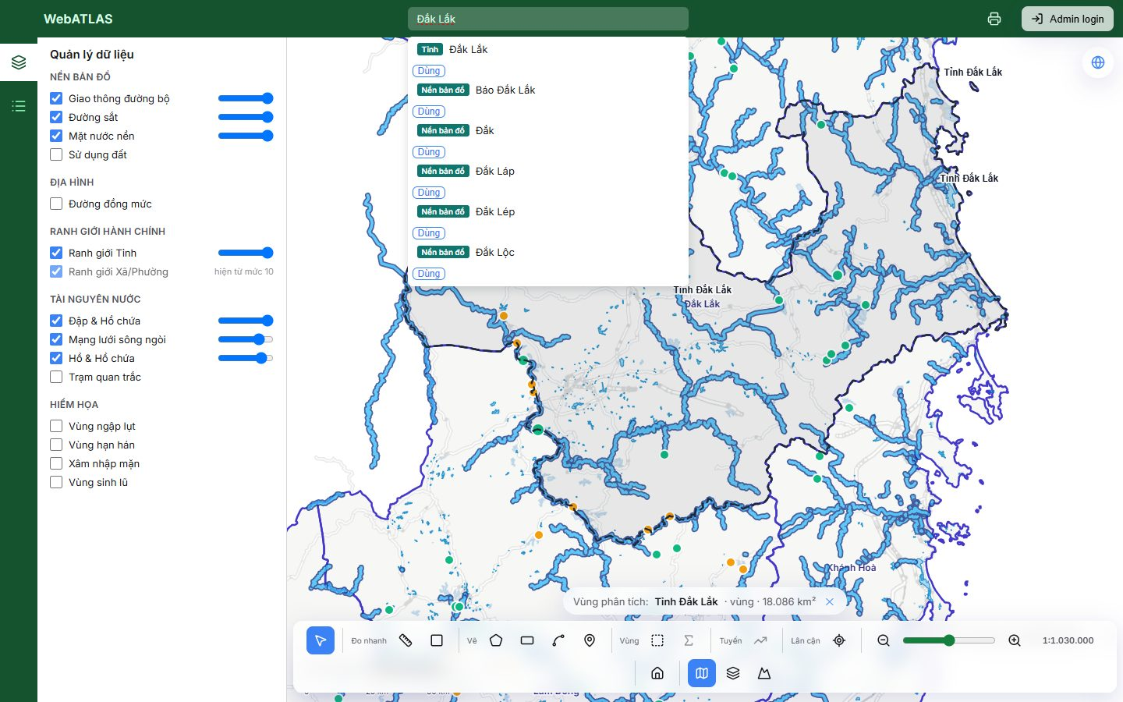
Figure 1. UC-1: the province set as the ROI from search, with the chip showing its area
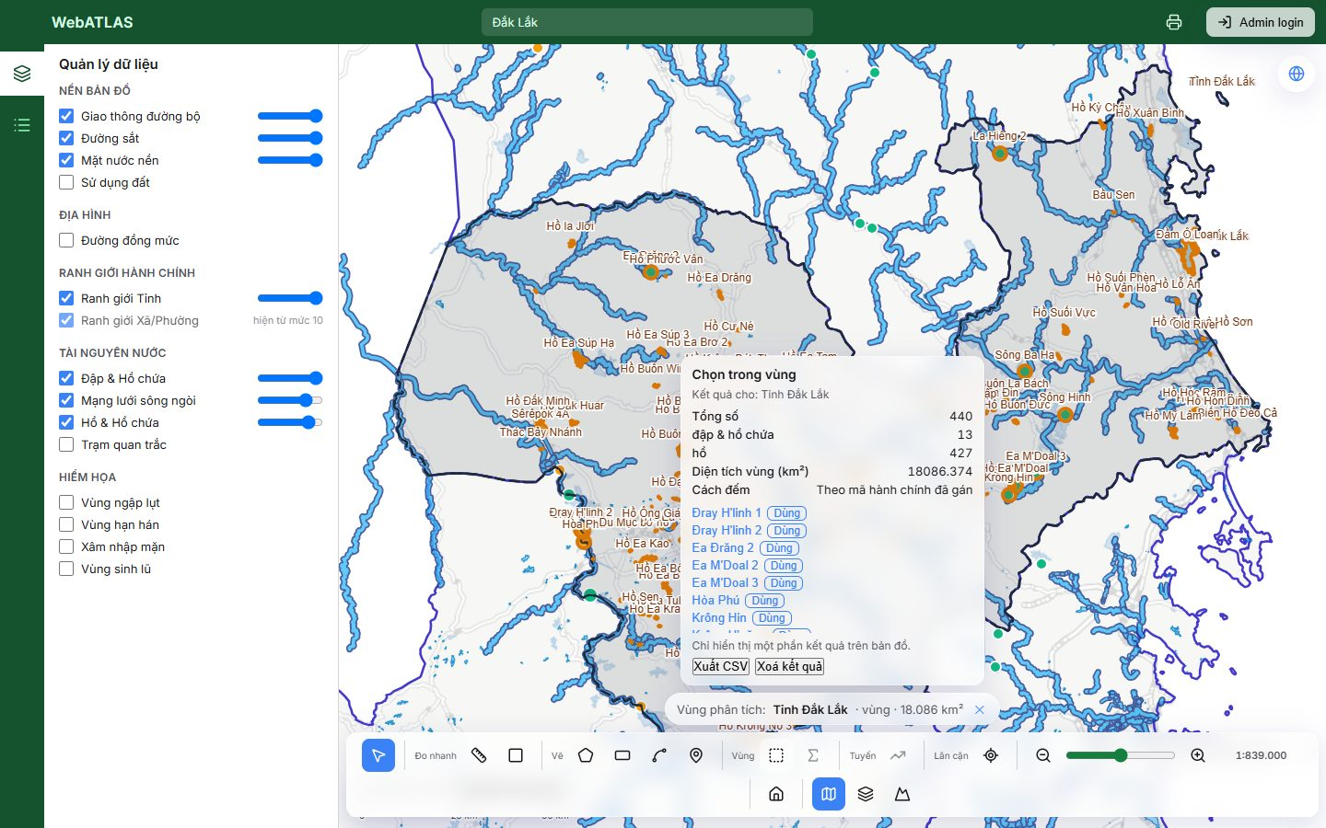
Figure 2. UC-1: 13 dams and 427 lakes in Tỉnh Đắk Lắk, counted by stamped administrative codes

UC-2 — "Xã này có những trạm quan trắc nào?"
Status: Done
ROI: Admin unit (ward) Tool: Chọn trong vùng
Xã Phú Ninh was used because it contains a monitoring station. Only two wards in the data hold one; the station layer has 2 active stations.
Chip: "Xã Phú Ninh · vùng · 132 km²". Result: 1 station, "Trạm Đo Mưa Phú Ninh", counted by stamped codes.
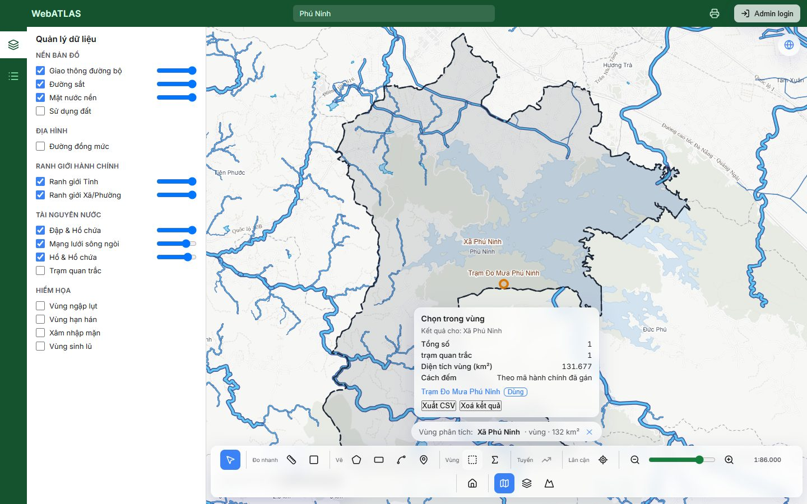
Figure 3. UC-2: the monitoring stations in Xã Phú Ninh

UC-3 — "Những đập nào nằm trong 5 km quanh sông Thu Bồn?"
Status: Done
ROI: River entity + 5 km Tool: Chọn trong vùng
Searching "Thu Bồn" offers the river (badge "Sông") alongside the ward Xã Thu Bồn and a basemap entity. The river resolves as a whole-river line: "Sông Thu Bồn · đường · 95 km".
Adding a 5 km radius from the chip makes it "Sông Thu Bồn + 5 km · vùng · 850 km²". The honest answer is 0 dams: there is none within 5 km of the river in the data.
At 10 km (1,672 km²) the answer is 1 dam, Sông Tranh 4. The buffered ROI is drawn as a dark dashed outline with a faint fill (U-7).
Gaps and notes
- Not a defect: the spec's example returns 0 dams, so demos should use 10 km.
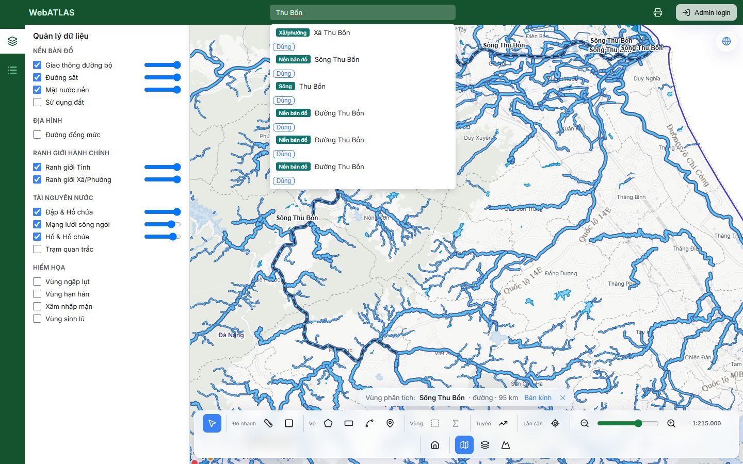
Figure 4. UC-3: Sông Thu Bồn as a line ROI, 95 km
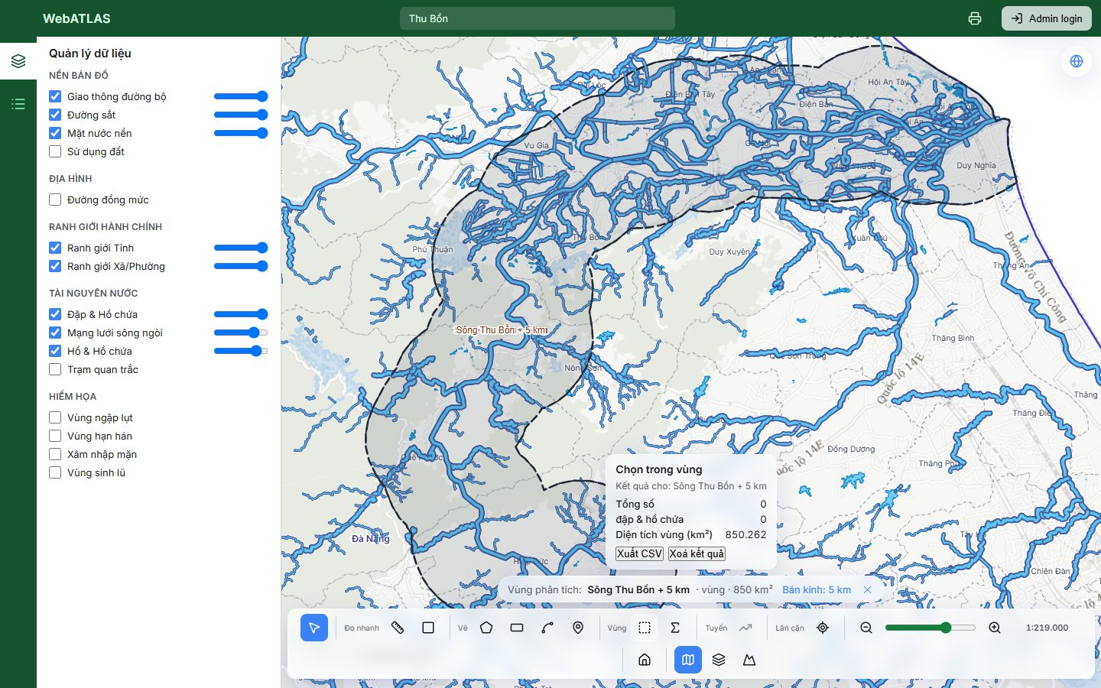
Figure 5. UC-3: Sông Thu Bồn + 5 km has no dams
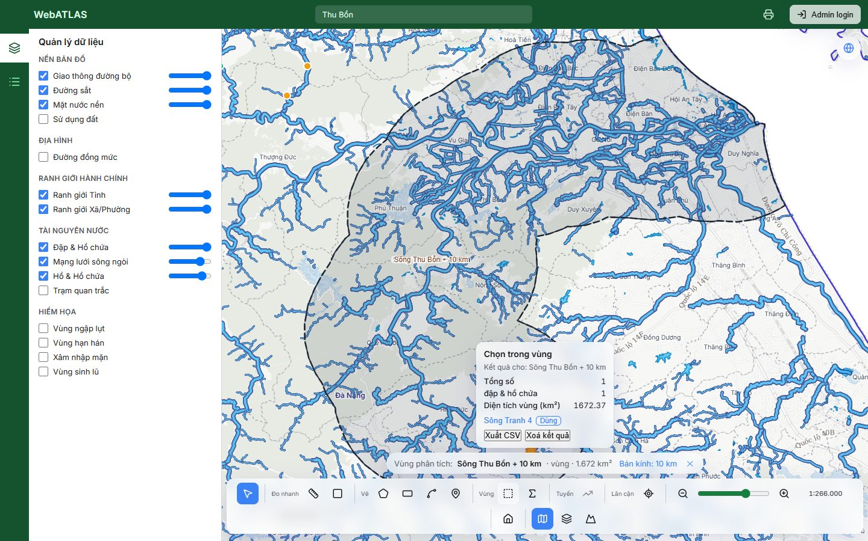
Figure 6. UC-3: Sông Thu Bồn + 10 km has 1 dam (Sông Tranh 4)

UC-4 — "Dọc Quốc lộ 14, trong 2 km có những hồ nào?"
Status: WIP
ROI: Reference entity (road) + 2 km Tool: Chọn trong vùng
The mechanism works: a basemap road from search takes a radius and becomes an area, and Chọn trong vùng lists the lakes inside it. With the third "Quốc lộ 14" hit + 2 km (149 km²), the answer is 10 lakes.
The answer does not cover Quốc lộ 14 itself, though. Searching "Quốc lộ 14" returns three rows, all labelled "Quốc lộ 14". They resolve to a 6.55 km fragment, an 8.1 km fragment and a 42 km section that the chip labels "HCM".
Gaps and notes
- The whole highway is a separate entity, "Quốc lộ 14 - Đường Hồ Chí Minh" (ref QL.14, 998 km). It does not appear in the search results for "Quốc lộ 14".
- Resolving that entity directly is refused: "22.662 điểm vượt giới hạn 10.000 điểm…; 647 phần rời rạc vượt giới hạn 300 phần". So the question as asked cannot be answered for the full road.
- Identical search labels give no way to tell the fragments apart, such as a length or a ref. The chip's label ("HCM") also differs from the search row's label.
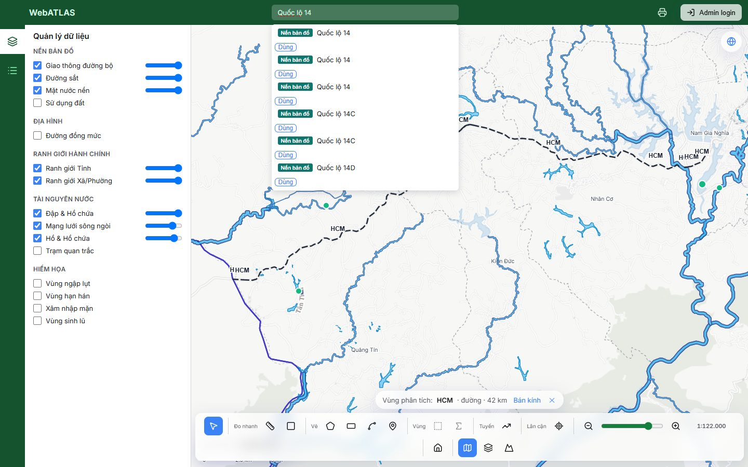
Figure 7. UC-4: three identical "Quốc lộ 14" rows in search, none of which is the full highway
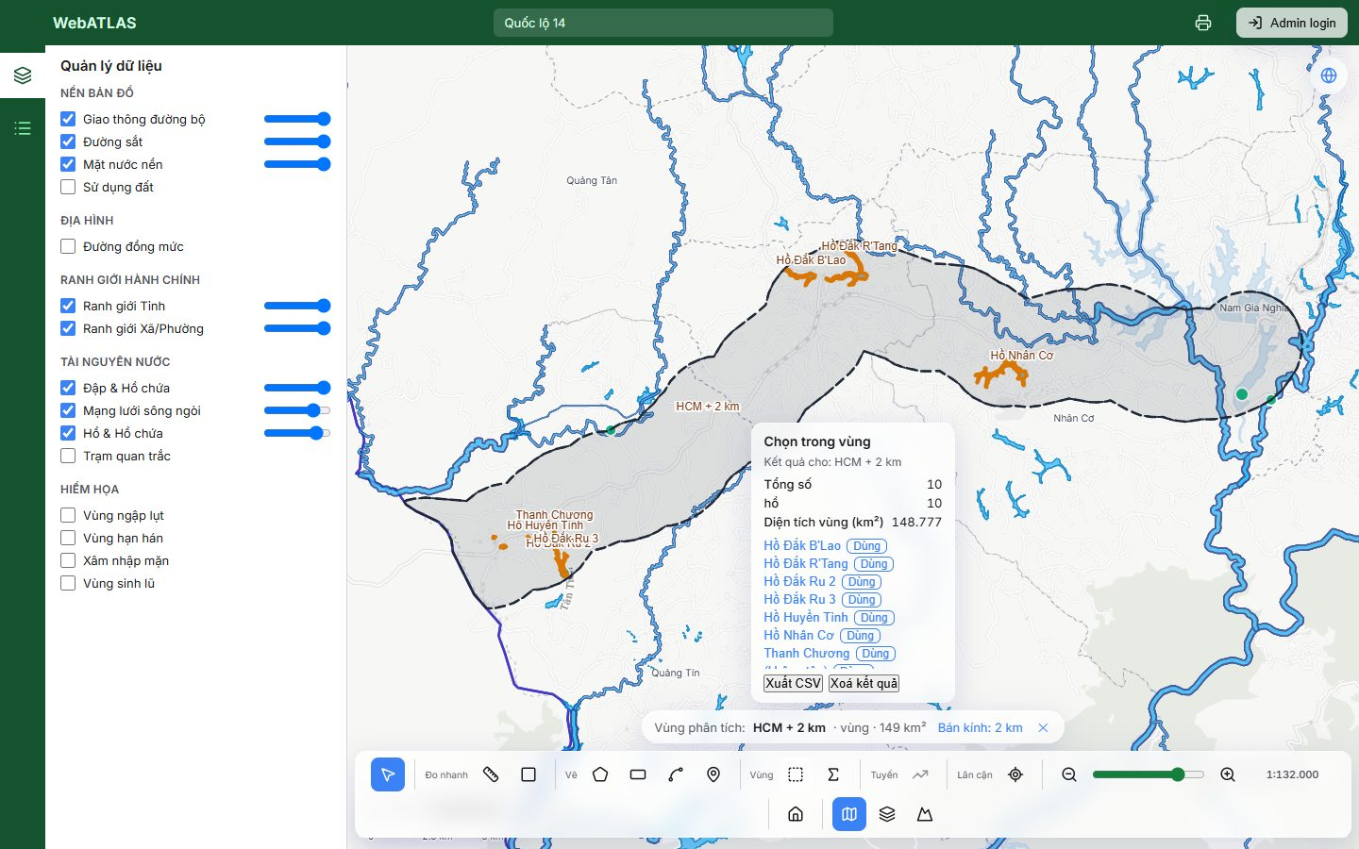
Figure 8. UC-4: the third hit (resolved as "HCM", 42 km) + 2 km contains 10 lakes

UC-5 — "Trắc diện độ cao dọc sông Ba"
Status: WIP
ROI: River entity (line) Tool: Trắc diện độ cao
Sông Ba from search becomes "Sông Ba · đường · 349 km". Trắc diện độ cao enables and returns a profile from 460 m to 19 m, with 100/100 samples and the FABDEM attribution.
Gaps and notes
- The profile's length is 268.31 km against the ROI's 349 km. For a multi-part river, only the longest part is profiled, and the card does not say so. This is the Phase 4 review's known follow-up, "profile covers only the longest part".
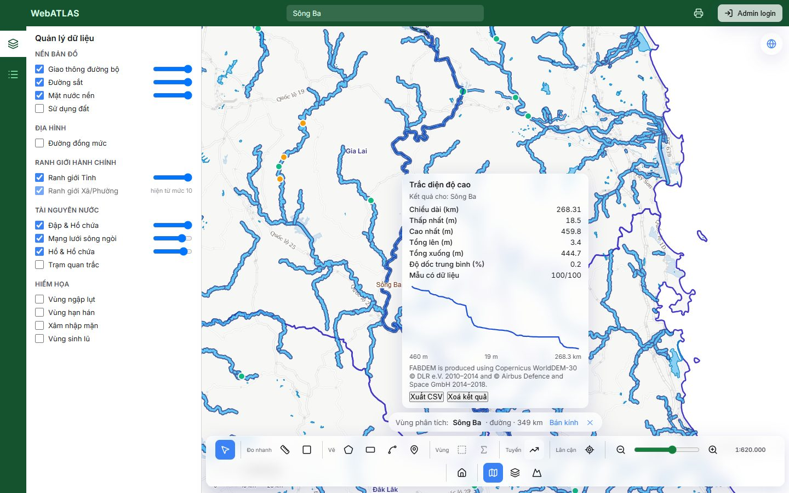
Figure 9. UC-5: elevation profile of Sông Ba, covering 268 of 349 km

UC-6 — "Trắc diện theo tuyến tôi vẽ"
Status: Done
ROI: Drawn line Tool: Trắc diện độ cao
"Vẽ đường" puts the drawing hint and a live length in the chip. Enter finishes the line and the ROI becomes "Hình vẽ · đường · 33 km".
Trắc diện độ cao then returns a 33.18 km profile (5–761 m, average slope 11.6 %).
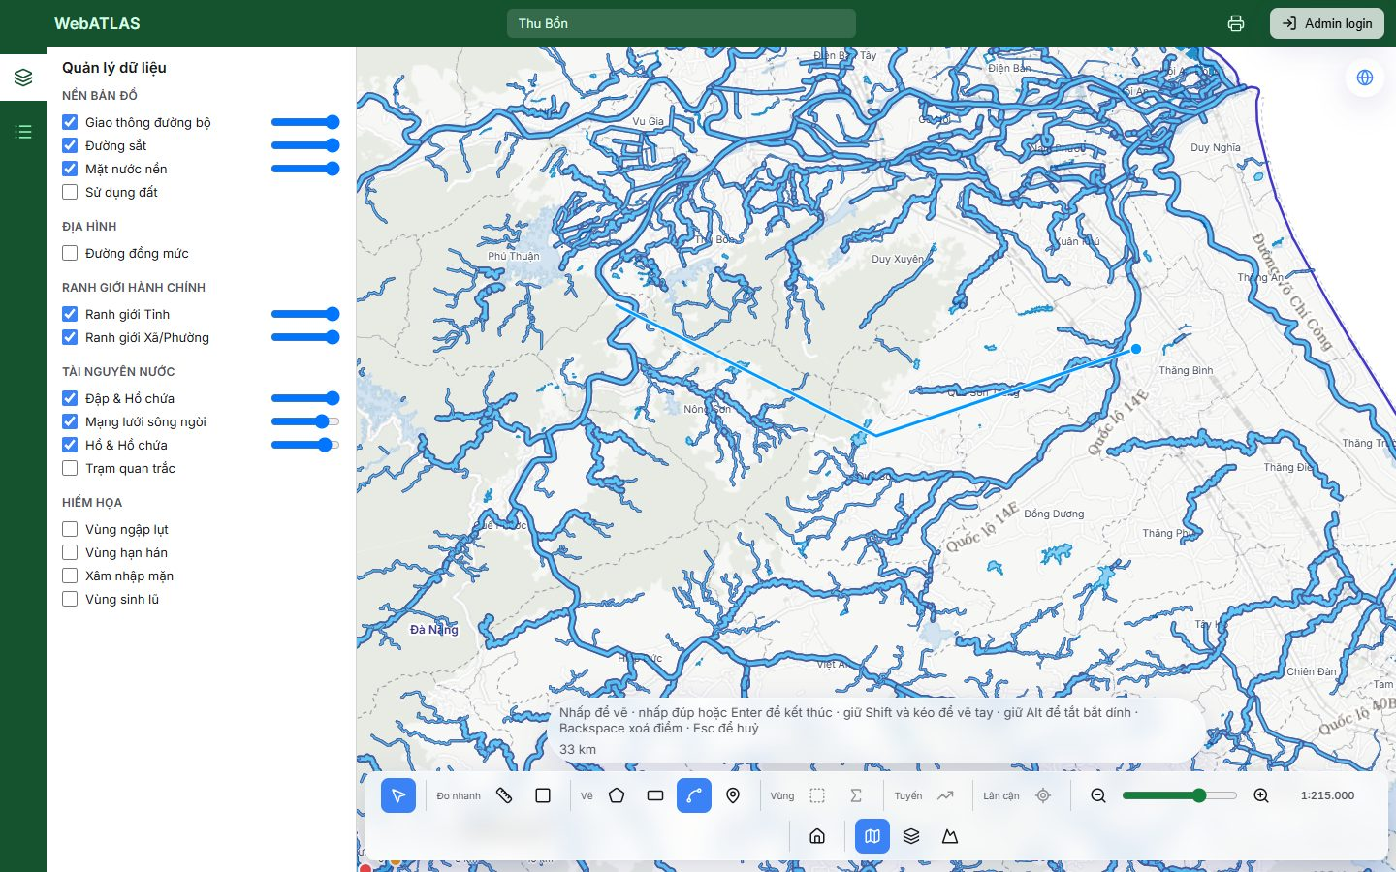
Figure 10. UC-6: drawing a line, with the hint and the live length (33 km) in the chip
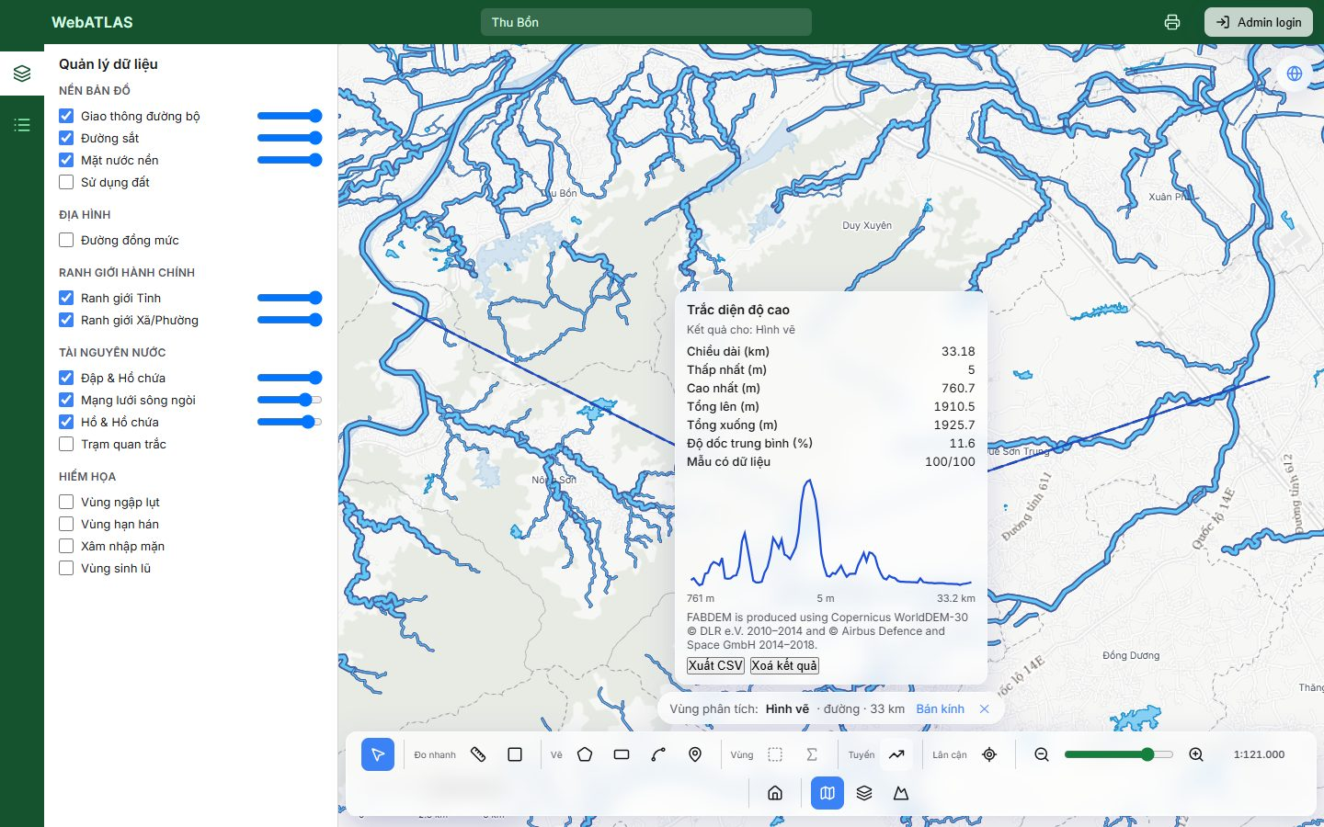
Figure 11. UC-6: the profile along the drawn line

UC-7 — "Độ cao thấp nhất, cao nhất, trung bình của vùng này"
Status: Done
ROI: Drawn area, lake, or ward Tool: Thống kê độ cao
Drawn polygon (58 km²): lowest 25.6 m, highest 393.5 m, mean 87 m, over 63,701 pixels.
Lake Hồ Ea Kar (lakes layer, 1.32 km²): lowest 474 m, highest 482.1 m, mean 474.1 m.
Wards fit under the 5,000 km² limit. Provinces are refused by design, with the reason shown (see UC-1).
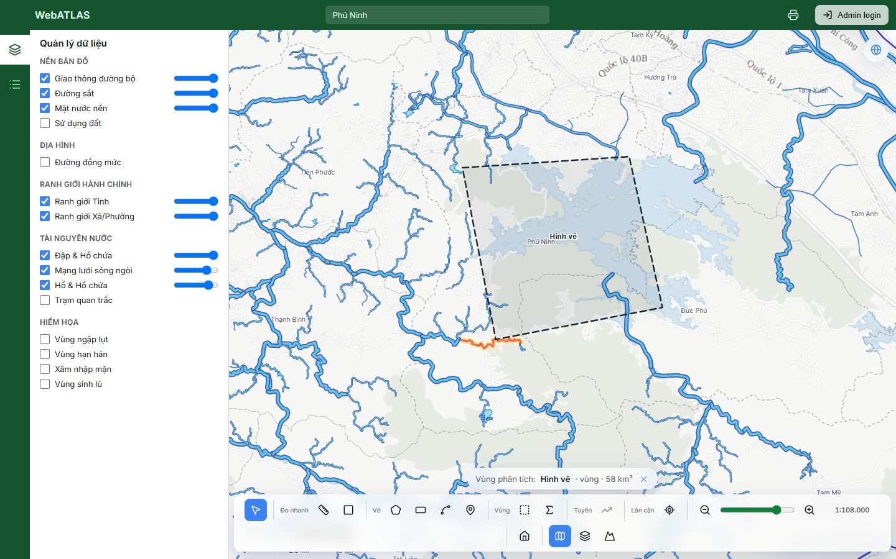
Figure 12. UC-7: a drawn polygon committed as the ROI ("Hình vẽ · vùng · 58 km²")
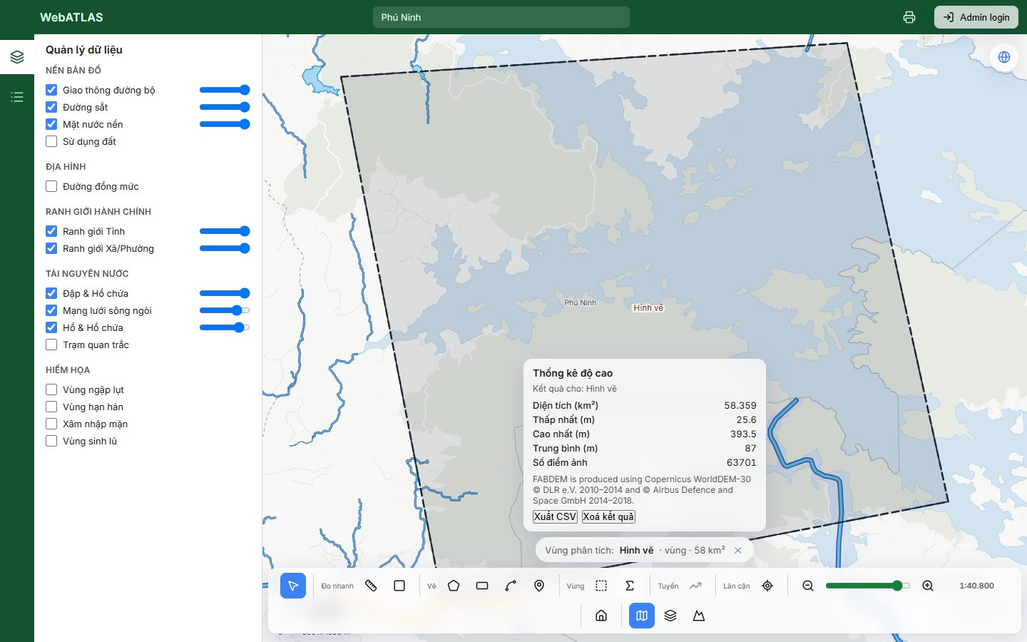
Figure 13. UC-7: elevation statistics for the drawn area
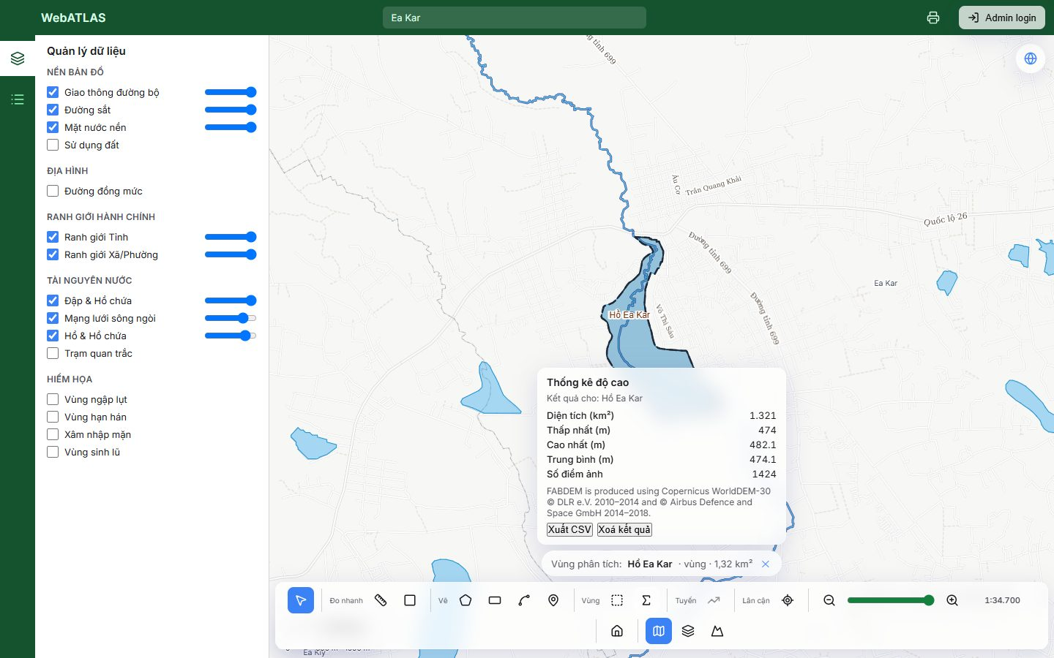
Figure 14. UC-7: elevation statistics for Hồ Ea Kar

UC-8 — "Ba trạm gần đập X nhất" / "trạm gần hồ này nhất"
Status: Done
ROI: Dam (point), or any ROI via its centroid Tool: Gần nhất
With the dam Sông Tranh 4 as the ROI, Gần nhất (layer: trạm quan trắc, k = 3) returns both stations that exist: Trạm Đo Mưa Phú Ninh at 32.3 km and Trạm Thủy văn An Khê at 174.69 km. The card names the origin ("Tính từ: Sông Tranh 4") and the map draws the connecting lines.
Only 2 are returned for k = 3 because the layer holds only 2 active stations.
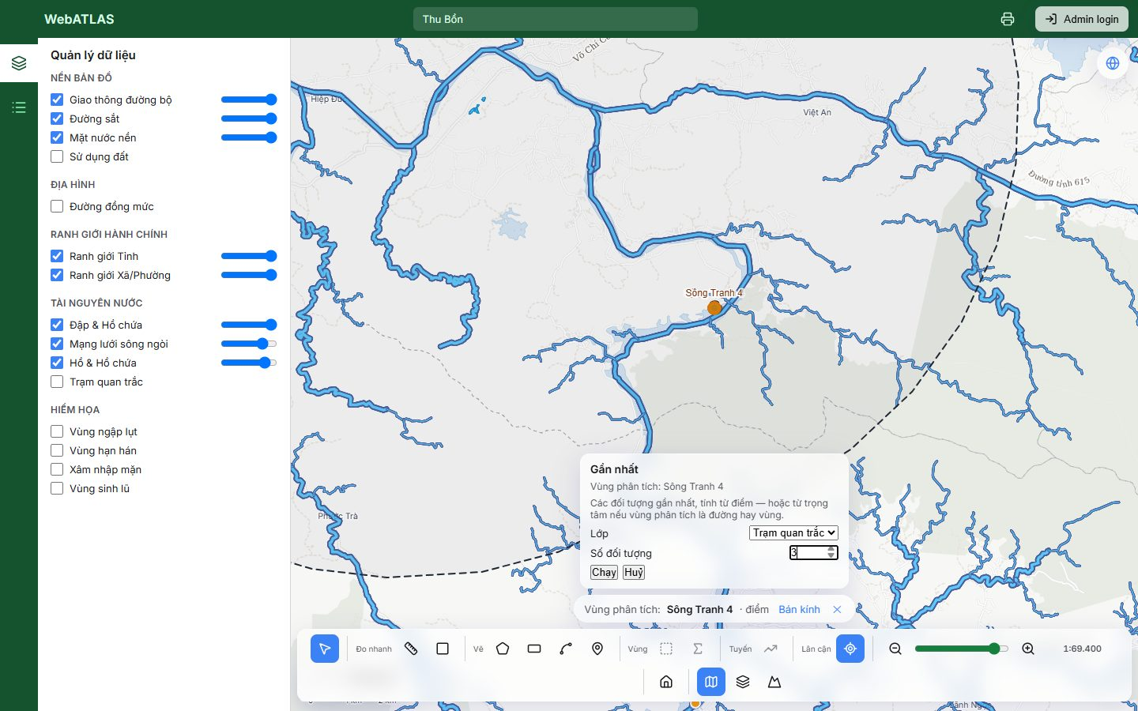
Figure 15. UC-8: the Gần nhất panel shows only its own parameters (layer, k) and "Chạy"
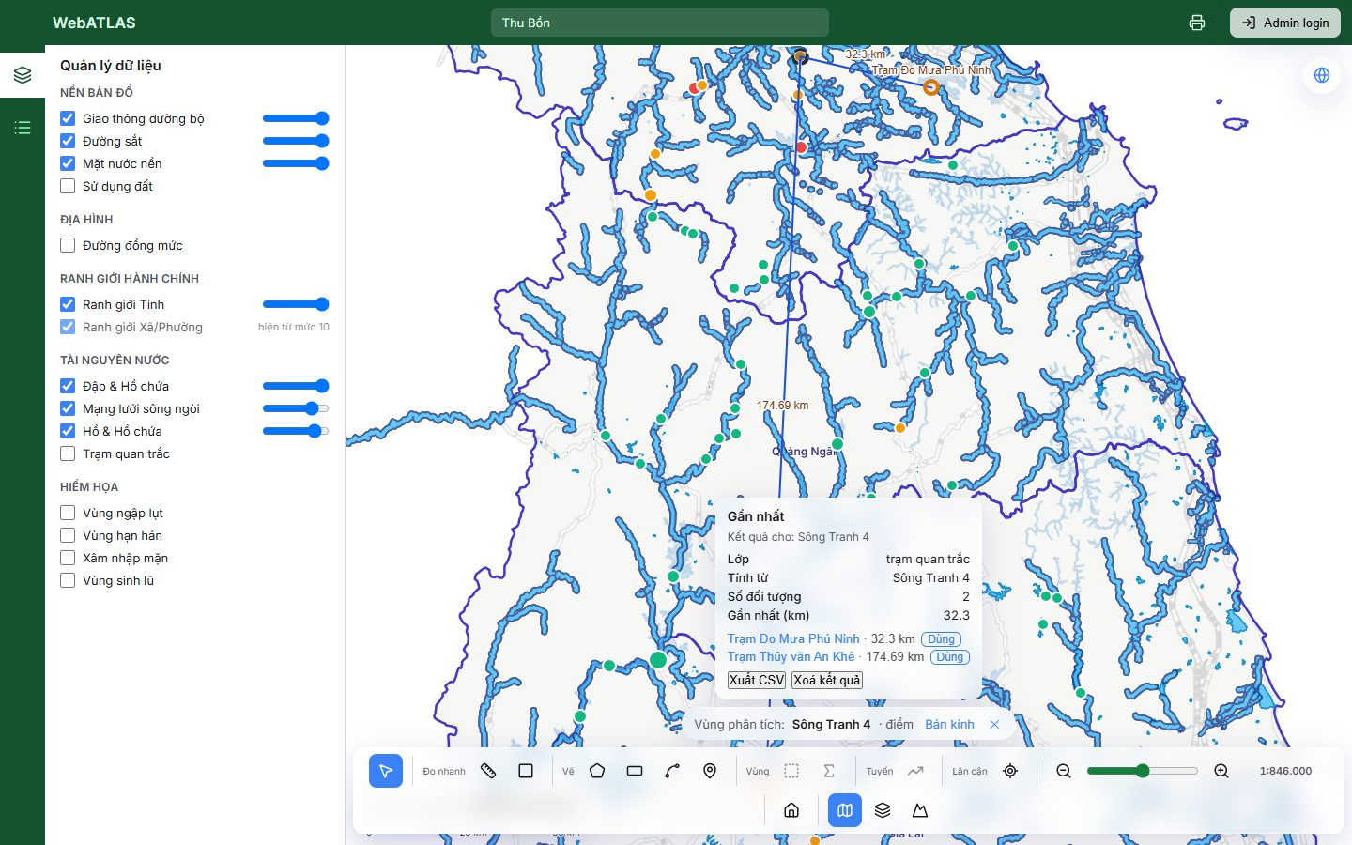
Figure 16. UC-8: the stations nearest to the dam Sông Tranh 4

UC-9 — "Sông này dài bao nhiêu? Vùng tôi khoanh rộng bao nhiêu?"
Status: Done
ROI: Any line or area Tool: The chip's measure
The chip always states the ROI's measure: "Sông Thu Bồn · đường · 95 km", "Sông Ba · đường · 349 km", "Hình vẽ · vùng · 58 km²", "Tỉnh Đắk Lắk · vùng · 18.086 km²". Numbers use Vietnamese formatting (FR-5).
See Figure 4.
See Figure 12.

UC-9b — "Từ đây tới đó bao xa?" — a quick check mid-analysis
Status: Done
ROI: None; the ROI must survive Tool: Đo nhanh ruler
With the dam ROI active, "Đo chiều dài" measures live ("Đang đo: 67 km", then 98 km). The chip still reads "Vùng phân tích: Sông Tranh 4 · điểm" throughout, and after the ruler is closed (FR-16, D9).
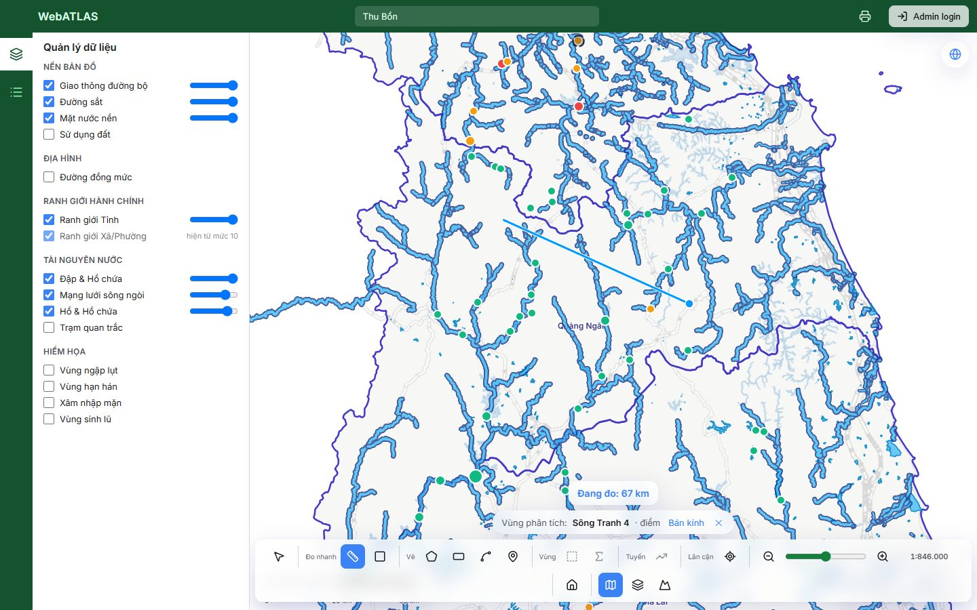
Figure 17. UC-9b: the ruler measuring while the ROI stays in the chip
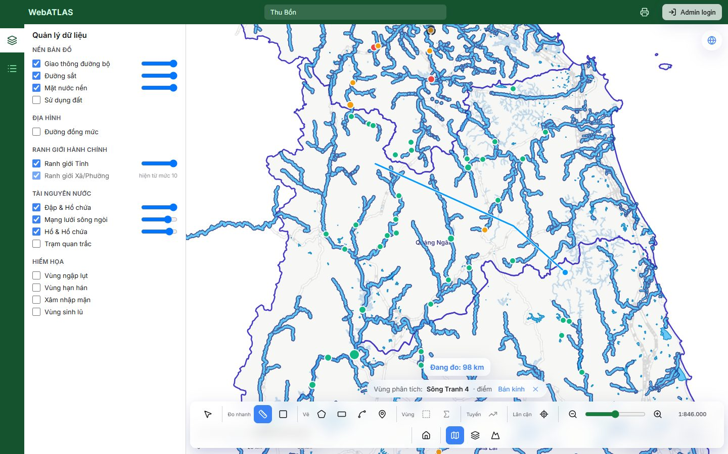
Figure 18. UC-9b: the finished measurement, with the ROI untouched

UC-10 — Chained: "sông Thu Bồn + 5 km → các đập trong đó → trạm gần đập lớn nhất"
Status: Done
ROI: River + radius, then a dam from the result list Tool: Chọn trong vùng, then Gần nhất
Sông Thu Bồn + 10 km → Chọn trong vùng (dams) → "Dùng" on the Sông Tranh 4 row → Gần nhất (stations). A 10 km radius was used because 5 km contains no dam (UC-3).
After the row's "Dùng", the ROI becomes the dam and the map fits to it. The old card still names the ROI it was computed for, "Sông Thu Bồn + 10 km" (F6 step 3, C-6).
See Figure 6.
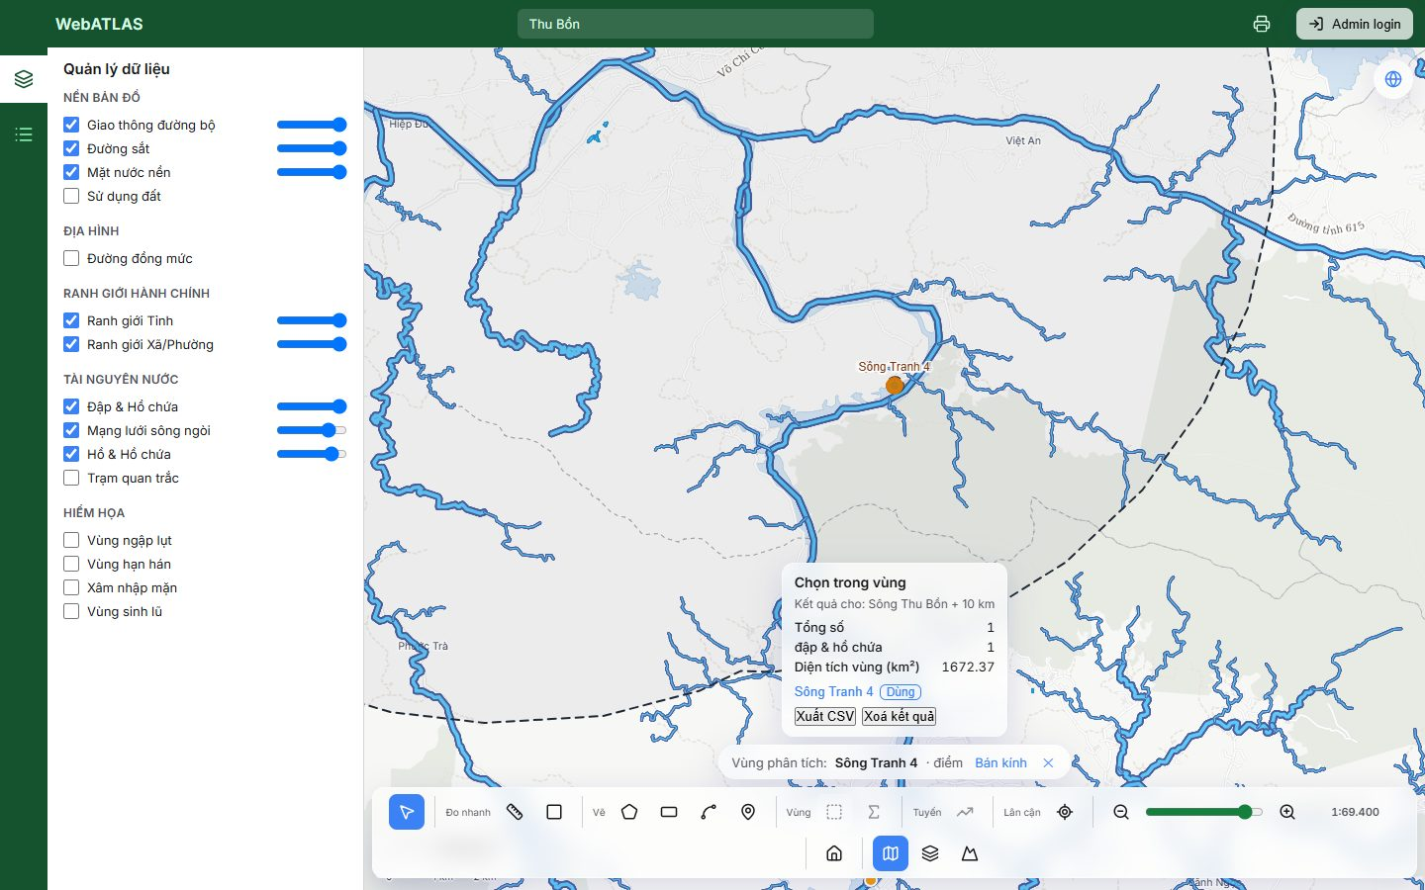
Figure 19. UC-10 / F4: the dam from the result row becomes the ROI, while the card keeps its own ROI label
See Figure 16.

UC-11 — "Xuất kết quả" / "in bản đồ có vùng phân tích"
Status: Done
ROI: Any Tool: Existing CSV export; existing print
"Xuất CSV" downloads phan-tich-<tool>.csv. The Gần nhất export begins "Lớp, trạm quan trắc / Tính từ, Sông Tranh 4 / Số đối tượng, 2".
The print page (top-bar printer icon) shows the map with the ROI outline, the legend, scale, CRS, date and the result table, and offers "Tải PNG" and "In / PDF".
Gaps and notes
- The print's result section does not name the ROI ("Kết quả cho: …"), unlike the on-screen card.
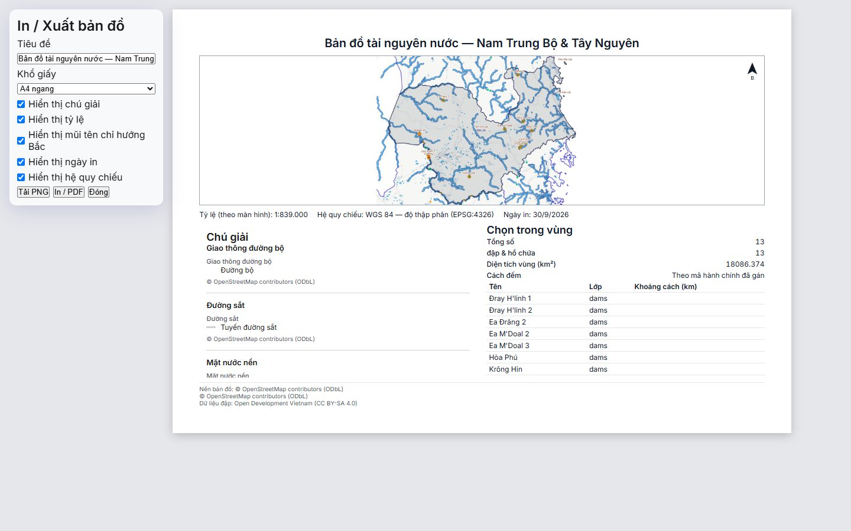
Figure 20. UC-11: print preview with the Đắk Lắk ROI outline and the Chọn trong vùng table

UC-12 — Start over
Status: Done
ROI: — Tool: Clear the ROI
✕ on the chip ("Bỏ vùng phân tích") removes the ROI and its outline. The chip returns to the empty-state text and every tool disables again with "Chưa có vùng phân tích" (F7).
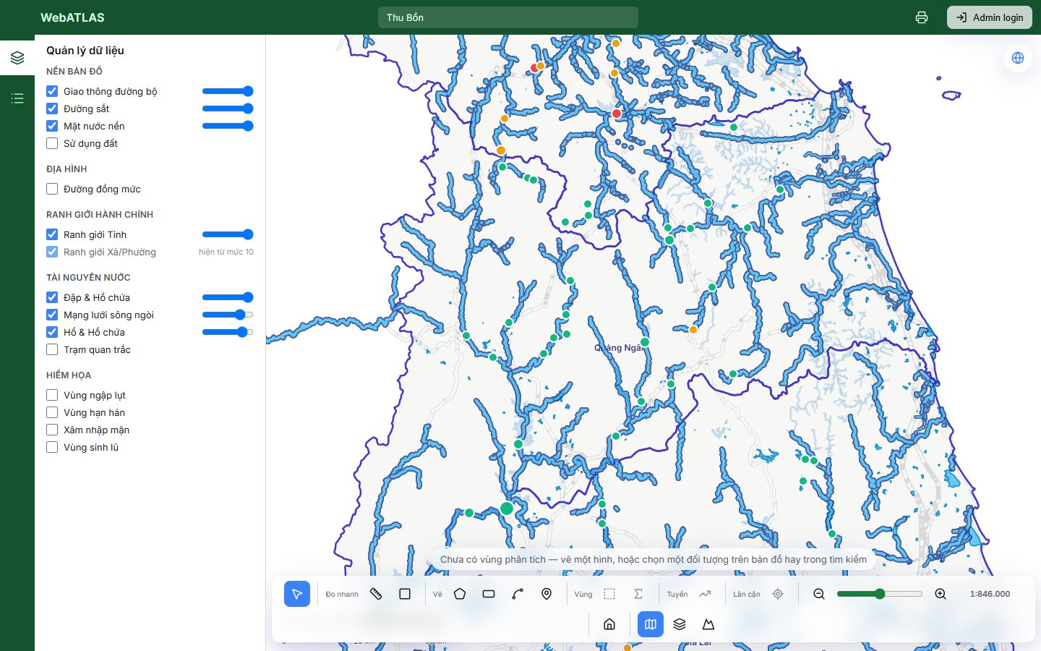
Figure 21. UC-12: after clearing, the chip is empty and the tools are disabled

4. User flows
Flow | Description | Status | Evidence / notes
F1 | Draw an ROI | Done | Hint, live measure, snap-to-close cue ("Nhấp để khép vùng"), Enter to finish, and self-intersection refused ("Vùng tự cắt nhau — hãy vẽ lại").
F2 | Pick from search | Done | Provinces, wards, layer features and basemap entities all carry "Dùng". Cosmetic: the button wraps onto its own line under each hit.
F3 | Pick from the map popup | Done | The popup lists candidates most specific first. A river way offers the whole river ("Sông Tranh · cả sông", FR-13), then the ward, then the province.
F4 | Pick from a result | Done | Every result row with a feature has "Dùng". Shown in UC-10.
F5 | Add, change or remove a radius | Done | An inline editor with presets 1/2/5/10 km, a number field, Enter/Esc and "Bỏ bán kính". The chip shows "Bán kính: N km" once a radius is set.
F6 | Run a tool | Done | The panel shows only the tool's parameters and "Chạy", and the card names its ROI. Disabled tools stay focusable and show their reason on hover, focus or press (U-2).
F7 | Clear | Done | Shown in UC-12.
F7b | Quick measurement | Done | Shown in UC-9b. The ruler never touches the ROI.
F8 | Failure | WIP | Over-limit and outside-the-working-region errors keep the previous ROI and give a clear Vietnamese reason. A shape outside Vietnam's bounds shows "Validation failed": the API's Vietnamese reason sits in details.fieldErrors, and the chip does not read it.

F1 — Draw an ROI
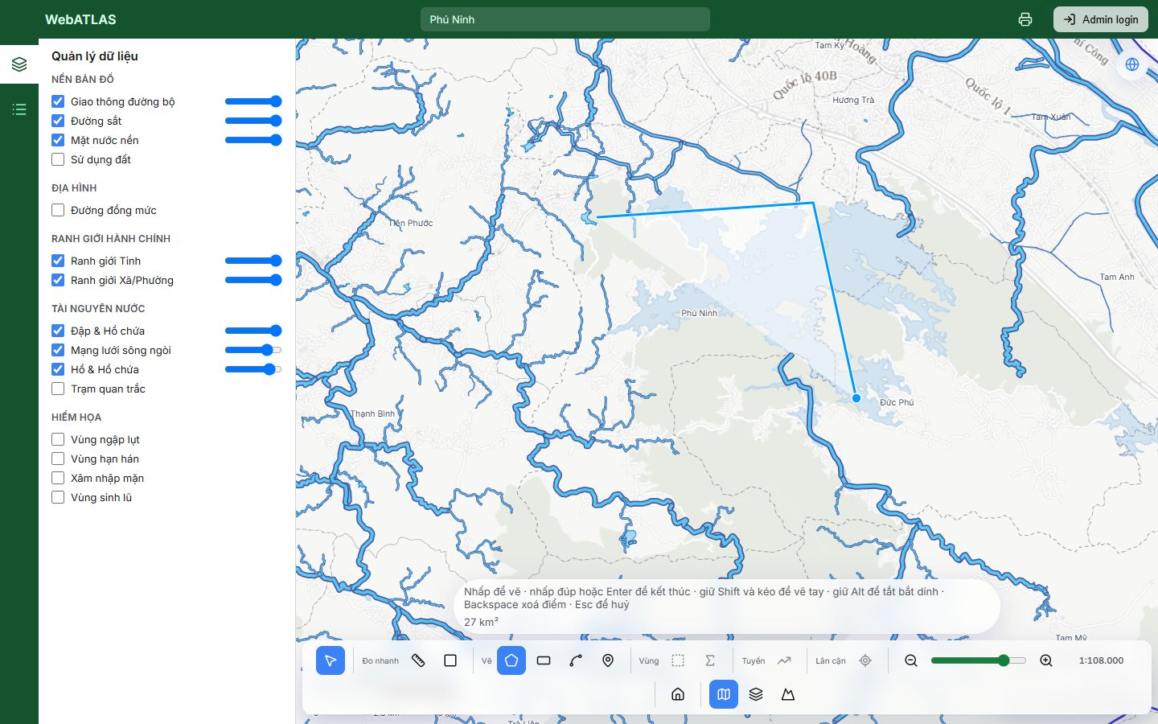
Figure 22. F1: drawing a polygon, with the full hint and live area in the chip
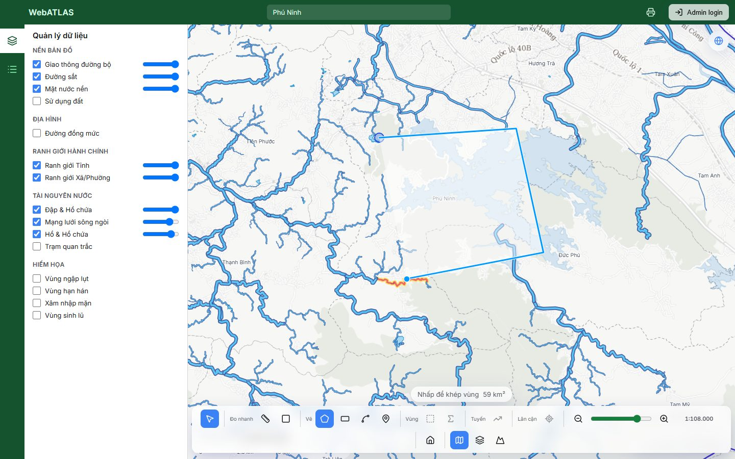
Figure 23. F1 / U-11: the first vertex is enlarged and the hint becomes "Nhấp để khép vùng"
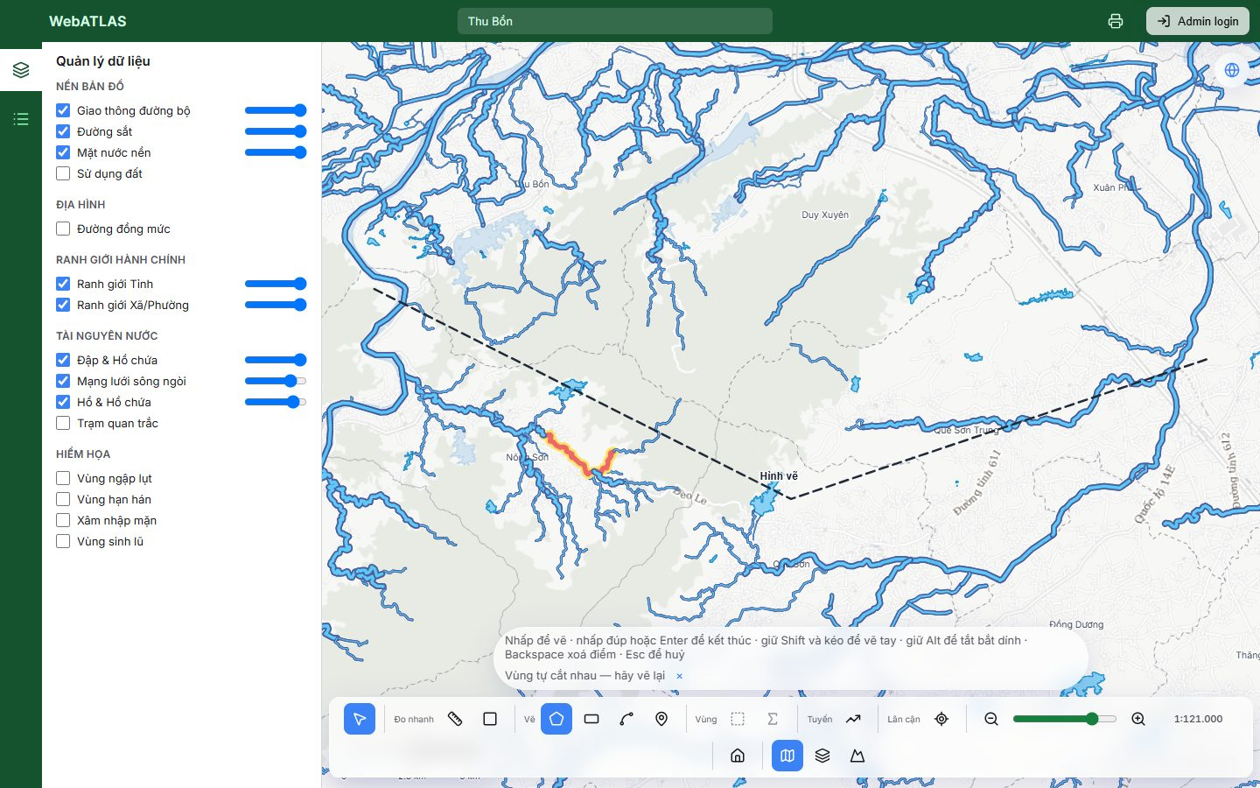
Figure 24. F1 / U-11: a self-intersecting polygon is refused before any request

F2 — Pick from search
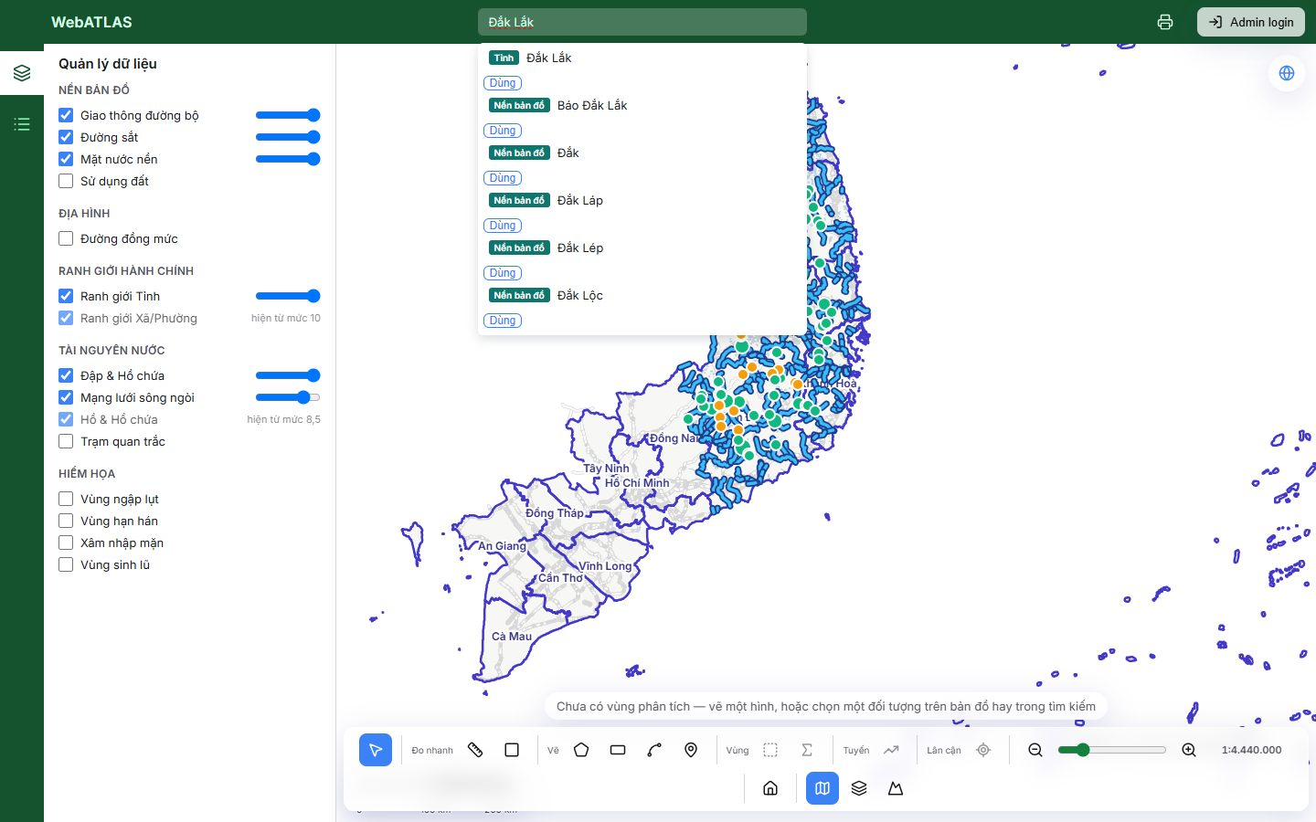
Figure 25. F2: search results for "Đắk Lắk", with badges (Tỉnh, Nền bản đồ, Xã/phường) and "Dùng"
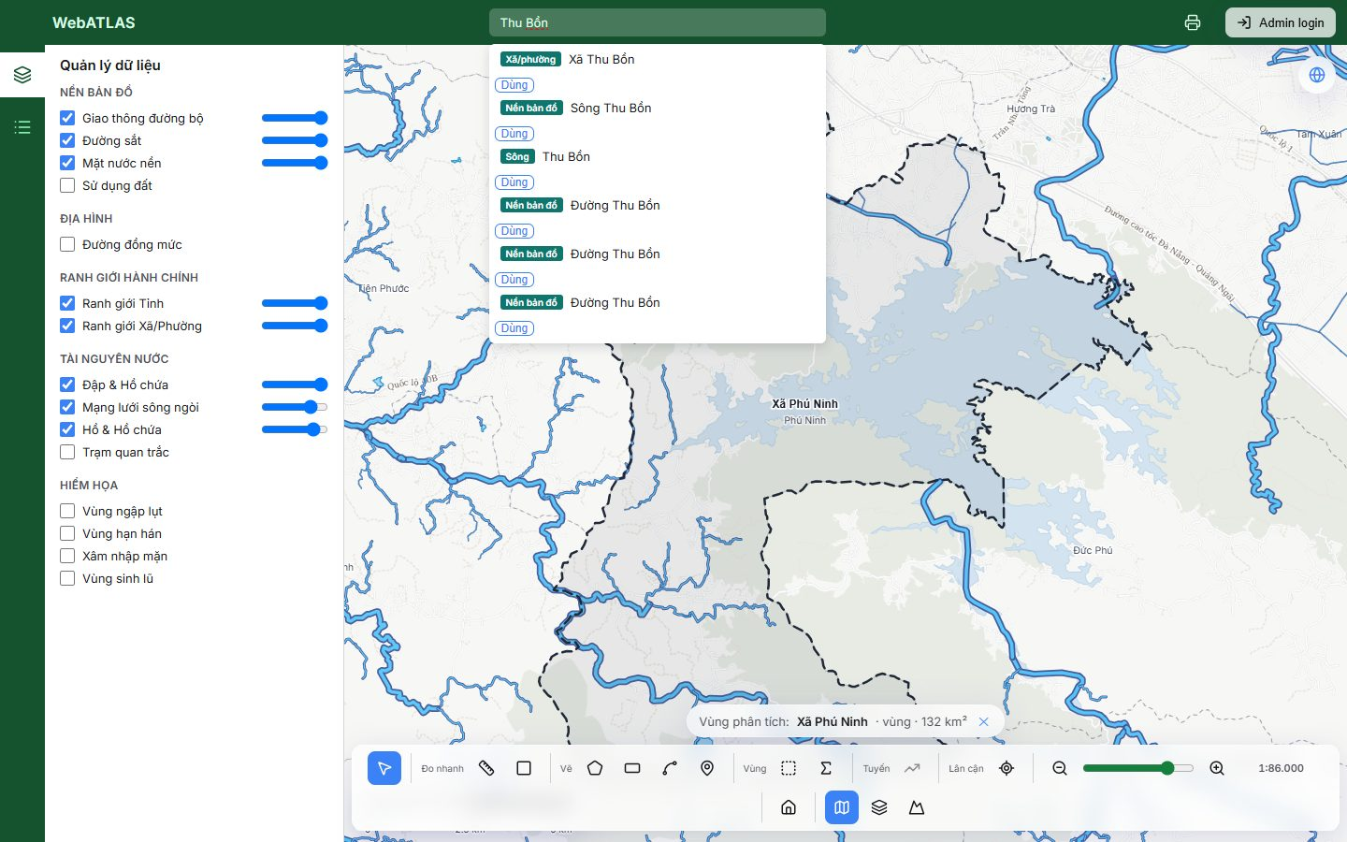
Figure 26. F2: search results for "Thu Bồn": the ward, the basemap entity and the river

F3 — Pick from the map popup
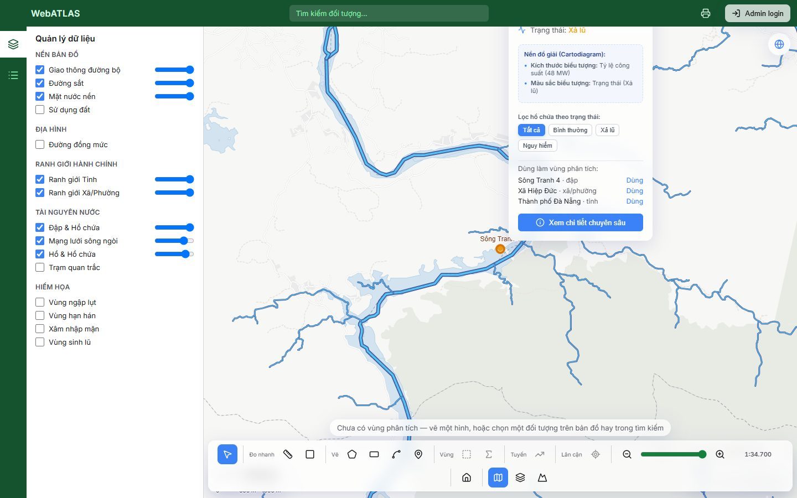
Figure 27. F3: popup on a dam, listing the dam, ward and province candidates
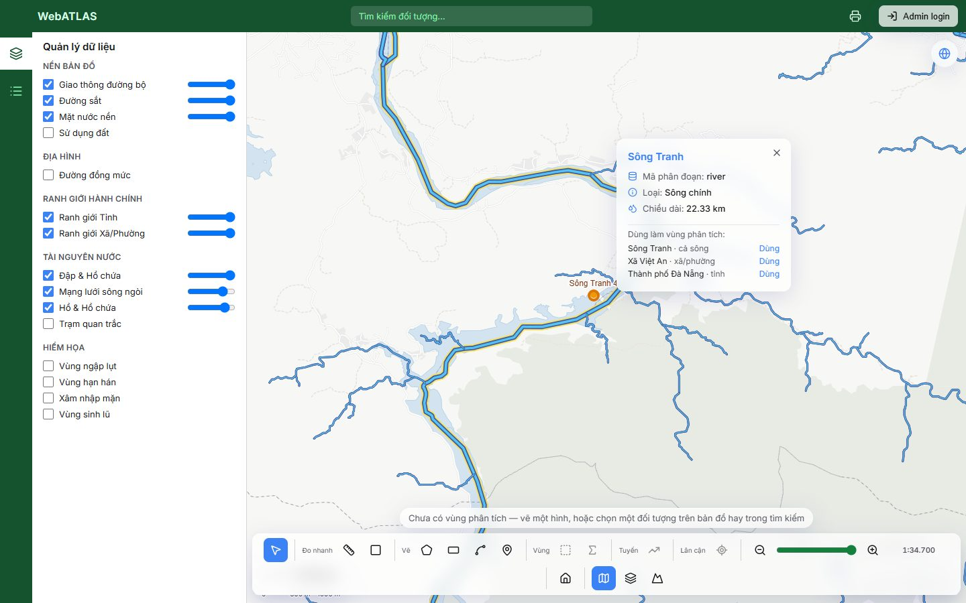
Figure 28. F3: popup on a river way, offering the whole river first
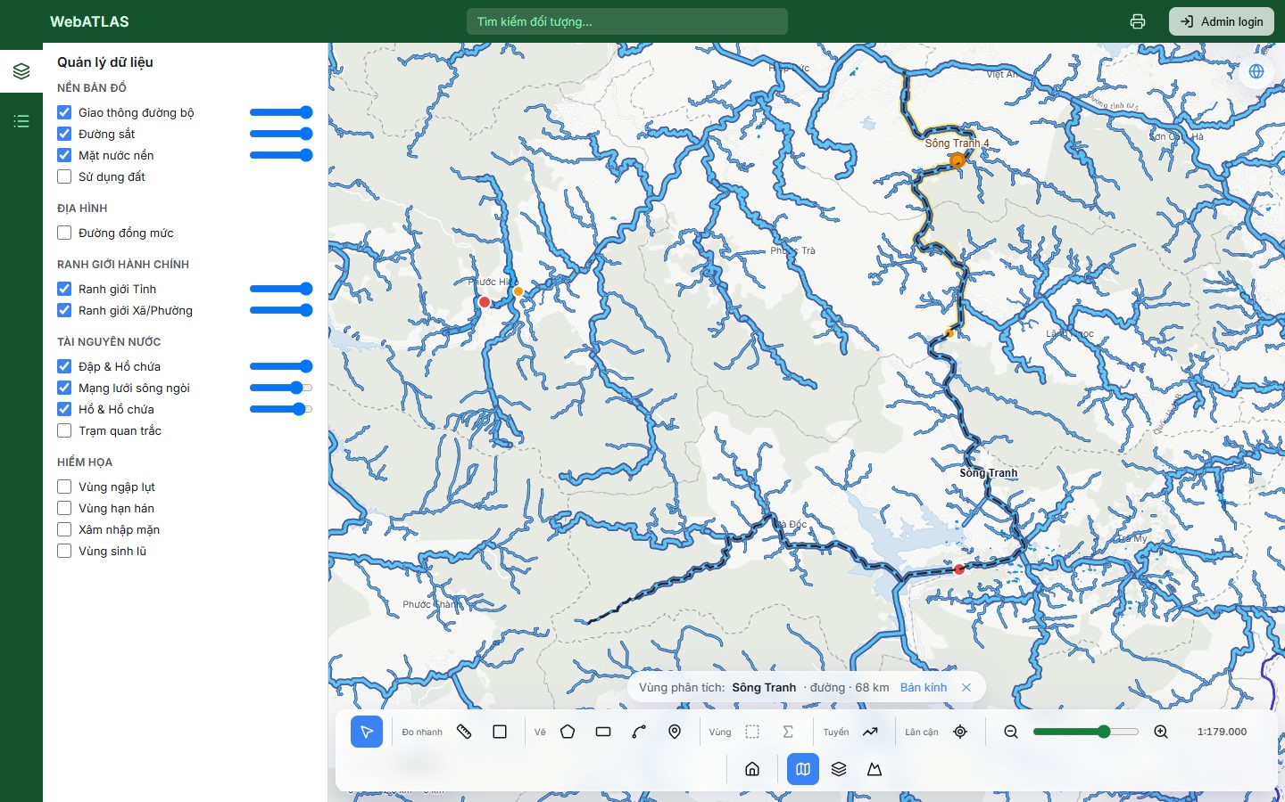
Figure 29. F3: "Sông Tranh" set as the ROI from the popup (68 km)

F5 — Add, change or remove a radius
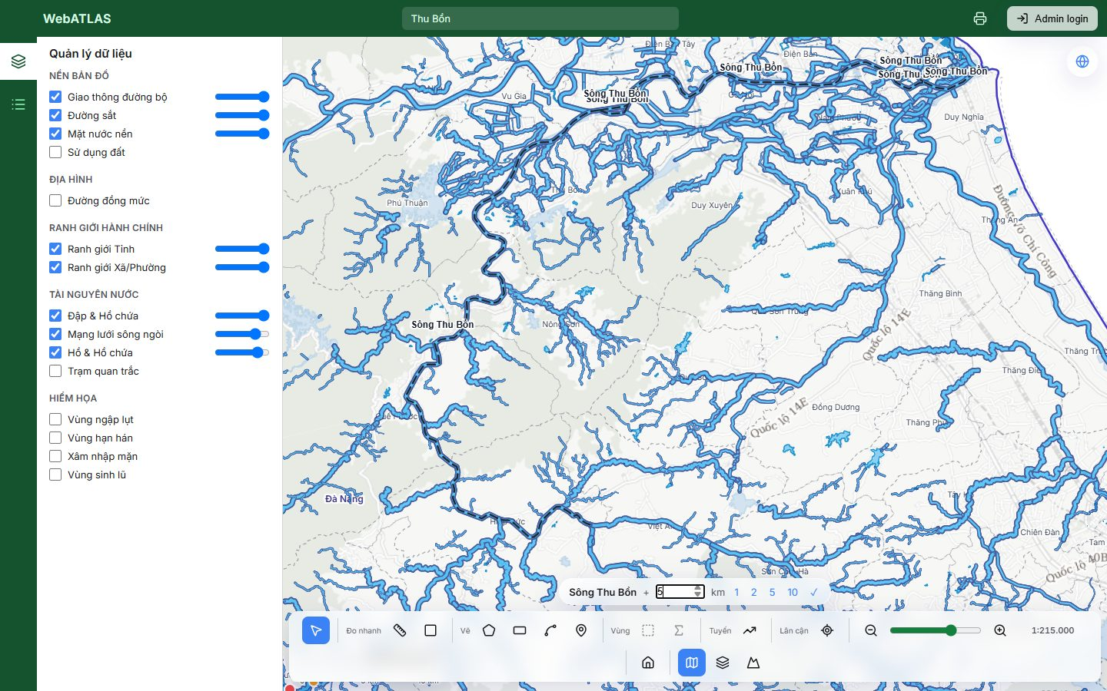
Figure 30. F5: the inline radius editor on the chip

F6 — Run a tool
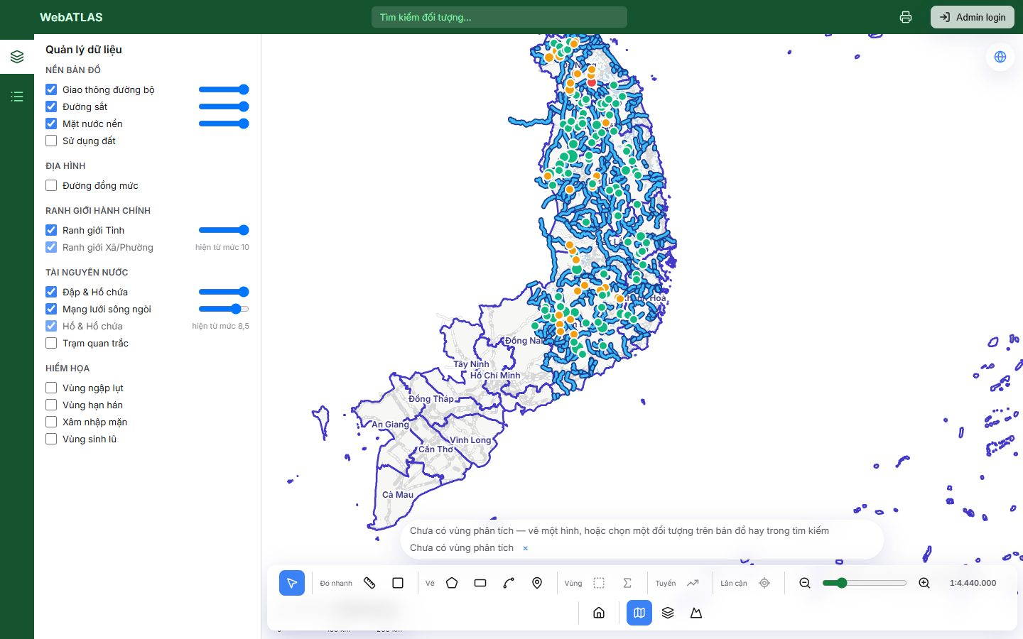
Figure 31. F6 / U-2: pressing a disabled tool shows its reason in the chip
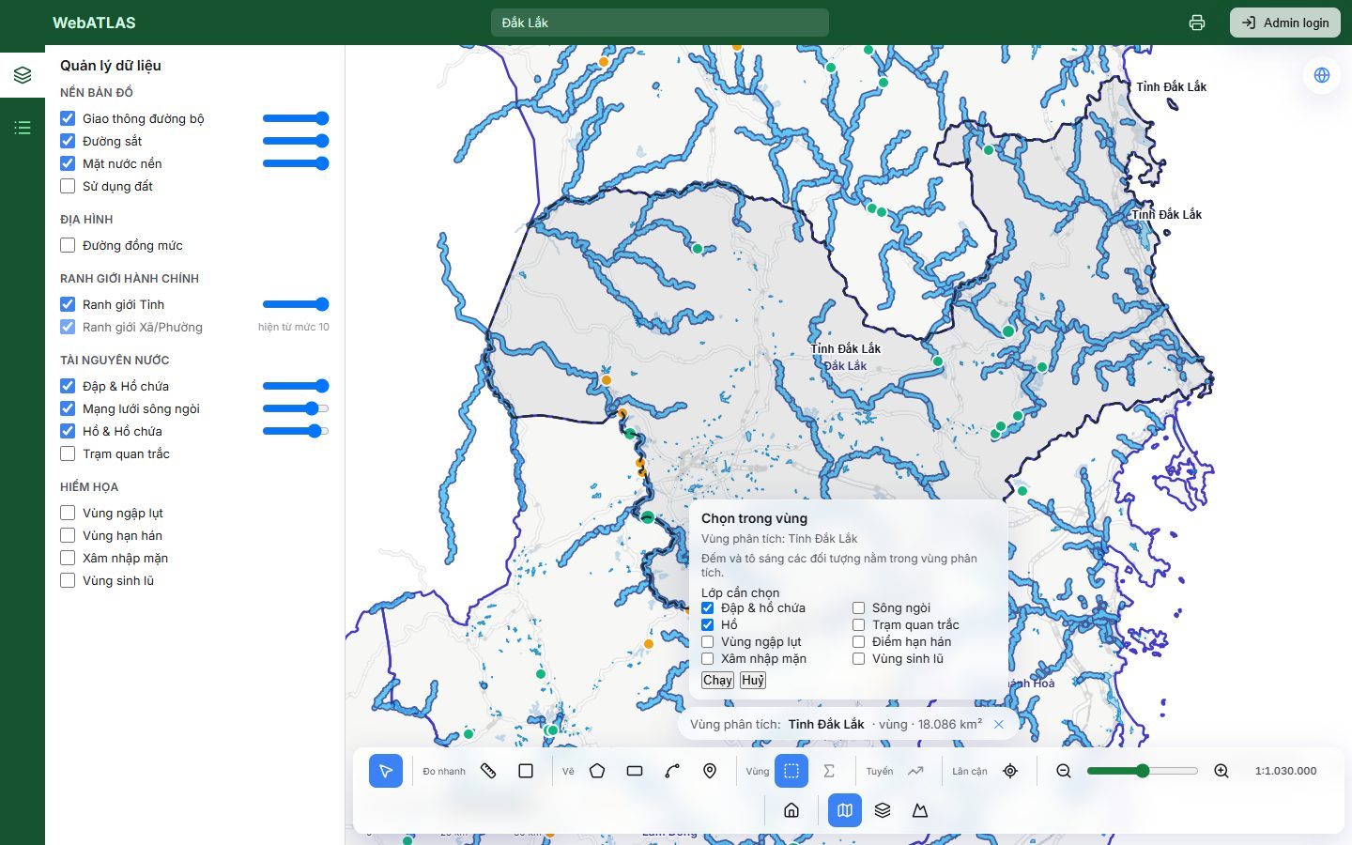
Figure 32. F6: the Chọn trong vùng panel, with layer choices only

F8 — Failure
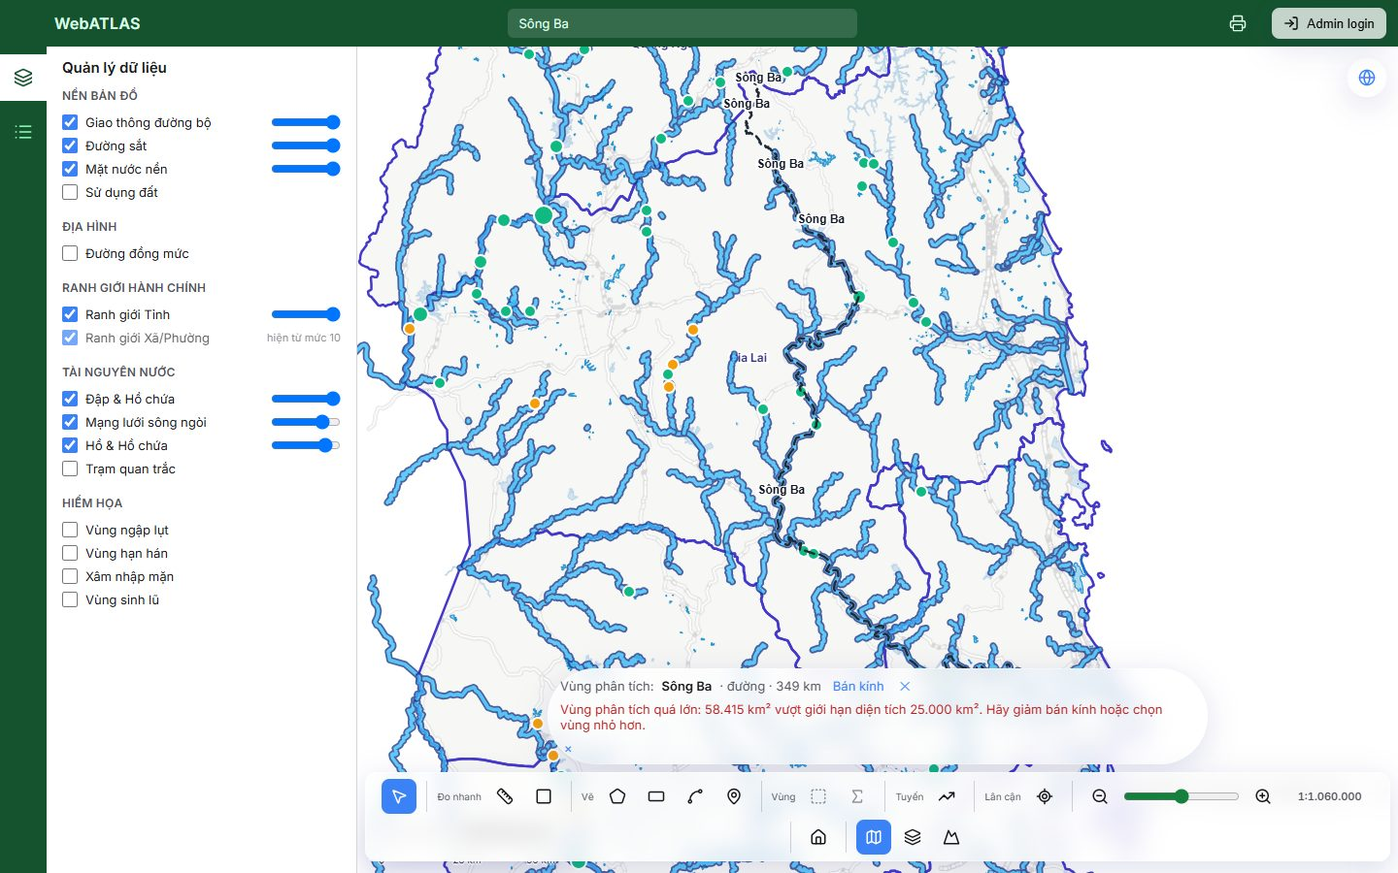
Figure 33. F8: Sông Ba + 100 km is refused (58.415 km² > 25.000 km²) and the previous ROI is kept
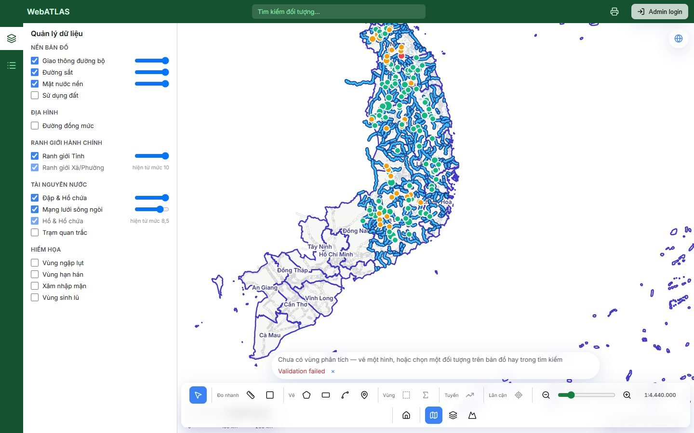
Figure 34. F8: a rectangle drawn in the sea outside Vietnam's bounds shows the raw "Validation failed"

5. Deferred items (not in Phase 4)
The spec (§14) lists these as outside Phase 4. They are included so the status picture is complete.
Item | Status | Planned in
The assistant takes the roi object in its tool schemas, and sets the ROI through setRoi | Not Started | Phase 5
resolve_entity, upstream_of and related_entities assistant tools | Not Started | Phase 5
Keeping the ROI across page reloads (FR-15) | Not Started | Not planned
ROI history or undo (D1) | Not Started | Not planned
Circle draw tool (D5: a point plus a radius covers it) | Not Started | Not planned
Editing the vertices of a finished drawing (U-11) | Not Started | Not planned
Exporting the ROI geometry as a file | Not Started | Not planned

6. Findings from this pass
- UC-4, the road case. Searching "Quốc lộ 14" never surfaces the whole-road entity ("Quốc lộ 14 - Đường Hồ Chí Minh", 998 km). That entity is also over the resolve limits: 22,662 vertices against 10,000, and 647 parts against 300. Long national roads need either a higher-limit simplified geometry or per-segment selection.
- Search shows identical labels for different entities. Three "Quốc lộ 14" rows are indistinguishable, and one of them resolves under the label "HCM". Showing the length or ref in the row would disambiguate them.
- UC-5, the profile. Only the longest part of a multi-part river is profiled (268 of 349 km for Sông Ba), and nothing on the card says so.
- F8, the error message. For a shape outside Vietnam's bounds the chip shows "Validation failed". The API already returns "Hình không hợp lệ: … nằm trong Việt Nam" in details.fieldErrors, which the client should display.
- UC-11, print. The printed result section does not name the ROI it was computed for.
- Cosmetic. In the search dropdown, "Dùng" wraps onto its own line under every hit. The result-card buttons ("Xuất CSV", "Xoá kết quả") and the print-page controls render as unstyled browser buttons. A river popup shows "Mã phân đoạn: river", a level name where a segment code is expected.
- Data, not a defect. Sông Thu Bồn + 5 km contains no dams, so demos should use 10 km. The station layer holds only 2 active stations, which limits UC-2 and UC-8 demonstrations.
- Environment. atlas:verify reports basemap and reference_entities as stale after the Geofabrik pin (f67f25e). The next npm run atlas:up will rebuild them.

