WebATLAS — Data Pipeline Report
The dataset registry and the one-command build (npm run atlas:up)
Date: 30 September 2026
Code: packages/atlas-data on branch feat/registry-plan-b at f67f25e (Plan B not yet merged to main)
Sources: the registry descriptors and runner, the registry design specifications, the Plan B progress ledger and fresh-clone acceptance report, and the live development database
Audience: supervisor, project team and technical reviewers

Contents
Contents 2
1. Summary 3
2. Why the pipeline exists 4
2.1 Binding decisions 4
3. Architecture 5
3.1 Where each stage runs 5
4. Registered datasets 6
5. Stage types 8
6. Build semantics 8
7. Lineage and licensing 10
8. Operations 11
8.1 Commands 11
8.2 A fresh clone, measured 11
8.3 State of the development machine 12
9. Technical debt: escape hatches 13
10. Issues, risks and next steps 14
10.1 Open issues 14
10.2 Next steps 14

1. Summary
The data pipeline builds every dataset the atlas serves, from its upstream source through PostGIS into GeoServer. It is declarative: each dataset is a descriptor in a registry. A descriptor names the dataset's sources, licence, dependencies, and ordered stages, plus a probe that proves the output serves. One runner executes the registry in dependency order and skips work that is already done. It records ISO 19115-style lineage for everything that ran.
A developer now goes from a fresh clone to a working atlas with npm install && npm run atlas:up. This replaced a nine-step manual runbook, a locally installed Python geo stack and a hand-downloaded 684 MB extract. The host needs only Node 22, Docker and git. Every heavy tool runs inside the atlas-tools container.
Table 1. Delivery status
Work package | Status | Notes
Plan 1 — registry foundation (atlas:build, atlas:status) | Merged | On main since 18 Sep 2026
Plan A — cascade invalidation; run, fetch-http, publish-geoserver executors | Merged | Merged to main as 0f4225c on 30 Sep 2026
Plan B — tools image, every runbook step registered, atlas:up, atlas:verify, atlas:adopt | In progress | Tasks 1–11 done and reviewed. Task 12, the fresh-clone acceptance, is running; the basemap fetch failed upstream and has since been pinned (f67f25e)
Plan C — packages/versioning, load-geojson executor, seeds and rivers migrated, old commands retired | Not started | Retires 2 of the 12 escape hatches and makes seed loading content-idempotent
Sub-projects C (rasters out of PostGIS) and D (map styles from design tokens) | Not started | Deliberately after Plan C

Table 2. Key figures
Measure | Value
Registered datasets | 7: demo, seeds, rivers, basemap, reference_entities, dem, contours
Stages | 24: 12 run, 9 publish-geoserver, 2 sql, 1 fetch-http
Data produced | about 1.8 GB in PostGIS; 12 thematic and contour layers on GeoServer, plus the basemap layers and their layer group
Fresh-clone build (measured, without the basemap) | 12 min for 18 stages. Full build estimated at 25–35 min on a ~60 Mbit/s line
Re-run after a completed build | 23 s: every stage skipped
Pipeline test suite | 38 test files, 308 tests passing; one gated tools suite of 7 tests
This development machine | atlas:verify passes 27 of 29 checks. basemap and reference_entities are stale because their descriptor changed (§8.3)

2. Why the pipeline exists
Before the registry, building the atlas meant following nine runbook steps whose order was stated only in prose. About 1.4 GB of data lived outside git behind manual downloads, and the Python geo stack, GDAL and raster2pgsql had to be installed on the host. A fresh clone could not reach a working map without that tacit knowledge. The pipeline addresses five problems:
Table 3. Problems and how the registry answers them
Problem | Answer in the pipeline
A fresh clone cannot build | atlas:up checks the machine, starts the stack, builds the tools image, migrates and builds every dataset
Order known only from prose (for example, reference entities must be rebuilt after every basemap load) | dependsOn edges in the descriptors; the runner builds in topological order and invalidates dependents
Interrupted work (network drop, Ctrl-C) is indistinguishable from finished work | Per-stage state keyed by an input hash; downloads written to .part and renamed only when complete and verified
Licences and sources recorded only in migration comments | Declared lineage per dataset (ISO 19115 LI_Lineage / LI_Source), with process steps appended by the runner
"Is it working?" answered by opening the map | atlas:status for build state; atlas:verify probes row counts, WFS/WMS responses and lineage

2.1 Binding decisions
- Migrations create structure; the pipeline only populates it. No stage issues DDL for a table it fills.
- Lineage is ISO 19115-shaped. Versioning (app.dataset_versions) stays as it is; lineage lives in its own tables.
- `run` stages are temporary escape hatches. Each declares the built-in stage that should absorb it (promoteTo) and a deadline (promoteBy). The registry test fails the build the day after that deadline.
- The host needs only Node 22 and Docker (decision D2). The Python geo stack and PostGIS client tools live in the atlas-tools image.
- A bare `atlas:up` builds everything, DEM and contours included (D3). --except dem is the opt-out.
- Onboarding uses full real data, not sample data.
- The monorepo stays. The pipeline is its own workspace, packages/atlas-data, not a separate repository.

3. Architecture
The pipeline is a TypeScript workspace, packages/atlas-data, with a small set of single-purpose modules. Its only runtime dependencies are pg and zod.
Table 4. Components
Component | Where | Responsibility
Descriptors | src/descriptors/*.ts | One file per dataset: id, kind, lineage, dependsOn, stages, probe
Registry validation | registry.ts, schema.ts | Before any build: zod schema of every descriptor, an executor for every stage type, unique ids, no cycles, no overdue escape hatch
Dependency graph | graph.ts | Topological order; transitive dependents for invalidation
Build state | state.ts → app.dataset_stage_state | Chained input hash per stage; status ok or failed
Runner | runner.ts | Executes stages in order: skip rule, invalidate-before-execute, per-dataset isolation, build report
Stage executors | stages/*.ts | fetch-http, run, sql, publish-geoserver
Lineage | lineage.ts → app.dataset_lineage* | Declared sources upserted; one process step appended per executed stage; licence resolution through dependsOn
Probes and verify | probes.ts, verify.ts | Cheap read-only checks: row counts, WFS/WMS answers, a DEM elevation at a known place
Adopt | adopt.ts | Records an already-built machine as built, if its probes pass, without executing anything
Orchestration | up.ts, cli/*.ts | atlas:up, atlas:build, atlas:status, atlas:verify, atlas:adopt
Tools image | tools/Dockerfile, compose profile tools | Debian bookworm, PGDG postgresql-client-16, PostGIS raster2pgsql 3.6, Python 3.11 venv (geopandas, rasterio, pyogrio, psycopg2); about 764 MB

3.1 Where each stage runs
- Host stages run node npm-cli.js <argv> in the repository, never through a shell. Spawning npm directly fails on Windows, where npm is a .cmd shim.
- Tools stages run docker compose --profile tools run --rm -T --no-deps tools <argv>. The container joins the compose network with in-network database and GeoServer addresses. The repository is bind-mounted at /repo, so an edited script needs no image rebuild.
- `sql` and `publish-geoserver` stages run inside the runner: through the database pool and the GeoServer REST API.
- Secrets reach scripts through the environment (infra/.env via compose), never through argv.

4. Registered datasets
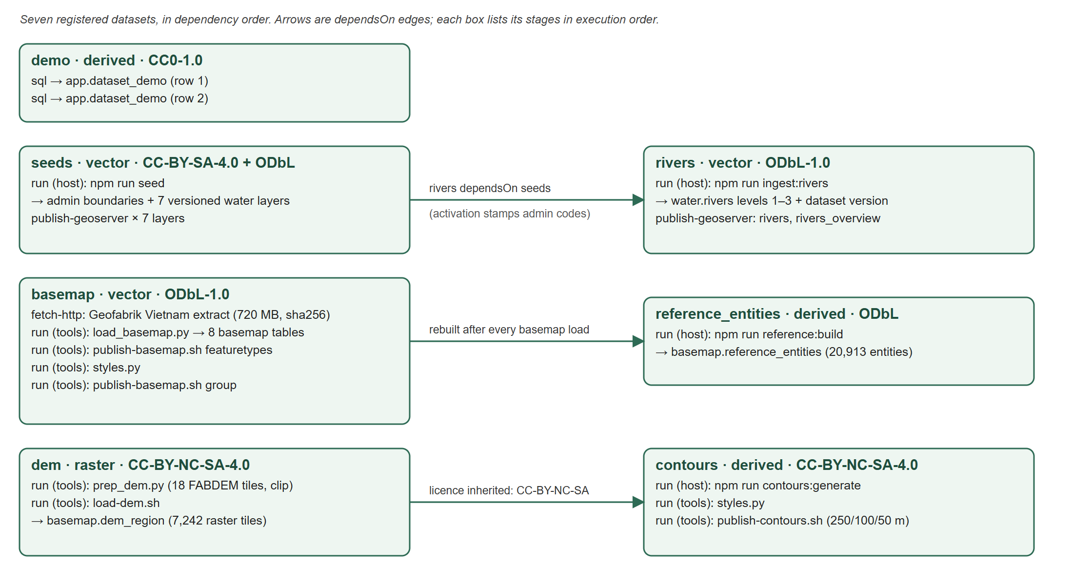
Figure 1. The registry: datasets, their stages, and their dependsOn edges
Table 5. Datasets
Dataset | Kind | Depends on | Produces | Probe (what "built" means)
demo | derived | — | Two rows in app.dataset_demo. Proves stage order end to end without real data | —
seeds | vector | — | admin.provinces (34), admin.wards (616), and a new active version of 7 water layers; 7 GeoServer layers | Row counts of both admin tables and all 7 active views; each layer serves WFS
rivers | vector | seeds | water.rivers: 588 named rivers, 13,045 reaches, 9,486 OSM ways; layers rivers and rivers_overview | Level-1 rivers > 0; webatlas:rivers serves WFS
basemap | vector | — | 8 basemap.* tables from the Geofabrik extract; styles; the webatlas:basemap layer group | All 8 tables non-empty; the basemap renders over WMS
reference_entities | derived | basemap | basemap.reference_entities: 20,913 named groups over 5 layers | Entities present in each of the 5 layers
dem | raster | — | basemap.dem_region: FABDEM clipped to the mainland of the 6 provinces, 7,242 tiles | Buôn Ma Thuột reads 440–500 m (measured 472 m)
contours | derived | dem | basemap.contours at 250/100/50 m; layers contours_250/100/50 | Each interval non-empty and each layer renders

Table 6. Upstream sources
Source | Licence | Resolution | How it arrives
Open Development Vietnam — hydropower plants (Oct 2020) | CC-BY-SA-4.0 | — | GeoJSON committed to git
OpenStreetMap lakes and waterways (Overpass) | ODbL-1.0 | — | GeoJSON committed to git
Synthetic demonstration layers (stations and 4 hazard layers) | LicenseRef-webatlas-synthetic | — | GeoJSON committed to git: placeholders, not measurements
Province and ward boundaries after the 1 Jul 2025 reorganisation | MIT | simplified ~11 m | GeoJSON committed to git
HydroSHEDS HydroRIVERS v1.0 (Asia) | CC-BY-4.0 | 15 arc-seconds | Region extract committed to git
Geofabrik Vietnam extract of OpenStreetMap | ODbL-1.0 | — | fetch-http, 720 MB, pinned by date and sha256
FABDEM V1-2 (University of Bristol) | CC-BY-NC-SA-4.0 | 1 arc-second (~30 m) | Fetched per tile by prep_dem.py (18 tiles, about 512 MB)

5. Stage types
Table 7. Stage executors
Stage | Behaviour | Status | Used by
fetch-http | Downloads into data/cache as <target>.part and renames only on completion. A declared sha256 is checked before the rename, so a mismatch leaves the previous file intact. A download idle for 60 s is aborted. A cached file is reused only if it matches the pin and its .source sidecar names the same URL. Network errors name the URL and the underlying cause | Implemented | basemap
run | Runs an argument vector on the host or in the tools container. Must declare produces, promoteTo and promoteBy. A non-zero exit fails the stage with the last output lines and the command that re-runs only this dataset | Implemented | 12 stages in 6 datasets
sql | Executes one statement | Implemented | demo
publish-geoserver | Publishes a relation as webatlas:<layer>, by default the <layer>_active resolution view, optionally with a style | Implemented | seeds (7), rivers (2)
load-geojson | Versioned, content-idempotent load of a GeoJSON file into a water table through the versioning core | Designed | Plan C: will replace the seeds and rivers run stages

6. Build semantics
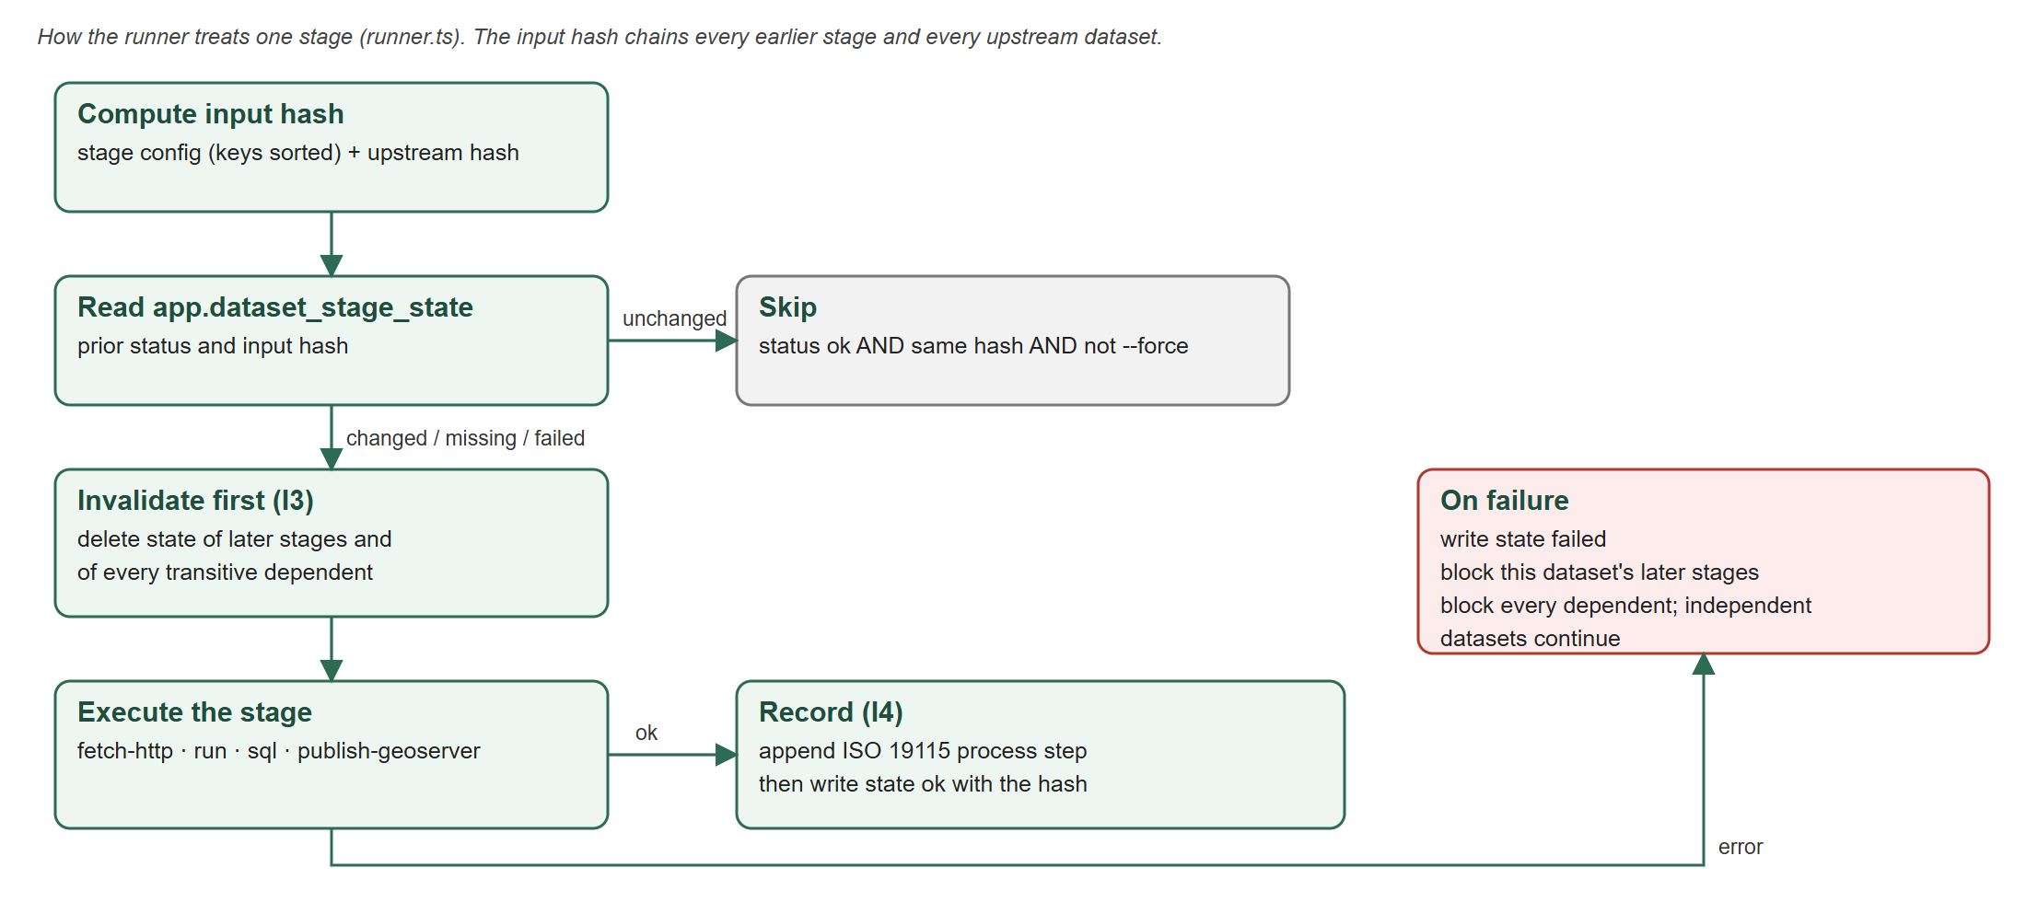
Figure 2. How the runner handles one stage
- Chained input hash. A stage's hash covers its own configuration, with object keys sorted and functions serialised as source. It also covers the previous stage's hash, or for a first stage, the final hash of every dependency. A change anywhere upstream therefore makes exactly the downstream stages stale. atlas:status computes the same plan, so the two cannot disagree.
- Skip rule. A stage is skipped when its recorded status is ok with the same hash and the dataset is not forced.
- Invalidate before executing (I3). Before a stage runs, the recorded state of the dataset's later stages and of every transitive dependent is deleted. A crash can then only leave downstream work "missing", never falsely "ok". Dependents are computed over the whole registry, so a dataset excluded by --except still shows as missing afterwards.
- Lineage from what ran (I4). After each executed stage the runner appends a process step: the stage key, the first 12 characters of its input hash, and a one-line summary. Steps are append-only; their foreign key is ON DELETE RESTRICT.
- Per-dataset isolation. A failure is recorded against its dataset, whose later stages and dependents are reported "blocked". Independent datasets continue, so one failure does not waste an hours-long build.
- Selection. --only <ids>, --except <ids> (which also drops that dataset's dependents, and says so) and --force <ids>. Forcing a dataset invalidates its dependents, which rebuild only if they are selected.
- Idempotency is each command's own. The runner guarantees a stage re-runs only when its inputs changed. It cannot make a non-idempotent command safe: npm run seed appends a new version of every seed layer each time it runs (§9).

7. Lineage and licensing
Lineage is written to four tables in the app schema. Declared lineage (the statement, the licence and the sources) is replaced wholesale in one transaction, so it always describes the descriptor as it is now. The process-step history is append-only.
Table 8. Lineage tables
Table | Content
app.dataset_lineage | One row per dataset: statement, licence (SPDX expression). ISO 19115 LI_Lineage
app.dataset_lineage_source | Citation, licence, URI and resolution of each upstream source (LI_Source). Deleted with the dataset (CASCADE)
app.dataset_lineage_step | Append-only process steps (LI_ProcessStep): description, tool, time. ON DELETE RESTRICT
app.dataset_stage_state | The runner's build state: dataset, stage key, input hash, status, time

The licence that applies to a dataset is resolved through dependsOn, without touching the database, so export tooling and CI can ask the question. Two consequences are designed in:
- contours resolves to CC-BY-NC-SA-4.0 through dependsOn dem. The non-commercial clause of FABDEM therefore binds the contour layers and anything exported from them.
- contours deliberately does not depend on basemap, although it publishes to the same GeoServer store. A dependsOn there would wrongly make contours inherit OpenStreetMap's ODbL.
Table 9. Licence per dataset (from app.dataset_lineage on this machine)
Dataset | Licence | Implication
demo | CC0-1.0 | —
seeds | CC-BY-SA-4.0 AND ODbL-1.0 | Attribution and share-alike
rivers | ODbL-1.0 | The combined product takes the stricter of HydroRIVERS (CC-BY) and OSM (ODbL)
basemap, reference_entities | ODbL-1.0 | Share-alike for derived databases
dem, contours | CC-BY-NC-SA-4.0 | Non-commercial. Must be reviewed before any commercial or public deployment

8. Operations

8.1 Commands
Table 10. Pipeline commands
Command | Purpose
npm run atlas:up | The entry point: preflight, stack up (never recreates or stops a running service, never touches volumes), readiness polling, tools image, migrations, build, verify, next-step summary. Safe to re-run: finished work is skipped
npm run atlas:build | Build the registry, or a selection (--only, --except, --force)
npm run atlas:status | Each dataset's stages as ok, stale, missing or failed, with the reason and the command to run next
npm run atlas:verify | Observed behaviour, not the test suite: every stage ok, every probe passing, every published layer answering, every dataset with a licensed lineage row
npm run atlas:adopt | For a machine built before the registry: marks datasets whose probes pass as built, without re-running hours of work

8.2 A fresh clone, measured
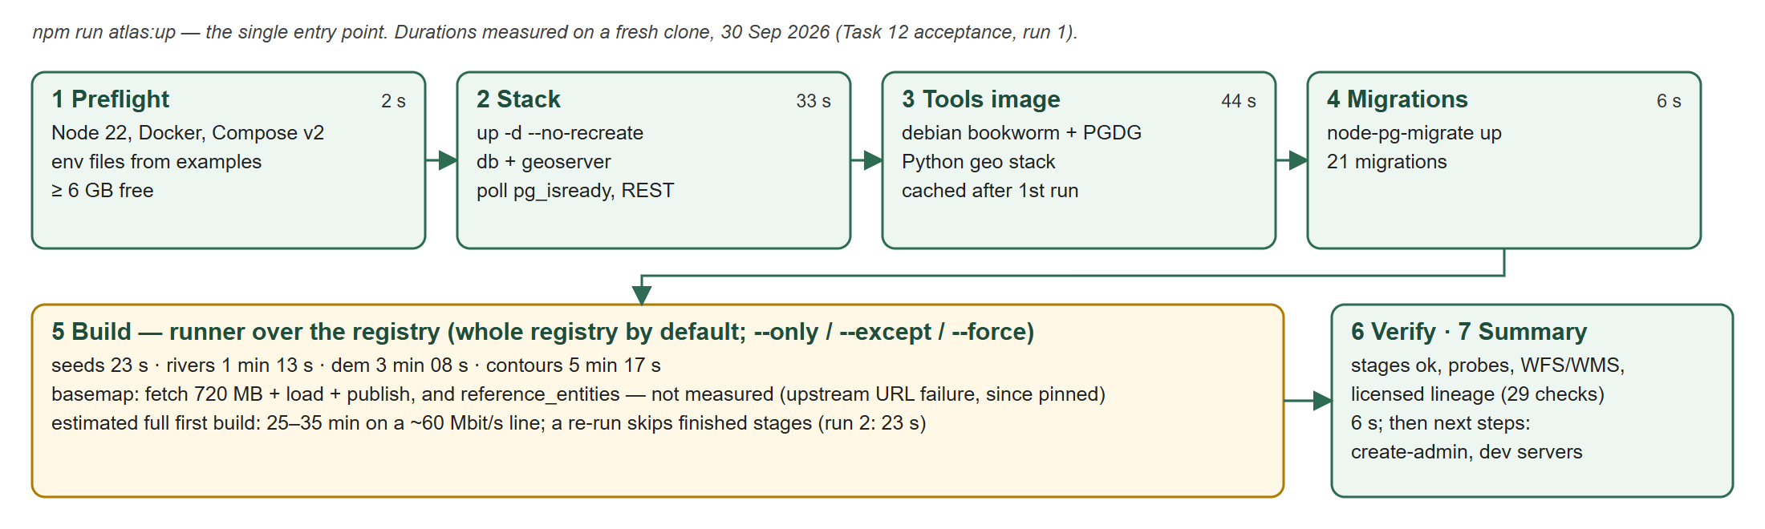
Figure 3. atlas:up, with durations measured in the fresh-clone acceptance run on 30 Sep 2026
The acceptance run cloned the branch into a throwaway directory and built it against a separate compose project (webatlas_accept, ports 55432 and 58080). Everything except the basemap was built and verified: 18 stages executed in 12 minutes. The basemap failed at the download (§10.1), which blocked reference_entities. A second run after the fix skipped all 18 finished stages in 23 s, confirming the resume behaviour.
Table 11. Measured stage durations (fresh clone)
Step | Duration | Result
Preflight | 2 s | Node, Docker, Compose, env files, disk space
Stack up and ready | 33 s | New network, volumes and containers
atlas-tools image | 44 s | Built once; 4 s when cached
Migrations | 6 s | 21 migrations
seeds | 23 s | 34 provinces, 616 wards, 151 dams, 3,868 lakes; 7 layers published
rivers | 1 min 13 s | 23,119 features, 588 named rivers
dem | 3 min 08 s | 18 FABDEM tiles, 7,242 raster tiles, 406 MB. Buôn Ma Thuột 472.2 m, Chư Yang Sin 2,414.5 m
contours | 5 min 17 s | 19,275 / 50,760 / 103,672 lines at 250 / 100 / 50 m
basemap + reference_entities | not measured | Estimated 10–20 min plus about 2 min to download 720 MB
verify | 6 s | 24 of 29 checks passed; the 5 failures were the unfetched basemap and its dependent

8.3 State of the development machine
The development machine was adopted into the registry on 30 Sep 2026: 5 datasets in 11 s, then a build that re-ran only rivers (57 s), and atlas:verify passed 29 of 29. Today it reports 27 of 29. The basemap descriptor changed in f67f25e, which pinned a dated extract in place of the unreachable -latest alias. That makes basemap and its dependent reference_entities stale by design. The loaded data still passes its probes. The next atlas:build will download the pinned 720 MB extract and reload both.

9. Technical debt: escape hatches
Twelve stages are run escape hatches: they call an existing script rather than a built-in, declarative stage. Each names its successor and a deadline. validateRegistry fails the registry test, and therefore CI and every build, on the first UTC day after the deadline, so none can quietly become permanent.
Table 12. Escape hatches and their deadlines
Dataset | Stage (argv) | Promote to | Deadline
seeds | npm run seed -w @webatlas/api (host) | load-geojson | 2026-12-31
rivers | npm run ingest:rivers -w @webatlas/api (host) | load-geojson | 2026-12-31
basemap | load_basemap.py <extract> (tools) | load-ogr | 2027-06-30
basemap | publish-basemap.sh featuretypes (tools) | publish-geoserver | 2027-06-30
basemap | styles.py (tools) | publish-geoserver | 2027-06-30
basemap | publish-basemap.sh group (tools) | publish-geoserver | 2027-06-30
reference_entities | npm run reference:build (host) | sql | 2027-06-30
dem | prep_dem.py --mainland (tools) | fetch-cog | 2027-06-30
dem | load-dem.sh (tools) | load-raster | 2027-06-30
contours | npm run contours:generate (host) | sql | 2027-06-30
contours | contours/styles.py (tools) | publish-geoserver | 2027-06-30
contours | publish-contours.sh (tools) | publish-geoserver | 2027-06-30

The two 2026-12-31 deadlines fall to Plan C. If Plan C slips past the end of the year, every build fails until the deadlines are moved deliberately. That is the intended behaviour, but it needs planning.

10. Issues, risks and next steps

10.1 Open issues
Table 13. Issues found in the code, the acceptance run and the database
Issue | Severity | Detail and recommendation
Basemap download is pinned to a dated daily file | High | On 30 Sep every Geofabrik -latest URL was in a 301 redirect loop, so f67f25e pinned vietnam-260929-free.shp.zip with its sha256. Geofabrik prunes daily files after about a week and first-of-month files after about three months. A fresh clone will then fail at the fetch until someone bumps the pin. Recommendation: pin a first-of-month file and bump it on a schedule, or mirror the extract on the project's own storage (needed anyway for on-premises hosting)
Fresh-clone acceptance not finished | High | The basemap and reference_entities path has not been built end to end from a clean clone. The README still says "<measured in Task 12>" for the build time. Plan B should not merge until this passes
Seed reloads append versions to every layer | Medium | Each npm run seed writes a new version of all 7 seed layers, whether or not the file changed. The database holds 10 ingest versions per seed layer; 90% of stored lake rows (34,812 of 38,680) belong to inactive versions, and water.lakes occupies 744 MB. CI and the API tests also call seed. Plan C's content-idempotent load-geojson fixes the cause; a prune that keeps each active version's ancestor chain reclaims the space
Steward edits can be hidden by a reload | Medium | A new ingest version supersedes edits made in the app. The designed guard (refuse and name the layer; proceed with --supersede-edits <id>) is not built. It belongs in Plan C
Pipeline tests are not in CI | Medium | CI runs the shared, web and API suites, and builds data with the old migrate, seed and ingest:rivers commands. The 38 pipeline test files and the registry deadline check run only locally. Add npm test -w @webatlas/atlas-data to CI
DEM held inside PostGIS | Low | Invariant INV-5 calls for rasters as cloud-optimised files served as coverages. basemap.dem_region holds 406 MB of raster tiles. This is sub-project C
Tool version skew | Low | The tools image ships raster2pgsql 3.6 while the server runs PostGIS 3.4. Accepted deliberately: the raster WKB format is unchanged, and the load is verified against known summits
Preflight disk check | Low | Free space is measured on the cache disk, not on the disk that holds the Docker volumes

10.2 Next steps
- Finish Task 12: a complete fresh-clone build including the basemap, then record the measured time in the README. Merge Plan B.
- Decide how the basemap extract is sourced over time: a scheduled pin bump, or a project mirror.
- Add the pipeline test suite to CI.
- Plan C, before 31 Dec 2026: move the versioning core to packages/versioning, add the load-geojson executor and the steward-edit guard, migrate seeds and rivers, and retire npm run seed, ingest:rivers and publish:geoserver.
- Prune inactive dataset versions, keeping every active version's ancestor chain.
- Then sub-projects C and D, and the on-premises deployment and CI/CD work parked until the restructure settles.

