WebATLAS
Database Design Report
The PostgreSQL/PostGIS schema: organisation, entity and temporal models, integrity, performance and security
Date: 22 September 2026
Schema revision: migration 21 (1000000000021_reference-member-index); architecture document revision 1.4

Contents
Contents 2
1. Summary 3
2. Principles and invariants 3
3. Schema organisation 5
4. Entity model 6
4.1 The common feature-table pattern 6
4.2 Identity and keys 7
4.3 The river hierarchy 7
5. Temporal model 8
6. Spatial reference and administrative geography 8
7. Reference data 9
7.1 Basemap tables, raster and contours 9
7.2 Reference entities 9
8. Derived values and the activation contract 9
9. Integrity, indexing and performance 11
9.1 Constraints 11
9.2 Indexes 11
9.3 Measured performance rules 11
10. Security 12
11. Schema evolution 12
12. Findings and recommendations 14
13. Designed but not yet implemented 14

1. Summary
WebATLAS stores all of its geographic data in one PostgreSQL 16 database with PostGIS 3.4. The database is the single authoritative store. GeoServer publishes a read-only view of it, the API is the only writer, and the web client holds only a transient cache. Every rule expressed in the schema therefore holds for every consumer.
Five design decisions shape the schema:
- Four schemas divided by governance: app, water, admin and basemap. Who writes the data and how often decides where it lives (§3).
- Immutable snapshot versioning of the eight thematic layers. An edit writes new rows into a new version, and a view per layer resolves the active version (§5).
- Stable business keys (external_id) for every relationship, never primary keys, because a primary key changes with every edit (§4).
- Stamped administrative codes: each feature carries the province and ward codes it intersects, computed once on activation. "How many dams in this province" is then an indexed lookup (§6).
- One maintenance point for derived values. Every activation of a version runs through one function, which rebuilds the river hierarchy, checks it, stamps codes and moves the active pointer (§8).
Table 1. Key figures (development database, 30 Sep 2026)
Measure | Value
Engine | PostgreSQL 16.4; PostGIS 3.4.3 with raster and topology; pg_trgm 1.6; citext; fuzzystrmatch
Size | 1.8 GB in total
Schemas / tables / views | 4 schemas; 30 tables; 10 views (8 resolution views and 2 per-level river views)
Migrations | 21, managed by node-pg-migrate
Indexes | 103: water 55, basemap 29, app 14, admin 5
Thematic features (active) | rivers 23,119 (588 rivers / 13,045 reaches / 9,486 ways); lakes 3,868; dams 151; stations 2; 4 hazard layers with 2 placeholder rows each
Reference data | 527,215 road segments; 20,913 named reference entities; 173,707 contour lines; 7,242 DEM raster tiles
Dataset versions | 72, of which 8 are active (one per thematic layer)
Database roles | webatlas (owner: API and pipeline); webatlas_assistant (SELECT on 10 views only)

2. Principles and invariants
Five invariants were fixed at the start of the project. Those that constrain the database are:
Table 2. Invariants material to the database
ID | Invariant | Consequence for the schema
INV-1 | Feature data resides only in PostGIS; GeoServer stores nothing; all writes pass through the API | No second copy of the data, so no graph database and no map-server-side store (§9)
INV-2 | The layer catalogue is single and authoritative | The client layer panel and GeoServer publication derive from one list
INV-4 | Each layer's attribute schema has exactly one definition | Migrations, API validation and the client use the same definition
INV-5 | Raster earth-observation products are stored as cloud-optimised files, not in PostGIS | Not yet met: the DEM is in basemap.dem_region (§10)

Two working rules follow. Migrations create structure; the data pipeline only populates it. And every derived value has exactly one maintenance point, the activation of a dataset version (§8).

3. Schema organisation
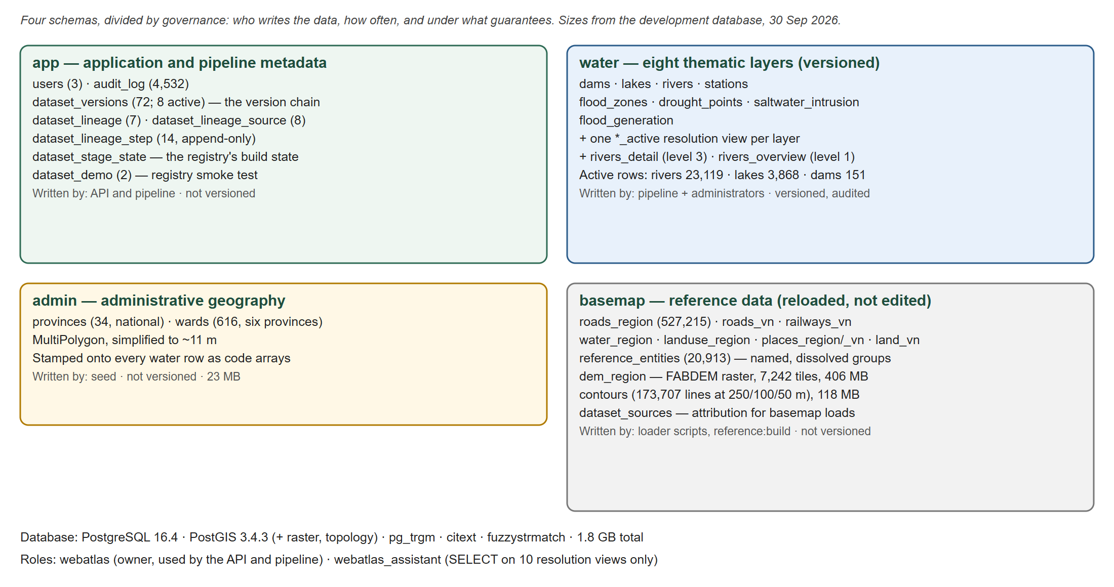
Figure 1. The four schemas and their contents
Table 3. Schemas
Schema | Contents | Written by | Versioned | Size
app | Users, audit log, dataset versions, pipeline lineage and build state | API and pipeline | n/a | < 5 MB
water | Eight thematic feature layers and their resolution views | Pipeline and administrators | Yes | ≈ 880 MB (lakes 744 MB, rivers 120 MB)
admin | 34 provinces (national) and 616 wards (six working provinces) | Seed | No | 27 MB
basemap | OSM reference layers, reference entities, the DEM raster, contours | Loader scripts and reference:build | No | ≈ 870 MB

Thematic data is editable, so it carries the temporal model, the audit trail and per-feature authorisation. Reference data changes only when an operator reloads it, so carrying the same machinery would add cost without benefit. Administrative boundaries change rarely but are authoritative for reporting, so they have their own schema rather than being mixed with imported data.
One table departs from the governance rule: basemap.reference_entities is written by the application's reference:build, not by the loader. It lives in basemap because it is derived entirely from those tables. The loader drops and recreates its own tables on every run, which destroys their indexes. That is why the search indexes sit on this table instead (§7.2).

4. Entity model
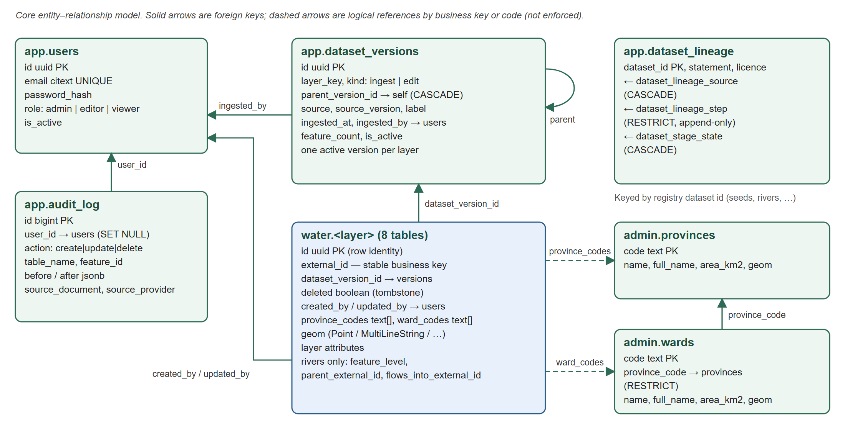
Figure 2. Core entity–relationship model

4.1 The common feature-table pattern
All eight water tables share one shape. Only the layer attributes and the geometry type differ.
Table 4. Columns common to every thematic table
Column | Type | Meaning
id | uuid, PK | Identity of this row in this version. It changes when the feature is edited
external_id | text (integer on dams, lakes) | Stable business key; the target of every relationship
dataset_version_id | uuid → app.dataset_versions | The snapshot the row belongs to
deleted | boolean | Tombstone: records a deletion in an edit version
province_codes, ward_codes | text[] | Stamped administrative units the feature intersects (§6)
created_by, updated_by | uuid → app.users (SET NULL) | Who wrote the row
created_at, updated_at | timestamptz | Row timestamps
geom | geometry, SRID 4326 | Point, MultiLineString or MultiPolygon by layer

Table 5. Thematic layers
Table | Geometry | Layer attributes | Active rows | Data
dams | Point (nullable) | name, name_en, wattage_mw, annual_output, year_launched, year_operational, status | 151 | Real (ODV)
lakes | MultiPolygon | name, lake_type, area_km2, volume_mcm, shore_len_km | 3,868 | Real (OSM)
rivers | MultiLineString | name, code, stream_order, length_m, feature_level, parent_external_id, flows_into_external_id, match_confidence | 23,119 | Real (HydroRIVERS + OSM)
stations | Point | name, station_type, status, value | 2 | Placeholder
flood_zones | MultiPolygon | name, hazard_type, area, risk_level | 2 | Placeholder
drought_points | Point | name, risk_level, status, survey_date | 2 | Placeholder
saltwater_intrusion | Point | name, salinity, risk_level, status | 2 | Placeholder
flood_generation | MultiPolygon | name, risk_level, area, flow_rate | 2 | Placeholder

4.2 Identity and keys
Relationships reference external_id, never id. An edit does not modify a row; it writes a new row with a new primary key into a new version. A reference to a primary key would silently point at a superseded row the moment its target was edited.
For rivers, three sources share one identity space and their numeric identifiers can collide. The key is therefore text, namespaced by source:
Table 6. River key namespaces
Prefix | Meaning | Example
osm: | OpenStreetMap way | osm:12207485
hyriv: | HydroRIVERS reach | hyriv:41295432
river: | Derived named river; the suffix is its outlet reach, so a rebuild reproduces the same key | river:41295269 (Sông Thu Bồn)
edit: | A feature created by an administrator, with no upstream identifier | edit:<uuid>

4.3 The river hierarchy
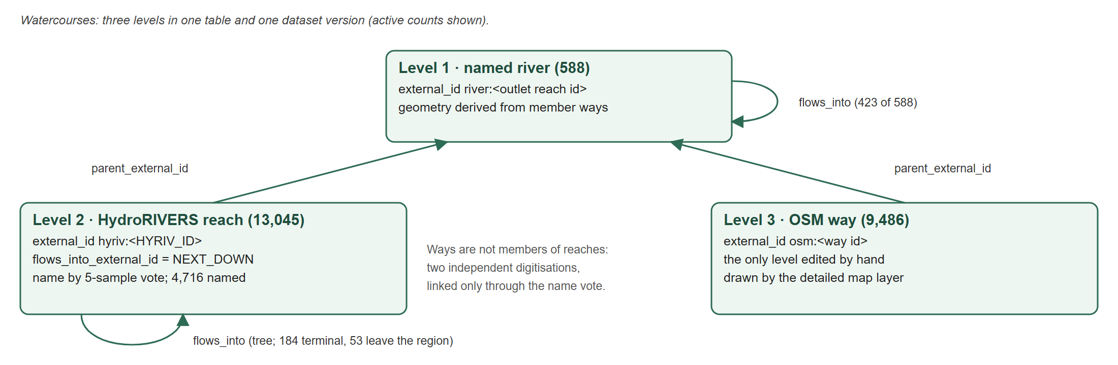
Figure 3. Three levels of watercourse in one table
Watercourses are stored in one table at three levels, all in one dataset version. Identity, authorisation, versioning and audit then apply uniformly, and a query can select any level without a union. The cost is that filtering by level is each consumer's responsibility. The three consumers each state their level:
- water.rivers_detail (level 3) backs the detailed map layer.
- water.rivers_overview (level-1 rivers that include an OSM waterway=river way, simplified) backs the far-zoom layer.
- Search and every analysis query use level 1, through one shared predicate.
Two relationships are kept in separate columns. parent_external_id is composition: a reach or a way belongs to a river. flows_into_external_id is hydrology: HydroRIVERS' NEXT_DOWN on a reach, and a derived link on a river. One overloaded column was rejected, because its meaning would depend on the row's level. HydroRIVERS carries topology but no names, and OSM carries names but no topology. A reach is named by sampling five points and taking a strict-majority vote over nearby named ways. It records a confidence between 0.3 and 1.0; 0.2 marks a bridged gap. Only level-3 ways may be edited by hand, because levels 1 and 2 are rebuilt or ingested.

5. Temporal model
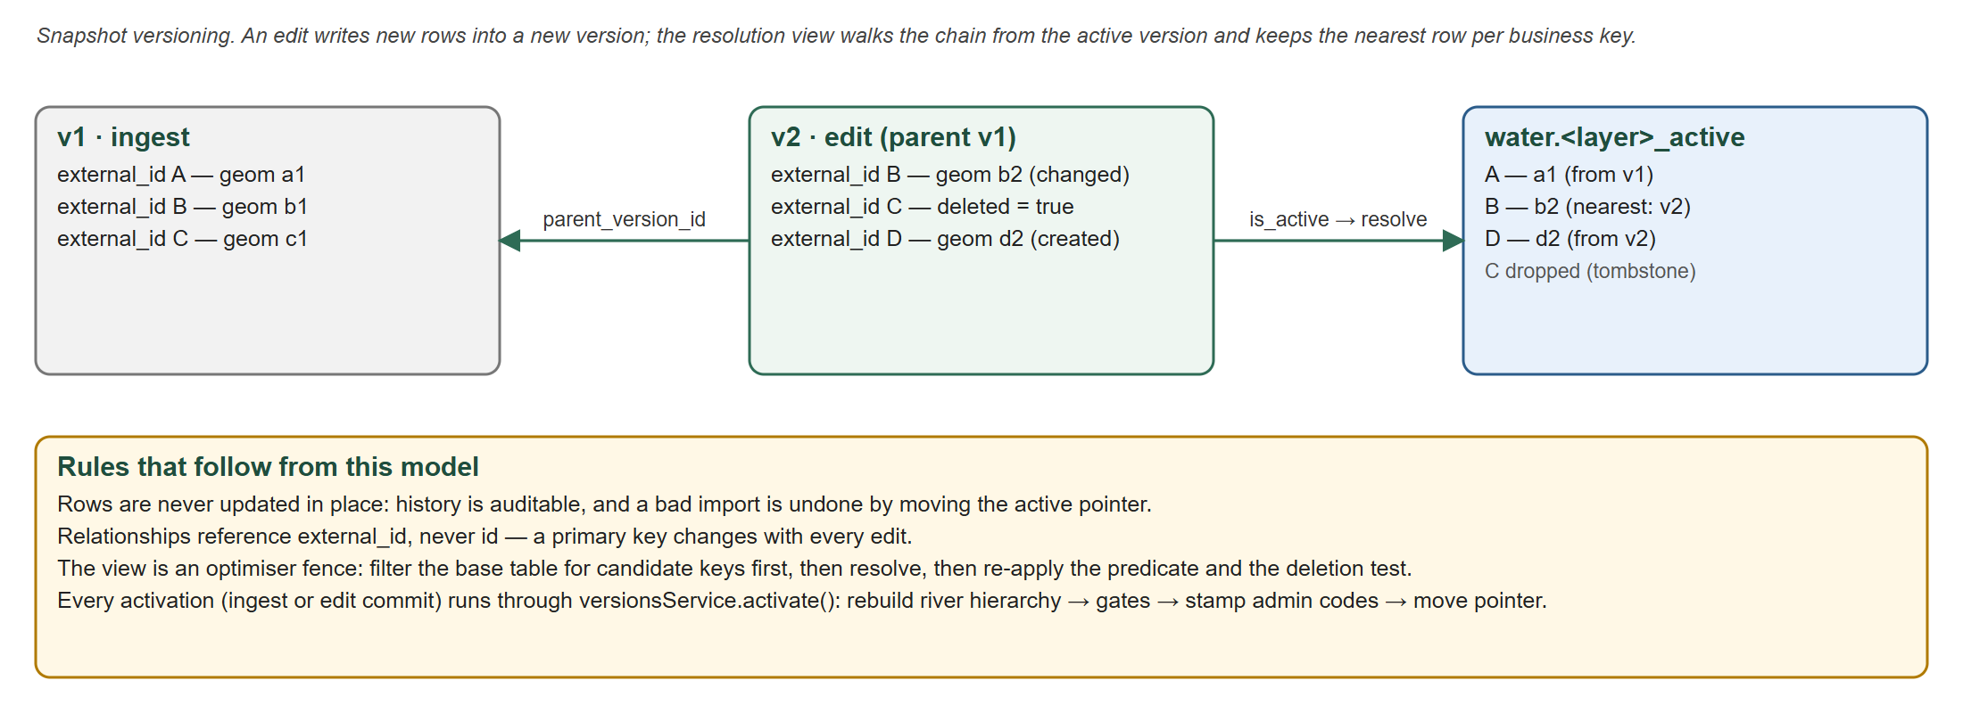
Figure 4. Snapshot versioning and resolution
Each thematic layer is versioned by immutable snapshot. A version is either an ingest (a load from a source) or an edit (one editing session). An edit version has a parent, and exactly one version per layer is active. The resolution view water.<layer>_active is a recursive query. It walks from the active version through its parents, keeps the row from the nearest version for each external_id, and drops tombstones.
- Benefits: an auditable history, a bad import undone by moving a pointer rather than restoring a backup, and a self-consistent state for every reader.
- Query rule: the resolution view is an optimiser fence, so a predicate on it cannot use an index. Indexed queries filter the base table first for candidate keys, resolve only those, then re-apply the predicate and the deletion test. Skipping that re-check has caused defects in the past.
- Accumulation: every reload adds a version. The development database once held 2,647 versions, of which about 1.4 GB (63% of the database) were unreachable. Pruning must keep each active version's entire ancestor chain, because the view inherits rows from it.
The audit log complements versioning. It records every modification with the before and after values as JSON, the acting user and, for changes proposed through the assistant, the source document and supplying organisation.

6. Spatial reference and administrative geography
- One coordinate system for storage: WGS 84 (EPSG:4326). VN-2000 national and provincial projections are a presentation concern in the client, so no query reasons about mixed systems.
- Boundaries: admin.provinces holds all 34 provinces nationally; admin.wards holds only the 616 wards of the six working provinces. Both are MultiPolygon, committed to git and simplified to about 11 m.
- Stamping: each feature stores the provinces and wards it intersects as indexed text arrays. Arrays rather than scalars, because a river crosses several provinces. The codes are computed on activation, which covers both an ingest and an edit commit.
- Why denormalise: "how many dams are in Đắk Lắk" is a stable relational fact. Answering it by polygon intersection on every request took 5.2 s cold for the largest province, against a five-second budget. The stamped-code path answers a four-layer count in about 1.7 s, and the assistant uses the same method, so both give the same number.
- Accuracy limit: a feature within about 11 m of a boundary may be attributed to the neighbouring unit. That is acceptable for counting and cartography, not for statutory determinations.

7. Reference data

7.1 Basemap tables, raster and contours
Table 7. Reference tables in basemap
Table | Rows | Size | Content
roads_region | 527,215 | 201 MB | Roads in the six provinces, in detail
roads_vn / railways_vn | 62,598 / 3,736 | 29 / 1.4 MB | National network, simplified
landuse_region / water_region | 12,075 / 5,848 | 12 / 13 MB | Land use and water bodies in the region
places_region / places_vn / land_vn | 6,145 / 1,600 / 34 | < 2 MB | Settlements and the land mask
reference_entities | 20,913 | 80 MB | Named, dissolved groups of segments (§7.2)
dem_region | 7,242 tiles | 406 MB | FABDEM bare-earth elevation, 30 m, as PostGIS raster
contours | 173,707 | 118 MB | Contour lines at 250, 100 and 50 m, with an index-line flag
dataset_sources | 2 | — | Attribution for basemap loads

7.2 Reference entities
A national highway is several hundred stored segments. basemap.reference_entities groups segments into named entities by coalesce(ref, name). A multi-valued ref such as QL.14;HCM is split, so one segment can belong to two routes. Each group is then clustered spatially (DBSCAN, 0.02°), which keeps unrelated same-named features apart: "Thôn 3" yields 147 separate hamlets. Each entity stores its dissolved geometry and the OSM ids of its members. The entity_id is stable across rebuilds. The table is rebuilt whole, one layer per transaction, so a reader never sees a half-built layer.
The trigram search indexes are on this table rather than on the raw tables, because the loader drops and recreates those tables on every run and would silently discard any index a migration created. A GIN index on member_ids answers "which road is the segment I clicked part of".

8. Derived values and the activation contract
An earlier design refreshed a materialised view from a single call site. A caller that bypassed that site activated a new rivers version, and the view described the previous one for two days. The lesson recorded is that a derived value whose refresh obligation lives in a call site rather than a contract will eventually be stale.
The contract is activation. Every path by which a version becomes active passes through versionsService.activate(), which runs in this order:
- Rebuild the river hierarchy: name the reaches, bridge gaps, group rivers, and derive their geometry and links. Only differences are written, so a no-op edit writes nothing. About 10 s.
- Assert the gates: no cycle in the downstream link, Strahler order never decreasing downstream, every river with at least one reach, no dangling link. An ingest must also meet the pinned match-rate baseline (4,754 named reaches, 439 names, 588 rivers). About 15 s.
- Stamp administrative codes, for every layer.
- Move the active pointer.
A failure in steps 1 or 2 aborts the transaction, and the previous version stays live. The order of steps 1 and 3 matters: stamping after the rebuild means new river rows get their codes. The old materialised view was replaced by a plain view, which has no refresh obligation to forget.

9. Integrity, indexing and performance

9.1 Constraints
Table 8. Referential constraints
Reference | On delete | Reason
water.* → app.dataset_versions | NO ACTION | A version holding rows cannot be deleted by accident; pruning deletes rows first
app.dataset_versions.parent_version_id → self | CASCADE | Deleting a version removes the edit versions built on it
water.* created_by / updated_by, audit_log.user_id, versions.ingested_by → app.users | SET NULL | Removing a user keeps the data and the audit history
admin.wards.province_code → admin.provinces | RESTRICT | A province cannot vanish from under its wards
app.dataset_lineage_step → app.dataset_lineage | RESTRICT | Process history is append-only
app.dataset_lineage_source, app.dataset_stage_state → app.dataset_lineage | CASCADE | Declared sources and build state belong to the dataset
province_codes / ward_codes → admin | none (arrays) | Logical references; correctness guaranteed by stamping on activation
parent_external_id / flows_into_external_id | none | Business-key links across versions; checked by the activation gates

Uniqueness: one row per (dataset_version_id, external_id) in every water table; app.users.email (case-insensitive citext); (layer_key, entity_key, cluster_id) on reference entities. Enumerations: user_role (admin, editor, viewer), dataset_version_kind (ingest, edit), audit_action (create, update, delete).

9.2 Indexes
Table 9. Index strategy (water.rivers shown in full as the example)
Index | Purpose
GiST on every geometry | Spatial predicates and nearest-neighbour ordering
Unique (dataset_version_id, external_id) | One row per key per version
B-tree on dataset_version_id | Version-chain resolution
GIN trigram on name (and on entity name and ref) | Fuzzy search
GIN on province_codes, ward_codes | Counting and filtering by administrative unit
B-tree on feature_level, parent_external_id, flows_into_external_id (rivers) | Level filters, composition lookups, network walks
GIN on reference_entities.member_ids | The entity a clicked segment belongs to

9.3 Measured performance rules
- Match the index expression. An elevation-profile predicate that did not match the raster index scanned all 7,242 tiles per sample (1,941 ms). Rewritten, it took 103 ms, and a test now asserts the query plan.
- Materialise before joining through the fence. Joining reaches to named ways through rivers_active did not finish in 120 s; over a materialised copy it took 10.9 s. Every network builder now materialises its resolved input first.
- Bound the work of public requests. Analysis runs in a read-only transaction with a 5 s statement timeout, on its own connection pool. It also enforces four limits: source entities of at most 10,000 vertices and 300 parts, checked before any buffer is computed; resulting regions of at most 25,000 km² and 5,000 vertices. A buffer of an oversized entity once killed a database backend with an out-of-memory error.

10. Security
- Authorisation in the API. Only the admin role may modify features; editor and viewer are read-only. Client controls are a convenience, never the boundary.
- Least privilege for generated SQL. The assistant's generated read-only queries run as webatlas_assistant. That role can read the 8 resolution views and the 2 per-level river views, and nothing else: no app schema, no basemap, no credentials or audit history. The privilege boundary, not the SQL parser, is the control. Recreating a view drops its grants, so migrations 16, 18, 19 and 20 re-grant explicitly.
- Connection isolation. Public analysis draws from a bounded pool of its own, so a saturated analysis workload cannot exhaust connections needed for sign-in and ordinary reads.

11. Schema evolution
The schema changes only through ordered, reviewed migrations. The data pipeline populates tables and never creates them.
Table 10. Migration history
# | Migration | Effect
1 | app-schema | Users, audit log, role and action enums
2 | water-schema | The thematic feature tables
3 | dams-geom-nullable | Dams without a location can be stored
4 | dataset-versions | Snapshot versioning: app.dataset_versions, version columns on every layer
5 | active-version-views | The recursive resolution views
6 | lakes-schema | The lakes layer
7 | pg-trgm-search | Trigram name search
8 | assistant-db-role | webatlas_assistant and its view-only grants
9 | river-overview | The far-zoom river layer (a plain view since migration 20)
10 | dem-raster | basemap.dem_region, created empty
11 | contours | basemap.contours, created empty
12 | dataset-sources-attribution | Attribution for basemap loads
13 | dataset-lineage | Registry lineage and build-state tables
14 | audit-source | Source document and provider on the audit log
15 | admin-boundaries | The admin schema: provinces and wards
16 | admin-stamping | Code arrays and their GIN indexes on every layer
17 | reference-entities | basemap.reference_entities and its trigram indexes
18 | rivers-external-id-text | River keys become namespaced text; views rebuilt and re-granted
19 | rivers-hierarchy | feature_level, parent and flows-into links, match confidence
20 | rivers-level-views | rivers_detail and rivers_overview; materialised view withdrawn
21 | reference-member-index | GIN index on reference_entities.member_ids

12. Findings and recommendations
Table 11. Findings from this review
Finding | Priority | Detail and recommendation
Inactive versions dominate storage | High | Each seed layer holds 10 ingest versions with one active; 34,812 of 38,680 stored lake rows (90%) are inactive, and water.lakes is 744 MB. Prune versions outside every active chain, then VACUUM. Plan C's content-idempotent load stops the growth at its source
Business-key type is inconsistent | Medium | external_id is text on rivers, stations and the hazard layers, but integer on dams and lakes. The designed cross-entity relationship table (§13) references features by business key across layers. Converting dams and lakes to namespaced text first avoids a second key migration
Five of eight layers are placeholders | Medium | Stations and the four hazard layers hold 2 synthetic rows each. The schema is ready, but analyses over them are uninformative until real data is loaded
DEM stored in PostGIS | Medium | Contrary to INV-5; 406 MB of the database. Moving it to a cloud-optimised GeoTIFF served as a coverage is sub-project C
Logical references are unenforced | Low | Code arrays and river links have no foreign keys by design. The activation gates and stamping are the only guard, so any new write path must go through activate()
Boundary precision | Low | Simplified boundaries (~11 m) are unsuitable for statutory use. Exact boundaries should arrive as a registered dataset rather than by editing the simplified ones

13. Designed but not yet implemented
Table 12. Designed elements
Element | Status | Notes
Cross-entity relationships (dam ↔ reach, dam ↔ reservoir, station ↔ water body, road ↔ river) | Designed | One relation with a relationship type and a confidence; recomputation must never overwrite a relationship an administrator asserted
Upstream and downstream walks as analysis operations | Designed | The data supports them today (the gates walk all 13,045 reaches on every activation); they arrive with the assistant tools in Phase 5
Routable road network | Not started | Deferred: it needs node splitting over 527,215 segments and a routing extension absent from the database image. The edge relation would follow the routing extension's conventional schema
packages/versioning shared by API and pipeline | Planned | Registry Plan C

Two alternatives were considered and rejected. A separate graph database would be a second authoritative copy of the data, contrary to INV-1, and the only traversal needed is a tree walk that recursive SQL does natively. A star schema serves aggregation, not traversal; if pre-aggregated reporting is needed later, it will be produced as derived datasets in the registry.

