Freight price:
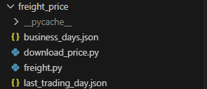
Load price from softmar and save it in files
- Each contract is in a separate file.
- Each merged timeseries is a sereprate file
Run download_price.py will download the price.
- Change start date to 2017-01-04 when you run it for the first time
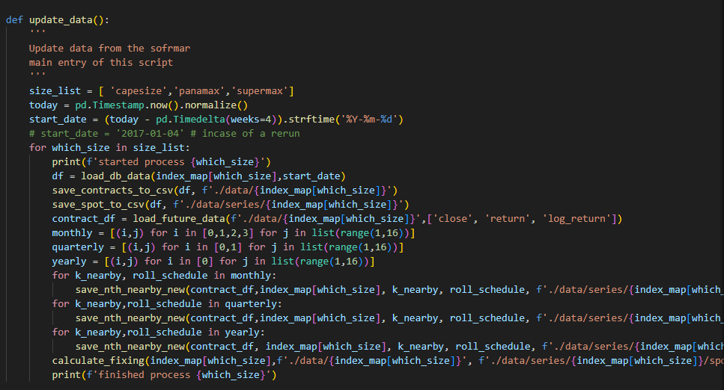
Business_days.json is business days of Baltic exchange up to 2027 (need to update )
Last_trading_day.json is last trading day of contract up to 2027. (need to update by the end of 2026)
Freight.py it’s a config which has the weight of freight. Don’t think it’s used in the end

Definition of functions in comment of the script, its self-explanatory.

