Auto-Suggests And Spell-Checker



**BTech/II Year CSE/IV Semester 19CSE212/Data Structures and Algorithms Case Study Report**

|  |  |
| --- | --- |
| **Roll.No** | **Nam e** |
| CB.EN.U4CSE21232 | K Rishith Pranav Kumar |
| CB.EN.U4CSE21221 | Gautham Gopinathan |

# INTRODUCTION:

A software programme called a spell checker can find and fix spelling mistakes in written text. It looks up terms in the input against a dictionary to look for possible errors. Based on algorithms that take into account things like word frequency and phonetic similarity, it suggests revised words. Spell checkers assist users avoid embarrassing errors and preserve consistency, improving the correctness and professionalism of their writing.

A tool known as autocomplete or autosuggest offers real-time suggestions as users type. It improves typing productivity, makes it easier to find certain words or phrases, and improves user experience. Using context, past input, or frequently asked questions, autosuggest algorithms analyze user input and produce suggestions. By eliminating th e need to write complete words or sentences, it saves time and helps avoid mistakes by offering the best possibilities. To improve user experience and input accuracy, autosuggest is frequently used in search engines, web forms, messaging platforms, and other places.

# OBJECTIVE:

Our project's goal is to develop and use a hybrid data structure that will enable us to efficiently establish an autosuggest and spell-checker.

The key objectives are:

* + - Auto suggestion of words based on the users input
    - Spell checker for the sentence typed
    - Practical application
    - Analysis of time complexity

# SIGNIFICANCE OF HYBRID DATA STRUCTURE:

Hybrid data structures are significant because they can combine the benefits of many data structures to produce effective operations and enhanced performance. Hybrid data structures provide customisation, trade-off optimisation, and problem-specific solutions by utilising the distinctive qualities of each structure. They give flexibility in adjusting to various requirements and enable effective management of complex activities. Developers can achieve quicker execution speeds, lower memory utilisation, and overall better efficiency with hybrid data structures, leading to more efficient and optimised solutions for a variety of applications and problem areas.

# TRIE AND ITS ADVANTAGES:

A trie is a hybrid data structure that combines arrays and linked structures. In this context, each

node of the trie is represented by the TrieNode class. The node contains an array called trie with a size of 256, allowing for one element for each ASCII character. This array acts as a mapping mechanism, associating characters with child nodes.

To facilitate efficient searching and retrieval, each node also has a boolean flag called isEnd. This flag is used to indicate whether a particular node represents the end of a word.

By leveraging this trie data structure, the code efficiently stores a dictionary of words and performs word lookup operations. When a word is inputted, the code checks if it is present in the trie. If the word is not found, the code generates suggestions by traversing the trie and printing all the words that can be formed by following the path from the current node.

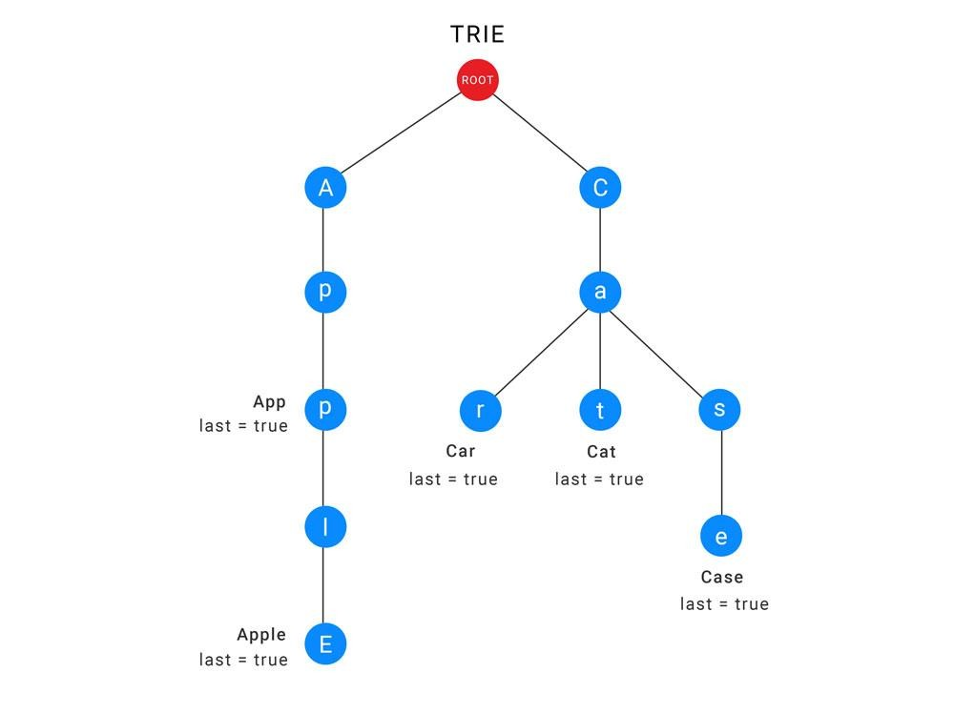

# Advantages of tries:

1. Efficient Prefix Matching: Tries are particularly well-suited for prefix matching operations. They allow for quick identification of words with a common prefix, making them highly efficient for autocomplete and spell checking tasks. Other data structures like hash tables or binary search trees would require additional operations or modifications to perform efficient prefix matching.
2. Fast Lookup and Retrieval: Tries provide fast lookup and retrieval of words. They have a time complexity of O(m), where m is the length of the word being searched. This is advantageous compared to hash tables or binary search trees that typically have an average-case time complexity of O(log n) or O(1) respectively.
3. Autocomplete and Suggestions: Tries naturally lend themselves to generating word

suggestions for misspelled words or autocomplete functionality. By traversing the trie from a specific node, it becomes straightforward to retrieve all the words that can be formed by following the path from that node.

1. Handling Large Dictionaries: Tries handle large dictionaries efficiently without compromising search performance. As the number of words in the dictionary grows, tries maintain their search speed since the search time is primarily dependent on the length of the word being queried, not the size of the dictionary.
2. Flexibility for Language-Specific Features: Tries can easily accommodate language-specific features and linguistic rules.
3. **IMPLEMENTATION:**

The code is implemented by building and utilising a trie data structure for auto-suggestion and spell checking. The code begins by reading a dictionary file and placing each word into the trie. The TrieNode class provides an array to hold child nodes and a flag to indicate the end of a word. It represents nodes in the trie.

The insert_trie() function adds a word to the trie and generates any necessary child nodes. When it reaches the end of a word, the print_suggestions() method recursively traverses the trie and prints ideas for auto-completion.

A word is checked for presence in the trie using the check_present() method. Print_suggestions() is used to display suggestions if the term is not entirely present. The main loop asks for user input, breaks it up into words, changes their case to lowercase, and then uses check_present() to see if they are present in the trie.

## Linked structure :

References to child TrieNode objects are kept in each TrieNode's trie array to simulate a connected structure. The value at each index in the trie array refers to the child node for the character that corresponds to that index in the trie array. The code creates a kind of linked structure by utilising array indices to represent the connections between nodes.

## Trees:

Each instance of the TrieNode class represents a node in the tree-like structure. The trie array within each TrieNode serves as the children of that node, similar to the branches in a tree.The trie array within each TrieNode establishes the parent-child relationship.it leverages a tree-like structure through the TrieNode class and the recursive operations performed on it. The nodes

and connections in the trie form a tree structure, enabling efficient retrieval, suggestion, and checking operations on the stored dictionary words.

## Integration and Interplay of constituent data structures:

Within a trie data structure, linked structures and trees are combined and interact as follows:

Linked Structures: Pointers or references between nodes are used to create the linked structures in a trie. To keep references to its child nodes, each TrieNode has an array or a comparable data structure. The hierarchical relationships between parent and child nodes are established by these linked connections.

A trie's tree-like structure results from the nodes being arranged in a hierarchical fashion. The edges between nodes reflect the relationships between characters, and each node represents a character or string fragment. Starting from the root node, a complete string is formed by each path leading to a leaf node.

## Following are some explanations for how these two basic data structures interact and integrate:

The tree-like structure of the trie is made possible by the linked structures, which are represented by the references between nodes. The trie may be traversed and navigated through effectively thanks to the references that link parent and child nodes. The foundation for arranging the letters and strings in a hierarchical fashion is provided by these linkages.

Linked structures are established by following the tree structure, which acts as a guide. Each node in the trie represents a different character, and the links between the child nodes reflect the relationships between those characters. The placement of nodes and the connections between them are determined by the tree structure, which guarantees the correct traversal path for searching, insertion, and other trie operations.

The trie data structure combines linked structures and trees, combining their hierarchical organisation and retrieval capabilities with the effective traversal and navigation offered by linked structures. Fast text lookup, prefix matching, auto-suggestion, and other actions often related to attempts are made possible by this integration.

# Design choices:

**Trie Data Structure**: Employing a trie data structure is a design decision that offers effective spell-checking and autocomplete functionality. The tree-like structure of Tries enables quick prefix matching and suggests potential completions.

**Recursive Insertion**: By recursively constructing nodes for each letter in the dictionary words,

the recursive insertion method makes it possible to assemble the trie quickly. This design decision guarantees that words are accurately kept in the trie and makes the code implementation simpler.

**Linked Structures:** The array of child node references found within each TrieNode of a linked structure, which is used, allows for quick and easy trie traversal. Quick access to child nodes and branch traversal are made possible by the connected connections.

# Trade-offs:

**Memory Usage**: Tries can use a lot of memory, particularly when working with big dictionaries. There may be a trade-off in terms of memory utilisation because each node in the trie needs memory allocation, especially if the dictionary is large.

**Construction Time**: Building the trie from scratch might be time-consuming, especially if the dictionary has a lot of terms in it. The time complexity of creating the trie might increase due to the usage of the recursive insertion technique in the code.

**Suggestion Accuracy**: Trie-based recommendations might offer quick completions that are pertinent to the problem at hand, but they aren't necessarily the most precise. The given code makes completion suggestions based on the trie structure, but it ignores additional elements like word frequency or context. Additional methods can be required, depending on the use case, to improve the precision of proposals.

**Efficiency of Spelling Checking**: The code's spell-checking functionality depends on navigating the trie to look for words. This method occasionally calls for visiting numerous nodes in order to assess whether a word is accurate. This may affect how effectively the spell -checking procedure works with huge dictionaries or lengthy input strings.

# Practical applications:

**Search Engines**: As users write their queries, auto-suggest is frequently utilised in search engines to offer real-time options. By providing pertinent search phrases and fixing typos, it improves the search experience.

**Text Editors and Word Processors**: Spell checkers are extensively used in text editors and word processors to detect and correct spelling mistakes in written documents. They help improve the accuracy and professionalism of written content.

**Messaging and Email Platforms** : Auto-suggest is valuable in messaging and email platforms, where it suggests commonly used phrases or predicts the next word, saving time and effort for users.

**Code Editors and IDEs:** Spell checkers and auto-suggest functionalities are beneficial in code

editors and integrated development environments (IDEs) to assist developers in writing correct and efficient code. They can suggest code snippets, correct typos, and identify syntax errors.

**Mobile Devices**: Auto-suggest and spell checkers are essential features in mobile devices' virtual keyboards. They facilitate fast and accurate typing on smaller touchscreens by offering word suggestions and correcting misspelt words.

**Social Media Platforms**: Auto-suggest is widely used in social media platforms for hashtags, mentions, and content suggestions. It helps users find relevant content and engage with others effectively.

**Online Forms and Surveys**: Spell checkers play a crucial role in online forms and surveys, ensuring accurate data entry by highlighting spellin g errors in real-time.

# Performance Analysis:

**insert_trie(root, s):** This function is responsible for inserting a word s into the trie. The time complexity of this function is O(L), where L is the length of the word s. It iterates over each character of the word and performs constant time operations to create new nodes and update references.

**print_suggestions(root, res)**: This function is used to print all the suggestions (completions) for a given prefix res. The time complexity of this function depen ds on the number of suggestions and the structure of the trie. In the worst case, if there are a large number of suggestions, the time complexity can be O(M), where M is the total number of nodes in the trie.

**check_present(root, key):** This function checks if a given word key is present in the trie and suggests alternatives if it is not found. The time complexity of this function is O(K), where K is the length of the word key. It iterates over each character of the word and performs constant time operations to traverse the trie and suggest alternatives if necessary.

# Space Analysis:

**Dictionary:** The quantity of words and their average length determine the complexity of the storage space required for the dictionary. The space complexity for storing the dictionary would be O(N * L) if there were N words in the dictionary with an average length of L. This is necessary in order to save each word as a distinct string.

**Trie Data Structure:** The trie data structure's node count affects how complicated it is in terms of space. In the worst situation, every word in the dictionary creates a distinct path in the trie, leading to a node for every word. As a result, the trie's space complexity is O(N * L), where N

represents the number of words and L represents the average word length.

# Performance Analysis:

**Auto-Suggest:**

**Trie:** When it comes to developing auto-suggest functionality, the trie data structure is quite effective. Prefix matching is made possible, allowing for quick retrieval of ideas depending on user input. A trie is a good choice for real-time suggestions since the time complexity of obtaining ideas is related to the length of the prefix being matched. Tries offer quick lookups and effectively manage huge vocabularies.

Additional Data Structures You may also utilise other data structures for auto-suggest, such as hash tables or binary search trees. To produce ideas, they could need extra processing, though. For instance, in order to locate matches, hash tables would need to cycle through all keys, whereas binary search trees would need to take additional steps for prefix matching.

**Spelling check:**

Due to their effective lookup capabilities, tries are frequently employed in the implementation of spell checkers. The trie's hierarchical structure enables quick searches and valid word detection. A trie is a very effective spell checker since its temporal complexity is inversely correlated with the length of the word. Tries also give the option of suggesting different words by going through the trie, which leads to quicker spell-checking performance.

Additional Data Structures Spell checking can also make use of other types of data structures, such as hash sets or bloom filters. When it comes to providing alternatives or dealing with terms that share a prefix, they could be constrained. While bloom filters can include recommendations, hash sets may only allow precise matches. When compared to attempts, these restrictions may affect the spell checker's performance and accuracy.

# DISCUSSION :

## Practicality:

**Efficiency**: Due to Tries' effective search and retrieval capabilities, these programmes are well-

suited for jobs like auto-suggest and spell checking. The code quickly facilitates prefix matching and recommendation creation by effectively organising the dictionary terms in a trie. Even with enormous dictionaries, it guarantees speedy reaction times, making it useful for real-time applications.

**Accuracy**: Attempts to deliver accurate auto-suggest and spell-checking results. The algorithm makes sure that suggestions are founded on true dictionary definitions and provides backup choices in the event that an input cannot be located. This precision is essential for giving trustworthy suggestions and precise spell checking, which makes the code useful for applications where accuracy is key.

**Customizability**: The code is highly adaptable and may be expanded to meet certain needs. The code may be expanded to provide other features like handling special characters, adding language-specific restrictions, or employing cutting-edge algorithms for recommendation ranking. Its usefulness is increased by the flexibility that enables modification and adaption to various use cases.

## Effectiveness :

The trie data structure is used by the algorithm to deliver precise auto-suggestions and spell checking. It takes into account the full vocabulary and offers legitimate substitutions depending on the input, enhancing the accuracy of suggestions and corrections.

Fast word retrieval and traversal made possible by the usage of a trie make auto-suggestions and spell checking more effective. Quick answers are achieved by optimising the temporal complexity of activities like insertion, search, and recommendation creation .

By offering comments and fixes in real-time, the code improves the user experience. Users can rapidly spot and fix spelling mistakes, increasing the accuracy and effectiveness of their work.

## Limitations and challenges :

The code that uses a trie data structure for auto-suggest and spell-checking features has a number of advantages, but it also has certain drawbacks and difficulties:

**Memory Usage**: Tries can use a lot of memory, particularly when working with big dictionaries. Memory must be allocated for each node in the trie, and for dictionaries containing a large number of uncommon words, the memory use might grow significantly. In situations with little available memory, this could be a drawback.

**Initialization Time**: Adding every word from the dictionary to the trie might be time-consuming, especially for very big dictionaries. Before the auto-suggest and spell checking functions are

made available, there can be an observable delay during the startup phase of the code.

Additional optimisations may be needed to address these issues, such as trie structure compression, effective updating mechanisms, integration of cutting-edge language processing methods, and enhanced error correction algorithms.

# CONCLUSION :

In conclusion, a trie-based hybrid data structure is effective and feasible for the construction of an auto-suggest and spell-checker. The algorithm allows for quick word lookup, accurate recommendation, and real-time spell checking by merging linked structures and trees. The trie's hierarchical structure and effective traversal make it easy to complete tasks quickly and precisely, improving user experience and productivity. The code's versatility to customization enables language support, scalability, and application-specific adaptation. The use of memory, startup times, dictionary updates, and problems with ambiguous terms and sophisticated error correction should all be addressed, in addition to memory usage, initialization times, and these issues. Overall, the auto-suggest and spell checking are implemented using a trie-based hybrid data structure, which is a strong tool for enhancing text input applications.