GawaHelper

Final Project in IT Elective

Members:
Samantha Nicole Cabrillos
Louie Jhe Antigua
Alexander Ducay
Marion Gerunda

Benedict M. Castro, MIT

May 2x, 2026
PROJECT OVERVIEW
Project Introduction
GawaHelper is a comprehensive online task marketplace designed to connect individuals who need help with everyday chores or errands to skilled community members willing to do the work. By bridging the gap between clients and local helpers, the system aims to solve the problem of finding reliable, on-demand assistance for short-term tasks. It provides a secure, organized, and accessible platform where users can post tasks, negotiate, and collaborate efficiently within their community.
Features
Task Management: Users can easily post new tasks, view available tasks in their area, and track the status of ongoing jobs.
Real-Time Messaging: A built-in chat system allows clients and helpers to communicate instantly, discuss details, and negotiate terms.
Secure Authentication: Uses modern, passwordless biometric logins (like fingerprint or Face ID) alongside traditional email authentication for enhanced security.
Notification System: Keeps users updated with real-time alerts for new messages, task applications, and status changes.
User Profiles & Ratings: Both clients and helpers have public profiles showing their completion history and community ratings to build trust.
Admin Dashboard: A centralized control panel for administrators to monitor platform activity, manage users, and handle reports.

Purpose
The primary purpose of GawaHelper is to simplify the process of outsourcing daily tasks.

Why it was created: To create a localized, gig-economy platform that empowers communities to support one another.
What issues it aims to solve: It addresses the difficulty of finding trustworthy, immediate help for minor jobs (like cleaning, deliveries, or repairs) and provides a safe space to facilitate these agreements.
How it helps users: It gives busy individuals a quick way to get things done, while providing flexible earning opportunities for local workers, students, or anyone looking for extra income.
Functionality
The system works through a simple, user-friendly workflow. A user (Client) posts a task detailing what they need, the location, and their budget. Other users (Helpers) browse these postings and apply to tasks that match their skills. The Client reviews the applicants, communicates via the built-in chat, and accepts a Helper. Once the task is completed, both parties can leave a rating and review. Behind the scenes, the system securely manages user data, ensures real-time updates, and maintains a history of all transactions.

TEAM STRUCTURE
Role and Responsibilities
Marion Gerunda - Project Manager
Responsibilities: Oversees the entire project lifecycle. Responsible for coordinating team efforts, managing timelines, setting milestones, and ensuring the capstone project is delivered on schedule and meets all academic requirements.
Louie Jhe Antigua - Hustler
Responsibilities: Handles business logic, marketing strategy, and system testing. Responsible for ensuring the platform meets user needs, conducting quality assurance testing, and defining the core features that drive user engagement.

Samantha Nicole Cabrillos - Hipster
Responsibilities: Leads the UI/UX design process. Responsible for creating a clean, visually appealing, and user-friendly interface. Ensures the system is intuitive and provides a seamless experience across all devices.
Alexander Ducay - Hacker
Responsibilities: Serves as the lead developer and technical architect. Responsible for writing the core code, managing the database, ensuring system security, and integrating all backend and frontend functionalities.

SYSTEM FLOW DIAGRAM
The following diagram illustrates the high-level workflow of the GawaHelper platform, showing how users interact with the system from registration to task completion.
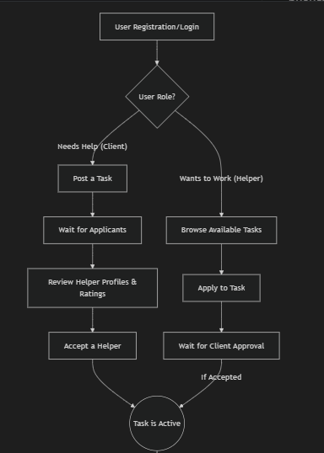
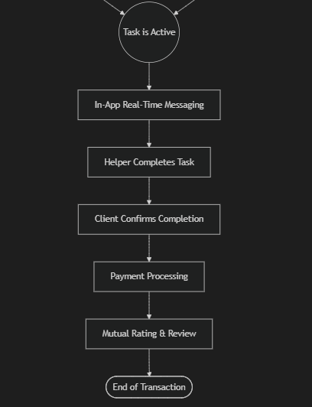

DATABASE DESIGN

Database Schema
User:
Admin:

Data Dictionary
The data dictionary provides a detailed breakdown of the primary tables and fields used in the system's PostgreSQL database.
1. Users Table
Stores all registered user accounts, including clients, helpers, and administrators.
Field Name | Data Type | Constraint | Description
UserID | SERIAL | Primary Key | Unique identifier for the user.
FullName | VARCHAR(100) | NOT NULL | The user's complete name.
Email | VARCHAR(100) | UNIQUE, NOT NULL | User's email address used for login.
PasswordHash | VARCHAR(255) | NOT NULL | Encrypted password string.
Rating | DECIMAL(3,1) | NULL | The average community rating of the user.
WalletBalance | DECIMAL(12,2) | DEFAULT 0.00 | Digital wallet balance for payments.
ProfileImage | VARCHAR(255) | NULL | URL to the user's avatar image.
IsAdmin | SMALLINT | DEFAULT 0 | Flag indicating if the user is an administrator (1) or not (0).
EmailVerified | SMALLINT | DEFAULT 0 | Flag indicating if the email has been confirmed.
2. Tasks Table
Stores all job postings created by users.
Field Name | Data Type | Constraint | Description
TaskID | SERIAL | Primary Key | Unique identifier for the task.
UserID | INT | Foreign Key | Links to Users.UserID (The task creator).
Title | VARCHAR(100) | NOT NULL | Short, descriptive title of the job.
Description | TEXT | NOT NULL | Detailed requirements of the task.
Location | VARCHAR(100) | NOT NULL | Physical location where the task occurs.
TaskTime | TIMESTAMPTZ | NOT NULL | Scheduled date and time for the task.
Budget | DECIMAL(10,2) | CHECK > 0 | The amount the client is willing to pay.
CategoryID | INT | Foreign Key | Links to Categories.CategoryID.
Status | VARCHAR(20) | DEFAULT 'Open' | Current state ('Open', 'Assigned', 'Completed', etc.).
3. TaskAssignments Table
Tracks which helper has been assigned to which task.
Field Name | Data Type | Constraint | Description
AssignmentID | SERIAL | Primary Key | Unique identifier for the assignment record.
TaskID | INT | Foreign Key | Links to Tasks.TaskID.
HelperID | INT | Foreign Key | Links to Users.UserID (The assigned helper).
AcceptedAt | TIMESTAMPTZ | DEFAULT NOW() | Timestamp when the helper was hired.
CompletedAt | TIMESTAMPTZ | NULL | Timestamp when the task was finished.
4. Categories Table
Defines the types of tasks available on the platform (e.g., Errands, Delivery, Tutoring).
Field Name | Data Type | Constraint | Description
CategoryID | SERIAL | Primary Key | Unique identifier for the category.
CategoryName | VARCHAR(50) | UNIQUE, NOT NULL | Name of the task category.
5. Messages Table
Stores real-time chat history between users.
Field Name | Data Type | Constraint | Description
MessageID | SERIAL | Primary Key | Unique identifier for the message.
TaskID | INT | Foreign Key | Links to Tasks.TaskID (The related job context).
SenderID | INT | Foreign Key | Links to Users.UserID (Who sent it).
RecipientID | INT | Foreign Key | Links to Users.UserID (Who receives it).
Content | TEXT | NOT NULL | The actual text message.
IsRead | SMALLINT | DEFAULT 0 | Flag indicating if the message was seen.
6. Reviews Table
Stores post-task ratings and feedback.
Field Name | Data Type | Constraint | Description
ReviewID | SERIAL | Primary Key | Unique identifier for the review.
TaskID | INT | Foreign Key | Links to Tasks.TaskID.
ReviewerID | INT | Foreign Key | Links to Users.UserID (Who wrote it).
ReviewedUserID | INT | Foreign Key | Links to Users.UserID (Who received it).
Rating | DECIMAL(2,1) | CHECK 0.5 - 5.0 | Star rating given.
Comment | TEXT | NULL | Optional written feedback.

DESIGN OF THE PROTOTYPE

Figure 1: Login Page
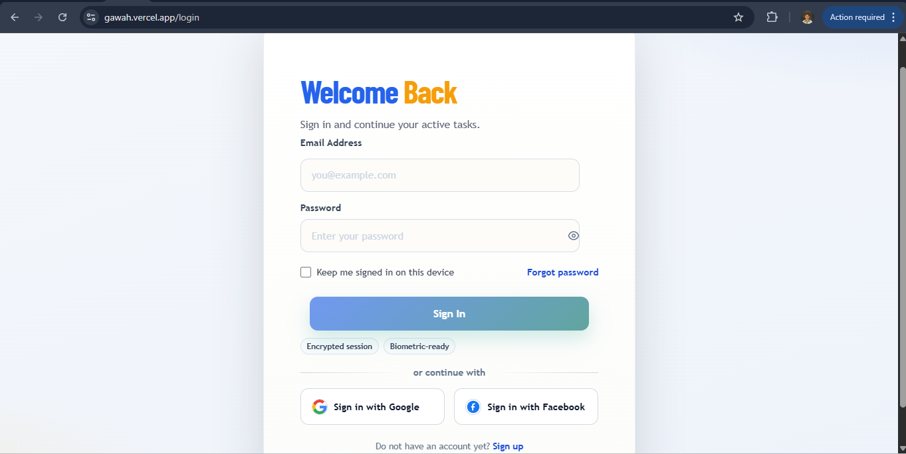
Figure 2: Sign Up Page
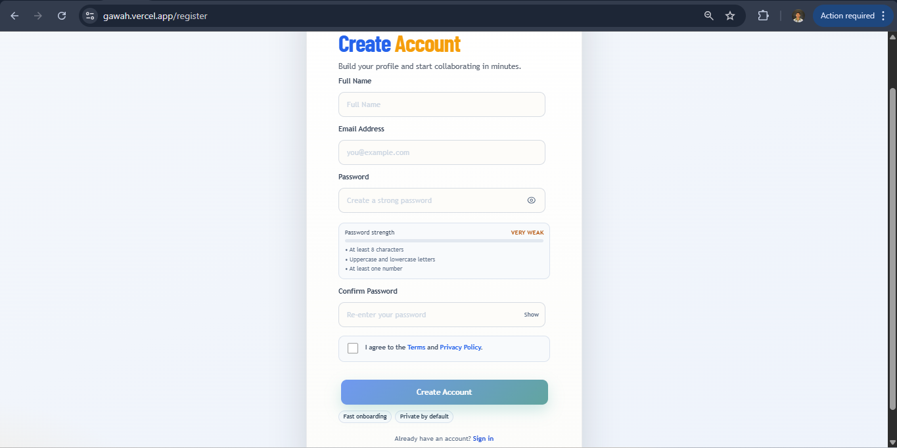
Figure 3: Home Page
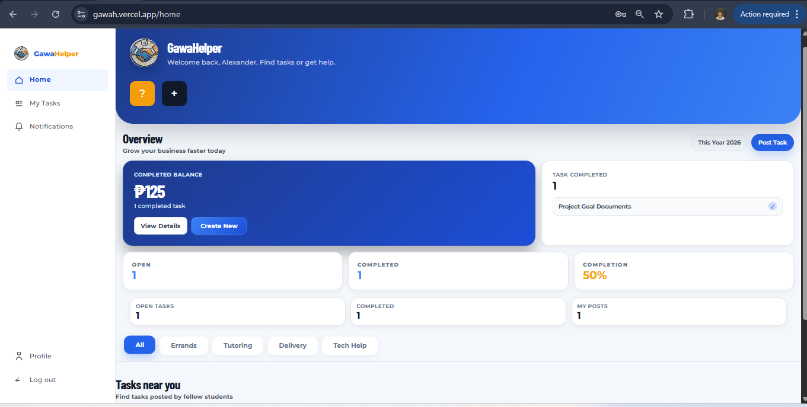
Figure 4: Admin Login Page
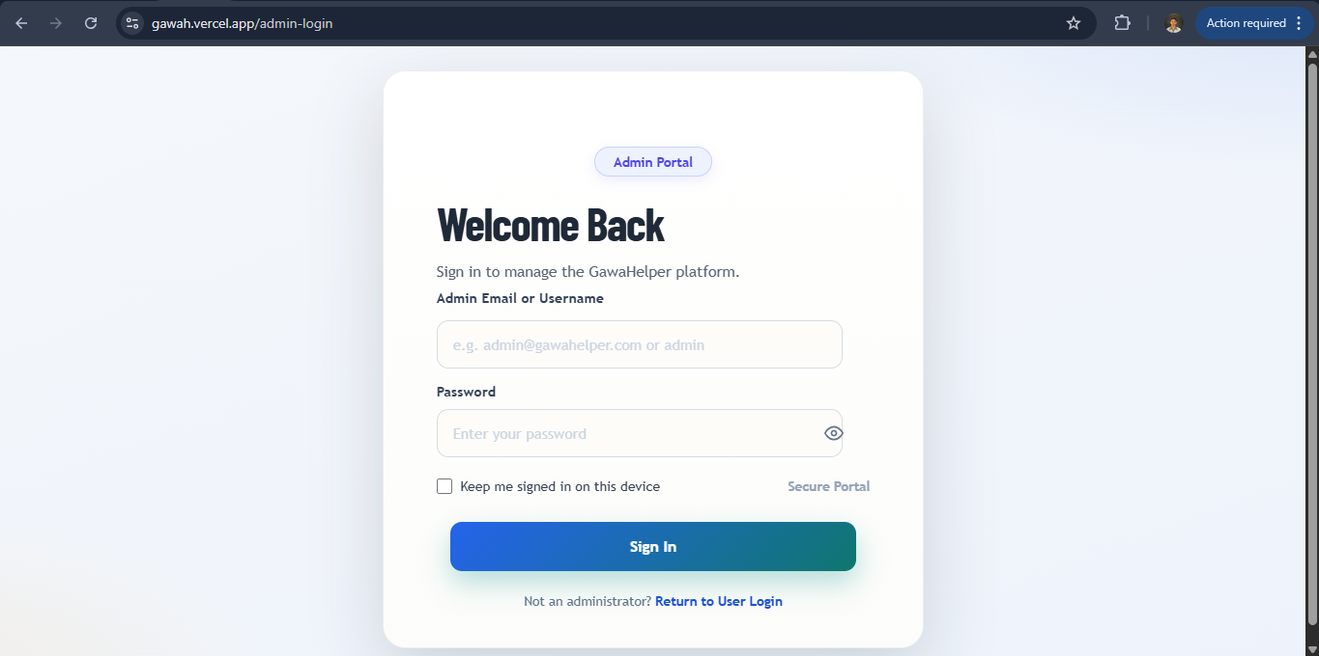
Figure 5: Admin Home Page
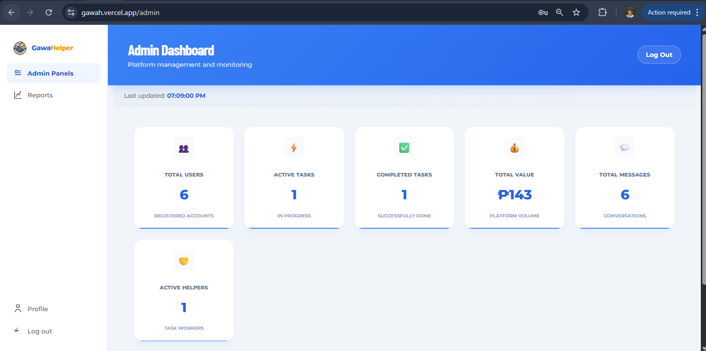
Framework Development & Core
Software and Tools Use
Visual Studio Code (Code Editor)
Git & GitHub (Version Control)
Postman (API Testing)
Vercel (Frontend Hosting)
Railway (Backend & Database Hosting)
Resend API (Email Services) Supabase (File & Image Storage)
Web App Development
Backend: Node.js (JavaScript)
Database: PostgreSQL
Frontend: React.js powered by Vite

Github Link: https://github.com/Alexandercode-web/gawah

Google Link:
- Sourcecode (winrar/zipped)
- Final Documentation

